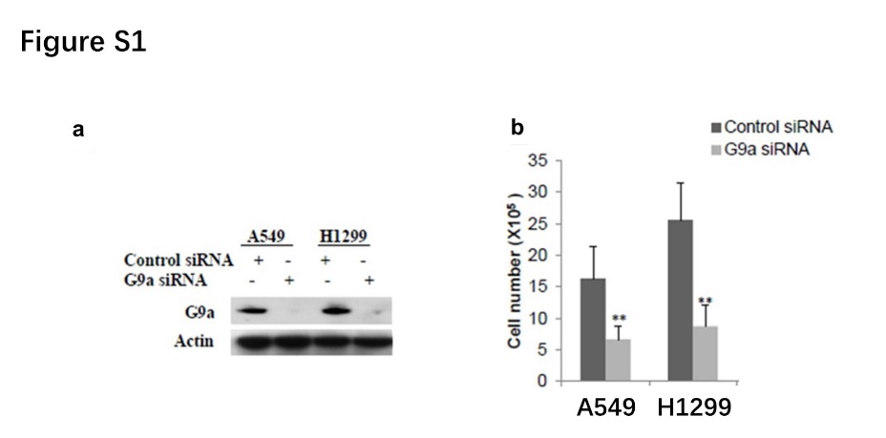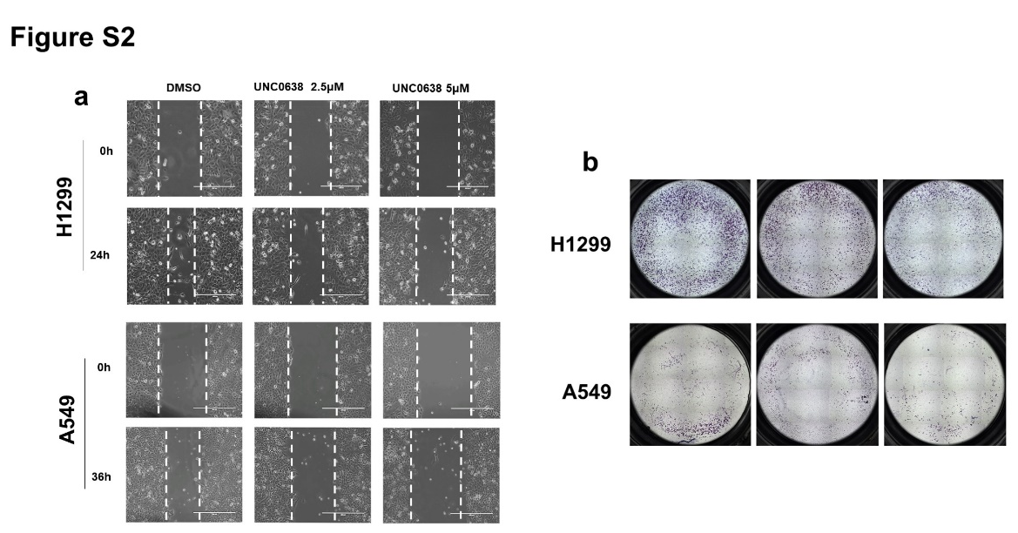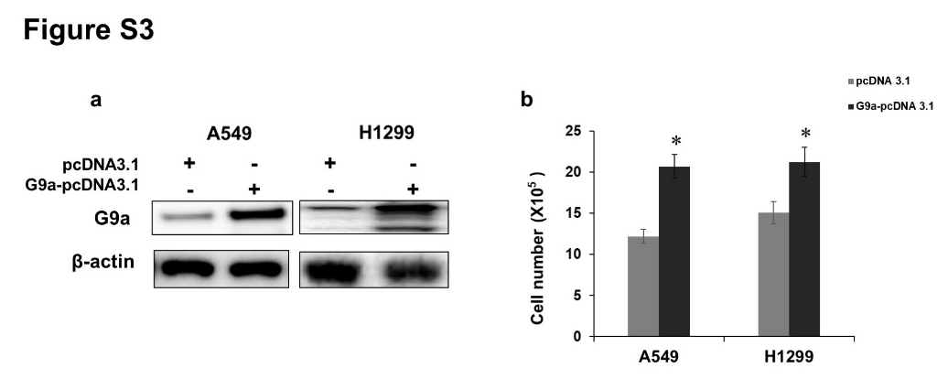

Supplementary materials
Figure S1. G9a silencing suppresses cell proliferation in A549 and H1299 NSCLCs
a. G9a was suppressed in NSCLC cell lines transfected with G9a siRNA. b. Cell proliferation was suppressed upon silence of G9a in NSCLCs. ** P < 0.01 (compared to control siRNA).
Figure S2. Cell migratory and invasive ability are suppressed by G9a inhibitor UNC0638 in NSCLCs.
a. Representative images of invasive cells showed that cell migration was suppressed in NSCLC cell lines treated by UNC0638. Scale bar refers to 200µm. b. Representative image of invasive cells showed that cell invasive ability was suppressed in NSCLC cell lines treated by UNC0638. Scale bar refers to 2000µm.
Figure S3. G9a overexpression increases cell proliferation in NSCLCs.
a. Western blots showed that G9a was overexpressed in NSCLCs. b. Cell proliferation was enhanced upon overexpression of G9a in NSCLCs. * P < 0.05 (Compared to pcDNA 3.1).

