Supplementary Table 1. Clinical characteristics of full-term normal pregnancies

 | Normal pregnancies (n=12)
Maternal age (years) | 29.9±3.5
Gestational age (days) | 271.0±4.7
Maternal BMI (Kg/m²) | 28.7±3.5
Systolic pressure (mmHg) | 111.2±10. 9
Diastolic pressure (mmHg) | 74.7±6.7
Gravidity  1  >1 | 4  8
Newborn sex  female  male | 6  6
Birth weight (g) | 3334.6±127.2
Placental weight (g) | 580.0±81.7
Continuous variables were shown as mean±standard deviation, counting data described as frequency.

Supplementary Table 2. The baseline clinical data of full-term AGA and SGA pregnancies

 | AGA (n=10) | SGA (n=8) | p value
Maternal age (years) | 29.2±3.0 | 28.5±3.5 | 0.655
Gestational age (days) | 270.8±5.0 | 270.1±3.2 | 0.746
Maternal BMI (Kg/m²) | 28.98±3.1 | 27.8±4.4 | 0.500
Systolic pressure (mmHg) | 109.3±9.9 | 106.8±8.6 | 0.573
Diastolic pressure (mmHg) | 74.6±7.1 | 71.13±2.3 | 0.202
Gravidity  1  >1 | 3  7 | 4  4 | 0.748
Newborn sex  female  male | 4  6 | 4  4 | 0.671
Birth weight (g) | 3341.5±131.2 | 2762.5±87.6 | 0.000
Placental weight (g) | 583.0±80.6 | 515.6±86.4 | 0.107
Continuous variables were shown as mean±standard deviation, counting data described as frequency.
Supplementary Table 3 The overlapped lipid components with differential concentrations between DJ and L side of mouse placentas from Ctrl and Rapa group

 | DJ side |  |  | L side
Lipid name | Fold change  (Rapa/Ctrl) | change | p value | Fold change  (Rapa/Ctrl) | change | p value
BMP36:2(18:2_18:0) | 1.25 | up | 0.03 | 1.46 | up | 0.04
CE-16:0 | 1.65 | up | 0.04 | 1.74 | up | 0.00
CE-18:0 | 1.74 | up | 0.00 | 2.05 | up | 0.00
CE-18:2 | 1.85 | up | 0.01 | 1.84 | up | 0.00
CE-18:3 | 1.92 | up | 0.00 | 1.74 | up | 0.01
CE-20:3 | 1.75 | up | 0.00 | 1.84 | up | 0.00
CE-20:4 | 1.92 | up | 0.00 | 1.63 | up | 0.02
CE-20:5 | 2.17 | up | 0.00 | 2.09 | up | 0.00
CE-22:4 | 1.66 | up | 0.03 | 1.41 | up | 0.03
CE-22:6 | 1.91 | up | 0.01 | 2.03 | up | 0.00
CL66:4(16:1) | 0.25 | down | 0.00 | 0.28 | down | 0.00
CL68:5(16:1) | 0.34 | down | 0.00 | 0.39 | down | 0.00
CL68:5(18:2) | 0.64 | down | 0.00 | 0.63 | down | 0.00
CL68:6(16:1) | 0.41 | down | 0.00 | 0.44 | down | 0.00
CL70:4(16:1) | 0.51 | down | 0.00 | 0.54 | down | 0.00
CL70:5(16:1) | 0.55 | down | 0.00 | 0.58 | down | 0.00
CL70:5(18:2) | 0.80 | down | 0.01 | 0.85 | down | 0.01
CL70:6(16:1) | 0.68 | down | 0.00 | 0.68 | down | 0.00
CL70:6(18:2) | 0.78 | down | 0.01 | 0.81 | down | 0.00
CL70:7(16:1) | 0.76 | down | 0.01 | 0.84 | down | 0.03
CL72:8(16:1) | 0.75 | down | 0.02 | 0.73 | down | 0.00
CL72:9(16:1) | 0.75 | down | 0.00 | 0.79 | down | 0.00
CL74:10(16:1) | 0.69 | down | 0.02 | 0.66 | down | 0.00
CL74:7(18:2) | 1.39 | up | 0.03 | 1.21 | up | 0.00
CL74:8(18:2) | 1.32 | up | 0.02 | 1.27 | up | 0.00
CL74:9(18:2) | 1.28 | up | 0.00 | 1.24 | up | 0.00
CL74:9(20:3) | 1.24 | up | 0.04 | 1.34 | up | 0.00
CL76:10(18:2) | 1.37 | up | 0.02 | 1.14 | up | 0.02
CL76:11(16:1) | 0.66 | down | 0.01 | 0.71 | down | 0.00
CL76:13(16:1) | 0.58 | down | 0.00 | 0.56 | down | 0.00
CL76:14(16:1) | 0.59 | down | 0.01 | 0.55 | down | 0.00
CL78:12(18:2) | 1.60 | up | 0.03 | 1.25 | up | 0.03
CL78:13(18:2) | 1.33 | up | 0.02 | 1.32 | up | 0.02
DAG38:4(18:0/20:4) | 1.30 | up | 0.04 | 1.19 | up | 0.03
DAG38:5(18:0/20:5) | 1.30 | up | 0.04 | 1.38 | up | 0.00
DAG38:6(16:0/22:6) | 1.50 | up | 0.01 | 1.28 | up | 0.01
FFA18:2 | 1.50 | up | 0.00 | 1.50 | up | 0.01
FFA20:3 | 1.48 | up | 0.01 | 1.52 | up | 0.04
FFA20:4 | 1.84 | up | 0.01 | 1.59 | up | 0.02
FFA20:5 | 2.12 | up | 0.01 | 1.95 | up | 0.02
FFA22:6 | 1.89 | up | 0.00 | 1.52 | up | 0.01
Gb3 d18:1/16:0 | 1.45 | up | 0.00 | 1.27 | up | 0.04
LPE18:0p | 1.24 | up | 0.04 | 1.25 | up | 0.03
LPE18:1 | 0.55 | down | 0.04 | 0.72 | down | 0.01
LPS16:0 | 0.62 | down | 0.02 | 0.73 | down | 0.01
LPS18:1 | 0.79 | down | 0.02 | 0.73 | down | 0.03
PC40:6 | 1.69 | up | 0.02 | 1.23 | up | 0.01
PE34:1 | 0.48 | down | 0.00 | 0.65 | down | 0.00
PE36:1 | 0.66 | down | 0.00 | 0.68 | down | 0.01
PE38:2p | 0.62 | down | 0.00 | 0.78 | down | 0.00
PS 32:0 | 0.72 | down | 0.02 | 0.68 | down | 0.02
PS 32:1 | 0.48 | down | 0.00 | 0.70 | down | 0.02
PS 34:1 | 0.61 | down | 0.00 | 0.73 | down | 0.03
PS 40:4 | 0.91 | down | 0.02 | 0.86 | down | 0.03
PS 40:6 | 1.30 | up | 0.03 | 1.26 | up | 0.00
TAG48:0(16:0) | 1.48 | up | 0.04 | 1.36 | up | 0.04
TAG50:2(16:0) | 1.35 | up | 0.04 | 1.51 | up | 0.00
TAG50:2(18:2) | 1.58 | up | 0.02 | 1.50 | up | 0.00
16:1-carnitine | 0.52 | down | 0.02 | 0.56 | down | 0.00
18:1-carnitine | 0.55 | down | 0.01 | 0.60 | down | 0.00
20:1-carnitine | 0.43 | down | 0.00 | 0.54 | down | 0.04
BMP: bis-monoacylglycerol phosphate, CE: cholesteryl esters, CL: cardiolipins, DAG: diacylglycerols, FFA: free fatty acid, Gb3: ceramide trihexoside, LPE: lyso- phosphatidylethanolamines, LPS: lyso-phosphatidylserines, PC: phosphatidylcholines; PE: phosphatidylethanolamines, PS: phosphatidylserines, TAG: triacylglycerols.

Supplementary Table 4 RT-qPCR primer sequences for mouse

Gene | Forward primer（5’-3’） | Reverse primer（5’-3’）
Cpt1a  Cpt1b  Cpt1c  Acaca  Acacb  Fasn  Slc27a2  Slc27a4  Slc27a6  Cd36  Srebf1  Srebf2  Soat1  Soat2  Ppar-α  Ppar-β/δ  Ppar-γ  Enpp7  Clps  Cyp4f18  Msr1  Tpbpa  β-Actin | CTACATCACCCCAACCCATATT  GAGGAAGGGTAGAGTGGGCAGAG  CATTGGTCAGAATCTTTTCCGG  CCCAGAGATGTTTCGGCAGTCAC  CCTTTGGCAACAAGCAAGGTA  TAAAGCATGACCTCGTGATGAA  CCCAGGATGTCATCTATACCAC  GGTTACCTGTACTTCCGAGATC  CTGGTCACGGTGCTGGATAAGTTC  CTTTGAAAGAACTCTTGTGGGG  GCTACCGGTCTTCTATCAATGA  TTTTACTGAAGTAGAGCGGGTC  CACGACTGGCTCTACTACTATG  CGAGATGCTGCGGTTTGGAGAC  GAGCTGCAAGATTCAGAAGAAG  CGAGTTTGCTGTCAAGTTCAAT  CCAAGAATACCAAAGTGCGATC  AAGCCCAGTATATGACTCCTGC  GAACAGTATGCAGTGTAAGAGCA  TGTTTTTGAGAACTCTCTTCGCC  GCACAATCTGTGATGATCGCT  TTCCTAGTCATCCTATGCCTGG  GAAATCGTGCGTGACATCAAAG | GATCCCAGAAGACGAATAGGTT  TCATCCAGGGTCACAAAGAAAGCAG  GTACAGACTCTAGGTACTTGCG  GTCAGGATGTCGGAAGGCAAAGG  AGTCGTACACATAGGTGGTCC  GAAGTTCAGTGAGGCGTAGTAG  CAATGTACTGAATGACCGTGAC  CCTTTTTCAAGGTCTGTGCAAA  AGCGAGGAGTGGTTCAGGAGAG  GTCTGTGCCATTAATCATGTCG  CGCAAGACAGCAGATTTATTCA  CATGCATGGCTCTACAGGTATA  CAAAGAACATGAAGAGCACGAA  AGGTGCGGTAGTAGTTGGAGAAGG  GAATCTTTCAGGTCGTGTTCAC  GAATTCTAGAGCCCGCAGAAT  TCACAAGCATGAACTCCATAGT  ACCGTGCTGGTGGTATTGTAG  GCAGATGCCATAGTTGGTGTTG  TGGAATATGCGGATGACTGGG  CCCAGCATCTTCTGAATGTGAA  GGTCATTTTCGCTACTGTGAAGT  TGTAGTTTCATGGATGCCACAG

Supplementary Table 5 RT-qPCR primer sequences for human

Gene | Forward primer（5’-3’） | Reverse primer（5’-3’）
CPT1A  CPT1B  CPT1C  ACACA  ACACB  FASN  SLC27A2  SLC27A4  SLC27A6  CD36  SREBF1  SREBF2  SOAT1  SOAT2  PPAR-α  PPAR-β/δ  PPAR-γ  ENPP7  CLPS  GAPDH | GTGAGCGACTGGTGGGAGGAG  CGCCGTAAACTGGACCGTGAAG  GGTTCAGAGGGTCAGGGAAGGAG  TACCTTCTTCTACTGGCGGCTGAG  GACCATGTTCGTTCTCATCATG  CCATCTACAACATCGACACCAG  ATGCTTTCCGCCATCTACACAGTC  CTGTTGTTCCTCTACTTGGGAT  TCATAGTTCAGCAGCTATCCTG  CTGTTATGGGGCTATAGGGATC  CTGTGTGACCTGCTTCTTGT  GGAAAGCAGATGGGCAGCAGAG  ACTCATTTGTCAGAGAGAACGT  CACCATCTACCACATGTTCATC  TCGGCGAGGATAGTTCTGGAAGC  GATCCACGACATCGAGACATT  AGATCATTTACACAATGCTGGC  TGAGGGCTGGCTCCTTCTTCTAC  TGAATAGTGCCCAGTGTAAGAG  GACAGTCAGCCGCATCTTCT | TGCTGCCTGAATGTGAGTTGGAAG  GATCCGAGTGGTGTTGAACATCCTC  CAGAAGTCGGTGGATGTCATTGAGG  GCCTTCACTGTTCCTTCCACTTCC  TATTGCCGATGGTAATTCGGTA  CTTCCACACTATGCTCAGGTAG  GAAGAAGTATGGGCAGCAGAGGTTC  GTCTCGGAAGTACAGGTAGC  ATACTTCTTGCAGTCACTCCAA  ACTCCATCTGCAGTATTGTTGT  CTCATGTAGGAACACCCTCC  TAGCGACAGTAGCAGGTCACAGG  TAGCGACATAACCCCATCTTAC  AGATCAGTAGGTCAAACTCCAG  ACCACAGGATAAGTCACCGAGGAG  CGCCATACTTGAGAAGGGTAA  TAAAGTCACCAAAAGGCTTTCG  TGTTCGCTCTCCACTCCGTCTC  GGGACACTTGTAGTAAATCCCA  TTAAAAGCAGCCCTGGTGAC

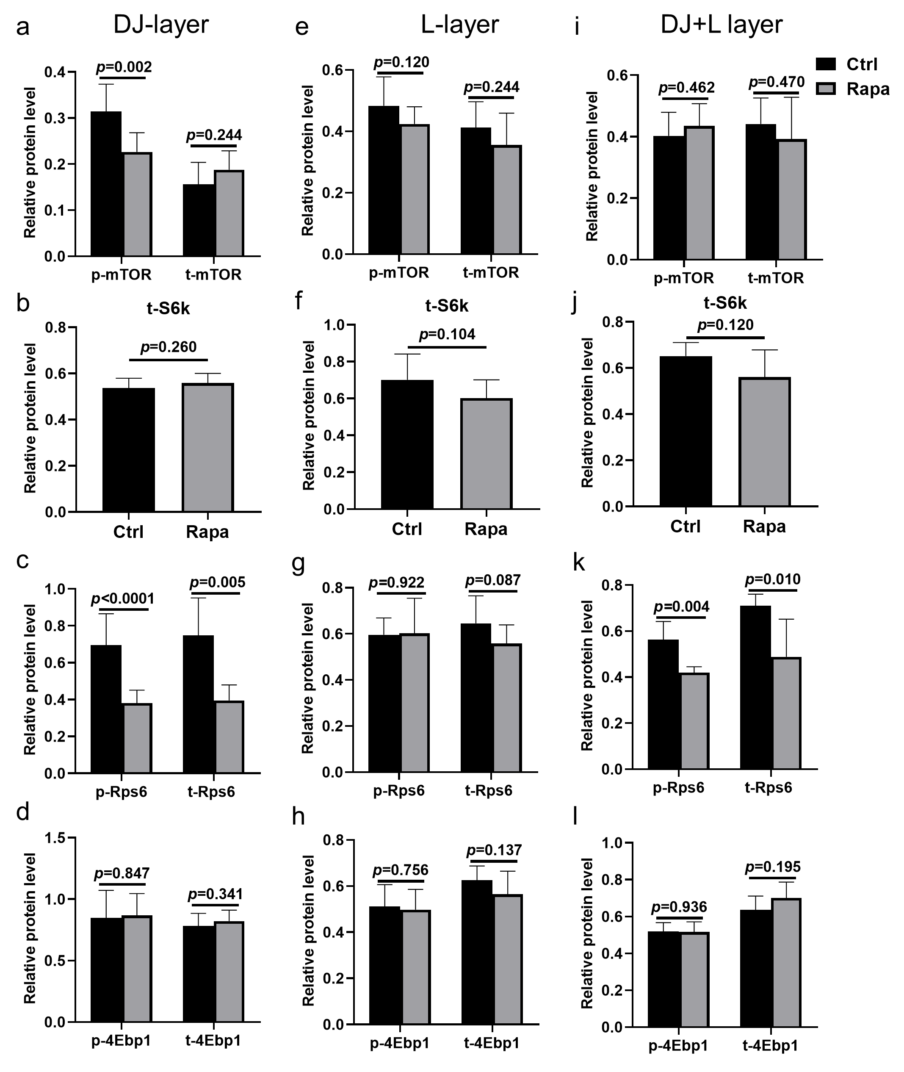
Figure S1 The analysis of the key proteins of mTOR signaling pathway in mouse placentas between Ctrl and Rapa group at E14.5. (a-d): The expressions of mTOR-related proteins in placental DJ-layers between the two groups (n=9/each group). (e-h): The expressions of mTOR-related proteins in placental L-layers between the two groups (n=9/each group). (i-l): The expressions of mTOR-related proteins in placental DJ+L layers between the two groups (n=9/each group). Student’s t-test was used for statistical analysis and p-value <0.05 was significant (ns: not significant).

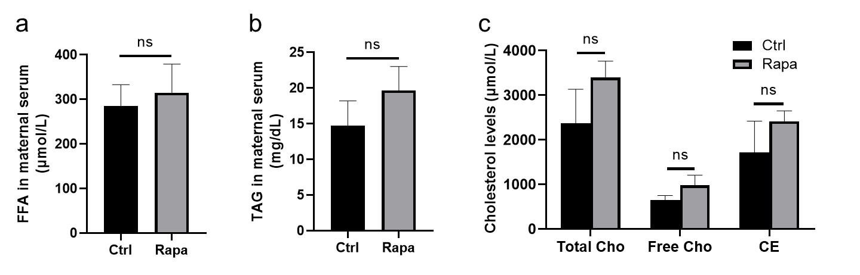
Figure S2 The levels of FFA (a), TAG (b) and Cho (c) in peripheral serum of pregnant mice between Ctrl and Rapa group (n=6/each group) at E14.5. Student’s t-test was used for statistical analysis and p-value <0.05 was significant (ns: not significant).

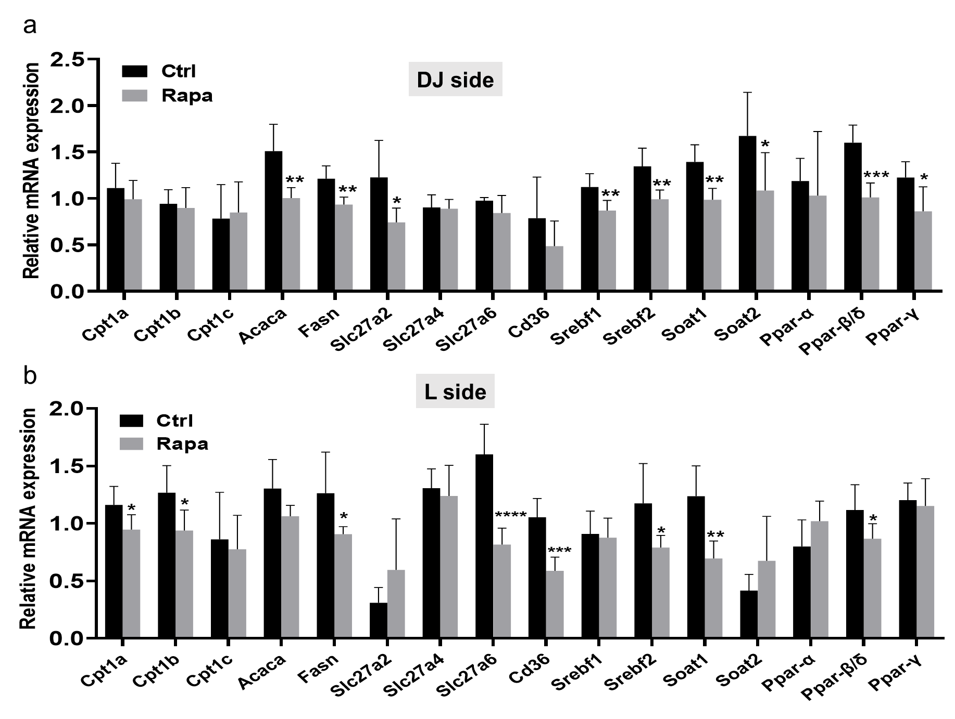
Figure S3 The mRNA expressions of genes linked with lipid oxidation (Cpt1a, Cpt1b, Cpt1c, Acaca) and lipogenesis (Fasn), lipid transport (Slc27a2, Slc27a4, Slc27a6 and Cd36) and relevant regulation factors (Srebf1, Srebf2, Soat1, Soat2, Ppar-α, Ppar-β/δ and Ppar-γ) in DJ-sides (a) or L-sides (b) of mouse placentas between Ctrl and Rapa group (n=6/each group) at E14.5, respectively. Student’s t-test was used for statistical analysis. *p<0.05, **p<0.01, ***p<0.001, ****p<0.0001.

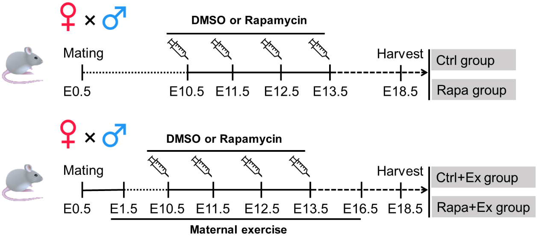

Figure S4 The experimental design in exploring whether maternal exercise improves FGR induced by rapamycin. Pregnant mice were divided to four groups, including: a) Ctrl group treated with DMSO injection at E10.5-E13.5; b) Rapa treated with rapamycin injection at E10.5-E13.5; c) Ctrl+Ex group experiencing running exercise during E1.5-E16.5 and DMSO injection at E10.5-E13.5; d) Rapa+Ex group undergoing running exercise during E1.5-E16.5 and rapamycin injection at E10.5-E13.5.

