Supporting Information:
Scheme S1: Chemical formula of chitosan, PVP, dextran, and doxorubicin.
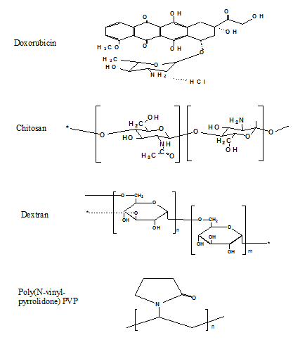

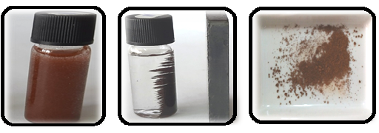
Figure S1. From (left) to (right): Aqueous suspension of Fe₃O₄ nanoparticles before and after imposing an external magnetic field, and dry Fe₃O₄ nanoparticles.

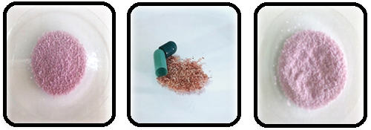
Figure S2a. Hybrid drug carrier microcapsules photography: (left) systems (A), (middle and right) system (B)

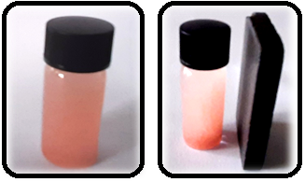
Figure S2b. Photography of hybrid drug carrier microcapsules (A) in aqueous solution before and after imposing a magnetic field.

