Supplementary information

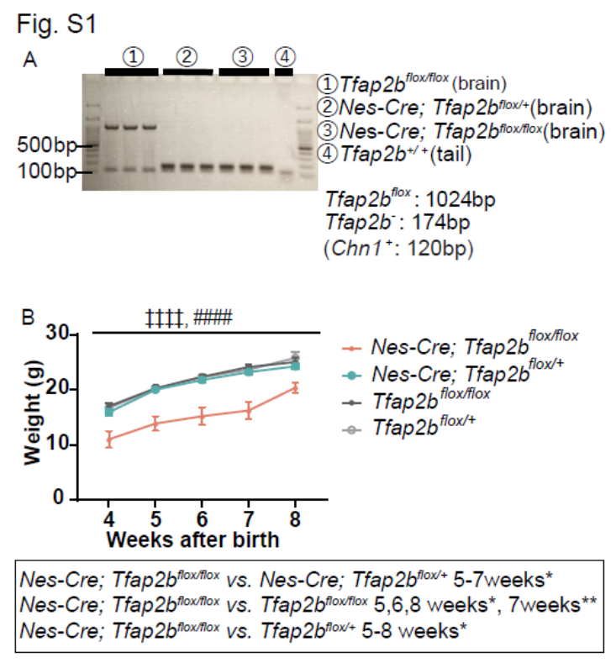
Fig. S1. Confirmation of Tfap2b deletion and comparison of bodyweight in nervous system-specific Tfap2b cKO and control mice.
(A) Results of PCR using genomic DNA obtained from the indicated tissues of WT mice, Tfap2b^{flox/flox} mice, Nes-Cre; Tfap2b^{flox/+} mice, and Nes-Cre; Tfap2b^{flox/flox} mice. (B) Comparison of bodyweight in nervous system-specific Tfap2b cKO and control mice. Data on male mice are shown. N=13 Tfap2b^{flox/+} mice (light grey), N=19 Tfap2b^{flox/flox} mice (dark grey), N=15 Nes-Cre; Tfap2b^{flox/+} mice (blue), N=8 Nes-Cre; Tfap2b^{flox/flox} mice (pink). # and ‡indicate a significant main effect of genotype and significant interaction between genotype and weeks after birth, respectively, in 2-way repeated-measures ANOVA (####, ‡‡‡‡ p<0.0001). * indicates significance in post-hoc Bonferroni multiple comparison test (* p<0.05, ** p<0.01). Data are presented as mean ± SEM.
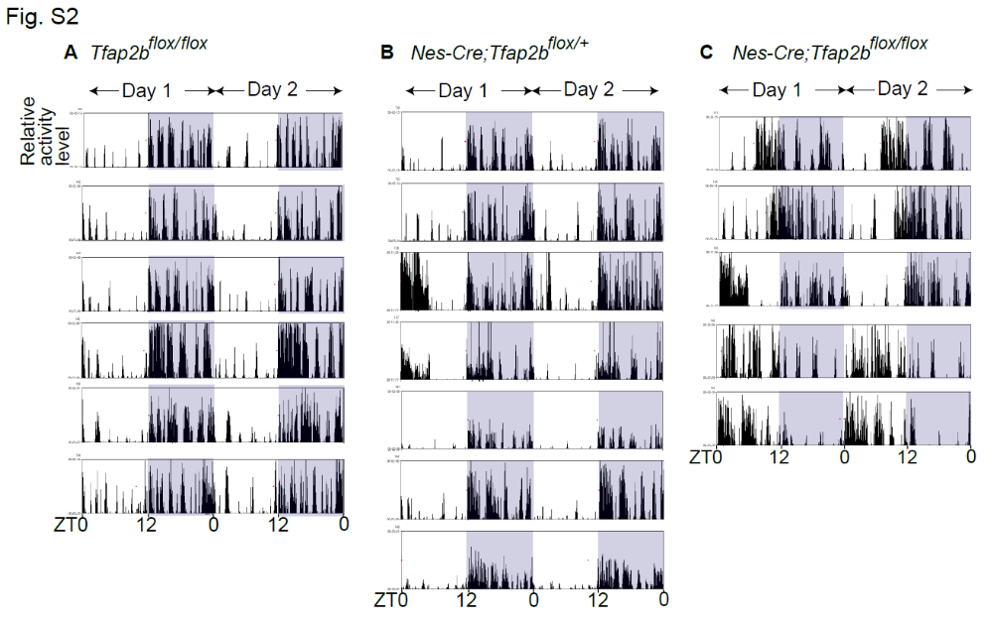

Fig. S2. Locomotor activity of nervous system-specific Tfap2b cKO mice.
(A-C) Patterns of infrared light-detected activity (5 min bin) across 2 consecutive days in individual Tfap2b^{flox/flox} mice (A), Nes-Cre; Tfap2b^{flox/+} mice (B), and Nes-Cre; Tfap2b^{flox/flox} mice (C).

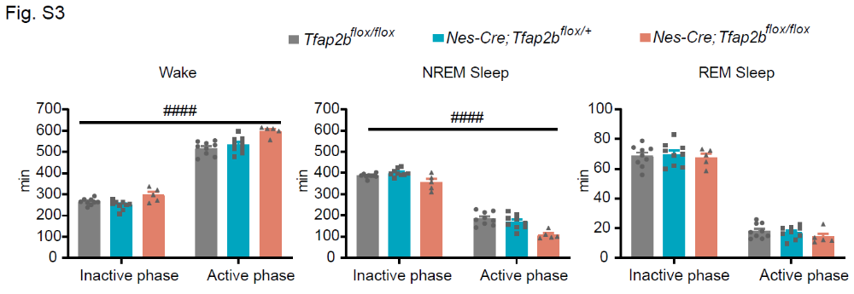

Fig. S3. Comparison of the amount of sleep/wake in nervous system-specific Tfap2b cKO and control mice during the active and inactive phase determined by locomotor activity.
Total amount of wakefulness, NREM sleep, and REM sleep in male mice during the inactive phase and the active phase, determined based on locomotor activity (see Materials and methods for details). N=9 Tfap2b^{flox/flox} mice (grey), N=9 Nes-Cre; Tfap2b^{flox/+} mice (blue), N=5 Nes-Cre; Tfap2b^{flox/flox} mice (pink). # indicates a significant main effect of genotype in 2-way repeated-measures ANOVA (#### p<0.0001). Data are presented as mean ± SEM.

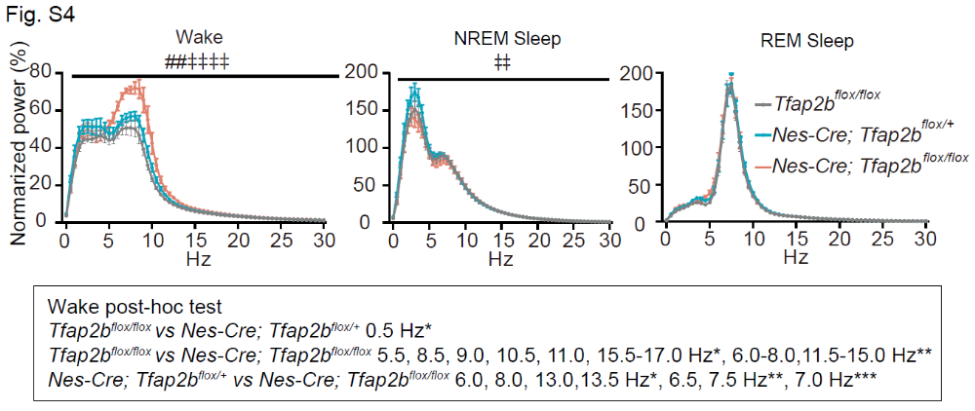
Fig. S4. Comparison of EEG power spectra in nervous system-specific Tfap2b cKO and control mice.
Comparison of the EEG power spectrum of wakefulness, NREM sleep, and REM sleep for 24 h between Tfap2b^{flox/flox}, Nes-Cre; Tfap2b^{flox/+}, and Nes-Cre; Tfap2b^{flox/flox} male mice. N=8 Tfap2b^{flox/flox} mice (grey), N=9 Nes-Cre; Tfap2b^{flox/+} mice (blue), N=6 Nes-Cre; Tfap2b^{flox/flox} mice (pink). # and ‡ indicate a significant main effect of genotype and significant interaction between frequency and genotype, respectively, in 2-way repeated-measures ANOVA (##, ‡‡ p<0.01, ‡‡‡‡ p<0.0001). * indicates significance in post-hoc Bonferroni multiple comparison test (* p<0.05, ** p<0.01, *** p<0.001). Data are presented as mean ± SEM.

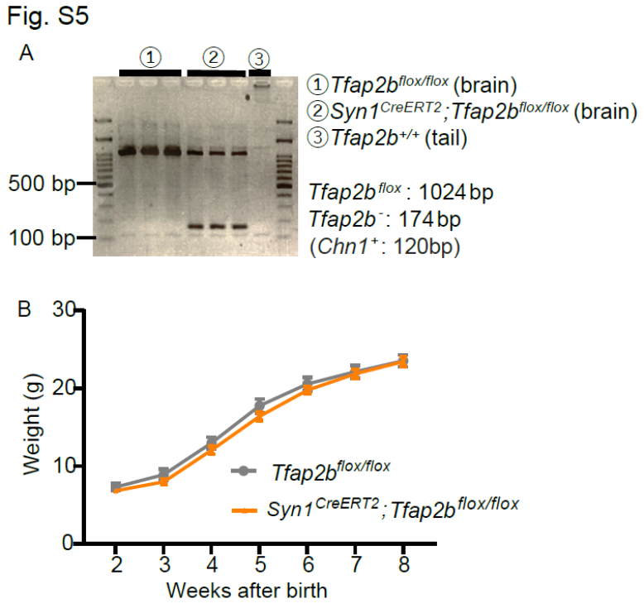

Fig. S5. Confirmation of Tfap2b deletion and comparison of bodyweight in postnatal neuron-specific Tfap2b cKO and control mice.
(A) Results of PCR using genomic DNA obtained from the indicated tissues of Tfap2b^{flox/flox} mice and Syn1^{CreERT2}; Tfap2b^{flox/flox} mice injected with tamoxifen (at P14, 17, and 21). (B) Comparison of bodyweight. Data of tamoxifen-injected (at P14, 17, and 21) male mice are shown. N=9 Tfap2b^{flox/flox} mice (grey), N=16 Syn1^{CreERT2}; Tfap2b^{flox/flox} mice (orange). Data are presented as mean ± SEM.

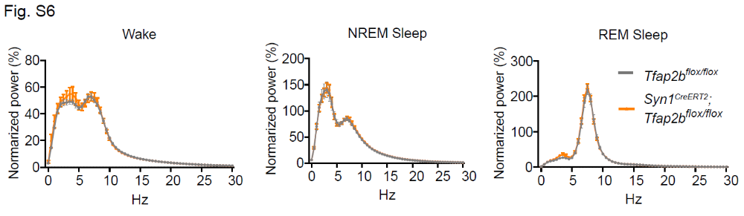

Fig. S6. Comparison of EEG power spectra in postnatal neuron-specific Tfap2b cKO and control mice.
Comparison of the EEG power spectrum of wakefulness, NREM sleep, and REM sleep for 24 h between Tfap2b^{flox/flox} and Syn1^{CreERT2}; Tfap2b^{flox/flox} mice. Data of tamoxifen-injected (at P14, 17, and 21) male mice are shown. N=6 Tfap2b^{flox/flox} mice (grey), N=8 Syn1^{CreERT2}; Tfap2b^{flox/flox} mice (orange). Data are presented as mean ± SEM.

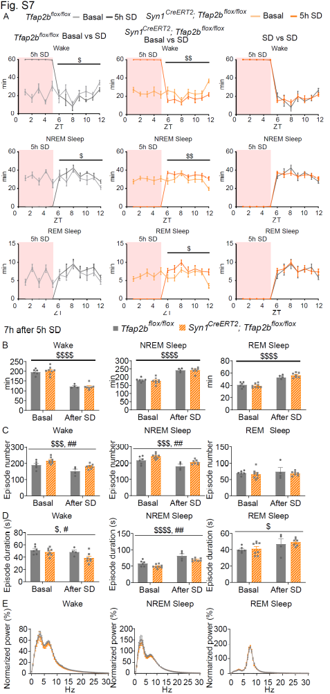
Fig. S7. Comparison of the sleep architecture after sleep deprivation (SD) in postnatal neuron-specific Tfap2b cKO and control mice.
(A) Hourly amount of wakefulness, NREM sleep, and REM sleep during 5 h of SD and subsequent 7 h in tamoxifen-injected (at P14, 17, and 21) male mice. For comparison, basal sleep data (same data as Fig. 2) are also shown. N=6 Tfap2b^{flox/flox} mice (basal sleep; light grey), N=4 Tfap2b^{flox/flox} mice (SD; dark grey). N=8 Syn1^{CreERT2}; Tfap2b^{flox/flox} mice (basal sleep; light orange), N=7 Syn1^{CreERT2}; Tfap2b^{flox/flox} mice (SD; dark orange). (B-D) Total amount (B), episode numbers (C), and durations (D) of wakefulness, NREM sleep, and REM sleep during the 7 h after SD (light phase). For comparison, basal sleep data (same data as Fig. 2) are also shown. N=6 Tfap2b^{flox/flox} mice (basal sleep), N=4 Tfap2b^{flox/flox} mice (SD). N=8 Syn1^{CreERT2}; Tfap2b^{flox/flox} mice (basal sleep), N=7 Syn1^{CreERT2}; Tfap2b^{flox/flox} mice (SD). (E) Comparison of the EEG power spectrum of wakefulness, NREM sleep, and REM sleep for 7 h after SD (light phase). N=4 Tfap2b^{flox/flox} mice (grey), N=7 Syn1^{CreERT2}; Tfap2b^{flox/flox} mice (orange). $ and # indicate a significant main effect of SD and genotype, respectively, in 2-way repeated-measures ANOVA ($, # p<0.05, $$, ## p<0.01, $$$ p<0.001, $$$$ p<0.0001). Data are presented as mean ± SEM.

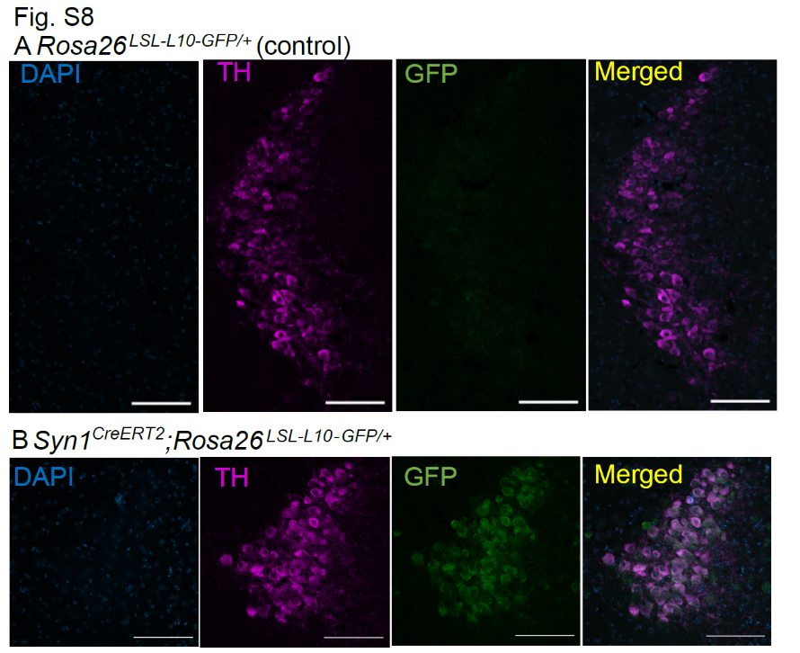

Fig. S8. Analyses of the Cre-mediated recombination pattern in Syn1^{CreERT2} mice at the LC.
(A, B) Images of areas including the LC in brain slices that underwent immunostaining for tyrosine hydroxylase (TH) derived from Rosa26^{LSL-L10-GFP/+} (control; A) and Syn1^{CreERT2}; Rosa26^{LSL-L10-GFP/+} (B) mice. Scale bars; 100 µm. Blue; DAPI. Magenta; TH. Green; GFP. Representative images from a replicate of N =2 Rosa26^{LSL-L10-GFP/+} mice, N =3 Syn1^{CreERT2}; Rosa26^{LSL-L10-GFP/+} mice are shown.

Video1. Representative video of nervous system-specific Tfap2b cKO and control mice.
(A-D) Video recordings of an individual Nes-Cre; Tfap2b^{flox/+} (A), Tfap2b^{flox/flox} (B), Nes-Cre; Tfap2b^{flox/+} (C), or Nes-Cre; Tfap2b^{flox/flox} (D) male mouse during the light phase.
Video2. Representative video of postnatal neuron-specific Tfap2b cKO and control mice.
(A, B) Video recordings of an individual Syn1^{CreERT2}; Tfap2b^{flox/flox} (A) or Tfap2b^{flox/flox} (B) male mouse injected with tamoxifen (at P14, 17, and 21) during the light phase.

