Supplementary Information
Designer Cellular Spheroids with DNA Origami for Drug Screening
Jiayi Wei^{1,2†}, Yueyang Sun^{3†}, Heming Wang^{1,2†}, Tong Zhu^{3†}, Li Li^{3†}, Ying Zhou³, Quan Liu⁴, Zhen Dai⁵, Wenjuan Li⁵, Taihua Yang⁶, Bingmei Wang⁷, Changfeng Zhu^{1,2}, Xizhong Shen^{1,2*}, Qunyan Yao^{1,2,9*}, Guangqi Song^{8*}, Yicheng Zhao^{4,10*} and Hao Pei^{3*}

¹Department of Gastroenterology and Hepatology, Zhongshan Hospital, Fudan University, Shanghai 200032, P.R. China;
²Shanghai Institute of Liver Diseases, Shanghai 200032, P.R. China;
³Shanghai Key Laboratory of Green Chemistry and Chemical Processes, School of Chemistry and Molecular Engineering, Shanghai Center of Brain-inspired Intelligent Materials and Devices, East China Normal University, Shanghai 201203, P. R. China;
⁴Center for Pathogen Biology and Infectious Diseases, Key Laboratory of Organ Regeneration and Transplantation of the Ministry of Education, The First Hospital of Jilin University, Changchun 130117, China;
⁵Guangzhou Institutes of Biomedicine and Health, Chinese Academy of Sciences, Guangzhou 510530, China;
⁶ Department of Liver Surgery, Renji Hospital, School of Medicine, Shanghai Jiaotong University, Shanghai, 200001, China;
⁷Changchun University of Chinese Medicine, Changchun, 130117, China;
⁸Joint Laboratory of Biomaterials and Translational Medicine, Puheng Technology, Suzhou 215000, China;
⁹Shanghai Geriatric Medical Center, Shanghai 201104, P.R. China;
¹⁰State Key Laboratory for Diagnosis and Treatment of Severe Zoonotic Infectious Diseases, Key Laboratory for Zoonosis Research of the Ministry of Education, Institute of Zoonosis, and College of Veterinary Medicine, Jilin University, Changchun 130062, P. R. China.

†These authors contributed equally to this work.

This PDF file includes:
Supplementary Figures 1-15.
Supplementary Tables 1-4.

Figures and Tables
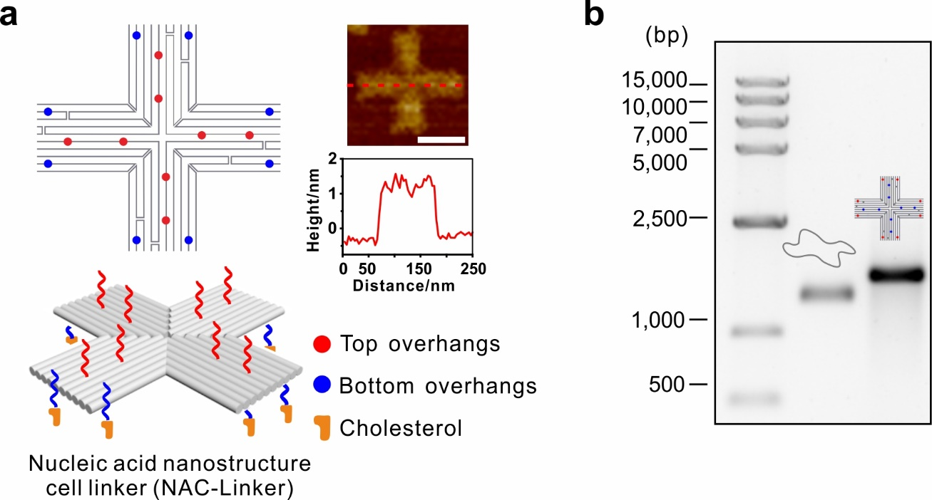
Supplementary Figure 1 | Design and characterization of nucleic acid nanostructure cell linkers (referred to as NAC-Linkers). a, Schematic illustration of NAC-Linker and its corresponding AFM image and cross-section height analysis. Scale bars, 50 nm. b, Characterization of NAC-Linkers formation by 1% agarose gel electrophoresis. From left to right: DNA ladder, M13mp18 scaffold, NAC-Linkers.

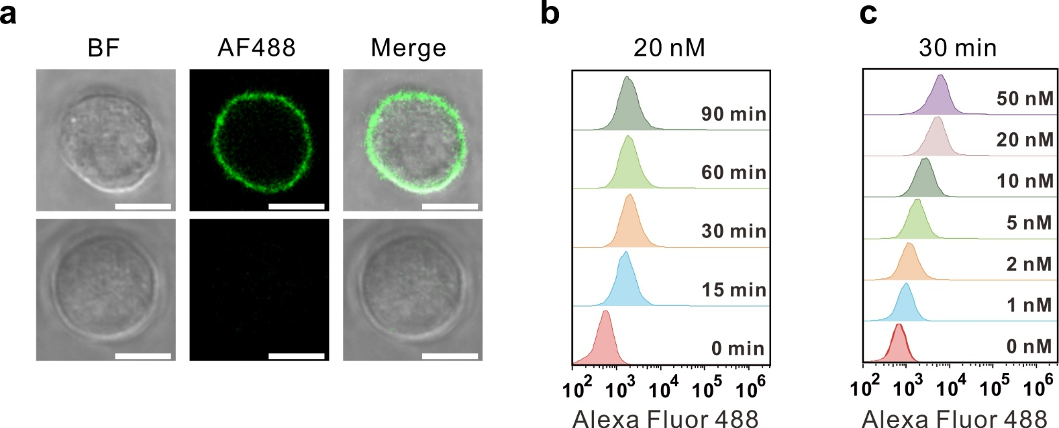
Supplementary Figure 2 | Modification of cell surface with NAC-Linkers. a, Representative confocal images of cells modified with or without AF488-labeled NAC-Linkers. Scale bars, 10 μm. b, Flow cytometry analysis of cells incubated with 20 nM AF488-labeled NAC-Linkers at room temperature for different incubation times. c, Flow cytometry analysis of cells incubated with AF488-labeled NAC-Linkers of different concentrations at room temperature for 30 minutes.
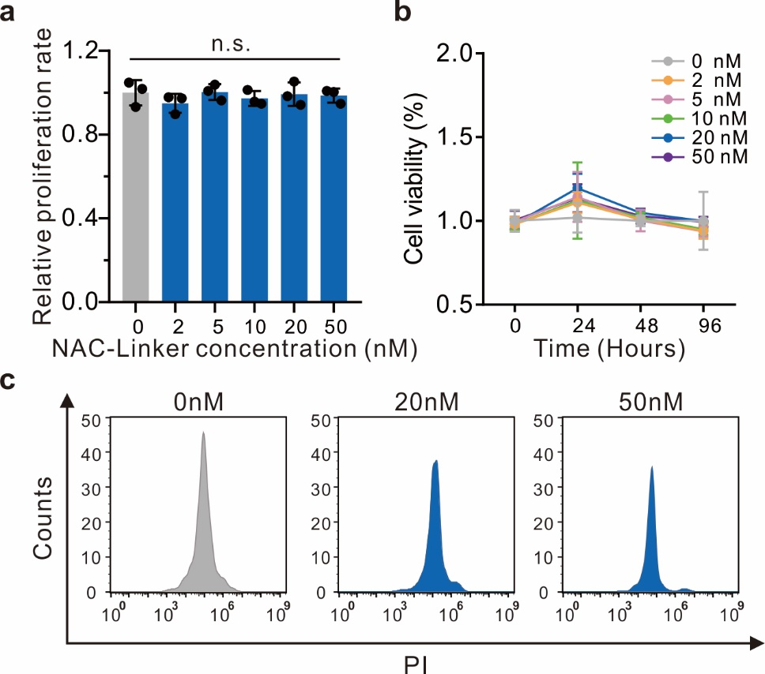
Supplementary Figure 3 | Biocompatibility of NAC-Linkers. a, Proliferation test of cells after 96 hours incubation with different concentrations of NAC-Linkers. Data are mean ± s.d. of n = 3 independent experiments. b, Viability of cells incubated with different concentrations of NAC-Linkers. Data are mean ± s.d. of n = 5. c, Flow cytometry analysis of cells stained with propidium iodide (PI) after 96 hours of incubation with different concentrations of NAC-Linkers. Data are from n = 3 independent experiments.

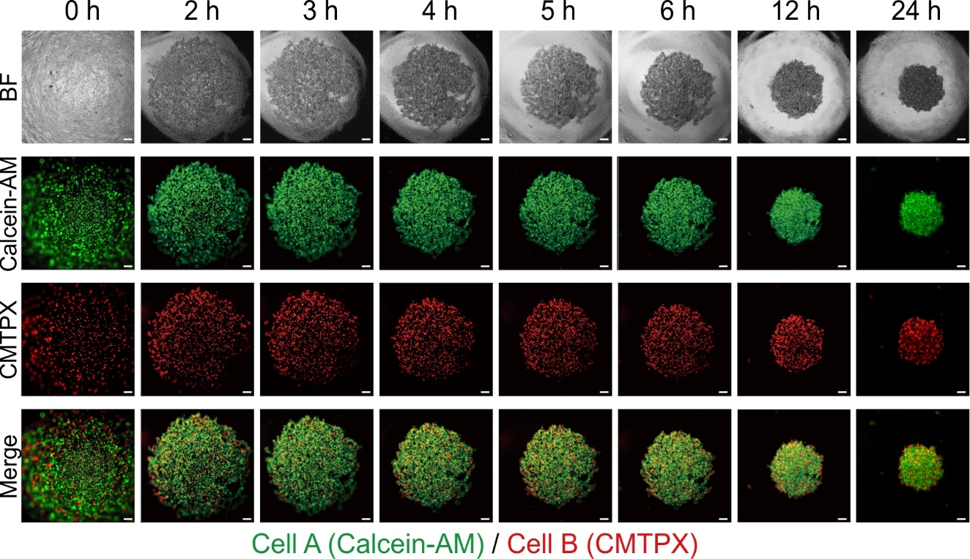
Supplementary Figure 4 | Efficient assembly of the 3D spheroid with matched NAC-Linkers. Time-lapse images of a spheroid with 5×10⁴ Calcein-AM labeled hepatocytes (Cell A) and 5×10⁴ CMTPX labeled hepatocytes (Cell B) within 24 hours. Scale bars, 200 μm.
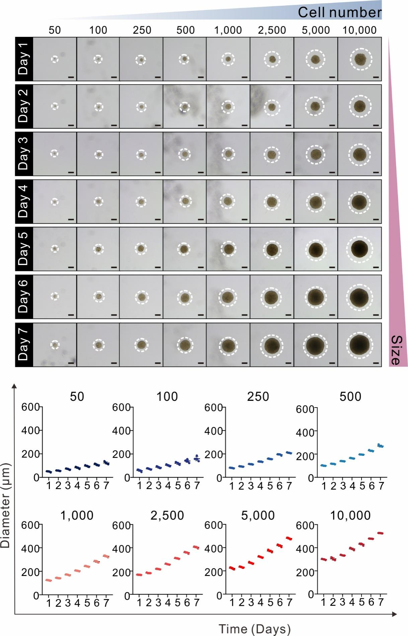
Supplementary Figure 5 | High proliferative capability of cells in NAC-spheroids. Representative bright images of spheroids with different cell numbers (50, 100, 250, 500, 1,000, 2,500, 5,000, and 10,000) cultured from day 1 to day 7 (top) and their corresponding diameter measurements (bottom). Scale bars, 200 μm. Data are mean ± s.d. of n = 5 independent experiments.
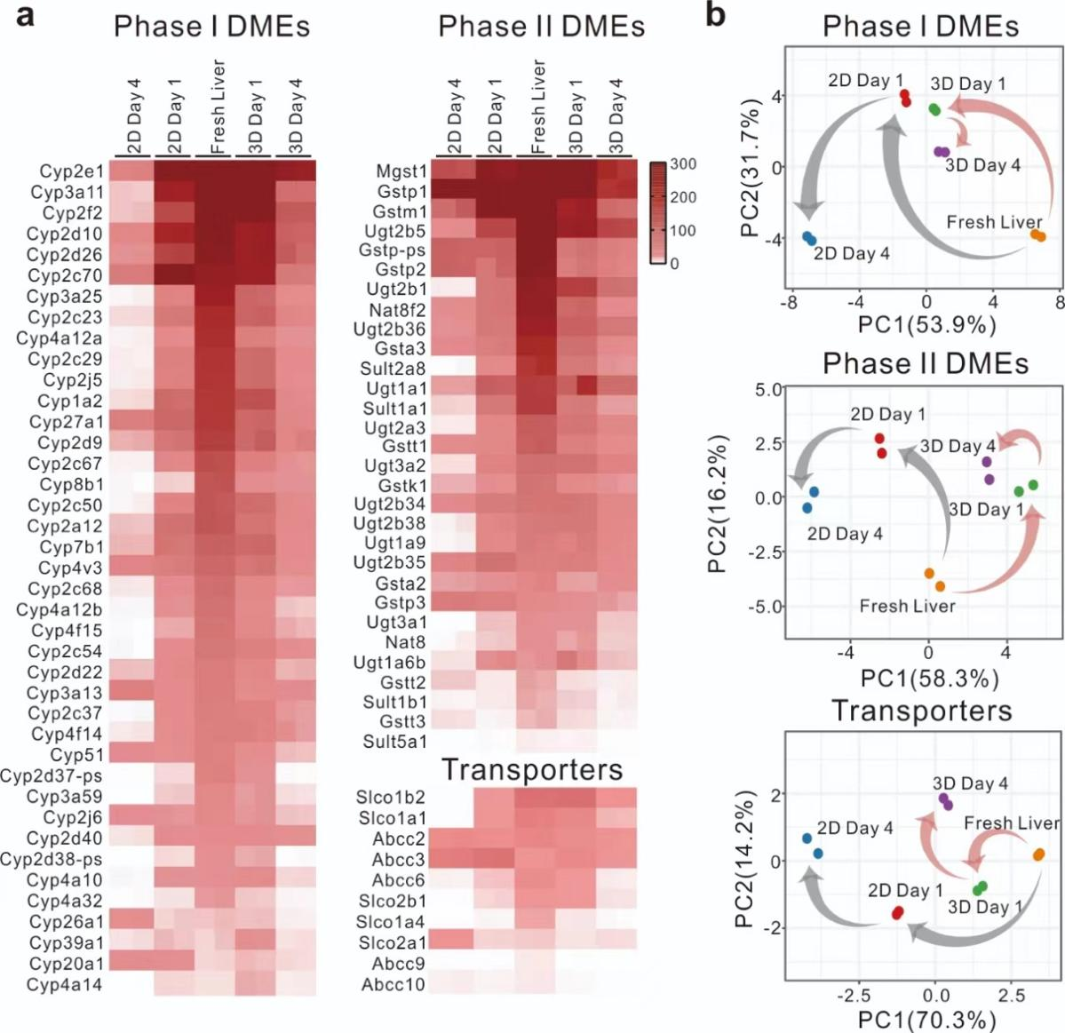
Supplementary Figure 6 | Transcriptomic profiling of drug metabolizing enzymes (DME) and transporter genes in NAC-Liver spheroids. a, Heatmap showing differentially expressed DME and transport genes among freshly isolated mouse liver tissue (Fresh Liver), 2D primary mouse hepatocytes at day 1 and day 4 (2D Day 1, 2D Day 4), and 3D NAC-Liver spheroids constructed by primary mouse liver cells at day 1 and 4 (3D Day 1, 3D Day 4). The genes were ranked in descending order based on their tissue expression levels after excluding genes with extremely low expression levels. b, Principal component analysis of DMEs and transporters among freshly isolated mouse liver tissue (Fresh Liver), 2D primary mouse hepatocytes at day 1 and day 4 (2D Day 1, 2D Day 4), and 3D NAC-Liver spheroids constructed by primary mouse liver cells at day 1 and day 4 (3D Day 1, 3D Day 4). Gray arrows represent temporal changes in transcriptomic signatures for 2D primary mouse hepatocytes, while red arrows represent changes for 3D NAC-Liver spheroids.

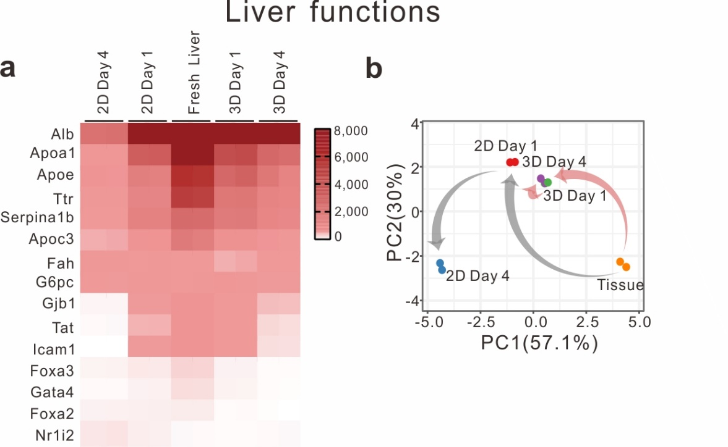
Supplementary Figure 7 |Transcription expression profiles of liver functions in 3D NAC-Liver spheroids. a, Heatmap for gene expression profiling of liver functions among freshly isolated mouse liver tissue (Fresh Liver), 2D primary mouse hepatocytes at day 1 and day 4 (2D Day 1, 2D Day 4), and 3D NAC-Liver spheroids constructed by primary mouse liver cells at day 1 and day 4 (3D Day 1, 3D Day 4). b, Principal component analysis of liver function expression. Gray arrows represent temporal changes in transcriptomic signatures for 2D primary mouse hepatocytes, while red arrows represent changes for 3D NAC-Liver spheroids. DME, drug metabolizing enzymes.

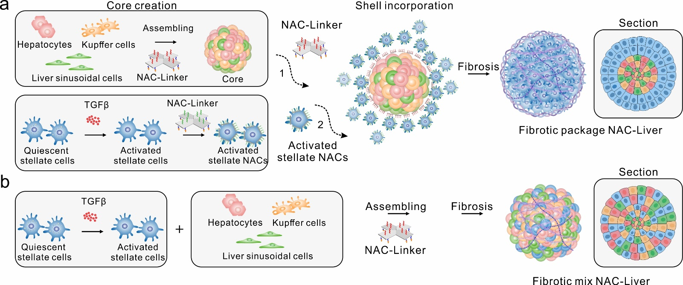
Supplementary Figure 8 | Schematic of the construction process of fibrotic package NAC-Liver and mix NAC-Liver. a, Schematic illustration of the construction of fibrotic package NAC-Liver. Hepatocytes, liver sinusoidal endothelial cells, and Kupffer cells were mixed at a ratio of 10:6:3 to form the core of NAC-Liver. While stellate cells were pre-activated with 10 ng/mL TGFβ for 48 hours. Then, the NAC-Liver core and activated stellate cells were respectively incubated with NAC-Linker A and B for 30 minutes, followed by assembly and cultivation. After 24 hours, the activated stellate cells formed a shell layer, leading to the formation of fibrotic package NAC-Liver (pNAC-Liver), which mimics the process of fibrosis. b, Schematic illustration of the construction of fibrotic mix NAC-Liver. Firstly, stellate cells were pre-activated with 10 ng/mL TGFβ for 48 hours. Then, hepatocytes, liver sinusoidal endothelial cells, Kupffer cells, and activated stellate cells were assembled based on the matched NAC-Linkers, resulting in the formation of fibrotic mix NAC-Liver (mNAC-Liver), which incorporated all the relevant cell types in a mixed configuration. TGFβ, transforming growth factor β.

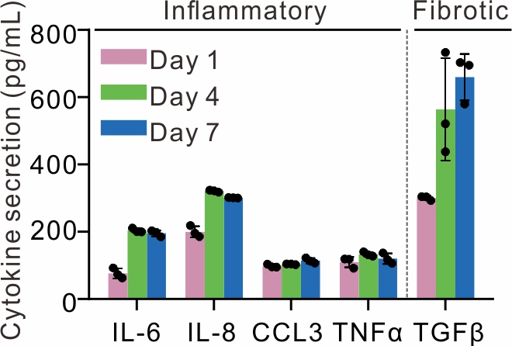
Supplementary Figure 9 | Cytokine secretion levels of fibrotic mNAC-Livers. a, Enzyme-linked immunosorbent assay (ELISA) measurement of inflammatory (IL-2, IL-8, CCL3, TNFα) and fibrotic (TGFβ) cytokines secretion in fibrotic mNAC-Livers at day 1, day 4, day 7. Data are mean ± s.d. of n = 3 independent experiments.

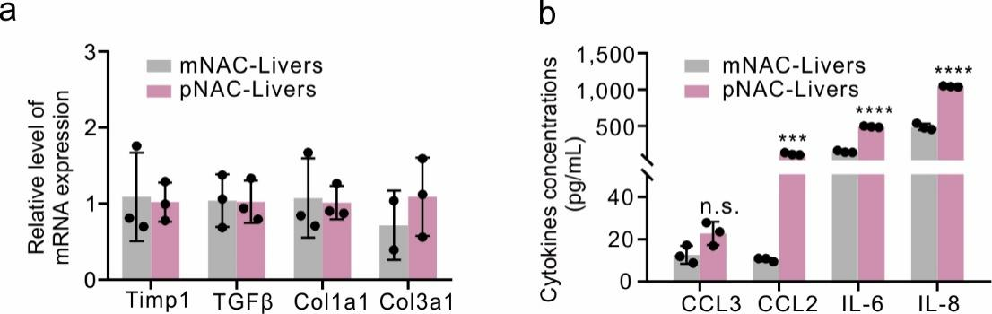
Supplementary Figure 10 | Pathological characteristics of fibrotic mNAC-Livers and pNAC-Livers. a, qPCR analysis of fibrosis-related gene expression levels (Timp1, TGFβ, Col1a1, Col3a1) of fibrotic mNAC-Livers and pNAC-Livers after cultured for 96 hours. The relative levels of mRNA expression were normalized to mNAC-Livers. b, ELISA measurement of inflammatory cytokine (CCL3, CCL2, IL-8, IL-6) by fibrotic mNAC-Livers and pNAC-Livers after cultured for 96 hours. Data in (a-b) are mean ± s.d. of n = 3 independent experiments. n.s., not significant. *** P < 0.001; **** P < 0.0001. qPCR, quantitative polymerase chain reaction; ELISA, enzyme-linked immunosorbent assay.

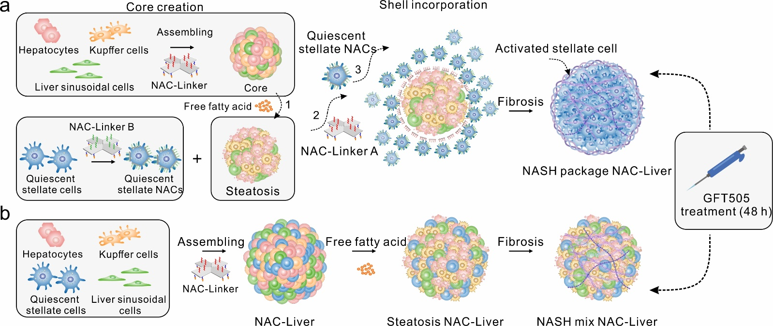
Supplementary Figure 11 | Schematic illustration of the construction of NASH package NAC-Liver NASH and mix NAC-Liver. a, Schematic illustration of the construction of NASH package NAC-Liver. Firstly, hepatocytes, liver sinusoidal endothelial cells, and Kupffer cells were assembled based on the matched NAC-Linkers to form the core of pNAC-Liver. Then, the core was cultured in a NASH induction medium containing free fatty acids for 48 hours, which induced a steatosis modification. Next, steatosis NAC-Liver core and quiescent stellate cells were respectively incubated with NAC-Linker A and B for 30 minutes, followed by assembly and cultivation. After 24 hours, the stellate cells formed a shell layer. Quiescent stellate cells were further activated by pro-inflammatory and pro-fibrotic factors produced by the steatosis NAC-Liver, simulating the process of NASH-related fibrosis. b, Schematic illustration of the construction of NASH mix NAC-Liver. Firstly, hepatocytes, liver sinusoidal endothelial cells, Kupffer cells, and quiescent stellate cells were assembled based on the matched NAC-Linkers, resulting in the formation of NAC-Liver. Then, the NAC-Liver was cultured in a NASH induction medium containing free fatty acids for 48 hours, inducing a steatosis modification and eventually resulting in the formation of NASH mix NAC-Liver.
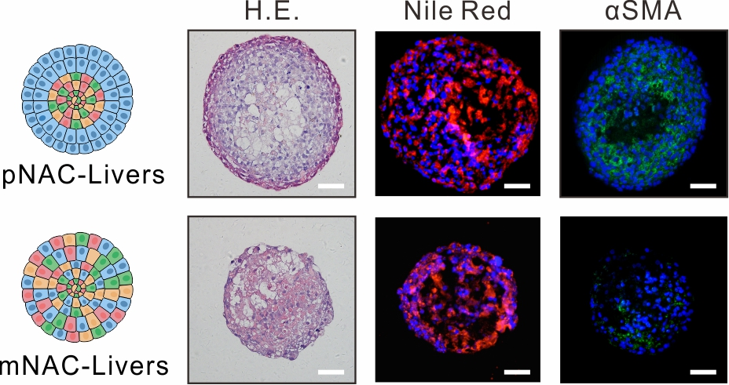
Supplementary Figure 12 | H&E, Nile Red, and αSMA staining of NASH pNAC-Liver and mNAC-Liver. The number of HSCs in NASH mNAC-Liver was assessed in relation to the total cell number of PHHs, LSECs, and KCs, following a ratio of 1:1. Additionally, in the NASH pNAC-Liver shell layer, the number of HSCs was evaluated relative to the total cell number in the core, also following a ratio of 1:1. Scale bars, 50 μm. H&E, hematoxylin and eosin; α-SMA, α-smooth muscle actin; NASH, Non-alcoholic steatohepatitis; PHHs, hepatocytes; HSCs, hepatic stellate cells; LSECs, liver sinusoidal cells; KCs, Kupffer cells.

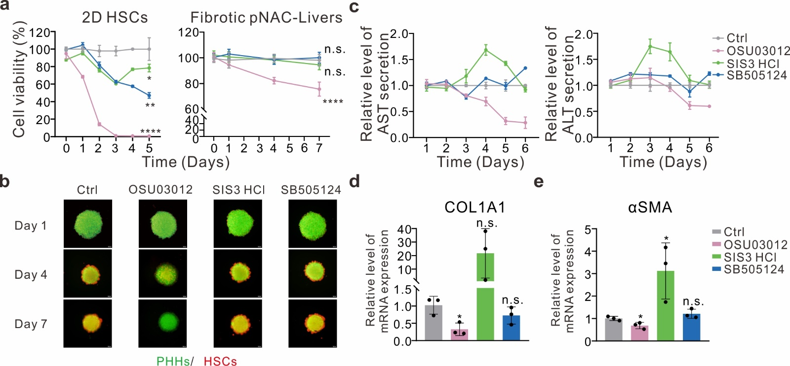
Supplementary Figure 13 |Therapeutic efficacy of OSU03012, SIS3 HCl, and SB505124 on fibrotic pNAC-Livers in vitro. a, Cell viability assay of 2D HSCs and 3D fibrotic pNAC-Livers with treatments of 0.1% DMSO (Ctrl), 10 μM OSU03012, 10 μM SIS3HCl, and 10 μM SB505124. Data are mean ± s.d. of n = 4 independent experiments. n.s., not significant. * P < 0.05; ** P < 0.01; **** P < 0.0001.b, Representative fluorescence images of fibrotic pNAC-Livers at day 1, day 4, and day 7. PHHs were labeled with Calcein-AM (green) and HSCs were labeled with CMTPX (red). The total number of PHHs, LSECs, and KCs included in the pNAC-Livers core is 5.7×10³, and the ratio is 10:6:3. The number of HSCs in the shell layer is equal to the total cell number in the core, with a ratio of 1:1. Scale bars, 200 μm. c, Long-term AST and ALT levels of fibrotic pNAC-Livers. The relative levels of AST and ALT secretion were normalized to 0.1 % DMSO (Ctrl). d-e, qPCR analysis of fibrosis-related gene expression in fibrotic pNAC-Livers after treatment with 96 hours. The relative levels of mRNA expression were normalized to 0.1 % DMSO (Ctrl). Data in (c-e) are mean ± s.d. of n = 3 independent experiments. n.s., not significant. * P < 0.05. HSCs, hepatic stellate cells; DMSO, Dimethyl sulfoxide; Ctrl, control; PHHs, primary human hepatocytes; LSECs, liver sinusoidal cells; KCs, Kupffer cells; ALT, alanine aminotransferase; AST, aspartate aminotransferase.

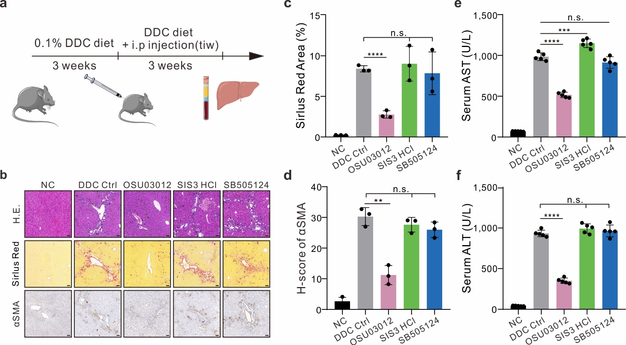
Supplementary Figure 14 | Therapeutic efficacy of OSU03012, SIS3HCl, and SB505124 in the mouse model. a, Schematic illustration of the 0.1 % DDC diet mouse model treated with intraperitoneal injections of OSU03012, SIS3HCl, and SB505124. b, H&E, Sirius Red, and αSMA staining of liver sections from five treatment groups: negative control (NC), DDC Ctrl, OSU03012, SIS3 HCl, and SB505124. NC represents the group with normal diet modeling, and DDC Ctrl represents the group with 0.1 % DDC diet modeling and intraperitoneal injection of solvent (saline containing 2% DMSO, 30% PEG300, and 2% Tween 80). OSU03012, SIS3HCl, and SB505124 respectively represent the groups with 0.1 % DDC diet modeling and intraperitoneal injection of OSU03012, SIS3HCl, and SB505124. See Supplementary Table S2 for the concentration for in vivo administration. Scale bars, 200 μm. c, Quantification of Sirius Red positive area of each group in (b). h, Quantification of the H-score in αSMA immunohistochemical staining slices of each group in (b). e-f, The concentrations of serum alanine aminotransferase (ALT) (e) and aspartate aminotransferase (AST) (f) in mouse serum of each group in (b). Data in (c-f) are mean ± s.d. of n = 6 independent experiments. n.s., not significant. n.s., not significant. ** p < 0.01; *** p < 0.001, **** P < 0.0001. DDC, 2',3'-dideoxycytidine; H&E, hematoxylin and eosin; α-SMA, α-smooth muscle actin.

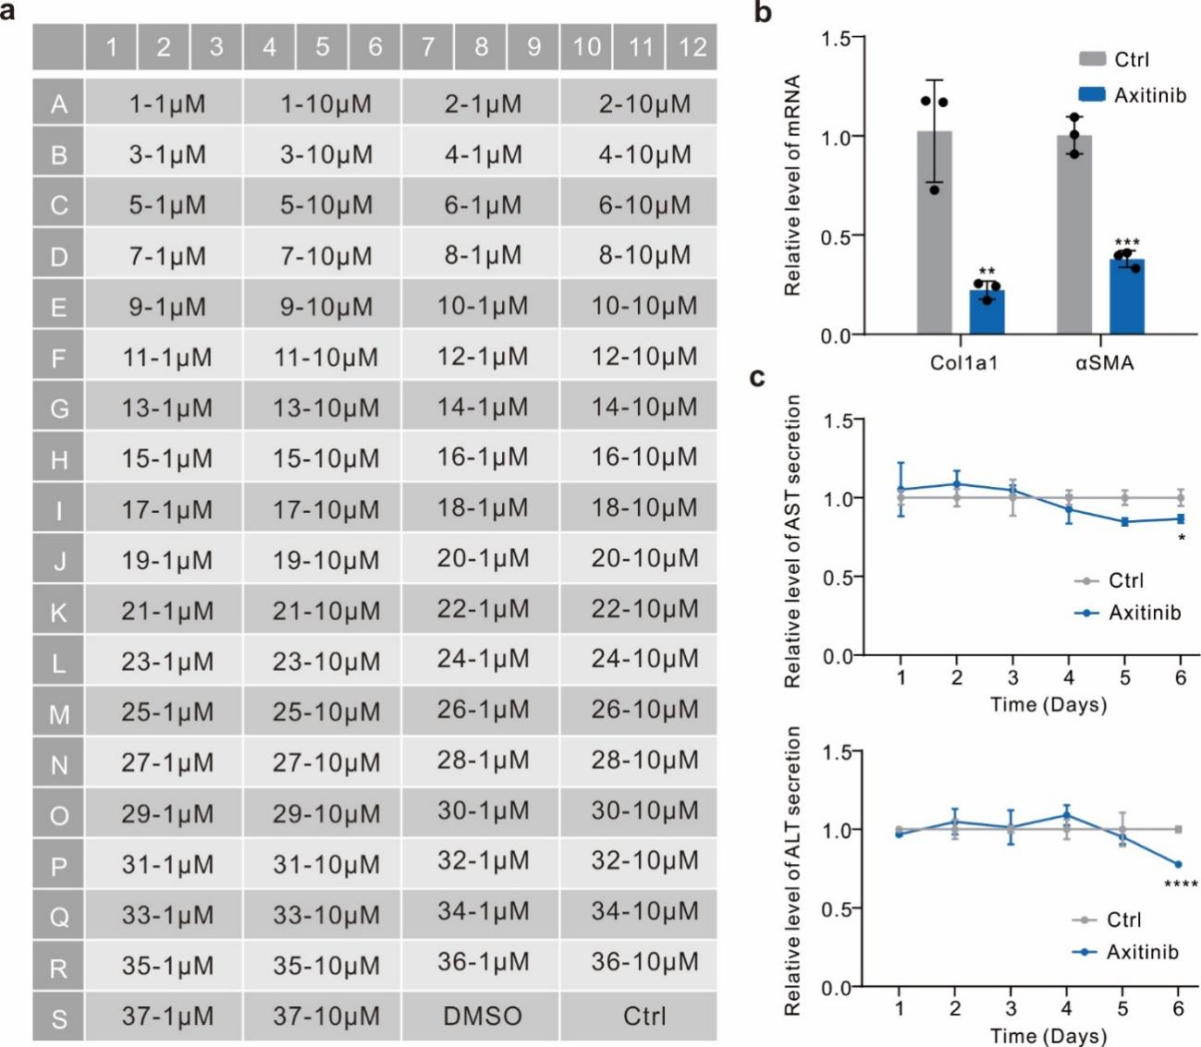
Supplementary Figure 15 | Drug efficacy of Axitinib in the treatment of fibrotic pNAC-Livers. a, Table of the locations and concentrations of 37 candidate molecules for high-throughput drug screening in Fig.5, presented as the number of candidate molecules (n) and their respective concentrations (c) (referred to as n-c μM). All candidate molecules were dissolved in saline containing 0.1 % DMSO. 20 % DMSO was used as a positive control for toxic drugs (DMSO) and 0.1 % DMSO served as a blank control (Ctrl). b, qPCR analysis of fibrosis-related gene expressions after treatment with 0.1 % DMSO (Ctrl) and 10 μM Axitinib for 96 hours. The relative levels of mRNA expression were normalized to 0.1 % DMSO (Ctrl). c, The relative levels of serum aspartate aminotransferase (AST) and alanine aminotransferase (ALT) secretion of fibrotic pNAC-Livers after treatment with 0.1% DMSO (Ctrl) and 10 μM Axitinib. The relative levels of ALT and AST secretion were normalized to DMSO (Ctrl). n.s., not significant. * P < 0.05, ** P < 0.01, *** P < 0.001, **** P < 0.0001. Data in (b-c) are mean ± s.d. of n = 3 independent experiments. qPCR, quantitative polymerase chain reaction; DMSO, Dimethyl sulfoxide.
Supplementary Table 1 | Drug information for hepatotoxicity analysis.
Name | DILI concernª | Molecular weight (g/mol) | Cmax  (μM) ^{b} | Treated concentration  (μM)
Mannitol | No DILI-concern | 182.17 | - | 10/100/500/1,000/5,000/10,000
Troglitazone | Most-DILI-Concern | 441.54 | 6.4 | 1/10/50/100/500/,1000
Chlorpromazine | Less-DILI-Concern | 318.86 | 1.6 | 1/10/50/100/500/1,000
Acetaminophen | Most-DILI-Concern | 151.16 | 139 | 100/1,000/5,000/10,000/50,000/100,000
- The DILI (Drug Induced Liver Injury) concern is evaluated by the DILIrank database (https://www.fda.gov/science-research/liver-toxicity-knowledge-base-ltkb/drug-induced-liver-injury-rank-dilirank-dataset)
- The clinical maximum plasma concentration of the drug (Cmax) is collected from Drug.com (https://www.drugs.com)

Supplementary Table 2 | In vivo experimental dosing in mice model
Name | Molecular weight  (g/mol) | Molar concentration  (μM) | Injection volume  (mg/kg)
OSU03012 | 460.45 | 754.09 | 25.00
SIS3 HCl | 489.99 | 754.09 | 26.60
SB505124 | 335.40 | 754.09 | 18.21
Axitinib | 386.47 | 754.09 | 20.98

Supplementary Table 3 | Drug information for high content analysis
ID | Name | Formula | Molecular weight (g/mol)
1 | Adenosine | C₁₀H₁₃N₅O₄ | 267.24
2 | 5'-monophosphate | C₁₀H₁₄N₅O₇P | 347.22
3 | L(+)-Ascorbic acid | C₆H₈O₆ | 176.12
4 | Axitinib | C₂₂H₁₈N₄OS | 386.47
5 | Azlocillin sodium | C₂₀H₂₂N₅NaO₆S | 483.47
6 | Bleomycin Sulfate | C₅₅H₈₅N₁₇O₂₅S₄ | 1512.62
7 | Brivudine | C₁₁H₁₃BrN₂O₅ | 333.14
8 | (R)-Elagolix | C₃₂H₃₀F₅N₃O₅ | 631.59
9 | Cladribine | C₁₀H₁₂ClN₅O₃ | 285.69
10 | Clofarabine | C₁₀H₁₁ClFN₅O₃ | 303.68
11 | Crizotinib | C₂₁H₂₂Cl₂FN₅O | 450.34
12 | Curcumin | C₂₁H₂₀O₆ | 368.39
13 | Demeclocycline hydrochloride | C₂₁H₂₁ClN₂O₈·HCl | 501.32
14 | Didanosine | C₁₀H₁₂N₄O₃ | 236.23
15 | Doxorubicin hydrochloride | C₂₇H₂₉NO₁₁·HCl | 579.99
16 | Epirubicin hydrochloride | C₂₇H₃₀ClNO₁₁ | 579.98
17 | Fludarabine | C₁₀H₁₂FN₅O₄ | 285.23
18 | Hesperidin | C₂₈H₃₄O₁₅ | 610.56
19 | Idarubicin HCl | C₂₆H₂₇NO₉·HCl | 533.95
20 | Imidazolidinyl urea | C₁₁H₁₆N₈O₈ | 388.3
21 | Iohexol | C₁₉H₂₆I₃N₃O₉ | 821.14
22 | Lactose | C₁₂H₂₂O₁₁ | 342.3
23 | Lactulose | C₁₂H₂₂O₁₁ | 342.3
24 | Minocycline hydrochloride | C₂₃H₂₈ClN₃O₇ | 493.94
25 | Mitoxantrone | C₂₂H₂₈N₄O₆ | 444.48
26 | Olmesartan | C₂₄H₂₆N₆O₃ | 446.5
27 | Pexidartinib | C₂₀H₁₅ClF₃N₅ | 417.81
28 | Regadenoson | C₁₅H₁₈N₈O₅ | 390.35
29 | Rutin | C₂₇H₃₀O₁₆ | 610.52
30 | Salmeterol | C₂₅H₃₇NO₄ | 415.57
31 | steviolbioside | C₃₂H₅₀O₁₃ | 642.73
32 | Vidarabine | C₁₀H₁₃N₅O₄ | 267.24
33 | Zidovudine | C₁₀H₁₃N₅O₄ | 267.24
34 | BX912 | C₂₀H₂₃BrN₈O | 471.35
35 | BX795 | C₂₃H₂₆IN₇O₂S | 591.47
36 | BX517 | C₁₅H₁₄N₄O₂ | 282.3
37 | OSU03012 | C₂₆H₁₉F₃N₄O | 460.45

Supplementary Table 4 | Primer sequences.
Gene | Primer | Sequence (from 5’ to 3’) | Species
GAPDH | Forward primer | AGCCACATCGCTCAGACAC | Human
GAPDH | Reverse primer | GCCCAATACGACCAAATCC | Human
ACTA1 | Forward primer | GGCATTCACGAGACCACCTAC | Human
ACTA1 | Reverse primer | CGACATGACGTTGTTGGCATAC | Human
Timp1 | Forward primer | CTTCTGCAATTCCGACCTCGT | Human
Timp1 | Reverse primer | ACGCTGGTATAAGGTGGTCTG | Human
TGFβ | Forward primer | CAATTCCTGGCGATACCTCAG | Human
TGFβ | Reverse primer | GCACAACTCCGGTGACATCAA | Human
PDGFβ | Forward primer | AGACACGGGAGAATACTTTTGC | Human
PDGFβ | Reverse primer | AGTTCCTCGGCATCATTAGGG | Human
COL1a1 | Forward primer | GTGCGATGACGTGATCTGTGA | Human
COL1a1 | Reverse primer | CGGTGGTTTCTTGGTCGGT | Human
COL3a1 | Forward primer | TTGAAGGAGGATGTTCCCATCT | Human
COL3a1 | Reverse primer | ACAGACACATATTTGGCATGGTT | Human
Coagulation Factor 2 (F2) | Forward primer | GGCTCTTCATGACAAAGGGT | Human
Coagulation Factor 2 (F2) | Reverse primer | ATCCGCATCACTGACAACAT | Human
Coagulation Factor 10 (F10) | Forward primer | CACTGGTCGCCATCTTTGTA | Human
Coagulation Factor 10 (F10) | Reverse primer | AGTGCATGGAAGAGACCTGC | Human
NTCP | Forward primer | AGGGGGACATGAACCTCAG | Human
NTCP | Reverse primer | AGGTCCCCATCATAGATCCC | Human

