Appendix A.

Figure A.1
Sample Conservation Message sent to all treated customers

July 10, 2015
Dear Norman Resident,
As you are aware, the City of Norman as well as the rest of the State of Oklahoma has suffered drought conditions over the past few years. The City’s main source of drinking water is Lake Thunderbird which is shared with Del City and Midwest City and is managed by the Central Oklahoma Master Conservancy District (COMCD). Norman has exceeded its allotment of water from Lake Thunderbird, 15 times since 1988 due to population growth and insufficient rainfall.
Even with adequate rainfall, the City faces limits on its infrastructure capacity, and high demand on summer days causes the City to have to purchase water from Oklahoma City. The City has adopted mandatory conservation policies such as even-odd watering days throughout the year, and a drought contingency plan to encourage conservation when needed.
The City of Norman, in conjunction with the COMCD, is working on several plans to address Norman’s current and future water scarcity issues and all of them are expensive. Building new wells, expanding water treatment plant capacity, and purchasing water from Oklahoma City on an emergency basis place significant fiscal burdens on the City budget. To address infrastructure needs, voters in the City of Norman approved increased water rates this year.
Addressing water scarcity is everyone’s responsibility. Summer is the most critical time for conservation.
Reducing your consumption will save you money and help the City to manage scarce water resources. Included in this envelope is a list of ways you can reduce your water use. Use these tips to reduce your household’s use and preserve the city’s priceless water resources.

Figure A.2
Sample Tip Sheet

How you can help conserve
Norman’s water

Outdoor

- Water the lawn and garden in the early morning or at night when the sun won’t cause as much evaporation. Avoid sprinklers with fine mists, they increase evaporation.

- Keep grass two to three inches long to enhance root development with minimal watering.

- Use drought-tolerant plants. Ask your local nursery about plants and trees appropriate for Oklahoma.

- Wash your car with a bucket and sponge rather than with a running hose. This cuts usage by as much as 90 gallons.

- Pay careful attention to sprinklers to prevent watering driveways, streets and sidewalks.

- Water your lawn with only one inch of water every seven to ten days. (Less often if there has been recent rain.) Overwatered lawns and plants grow shallower roots and are more likely to die during droughts.

- Use mulch in gardens to minimize weed growth, slow erosion, and diminish evaporation.

- Check for leaks in pipes, hoses, faucets, couplings, and lawn sprinkler systems. Repair any problems immediately! One broken sprinkler can use an additional 100 gallons in a typical 10 minute watering cycle.

- Use a low flow nozzle on your hose. Using a standard nozzle on your hose to wash your car or water your plants can require hundreds of gallons more than a low flow nozzle.

- Avoid using a hose to clean your driveway or sidewalk. Use a broom to save hundreds of gallons of water.

Indoor

- Install low flow showerheads. They are easy to install and save both water and energy.

- Install low flow toilets or install a toilet tank displacement insert or dam to reduce the volume of water used per flush. Placing a plastic jug filled with water in the tank is an effective displacement device.

- Check for leaks inside toilets. Leaks can waste up to 200 gallons of water a day. Toilet leaks can be detected by adding a few drops of food coloring to water in the toilet tank. If the colored water appears in the bowl, the toilet is leaking.

- Never use the toilet as a wastebasket.

- Operate the dishwasher and washing machines only when completely full.

- Don’t let the faucet run continuously when brushing your teeth or shaving.

- Take a short shower instead of a bath. Taking a five minute shower uses 10 to 25 gallons as opposed to 30-70 gallons for a bath. If you take a bath, stopper the drain immediately and adjust the temperature as you fill the tub.

Figure A.3
Sample Peer Comparison

July 10, 2015
Dear Norman Resident,
As you are aware, the City of Norman as well as the rest of the State of Oklahoma has suffered drought conditions over the past few years. The City’s main source of drinking water is Lake Thunderbird which is shared by Del City, Midwest City and is managed by the Central Oklahoma Master Conservancy District (COMCD). Norman has exceeded its allotment of water from Lake Thunderbird, 15 times since 1988 due to population growth and insufficient rainfall.
Even with adequate rainfall, the City’s ability to provide clean drinking water is limited by infrastructure capacity. On high demand summer days when water capacity is insufficient, the City imposes mandatory conservation policies such as even-odd watering days, and days when no outside watering is allowed.
The City of Norman, in conjunction with the COMCD, is working on several plans to address Norman’s current and future water scarcity issues and all of them are expensive. Building new wells, expanding water treatment plant capacity, and purchasing water from Oklahoma City on an emergency basis place significant fiscal burdens on the City budget. To address funding needs, the City of Norman increased water rates this year.
Addressing water scarcity is everyone’s responsibility. Summer is the most critical time for conservation.
[INSERT FOR FULL TREATMENT GROUP]
For the months June through September of last year,
Your total consumption was: X gallons
Your water-conscious neighbor’s total consumption was: X gallons
You used X% more than your most water-conscious neighbors.*
*water-conscious neighbors use less than 80% of neighbors in same water meter route.
[END INSERT]
Reducing your consumption could save you money and help the City to avoid water scarcity. Included in this envelope is a list of ways you can reduce your water use. Use these tips to reduce your household’s use and preserve the city’s priceless water resources.

Appendix B.
Details and Test Regarding Misreporting
Misreporting impacted only the peer treatment groups. Two components of the peer comparison letter were influenced: the amount of water used by the customer in the previous year, and the difference between the customer’s use and the water conscious neighbor which is expressed in percentage terms. The concern is that the errors in the reported messages is systematically related to the estimated treatment impacts. This appendix presents evidence to mitigate these concerns.
The usage reported to the customers was incorrectly calculated based on the billing amount rather than the usage amount in the utility billing records. Because of the graduated rate structure, the billing amounts are related to the usage, but not in a strictly linear fashion. The error would greatly depend on the usage and the discontinuities in the rate structure (the breaks). Given the randomization of the treated groups, we don’t expect the inflation of reported usage to be important. Results presented in Tables B.1 and B.2 confirm this. Table B.1 provides estimates of water consumption for the same specifications as table 5 and table B.2 corresponds to table 6. The estimated coefficients on the percent reported usage error are very small and statistically insignificant in all the specifications.
As discussed in the text, both the calculation of the individual customer usage and that of the water conscious neighbor (the comparison anchor) were affected. However, the relative usage ranks were not impacted. Recall that the peer messages reported relative differences as a percent: “you used X% above/below the water conscious neighbor.” The reported peer comparisons could have been larger or smaller than the actual differences. Given that peer comparisons were rounded to the nearest whole number, many of the calculation errors did not result in reporting errors on the peer messages. Figures B.1 and B.2 show scatter plots of the misreported peer comparisons (difference between the percent reported and the actual percent) plotted against customer’s consumption for the observations which receive the peer message. For most of the sub-sample the difference is small and the average size of the misreported peer comparison is only three tenths of a percentage. Notably, the highest misreport of percentage use was for a customer who consumed over 300,000 gallons in July of 2014. The next highest misreport was less than 10% different from the correct percent.
To investigate whether the misreporting impacted estimates of treatment impacts, we add variables which measure the misreporting to empirical models estimated in the papers. The results shown in Table B. 3 suggest that the misreporting likely had little impact on the estimated peer treatment impact using incremental treatment variables. The estimated coefficient for misreported consumption variables are small and are statistically insignificant. The estimated treatment impacts are nearly identical to those provided in Table 5. Table B.4 presents a similar set of estimates using the exclusive treatment variables. The estimated coefficients associated with the misreported variables are small in size and insignificant. The estimated coefficients for the treatment impacts are very similar in magnitude and significance. Tables B.3 and B.4 provide further evidence that the misreporting did not systematically impact the treatment estimates reported in the paper. The coefficients for misreporting consumption and misreporting peer impacts were small in size and not statistically significant. Further, the estimated peer treatment impacts were robust to adding these variables to the specifications.
Taken as a whole these estimates ease concerns that the reporting errors influence our estimates of the peer comparison treatments.

Table B.1
Test for impact of misreported water usage on water consumption (Corresponds to Table 5)

 | (1) |  | (2) |  | (3)
 | Coefficient/SE |  | Coefficient/SE |  | Coefficient/SE
Conservation Message | -5.377*** | 1.975 | -8.553*** | 1.788 | -9.515*** | 1.973
Peer | -2.022 | 1.836 | -4.516*** | 1.671 | -4.116** | 1.839
Tip Sheet | 2.549 | 2.124 | 2.879 | 1.938 | 3.092 | 2.136
Misreported % | -0.104 | 0.250 | -0.115 | 0.214 | -0.027 | 0.246
Lagged Rain | -0.531*** | 0.014 | -0.303*** | 0.012 | -0.400*** | 0.018
Constant | 90.806*** | 0.360 | 89.779*** | 0.281 | 90.226*** | 0.299
Household FE | x |  | x |  | x
Month FE | x |  | x |  | x
Months Covered | Apr-Sept |  | Apr-Sept |  | June-Sept
Years Covered | 2014-2015 |  | 2013-2015 |  | 2013-2015
note: *** p<0.01, ** p<0.05, * p<0.1

Table B.2
Test for impact of misreporting of peer-message comparison percentages on water consumption (Corresponds to Table 6)

 | (1) |  | (2)
 | Coefficient/SE |  | Coefficient/SE
CON_noTIP_PEER | -4.412* | 2.268 | -7.205*** | 2.055
CON_noTIP_noPEER | -2.921 | 2.109 | -5.774*** | 1.921
CON_TIP_PEER | -3.747* | 2.217 | -6.965*** | 2.015
CON_TIP_noPEER | 1.422 | 2.106 | -0.382 | 1.919
Misreport % | -0.109 | 0.250 | -0.120 | 0.214
Rain | -0.531*** | 0.014 | -0.303*** | 0.012
Constant | 90.806*** | 0.360 | 89.779*** | 0.281
Household FE | x |  | x
Month FE | x |  | x
Months Covered | April-Sept |  | April-Sept
Years Covered | 2014-2015 |  | 2013-2015
note: *** p<0.01, ** p<0.05, * p<0.1

Table B.3
Test for impact of misreporting using incremental treatment variables

 | Benchmark |  | Adding Misreported Consumption |  | Adding Misreported Peer Comparison
 | Coefficient/SE |  | Coefficient/SE |  | Coefficient/SE
Conservation Message | -2.393* | 1.235 | -2.389* | 1.236 | -1.520 |  | 1.299
Peer | -4.418*** | 1.257 | -4.313*** | 1.364 | -4.491*** |  | 1.320
Tip Sheet | 0.765 | 1.427 | 0.758 | 1.428 | -0.120 |  | 1.499
Misreported Consumption |  |  | -0.044 | 0.223
Misreported Peer Comparison |  |  |  |  | -1.129 |  | 4.630
Constant | 87.106*** | 0.239 | 87.106*** | 0.239 | 79.116*** |  | 0.251
Household FE | Yes |  | Yes |  | Yes
Month FE | Yes |  | Yes |  | Yes
Year FE
Months Covered | Apr-Sept |  | Apr-Sept |  | Apr-Sept
Years Covered | 2014-2015 |  | 2014-2015 |  | 2014-2015
note: *** p<0.01, ** p<0.05, * p<0.1

Table B.4
Test for impact of misreporting using exclusive treatment variables

 | Benchmark |  | Adding Misreported Consumption |  | Adding Misreported Peer Comparison
 | Coefficient/SE |  | Coefficient/SE |  | Coefficient/SE
CON_noTIP_PEER | -3.667** | 1.458 | -3.543** | 1.558 | -4.146*** | 1.531
CON_noTIP_noPEER | -3.105** | 1.420 | -3.105** | 1.420 | -1.847 | 1.494
CON_TIP_PEER | -4.389*** | 1.443 | -4.281*** | 1.519 | -4.947*** | 1.515
CON_TIP_noPEER | -0.923 | 1.413 | -0.923 | 1.413 | -1.317 | 1.484
Misreported Consumption |  |  | -0.050 | 0.223
Misreported Peer Comparison |  |  |  |  | -1.156 | 4.630
Constant | 87.106*** | 0.239 | 87.106*** | 0.239 | 79.116*** | 0.251
Household FE | Yes |  | Yes |  | Yes
Month FE | Yes |  | Yes |  | Yes
Year FE
Months Covered | Apr-Sept |  | Apr-Sept |  | Apr-Sept
Years Covered | 2014-2015 |  | 2014-2015 |  | 2014-2015
note: *** p<0.01, ** p<0.05, * p<0.1

Figure B.1
Scatter Plot of Misreported Peer Comparison (Reported percent minus actual percent)

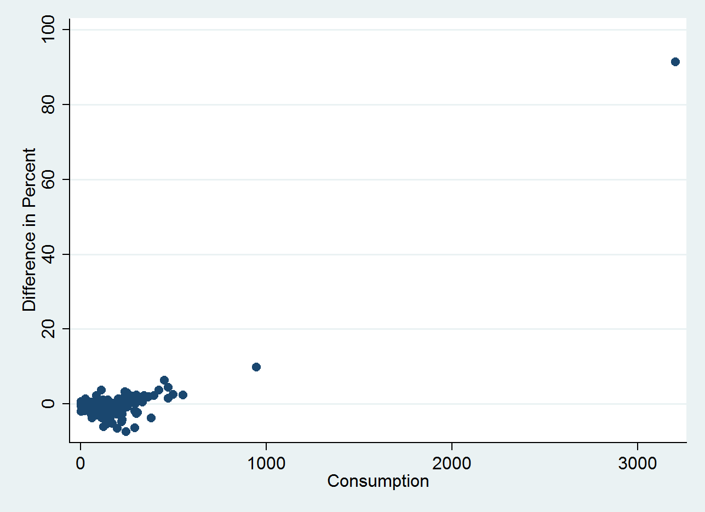

Figure B.2
Scatter Plot of Misreported Peer Comparison (Reported percent minus actual percent)

