Table 1.A.Supplementary
Gene | Ensembl ID | Gene Name | M (log2-ratio) | Probability
APP | ENSG00000142192 | amyloid beta precursor protein | 8.19 | 1.00
HIF1A | ENSG00000100644 | hypoxia inducible factor 1 subunit alpha | 7.80 | 1.00
TXNDC5 | ENSG00000239264 | thioredoxin domain containing 5 | 7.67 | 1.00
CHMP2A | ENSG00000130724 | charged multivesicular body protein 2A | 6.49 | 0.98
DPH1 | ENSG00000108963 | diphthamide biosynthesis 1 | 6.25 | 0.98
ZNF207 | ENSG00000010244 | zinc finger protein 207 | 6.25 | 0.97
ITGA3 | ENSG00000005884 | integrin subunit alpha 3 | 6.23 | 0.97
TMEM14C | ENSG00000111843 | transmembrane protein 14C | 6.23 | 0.97
IPO5 | ENSG00000065150 | importin 5 | 6.01 | 0.96
LAMA4 | ENSG00000112769 | laminin subunit alpha 4 | 5.91 | 0.96
SLC44A2 | ENSG00000129353 | solute carrier family 44 member 2 | 5.85 | 0.95
RPL17-C18orf32 | ENSG00000215472 | RPL17-C18orf32 read through | 2.78 | 0.92
GMPPA | ENSG00000144591 | GDP-mannose pyrophosphorylase A | 5.71 | 0.94
FGF2 | ENSG00000138685 | fibroblast growth factor 2 | 5.66 | 0.94
NEDD8-MDP1 | ENSG00000255526 | NEDD8-MDP1 read through | 3.61 | 0.93
RPS10-NUDT3 | ENSG00000270800 | RPS10-NUDT3 read through | 3.69 | 0.93
CSE1L | ENSG00000124207 | chromosome segregation 1 like | 5.51 | 0.93
ATP2B4 | ENSG00000058668 | ATPase plasma membrane Ca2+ transporting 4 | 5.49 | 0.92
G6PD | ENSG00000160211 | glucose-6-phosphate dehydrogenase | 5.22 | 0.89
SPPL2A | ENSG00000138600 | signal peptide peptidase like 2A | 5.12 | 0.88
FST | ENSG00000134363 | Follistatin | 5.08 | 0.88
RAB5B | ENSG00000111540 | RAB5B, member RAS oncogene family | 5.07 | 0.87
CALCOCO2 | ENSG00000136436 | calcium binding and coiled-coil domain 2 | 5.06 | 0.87
IGF2BP2 | ENSG00000073792 | insulin like growth factor 2 mRNA binding protein 2 | 4.95 | 0.86
NSMCE1 | ENSG00000169189 | NSE1 homolog, SMC5-SMC6 complex component | 4.93 | 0.85
RDX | ENSG00000137710 | Radixin | 4.90 | 0.85
TULP3 | ENSG00000078246 | TUB like protein 3 | 4.89 | 0.85
PMM2 | ENSG00000140650 | phosphomannomutase 2 | 4.83 | 0.84
C16orf62 (VPS35L) | ENSG00000103544 | VPS35 endosomal protein sorting factor like | 4.82 | 0.84
MRPL34 | ENSG00000130312 | mitochondrial ribosomal protein L34 | 4.78 | 0.83
INTS10 | ENSG00000104613 | integrator complex subunit 10 | 4.65 | 0.81
Table showing up-regulated differentially expressed genes as compared to control with the default threshold (0.8).The tables show the names of the genes, their Ensembl ID, their fold change based on log2-ratio and the probability of differential expression.

Table 1.B. Supplementary.
 | Gene | Ensembl ID |  | Gene Name |  | M (log2-ratio) |  | Probability
P4HA1 |  |  | ENSG00000122884 |  | prolyl 4-hydroxylase subunit alpha 1 |  | -6.14 |  | 0.97
CIZ1 |  |  | ENSG00000148337 |  | CDKN1A interacting zinc finger protein 1 |  | -5.65 |  | 0.95
TSG101 |  |  | ENSG00000074319 |  | tumor susceptibility 101 |  | -5.55 |  | 0.94
METTL9 |  |  | ENSG00000197006 |  | methyltransferase like 9 |  | -5.39 |  | 0.92
SUN1 |  |  | ENSG00000164828 |  | Sad1 and UNC84 domain containing 1 |  | -5.36 |  | 0.92
CSNK1G2 |  |  | ENSG00000133275 |  | casein kinase 1 gamma 2 |  | -5.29 |  | 0.91
SMARCA4 |  |  | ENSG00000127616 |  | SWI/SNF related, matrix associated, actin dependent regulator of chromatin, subfamily a, member 4 |  | -5.24 |  | 0.91
USP16 |  |  | ENSG00000156256 |  | ubiquitin specific peptidase 16 |  | -5.24 |  | 0.91
UBE3C |  |  | ENSG00000009335 |  | ubiquitin protein ligase E3C |  | -5.24 |  | 0.90
NUSAP1 |  |  | ENSG00000137804 |  | nucleolar and spindle associated protein 1 |  | -5.21 |  | 0.90
NECAP2 |  |  | ENSG00000157191 |  | NECAP endocytosis associated 2 |  | -5.19 |  | 0.90
TRMT1 |  |  | ENSG00000104907 |  | tRNA methyltransferase 1 |  | -5.15 |  | 0.90
SRPRB |  |  | ENSG00000144867 |  | SRP receptor subunit beta |  | -5.12 |  | 0.89
DCAF6 |  |  | ENSG00000143164 |  | DDB1 and CUL4 associated factor 6 |  | -5.06 |  | 0.88
SSBP4 |  |  | ENSG00000130511 |  | single stranded DNA binding protein 4 |  | -5.02 |  | 0.88
SMARCE1 |  |  | ENSG00000073584 |  | SWI/SNF related, matrix associated, actin dependent regulator of chromatin, subfamily e, member 1 |  | -5.01 |  | 0.88
SPAG9 |  |  | ENSG00000008294 |  | sperm associated antigen 9 |  | -4.87 |  | 0.86
STX5 |  |  | ENSG00000162236 |  | syntaxin 5 |  | -4.84 |  | 0.85
RNF4 |  |  | ENSG00000063978 |  | ring finger protein 4 |  | -4.77 |  | 0.84
DHRS7 |  |  | ENSG00000100612 |  | dehydrogenase/reductase 7 |  | -4.77 |  | 0.84
ZDHHC4 |  |  | ENSG00000136247 |  | zinc finger DHHC-type palmitoyltransferase 4 |  | -4.70 |  | 0.83
OSBPL5 |  |  | ENSG00000021762 |  | oxysterol binding protein like 5 |  | -4.70 |  | 0.83
ALDH7A1 |  |  | ENSG00000164904 |  | aldehyde dehydrogenase 7 family member A1 |  | -4.68 |  | 0.83
MAP2K1 |  |  | ENSG00000169032 |  | mitogen-activated protein kinase kinase 1 |  | -4.66 |  | 0.82
MDFIC |  |  | ENSG00000135272 |  | MyoD family inhibitor domain containing |  | -4.66 |  | 0.82
LRRFIP1 |  |  | ENSG00000124831 |  | LRR binding FLII interacting protein 1 |  | -4.65 |  | 0.82
ATP6V0A1 |  |  | ENSG00000033627 |  | ATPase H+ transporting V0 subunit a1 |  | -4.65 |  | 0.82
EMC1 |  |  | ENSG00000127463 |  | ER membrane protein complex subunit 1 |  | -4.62 |  | 0.82
RABEP1 |  |  | ENSG00000029725 |  | rabaptin, RAB GTPase binding effector protein 1 |  | -4.61 |  | 0.81
NUP107 |  |  | ENSG00000111581 |  | nucleoporin 107 |  | -4.61 |  | 0.81
ECT2 |  |  | ENSG00000114346 |  | epithelial cell transforming 2 |  | -4.57 |  | 0.81
SNRPD2 |  |  | ENSG00000125743 |  | small nuclear ribonucleoprotein D2 polypeptide |  | -7.34 |  | 1.00
MAP4K4 |  |  | ENSG00000071054 |  | mitogen-activated protein kinase kinase kinase kinase 4 |  | -6.98 |  | 0.99
HNRNPH3 |  |  | ENSG00000096746 |  | heterogeneous nuclear ribonucleoprotein H3 |  | -6.89 |  | 0.99
ACLY |  |  | ENSG00000131473 |  | ATP citrate lyase |  | -6.48 |  | 0.98
Table showing down-regulated differentially expressed genes as compared to control with the default threshold (0.8).

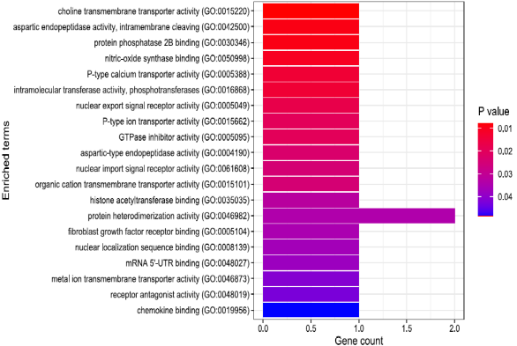
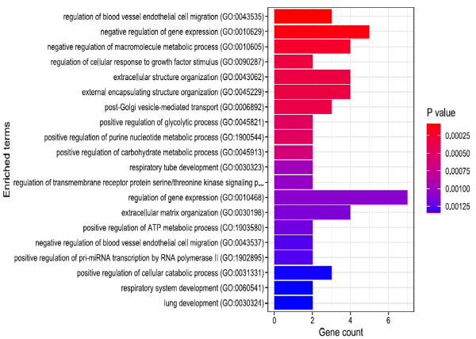
B
A

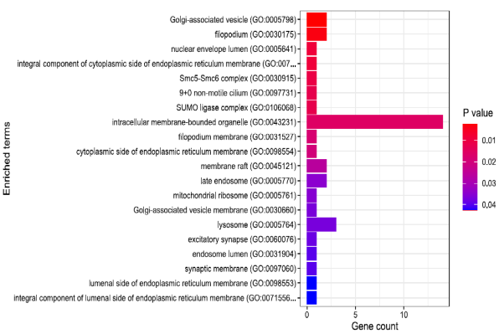
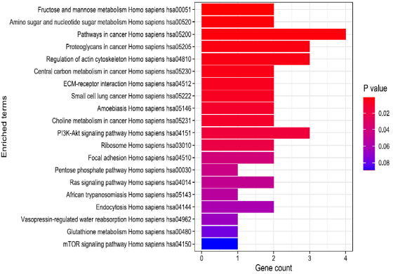
D
C
C

Figure 1- Supplementary. Gene enrichment analysis of the up-regulated DEGs. Go term enrichment analysis showing the top 20 results from enrichment analysis of up-regulated genes in A. biological process, B. Molecular function. C. Cellular localization. D. KEGG pathway enrichment of the top 20.

Table 2. Supplementary
Term | Overlap | P-value | Adjusted P-value | Odds Ratio | Genes
Regulation Of Blood Vessel Endothelial Cell Migration (GO:0043535) | 3/54 | 0.0001 | 0.0368 | 41.84 | ATP2B4;HIF1A;FGF2
Negative Regulation Of Gene Expression (GO:0010629) | 5/336 | 0.0002 | 0.0368 | 11.41 | APP;ATP2B4;IGF2BP2;HIF1A;FGF2
Negative Regulation Of Macromolecule Metabolic Process (GO:0010605) | 4/186 | 0.0002 | 0.0368 | 16.11 | APP;ATP2B4;HIF1A;FGF2
Regulation Of Cellular Response To Growth Factor Stimulus (GO:0090287) | 2/19 | 0.0004 | 0.0576 | 80.94 | ITGA3;FST
Regulation Of Nitric-Oxide Synthase Activity (GO:0050999) | 2/28 | 0.0009 | 0.0679 | 52.90 | ATP2B4;HIF1A
Regulation Of Transmembrane Receptor Protein Serine/Threonine Kinase Signaling Pathway (GO:0090092) | 2/31 | 0.0011 | 0.0679 | 47.42 | ITGA3;FST
Positive Regulation Of Small Molecule Metabolic Process (GO:0062013) | 2/33 | 0.0012 | 0.0679 | 44.36 | APP;HIF1A
Negative Regulation Of Blood Vessel Endothelial Cell Migration (GO:0043537) | 2/33 | 0.0012 | 0.0679 | 44.36 | ATP2B4;FGF2
Organophosphate Biosynthetic Process (GO:0090407) | 2/34 | 0.0013 | 0.0679 | 42.97 | G6PD;FGF2
Positive Regulation Of Carbohydrate Metabolic Process (GO:0045913) | 2/34 | 0.0013 | 0.0679 | 42.97 | APP;HIF1A
Regulation Of Gene Expression (GO:0010468) | 7/1127 | 0.0014 | 0.0679 | 4.91 | APP;RDX;ATP2B4;TULP3;IGF2BP2;HIF1A;FGF2
Negative Regulation Of Endothelial Cell Migration (GO:0010596) | 2/37 | 0.0015 | 0.0679 | 39.28 | ATP2B4;FGF2
Regulation Of Glycolytic Process (GO:0006110) | 2/40 | 0.0017 | 0.0679 | 36.17 | APP;HIF1A
Regulation Of Chemokine Production (GO:0032642) | 2/41 | 0.0018 | 0.0679 | 35.24 | APP;HIF1A
Regulation Of Macromolecule Metabolic Process (GO:0060255) | 3/162 | 0.0020 | 0.0679 | 13.35 | APP;IGF2BP2;HIF1A
Positive Regulation Of miRNA Transcription (GO:1902895) | 2/43 | 0.0020 | 0.0679 | 33.52 | HIF1A;FGF2
Hexose Metabolic Process (GO:0019318) | 2/45 | 0.0022 | 0.0679 | 31.96 | G6PD;PMM2
Mitotic Nuclear Division (GO:0140014) | 2/45 | 0.0022 | 0.0679 | 31.96 | CHMP2A;ZNF207
Positive Regulation Of Macromolecule Metabolic Process (GO:0010604) | 4/364 | 0.0023 | 0.0679 | 8.07 | APP;RDX;HIF1A;FGF2
Positive Regulation Of Blood Vessel Endothelial Cell Migration (GO:0043536) | 2/46 | 0.0023 | 0.0679 | 31.23 | HIF1A;FGF2
Table representation of the top 20 Gene enrichment based on GO Biological Process of the up-regulated genes in cells with cotton.

Table 3. Supplementary.
Term | Overlap | P-value | Adjusted P-value | Odds Ratio | Genes
SHC1 | 3/195 | 0.0034 | 0.3787 | 11.04 | APP;CALCOCO2;HIF1A
TP53 | 4/502 | 0.0072 | 0.3787 | 5.79 | DPH1;LAMA4;CSE1L;HIF1A
HSPA5 | 2/121 | 0.0151 | 0.3787 | 11.50 | APP;DPH1
HGS | 2/122 | 0.0153 | 0.3787 | 11.41 | APP;RDX
TUBB | 2/125 | 0.0160 | 0.3787 | 11.13 | APP;LAMA4
GRIN1 | 2/149 | 0.0223 | 0.3787 | 9.30 | CSE1L;ATP2B4
SUMO2 | 2/162 | 0.0260 | 0.3787 | 8.54 | LAMA4;IPO5
MEPCE | 2/165 | 0.0269 | 0.3787 | 8.38 | IGF2BP2;IPO5
MDM2 | 2/197 | 0.0372 | 0.3787 | 6.99 | APP;HIF1A
GABARAP | 3/479 | 0.0374 | 0.3787 | 4.39 | GMPPA;IGF2BP2;IPO5
Table representation of the top 10 Gene enrichment terms based on “PPI Hub Genes” in the up-regulated genes in cells with cotton.

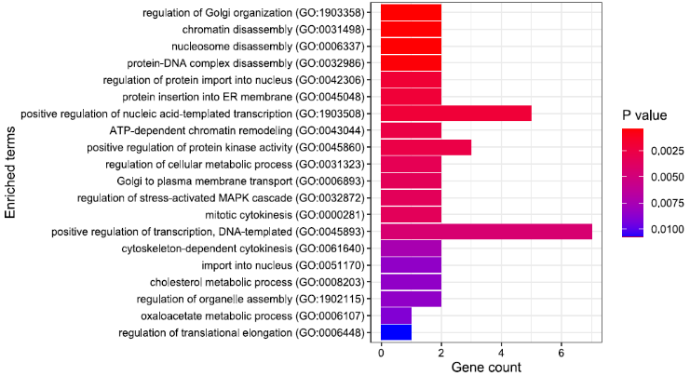
A
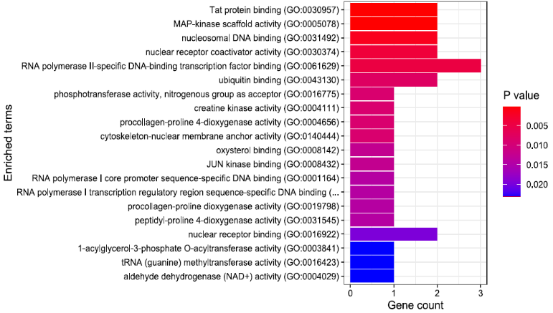
B

\

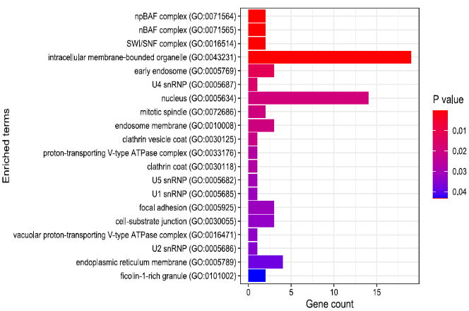
C
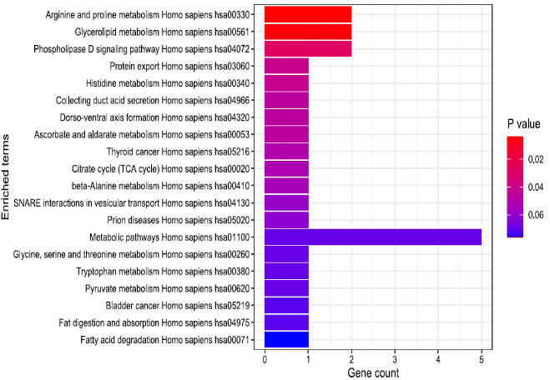
D

Figure 2- Supp. Gene enrichment analysis of the down-regulated DEGs. Go term enrichment analysis showing the top 20 results from enrichment analysis of up-regulated genes in A. biological process, B. Molecular function. C. Cellular localization. D. KEGG pathway enrichment of the top 20.

Table 4. Supplementary.
Term | Overlap | P-value | Adjusted P-value | Odds Ratio | Genes
Vesicle-Mediated Transport (GO:0016192) | 6/411 | 0.0001 | 0.0197 | 9.66 | SPAG9;NECAP2;TSG101;RABEP1;STX5;CSNK1G2
Regulation Of Stress-Activated MAPK Cascade (GO:0032872) | 3/51 | 0.0001 | 0.0197 | 37.72 | MAP2K1;MDFIC;MAP4K4
Regulation Of Golgi Organization (GO:1903358) | 2/16 | 0.0004 | 0.0440 | 83.82 | MAP2K1;STX5
Nucleosome Disassembly (GO:0006337) | 2/18 | 0.0005 | 0.0440 | 73.34 | SMARCE1;SMARCA4
protein-DNA Complex Disassembly (GO:0032986) | 2/20 | 0.0006 | 0.0440 | 65.18 | SMARCE1;SMARCA4
Regulation Of Nucleotide-Excision Repair (GO:2000819) | 2/26 | 0.0010 | 0.0623 | 48.87 | SMARCE1;SMARCA4
Regulation Of Metaphase/Anaphase Transition Of Cell Cycle (GO:1902099) | 2/32 | 0.0015 | 0.0679 | 39.09 | SMARCE1;SMARCA4
Regulation Of G0 To G1 Transition (GO:0070316) | 2/33 | 0.0016 | 0.0679 | 37.82 | SMARCE1;SMARCA4
Regulation Of Cell Cycle Process (GO:0010564) | 3/130 | 0.0016 | 0.0679 | 14.20 | SMARCE1;ECT2;SMARCA4
Regulation Of Protein Import Into Nucleus (GO:0042306) | 2/38 | 0.0021 | 0.0679 | 32.56 | MDFIC;ECT2
Positive Regulation Of Myoblast Differentiation (GO:0045663) | 2/38 | 0.0021 | 0.0679 | 32.56 | SMARCE1;SMARCA4
Positive Regulation Of Lymphocyte Differentiation (GO:0045621) | 2/39 | 0.0022 | 0.0679 | 31.68 | SMARCE1;SMARCA4
Positive Regulation Of Stem Cell Population Maintenance (GO:1902459) | 2/40 | 0.0024 | 0.0679 | 30.85 | SMARCE1;SMARCA4
Positive Regulation Of Nucleic Acid-Templated Transcription (GO:1903508) | 5/557 | 0.0030 | 0.0758 | 5.67 | MAP2K1;USP16;MDFIC;RNF4;SMARCA4
Golgi To Plasma Membrane Transport (GO:0006893) | 2/47 | 0.0032 | 0.0758 | 26.04 | RABEP1;OSBPL5
Regulation Of T Cell Differentiation (GO:0045580) | 2/47 | 0.0032 | 0.0758 | 26.04 | SMARCE1;SMARCA4
Regulation Of Mitotic Metaphase/Anaphase Transition (GO:0030071) | 2/49 | 0.0035 | 0.0775 | 24.93 | SMARCE1;SMARCA4
Regulation Of Myoblast Differentiation (GO:0045661) | 2/54 | 0.0043 | 0.0856 | 22.52 | SMARCE1;SMARCA4
Regulation Of Stem Cell Population Maintenance (GO:2000036) | 2/56 | 0.0046 | 0.0856 | 21.69 | SMARCE1;SMARCA4
post-Golgi Vesicle-Mediated Transport (GO:0006892) | 2/56 | 0.0046 | 0.0856 | 21.69 | RABEP1;OSBPL5
Representation of the top 20 Gene enrichment terms based on “GO Biological Process” in the Down-regulated genes in cells with cotton.

Table 5. Supplementary.
Term | Overlap | P-value | Adjusted P-value | Odds Ratio | Genes
AR | 5/243 | 0.0001 | 0.0091 | 13.37 | SMARCE1;TSG101;RNF4;SMARCA4;DCAF6
MYC | 6/498 | 0.0002 | 0.0154 | 7.92 | SPAG9;MAP2K1;P4HA1;UBE3C;ECT2;SMARCA4
MAPK8 | 5/352 | 0.0004 | 0.0169 | 9.12 | SPAG9;MAP2K1;LRRFIP1;SSBP4;MAP4K4
NR3C1 | 4/209 | 0.0005 | 0.0169 | 12.05 | SMARCE1;TSG101;SMARCA4;DCAF6
CDK1 | 6/659 | 0.0010 | 0.0270 | 5.91 | ACLY;MAP2K1;USP16;ECT2;SSBP4;MAP4K4
HGS | 3/122 | 0.0014 | 0.0293 | 15.16 | ACLY;TSG101;OSBPL5
ARF6 | 3/163 | 0.0031 | 0.0574 | 11.25 | SPAG9;ACLY;SRPRB
SP1 | 3/195 | 0.0051 | 0.0829 | 9.36 | RNF4;SMARCA4;DCAF6
MAPK9 | 3/222 | 0.0074 | 0.1054 | 8.20 | SPAG9;MAP2K1;MAP4K4
NCK1 | 3/244 | 0.0095 | 0.1228 | 7.44 | ECT2;CSNK1G2;MAP4K4
Table representation of the top 10 Gene enrichment terms based on “PPI Hub Genes” in the Down-regulated genes in cells with cotton.no need

Table 6. Supplementary.
Gene | Ensembl ID |  | Gene Name |  | M (log2-ratio) |  | Probability
APP | ENSG00000142192 |  | amyloid beta precursor protein |  | 8.19 |  | 1.00
HIF1A | ENSG00000100644 |  | hypoxia inducible factor 1 subunit alpha |  | 7.80 |  | 1.00
TXNDC5 | ENSG00000239264 |  | thioredoxin domain containing 5 |  | 7.67 |  | 1.00
CHMP2A | ENSG00000130724 |  | charged multivesicular body protein 2A |  | 6.49 |  | 0.98
DPH1 | ENSG00000108963 |  | diphthamide biosynthesis 1 |  | 6.25 |  | 0.98
ZNF207 | ENSG00000010244 |  | zinc finger protein 207 |  | 6.25 |  | 0.97
ITGA3 | ENSG00000005884 |  | integrin subunit alpha 3 |  | 6.23 |  | 0.97
TMEM14C | ENSG00000111843 |  | transmembrane protein 14C |  | 6.23 |  | 0.97
IPO5 | ENSG00000065150 |  | importin 5 |  | 6.01 |  | 0.96
LAMA4 | ENSG00000112769 |  | laminin subunit alpha 4 |  | 5.91 |  | 0.96
SLC44A2 | ENSG00000129353 |  | solute carrier family 44 member 2 |  | 5.85 |  | 0.95
RPL17-C18orf32 | ENSG00000215472 |  | RPL17-C18orf32 read through |  | 2.78 |  | 0.92
GMPPA | ENSG00000144591 |  | GDP-mannose pyrophosphorylase A |  | 5.71 |  | 0.94
FGF2 | ENSG00000138685 |  | fibroblast growth factor 2 |  | 5.66 |  | 0.94
NEDD8-MDP1 | ENSG00000255526 |  | NEDD8-MDP1 read through |  | 3.61 |  | 0.93
RPS10-NUDT3 | ENSG00000270800 |  | RPS10-NUDT3 read through |  | 3.69 |  | 0.93
CSE1L | ENSG00000124207 |  | chromosome segregation 1 like |  | 5.51 |  | 0.93
ATP2B4 | ENSG00000058668 |  | ATPase plasma membrane Ca2+ transporting 4 |  | 5.49 |  | 0.92
P4HA1 |  | ENSG00000122884 |  | prolyl 4-hydroxylase subunit alpha 1 |  | -6.14 |  | 0.97
CIZ1 |  | ENSG00000148337 |  | CDKN1A interacting zinc finger protein 1 |  | -5.65 |  | 0.95
TSG101 |  | ENSG00000074319 |  | tumor susceptibility 101 |  | -5.55 |  | 0.94
METTL9 |  | ENSG00000197006 |  | methyltransferase like 9 |  | -5.39 |  | 0.92
SUN1 |  | ENSG00000164828 |  | Sad1 and UNC84 domain containing 1 |  | -5.36 |  | 0.92
CSNK1G2 |  | ENSG00000133275 |  | casein kinase 1 gamma 2 |  | -5.29 |  | 0.91
SMARCA4 |  | ENSG00000127616 |  | SWI/SNF related, matrix associated, actin dependent regulator of chromatin, subfamily a, member 4 |  | -5.24 |  | 0.91
USP16 |  | ENSG00000156256 |  | ubiquitin specific peptidase 16 |  | -5.24 |  | 0.91
UBE3C |  | ENSG00000009335 |  | ubiquitin protein ligase E3C |  | -5.24 |  | 0.90
NUSAP1 |  | ENSG00000137804 |  | nucleolar and spindle associated protein 1 |  | -5.21 |  | 0.90
NECAP2 |  | ENSG00000157191 |  | NECAP endocytosis associated 2 |  | -5.19 |  | 0.90
TRMT1 |  | ENSG00000104907 |  | tRNA methyltransferase 1 |  | -5.15 |  | 0.90
SNRPD2 |  | ENSG00000125743 |  | small nuclear ribonucleoprotein D2 polypeptide |  | -7.34 |  | 1.00
MAP4K4 |  | ENSG00000071054 |  | mitogen-activated protein kinase kinase kinase kinase 4 |  | -6.98 |  | 0.99
HNRNPH3 |  | ENSG00000096746 |  | heterogeneous nuclear ribonucleoprotein H3 |  | -6.89 |  | 0.99
ACLY |  | ENSG00000131473 |  | ATP citrate lyase |  | -6.48 |  | 0.98
Table showing differentially expressed genes as compared to control with the stringent threshold (0.9).

