Supplementary Materials
- Carbon and Energy Footprint
Mass Carbon $F^{CO_{2}}$and Energy$F^{E}$ footprint per unit of mass of each metal $m$ have been found in GrantaEduPack© Software. GrantaEduPack compiles data from various sources reporting carbon and energy footprints and calculates their averages. Notably, some metals show significant variations in the reported values. When faced with multiple sources, we have opted for the values reported in EcoInvent®. However, it's important to mention that no data for Arsenide was available in GrandaEduPack, leading us to reference the value provided in Nuss et al¹.
Mass footprints have been converted into molar footprints $f^{CO_{2}}$ and $f^{E}$ as follows:
$$f_{m}^{CO_{2}}=F_{m}^{CO_{2}}M_{m}$$
$$f_{m}^{E}= F_{m}^{E}M_{m}$$
with $M$ the molar mass (in kg/mol) of the chemical element $m$. The molar footprint of the elements are reported in Table I.1. The footprints of the HEA $j$ composed of $n$ metals $m$ in a concentration $x$have been calculated as follows:
$$f_{HEA}^{CO_{2}}=\sum_{m=1}^{n}{x_{m}f_{m}^{CO_{2}}}$$
$$f_{HEA}^{E}=\sum_{m=1}^{n}{x_{m}f_{m}^{E}}$$

Table I.1: Molar CO2 and Energy footprint of the production of the 40 elements palette
Elements | Z | CO2 footprint min (CO2/mol) | CO2 footprint max (CO2/mol) | Energy footprint min (MJ/mol) | Energy footprint max (MJ/mol)
Mg | 12 | 0.6 | 0.6 | 8.9 | 9.8
Al | 13 | 0.3 | 0.4 | 5.1 | 5.6
Si | 14 | 0.3 | 0.3 | 3.5 | 3.8
Sc | 21 | 139.8 | 154.2 | 2346.7 | 2585.0
Ti | 22 | 1.5 | 1.7 | 26.8 | 29.5
V | 23 | 11.7 | 12.9 | 179.8 | 198.7
Cr | 24 | 1.0 | 1.2 | 23.9 | 26.4
Mn | 25 | 0.3 | 0.3 | 3.9 | 4.3
Fe | 26 | 0.1 | 0.1 | 1.1 | 1.2
Co | 27 | 2.4 | 2.7 | 118.5 | 131.4
Ni | 28 | 0.9 | 1.0 | 11.5 | 12.7
Cu | 29 | 0.4 | 0.4 | 5.9 | 6.5
Zn | 30 | 0.2 | 0.3 | 2.8 | 3.1
Ga | 31 | 11.3 | 12.5 | 173.6 | 191.7
Ge | 32 | 618.1 | 682.0 | 68.4 | 75.5
As | 33 | 0.0 | 0.0 | 0.4 | 0.4
Y | 39 | 7.5 | 8.3 | 124.5 | 136.9
Zr | 40 | 8.9 | 9.9 | 139.6 | 154.2
Nb | 41 | 10.9 | 12.0 | 163.5 | 180.2
Mo | 42 | 1.5 | 1.7 | 13.9 | 15.4
Ru | 44 | 168.8 | 186.0 | 2344.8 | 2587.4
Rh | 45 | 5207.2 | 5732.1 | 127608.4 | 140986.7
Pd | 46 | 769.4 | 848.2 | 18729.9 | 20645.5
Ag | 47 | 46.5 | 51.2 | 710.9 | 784.2
Cd | 48 | 0.6 | 0.6 | 9.8 | 10.8
In | 49 | 13.0 | 14.4 | 284.8 | 314.6
Sn | 50 | 1.4 | 1.5 | 19.5 | 21.4
Sb | 51 | 1.0 | 1.1 | 15.3 | 16.8
Te | 52 | 0.8 | 0.9 | 15.2 | 16.7
Hf | 72 | 12.5 | 13.7 | 187.4 | 207.0
Ta | 73 | 48.9 | 53.9 | 741.9 | 817.9
W | 74 | 6.7 | 7.3 | 101.1 | 111.4
Re | 75 | 172.6 | 189.9 | 1534.4 | 1692.6
Os | 76 | 681.0 | 749.5 | 11699.1 | 12897.6
Ir | 77 | 532.4 | 586.3 | 8707.6 | 9591.8
Pt | 78 | 7686.3 | 8466.6 | 208739.9 | 228248.3
Au | 79 | 11621.0 | 12802.8 | 79574.5 | 87650.1
Hg | 80 | 2.2 | 2.4 | 21.5 | 23.5
Pb | 82 | 0.4 | 0.5 | 5.4 | 6.0
Bi | 83 | 1.8 | 2.0 | 28.8 | 31.8
- Carbon Intensity of Energy sources
The source data for the Carbon Intensity of each energy source are based on the report of the United Nation Economic Commission for Europe² and represented in table II.1
Table II.1 Carbon intensity of different energy sources
Energy source |  | Carbon intensity (gCO2/kWh) |  |  | Carbon intensity (gCO2/MJ)
 |  | min | average | max | min | average | max
Coal power | without  Carbon capture | 751 | 923 | 1095 | 208.6 | 256.4 | 304.2
Coal power | with  Carbon capture | 147 | 308 | 469 | 40.8 | 85.6 | 130.3
Natural Gas | without  Carbon capture | 403 | 458 | 513 | 111.9 | 127.2 | 142.5
Natural Gas | With  Carbon capture | 92 | 156 | 220 | 25.6 | 43.3 | 61.1
Hydropower |  | 6 | 76.5 | 147 | 1.7 | 21.3 | 40.8
Solar Energy | Concentrated solar power | 27 | 74.5 | 122 | 7.5 | 20.7 | 33.9
Solar Energy | Photovoltaics | 8 | 45.5 | 83 | 2.2 | 12.6 | 23.1
Wind Power | Onshore | 7.8 | 11.9 | 16 | 2.2 | 3.3 | 4.4
Wind Power | Offshore | 12 | 17.5 | 23 | 3.3 | 4.9 | 6.4
Nuclear Power |  | 5.1 | 5.75 | 6.4 | 1.4 | 1.6 | 1.8

For sake of the clarity of the figure 1, the data sources have been sorted within the following categories: Fossil without Carbon capture (Coal and Gas), Fossil with carbon capture (Coal and Gas), Renewables (Hydropower, Solar Energy and wind power), Nuclear Power. The data are represented in the table II.2.
Table 2 Carbon intensity of the different categories of energy sources
Energy source | Carbon intensity (gCO2/kWh) |  |  | Carbon intensity (gCO2/MJ)
Energy source | min | average | max | min | average | max
Fossil without Carbon capture | 403 | 749 | 1095 | 111.9 | 208.1 | 304.2
Fossil with Carbon Capture | 92 | 280.5 | 469 | 25.6 | 77.9 | 130.3
Renewable | 6.0 | 45.2 | 147.0 | 1.7 | 12.6 | 40.8
Nuclear Power | 5.1 | 5.75 | 6.4 | 1.4 | 1.6 | 1.8

- Production and Reserves,
The production $P_{m}$ (respectively reserve$R_{m}$) of a metal $m$ are found in the US Geological Survey³. A few elements (Y, Ge, Sc, Pt, Ru, Pd, Ir, Rh, Os) were not quantitatively documented in the USGS repport. We completed the USGS data on Y, Ge, Sc and Os with the data available in the Study on the EU's list of Critical Raw Materials (Critical Raw Materials Factsheets 2020) of the EU Commission⁴. For the Platinum Group Metals, Nassar et al.⁵ (see Table S3 of the Supplementary Informations) gathered the production of each PGM (except Os) in each mine (see Table S3 of the Supplementary Informations of Nassar et al.⁵). This allowed us to calculate the each PGM production per country.
These levels of production and reserve are used to calculate an average production $PS_{HEA}$ and reserve $RS_{HEA}$ sollicitation (in %/ton) respectively:
$${PS}_{HEA}=\sum_{m=1}^{n}{x_{m}×\frac{100}{P_{m}}}$$
$${RS}_{HEA}=\sum_{m=1}^{n}{x_{m}×\frac{100}{R_{m}}}$$

To size the maximal production of a given alloy based on the constraint given by the most critical element, the production and reserve solicitation of the most critical element is calculated as follows:
$${PS}_{HEA}^{max}=\max\left\{{PS}_{1}, {PS}_{2}…{PS}_{m}\right\}$$

$${RS}_{HEA}^{max}=\max\left\{{RS}_{1}, {RS}_{2}…{RS}_{m}\right\}$$

- ESG and Supply risk data
Supply concentration is estimated using the Herfindahl-Hirschman Index $HHI$, which is expressed for a metal $m$as follows:
$$HHI(m)= \sum_{c}{s_{c}^{2}(m)}$$
Producing countries c and their respective production share $s_{c}$ are obtained from the US Geological Survey³ (USGS). ESG risk assessment per mine has been published by Lèbre et al.⁶. This has made it possible to calculate an ESG score for 20 commodities including 16 of the 40 elements of this study. However, if was not possible to use mine-by-mine data for the 24 other elements. Therefore, and for sake of consistency, the ESG score has been calculated based on the country score calculated by Lèbre et al. (See “Source Data file” of the paper of Lèbre et al.⁶) for the 40 elements. The ESG risk of each metal has been calculated as follows:
$$ESG\left(m\right)=\sum_{c}{E_{c}s_{c}(m)+S_{c}s_{c}(m)+G_{c}s_{c}(m)}$$
The supply risk indicator is used by many governmental agencies to have an indicator that both combines the supply concentration and the ESG risk:
$$SR(m)= \sum_{C}{\left(E_{c}+S_{c}+G_{c}\right)}s_{c}^{2}(m)$$
Supply concentration (HHI), ESG scores and Supply risk index are represented for each metal in Table IV.1.
for an HEA $j$ combines the supply concentration and the ESG risk with the following formula:
$$SR_{HEA}= \sum_{m=1}^{n}{\sum_{C}{\left(E_{c}+S_{c}+G_{c}\right)}}s_{c}^{2}(m)$$

Table 3 HHI, ESG Score and Supply risk index of the 40 elements
Element | HHI (USGS) | ESG Score | Supply risk
Ag | 0.13 | 2.93 | 0.40
Al | 0.37 | 2.68 | 1.27
As | 0.38 | 3.57 | 1.36
Au | 0.09 | 2.48 | 0.15
Bi | 0.66 | 3.61 | 2.43
Cd | 0.21 | 3.14 | 0.74
Co | 0.50 | 3.67 | 1.99
Cr | 0.26 | 3.18 | 0.91
Cu | 0.12 | 2.73 | 0.31
Fe | 0.18 | 3.05 | 0.53
Ga | 0.96 | 3.64 | 3.51
Graphite | 0.64 | 3.57 | 2.32
Hg | 0.82 | 3.64 | 2.98
In | 0.41 | 3.21 | 1.44
Ir | 0.91 | 3.55 | 3.25
Li | 0.34 | 2.88 | 0.93
Mg | 0.78 | 3.52 | 2.85
Mn | 0.21 | 3.25 | 0.72
Mo | 0.24 | 3.35 | 0.82
Nb | 0.82 | 3.10 | 2.63
Ni | 0.28 | 2.88 | 0.91
Pb | 0.23 | 3.01 | 0.79
Pd | 0.37 | 2.99 | 1.12
Pt | 0.57 | 3.38 | 2.03
Re | 0.31 | 3.04 | 0.91
Rh | 0.71 | 3.41 | 2.54
Ru | 0.93 | 3.55 | 3.33
Sb | 0.35 | 3.36 | 1.27
Sc | 0.54 | 3.36 | 1.89
Si | 0.48 | 3.25 | 1.73
Sn | 0.18 | 3.10 | 0.60
Ta | 0.26 | 1.97 | 0.24
Te | 0.33 | 3.24 | 1.16
Ti | 0.41 | 3.42 | 1.45
V | 0.51 | 3.47 | 1.83
W | 0.72 | 3.53 | 2.62
Y | 0.75 | 3.40 | 2.71
Zn | 0.17 | 2.80 | 0.51
Zr | 0.20 | 2.80 | 0.56

- Sustainability Risk Score
In our assessment framework to establish a robust decision support system encompassing various sustainability dimensions, we have identified and incorporated five critical criteria, chosen for their effectiveness in representing sustainability considerations:
- The first criterion is the CO₂ footprint, which is linearly related to the energy footprint
- The second criterion is Supply Risk, an integrated indicator that combines Environmental, Social, and Governance (ESG) risk factors with supply diversity (HHI)
- The third criterion pertains to maximal companionability, reflecting the degree to which an alloy relies on companion metals in production
- The fourth and fifth criteria involve the average reserve and production solicitation

These criteria provide insights into the reliance on primary resources and current production rates. To amalgamate these criteria into a unified indicator, we developed a scoring for each of the 30,201 alloys considered in this study (Figure V.I). Each alloy’s performance within each criterion is categorised into ten deciles. For example, if an alloy falls within the 5th decile for a particular criterion, it contributes 5 points to the overall Sustainability Risk Score. This scoring methodology results in a Sustainability Risk Score ranging from 5 points (indicating the lowest sustainability risk) to 50 points (signifying the highest sustainability risk). The decile sorting and the Sustainability Risk Score of the 30,201 HEAs is available as an extended data file.

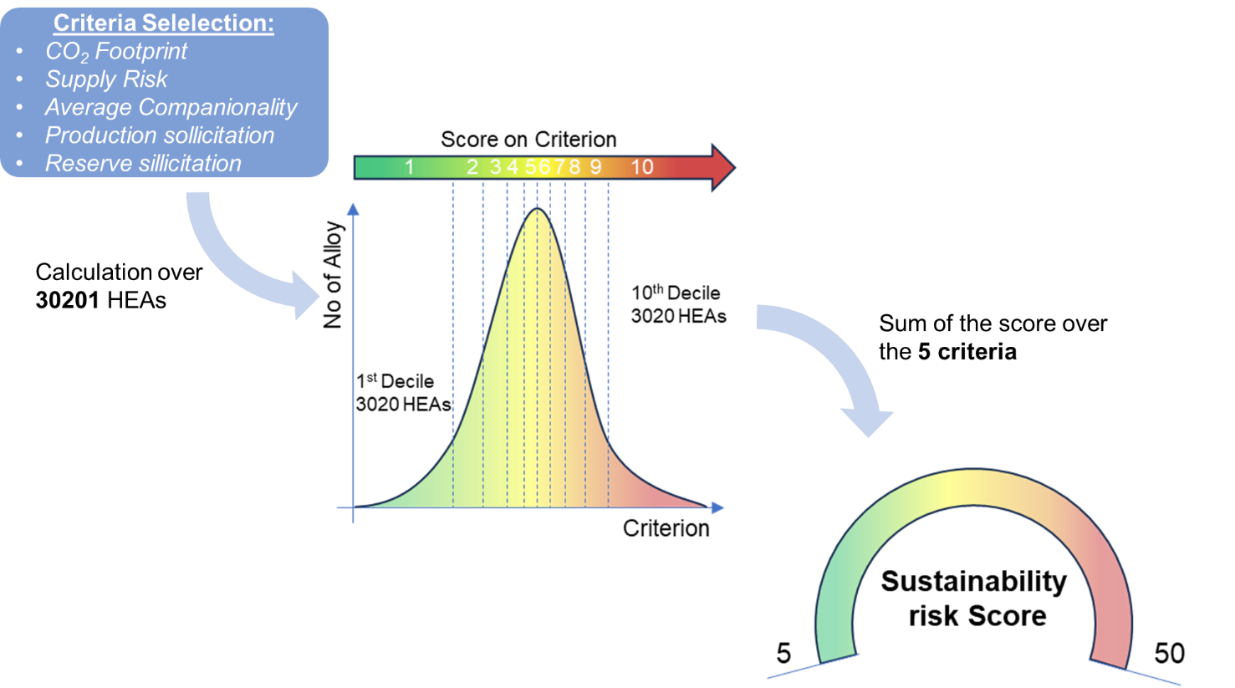
Figure V.1: Schematical representation of the different steps of the calculation of the Sustainability Risk Score

- References
1. Nuss, P. & Eckelman, M. J. Life Cycle Assessment of Metals: A Scientific Synthesis. PLOS ONE 9, e101298 (2014).
2. United Nations Economic Commission for Europe. Carbon Neutrality in the UNECE Region: Integrated Life-cycle Assessment of Electricity Sources. (United Nations, 2022). doi:10.18356/9789210014854.
3. Mineral commodity summaries 2022. Mineral commodity summaries 2022 vol. 2022 202 http://pubs.er.usgs.gov/publication/mcs2022 (2022).
4. Directorate-General for Internal Market, I. et al. Study on the EU’s list of critical raw materials (2020): final report. (Publications Office of the European Union, 2020).
5. Nassar, N. T., Graedel, T. E. & Harper, E. M. By-product metals are technologically essential but have problematic supply. Science Advances 1, e1400180 (2015).
6. Lèbre, É. et al. The social and environmental complexities of extracting energy transition metals. Nat Commun 11, 4823 (2020).

