Assessing the reporting rates
Overall, the completeness of monthly health facility reports for the main forms that report the number of diarrhoea cases and immunization was at least 90% in all reporting periods and was observed to be closer to 100% for the 2020 and 2021 reporting years (Figure 1). The percentage of the districts whose reporting rate for immunization was below 90% was high in 2015 (70%) but reduced in the subsequent years but remained stable at 40% between 2016 and 2018 (Figure 2). The district immunization reporting rate was reduced to 15% and 11% in 2020 and 2021 respectively. Similarly, between 2015-2018, the district Diarrhoea OPD reporting rate was close to 40%, which was later reduced to 7% in 2020 and 4% in 2021.
Figure 1: trends in reporting rates
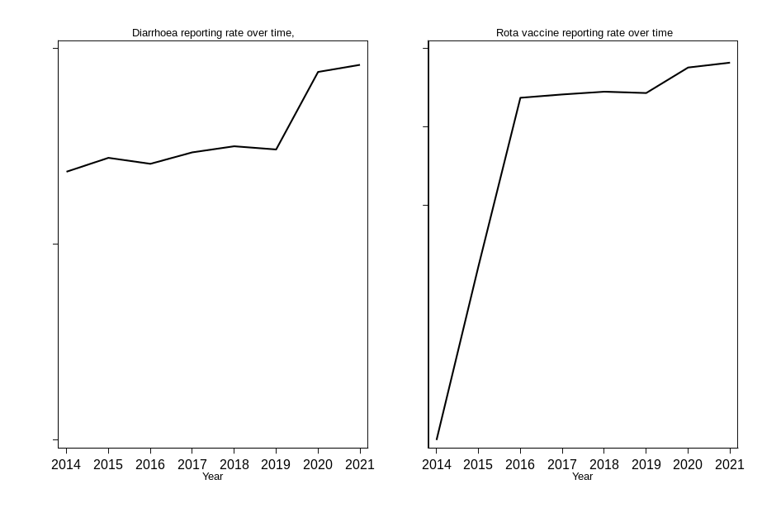
Figure 2: Proportion of districts where the reporting rate for immunization is lower than 90%
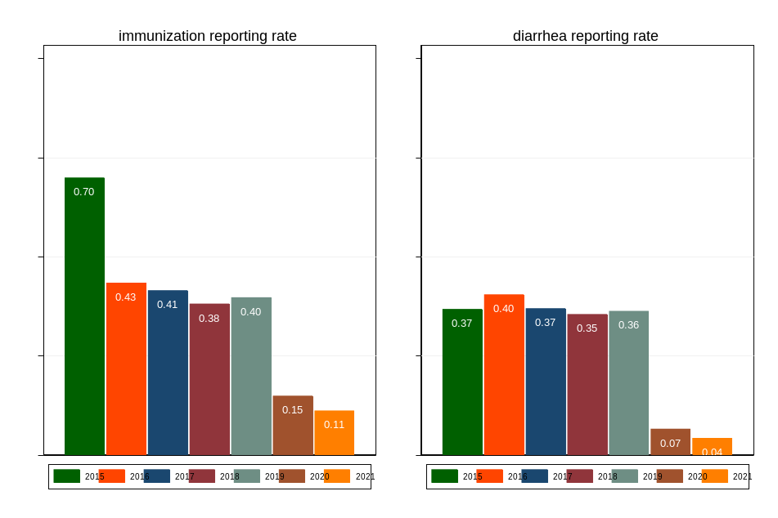
Figure 2: Predicted average number of cases per district per month after the vaccine introduction.
