Supplementary information

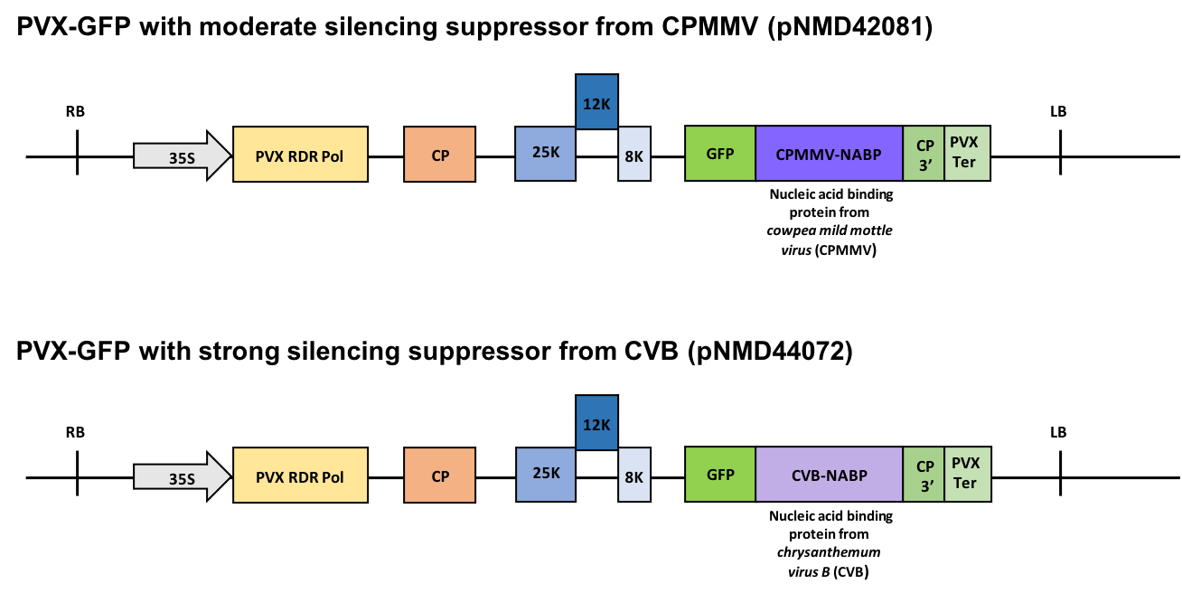
Figure S1: Illustration of PVX-GFP vectors with additional silencing suppressors. PVX-GFP vectors pNMD42081 and pNMD44072 consisting a Cauliflower Mosaic Virus (CMV) 35S promoter (35S), the viral RNA dependent RNA polymerase (PVX RDR Pol), PVX Coat Protein (CP), PVX triple gene block movement proteins (25K, 12K and 8K), green fluorescent protein (GFP), Coat Protein 3’ untranslated region (CP 3’) and the PVX terminator (PVX Ter). Additionally, pNMD42081 encodes for a nucleic acid binding protein (NABP) from cowpea mild mottle virus (CPMMV) which functions as a moderate silencing suppressor, whereas pNMD44072 contains a strong silencing suppressor in form of a NABP from chrysanthemum virus B (CVB). LB and RB represent the left and right boarders of the T-DNA.

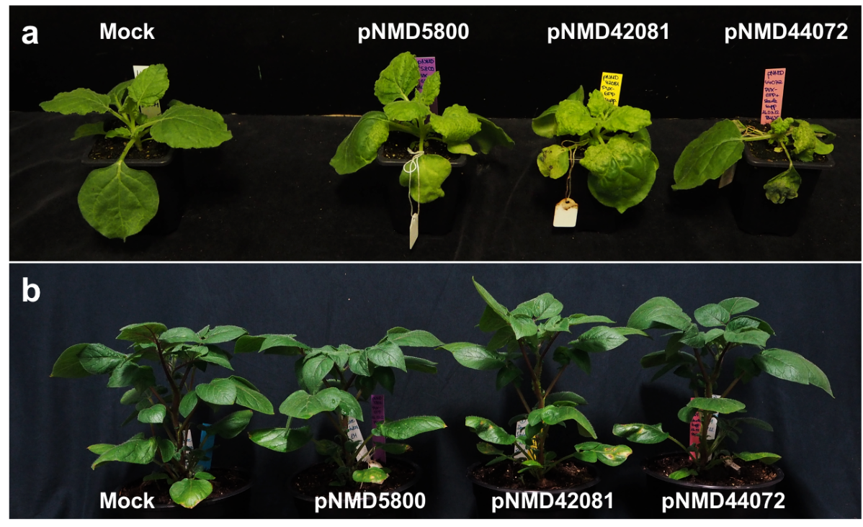
Figure S2: Phenotypes of PVX-infected plants. N. benthamiana (a) and S. tuberosum (b) plants were either mock-treated by infiltrating 10 mM MgCl₂ or infiltrated with Agrobacteria carrying the PVX-GFP (pNMD5800), PVX-GFP + CPMMV (pNMD42081) or PVX-GFP + CVB (pNMD44072) vector. Pictures were taken 6 weeks post infection (wpi).

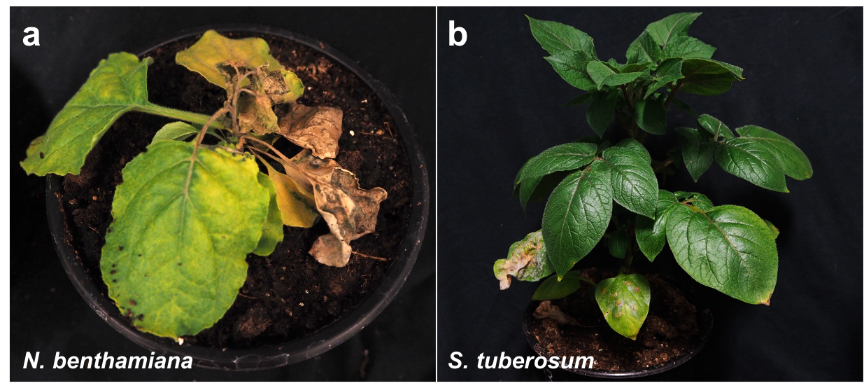
Figure S3: Phenotypes of PVX and PVY co-infected plants. N. benthamiana (a) and S. tuberosum (b) plants were first mechanically inoculated with PVY and 3 dpi agro-infected with PVX-GFP (pNMD5800). Pictures were taken 6 weeks post infection (wpi).

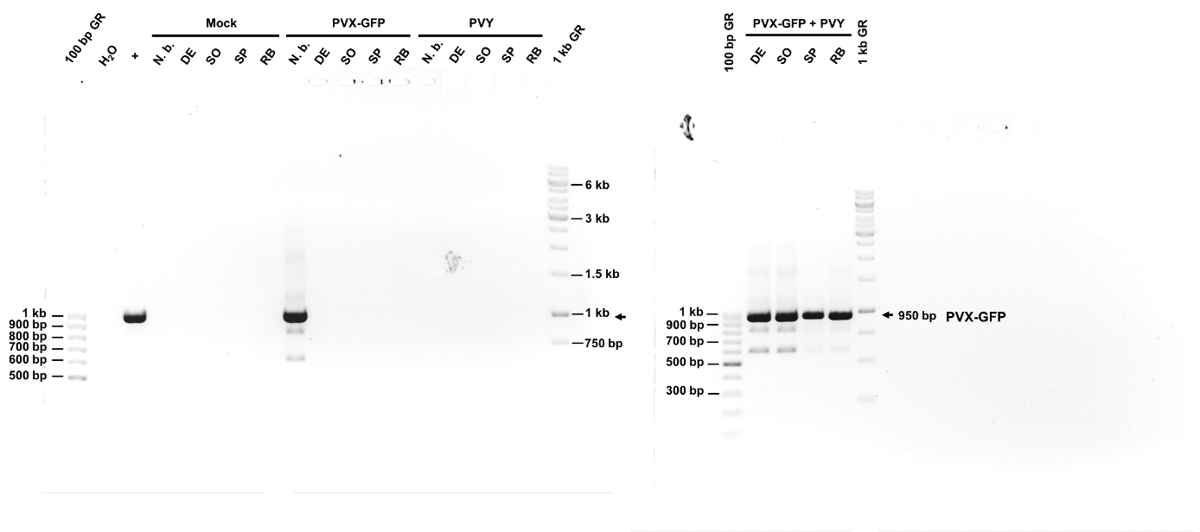
Figure S4: Detection of PVX-GFP transcripts by RT-PCR in mock-, single-, and co-infected N. benthamiana and S. tuberosum cultivars Désirée (DE), Solara (SO), Spunta (SP) and Russet Burbank (RB). pNMD5800 plasmid served as positive control (+). A 100 bp and 1 kb GeneRuler (GR) were used to determine PVX-GFP transcript fragment size (indicated by arrows and expected size).

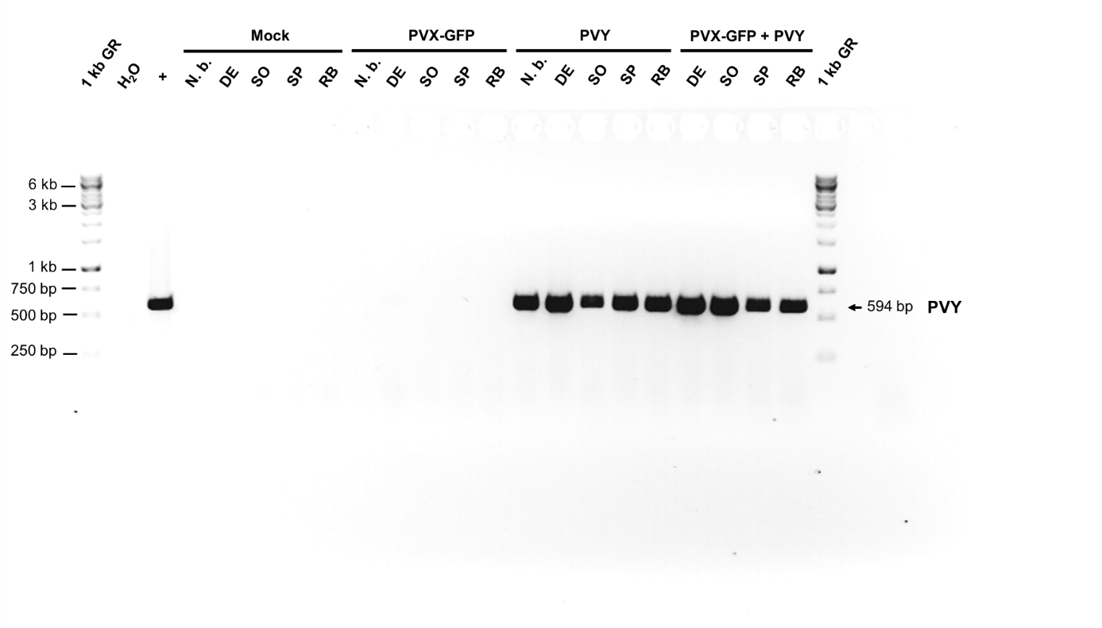
Figure S5: Detection of PVY transcripts by RT-PCR in mock-, single-, and co-infected N. benthamiana and S. tuberosum cultivars Désirée (DE), Solara (SO), Spunta (SP) and Russet Burbank (RB). Infectious PVY inoculum served as positive control (+). A 1 kb GeneRuler (GR) was used to determine PVY transcript fragment size (indicated by arrow and expected size).

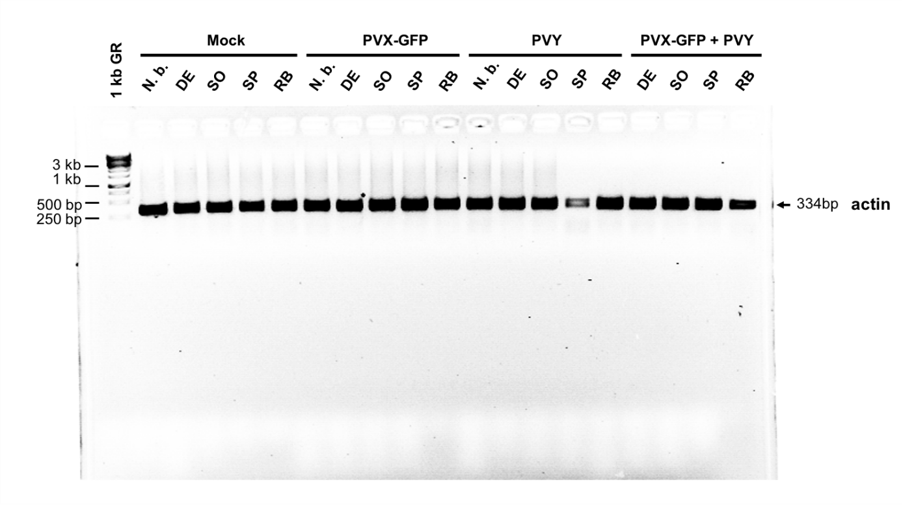
Figure S6: Detection of actin transcripts (as control) by RT-PCR in mock-, single-, and co-infected N. benthamiana and S. tuberosum cultivars Désirée (DE), Solara (SO), Spunta (SP) and Russet Burbank (RB). A 1 kb GeneRuler (GR) was used to determine actin transcript fragment size (indicated by arrow and expected size).

