Supporting information

Exploiting hot electrons from a plasmon nanohybrid system for the photoelectroreduction of CO₂

Ananta Dey^{1#}, Vitor R. Silveira^{1#}, Robert Bericat Vadell¹, Andreas Lindblad², Rebecka Lindblad², Vitalii Shtender³, Jacinto Sá^{1,4}*

# equal contribution
*Corresponding author: jacinto.sa@kemi.uu.se

¹ Department of Chemistry-Ångström, Physical Chemistry division, Uppsala University, Box 532, 751 20 Uppsala, Sweden
² Department of Physics, Division of X-ray Photon Science, Uppsala University, 751 21 Uppsala, Sweden
³ Department of Materials Science and Engineering, Division of Applied Materials Science, Uppsala University, 75103 Uppsala, Sweden
⁴ Institute of Physical Chemistry, Polish Academy of Sciences, Marcina Kasprzaka 44/52, 01-224 Warsaw, Poland

*jacinto.sa@kemi.uu.se

Sample preparation:
Au naniparticles (NPs) synthesis:
Sodium citrate tribasic dihydrate 50 mL (6.6 mM) water solution was taken in a 100 mL round bottom flask and stirred at 70ºC on an oil bath. Then 0.1 mL (2.5 mM) tannic acid was added to the reaction mixture. Finally, 1mL of (25 mM) HAuCl₄ was added instantly. After 5 minutes the reaction mixture colour changed from dark blue to wine. The change in colour confirms the formation of the Au nanoparticles. The synthesized Au nanoparticles were stored in a fridge. The size of the Au nanoparticles was analysed using dynamic light scattering (DLS).

Re^{I}(phen-NH₂)(CO)₃Cl (phen-NH₂ = 1, 10-Phenanthrolin-5-amine) catalyst synthesis:
1, 10-Phenanthrolin-5-amine 200 mg (1.02 mmol) and pentacarbonylchlororhenium (I) 368.94 mg (1.02 mmol) were suspended in 40 mL toluene using a 100 mL round bottom flask. The reaction mixture was stirred at 110ºC for 6 hours. Then the reaction mixture was cooled down to room temperature. The obtained yellow colour precipitate was filtered using a G4 gooch crucible under vacuum and finally washed 3 times with 50 mL toluene. Yield 379.57 mg (74%). ¹H NMR (400 MHz, DMSO-d₆): δ ppm 9.38 (1H, dd, J = 5.2, 1.2 Hz), 9.12 (1H, dd, J = 8.8, 1.2 Hz), 8.94 (1H, dd, J = 4.8, 1.2 Hz), 8.49 (1H, dd, J = 8.4, 1.2 Hz), 8.06 (1H, dd, J = 8.6, 5.2 Hz), 7.79 (1H, dd, J = 8.4, 5.2 Hz), 7.07 (1H, s), 6.89 (2H, s). ¹³C NMR (100 MHz, DMSO-d₆): δ(ppm) 197.90, 190.18, 153.15, 147.87, 146.73, 144.88, 139.62, 135.60, 134.35, 132.68, 126.21, 125.04, 123.56, 101.17.

Preparation of the thin films:
The preparation and process of NiO film:
The NiO paste was purchased from Solaronix and used as received. A small portion of the NiO paste was placed on a screen, placed on top of the cleaned FTO glass and manually printed on conducting side of the FTO glass. Then the NiO-printed FTO glass plates were annealed at 500ºC for 1 hour at a rate of 10ºC/minute.

Assembly of the Au nanoparticles on NiO film:
The synthesised Au nanoparticles were sprayed manually on NiO films and annealed at 500ºC for 1 hour at a rate of 10ºC/minute.

Assembly of the catalyst on NiO/Au surface:
We prepared a complete system with two different loadings of catalysts, which severed different purposes in our study.
Lower catalyst loading: The annealed NiO-Au films were dipped into a 2mg/mL solution of the synthesised Re^{I}(phen-NH₂)(CO)₃Cl catalyst in Dimethylformamide for 48 hours. Finally, we could get the self-assembled NiO/Au/Re^{I}(phen-NH₂)(CO)₃Cl composite system. We have also sprayed Au nanoparticles only on FTO glass for experimental purposes.
Higher catalyst loading: The annealed NiO-Au films were dipped into a 2mg/mL solution of the synthesised Re^{I}(phen-NH₂)(CO)₃Cl catalyst in Dimethylformamide for 48 hours at 100º C temperature. Finally, we could get the self-assembled NiO/Au/Re^{I}(phen-NH₂)(CO)₃Cl composite system. We have also sprayed Au nanoparticles only on FTO glass for experimental purposes.

Samples characterization:
UV-Vis measurements:
The UV-Vis spectra were collected using a Cary 5000 UV-VIS-NIR spectrophotometer.

DLS measurements:
The DLS data was collected in a Malvern Zetasizer nanoS instrument and a total of 3 measurements comprised of 12 scans each time was done.

Atomic Force Microscopy (AFM) measurements:
The AFM data was collected on AFM nanosurf with a long Si cantilever in tapping mode with Al reflex.

¹H nuclear magnetic resonance (NMR) measurement:
The ¹H NMR was measured using a JEOL 400 machine in DMSO-d₆.

Standard Fourier-transformed infrared (FT-IR) measurements:
FT-IR data were measured using a universal ATR sampling assembly on a VERTEX 70v instrument.

In-situ Fourier-transformed infrared (FT-IR) measurements:
FT-IR data were measured in transmission in a TensorII instrument. The photosystem films were deposited on CaF₂ and inserted in a homemade liquid transmission flow cell with adjustable light path length. The samples were measured in dry acetonitrile after saturation for 1h with Ar or CO₂. The sample was illuminated with a 532 nm CW laser, and the changes were monitored every with minute intervals with a spectral resolution of 4 cm⁻¹ with an MCT detector.

Electrochemistry measurements:
The electrochemical data were measured using an EmStat potentiostat instrument. For the electrochemical experiments, a typical cylindrical closed cell was used. The FTO films were placed on the side of the cell so that it could face the light.

Bulk electrolysis:
Pt wire counter electrode and Ag/AgCl (0.1 M TBAPF₆/acetonitrile) reference electrode were purchased from Redox.me and used as received. 0.1 M Tetrabutylammonium hexafluorophosphate purchased from Merck was used as a supporting electrolyte without further purification in dry acetonitrile.

Photo-electrocatalytic chronoamperometry:
The photoelectrode exposed area to light is 0.79 cm². Plasmonic excitation was performed with a 532 nm laser of the intensity of 53 mW/cm². Pt wire counter electrode and Ag/AgCl (0.1 M TBAPF₆/acetonitrile) reference electrode were purchased from Redox.me and used as received. Tetrabutylammonium hexafluorophosphate purchased from Merck was used as a supporting electrolyte without further purification.
Similar experiments were performed under CO₂ gas flow (20 mL/min) to enable the detection of the exhaust on a Hiden Analytical quadrupole mass spectrometer.

Quantum yield (QY) calculations
Plasmonic hot carriers are formed via resonance decay, not direct photon excitation. This makes quantum yield calculations with plasmonic complex since the photons absorbed are not equivalent to a maximum number of electrons produced (denominator of quantum yield formula), which is the case on gap materials, where one photon can only have one electron-hole pair. Nevertheless, we used the classical formula to calculate quantum yield (QY), namely:

QY = (number of electrons reacted/number of photons absorbed) x 100

XPS and HAXPES measurements:
Photoelectron spectra were recorded using two-photon energies, Al Kα (1487 eV) and Ga Kα (9.25 keV). The electron energy analyser used was a Scienta Omicron EW-R4000. The spectra were recorded in a vast region between 0 and 100 eV electron binding energy, giving a significant difference in information depth for the two photon energies. The samples were measured as thin films on conductive glass.

Inductively coupled plasma-optical emission spectrometry (ICP-OES) measurement:
The ICP-OES was used to estimate the rhenium amount in the sample. The film was digested for four hours in 4 ml of nitric acid (Nitric acid 65%, FisherScientific), the small probe was diluted 10 times with milliQ water containing 5% HNO₃ and filtered with 0.2 μm syringe filters (Whatman) before measurement. Avio 200 Scott/Cross-Flow Configuration was used for ICP measurements. A calibration curve was formed for the measurements using a Rhenium Calibration Standard (Merk). Concentrations of 0, 0.1, 1 and 10 ppm of the Re were used to create a 4-point linear regression. All measured values are within a relative standard deviation (RSD) of 2%.

Transient absorption spectroscopy (TAS)
A 40-fs pulsed laser with a 3 kHz repetition rate was generated through the Libra Ultrafast Amplifier System designed by Coherent. An optical parametric oscillator (TOPAS- prime, Light Conversion) was used to generate the excitation beam. The signals were detected with a UV-NIR detector, namely a Newport MS260i spectrograph with interchangeable gratings. The fundamental laser (probe, 795 nm) passes through the delay stage (1-2 fs step size) and is focused in a Sapphire optical window in order to generate visible light from 400 to 750 nm. The instrument response function obtained for our system is ca. 95 fs.

Transient infrared absorption spectroscopy (TIRAS)
Briefly, a 40-fs pulsed laser with a 3 kHz repetition rate was generated through the Libra Ultrafast Amplifier System designed by Coherent. Two optical parametric oscillators (TOPAS- prime, Light Conversion) were used to generate either the excitation beam and/or the probe light in the Mid-IR (3000-10000 nm). The signals were detected with a Horiba iHR 320 spectrometer. The pump laser power was constantly monitored with less than a 2% standard deviation. The timing resolution, i.e., the instrument response function, is ca. 100 fs.

Additional data:
FIGURE S1: Dynamic light scattering (DLS) analysis of Au NPs in water.

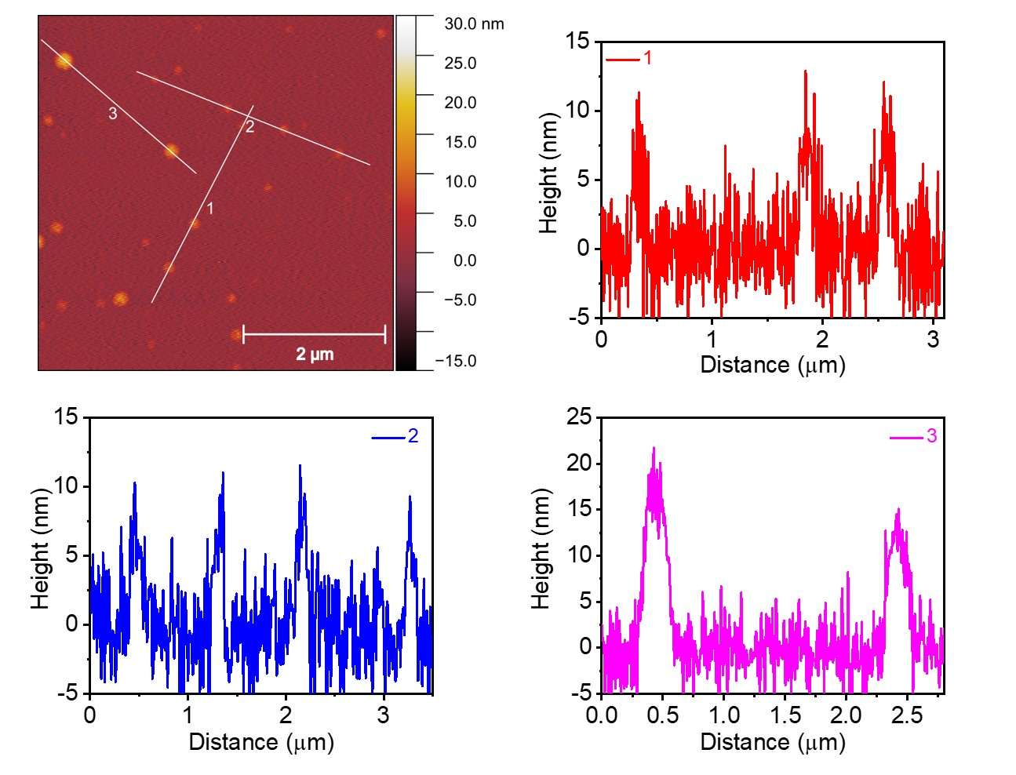
C
D
A
B
FIGURE S2: AFM of Au NPs on Si after annealing. A) AFM micrograph; and B to D) line tarces showing average particle height.
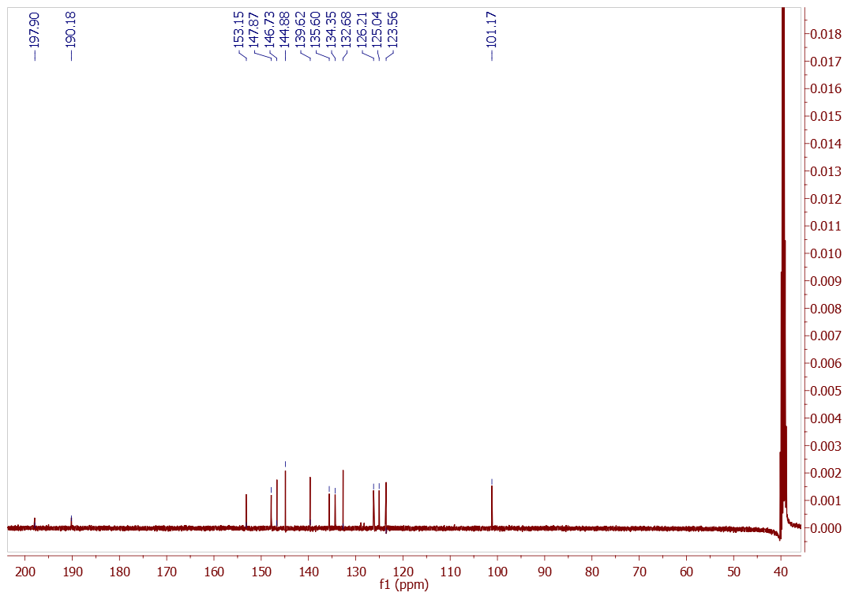
FIGURE S3: ¹³C NMR spectrum of Re^{I}(phen-NH₂)(CO)₃Cl in DMSO-d₆.

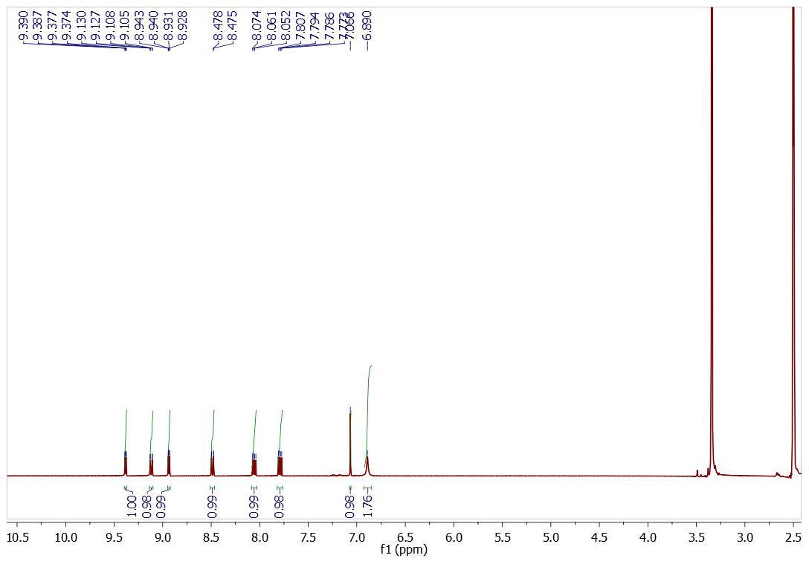
FIGURE S4: ¹H Nuclear magnetic resonance (NMR) spectrum of Re^{I}(phen-NH₂)(CO)₃Cl in DMSO-d₆.
FIGURE S5: Optical spectrum of Re^{I}(phen-NH₂)(CO)₃Cl in dimethylformamide.

FIGURE S6: Cyclic voltammograms of the NiO/Au/Re^{I}(phen-NH₂)(CO)₃Cl in argon and CO₂ purging conditions.

FIGURE S7: TIRAS contour plot of NiO/Au/Re^{I}(phen-NH₂)(CO)₃Cl in the carbonyl region.

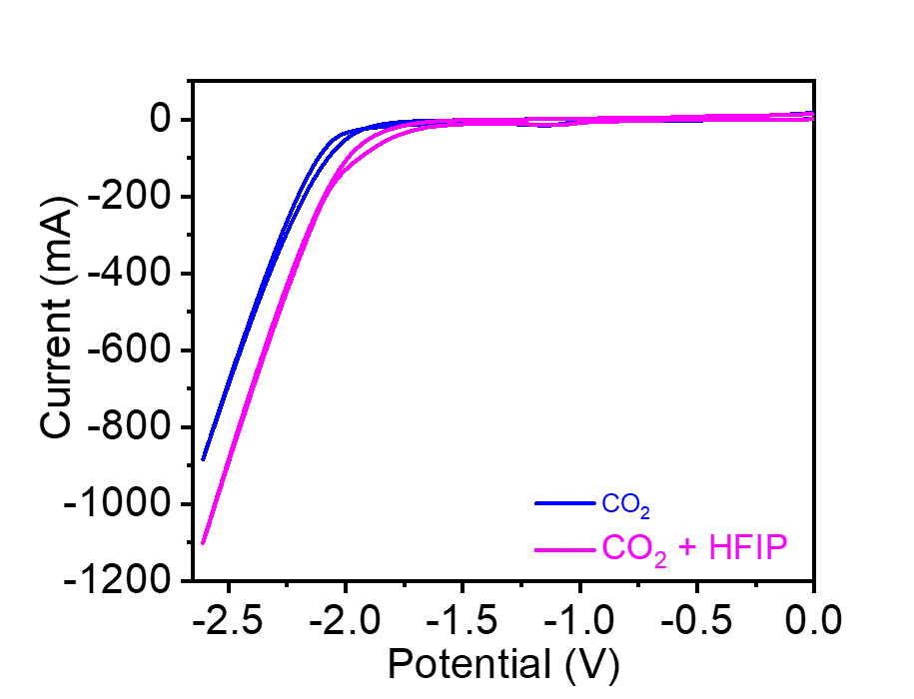FIGURE S8: Cyclic voltammograms comparison of the NiO/Au/Re^{I}(phenNH₂)(CO)₃Cl in CO₂ after introduction a proton donor 1,1,1,3,3,3-Hexafluoro-2-propanol (HFIP).

