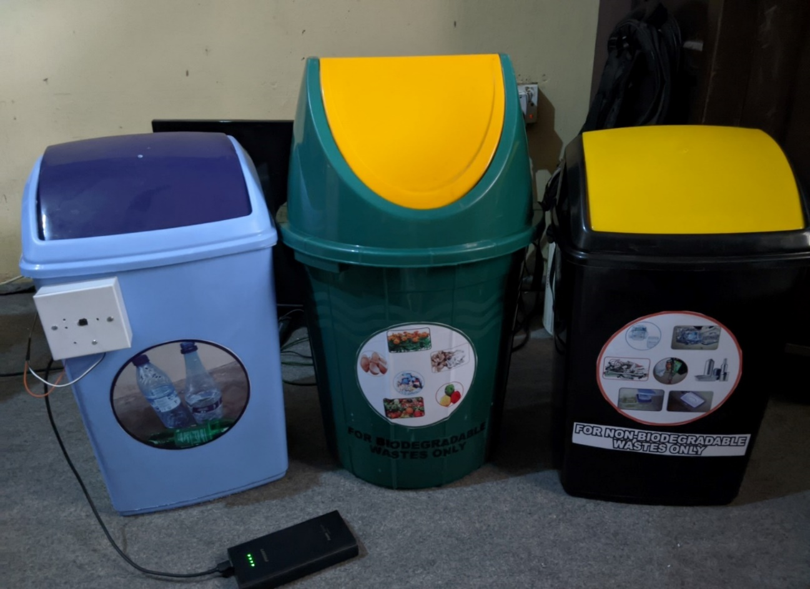
Plate 3.1: The Completed Triplet Waste Bins

