Supplementary materials, tables and Figures

Table S1: Sequence of Col6a5 primers used for genotyping
Primer | Sequence
Forward | AATGGAAATAATTCTGCACCAAGTG
Reverse | TAAGACAGAGGTCAGTGGAGCTGGG

Table S2: Sequence of Col6a5 and Tbp probes and primers used for RTddPCR
Primer /Probe | Sequence
Col6a5-Forward primer sequence (5’-3’) | AGGAAAGCCACGTCCATGTAATA
Col6a5-Reverse primer sequence (5’-3’) | GGAAATGACCGGGAATCTGTAG
wt-Col6a5-probe | AGTCATGGCAGAGAAGAACTGGGT
Mut-Col6a5-probe | AAGTCATGGCCGATAAGAGCTGGG
Tbp - Forward primer sequence (5’-3’) | CTACCGTGAATCTTGGCTGTAA
Tbp -Reverse primer sequence (5’-3’) | GTTGTCCGTGGCTCTCTTATT
Tbp-Probe | AATCCCAAGCGATTTGCTGCAGTC

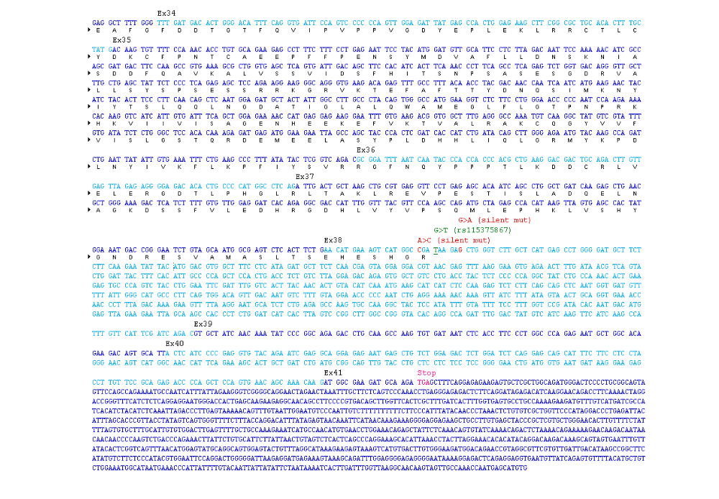Figure S1 mRNA sequence detail of target exons 38. The sequence of exon 38 and surrounded exons are shown. In addition, Exon 38 target mutation and silent mutation position showed.

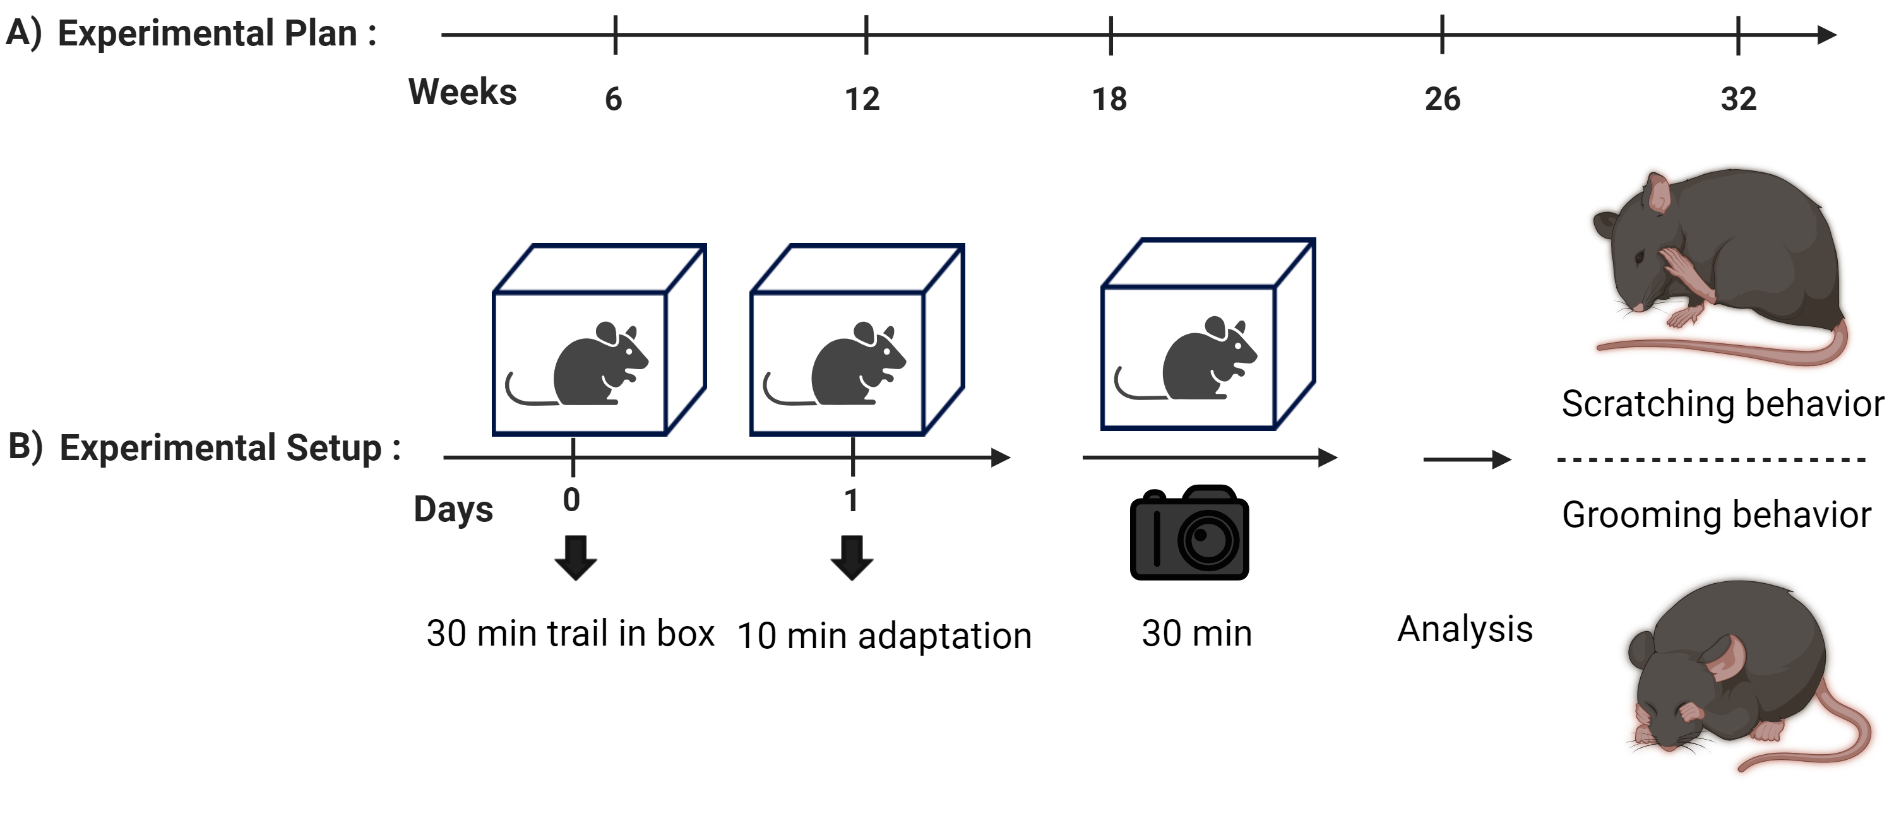

Figure S2: Experimental study of scratching behavior and control groups. (A) The whole experiment started when mice were 6 weeks old and ended after 32 weeks. (B) The experimental setup shows that on day 0, mice were given 30 min in the experimental box for adaptation. On experimental day 1, mice were given 10 min adaptation time followed by 30 min of the experiment.

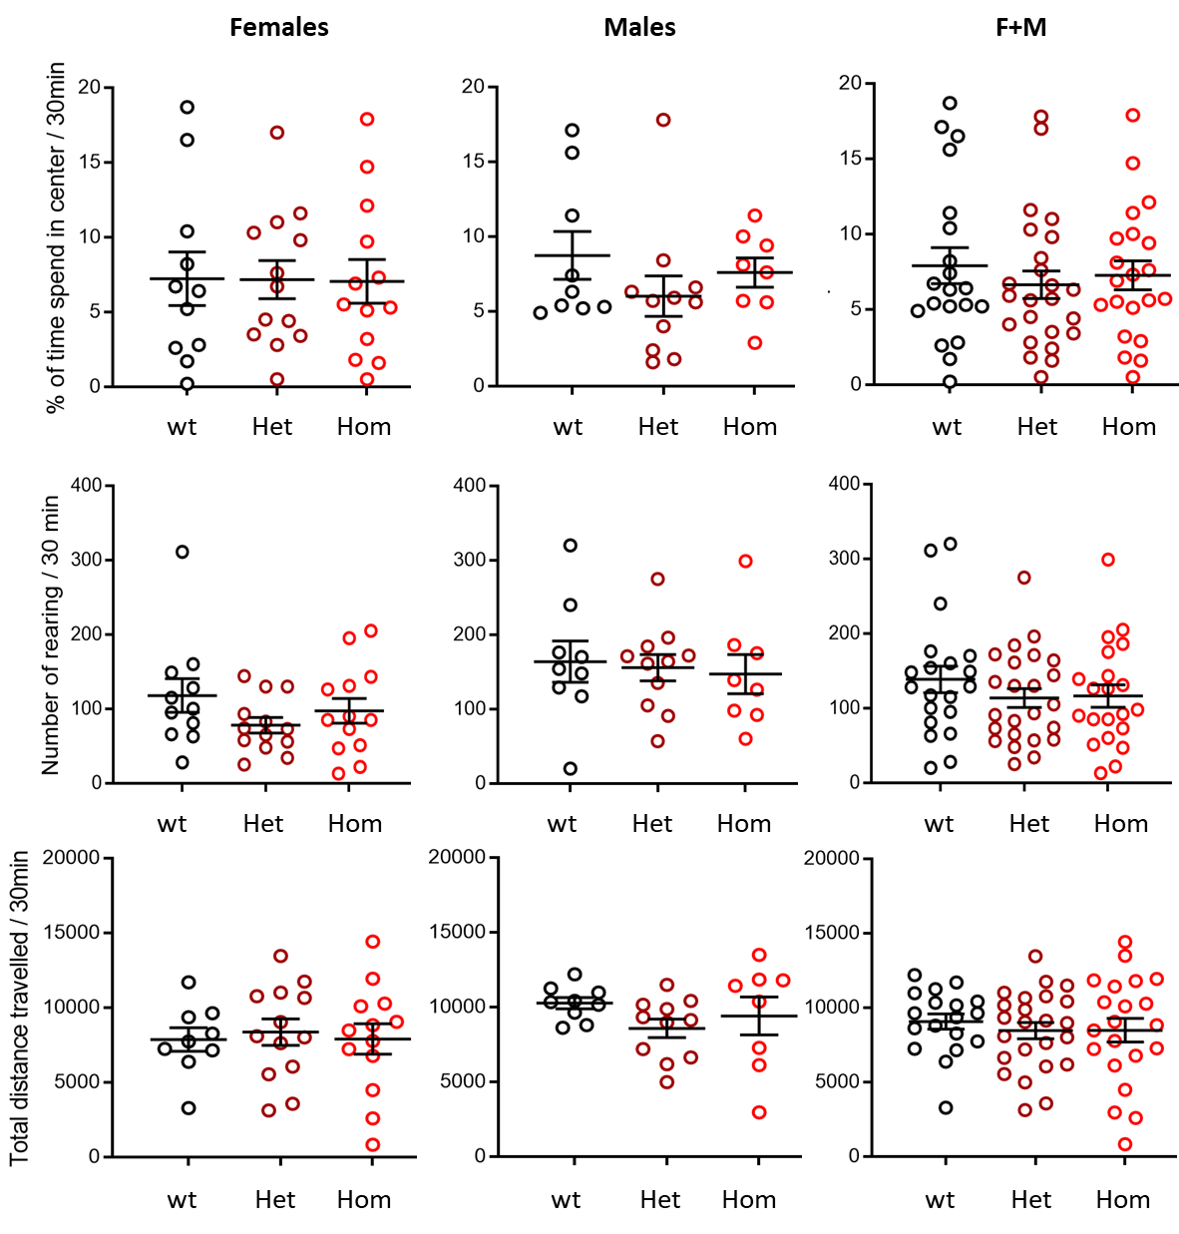

Figure S3: Normal locomotor activity of COL6A5-p.Glu2272* mice. The open-field test showed no difference between mutant and wt mice. This indicates that mutant mice had normal locomotor activities. The wt littermate (wt), heterozygous (Het), and homozygous (Hom) mice were compared. Male, n=8-11 /group; Female, n=11-13 /group.

Figure S4: No significant phenotype found in COL6A5-p.Glu2272* mice in the tail suspension test. Heterozygous (Het) or homozygote (Hom) mutant mice showed mice no difference in immobility time compared to their wt littermates. Mice, n=9-14 /group. Females: one-way ANOVA (F(2, 34) = 1.223; P=0.3071) and males: one-way ANOVA(F(2,26) =1.632;P=0.2150).

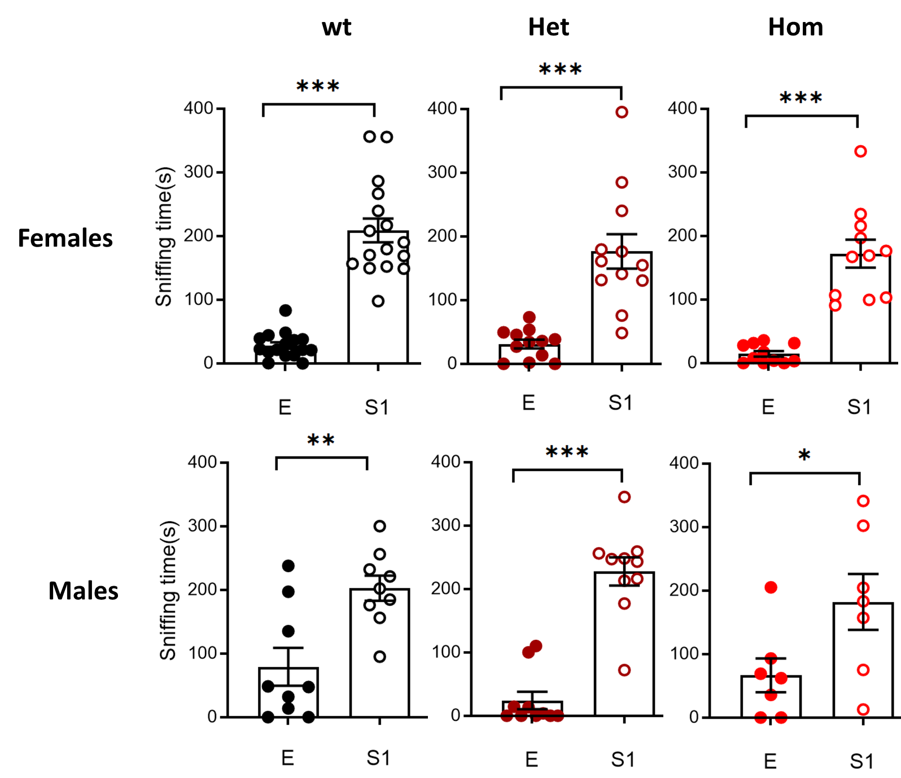

Figure S5: COL6A5-p.Glu2272* mice showed no change in social preference. In the three-chamber test, mice of all genotypes, including wt littermate (wt), heterozygous (Het), and homozygous (Hom), showed significantly more sniffing time towards stranger 1 (S1) mice as compared to the empty cage (E). Males, n=7-10 /group; females, n=12-16 /group. A p-value was considered as significant as *p < 0.05, **p < 0.01, and ***p < 0.001.

