Journal Name: Environmental Science and Pollution Research

Analysing the factors influencing groundwater quality using the Leachate Pollution Index (LPI), Heavy Metal Pollution Index (HPI), and Partial Least Squares - Structural Equation Modelling (PLS-SEM) in the vicinity of an open dumping yard in Saduperi, Vellore, Tamil Nadu, India.
Venkatesh Arumugasamy Thangapandian ª, Sujatha Rajkumar ^{b}, Uma Shankar Masilamani ^{c, *}
^{a,c} Department of Environmental and Water Resources Engineering, School of Civil Engineering, Vellore Institute of Technology (VIT), Vellore, 632014, India.
^{b} Department of Embedded Technology, School of Electronics Engineering, Vellore Institute of Technology (VIT), Vellore, 632014, India
* Corresponding author: Uma Shankar Masilamani, E-mail address: mumashankar@vit.ac.in

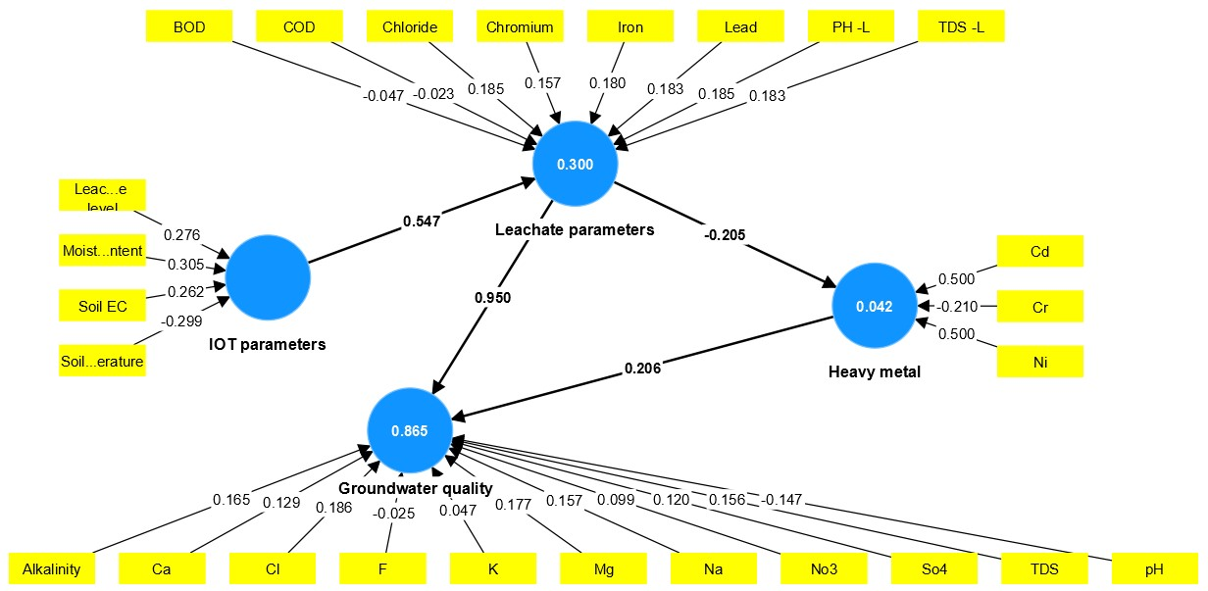
Fig. S1 PLS-SEM model for Sampling Location S1
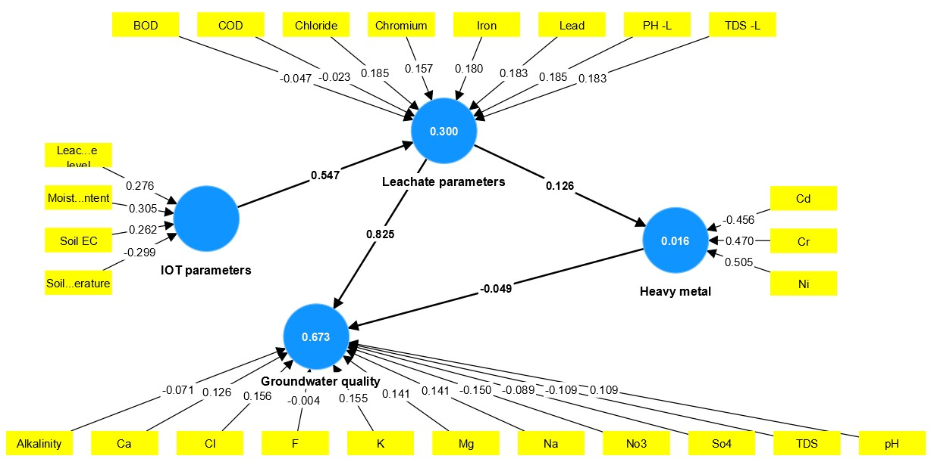
Fig. S2 PLS-SEM model for Sampling Location S2
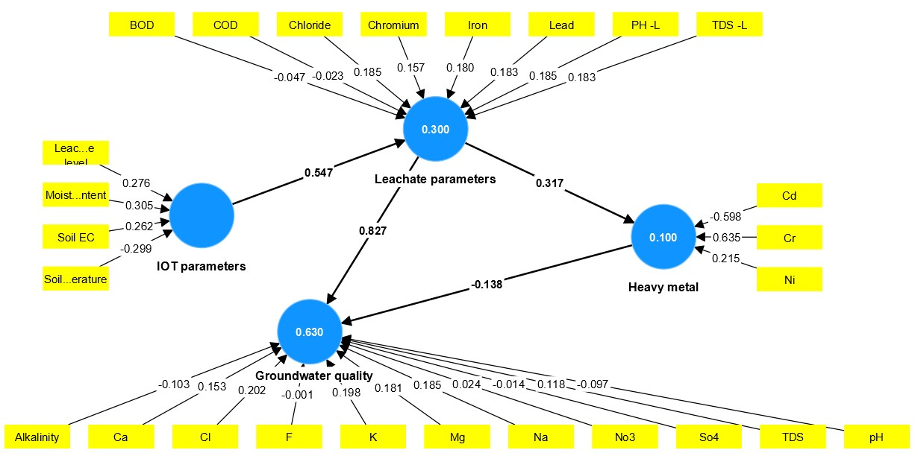
Fig. S3 PLS-SEM model for Sampling Location S3
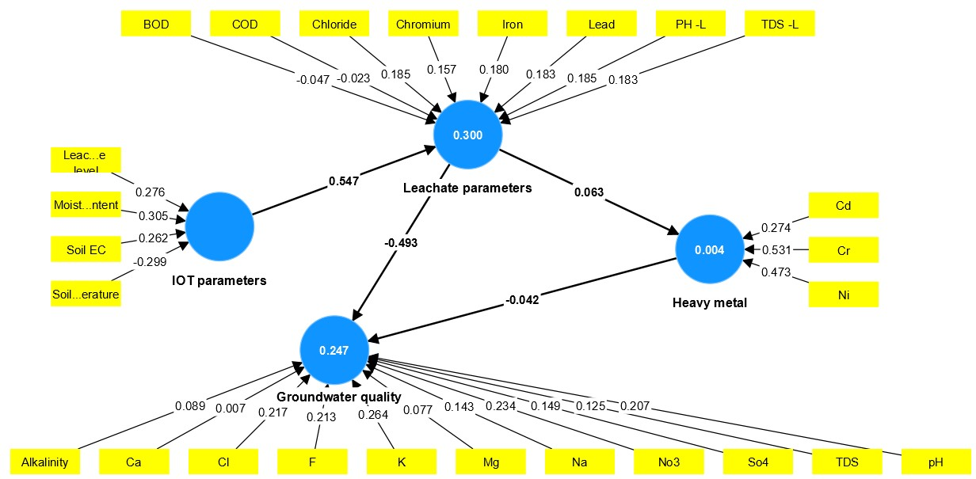
Fig. S4 PLS-SEM model for Sampling Location S6
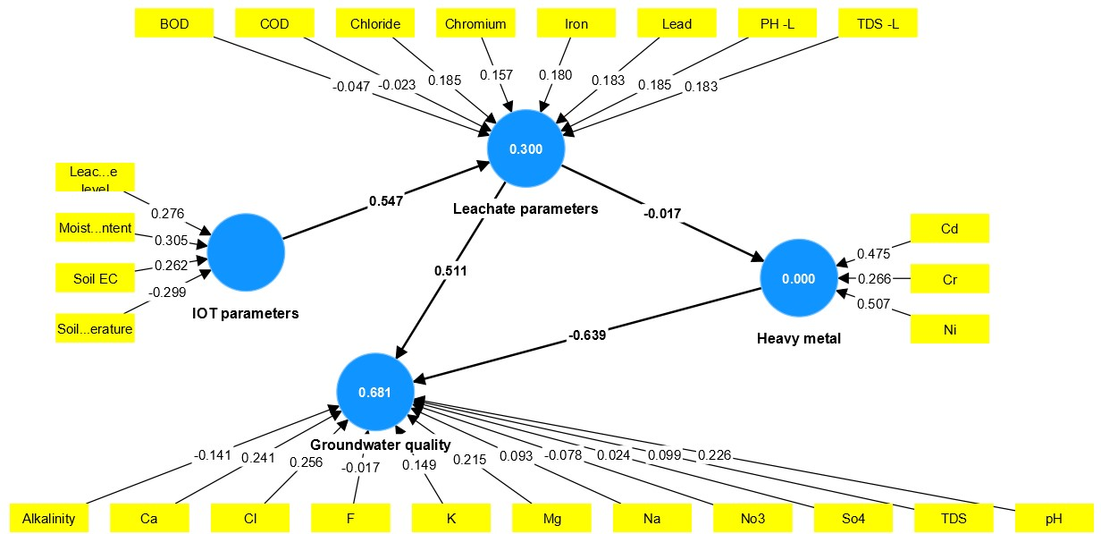
Fig. S5 PLS-SEM model for Sampling Location S7
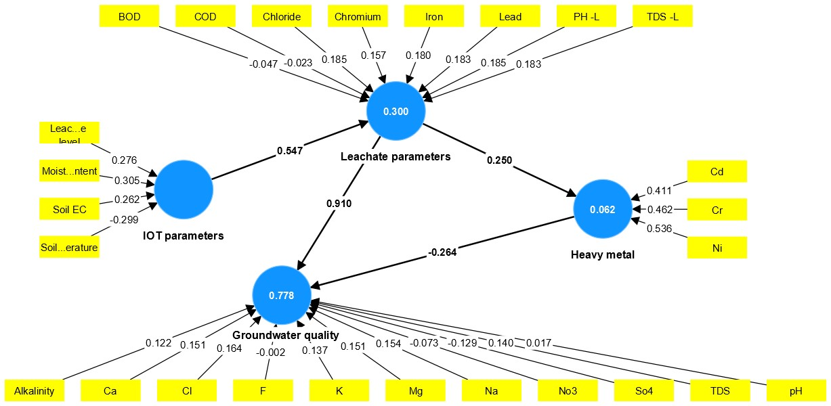
Fig. S6 PLS-SEM model for Sampling Location S8
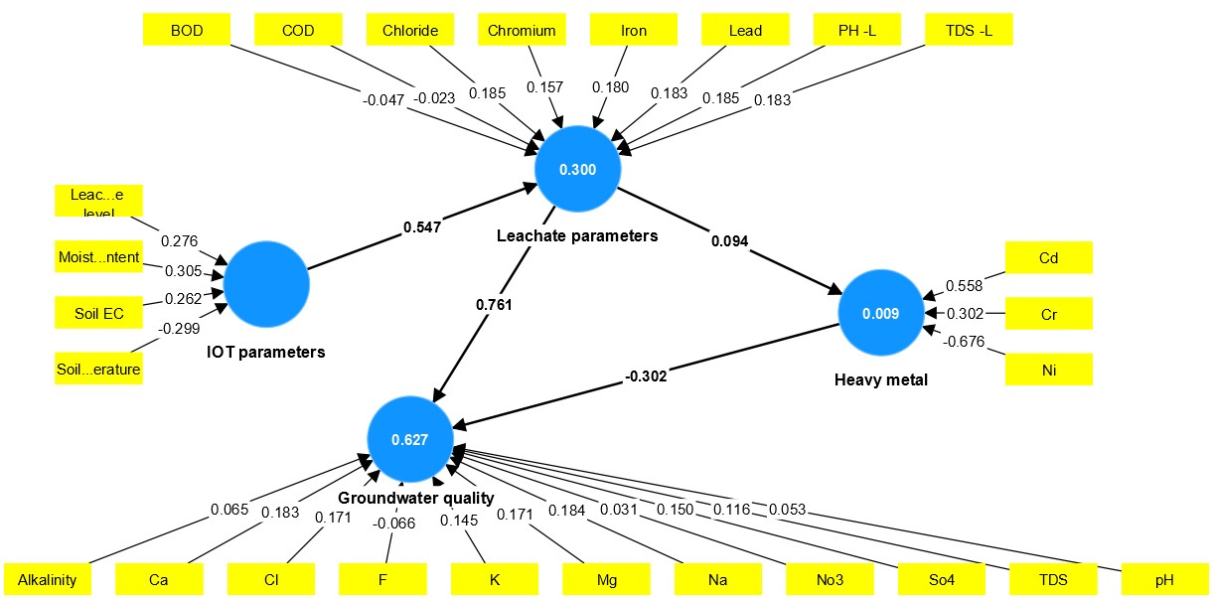
Fig. S7 PLS-SEM model for Sampling Location S10
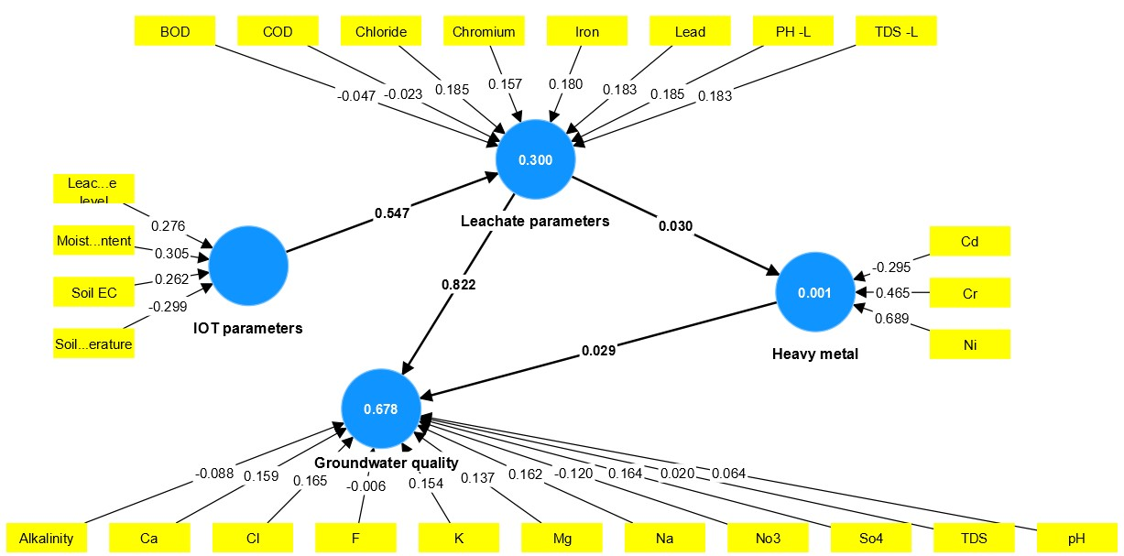
Fig. S8 PLS-SEM model for Sampling Location S11
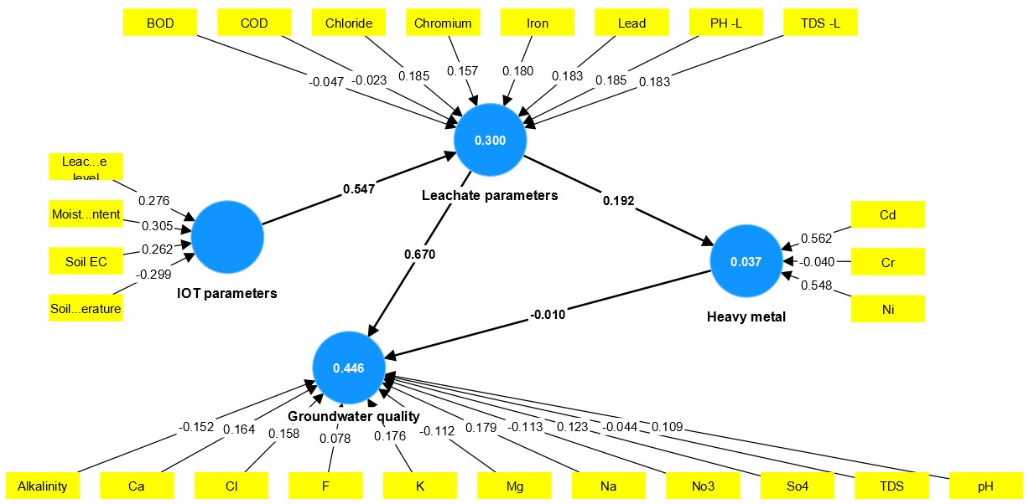
Fig. S9 PLS-SEM model for Sampling Location S12
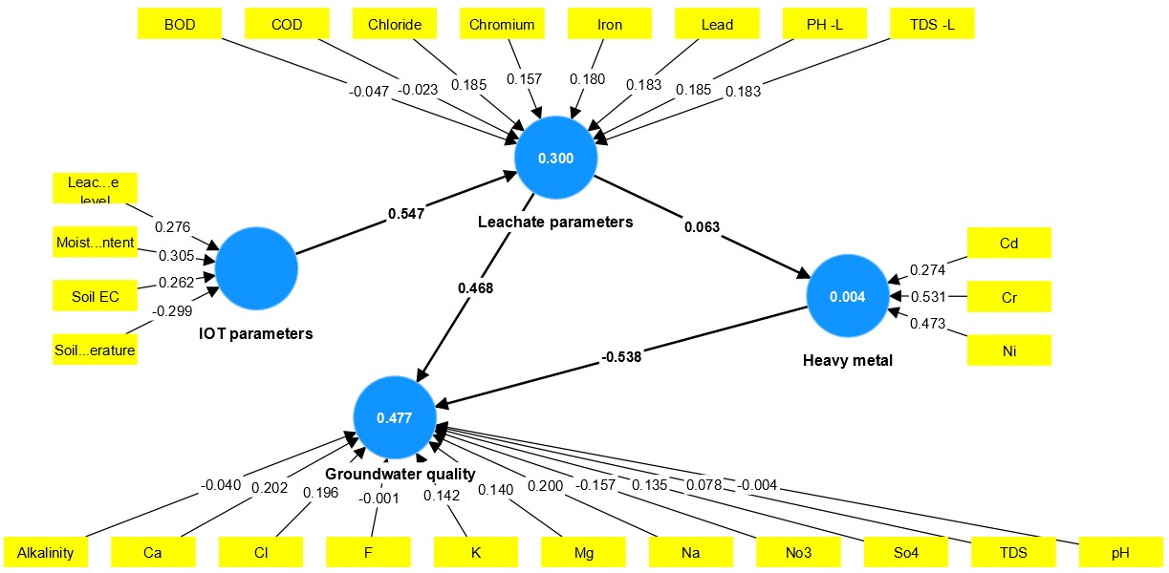
Fig. S10 PLS-SEM model for Sampling Location S13
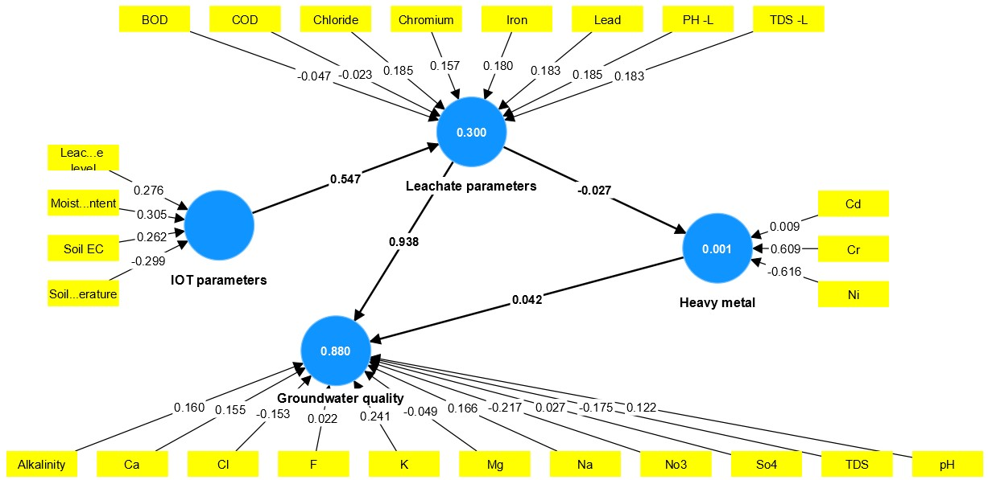
Fig. S11 PLS-SEM model for Sampling Location S14
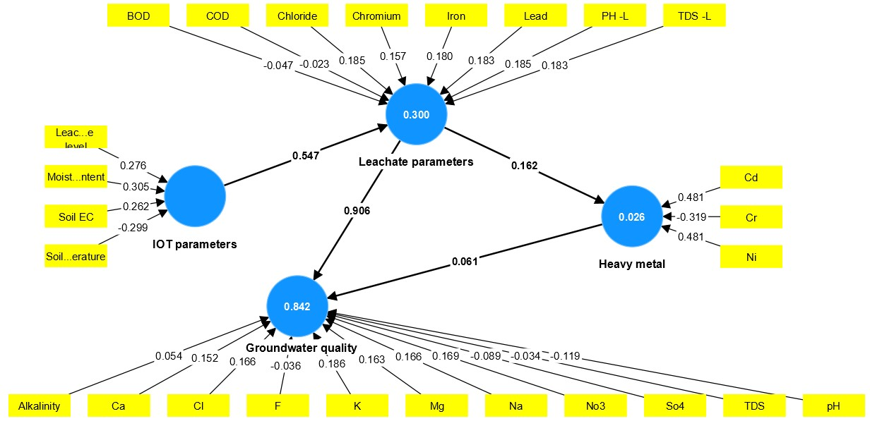
Fig. S12 PLS-SEM model for Sampling Location S15
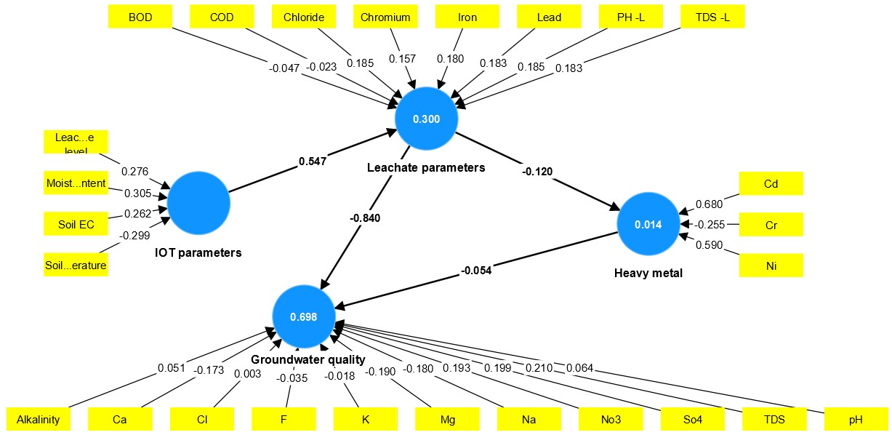
Fig. S13 PLS-SEM model for Sampling Location S16
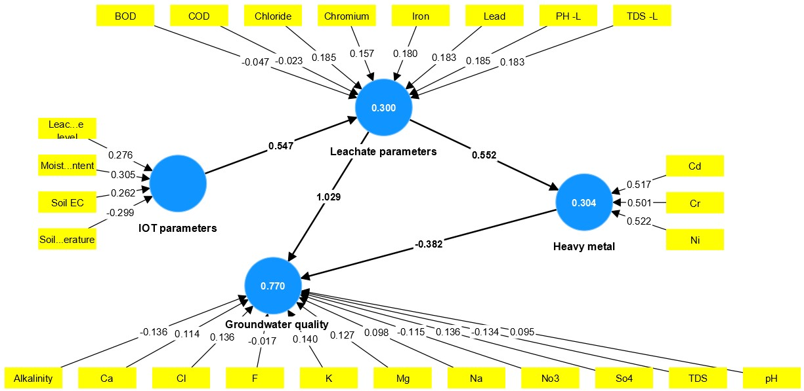
Fig. S14 PLS-SEM model for Sampling Location S17

