Supplementary Information for
Controllable Structure and Superior Mechanical Properties of Metallic Glasses through Atomic Manufacturing
Hang Zhao^{1,2}, Jing Zhou¹, Baoshuang Shang¹, Rongce Sun¹, Yuqiang Yan¹, Xing Tong¹, Haijie Xian¹, Yong Ding², Bo Zhang¹, Haibo Ke^{1*}, Weihua Wang^{1,2,3*}
¹ Songshan Lake Materials Laboratory, Dongguan 523808, People’s Republic of China
² School of Physics, Liaoning University, Shenyang 110036, People’s Republic of China
³Institute of Physics, Chinese Academy of Sciences, Beijing 100190, China
*Corresponding author: kehaibo@sslab.or.cn (H.B. Ke), whw@iphy.ac.cn (W.H. Wang)

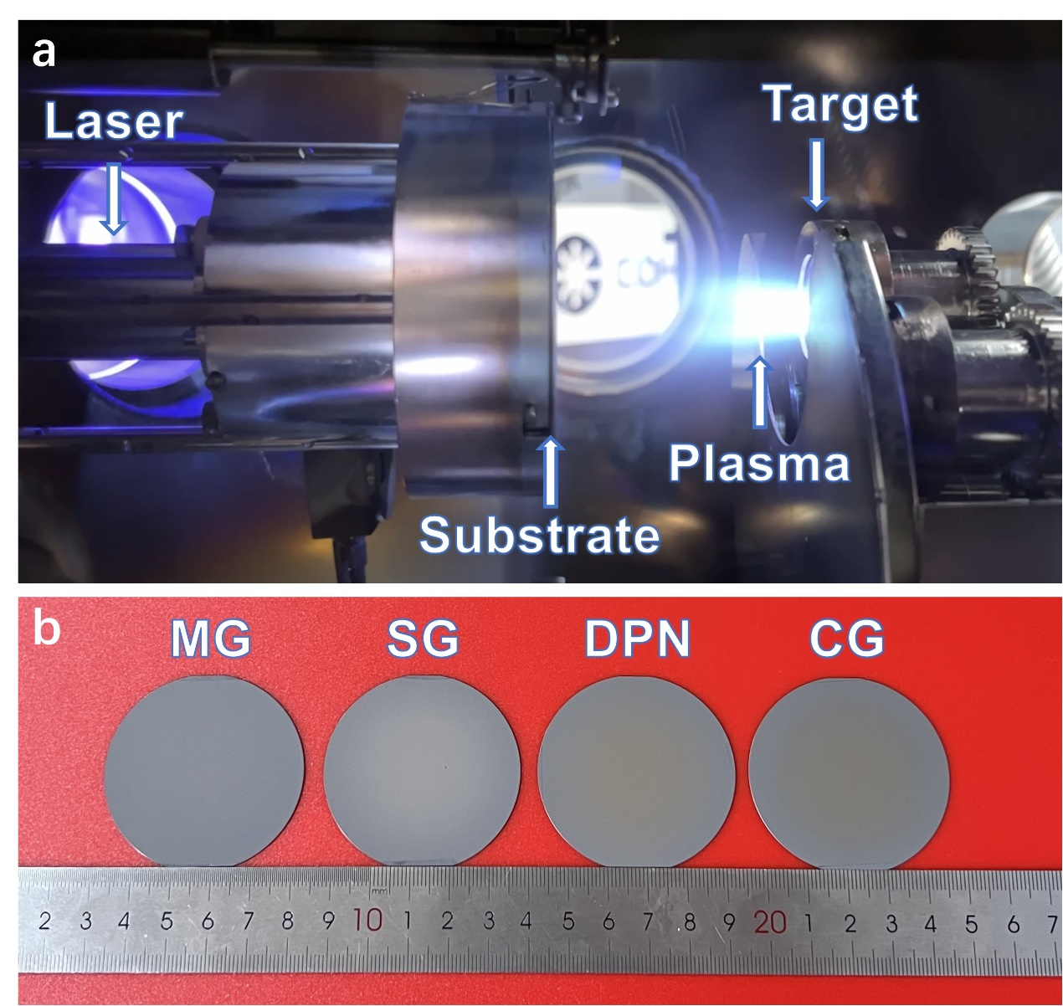
Supplementary Fig. 1 | The optical appearance of schematic diagram of the equipment operating condition and the synthesized specimens. a, A pulsed laser is directed through the left window into the vacuum chamber, exciting a plasma plume at the target which condenses to form a thin film on the substrate. b, Optical micrographs of the various nanostructured specimens synthesized by tuning atomic manufacturing parameters, spanning MG, SG, DPN, and CG morphology from left to right.

Supplementary Fig. 2 | XRD patterns for the nanostructured samples with labeled peaks indicating the respective crystal phases. The color gradient region demarcates the transition between the distinct nanostructured states. The degree of structural order incrementally increases from bottom to top.

Supplementary Fig. 3 | Nanoindentation hardness distributions across the nanostructures, with SG and DPN exhibiting higher albeit more dispersed values. MG and CG samples show more concentrated yet lower hardness. This implies enhanced mechanical performance for the SG and DPN morphologies.

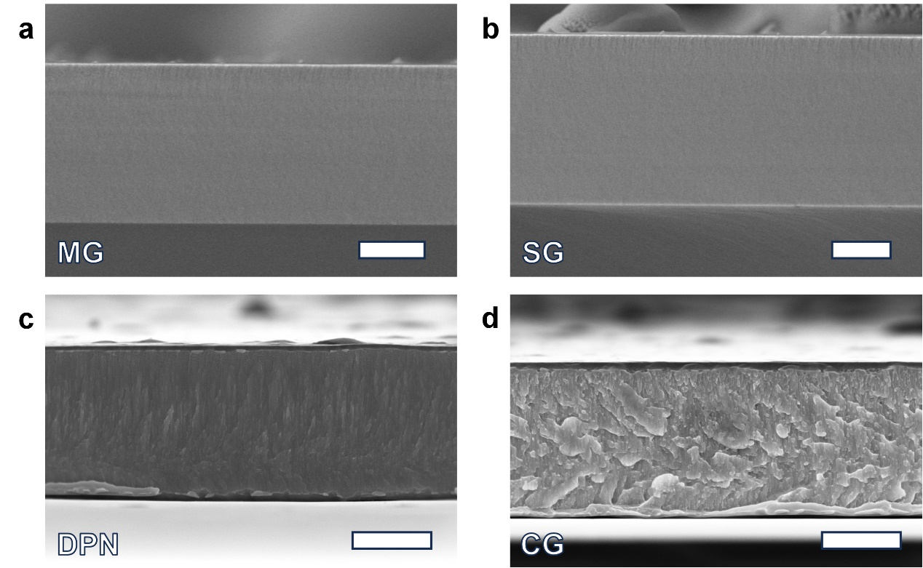
Supplementary Fig. 4 | SEM cross-sectional morphologies of different nanostructured films. a, MG. b, SG. c, DPN. d, CG. The scale bars are 500 nm.

Supplementary Fig. 5 | a, Engineering stress-strain curves for three micro-compression experiments on MG samples. b,c, SEM morphology before and after micro-compression of sample corresponding to navy curve. d,e, SEM morphology before and after micro-compression of sample corresponding to turquoise curve. f,g, SEM morphology before and after micro-compression of sample corresponding to lime curve. The scale bars are 1000 nm.

Supplementary Fig. 6 | a, Engineering stress-strain curves for three micro-compression experiments on SG samples. b,c, SEM morphology before and after micro-compression of sample corresponding to navy curve. d,e, SEM morphology before and after micro-compression of sample corresponding to turquoise curve. f,g, SEM morphology before and after micro-compression of sample corresponding to lime curve. The scale bars are 500 nm.

Supplementary Fig. 7 | a, Engineering stress-strain curves for three micro-compression experiments on DPN samples. b,c, SEM morphology before and after micro-compression of sample corresponding to navy curve. d,e, SEM morphology before and after micro-compression of sample corresponding to turquoise curve. f,g, SEM morphology before and after micro-compression of sample corresponding to lime curve. The scale bars are 500 nm.

Supplementary Fig. 8 | a, Engineering stress-strain curves for three micro-compression experiments on CG samples. b,c, SEM morphology before and after micro-compression of sample corresponding to navy curve. d,e, SEM morphology before and after micro-compression of sample corresponding to turquoise curve. Micro-compression experiments with unloading at an indentation depth of 300 nm. f,g, SEM morphology before and after micro-compression of sample corresponding to lime curve. Micro-compression experiments with unloading at an indentation depth of 250 nm. The scale bars are 1000 nm.

Supplementary Fig. 9 | Analysis of work-hardening process of SG samples. a, The true stress-strain curve obtained by loading to an indentation depth of 170 nm and unloading, and then loading again until the end of deformation. b, SEM morphologies corresponding to the six different stages in a. The scale bars are 500 nm.

Supplementary Fig. 10 | Yield strength and plasticity modulation range and error bars for four different nanostructures.
Supplementary Fig. 11 | Dynamic atomic homogenization during plastic deformation of SG. a-c, HAADF-STEM images captured at different strains, starting from the initial state, 20% strain, and 75% strain, respectively, are employed. Energy-dispersive X-ray spectroscopy (EDS) mapping, performed with near-atomic resolution under identical conditions, reveals a considerable alteration in morphology. The scale bars are 10 nm. d-f, The 1D composition distribution maps of the deformation region shown in the white shear head in panels d-f, demonstrate a decrease in the degree of entanglement between the two amorphous structures as the strain increases.

