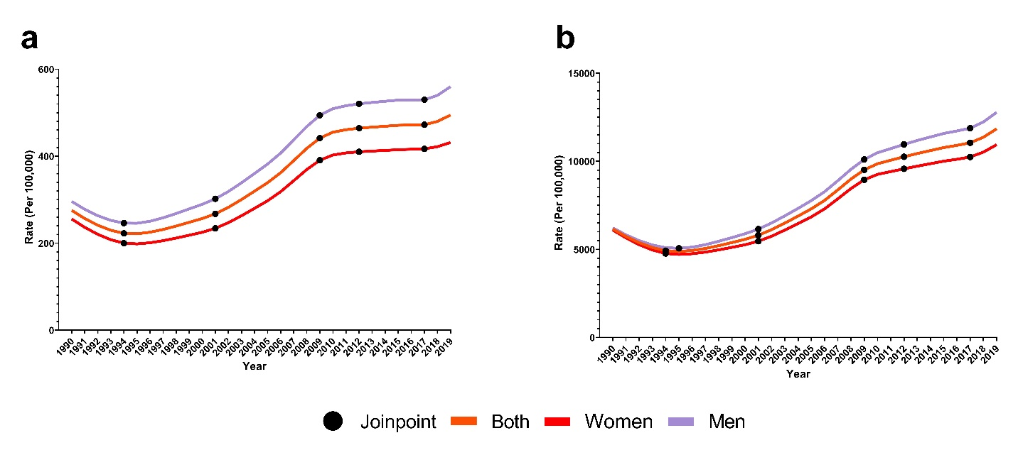
Supplementary Fig. 1 Sex-specific temporal trends based on the joinpoint regression analysis in all-age incidence of diabetes among both sexes (a), women (c), and men (e) and in all-age prevalence of diabetes among both sexes (b), women (d), and men (f) from 1990 to 2019 in U.S.

