Figure 1: ∆ntrC complement graph
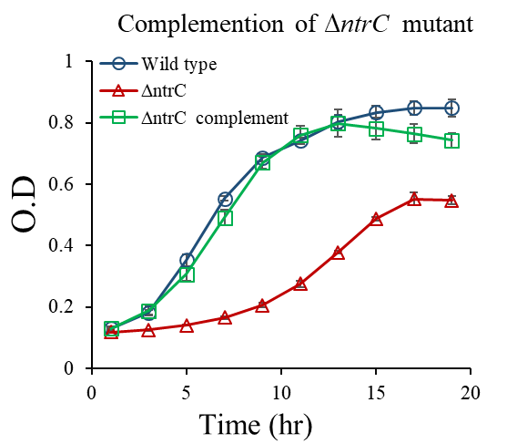

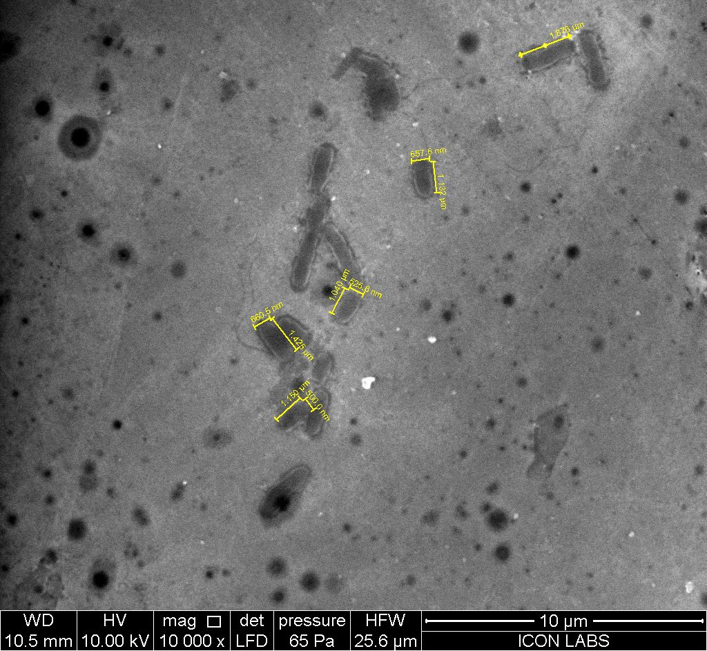
Fig. 2(a): wild type cell size in glucose limiting condition (100 µg/ml) in M9 minimal media.

Fig.2(b): wild type cell size in glucose limiting condition (100 µg/ml) in M9 minimal media.
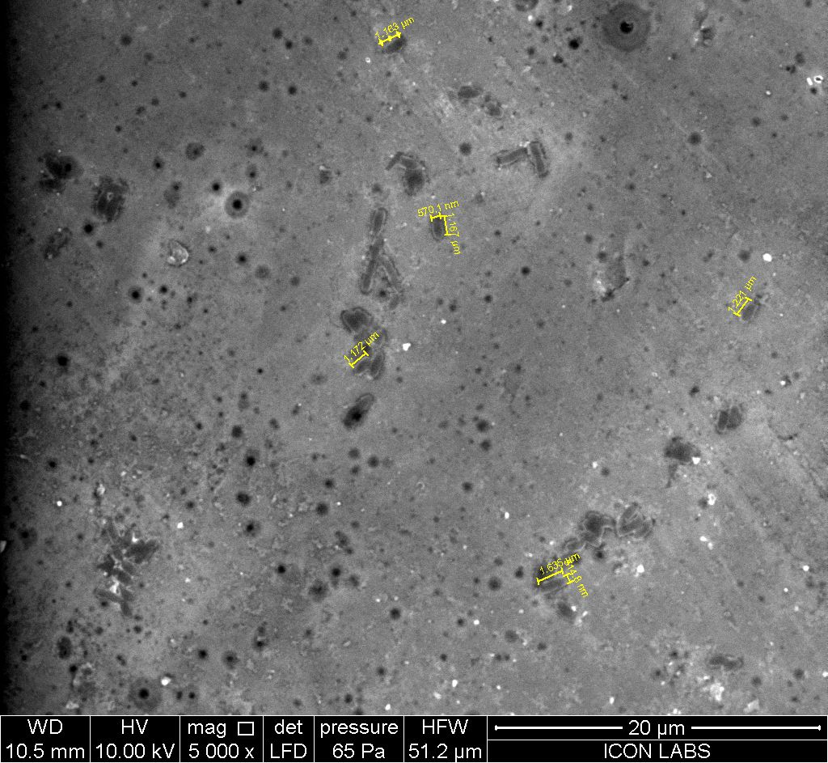

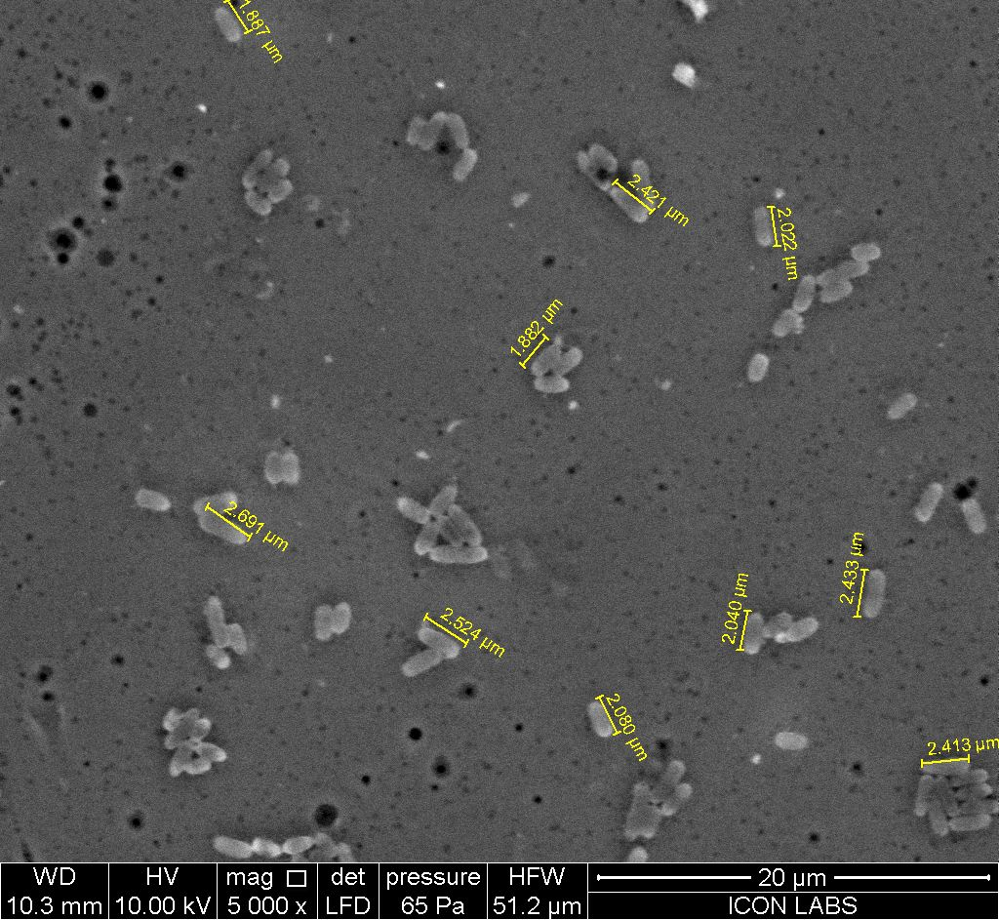
Fig. 3: wild type cell size in optimal glucose concentration (0.4%) in M9 minimal media.

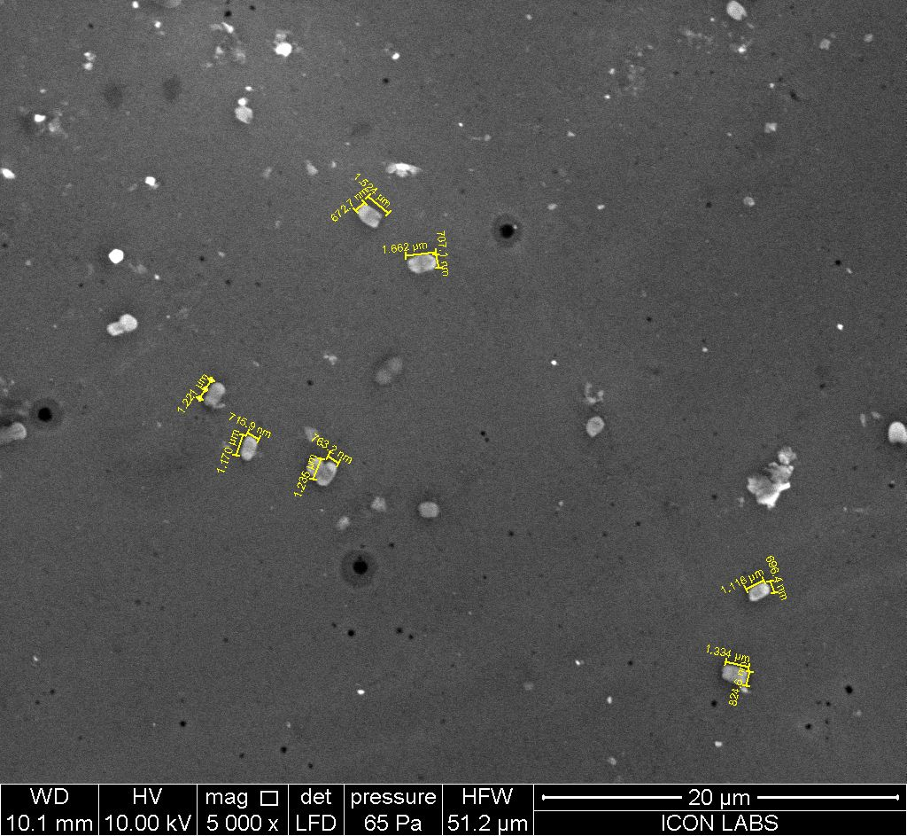
Fig. 4: The ∆ntrC mutant size in optimal glucose concentration (0.4%) in M9 minimal media.

S. No | Gene name | Fold change | Standard deviation
1 | malM | 29.5 | 3.5
2 | malK | 25 | 3.8
3 | malQ | 29 | 2.84
4 | malP | 41 | 5.27
5 | lamB | 34 | 5.75
6 | malG | 14.5 | 3.36
7 | malE | 19 | 4.6
8 | malF | 21 | 4.83
9 | malT | 5.17 | 1.47
10 | sseA | 14.7 | 1.83
11 | ssaM | 13 | 1.62
12 | sseD | 4.4 | 0.98
13 | ssaL | 10 | 1.35
14 | sseG | 22 | 2.9
15 | pipB2 | 13 | 2.3
16 | ssaD | 17 | 1.2
17 | ssaP | 8.3 | 1.57
18 | ssaG | 17 | 2.6
19 | ptsG | -0.47 | 1.93
20 | ptsH | -2.78 | 3.32
21 | crr | -0.95 | 1.84
22 | mglA | -4.45 | 0.7
23 | mglB | -4.14 | 0.5
24 | manX | -4.95 | 0.34
25 | manY | 0.03 | 2.45
26 | amtB | -12.5 | 2.5
27 | glnA | -16 | 4
Table1: Showing the relative gene expression (RT-PCR) in wild type and ∆ntrC mutant in M9 minimal medium at log phase.

Table 2: Showing the relative expression (Transcriptome) of secretory genes in ∆crp mutant as compare to the wild type in M9 minimal medium at log phase.
S. No | Gene name | Fold change | P-Value
1 | ssaP | 13 | P < 0.05
2 | ssaS | 14 | P < 0.05
3 | ssaG | 23 | P < 0.05
4 | ssaJ | 53 | P < 0.05
5 | ssaV | 22 | P < 0.05
6 | sseB | 49 | P < 0.05
7 | sseG | 10 | P < 0.05
8 | pipB2 | 14 | P < 0.05
9 | sseD | 27 | P < 0.05
10 | sseQ | 14 | P < 0.05
11 | ssaM | 29.5 | P < 0.05
12 | ssaH | 7.7 | P < 0.05
13 | ssaE | 16 | P < 0.05
14 | ssaD | 13 | P < 0.05
15 | sscB | 17 | P < 0.05
16 | sifA | 6.4 | P < 0.05
17 | ssaA | 42 | P < 0.05
18 | sseL | 21 | P < 0.05
19 | pipB | 30 | P < 0.05
20 | ssaC | 18 | P < 0.05
21 | sseF | 15 | P < 0.05
22 | ssaN | 23 | P < 0.05
23 | sseC | 34 | P < 0.05
24 | sseI | 20 | P < 0.05
25 | ssaL | 26 | P < 0.05
26 | sopD2 | 14.7 | P < 0.05
27 | ssaO | 16 | P < 0.05
28 | ssaI | 26 | P < 0.05
29 | sseE | 20 | P < 0.05
30 | sseJ | 6.2 | P < 0.05
31 | ssaT | 9.94 | P < 0.05
32 | sscA | 29.24 | P < 0.05

