ICAM-1
VCAM-1
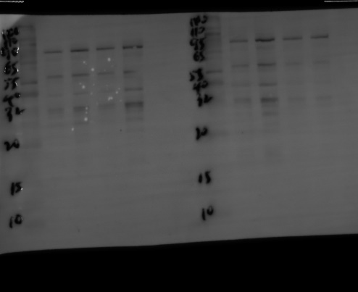
β-actin
The biological replicates of western blotting: Figure 2L

Nrf2
HO-1
β-actin
(以下是细胞实验的数据)The biological replicates of western blotting: Figure 5N

NLRP3
ASC
caspase-1
IL-1β
IL-18
β-actin
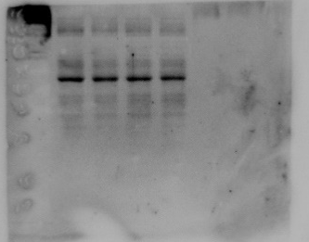
The biological replicates of western blotting: Figure 6L

(以下是细胞实验的数据) The biological replicates of western blotting: Figure 6R
NLRP3
ASC
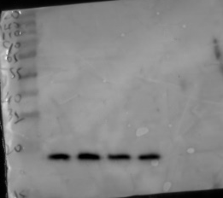
caspase-1
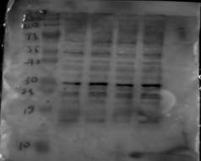
IL-1β
IL-18
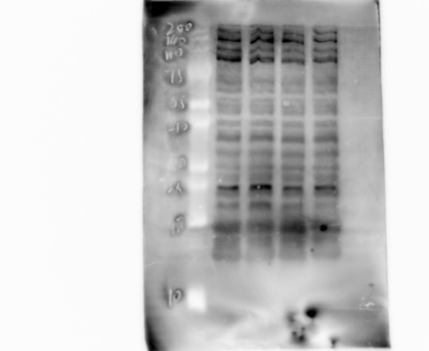

β-actin

The biological replicates of western blotting: Figure 7C

TLR4
HMGB1
NF-κB
TNF-α
β-actin

The biological replicates of western blotting: Figure 7H
HMGB1
NF-κB
TNF-α
β-actin

