Supporting Information
Cu-MOF-derived Cu₂V₂O₇@C nanofilm for electrochromic properties
Jinxiu Dong, ª Shuokun Sun, ª Shichuang Cui, ^{ab} Fei Wang, ª Mingrui Gao, ª Wei Wei, ^{ac} Ziluo Yin, ª Yuqing Zhang, ª Quanyao Zhu. *ª
ª School of Materials Science and Engineering, Wuhan University of Technology, Wuhan
430070, Hubei, China. E-mail: cglamri@whut.edu.cn
^{b} State Key Laboratory of Advanced Technology For Materials Synthesis and Processing, Wuhan 430070, Hubei, China
^{c} Department of Physics, Changji University, Changji 831100, Xinjiang, China
Figure S1. XRD pattern of V₂O₅·1.6H₂O dry gel film.
Figure S2. XRD pattern of V₂O₅.
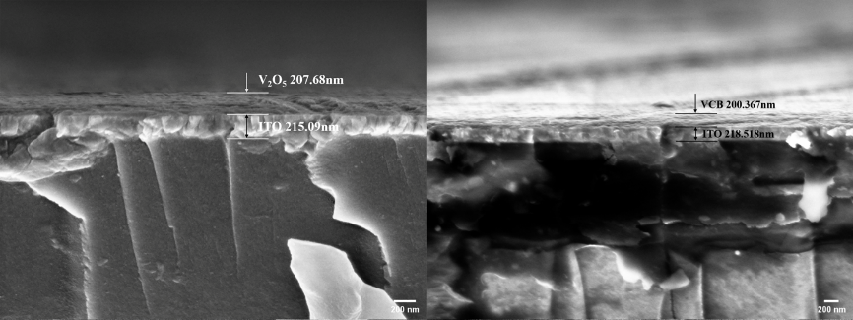
Figure S3. Left image: FESEM image of V₂O₅·1.6H₂O dry gel film cross section. Right image: FESEM image of VCB film cross section.
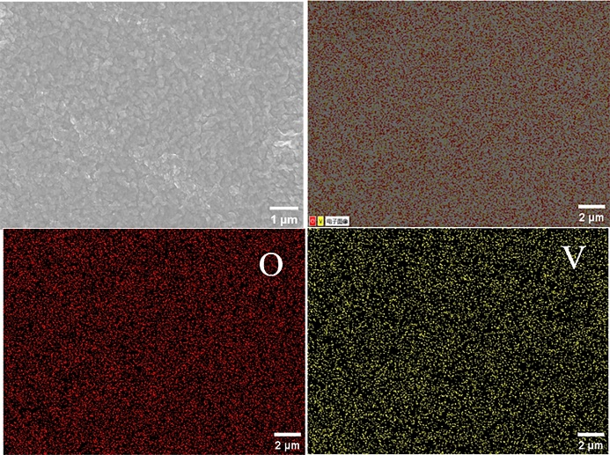
Figure S4. SEM and EDS images of V₂O₅·1.6H₂O dry gel films.

Figure S5. XPS full spectrum image of VCB film.
Figure S6. CV curves of VCB films under different electrolytes.
The CV characteristics of the VCB films were tested in 1 M LiClO₄, 1 M LiCl, 1 M NaCl, 1 M ZnCl₂, and 1 M ZnSO₄ as shown in Figure S6. The results show that the VCB films have high electrochemical activity and large charge/discharge capacity in 1 M LiClO₄ / PC electrolyte. This is because the LiClO₄ / PC electrolyte has a lower charge intercalation/deintercalation resistance and a smaller ionic radius[1-4].

Charge capacity calculation
According to the tested CV curves, the estimated baseline was removed by Iviumsoft to avoid the effect of the pseudo capacitance, and the charge capacity Q was subsequently calculated by the following equation[5]:
$$\begin{aligned}Q = \frac{1}{ϑ}\int_{V_{i}}^{V_{f}}{I(V)dV}\#(S1)\end{aligned}$$
where ϑ is the scan rate, V_{i} is the initial scan voltage, V_{f} is the final scan voltage, and I is the current.

Figure S7. CV curve of V₂O₅ film at 2000 cycles, inset shows CV curve at 500 cycles interval.
The CV curve of the V₂O₅ film decreases very significantly for the first 1000 cycles, and is barely visible by 2000 turns.

Figure S8. Peak current versus scan rate of VCB film.

Figure S9. CA curve of V₂O₅ film.
The coloring time of V₂O₅ film was 9.2 s, and the bleaching time was 5.2 s.

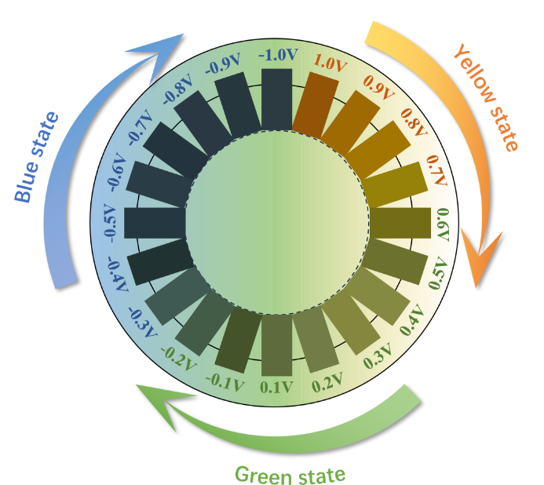
Figure S10. Physical diagram of V₂O₅ film with different colors at different voltages.

Figure S11. Visible-NIR transmission spectra of V₂O₅ films in the yellow (1 V), pristine (0 V) and blue (-1 V) states.
Figure S11 shows the optical transmittance variation of the V₂O₅ film in the three main states, with the film switching reversibly between blue-green-yellow, and the optical transmittance difference ΔT_{max} at 746 nm is 34.36%, much lower than the 68.82% of the VCB film. The CuBTC improves the modulation of the transmittance, indicating that the unique backbone structure in MOF contributes to reversible and sustainable light modulation, contributing to the optical modulation of the EC film.
Figure S12. CIE spatial coordinate diagram of V₂O₅ film in different color states.

References
- Weiss M, Ruess R, Kasnatscheew J, et al. Fast charging of lithium‐ion batteries: a review of materials aspects[J]. Advanced Energy Materials, 2021, 11(33): 2101126.
- Cheng A, Zhang H, Zhong W, et al. Few-layer MoS₂ embedded in N-doped carbon fibers with interconnected macropores for ultrafast sodium storage[J]. Carbon, 2020, 168: 691-700.
- Shen P, Li X, Luo Y, et al. High-efficiency N₂ electroreduction enabled by Se-vacancy-rich WSe_{2-x} in water-in-salt electrolytes[J]. ACS nano, 2022, 16(5): 7915-7925.
- Kim H S, Jeong C S, Kim Y T. Shuttle inhibitor effect of lithium perchlorate as an electrolyte salt for lithium-sulfur batteries[J]. Journal of Applied Electrochemistry, 2012, 42: 75-79.
- Kalu E E, Nwoga T T, Srinivasan V, et al. Cyclic voltammetric studies of the effects of time and temperature on the capacitance of electrochemically deposited nickel hydroxide[J]. Journal of power sources, 2001, 92(1-2): 163-167.
- Feng S, Wang J, Tong Z, et al. Metal-organic framework thin films with diverse redox-active/inactive components for enhanced optical modulation and coloration efficiency[J]. Chemical Engineering Journal, 2022, 442: 136158.

