Table 1 Classification of chronic conditions

Table 2 Characteristics of the study population and average annual healthcare expenditure per number of co-existing conditions (in 2022 Euro)

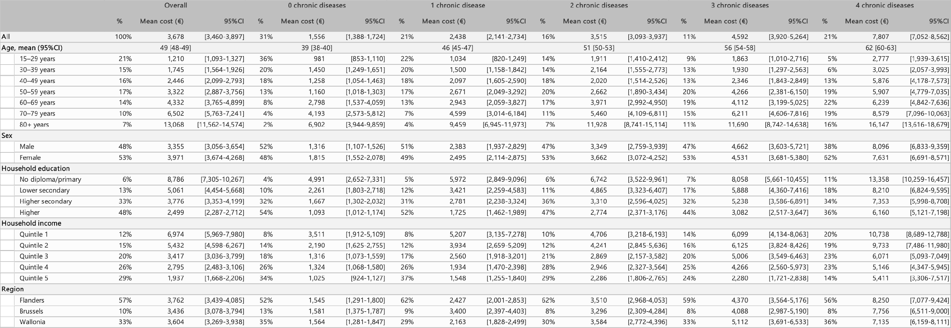
*Note: Quintile 1: <750, Quintile 2: 751-1000, Quintile 3: 1001-1500, Quintile 4: 1501-2500, Quintile 5: >2500

Table 3 Aggregated costs of the most prevalent and expensive dyads and triads (in 2022 Euro)
*Total health expenditure was €36,178,000,000 in 2018(34)

