Supplementary Material

Using Water and Wastewater Decentralization to Enhance the Resiliency and Sustainability of Cities

Manel Garrido-Baserba, David L. Sedlak, Irene Barnosell, Maria Molinos-Senante, Oliver Schraa, Diego Rosso, Manel Poch

Contents
1 Residential and Urban development information 6
2 Sewer length and cost 7
3 Pumping costs 9
4 Treatment sizing and costs 10
4.1 UASB 10
4.1.1 Calculation of the BW flow 10
4.1.2 Estimation of the UASB’s effluent flow 10
4.1.3 Calculation of the biogas production 11
4.1.4 Energy balance 11
4.1.5 Remaining biogas 12
4.1.6 Reactor volume 12
4.1.7 CAPEX and OPEX 13
4.2 OLAND 13
4.2.1 Biofilm surface and volume 14
4.2.2 CAPEX and OPEX 14
4.3 Struvite reactor 15
4.3.1 Final ammonia, TN and TP concentrations 15
4.3.2 Struvite production 16
4.3.3 Mg(OH)₂ consumption 17
4.3.4 Electricity demand 17
4.3.5 Reactor volume 17
4.3.6 Decanter volume 18
4.3.1 CAPEX and OPEX 19
4.4 MBR 20
4.4.1 Reactor volume and membrane area 20
4.4.2 CAPEX and OPEX 21
4.5 anMBR 22
4.5.1 Reactor volume and membrane area 22
4.5.2 Biogas production 23
4.5.3 Sludge production 23
4.5.4 CAPEX and OPEX 23
4.6 MABR 24
4.6.1 Liquid fertilizer recovery 24
4.6.2 CAPEX and OPEX 24
4.7 Uridis cell 24
4.7.1 Phosphorus recovery 25
4.7.2 CAPEX and OPEX 25
4.8 RO 25
4.8.1 Models and sizes 25
4.8.2 CAPEX and OPEX 25
4.9 UV 26
4.9.1 Models and sizes 26
4.9.2 CAPEX and OPEX 26
4.10 References 28
4.11 Tank sizing 29
5 Construction costs 29
6 Sewer infrastructure CAPEX and OPEX 30
7 Breakdown of costs and benefits (without monitoring costs) for all scenarios 31
8 Total costs including monitoring for all scenarios ($) 41
8.1 Total costs of synergetic scenarios 52
9 SIMBA model overview 63
10 The SIMBA modules 64
10.1 The Anaerobic Digestion Module 65
10.2 The Nitrogen Recovery Module 66
10.3 The Co-Digestion Module 67
10.4 The Greywater Module 68
10.5 The Rainwater Harvesting Module 69
10.6 Material flow analysis and SIMBA# models 70
10.7 Detailed mass and energy flow analysis 82
11 Influent composition 89
12 Effluent composition 90
13 Space requirements (Extended discussion) 90
14 Breakdown costs (Extended discussion) 91
15 Process Monitoring 92
16 Vertical farming 95
16 Photovoltaic Energy 99
17 Bibliography 103

Tables
Table 1-1: on Information each building type considered. 6
Table 2-1: Sewer information for the V1 scenario. 8
Table 3-1: Black water pumping CAPEX for the V1 and V2 scenarios. 9
Table 3-2: Black water pumping OPEX for the V1 and V2 scenarios. 9
Table 4-1: Design parameters for the UASB reactor. 12
Table 4-2: Volumes of UASB reactors (V1). 13
Table 4-3: UASB energy consumption and biogas production (V1). 13
Table 4-4: Total CAPEX and OPEX for the UASB reactors (V1). 13
Table 4-5: Design parameters of the RBC (Roefs et al., 2017). 14
Table 4-6: Characteristics of the OLAND reactors (V1). 14
Table 4-7: CAPEX and OPEX of the RBC (V1). 14
Table 4-8: Parameters for the application of Stokes' law in the struvite reactor. 18
Table 4-9: Characteristics of the struvite reactors and decanters (V1). 19
Table 4-10: CAPEX and OPEX of the struvite reactors and decanters for all building types (V1). 19
Table 4-11: Design parameters of the MBR. 20
Table 4-12: Volumes and sludge production for the MBRs in all building types (V1). 21
Table 4-13: Membrane area values obtained (V1). 21
Table 4-14: Breakdown of included elements in the MBR obtained from supplier data collection (example for MHR buildings, V1). 21
Table 4-15: CAPEX and OPEX of the MBRs in 2019 prices (V1). 22
Table 4-16: Volumes of anMBR reactors (V2). 22
Table 4-17: Breakdown of included elements in the anMBR obtained from supplier data collection (example for MHR buildings, V2). 23
Table 4-18: CAPEX and OPEX of the anMBRs for all building types (V2). 24
Table 4-19: CAPEX and OPEX for the MABR employed for the nitrification of urine (USS). 24
Table 4-20: CAPEX and OPEX for the electrochemical (Uridis) cell (USS). 25
Table 4-21: RO model and sizes for GW and BW. 25
Table 4-22: CAPEX and OPEX of the RO (V1). 26
Table 4-23: UV model and sizes for GW (Applied Membranes Inc., Vista, CA.) (V1). 26
Table 4-24: CAPEX and OPEX of the UV filters (V1). 26
Table 4-25: Literature and software employed for the modelling of each treatment. 28
Table 4-26: Storage capacity (m³) and CAPEX ($) of a week's wastewater production (principal scenario, V1). 29
Table 4-27: Storage capacity (m³) of two weeks’ wastewater production (additional scenario, V1). 29
Table 4-28: Volumes and costs of rainwater tanks (V1). 29
Table 5-1: Construction costs (where LQ: low quality; MQ: medium quality; HQ: high quality). 30
Table 6-1: Infrastructure charges for all assessed buildings. 30
Table 7-1: Breakdown of costs for all buildings for the V1 scenario. 31
Table 7-2: Benefits breakdown for the V1 scenario. 32
Table 7-3: Breakdown of costs for all buildings for the V2 scenario. 33
Table 7-4: Benefits breakdown for the V2 scenario. 34
Table 7-5: Breakdown of costs for all buildings for the C1 scenario. 35
Table 7-6: Benefits breakdown for the C1 scenario. 36
Table 7-7: Breakdown of costs for all buildings for the C2 scenario. 37
Table 7-8: Benefits breakdown for the C2 scenario. 38
Table 7-9: Breakdown of costs for all buildings for the USS scenario. 39
Table 7-10: Benefits breakdown for the USS scenario. 40
Table 8-1: Total costs including monitoring (V1). 41
Table 8-2: Total costs including monitoring (V2). 42
Table 8-3: Total costs including monitoring (C1). 43
Table 8-4: Total costs including monitoring (C2). 44
Table 8-5: Total costs including monitoring (USS). 45

Residential and Urban development information
The total floor space of each building is calculated to encompass the area destined to stairs, lifts, corridors, and walls in each storey, to obtain a realistic estimation of the total water catchment area at the roof of each apartment type. An additional floor is added to the number of storeys destined to housing to store equipment and technologies.
Low-rise housings are designed to represent the average terraced house, using floor space requirements per capita which are specific for houses instead of apartments, thus the final floor space per capita is larger than those of the rest of building types. It is assumed each house has two floors plus the basement where technologies are kept.
House and apartment floor space per capita are averages for South Europe. Shape factors (f₂) used in the UWIM model are also presented below.
Table 1-1: Information on each building type considered.
Building type | Low-rise | Low/Mid-rise | Mid-rise | Mid/high-rise | High-rise | City Block
Abbreviation | LR | ST | MR | MHR | HR | CB
Number of storeys (housing) | 2 | 2 | 6 | 8 | 15 | 96
Number of units per floor | 0.5 | 3 | 4 | 6 | 8 | 8
PE per floor | 2.4  (house) | 6 | 10 | 15 | 20 | 250 X 8 (building)
Total PE | 12 | 12 | 60 | 120 | 300 | 2000
Floor surface per storey (m₂) | 80 | 270 | 350 | 510 | 670 | 670
Total water catchment area (m₂) | 400 | 270 | 350 | 510 | 670 | 5360
f₂ | 2.29 | 1.44 | 1.44 | 1.44 | 1.44 | 1.44

In this study, we focused on a typical city block designed to accommodate 2,000 population equivalents (PE), consisting of eight high-rise buildings, each with 12 stories and 250 PE, following the typical occupancy rate found in Europe (i.e., 2.3 inhabitants per dwelling) and an average apartment floor space of 30 m2 per capita We estimated the per-story area, including space for common areas, using Equation 1, where As represents the area per story, Ahh is the area per household, γ is a constant (equal to 1.15), and Nhh is the number of households in the building. An additional 30 m2 per story was allocated for common spaces.
A_s=γ*A_hh*N_hh+30 Eq. 1

The total area available for rainwater collection per building, or rainwater catchment surface, was calculated to be 670 m2. These buildings were arranged around a central rectangular space and shared a common basement with a standard floor height of 3 for the storage of technology, resulting in a total rainwater collection area of 5,360 m2

Table 1-2: Sewer information for the V1 scenario.

Hab | 2,000.00
Hab/building | 250.00
Number eq household | 104.17
A (floor surface per storey) | 670.00
ρ | 0.16
f2 | 1.44
HH/storey | 9.31
Number of storeys | 11.19
Nº of buildings | 8
Area per building | 670
Area inside | 1340
Width | 21.1356
Lenght | 31.702
PE/house | 2.40
m2/PE | 30.00
m2/HH | 72.00

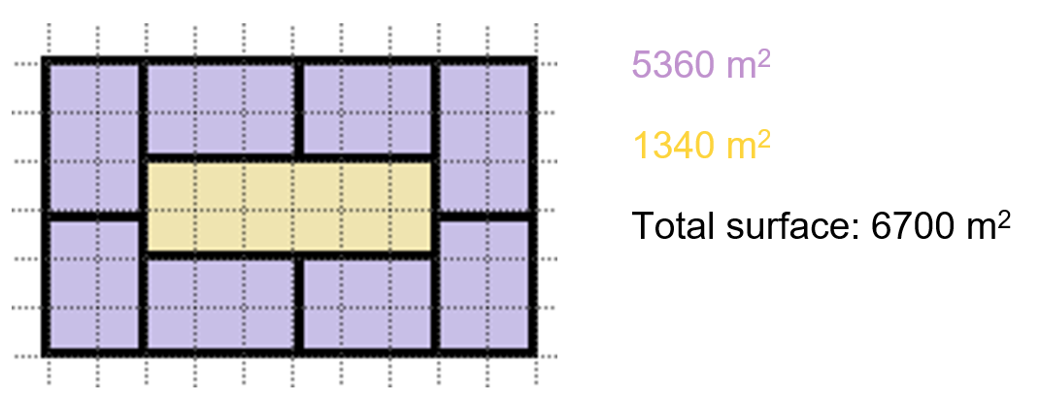

Sewer length and cost
Sewer lengths are calculated using the UWIM model (Maurer et al., 2013, 2010) through Eq. 1, where L_{s,private} is the length of private sewer [m], A is the size of the area [m²] and ρ is the building density [housing units*m⁻²]. The design equations include a model parameter (f2) which representing a housing shape factor and must be estimated for each scenario (Maurer et al., 2013).
$$L_{s,private}=0.5*A*\sqrt{f_{2}*ρ}$$ | Eq. 1

f₂ is a model parameter representing the form factor of a housing plot [no units]. Private sewers are thus defined as the pipelines from each house until the first Y-joint that makes connection the water main sewer infrastructure. For this study, f2 was estimated based on an adaptation of the sensitivity analysis for the determination of f2 carried out by Maurer et al. (2013) using the sewer lengths obtained for an average European residential area as a reference to minimize the relative error (RL)2 through Eq. 1 (Roefs et al., 2016). The described calculations lead to a value of f2 of 1.44, which agreed with standard values (1 – 2) for f2 and was consistent with typical proportions of buildings (Blumensaat et al., 2012; Maurer et al., 2010). To facilitate the comparison of costs, the studied buildings were all assumed to have a length: width ratio of 1.44, except for the low-rise housing type which was composed of five consecutive terraced houses with a shaping factor of 2.29 each to better fit the dwelling type.
$$R_{L}=\log\left(1-\frac{L_{s,data}-L_{s,sewer}}{L_{s,data}}\right)$$

As described by Maurer et al. (2013), the UWIM model is sensitive to f2 and may yield different sewer lengths depending on the value of this parameter. Furthermore, the model was applied to buildings instead of settlements. Therefore, the results using this methodology serve as estimates. In concordance with previous research (Adams et al., 1972; Maurer et al., 2010), the length of pipe per capita decreases as density increases.

CAPEX and OPEX for the sewer infrastructure are calculated depending on the pipeline type. For the scenarios using vacuum toilets, BW is evacuated using HDPE pipes operating at vacuum (ø = 70 mm), while RW and GW are transported with gravity pipes made of unreinforced concrete (ø = 110 mm). Both BW and GW are collected using unreinforced concrete, gravity sewers of diameters of 70 and 110 mm, respectively, in the cases using conventional toilets. For the separation of urine, GW is evacuated using the same pipeline as in the other cases while brown and yellow water are collected separately by gravity sewers of 70 and 32 mm, respectively.
Sewer CAPEX are obtained using Eq. 2 and Eq. 3 while OPEX are equivalent to 1 $/m*yr for vacuum pipelines and to 0.17 $/m*yr for gravity sewers (Roefs et al., 2017).
$$CAPEX Vacuum=∅ (mm)*0.59*0.7*1.1$$ | Eq. 2
$$CAPEX Gravity=130*{1.3}^{\frac{∅\left(mm\right)-300}{120}}$$ | Eq. 3
Pipeline lengths and costs are calculated for all scenarios (e.g., Table 2-1 displays all sewer-related data for the V1 scenario).
Table 2-1: Sewer information for the V1 scenario.
Building type | LR | ST | MR | MHR | HR
Equivalent households | 5.00 | 5.00 | 25.00 | 50.00 | 125.00
A | 400.00 | 270.00 | 350.00 | 510.00 | 670.00
ρ | 0.01 | 0.02 | 0.07 | 0.10 | 0.19
f2 | 2.29 | 1.44 | 1.44 | 1.44 | 1.44
Pipeline length, BW and BW (m) | 33.84 | 22.03 | 56.09 | 95.75 | 173.53
CAPEX BW ($) | 1076.08 | 700.64 | 1783.75 | 3045.09 | 5518.53
OPEX BW ($/year) | 33.84 | 22.03 | 56.09 | 95.75 | 173.53
CAPEX GW ($) | 859.01 | 2903.59 | 1890.56 | 4813.12 | 8216.62
OPEX GW ($/year) | 1.70 | 5.75 | 3.75 | 9.54 | 16.28

Pumping costs
Pumping costs for GW and RW are calculated assuming per capita CAPEX of 33 $ and OPEX of 1.13 $/yr as adapted from Roefs et al. (2017). Calculations taking operational flow as a base are also done taking CAPEX of 304 $/m³ and 10.5 $/yr*m³ to compare the results. Both methods yield the same final costs. The highest possible rainwater flow per day is assumed as a worst-case scenario for the sizing of rainwater pumps while the average GW flow is taken as wastewater is assumed constant.
For the V1 and V2 scenarios where vacuum pumping is required for BW, vacuum pump catalogues are consulted to obtain the most cost-effective fit for every building type considering pump capacities and prices. A vacuum on demand system is compared to a constant vacuum system, which is found more adequate for all building types. Terraced houses are thus designed to have a common vacuum system. Table 3-1 shows the compared costs of the CVS and VOD installations.
Table 3-1: Black water pumping CAPEX for the V1 and V2 scenarios.
 | Constant Vacuum System (CVS) |  |  | Vacuum on demand system (VOD)
 | 1 Vacuum generator |  |  | 1 Vacuum generator (vacuum tank + pump)
 | $/unit | Capacity (toilets) | TOTAL COST |  | $/unit |  | Capacity (toilets) | TOTAL COST
 | 4890.40 | 15.00 |  |  | 1713.60 | 1.00 |  | TOTAL COST
 | Units needed |  |  |  | Units needed |  |  | TOTAL COST
LR | 1.00 |  | 4890.40 |  | 5.00 |  |  | 8568.00
ST | 1.00 |  | 4890.40 |  | 5.00 |  |  | 8568.00
MR | 1.67 |  | 8150.67 |  | 25.00 |  |  | 42840.00
MHR | 3.33 |  | 16301.33 |  | 50.00 |  |  | 85680.00
HR | 8.33 |  | 40753.33 |  | 125.00 |  |  | 214200.00
OPEX for the BW line are calculated through the collection of data on OPEX for vacuum toilet installations. Costs regarding the pumping system are selected and electricity is found to be the principal source of operational costs.
Additionally, oil filters and gaskets for vacuum pumps need to be changed every 1000 operational hours and 5 years, respectively.
However, these costs are omitted since they can be considered negligible in front of the costs of electricity (oil filters have a price of around 18 $/unit while gaskets cost 32 $/unit).The average electricity consumption of vacuum pumps is that of 19.68 kWh/PE* yr (Fraunhofer Institute for Interfacial Engineering and Biotechnology IGB, 2016). Table 3-2 shows the final OPEX for all building types for the V1 and V2 scenarios.
Table 3-2: Black water pumping OPEX for the V1 and V2 scenarios.
 | PE | kWh/yr | OPEX ($/yr)
LR | 12.00 | 236.16 | 30.70
ST | 12.00 | 236.16 | 30.70
MR | 60.00 | 1180.80 | 153.50
MHR | 120.00 | 2361.60 | 307.01
HR | 300.00 | 5904.00 | 767.52

Treatment sizing and costs
The calculations described in this section have been performed for every scenario and every building type to adapt to the required operational flow and pollutant load of each specific treatment and housing facility. A complete example is shown for each technology to provide clear indications on the sizing and cost assessment methods. The values shown for the UASB, OLAND reactor, struvite reactor, MBR, RO, and UV correspond to the V1 scenario. For the anMBR, the V2 scenario is taken as an example, while for the electrochemical cell and MABR, the values are employed in the USS scenario.

UASB
UASB units were sized according to the calculated HRT and operation flow, with assumed removal efficiencies were those of 78% COD, 100% BOD, 9% TN, 39% TP, 93% TSS and 95% VSS (De Graaff et al., 2010).

The calculations to size the UASB reactor, find its biogas production and solve its energy balance were the following (an example of the procedure is given for the MHR building; the same steps were repeated for all buildings):

Calculation of the BW flow
$$5 \frac{L}{PE*day}*\frac{120 ppl}{building}=600 \frac{L}{building*day}=0.6 \frac{m^{3}}{building*day}$$ | Eq. 4

Estimation of the UASB’s effluent flow
The effluent from the UASB is estimated by using literature COD concentrations and removal efficiencies (de Graaff et al., 2010).
COD in influent: 9800 mg/L = g/m³
COD in effluent: 2400 mg/L = g/m³
$$0.6\frac{m^{3}}{day}*9800\frac{g}{m^{3}}=5880 \frac{g COD}{day}$$ | Eq. 5
$$5880\frac{g COD}{day}*\left(1-0.78\right)=1293,6 \frac{g COD}{day}$$ | Eq. 6
$$\frac{1293.6 \frac{g COD}{day}}{2400 \frac{g}{m^{3}}}=0.539 \frac{m^{3}}{day}$$ | Eq. 7
The remaining flow corresponds to the produced sludge: $0.6-0.539=0.061 m^{3}/day$

Calculation of the biogas production
Biogas production is calculated from COD removal knowing 1g DQO = 0.35 L CH₄ in STP. A conversion of 49% of total COD into methane is taken (de Graaff et al., 2010; Metcalff and Eddy, 2013).
However, since biogas is obtained at 1 atm and 25ºC, the data must be adapted to this temperature. Eq. 8 shows the reaction between methane and oxygen.
CH₄ + 2O₂ (COD) CO₂ + 2H₂O | Eq. 8
Thus, knowing that 24.45 L of methane at 25ºC (298.15 K) equivale to one mole of methane (ideal gas law), the litres of methane obtained per gram of COD can be calculated through Eq. 9:
$$24.25 \frac{L CH_{4}}{mole CH_{4}}*\frac{mole CH_{4}}{2 moles COD}* \frac{1 mole COD}{32 g COD}=0.382 \frac{L CH_{4}}{g COD}$$ | Eq. 9
Finally, since 78% of biogas is CH₄:
$$6336 \frac{g COD}{day}*0.49= 3104.64 \frac{g COD eliminated}{day}$$ | Eq. 10
$$3104.64 \frac{g COD}{day}*0.38 \frac{L CH_{4}}{g COD}=1185.97 \frac{L CH_{4}}{day}$$ | Eq. 11
$$\frac{1185.97}{0.78}=1520.48 L\frac{biogas}{day}$$ | Eq. 12

Energy balance
The used data were the following (de Graaff et al., 2010; Metcalff and Eddy, 2013):
- Density of BW: 1,020 kg/m³
- Specific heat capacity BW: 4.2 KJ/kg ºC
- Heat of combustion CH4: 38,846 KJ/m³
- Operation temperature: 25ºC
- BW temperature: 20ºC
- Efficiency: 0.8
The energy consumption, energy from biogas and remaining energy are calculated as follows. The produced biogas is used to supply the necessary energy in the reactor.
  - Consumption
$$0.6\frac{m^{3}}{day}*1020\frac{kg}{m^{3}}*4.2\frac{KJ}{kgºC}*\left(25-20\right)ºC=12,85 \frac{KJ}{day}$$  $$thus, \frac{12852}{0.8}=16065 \frac{KJ}{day}$$ | Eq. 13

$$16065 \frac{KJ}{day}*\frac{1 day}{3600s}*365 days=1628.81 \frac{KWh}{yr}$$ | Eq. 14
  - Biogas
$$\frac{V_{1}}{T_{1}}=\frac{V_{2}}{T_{2}}→\frac{1.18}{298.15}=\frac{V_{2}}{273.15}→V_{2}=1.09 \frac{m^{3}CH_{4}}{day} STP$$ | Eq. 15
$$1.09 \frac{m^{3}CH4}{day}STP*38,846\frac{KJ}{m^{3}}=42,225.6 \frac{KJ}{day}$$ | Eq. 16
$$42,225.6\frac{KJ}{day}*\frac{1 day}{3600s}*365 days=4281.2 \frac{KWh}{yr}$$ | Eq. 17
  - Balance
$$4281.2-1628.8=2652.4\frac{KWh}{yr}$$ | Eq. 18

Remaining biogas
The surplus biogas which can be sold to obtain benefits is also calculated as production per year which is not consumed by the same UASB:
$$2652.39\frac{KWh}{yr}*\frac{3600 s}{1 h}*\frac{1m^{3} CH_{4} STP}{38,846 KJ}=245.8\frac{m^{3}CH_{4 }STP}{yr}$$ | Eq. 19
$$\frac{V_{1}}{T_{1}}=\frac{V_{2}}{T_{2}}→\frac{245.8}{273.2}=\frac{V2}{298.2}→V2=268.3 \frac{m^{3}CH4}{yr}$$ | Eq. 20
$$\frac{268.3 \frac{m^{3}CH_{4}}{yr} }{0.78}=343.6 \frac{m^{3}biogas}{yr}$$ | Eq. 21

Reactor volume
The volume of the reactor is calculated from its hydraulic residence time using Eq. 22 and Eq. 23, where UASB_{volume} is the reactor’s volume [m³], HRT is the hydraulic retention time [hours], and the flow rate must be in m³/h.
The rest of design parameters can be found in Table 4-1.
$$UASB_{volume}=HRT*Flow rate$$ | Eq. 22
$$HRT=\left(C*\frac{SS}{X}\right)*R*\left(1-H\right)*SRT$$ | Eq. 23
Table 4-1: Design parameters for the UASB reactor.
UASB reactor |  | Units | Value
Solids retention time | SRT | days | 75.00
Hydrolysis level | H | - | 0.49
SS influent | SS | g/l | 0.65
Total DQO influent | C | g/l | 10.56
Sludge concentration | X | g COD/l | 34.20
Fraction of eliminated solids | R | - | 0.93
Hydraulic retention time | HRT | days | 7.16
The obtained volumes are the following:
Table 4-2: Volumes of UASB reactors (V1).
UASB reactor | Units | LR | ST | MR | MHR | HR
Volume | m³ | 0.43 | 0.43 | 2.15 | 4.29 | 10.73
Data on energy consumption and biogas production for all building types is shown in Table 4-3.
Table 4-3: UASB energy consumption and biogas production (V1).
 | LR | ST | MR | MHR | HR
L biogas/day 25ºC | 152.05 | 152.05 | 760.24 | 1520.48 | 3801.19
Energy consumption (kWh/yr) | 162.88 | 162.88 | 814.41 | 1628.81 | 4072.03
Energy from biogas (kWh/yr) | 427.93 | 427.93 | 2139.67 | 4279.35 | 10698.37
Net energy production | 265.05 | 265.05 | 1325.27 | 2650.54 | 6626.34
m³ CH4/day STP | 0.11 | 0.11 | 0.54 | 1.09 | 2.72
m³ CH4/yr STP | 39.66 | 39.66 | 198.29 | 396.58 | 991.46
Remaining m³ CH4/yr STP | 24.56 | 24.56 | 122.82 | 245.63 | 614.09
Remaining m³ biogas/yr 25ºC | 34.37 | 34.37 | 171.87 | 343.74 | 859.35

CAPEX and OPEX
As for the UASB’s CAPEX and OPEX, they are obtained through data from simulation software CapdetWorks. Table 4-4 shows the final costs for all types of buildings.
Table 4-4: Total CAPEX and OPEX for the UASB reactors (V1).
 | Construction costs  ($) | Other construction costs ($) | Total CAPEX ($) | Labour costs ($/yr) | Energy and material costs ($/yr) | Total OPEX ($/yr)
LR | 801.00 | 2540.00 | 3341.00 | 123.00 | 10.82 | 133.82
ST | 801.00 | 2540.00 | 3341.00 | 123.00 | 10.82 | 133.82
MR | 4005.00 | 12700.00 | 16705.00 | 615.00 | 54.10 | 669.10
MHR | 8010.00 | 25400.00 | 33410.00 | 1230.00 | 108.20 | 1338.20
HR | 20025.00 | 63500.00 | 83525.00 | 3075.00 | 270.50 | 3345.50

OLAND
The Oland process removal efficiencies were assumed as 38% COD, 70% TN, 8% TP and 38% TSS (Clippeleir et al., 2011; Roefs et al., 2016). The required biofilm surface, from which the reactor volumes were obtained, was calculated from the nitrogen load in the influent flow and the nitrogen surface load as follows:

Biofilm surface and volume
The RBC where the OLAND reaction is conducted is sized according to the nitrogen load to be treated. Initially, the biofilm surface required is calculated through Eq. 24.
$$BFS=\frac{N_{influent}}{N_{surface load}}$$ | Eq. 24
N influent is the nitrogen load in the influent (the UASB’s effluent) in kg/day, while the N surface load is a design parameter.
Table 4-5: Design parameters of the RBC (Roefs et al., 2017).
OLAND RBC |  | Units | Value
Surface of the carrier material |  | m²/m³ | 350
Nitrogen surface load | N_{surface load} | Kg N/m²day | 0.015
Biofilm surface | BFS | m² | Specific of each building type
The volumes [m³], shown in Table 4-6, are then obtained by:
$$V=\frac{BFS}{Surface of carrier material}$$ | Eq. 25
Table 4-6: Characteristics of the OLAND reactors (V1).
UASB reactor | Units | LR | ST | MR | MHR | HR
BFS | m² | 7.28 | 7.28 | 36.40 | 72.80 | 182.00
Volume | m³ | 0.02 | 0.03 | 0.10 | 0.21 | 0.52

CAPEX and OPEX
CAPEX of a RBC operating with the OLAND process can be estimated as 1686$/m³, while OPEX oscillate between 1.5-2.5 $/kg of N treated. Since the effluent from the UASB is heated, the RBC is expected to have no energy demand and thus the OPEX have been taken as 1.5$/kg N (Courtens et al., 2014; Lozano et al., 2007).
$$CAPEX=V*1686$$ | Eq. 26
$$OPEX=kg\frac{N}{yr}*1.5$$ | Eq. 27
Table 4-7: CAPEX and OPEX of the RBC (V1).
 | CAPEX ($) | OPEX ($/yr)
LR | 35.07 | 59.79
ST | 35.07 | 59.79
MR | 175.34 | 298.94
MHR | 350.69 | 597.87
HR | 876.72 | 1,494.68

Struvite reactor
Assuming a hydraulic retention time of 3.5h (Tarragó et al., 2016) and using Stokes’ law to determine reactor volumes and terminal particle diameter size, the operating flow for each building was obtained. The decanter was sized to separate and recirculate particles half the size of those not previously separated in the crystallizer to enhance secondary nucleation and has retention time of 1 h. P-removal and NH4-N-removal were calculated from the influent concentration assuming a phosphate removal efficiency of 90%, as reported by Siciliano et al. (2020).

The steps taken to assess the performance of the struvite reactor and decanter are described in this section, taking as an example the MHR building.

Final ammonia, TN and TP concentrations
To calculate the amount of nutrients in the influent which will be eliminated, the limiting reactant (either NH₄⁺ or PO₄³⁻) must be determined. To do so, influent concentrations are used:
$$0.539 \frac{m^{3}}{day}*269.45\frac{g N-NH_{4}^{+}}{m^{3}}= 145.23 \frac{g N-NH_{4}^{+}}{day}$$ | Eq. 28
$$145.2 \frac{g N-NH_{4}^{+}}{day}*\frac{1 mole N-NH_{4}^{+}}{14 g N-NH_{4}^{+}}*\frac{1 mole NH_{4}^{+}}{1 mole N-NH_{4}^{+}}= 10.37\frac{moles NH_{4}^{+}}{day}$$ | Eq. 29
$$0.539 \frac{m^{3}}{day}*162.43\frac{g TP}{m^{3}}*0.72=63.03 \frac{g TP}{day}$$ | Eq. 30
$$63 \frac{g P-PO_{4}^{3-}}{day}*\frac{1 mole P-PO_{4}^{3-}}{30.97 g P-PO_{4}^{3-}}*\frac{1 mole PO_{4}^{3-}}{1 mole P-PO_{4}^{3-}}=2.04 \frac{moles PO_{4}^{3-}}{day}$$ | Eq. 31
As seen for the MHR building, phosphate is the chemical entity which has the less moles, and which will therefore determine the extent of the reaction (shown in Eq. 32).
Mg²⁺ +NH₄⁺ + H_{n}PO₄^{n-3} MgNH₄PO_{4 ·} 6H₂O +nH⁺ | Eq. 32
From the reacted phosphate moles, the ammonia eliminated is calculated, enabling to find the final ammonia concentration. A 1.5 Mg²⁺:PO₄³⁻ molar ratio as used gives a conversion of 90% of phosphate is considered (de Graaff et al., 2010; Siciliano et al., 2020). The influent and effluent of the reactor are approximated to be equal since the reacted struvite, added base and recirculated solids represent only a small fraction of the influent (S. Puig, personal communication, 2017).
$$2.04\frac{moles PO_{4}^{3-}}{day}*0.9=1.836\frac{moles PO_{4}^{3-} reacted}{day}=\frac{moles NH_{4}^{+} reacted}{day}$$ | Eq. 33
$$10.37 \frac{moles NH_{4}^{+}}{day}-1.836\frac{moles NH_{4}^{+} reacted}{day}=8.53\frac{moles NH_{4}^{+} }{day}=119.5 \frac{g N-NH_{4}^{+}}{day}$$ | Eq. 34

$$Final N-NH_{4}^{+} concentration=\frac{119.5\frac{g N-NH_{4}^{+}}{day} }{0.539\frac{m^{3}}{day}}=221.7 \frac{g N-NH_{4}^{+}}{m^{3}}$$ | Eq. 35
The N concentration in the effluent can also be calculated by subtracting the reacted N in ammoniacal form, if the N concentration in the influent is known (in this case, 759.75 g TN/m³).
$$607.79\frac{g TN}{m^{3}}-\left(269.45 \frac{g N-NH_{4}^{+}}{m^{3}}-221.7 \frac{g N-NH_{4}^{+}}{m^{3}}\right)=560 g\frac{TN}{m^{3}}$$ | Eq. 36
The phosphorus concentration in the effluent is obtained knowing that initially 72% of the TP is in the form of phosphate:
$$2.04\frac{initial moles PO_{4}^{3-}}{day}-1.836 \frac{moles PO_{4}^{3-}reacted}{day}=0.20 \frac{moles PO_{4}^{3-} final}{day}$$ | Eq. 37
$$0.20 \frac{moles PO_{4}^{3-}}{day}*\frac{1 mole P-PO_{4}^{3-}}{1 mole PO_{4}^{3-}}*\frac{30.97 g P-PO_{4}^{3-}}{1 mole PO_{4}^{3-}}=6.19\frac{g P-PO_{4}^{3-}}{day}$$ | Eq. 38
$$\frac{6.19\frac{g P-PO_{4}^{3-}}{day}}{0.539\frac{m^{3}}{day}}=11.5 \frac{g P-PO_{4}^{3-}}{m^{3}}$$ | Eq. 39
$$162.42\frac{g TP}{m^{3}}-\left(162.42\frac{g TP}{m^{3}}*0.72-11.5 \frac{g P-PO_{4}^{3-}}{m^{3}}\right)=57 \frac{g TP}{m^{3}}$$ | Eq. 40

Struvite production
The reacted phosphate moles are also used to calculate the production of struvite (Eq. 32):
$$2.04 \frac{moles PO_{4}^{3-}}{day}*0.9*\frac{1 mole struvite}{1 mole PO_{4}^{3-}}=1.836\frac{moles struvite}{day}$$ | Eq. 41
$$1.836\frac{moles struvite}{day}*\frac{245.4 g struvite}{1 mol struvite}*\frac{1 kg}{1000 g}*\frac{365 days}{yr}=164\frac{kg struvite}{yr}$$ | Eq. 42

Mg(OH)₂ consumption
Using the aforementioned molar ratio between magnesium hydroxide and phosphate, the required base per year is calculated:
$$2.04 \frac{moles PO_{4}^{3-}}{day}*\frac{1.5 moles Mg{\left(OH\right)}_{2}}{1 mole{ PO}_{4}^{3-}}*\frac{58.32 g Mg{\left(OH\right)}_{2}}{1 mole Mg{\left(OH\right)}_{2}}*\frac{1 kg}{1000g }*\frac{365 days}{yr}=64.99\frac{kg Mg{\left(OH\right)}_{2}}{yr}$$ | Eq. 43

Electricity demand
Finally, the electricity demand is calculated as it will be necessary to obtain the struvite reactor’s OPEX. Struvite reactors have an energy consumption of around 2.2 kWh per each kilogram of recovered phosphorus (Ostara Nutrient Recovery Technologies Inc., Vancouver, Canada).
$$1.84\frac{moles struvite}{day}*\frac{1 mole TP}{1 mole PO_{4}^{3-}}*\frac{30.97 g TP}{1 mole TP}*\frac{1 kg}{1000 g}*\frac{365 days}{1 yr}=20.45 \frac{kg TP recovered}{yr}$$ | Eq. 44
$$20.45 \frac{kg TP recovered}{yr}*\frac{2.2 kWh}{kg}=45\frac{kWh}{yr}$$ | Eq. 45

Reactor volume
Assuming a reactor volume of 3.5 hours, which is sufficient for the obtention of struvite (Tarragó et al., 2016), the required volumes can be calculated with each building’s influent flow [m³/day] to the equipment by:
$$V=Influent flow*3.5h*\frac{1 day}{24 h}$$ | Eq. 46
The dimensions of the reactor can be obtained if a ratio between its diameter and height is set. In this study, a 1:4 correlation is taken to match with average struvite reactor models. Solving the system posed by Eq. 47 and Eq. 48 yields the diameter and height of the reactor:
$$V= π*\frac{D^{2}}{4}*h$$ | Eq. 47
$$h=4*D$$ | Eq. 48
By calculating the section area of the reactor, the ascensional velocity of the fluid is found, which allows to apply Stokes’ law and calculate the terminal diameter [m] of the struvite particles using Eq. 49 and Eq. 50. Table 4-8 shows the characteristics of the influent needed for the application of Stokes’ law.
$$v=\frac{Q}{A}$$ | Eq. 49
$$d_{P}={\left(\frac{v*18*μ}{g*\left(ρ_{s}-ρ_{l}\right)}\right)}^{\frac{1}{2}}$$ | Eq. 50

Table 4-8: Parameters for the application of Stokes' law in the struvite reactor.
Struvite reactor |  | Units | Value
Solid density | ρ_{s} | kg/m³ | 1700
Liquid density | ρ_{l} | kg/m³ | 995.65
Gravity | g | m*s² | 9.81
Viscosity | µ | kg*m⁻¹*s⁻¹ | 7.978E-4

Decanter volume
The decanter volume is also obtained through Stokes’ law. It is sized to separate and recirculate particles half the size of those not eliminated in the reactor:
$$u_{T}=\frac{1}{18}*\frac{{\left(\frac{d_{p}}{2}\right)}^{2}*g*\left(ρ_{s}-ρ_{l}\right)}{μ}$$ | Eq. 51
By fixing a retention time of 1h (S. Puig, personal communication, 2017), the dimensions of the decanter can be determined by Eq. 52, where h is the hight [m], v is the velocity [m/s] and t is the retention time [s] Considering the retention time equal to the settling velocity, Eq. 53 gives the volume of the decanter in m³ when knowing the influent flow [m³/day]. The diameter [m] can be found through Eq. 54. The final values obtained for each building type can be found in Table 4-9.
$$h=v*t$$ | Eq. 52
$$V=Influent flow*1h*\frac{1 day}{24 h}$$ | Eq. 53
$$V=π*\frac{D^{2}}{4}*h$$ | Eq. 54

Table 4-9: Characteristics of the struvite reactors and decanters (V1).
 | LR | ST | MR | MHR | HR
moles NH4+/day | 1.04 | 1.04 | 5.19 | 10.37 | 25.94
moles (PO4)3-/day | 0.20 | 0.20 | 1.02 | 2.04 | 5.09
g N-NH4+/m3 effluent | 221.88 | 221.88 | 221.88 | 221.88 | 221.88
g TN /m3 effluent | 560.21 | 560.21 | 560.21 | 560.21 | 560.21
moles (PO4)3- reacted/day | 0.02 | 0.02 | 0.10 | 0.20 | 0.51
g P-PO43-/m3 effluent | 11.69 | 11.69 | 11.69 | 11.69 | 11.69
g TP/m3 effluent | 57.17 | 57.17 | 57.17 | 57.17 | 57.17
Struvite production (kg/yr) | 16.41 | 16.41 | 82.04 | 164.08 | 410.19
Mg(OH)2 consumption (kg/yr) | 6.50 | 6.50 | 32.49 | 64.99 | 162.47
Electricity demand (kWh/yr) | 4.56 | 4.56 | 22.78 | 45.55 | 113.89
Reactor volume (m³) | 7.86E-03 | 7.86E-03 | 3.93E-02 | 7.86E-02 | 1.97E-01
Reactor diameter (m) | 1.35E-01 | 1.35E-01 | 2.32E-01 | 2.92E-01 | 3.97E-01
Reactor height (m) | 5.40E-01 | 5.40E-01 | 9.28E-01 | 1.17E+00 | 1.59E+00
v (m/s) | 4.36E-05 | 4.36E-05 | 7.38E-05 | 9.32E-05 | 1.26E-04
d_{p} (m) | 9.41E-06 | 9.41E-06 | 1.22E-05 | 1.38E-05 | 1.60E-05
u_{t} (m/s) | 1.09E-05 | 1.09E-05 | 1.84E-05 | 2.33E-05 | 3.15E-05
Decanter volume (m³) | 2.25E-03 | 2.25E-03 | 1.12E-02 | 2.25E-02 | 5.61E-02
Decanter height (m) | 3.92E-02 | 3.92E-02 | 6.63E-02 | 8.37E-02 | 1.13E-01
Decanter diameter (m) | 2.70E-01 | 2.70E-01 | 4.64E-01 | 5.84E-01 | 7.94E-01

CAPEX and OPEX
The CAPEX of the struvite reactor and the decanter can be divided in two groups, including equipment costs and construction costs.
The former is usually found around 0.76$/L of reactor, while the latter can be estimated at around 0.53$/L of reactor (Etter et al., 2011). Total CAPEX are those of 1.295 $/L tank for both the reactor and the struvite decanter (Eq. 55).
OPEX, on the other hand, depend on the consumption of magnesium hydroxide [kg] and electricity demand of the installation [kWh], as seen in Eq. 56. Total costs are shown in Table 4-10.
$$CAPEX={(V}_{reactor}+V_{decanter})*1.295$$ | Eq. 55
$$OPEX=0.2525*required Mg{\left(OH\right)}_{2}+0.13*electricity demand$$ | Eq. 56
Table 4-10: CAPEX and OPEX of the struvite reactors and decanters for all building types (V1).
 | CAPEX Reactor | CAPEX Decanter | CAPEX Total ($) | OPEX Total ($/yr)
LR | 10.18 | 2.91 | 13.09 | 2.23
ST | 10.18 | 2.91 | 13.09 | 2.23
MR | 50.90 | 14.54 | 65.44 | 11.17
MHR | 101.79 | 29.08 | 130.88 | 22.33
HR | 254.48 | 72.71 | 327.19 | 55.83

MBR

Reactor volume and membrane area
The MBR in this study uses a side-stream configuration being composed of a biologic treatment tank and a multi-tube membrane loop for crossflow flux. This installation is considered the most adequate for low-flow treatment in apartment buildings. The bioreactor and the membranes are sized individually. Two sizing procedures are followed for the former, giving similar results. Final reactor volumes are obtained by Eq. 57, designed specifically for the sizing of MBR systems (Fletcher et al., 2007; Wen et al., 1999; Xing et al., 2001), where V is the reactor volume [m3], Q the influent flow in m³, ϴ_{x} the sludge age [days], X the sludge concentration in the aeration tank [mg/l], k_{e} the substrate degradation rate constant [days⁻¹], C_{i} the COD concentration in the influent and C_{e} the cod concentration in the effluent [mg/l]. Kinetic parameters and average removal efficiencies were obtained from literature for MBR systems (Liu et al., 2005; Lo et al., 2015; Wen et al., 1999; Xing et al., 2003). However, the volumes obtained from the sizing of average biologic reactors (Eq. 58 and Eq. 59) are compared and used as reference.
$$V=\frac{QYθ_{x}(C_{i}-C_{e})}{X\left(1+k_{e}θ_{x}\right)-Y(C_{i}-C_{sup})}$$ | Eq. 57
$$HRT=\frac{(BOD_{i}-BOD_{e})}{k_{e}X*BOD_{e}}$$ | Eq. 58
$$V=HRT*Q$$ | Eq. 59
Design parameters are obtained from literature (Liu et al., 2005; Lo et al., 2015; Wen et al., 1999; Xing et al., 2003) and are displayed in Table 4-11.
Table 4-11: Design parameters of the MBR.
MBR |  | Units | Value
MLSS (X) for MT sMBR | Sludge concentration in aeration tank | mg/L | 13,000.00
ϴ_{x} | Sludge age | days | 30.00
Y | Cellular yield | mg VSS/mg COD | 0.56
K_{d} (30ºC) | Biomass decay constant | days⁻¹ | 0.08
K_{e} (30ºC) | Substrate degradation rate constant | days⁻¹ | 2.60E-03
HRT | Hydraulic residence time | days | 0.66
The volumes obtained through both procedures are shown in Table 4-12. Sludge production is also calculated by:
$$Sludge production=\frac{VX}{θ_{x}}$$ | Eq. 60
Table 4-12: Volumes and sludge production for the MBRs in all building types (V1).
Building type | Volume  (Eq. 58; m³) | Volume  (Eq. 59; Eq. 60; m³) | Sludge production  (P_{x}; g/day)
LR | 0.89 | 0.80 | 385.69
ST | 0.89 | 0.80 | 385.69
MR | 4.45 | 3.98 | 1928.43
MHR | 8.90 | 7.97 | 3856.86
HR | 22.25 | 19.92 | 9642.14
The required membrane area is calculated with Eq. 61, where A_{m} is expressed in [m²], Q_{o} is the flow rate [l/h], and J_{Q} is the clean water flux [LMH]. The obtained values are displayed in Table 4-13.

$$A_{m}=\frac{Q_{0}}{J_{Q}}$$ | Eq. 61

Table 4-13: Membrane area values obtained (V1).
anMBR | Units | LR | ST | MR | MHR | HR
Membrane area | m² | 1.12 | 1.12 | 5.62 | 11.25 | 28.12

CAPEX and OPEX
The CAPEX and OPEX of the MBR are calculated using published correlations for costs of sidestream MBRs using multitube membranes as in the present study (Fletcher et al., 2007; Lo et al., 2015). Since OPEX cost trends follow an adjusted relationship with treated flow but CAPEX can have higher variations depending on the specific installation, the obtained CAPEX values are complemented by the collection of supplier information and prices. Since the cited literature was published in 2015, prices are updated to 2019 prices using the all-items HICP annual average index (Eurostat). An example for the MHR building of the elements that are included in the prices of the MBRs is shown in Table 4-14.
Table 4-14: Breakdown of included elements in the MBR obtained from supplier data collection (example for MHR buildings, V1).
MHR MBR ($) | $ |  | $
Bioreactor | 5,143.13 | Membranes | 1,687.38
Air diffusers biologic treatment | 24.00 | Valves | 62.5
Pumps |  | Tanks
Cross flow pump for MT sMBR | 400 | Raw water and equalization tank | 1,863
Pump for sludge recycling | 220 | Treated water tank | 1,842
Permeate pump | 1100 | Cleaning chemicals tank | 108.09
Chemical addition pumps | 356 | Sludge tank | 1,146.97
Sludge purge pump | 220 | MT membrane screen (0.5 mm) | 1000
TOTAL ($) | 15,173
Total OPEX and final CAPEX obtained through both costing methods are presented for comparison in Table 4-15. CAPEX differences between both methods for the lower buildings are due to pumps and the membrane screen being oversized since no information on smaller units was available. Since these prices do not represent the best fit for the LR and ST apartment types, the costs obtained through literature have been used as final CAPEX. However, the closeness of costs for the MR, MHR, and HR buildings is relevant since both cost assessment methodologies are totally independent from each other and they still yield similar results. The configuration is shown in Fig. 4-1.
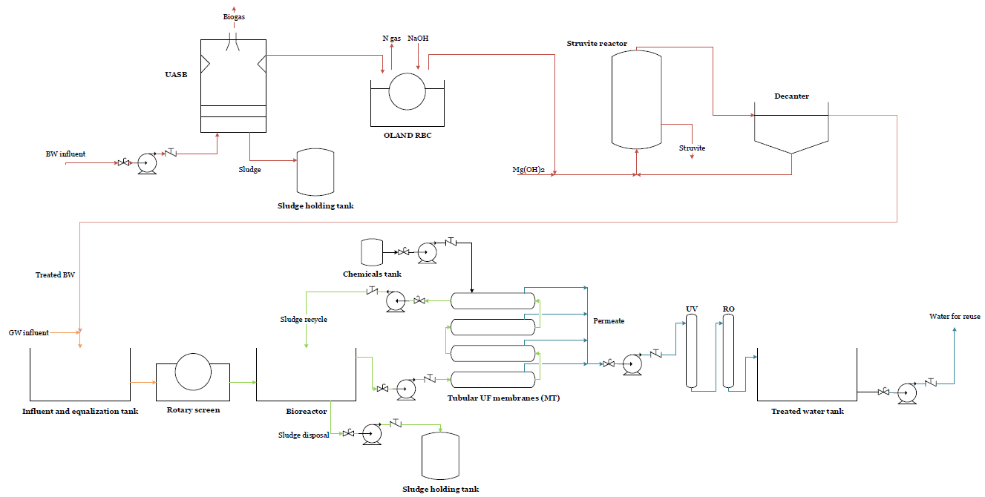
Fig. 4-1: BW and GW lines configuration
Table 4-15: CAPEX and OPEX of the MBRs in 2019 prices (V1).
 | CAPEX correlation ($) | CAPEX supplier data ($) | OPEX ($/yr)
LR | 1763.88 | 6585.64 | 409.45
ST | 1763.88 | 6585.64 | 409.45
MR | 7177.47 | 10680.20 | 1788.72
MHR | 13136.20 | 15173.07 | 3354.75
HR | 29206.09 | 26740.17 | 7650.97

anMBR

Reactor volume and membrane area
In the scenarios where a anMBR is incorporated, the anaerobic reactor volume is calculated from its hydraulic residence time assuming a frequently used value for the treatment of wastewater of 8h (Ariunbaatar et al., 2021; Foglia et al., 2020; Gouveia et al., 2015; Ribera-Pi et al., 2020; Shin et al., 2014; Shoener et al., 2016; Wang et al., 2018a, 2018b) using Eq. 62. The parameters in the equation are the reactor’s volume anMBR_{volume} [m³], the hydraulic retention time HRT [hours], and the flow rate [m³/h].
$$anM{BR}_{volume}=HRT*Flow rate$$ | Eq. 62
The membrane area is found following the same methodology as for the MBR (see Eq. 61). The obtained volumes and membrane areas for the variation of the vacuum scenario are shown in Table 4-16.
Table 4-16: Volumes of anMBR reactors (V2).
UASB reactor | Units | LR | ST | MR | MHR | HR
Volume | m³ | 0.45 | 0.45 | 2.26 | 4.52 | 11.3
Membrane area | m² | 56.5 | 56.5 | 282.5 | 565.0 | 1412.5

Biogas production
Biogas production is calculated assuming the production of 0.125 L CH₄ per kg of COD removed (Ariunbaatar et al., 2021), and a methane content of 78%. The same calculations described in the UASB section are performed to convert the L of CH₄ in STP to m³ of biogas obtained per day at 25ºC.
Energy consumption in the anMBR system is considered to be 0.49 kWh/m³ (Pretel et al., 2014). The net biogas volume obtained is also calculated according to the procedure described in the UASB section. All anMBRs for all scenarios where they are involved prove energy sufficient.

Sludge production
Sludge production in anMBRs is calculated from the COD content of the influent of the system, assuming 0.035 kg MLVSS/kg COD removed (Lin et al., 2011).

CAPEX and OPEX
The capital expenses related to the anMBR are estimated based on an inventory of components as done with the MBR. The costs are calculated for each scenario based on flowrates and pollutant concentrations for each building and scenario.
Bioreactor costs are adapted from Lin et al., 2011 and Verrecht et al., 2010 considering the tanks in this study are small-scale, thus a base of 1000 $ is added to the original price of 236.38$/m³ (Fletcher et al., 2007). Membrane and air diffuser costs are taken from Lin et al., 2011 and Verrecht et al., 2010 as 50 $/m². Valves, pumps, and tanks prices are provided by suppliers (see MBR section). The price of the membrane screen is taken from Fletcher et al., 2007.
Table 4-17: Breakdown of included elements in the anMBR obtained from supplier data collection (example for MHR buildings, V2).
MHR MBR ($) | $ |  | $
Bioreactor | 2,068.43 | Membranes | 565
Gas diffusers | 15 | Valves | 62.50
Gas blowers | 160 | Tanks
Pumps |  | Raw water and equalization tank | 1,863
Pump for sludge recycling | 220 | Treated water tank | 1,842
Permeate pump | 1100 | Cleaning chemicals tank | 108.09
Chemical addition pumps | 356 | Sludge tank | 282
Sludge purge pump | 220 | MT membrane screen (0.5 mm) | 1000
TOTAL ($) | 9,862.84
The OPEX are calculated assuming a cost of 0.06$/m³ (Lema and Martinez, 2017; Pretel et al., 2014). The total CAPEX and annual OPEX are shown in Table 4-18 for the scenario with vacuum toilets.

Table 4-18: CAPEX and OPEX of the anMBRs for all building types (V2).
 | CAPEX ($) | OPEX ($/yr)
LR | 5856.16 | 29.70
ST | 5856.16 | 29.70
MR | 7863.12 | 148.48
MHR | 9862.84 | 296.96
HR | 14150.99 | 742.41

MABR
For the scenario involving urine source-separation, an MABR is included to achieve the nitrification of urine.

Liquid fertilizer recovery
The liquid fertilizer volume obtained is calculated expecting 15% of the initial collected volume of urine is recovered in the concentrate (De Paepe et al., 2018). The price of fertilizer recovered from urine is around 10.5 $/L according to Chipako and Randall, 2020.

CAPEX and OPEX
CAPEX are obtained from literature data and assumed to be 732 $/m³d (Casey et al., 2008). OPEX are calculated from small-scale MABR observed annual power demand values (3.4 kWh/PE) assuming an average electricity cost of 0.13$/kWh (Gritti, 2019).
Table 4-19: CAPEX and OPEX for the MABR employed for the nitrification of urine (USS).
 | CAPEX ($) | OPEX ($/yr)
LR | 9 | 5
ST | 9 | 5
MR | 46 | 27
MHR | 92 | 53
HR | 231 | 133

Uridis cell
The stabilization of urine in the scenario where it is source-separated is carried out in an electrochemical cell coupled with a crystallizer (Uridis cell, Hydrohm).
The cell allows to increase the pH of urine due to the release of hydroxyl ions in the cathode of the cell, which causes the precipitation of salts (collected in a consecutive crystallizer), and hence the scaling potential of the flow is reduced (URIDIS technology, www.hydrohm.com). Phosphates in urine precipitate with calcium and magnesium, allowing for the recovery of the nutrient. Furthermore, water in the anode is acidified creating a potential cleaning and sanitizing flow for the toilets, membranes, and electrodes. Thus, pathogen presence and unpleasant odor can be avoided. The treated urine is collected and sent to the next stage of treatment. The authors propose the use of MABR to carry out the nitrification of ammoniacal nitrogen yielding a liquid solution which can be valorized as fertilizer (De Paepe, 2020; De Paepe et al., 2020a).

Phosphorus recovery
30% of phosphates in urine were expected to be recovered in the form of mainly calcium phosphate precipitates (De Paepe et al., 2020), which are sold at a price of 0.3 $/kg (Etter et al., 2011). An example on how to calculate the total mass of calcium phosphate recovered in the HR building for the USS scenario is shown in Eq. 63 and Eq. 64.
$$1.7575 \frac{moles PO_{4}^{3-}}{day}*0.9*\frac{1 mole Ca_{3}{\left(PO_{4}\right)}_{2}}{2 mole PO_{4}^{3-}}=0.791\frac{moles Ca_{3}{\left(PO_{4}\right)}_{2}}{day}$$ | Eq. 63
$$0.791\frac{moles Ca_{3}{\left(PO_{4}\right)}_{2}}{day}*\frac{310,18 g Ca_{3}{\left(PO_{4}\right)}_{2}}{1 mol Ca_{3}{\left(PO_{4}\right)}_{2}}*\frac{1 kg}{1000 g}*\frac{365 days}{yr}$$  $$=89.54\frac{kg struvite}{yr}$$ | Eq. 64

CAPEX and OPEX
CAPEX ARE estimated at 150 $/PE while OPEX ARE calculated from an annual energy consumption of 13 kWh/PE (Personal communication, K. Rabaey).
Table 4-20: CAPEX and OPEX for the electrochemical (Uridis) cell (USS).
 | CAPEX ($) | OPEX ($/yr)
LR | 1800 | 20
ST | 1800 | 20
MR | 9000 | 101
MHR | 18000 | 203
HR | 45000 | 507

RO

Models and sizes
The chosen model of reverse osmosis membranes Is selected because of its removal efficiency (Van Voorthuizen et al., 2005). The smallest available size is picked for both the treatment of GW and RW in all building types, except for the HR building in scenarios C1, C2, and USS, where the next available size is picked to match the operating flowrate requirements. Table 4-17 shows size and model information of the selected models.
Table 4-21: RO model and sizes for GW and BW.
Model | Length (m) | Diameter (m) | Volume (m^3)
XLE-2521 | 0.533 | 0.061 | 0.002
XLE-4021 | 0.533 | 0.099 | 0.004

CAPEX and OPEX
CAPEX ARE obtained from supplier data (Dow FilmTec.), while OPEX ARE estimated per m³ of treated wastewater (0.17 $/m³) (Almar Water Solutions Ltd.). Table 4-18 shows the final costs of the RO system for GW and RW treatment.
Table 4-22: CAPEX and OPEX of the RO (V1).
 | CAPEX supplier data ($) | OPEX GW ($/yr) | OPEX RW ($/yr)
LR | 173.59 | 81.92 | 8.24
ST | 173.59 | 81.92 | 8.24
MR | 173.59 | 409.59 | 41.22
MHR | 173.59 | 819.19 | 82.44
HR | 173.59 | 2047.96 | 206.09

UV

Models and sizes
UV filters for use in wastewater treatment (Applied Membranes Inc., Vista, CA) are fitted for each building type. The most adequate size is selected according to operational flux as shown in Table 4-19 (e.g., for scenario V1). All scenarios result in the same combination of UV filters. For RW, the smallest available model is selected for all building types.
Table 4-23: UV model and sizes for GW (Applied Membranes Inc., Vista, CA.) (V1).
 | Model | Length (m) | Diameter (m) | Volume (m³)
LR | 2 GPM UV-SPH-2 | 0.064 | 0.262 | 0.001
ST | 2 GPM UV-SPH-2 | 0.064 | 0.262 | 0.001
MR | 2 GPM UV-SPH-2 | 0.064 | 0.262 | 0.001
MHR | 3 GPM UV-SPH-3 | 0.064 | 0.363 | 0.001
HR | 11 GPM UV-SPH-11 | 0.064 | 0.894 | 0.003

CAPEX and OPEX
The same procedure as for the RO membranes was followed assuming an estimative cost of 0.16 $/m³ (Mazuki et al., 2020).

Table 4-24: CAPEX and OPEX of the UV filters (V1).
 | CAPEX supplier data GW ($) | CAPEX supplier data RW ($) | OPEX GW ($/yr) | OPEX RW ($/yr)
LR | 167.41 | 167.41 | 77.10 | 7.76
ST | 167.41 | 167.41 | 77.10 | 7.76
MR | 167.41 | 167.41 | 385.50 | 38.79
MHR | 176.87 | 167.41 | 771.00 | 77.59
HR | 345.47 | 167.41 | 1927.50 | 193.97

SAFETY considerations:
The MBR-RO-UV combination of technologies has been proved to eliminate bacteria and viruses (Friedler and Gilboa, 2010; Ghernaot et al., 2019; Tang et al., 2018). Close physical distances between treatment and equipment, as the proximity of feed to treated water tanks, could offer a chance for microbial transport (e.g., aerosols, cross-connections, etc.) (Bhattacharjee and Datta, 2019). The UV disinfection unit poses a barrier to the physical movement of bacteria and enhances microbial quality to ensure the resultant effluent represents no health risks. Periodical quality tests would be scheduled to avoid the growth of bacteria resistant to UV treatment, bacterial hopping, and regrowth. If elevated concentrations of viruses are detected in the recycled water, the UV fluence could be increased (Pullerits et al., 2020).

References
Table 4-25 summarizes the literature considered for the modelling of each treatment unit from which removal efficiencies, design parameters or costing methods were obtained. Additionally, some data has also been obtained from various suppliers, which have been cited along the paper.
Table 4-25: Literature and software employed for the modelling of each treatment.
 | References
UASB | de Graaf et al., 2010  Metcalff and Eddy, 2013  Oteng-Peprah et al., 2018 | Kujawa-Roeleveld and Zeeman, 2006  CapdetWorks  SIMBA
OLAND | Courtens et al., 2014  Clippeleir et al., 2011  Roefs et al., 2017 | Lozano et al., 2007  Oteng-Peprah et al., 2018  SIMBA
Struvite reactor | De Graaf et al., 2010  Siciliano et al., 2020  Tarragó et al., 2016 | Etter et al., 2011  Pastor Alcañiz, 2008  SIMBA
MBR | Fletcher et al., 2007  Wen et al., 1999  Xing et al., 2001; 2003  Liu et al., 2005  Merz et al., 2007 | Lo et al., 2015  Atasoy et al., 2007  Bani-Melhem et al., 2015  Lesjean and Gnirss, 2006  Oteng-Peprah et al., 2018  SIMBA
anMBR | Ariunbaatar et al., 2021  Foglia et al., 2020  Gouveia et al., 2015  Ribera-Pi et al., 2020  Shin et al., 2014  Pretel et al., 2014 | Shoener et al., 2016  Wang et al., 2018a, 2018b  Lin et al., 2011  Verrecht et al., 2010  Fletcher et al., 2007  SIMBA
MABR | Casey et al., 2008  Gritti, 2019  De Paepe et al., 2020  De Paepe et al., 2018 | Chipako and Randall, 2020
RO | Van Voorthuizen et al., 2005
UV | Mazuki et al., 2020
Uridis cell | Personal communication (K. Rabaey)  De Paepe et al., 2020  Etter et al., 2011

Tank sizing
Tank sizes have been chosen as explained in the main paper assuming one- or two-weeks storage of wastewater. Volumes and prices vary according to each treatment line configuration.
Table 4-26: Storage capacity (m³) and CAPEX ($) of a week's wastewater production (principal scenario, V1).
 | Raw water and  equalization tank | CAPEX ($) | Treated water tank | CAPEX ($) | Sludge tank | CAPEX ($)
LR | 4.72 | 626 | 9.45 | 783 | 0.21 | 103
ST | 4.72 | 626 | 9.45 | 783 | 0.21 | 103
MR | 23.62 | 1180 | 47.25 | 1381 | 1.04 | 713
MHR | 47.25 | 1863 | 94.49 | 1842 | 2.08 | 1147
HR | 118.12 | 2393 | 236.23 | 3125 | 5.19 | 2155
Table 4-27: Storage capacity (m³) of two weeks’ wastewater production (additional scenario, V1).
 | Raw water and  equalization tank | CAPEX ($) | Treated water tank | CAPEX ($) | Sludge tank | CAPEX ($)
LR | 30 | 1580 | 30 | 1580 | 0.9 | 448
ST | 30 | 1580 | 30 | 1580 | 0.9 | 448
MR | 160 | 3934 | 160 | 3934 | 4 | 713
MHR | 300 | 6793 | 300 | 6793 | 7 | 1147
HR | 800 | 19679 | 800 | 19679 | 18 | 2164
Both the rainwater collection and the potable water holding tanks were sized to store a month’s potable water demand. Table 4-28 shows the volumes and CAPEX of RW tanks for all building types.
Table 4-28: Volumes and costs of rainwater tanks (V1).
 | Volume (m³) | Collection tank CAPEX ($) | Treated water tank CAPEX ($)
LR | 3.73 | 717.39 | 745.53
ST | 3.72 | 717.39 | 745.53
MR | 18.60 | 1180.00 | 1296.00
MHR | 37.20 | 1805.00 | 1898.00
HR | 93.00 | 3340.00 | 3377.00

Construction costs
Construction costs for all building were calculated using architecture journals EME DOS and CONSTRUC. Since these provide Spanish prices, the values have been adjusted to EU-27 average prices using Eurostat indexes for the construction costs of new apartment buildings.
EME DOS provides 3 different costing values depending on the building’s quality, while CONSTRUC only gives one average value. The final values used for LR and ST buildings have been those of EME DOS for the highest quality to avoid underestimations.
For MR, MHR, and HR buildings CONSTRUC data has been used since the type of building described in the journal is the most fitting with the buildings assessed in the study.
Table 5-1: Construction costs (where LQ: low quality; MQ: medium quality; HQ: high quality).
 | LR  (1 house) | LR  (5 houses) | ST | MR | MHR | HR
Total m² | 180 | 900 | 810 | 2,450 | 4,590 | 10,720
EMEDOS LQ | 200,968 | 1,004,841 | 644,817 | 1,950,372 | 3,653,961 | 8,533,870
EMEDOS MQ | 211,039 | 1,055,196 | 776,741 | 2,349,403 | 4,401,535 | 10,279,837
EMEDOS HQ | 233,440 | 1,167,201 | 840,164 | 2,541,238 | 4,760,932 | 11,119,213
CONSTRUC | 225,180 | 1,125,900 | 609,080 | 1,575,081 | 2,950,865 | 6,891,781

Sewer infrastructure CAPEX and OPEX
The cost of the pipeline that needs to be deployed in order to provide the assessed buildings with wastewater collection services can be fully avoided in the present study. Thus, the saving benefits stemming from the use of a completely decentralized treatment system are calculated by considering both the construction and maintenance costs of the connector to water main and also the public charges allocated to the inhabitants of each block. Table 6-1 shows the breakdown of costs represented in Figure 9.
Table 6-1: Infrastructure charges for all assessed buildings.
 | LR | ST | MR | MHR | HR
Inhabitants | 12 | 12 | 60 | 120 | 300
Infrastructure charges
Water consumption (m³/month) | 45.8 | 45.8 | 228.8 | 457.6 | 1143.9
Infrastructure charges ($/month) | 12.9 | 12.9 | 64.3 | 128.6 | 321.4
Infrastructure charges ($/30 yr) | 2371.8 | 2371.8 | 11859.0 | 23718.0 | 59295.1
Connection to water main
Installation CAPEX ($) | 1262.8 | 1262.8 | 1262.8 | 1262.8 | 1262.8
Installation OPEX ($/30yr) | 2725.3 | 2725.3 | 2725.3 | 2725.3 | 2725.3
Total costs
Total CAPEX ($) | 1262.8 | 1262.8 | 1262.8 | 1262.8 | 1262.8
Total OPEX ($/30yr) | 5097.1 | 5097.1 | 14584.3 | 26443.3 | 62020.4

Breakdown of costs and benefits (without monitoring costs) for all scenarios
Table 7-1: Breakdown of costs for all buildings for the V1 scenario.
Total costs | Low-rise housing |  | Short top building |  | Mid-rise building |  | Mid/high-rise building |  | High-rise building
($) | CAPEX | OPEX | CAPEX | OPEX | CAPEX | OPEX | CAPEX | OPEX | CAPEX | OPEX
GW line
Sewer | 2,904 | 88 | 1,891 | 58 | 4,813 | 147 | 8,217 | 250 | 14,891 | 453
Pumping | 394 | 208 | 394 | 208 | 1,970 | 1,040 | 3,941 | 2,080 | 9,851 | 5,200
MBR | 1,764 | 6,294 | 1,764 | 6,294 | 7,177 | 27,497 | 13,136 | 51,571 | 29,206 | 117,614
RO | 174 | 1,259 | 174 | 1,259 | 174 | 6,296 | 174 | 12,593 | 174 | 31,482
UV | 167 | 1,185 | 167 | 1,185 | 167 | 5,926 | 177 | 11,852 | 345 | 29,630
Total treatments | 2,105 | 8,739 | 2,105 | 8,739 | 7,518 | 39,719 | 13,487 | 76,016 | 29,725 | 178,727
TOTAL GW | 5,403 | 9,035 | 4,389 | 9,004 | 14,302 | 40,906 | 25,644 | 78,346 | 54,467 | 184,380
BW line
Sewer | 1,076 | 520 | 701 | 339 | 1,784 | 862 | 3,045 | 1,472 | 5,519 | 2,668
Pumping | 4,890 | 472 | 4,890 | 472 | 8,151 | 2,360 | 16,301 | 4,719 | 40,753 | 11,799
UASB | 3,341 | 2,057 | 3,341 | 2,057 | 16,705 | 10,286 | 33,410 | 20,571 | 83,525 | 51,429
OLAND | 35 | 919 | 35 | 919 | 175 | 4,595 | 351 | 9,191 | 877 | 22,977
Struvite reactor | 13 | 34 | 13 | 34 | 65 | 172 | 131 | 343 | 327 | 858
Total treatments | 3,389 | 3,011 | 3,389 | 3,011 | 16,946 | 15,053 | 33,892 | 30,105 | 84,729 | 75,264
TOTAL BW | 9,356 | 4,003 | 8,980 | 3,821 | 26,880 | 18,275 | 53,238 | 36,297 | 131,001 | 89,730
Rain water
Pumping | 40 | 21 | 40 | 21 | 202 | 107 | 404 | 213 | 1,010 | 533
Tank | 1,463 |  | 1,463 |  | 2,476 |  | 3,703 |  | 6,717
RO | 174 | 127 | 174 | 127 | 174 | 634 | 174 | 1,267 | 174 | 3,168
UV | 167 | 119 | 167 | 119 | 167 | 596 | 177 | 1,193 | 345 | 2,982
Total rainwater | 1,844 | 267 | 1,844 | 267 | 3,019 | 1,337 | 4,457 | 2,673 | 8,246 | 6,683
TOTAL | 16,602 | 13,305 | 15,214 | 13,093 | 44,201 | 60,517 | 83,339 | 117,316 | 193,714 | 280,793
Table 7-2: Benefits breakdown for the V1 scenario.
 | LR | ST | MR | MHR | HR
Benefits struvite ($/yr) | 6.0 | 6.0 | 29.9 | 59.7 | 149.3
Benefits biogas ($/yr) | 3.1 | 3.1 | 15.5 | 30.9 | 77.4
Total benefits nutrient and biogas recovery ($/yr) | 9.1 | 9.1 | 45.3 | 90.7 | 226.7
Water saving benefits ($/yr) | 153.3 | 153.3 | 766.5 | 1,533.0 | 3,832.5
Sewer
TOTAL CAPEX ($) | 1,262.8 | 1,262.8 | 1,262.8 | 1,262.8 | 1,262.8
TOTAL OPEX ($/yr) | 5,097.1 | 5,097.1 | 14,584.3 | 26,443.3 | 62,020.4
Total OPEX benefits ($/yr) | 5,259.4 | 5,259.4 | 15,396.1 | 28,067.0 | 66,079.5
TOTAL BENEFITS ($): CAPEX & OPEX 30 YR | 82,113.4 | 82,113.4 | 237,939.0 | 432,721.1 | 1,017,067.4

Table 7-3: Breakdown of costs for all buildings for the V2 scenario.
Total costs | Low-rise housing |  | Short top building |  | Mid-rise building |  | Mid/high-rise building |  | High-rise building
($) | CAPEX | OPEX | CAPEX | OPEX | CAPEX | OPEX | CAPEX | OPEX | CAPEX | OPEX
Pipeline
GW line
Sewer | 2,904 | 88 | 1,891 | 58 | 4,813 | 147 | 8,217 | 250 | 14,891 | 453
Pumping | 394 | 208 | 394 | 208 | 1,970 | 1,040 | 3,941 | 2,080 | 9,851 | 5,200
BW line
Sewer | 1,076 | 520 | 701 | 339 | 1,784 | 862 | 3,045 | 1,472 | 5,519 | 2,668
Pumping | 4,890 | 472 | 4,890 | 472 | 8,151 | 2,360 | 16,301 | 4,719 | 40,753 | 11,799
Total pumping & sewer | 9,264 | 1,289 | 7,876 | 1,076 | 16,718 | 4,409 | 31,504 | 8,522 | 71,014 | 20,120
BW treatments
OLAND | 39 | 1,010 | 39 | 1,010 | 193 | 5,050 | 385 | 10,100 | 963 | 25,249
Struvite reactor | 15 | 56 | 15 | 56 | 73 | 281 | 146 | 563 | 364 | 1,407
GW & BW Treatments
anMBR | 5,840 | 457 | 5,840 | 457 | 8,668 | 2,283 | 10,272 | 4,565 | 11,290 | 11,413
RO | 174 | 1,265 | 174 | 1,265 | 174 | 6,325 | 174 | 12,650 | 174 | 31,624
UV | 167 | 1,191 | 167 | 1,191 | 167 | 5,953 | 177 | 11,906 | 345 | 29,764
Total treatments | 6,234 | 3,978 | 6,234 | 3,978 | 9,275 | 19,892 | 11,154 | 39,783 | 13,137 | 99,458
Rain water
Pumping | 40 | 21 | 40 | 21 | 202 | 107 | 404 | 213 | 1,010 | 533
Tank | 1,463 |  | 1,463 |  | 2,476 |  | 3,703 |  | 6,717
RO | 174 | 127 | 174 | 127 | 174 | 634 | 174 | 1,267 | 174 | 3,168
UV | 167 | 119 | 167 | 119 | 167 | 596 | 177 | 1,193 | 345 | 2,982
Total rainwater | 1,844 | 267 | 1,844 | 267 | 3,019 | 1,337 | 4,457 | 2,673 | 8,246 | 6,683
TOTAL | 17,342 | 5,534 | 15,954 | 5,322 | 29,011 | 25,637 | 47,115 | 50,978 | 92,396 | 126,260

Table 7-4: Benefits breakdown for the V2 scenario.
 | LR | ST | MR | MHR | HR
Struvite (kg/yr) | 27 | 27 | 134 | 269 | 672
Benefits struvite ($/yr) | 10 | 10 | 49 | 98 | 245
L CH4 CN/day | 126 | 126 | 628 | 1,256 | 3,140
L biogas/ day | 161 | 161 | 805 | 1,610 | 4,026
Energy consumption (kWh/yr) | 243 | 243 | 1,213 | 2,425 | 6,063
Energy from biogas (kWh/yr) | 453 | 453 | 2,266 | 4,532 | 11,330
Net energy production (kWh/yr) | 211 | 211 | 1,053 | 2,107 | 5,267
CH4 (m³ CN/day) | 0 | 0 | 1 | 1 | 3
CH4 (m³ CN/yr) | 42 | 42 | 210 | 420 | 1,050
Clean m3 CH4/yr STP | 20 | 20 | 98 | 195 | 488
Clean m³ biogas/yr 25ºC | 27 | 27 | 137 | 273 | 683
Benefits biogas ($/yr) | 2 | 2 | 12 | 25 | 62
Total benefits nutrient and biogas recovery ($/yr) | 12 | 12 | 61 | 123 | 306
Estalvi aigua (m³) | 12 | 12 | 60 | 120 | 300
Water cost ($/m³) | 153 | 153 | 767 | 1,533 | 3,833
Water saving benefits ($/yr) | 2 | 2 | 2 | 2 | 2
 | 307 | 307 | 1,533 | 3,066 | 7,665
Sewer
TOTAL CAPEX ($)
TOTAL OPEX ($/yr) | 1,263 | 1,263 | 1,263 | 1,263 | 1,263
 | 5,097 | 5,097 | 14,584 | 26,443 | 62,020
Total OPEX benefits ($/yr)
 | 5,416 | 5,416 | 16,179 | 29,632 | 69,992
TOTAL BENEFITS ($): CAPEX & OPEX 30 YR

Table 7-5: Breakdown of costs for all buildings for the C1 scenario.
Total costs | Low-rise housing |  | Short top building |  | Mid-rise building |  | Mid/high-rise building |  | High-rise building
($) | CAPEX | OPEX | CAPEX | OPEX | CAPEX | OPEX | CAPEX | OPEX | CAPEX | OPEX
Pipeline
GW line
Sewer | 2,904 | 88 | 1,891 | 58 | 4,813 | 147 | 8,217 | 250 | 14,891 | 453
Pumping | 394 | 208 | 394 | 208 | 1,970 | 1,040 | 3,941 | 2,080 | 9,851 | 5,200
Total pumping/sewer GW | 3,298 | 296 | 2,285 | 266 | 6,783 | 1,187 | 12,157 | 2,330 | 24,742 | 5,653
BW line
Sewer | 2,660 | 88 | 1,732 | 58 | 4,410 | 147 | 7,529 | 250 | 13,644 | 453
Pumping | 146 | 77 | 146 | 77 | 730 | 385 | 1,459 | 770 | 3,649 | 1,926
Total pumping/sewer BW | 2,806 | 165 | 1,878 | 135 | 5,140 | 532 | 8,988 | 1,021 | 17,292 | 2,379
Total pumping/sewer | 6,104 | 462 | 4,163 | 400 | 11,923 | 1,718 | 21,145 | 3,351 | 42,034 | 8,033
BW Treatments
OLAND | 39 | 1,010 | 39 | 1,010 | 193 | 5,050 | 385 | 10,100 | 963 | 25,249
Struvite reactor | 117 | 56 | 117 | 56 | 583 | 281 | 1,166 | 563 | 2,914 | 1,407
BW+GW Treatments
MBR | 2,133 | 8,103 | 2,133 | 8,103 | 8,680 | 35,285 | 15,886 | 66,067 | 35,319 | 150,283
RO | 174 | 1,657 | 174 | 1,657 | 174 | 8,284 | 174 | 16,568 | 241 | 41,420
UV | 167 | 1,559 | 167 | 1,559 | 167 | 7,797 | 345 | 15,593 | 345 | 38,983
Total treatments | 2,629 | 12,385 | 2,629 | 12,385 | 9,796 | 56,697 | 17,956 | 108,890 | 39,783 | 257,342
Rain water
Pumping | 40 | 21 | 40 | 21 | 202 | 107 | 404 | 213 | 1,010 | 533
Tank | 1,463 |  | 1,463 |  | 2,476 |  | 3,703 |  | 6,717
RO | 174 | 127 | 174 | 127 | 174 | 634 | 174 | 1,267 | 174 | 3,168
UV | 167 | 119 | 167 | 119 | 167 | 596 | 177 | 1,193 | 345 | 2,982
Total rainwater | 1,844 | 267 | 1,844 | 267 | 3,019 | 1,337 | 4,457 | 2,673 | 8,246 | 6,683
TOTAL | 10,578 | 13,114 | 8,636 | 13,053 | 24,738 | 59,752 | 43,558 | 114,914 | 90,063 | 272,058
Table 7-6: Benefits breakdown for the C1 scenario.
 | LR | ST | MR | MHR | HR
Struvite (kg/yr) | 27 | 27 | 134 | 269 | 672
Benefits struvite ($/yr) | 10 | 10 | 49 | 98 | 245
L CH4 CN/day | 0 | 0 | 0 | 0 | 0
L biogas/ day | 0 | 0 | 0 | 0 | 0
Energy consumption (kWh/yr) | 0.00 | 0.00 | 0.00 | 0.00 | 0.00
Energy from biogas (kWh/yr) | 0.00 | 0.00 | 0.00 | 0.00 | 0.00
Net energy production (kWh/yr) | 0.00 | 0.00 | 0.00 | 0.00 | 0.00
CH4 (m³ CN/day) | 0 | 0 | 0 | 0 | 0
CH4 (m³ CN/yr) | 0 | 0 | 0 | 0 | 0
Clean m³ CH4/yr STP | 0 | 0 | 0 | 0 | 0
Clean m³ biogas/yr 25ºC | 0 | 0 | 0 | 0 | 0
Benefits biogas ($/yr) | 0 | 0 | 0 | 0 | 0
Total benefits nutrient and biogas recovery ($/yr) | 10 | 10 | 49 | 98 | 245
PE | 12 | 12 | 60 | 120 | 300
Estalvi aigua (m³) | 0 | 0 | 0 | 0 | 0
Water cost ($/m³) | 2 | 2 | 2 | 2 | 2
Water saving benefits ($/yr) | 0 | 0 | 0 | 0 | 0
Sewer
TOTAL CAPEX ($) | 1,262 | 1,262 | 1,262 | 1,262 | 1,262
TOTAL OPEX ($/yr) | 5,097 | 5,097 | 14584.2925 | 26,443 | 62,020
Total OPEX benefits ($/yr) | 5,109 | 51,09 | 14,635 | 26,543 | 62,267
TOTAL BENEFITS ($) CAPEX & OPEX 30 YR | 79,799 | 79,799 | 226,242 | 409,297 | 958,461

Table 7-7: Breakdown of costs for all buildings for the C2 scenario.
Total costs | Low-rise housing |  | Short top building |  | Mid-rise building |  | Mid/high-rise building |  | High-rise building
($) | CAPEX | OPEX | CAPEX | OPEX | CAPEX | OPEX | CAPEX | OPEX | CAPEX | OPEX
Pipeline
GW line
Sewer | 2,904 | 88 | 1,891 | 58 | 4,813 | 147 | 8,217 | 250 | 14,891 | 453
Pumping | 394 | 208 | 394 | 208 | 1,970 | 1,040 | 3,941 | 2,080 | 9,851 | 5,200
BW line
Sewer | 2,660 | 88 | 1,732 | 58 | 4,410 | 147 | 7,529 | 250 | 13,644 | 453
Pumping | 146 | 77 | 146 | 77 | 730 | 385 | 1,459 | 770 | 3,649 | 1,926
GW & BW Treatments
OLAND | 39 | 1,010 | 39 | 1,010 | 193 | 5,050 | 385 | 10,100 | 963 | 25,249
Struvite reactor | 117 | 56 | 117 | 56 | 583 | 281 | 1,166 | 563 | 2,914 | 1,407
BW & GW Treatments
anMBR | 2,889 | 598 | 2,889 | 598 | 5,986 | 2,990 | 8,730 | 5,979 | 12,760 | 14,948
RO | 174 | 1,657 | 174 | 1,657 | 174 | 8,284 | 174 | 16,568 | 241 | 41,420
UV | 167 | 1,559 | 167 | 1,559 | 167 | 7,797 | 345 | 15,593 | 345 | 38,983
Total treatments | 3,385 | 4,880 | 3,385 | 4,880 | 7,102 | 24,401 | 10,800 | 48,803 | 17,224 | 122,007
Rain water
Pumping | 40 | 21 | 40 | 21 | 202 | 107 | 404 | 213 | 1,010 | 533
Tank | 1,463 |  | 1,463 |  | 2,476 |  | 3,703 |  | 6,717
RO | 174 | 127 | 174 | 127 | 174 | 634 | 174 | 1,267 | 174 | 3,168
UV | 167 | 119 | 167 | 119 | 167 | 596 | 177 | 1,193 | 345 | 2,982
Total rainwater | 1,844 | 267 | 1,844 | 267 | 3,019 | 1,337 | 4,457 | 2,673 | 8,246 | 6,683
TOTAL | 11,333 | 5,609 | 9,392 | 5,548 | 22,044 | 27,456 | 36,402 | 54,827 | 67,504 | 136,722

Table 7-8: Benefits breakdown for the C2 scenario.
 | LR | ST | MR | MHR | HR
Struvite (kg/yr) | 27 | 27 | 134 | 269 | 672
Benefits struvite ($/yr) | 10 | 10 | 49 | 98 | 245
L CH4 CN/day | 126 | 126 | 628 | 1,256 | 3,140
L biogas/ day | 161 | 161 | 805 | 1,610 | 4,026
Energy consumption (kWh/yr) | 318 | 318 | 1,588 | 3,176 | 7,941
Energy from biogas (kWh/yr) | 453 | 453 | 2,266 | 4,532 | 11,330
Net energy production (kWh/yr) | 136 | 136 | 678 | 1,356 | 3,389
CH4 (m³ CN/day) | 0 | 0 | 1 | 1 | 3
CH4 (m³ CN/yr) | 42 | 42 | 210 | 420 | 1,050
Clean m³ CH4/yr STP | 13 | 13 | 63 | 126 | 314
Clean m³ biogas/yr 25ºC | 18 | 18 | 88 | 176 | 440
Benefits biogas ($/yr) | 2 | 2 | 8 | 16 | 40
Total benefits nutrient and biogas recovery ($/yr) | 11 | 11 | 57 | 114 | 284
PE | 12 | 12 | 60 | 120 | 300
Estalvi aigua (m³) | 0 | 0 | 0 | 0 | 0
Water cost ($/m³) | 2 | 2 | 2 | 2 | 2
Water saving benefits ($/yr) | 0 | 0 | 0 | 0 | 0
Sewer
TOTAL CAPEX ($) | 1,263 | 1,263 | 1,263 | 1,263 | 1,263
TOTAL OPEX ($/yr) | 5,097 | 5,097 | 14,584 | 26,443 | 62,020
Total OPEX benefits ($/yr) | 5,110 | 5,110 | 14,643 | 26,559 | 62,307
TOTAL BENEFITS ($): CAPEX & OPEX 30 YR | 79,823 | 79,823 | 226,364 | 409,540 | 959,070
Table 7-9: Breakdown of costs for all buildings for the USS scenario.
Total costs | Low-rise housing |  | Short top building |  | Mid-rise building |  | Mid/high-rise building |  | High-rise building
($) | CAPEX | OPEX | CAPEX | OPEX | CAPEX | OPEX | CAPEX | OPEX | CAPEX | OPEX
Pipeline
GW line
Sewer | 2,904 | 88 | 1,891 | 58 | 4,813 | 147 | 8,217 | 250 | 14,891 |  | 453
Pumping | 394 | 208 | 394 | 208 | 1,970 | 1,040 | 3,941 | 2,080 | 9,851 |  | 5,200
BW line YW
Sewer | 2,448 | 88 | 1,594 | 58 | 4,058 | 147 | 6,928 | 250 | 12,556 |  | 453
BW line BrW
Sewer | 2,660 | 88 | 1,732 | 58 | 4,410 | 147 | 7,529 | 250 | 13,644 |  | 453
Pumping | 56 | 30 | 56 | 2 | 282 | 10 | 564 | 19 | 1,409 |  | 48
YW Treatments
Uridis cell | 1,800 | 312 | 1,800 | 312 | 9,000 | 1,559 | 18,000 | 3,118 | 45,000 |  | 7,794
Nitrification (MABR) | 9 | 82 | 9 | 82 | 46 | 408 | 92 | 815 | 231 |  | 2,038
GW & BrW Treatments
anMBR | 5,939 | 499 | 5,939 | 499 | 8,110 | 2,494 | 11,379 | 4,987 | 16,343 |  | 12,468
RO | 174 | 1,382 | 174 | 1,382 | 174 | 6,910 | 174 | 13,820 | 241 |  | 34,549
UV | 167 | 1,301 | 167 | 1,301 | 167 | 6,503 | 177 | 13,007 | 345 |  | 32,517
Total treatments (WW) | 8,089 | 3,575 | 8,089 | 3,575 | 17,497 | 17,873 | 29,822 | 35,746 | 62,160 |  | 89,366
Rain water
Pumping | 40 | 21 | 40 | 21 | 202 | 107 | 404 | 213 | 1,010 |  | 533
Tank | 1,463 |  | 1,463 |  | 2,476 |  | 3,703 |  | 6,717
RO | 174 | 127 | 174 | 127 | 174 | 634 | 174 | 1,267 | 174 |  | 3,168
UV | 167 | 119 | 167 | 119 | 167 | 596 | 177 | 1,193 | 345 |  | 2,982
Total rainwater | 1,844 | 267 | 1,844 | 267 | 3,019 | 1,337 | 4,457 | 2,673 | 8,246 |  | 6,683
TOTAL | 18,396 | 4,345 | 15,601 | 4,225 | 36,049 | 20,699 | 61,457 | 41,270 | 122,757 |  | 102,658

Table 7-10: Benefits breakdown for the USS scenario.
 | LR | ST | MR | MHR | HR
Phosphorus (kg/yr) | 4 | 4 | 18 | 36 | 90
Benefits calcium phosphate ($/yr) | 1 | 1 | 7 | 13 | 33
L CH4 CN/day | 139 | 139 | 697 | 1,393 | 3,483
L biogas/ day | 179 | 179 | 893 | 1,786 | 4,465
Energy consumption (kWh/yr) | 265 | 265 | 1,325 | 2,649 | 6,624
Energy from biogas (kWh/yr) | 503 | 503 | 2,514 | 5,027 | 12,568
Net energy production (kWh/yr) | 238 | 238 | 1,189 | 2,378 | 5,944
CH4 (m³ CN/day) | 0 | 0 | 1 | 1 | 3
CH4 (m³ CN/yr) | 47 | 47 | 233 | 466 | 1,165
Clean m³ CH4/yr STP | 22 | 22 | 110 | 220 | 551
Clean m³ biogas/yr 25ºC | 31 | 31 | 154 | 308 | 771
Benefits biogas ($/yr) | 0 | 0 | 0 | 0 | 0
Liquid fertilizer ($/yr) | 20 | 20 | 99 | 198 | 496
Total benefits nutrient and biogas recovery ($/yr) | 21 | 21 | 106 | 211 | 529
PE | 12 | 12 | 60 | 120 | 300
Water Savings (m³) | 110 | 110 | 548 | 1,095 | 2,738
Water cost ($/m³) | 2 | 2 | 2 | 2 | 2
Water saving benefits ($/yr) | 219 | 219 | 1,095 | 2,190 | 5,475
Sewer
TOTAL CAPEX ($) | 1,263 | 1,263 | 1,263 | 1,263 | 1,263
TOTAL OPEX ($/yr) | 5,097 | 5,097 | 14,584 | 26,443 | 62,020
Total OPEX benefits ($/yr) | 5,316 | 5,316 | 15,679 | 28,633 | 67,495
TOTAL BENEFITS ($): CAPEX & OPEX 30 YR | 82,984 | 82,984 | 242,292 | 441,427 | 1,038,832

Total costs including monitoring for all scenarios ($)
Table 8-1: Total costs including monitoring (V1).
 | LR | ST | MR | MHR | HR
CAPEX + Lifespan expectancy + Installation (connection PLC)
GW sewer CAPEX | 8,904 | 9,091 | 13,213 | 17,217 | 24,491
GW pumping CAPEX | 1,788 | 1,988 | 5,341 | 9,381 | 21,303
MBR CAPEX | 5,528 | 5,928 | 17,155 | 29,272 | 61,612
RO CAPEX | 1,151 | 1,251 | 1,351 | 1,401 | 1,451
UV CAPEX | 1,204 | 1,244 | 1,284 | 1,361 | 2,393
BW sewer CAPEX | 8,152 | 8,601 | 11,968 | 15,090 | 20,637
BW pumping CAPEX | 10,781 | 10,981 | 17,701 | 34,103 | 83,107
UASB CAPEX | 7,341 | 8,141 | 22,305 | 39,410 | 89,925
OLAND CAPEX | 5,105 | 6,105 | 7,526 | 8,552 | 10,630
Struvite reactor CAPEX | 5,039 | 6,039 | 7,196 | 7,893 | 8,982
RW pumping CAPEX | 1,121 | 1,321 | 2,006 | 2,712 | 4,630
RW tank CAPEX | 3,194 | 3,394 | 5,114 | 7,055 | 11,676
RW RO CAPEX | 1,651 | 1,851 | 2,051 | 2,151 | 2,251
RW UV CAPEX | 2,004 | 2,204 | 2,404 | 2,561 | 3,673
Monitoring CAPEX Sensor | 17,000 | 17,000 | 17,000 | 17,000 | 17,000
OPEX + Minimum energy requirement + Maintenance with VAN
 | LR | ST | MR | MHR | HR
GW sewer OPEX | 2,785 | 3,108 | 3,552 | 4,011 | 4,923
GW pumping OPEX | 2,904 | 3,259 | 4,446 | 5,840 | 9,670
MBR OPEX | 8,990 | 9,345 | 30,903 | 55,331 | 122,084
RO OPEX | 3,955 | 4,310 | 9,702 | 16,353 | 35,952
UV OPEX | 3,881 | 4,236 | 9,332 | 15,612 | 34,100
BW sewer OPEX | 3,216 | 3,390 | 4,268 | 5,232 | 7,137
BW pumping OPEX | 3,168 | 3,523 | 5,765 | 8,480 | 16,268
UASB OPEX | 4,753 | 5,108 | 13,691 | 24,332 | 55,898
OLAND OPEX | 3,615 | 3,970 | 8,001 | 12,951 | 27,447
Struvite reactor OPEX | 2,730 | 3,085 | 3,577 | 4,104 | 5,328
RW pumping OPEX | 2,717 | 3,072 | 3,512 | 3,974 | 5,003
RW RO OPEX | 2,823 | 3,178 | 4,039 | 5,028 | 7,638
RW UV OPEX | 2,815 | 3,170 | 4,002 | 4,953 | 7,452
Monitoring sensors | 92,235 | 92,235 | 92,235 | 92,235 | 92,235
TOTAL (CAPEX & OPEX) | 140,589 | 144,988 | 197,025 | 258,435 | 431,135

Table 8-2: Total costs including monitoring (V2).
 | LR | ST | MR | MHR | HR
CAPEX + Lifespan expectancy + Installation (connection PLC)
GW sewer CAPEX | 8,904 | 9,091 | 13,213 | 17,217 | 24,491
GW pumping CAPEX | 1,788 | 1,988 | 5,341 | 9,381 | 21,303
anMBR CAPEX | 13,679 | 14,079 | 20,136 | 23,545 | 25,780
RO CAPEX | 1,151 | 1,251 | 1,351 | 1,401 | 1,451
UV CAPEX | 1,504 | 1,604 | 1,704 | 1,811 | 2,873
BW sewer CAPEX | 8,152 | 8,601 | 11,968 | 15,090 | 20,637
BW pumping CAPEX | 10,281 | 10,381 | 17,001 | 33,353 | 82,307
OLAND CAPEX | 5,116 | 6,116 | 7,578 | 8,656 | 10,890
Struvite reactor CAPEX | 2,044 | 2,444 | 3,019 | 3,437 | 4,293
RW pumping CAPEX | 621 | 721 | 1,306 | 1,962 | 3,830
RW tank CAPEX | 2,694 | 2,794 | 4,414 | 6,305 | 10,876
RW RO CAPEX | 1,151 | 1,251 | 1,351 | 1,401 | 1,451
RW UV CAPEX | 1,504 | 1,604 | 1,704 | 1,811 | 2,873
Monitoring CAPEX Sensor | 17,000 | 17,000 | 17,000 | 17,000 | 17,000
OPEX + Minimum energy requirement + Maintenance with VAN
 | LR | ST | MR | MHR | HR
GW sewer OPEX | 2,785 | 3,108 | 3,552 | 4,011 | 4,923
GW pumping OPEX | 2,904 | 3,259 | 4,446 | 5,840 | 9,670
anMBR OPEX | 3,153 | 3,507 | 5,688 | 8,325 | 15,882
RO OPEX | 3,961 | 4,316 | 9,730 | 16,410 | 36,094
UV OPEX | 3,887 | 4,241 | 9,358 | 15,666 | 34,234
BW sewer OPEX | 3,216 | 3,390 | 4,268 | 5,232 | 7,137
BW pumping OPEX | 3,168 | 3,523 | 5,765 | 8,480 | 16,268
OLAND OPEX | 3,706 | 4,061 | 8,455 | 13,860 | 29,719
Struvite reactor OPEX | 2,752 | 3,107 | 3,687 | 4,323 | 5,877
RW pumping OPEX | 2,717 | 3,072 | 3,512 | 3,974 | 5,003
RW RO OPEX | 2,823 | 3,178 | 4,039 | 5,028 | 7,638
RW UV OPEX | 2,815 | 3,170 | 4,002 | 4,953 | 7,452
Monitoring sensors | 92,235 | 92,235 | 92,235 | 92,235 | 92,235
TOTAL (CAPEX & OPEX) | 130,122 | 134,167 | 158,738 | 188,337 | 272,133

Table 8-3: Total costs including monitoring (C1).
 | LR | ST | MR | MHR | HR
CAPEX + Lifespan expectancy + Installation (connection PLC)
GW sewer CAPEX | 8,904 | 9,091 | 13,213 | 17,217 | 24,491
GW pumping CAPEX | 1,788 | 1,988 | 5,341 | 9,381 | 21,303
MBR CAPEX | 6,266 | 6,666 | 20,160 | 34,771 | 73,838
RO CAPEX | 1,151 | 1,251 | 1,351 | 1,401 | 1,704
UV CAPEX | 1,504 | 1,604 | 1,704 | 2,823 | 2,873
BW sewer CAPEX | 11,321 | 10,664 | 17,220 | 24,057 | 36,888
BW pumping CAPEX | 792 | 892 | 2,159 | 3,669 | 8,097
OLAND CAPEX | 5,116 | 6,116 | 7,578 | 8,656 | 10,890
Struvite reactor CAPEX | 2,350 | 2,750 | 4,548 | 6,497 | 11,941
RW pumping CAPEX | 621 | 721 | 1,306 | 1,962 | 3,830
RW tank CAPEX | 2,694 | 2,794 | 4,414 | 6,305 | 10,876
RW RO CAPEX | 1,151 | 1,251 | 1,351 | 1,401 | 1,451
RW UV CAPEX | 1,504 | 1,604 | 1,704 | 1,811 | 2,873
Monitoring CAPEX Sensor | 17,000 | 17,000 | 17,000 | 17,000 | 17,000
OPEX + Minimum energy requirement + Maintenance with VAN
 | LR | ST | MR | MHR | HR
GW sewer OPEX | 2,785 | 3,108 | 3,552 | 4,011 | 4,923
GW pumping OPEX | 2,904 | 3,259 | 4,446 | 5,840 | 9,670
MBR OPEX | 10,799 | 11,154 | 38,691 | 69,827 | 154,753
RO OPEX | 4,353 | 4,708 | 11,690 | 20,328 | 45,890
UV OPEX | 4,255 | 4,610 | 11,202 | 19,354 | 43,453
BW sewer OPEX | 2,785 | 3,108 | 3,552 | 4,011 | 4,923
BW pumping OPEX | 2,773 | 3,128 | 3,791 | 4,531 | 6,396
OLAND OPEX | 3,706 | 4,061 | 8,455 | 13,860 | 29,719
Struvite reactor OPEX | 2,752 | 3,107 | 3,687 | 4,323 | 5,877
RW pumping OPEX | 2,717 | 3,072 | 3,512 | 3,974 | 5,003
RW RO OPEX | 2,823 | 3,178 | 4,039 | 5,028 | 7,638
RW UV OPEX | 2,815 | 3,170 | 4,002 | 4,953 | 7,452
Monitoring sensors | 92,235 | 92,235 | 92,235 | 92,235 | 92,235
TOTAL (CAPEX & OPEX) | 137,702 | 141,897 | 192,854 | 252,273 | 417,931

Table 8-4: Total costs including monitoring (C2).
 | LR | ST | MR | MHR | HR
CAPEX + Lifespan expectancy + Installation (connection PLC)
GW sewer CAPEX | 8,904 | 9,091 | 13,213 | 17,217 | 24,491
GW pumping CAPEX | 1,788 | 1,988 | 5,341 | 9,381 | 21,303
anMBR CAPEX | 7,778 | 8,178 | 14,771 | 20,460 | 28,720
RO CAPEX | 1,151 | 1,251 | 1,351 | 1,401 | 1,704
UV CAPEX | 1,504 | 1,604 | 1,704 | 2,823 | 2,873
BW sewer CAPEX | 11,321 | 10,664 | 17,220 | 24,057 | 36,888
BW pumping CAPEX | 792 | 892 | 2,159 | 3,669 | 8,097
OLAND CAPEX | 5,116 | 6,116 | 7,578 | 8,656 | 10,890
Struvite reactor CAPEX | 2,350 | 2,750 | 4,548 | 6,497 | 11,941
RW pumping CAPEX | 621 | 721 | 1,306 | 1,962 | 3,830
RW tank CAPEX | 2,694 | 2,794 | 4,414 | 6,305 | 10,876
RW RO CAPEX | 1,151 | 1,251 | 1,351 | 1,401 | 1,451
RW UV CAPEX | 1,504 | 1,604 | 1,704 | 1,811 | 2,873
Monitoring CAPEX Sensor | 17,000 | 17,000 | 17,000 | 17,000 | 17,000
OPEX + Minimum energy requirement + Maintenance with VAN
 | LR | ST | MR | MHR | HR
GW sewer OPEX | 2,785 | 3,108 | 3,552 | 4,011 | 4,923
GW pumping OPEX | 2,904 | 3,259 | 4,446 | 5,840 | 9,670
anMBR OPEX | 3,294 | 3,649 | 6,395 | 9,739 | 19,417
RO OPEX | 4,353 | 4,708 | 11,690 | 20,328 | 45,890
UV OPEX | 4,255 | 4,610 | 11,202 | 19,354 | 43,453
BW sewer OPEX | 2,785 | 3,108 | 3,552 | 4,011 | 4,923
BW pumping OPEX | 2,773 | 3,128 | 3,791 | 4,531 | 6,396
OLAND OPEX | 3,706 | 4,061 | 8,455 | 13,860 | 29,719
Struvite reactor OPEX | 2,752 | 3,107 | 3,687 | 4,323 | 5,877
RW pumping OPEX | 2,717 | 3,072 | 3,512 | 3,974 | 5,003
RW RO OPEX | 2,823 | 3,178 | 4,039 | 5,028 | 7,638
RW UV OPEX | 2,815 | 3,170 | 4,002 | 4,953 | 7,452
Monitoring sensors | 92,235 | 92,235 | 92,235 | 92,235 | 92,235
TOTAL (CAPEX & OPEX) | 130,197 | 134,393 | 160,558 | 192,185 | 282,595

Table 8-5: Total costs including monitoring (USS).
 | LR | ST | MR | MHR | HR
CAPEX + Lifespan expectancy + Installation (connection PLC)
GW sewer CAPEX | 8,904 | 9,091 | 13,213 | 17,217 | 24,491
GW pumping CAPEX | 1,788 | 1,988 | 5,341 | 9,381 | 21,303
anMBR CAPEX | 13,877 | 14,277 | 19,019 | 25,759 | 35,886
RO CAPEX | 1,151 | 1,251 | 1,351 | 1,401 | 1,704
UV CAPEX | 1,504 | 1,604 | 1,704 | 1,811 | 2,873
BW sewer CAPEX | 16,218 | 13,853 | 25,337 | 37,914 | 62,000
BW pumping CAPEX | 613 | 713 | 1,264 | 1,877 | 3,619
EC cell CAPEX | 10,400 | 11,400 | 34,000 | 61,500 | 143,000
MABR CAPEX | 2,028 | 2,428 | 2,938 | 3,277 | 3,892
RW pumping CAPEX | 621 | 721 | 1,306 | 1,962 | 3,830
RW tank CAPEX | 2,694 | 2,794 | 4,414 | 6,305 | 10,876
RW RO CAPEX | 1,151 | 1,251 | 1,351 | 1,401 | 1,451
RW UV CAPEX | 1,504 | 1,604 | 1,704 | 1,811 | 2,873
Monitoring CAPEX Sensor | 17,000 | 17,000 | 17,000 | 17,000 | 17,000
OPEX + Minimum energy requirement + Maintenance with VAN
 | LR | ST | MR | MHR | HR
GW sewer OPEX | 2,785 | 3,108 | 3,552 | 4,011 | 4,923
GW pumping OPEX | 2,904 | 3,259 | 4,446 | 5,840 | 9,670
anMBR OPEX | 3,195 | 3,550 | 5,899 | 8,748 | 16,938
RO OPEX | 4,078 | 4,433 | 10,315 | 17,580 | 39,019
UV OPEX | 3,997 | 4,352 | 9,909 | 16,767 | 36,987
BW sewer OPEX | 2,873 | 3,166 | 3,699 | 4,261 | 5,377
BW pumping OPEX | 2,726 | 3,081 | 3,554 | 4,058 | 5,214
EC cell OPEX | 3,008 | 3,363 | 4,964 | 6,878 | 12,264
MABR OPEX | 2,778 | 3,132 | 3,813 | 4,576 | 6,508
RW pumping OPEX | 2,717 | 3,072 | 3,512 | 3,974 | 5,003
RW RO OPEX | 2,823 | 3,178 | 4,039 | 5,028 | 7,638
RW UV OPEX | 2,815 | 3,170 | 4,002 | 4,953 | 7,452
Monitoring sensors | 92,235 | 92,235 | 92,235 | 92,235 | 92,235
TOTAL (CAPEX & OPEX) | 128,933 | 133,097 | 153,940 | 178,907 | 249,226

Table 8-6: Total costs for the housing development (city block) not including monitoring.
Total costs
 | CAPEX (€) | OPEX (€/yr) | OPEX (€)
BrW+nrcYW+FW
UASB | 556,833.33 | 27,269.61 | 419,200.72
OLAND | 3,027.66 | 5,161.71 | 79,348.14
Struvite reactor | 6,740.11 | 443.83 | 6,822.73
Grinding of FW (pre-treatment) | 17,215.63 | 7,678.40 | 118,035.87
Mixing of FW & BrW | 17,116.00 | 2,282.77 | 35,091.75
Treated efluent (BR+nrcYW+FW) + GW
MBR | 169,679.61 | 45,368.58 | 697,426.31
RO | 1,388.72 | 14,792.46 | 227,396.37
UV | 1,174.60 | 11,833.97 | 181,917.10
YW
Elecrochemical cell | 300,000.00 | 6,396.30 | 98,326.81
MABR | 561,078.00 | 1,010.00 | 15,526.18
Toilets | 375,000.00
Equalisation & collection
Influent | 1,491.00
Efluent | 1,597.00
Urine collection | 24,000.00
Sewer
BrW sewer | 99,699.95 | 215.57 | 3,313.87
BrW pumping | 66,000.00 | 2,260.00 | 34,741.74
YW sewer | 91,751.44 | 215.57 | 3,313.87
Connection | 22,055.12 |  | 3,138.96
Rainwater
RO | 347.18 | 3,641.01 | 55,971.18
UV | 276.38 | 2,741.46 | 42,143.00
Collection tanks | 15,078.00
Sewer | 11,893.93 | 26.95 | 414.23
Pumping | 16,114.70 | 553.31 | 8,505.73
Sludge treatment |  | 2,054.34 | 31,580.21
TOTAL | 2,359,558.36 |  | 2,062,214.76

Fig. 8-1: Total operational costs (OpEx) not including monitoring for all scenarios ($).

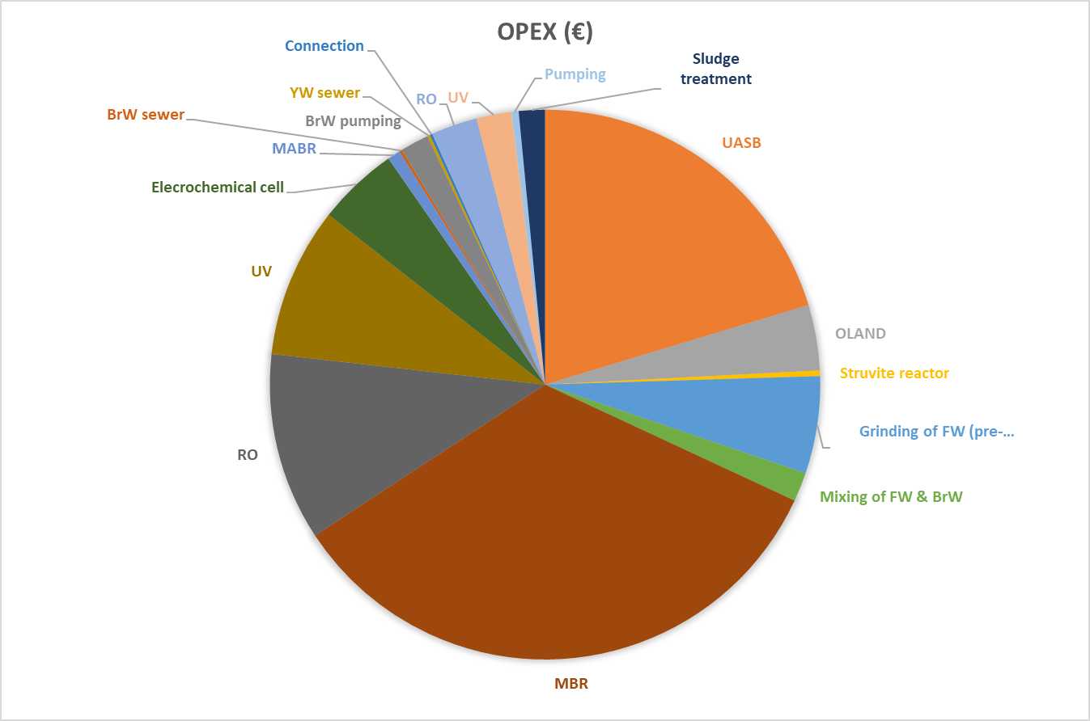

Fig. 8-2: Total Capital costs (CapEx) not including monitoring for all scenarios ($).

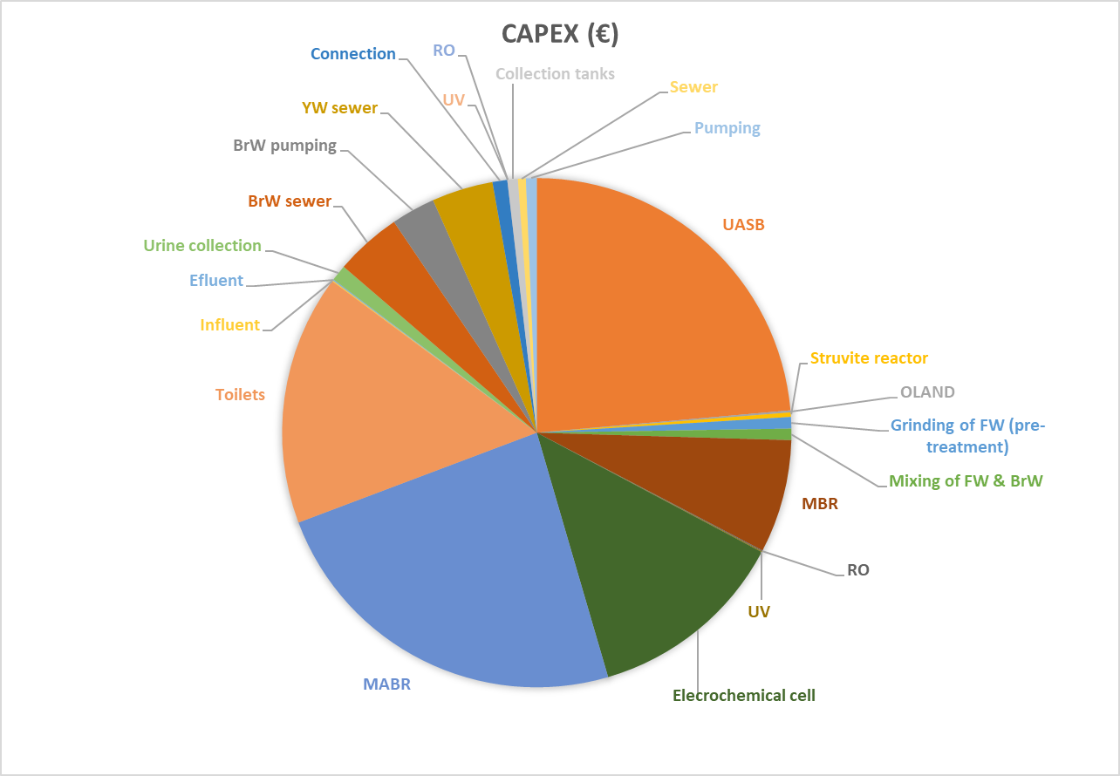

Table 8-6: Total costs for the housing development (city block) including monitoring.

Total costs
 | CAPEX (€) | OPEX (€/yr) | OPEX (€)
BrW+nrcYW+FW
UASB | 556,833.33 | 27,269.61 | 419,200.72
OLAND | 3,027.66 | 5,161.71 | 79,348.14
Struvite reactor | 6,740.11 | 443.83 | 6,822.73
Grinding of FW (pre-treatment) | 17,215.63 | 7,678.40 | 118,035.87
Mixing of FW & BrW | 17,116.00 | 2,282.77 | 35,091.75
Treated effluent (BR+nrcYW+FW) + GW
MBR | 169,679.61 | 45,368.58 | 697,426.31
RO | 1,388.72 | 14,792.46 | 227,396.37
UV | 1,174.60 | 11,833.97 | 181,917.10
Yellow Water
Elecrochemical cell | 300,000.00 | 6,396.30 | 98,326.81
MABR | 561,078.00 | 1,010.00 | 15,526.18
Toilets | 375,000.00
Equalisation & collection
Influent | 1,491.00
Effluent | 1,597.00
Urine collection | 24,000.00
Sewer
BrW sewer | 99,699.95 | 215.57 | 3,313.87
BrW pumping | 66,000.00 | 2,260.00 | 34,741.74
YW sewer | 91,751.44 | 215.57 | 3,313.87
Connection | 22,055.12 |  | 3,138.96
Rain Water
RO | 347.18 | 3,641.01 | 55,971.18
UV | 276.38 | 2,741.46 | 42,143.00
Collection tanks | 15,078.00
Sewer | 11,893.93 | 26.95 | 414.23
Pumping | 16,114.70 | 553.31 | 8,505.73
Monitoring sensors
Sludge treatment |  | 2,054.34 | 31,580.21
TOTAL | 2,359,558.36 |  | 2,062,214.76
**Biogas already accounted for in energy demand of UASB
Benefits | €/yr | €
Struvite; from struvite reactor | 974.47 | 14,979.97
YW; P from MEC | 192.35 | 2,956.92
YW; liquid fertilizer from MABR | 1,207,237.50 | 18,558,199.35
TOTAL | 1,208,404.32 | 18,576,136.24

Fig. 8-3: Total operational costs (OpEx) including monitoring for all scenarios ($).
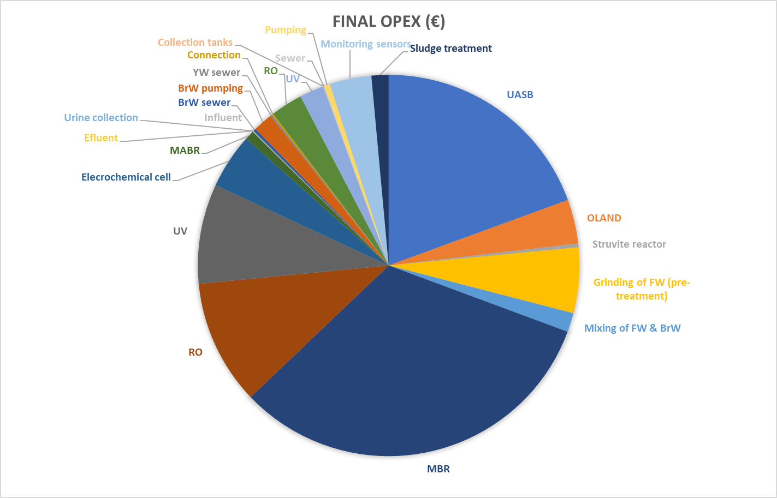

Fig. 8-2: Total Capital costs (CapEx) including monitoring for all scenarios ($).

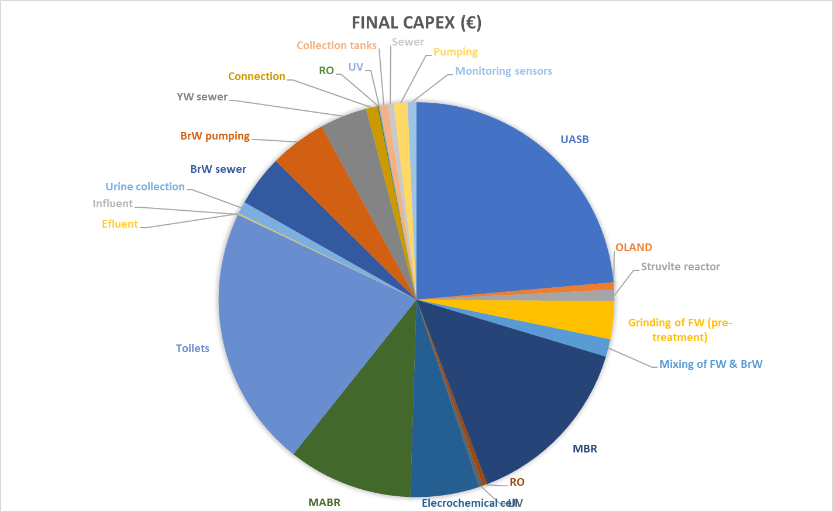

Total costs of synergetic scenarios

2nd term 2022 CONSTRUC | Simple Quality (€/m2) CAT | Average Quality (€/m2) CAT | High-End Quality (€/m2) CAT
Edificios entre medianeras (costs €/m2) - 3 types
Costs | 739.8 | 770.14 | 834.71
% plumbing | 2.14 | 3.65 | 5.36
Total to discount | 2.14 | 3.65 | 5.36
Final costs | 723.97 | 742.03 | 789.97
AVG EMEDOS | 861.23 |  | m2 per building | 8,040.00
AVG CONSTRUC | 751.99
Costs for city block
EMEDOS | Simple Quality (€/m2) CAT | Average Quality (€/m2) CAT | High-End Quality (€/m2) CAT | AVG
 | 6,299,897.09 | 6,579,339.95 | 7,893,539.86 | 6,924,258.97
CONSTRUC | 5,820,704.97 | 5,965,920.32 | 6,351,355.13 | 6,045,993.47

 | MAX CAT | EU-27
 | 63,148,318.90 | 65,075,251.04
 | DEC. | %
CONSTRUCTION COSTS EU-27 | D-SS CAPEX
65,075,251.04 | 2,318,850.33 | 3.18
CONSTRUCTION COSTS EU-27 | RW CAPEX
65,075,251.04 | 58,571.10 | 0.08
CONSTRUCTION COSTS EU-27 | VF CAPEX
65,075,251.04 | 2,468,709.50 | 3.38
CONSTRUCTION COSTS EU-27 | SOLAR ENERGY CAPEX
65,075,251.04 | 3,043,618.42 | 4.17
CONSTRUCTION COSTS EU-27 | TOTAL
65,075,251.04 | 7,889,749.35 | 10.81

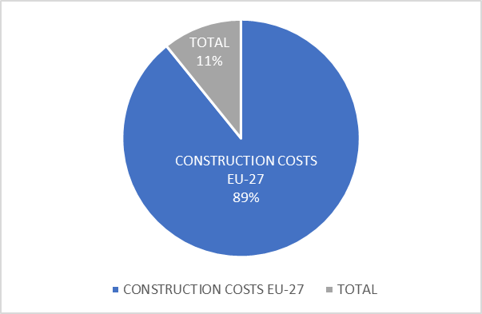

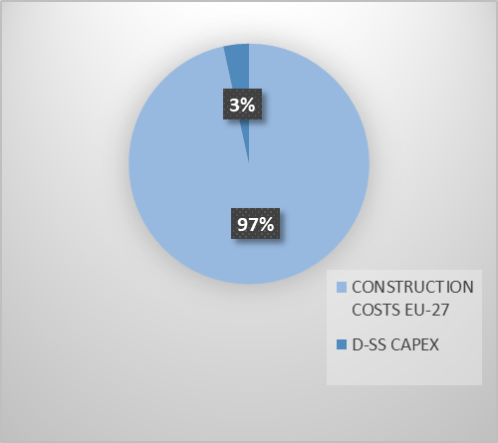

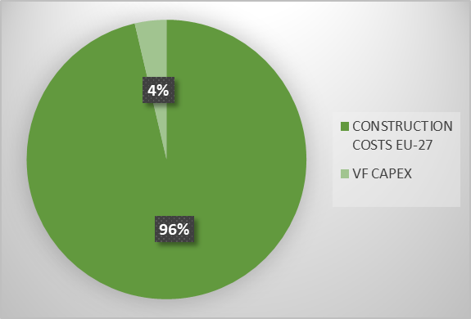

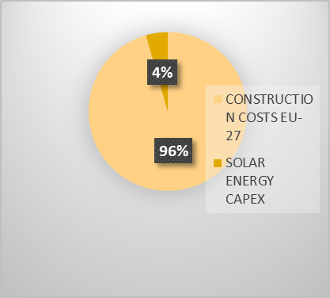

*Sim & Mauter, 2021 (does not include conveyance)
CAPACITY: AVERAGE (PROVIDING MORE THAN JUST ONE BLOCK)
 |  |  |  | *calculate for lower and upper bounds
COSTS OF STUDY |  |  | AVG
CAPEX | DPR | 1000 and 5300 $ per m3 d | 3150 | $/m3d
 | ONLY FAT | 1800 and 4100 $ per m3 d | 2950 | $/m3d
OPEX | ONLY FAT | 100 and 200 $ per m3 d*yr | 150 | $/m3d*yr
PLUMLEE ET AL. > FIND AVG CAPACITY
DPR | 4,874.16 | m3/day
*method A
FIND $/m3 |  | $/m3
11,431,250.00 | CAPEX (€) FAT | 0.40 | *plant life of 20 yrs > Giammar et al; Herman et al 2017
581,250.00 | OPEX (€/yr) FAT | 0.41 | 0.82 | Total $/m3
12,206,250.00 | CAPEX (€) DPR (includes DWT) | 0.43
 |  |  | *method B
*Keller et al 2022 |  | Treatments | CAPEX (€) | OPEX (€/yr) | for capacity
Advanced treatment train |  | MF+RO+UV combination | 8,908,000.00 | 529,820.00 | 3,875.00
 |  | $/m3 | 0.31 | 0.37 | 0.69
 |  | MF+RO+UV system | 15,500,000.00 | 904,000.00
 |  | $/m3 | 0.55 | 0.64 | 1.19
SEEC FAT continuous
SEEC FAT batch
SEEC FAT semi-batch
SEEC DPR w/o DWT
SEEC DPR + DWT (considered redundant)
SEEC IPR RO
SEEC IPR BAF
*Framework for Direct Potable Reuse
 | CAPEX (€/annualized) + OPEX (€/yr)
Groundwater desalinisation | 0.46 | 2.10 | range ($/m3) | Treatment + residuals/concentrate management+ conveyance
Seawater desalinisation | 1.98 | 3.57 | range ($/m3) | Treatment + residuals/concentrate management+ conveyance
Long distance transportation
Advanced treatment with RO + conveyance + residuals and concentrate management | 0.70 | 2.20 | range ($/m3) | : SEEC DPR w/o DWT
Conveyance |  | 0.81 | range ($/m3) | in range with calculations
  0.10
SEEC FAT continuous |  | Fully advanced treatment: MF/UF + RO + AOP | Lower bound | 0.69 | Total $/m3
SEEC FAT batch |  | Fully advanced treatment: MF/UF + RO + AOP | Higher bound | 0.82 | Total $/m3
SEEC FAT semi-batch |  | Fully advanced treatment: MF/UF + RO + AOP
SEEC DPR w/o DWT |  | Capacity | ~ 4000 (AVG) | 100000 | m3/day
 |  | Lower bound | 0.79 | 0.60
 |  | Higher bound | 1.63 | 1.43
SEEC DPR + DWT (considered redundant) |  | Capacity | ~ 4000 (AVG) | 100000 | m3/day
 |  | Lower bound | 0.94 | 0.74
 |  | Higher bound | 1.65 | 1.57
 |  | Capacity |  | 100000 | m3/day
SEEC IPR RO |  |  |  | 0.87
SEEC IPR BAF |  |  |  | 0.53
SEEC FAT continuous |  | Fully advanced treatment: MF/UF + RO + AOP | Lower bound | 1.86 | Total $/m3
SEEC FAT batch |  | Fully advanced treatment: MF/UF + RO + AOP | Higher bound | 2.24 | Total $/m3
SEEC FAT semi-batch
SEEC DPR w/o DWT |  | Capacity | ~ 4000 (AVG) | 100,000.00 | m3/day
 |  | Lower bound | 1.96 | 1.77
 |  | Higher bound | 3.05 | 2.85
SEEC DPR + DWT (considered redundant) |  | Capacity | ~ 4000 (AVG) | 100,000.00 | m3/day
 |  | Lower bound | 2.11 | 1.91
 |  | Higher bound | 3.08 | 2.99
 | 100,000.00 | m3/day | lower bound | upper bound
SEEC IPR RO |  |  | 2.04 | 2.29
SEEC IPR BAF |  |  | 1.70 | 1.95
 |  |  | low | high
Seawater desalinisation |  |  | 1.67 | 3.42 | Wittholz et al
Groundwater desalinisation |  |  | 1.50 | 1.90 | Qtaishat et al

*Herman et al, 2017 (not included: conventional WWT, water lost at RO, disposal of sludge)
SCE 1: purchase of water rights (DWTP treatment) |  |  |  |  | BAF | Biologically active filtration
SCE 2: | IPR: Advanced treatment (RO or BAC + MF +UV) + aquifer + conveyance (need to add DWT) |  |  |  | BAC | Biologically activated carbon
 | SEEC IPR RO
 | SEEC IPR BAF (it is BAC) | e |  |  | Capacity
SCE 3: | Advanced treatment + DWT + conveyance |  |  |  | 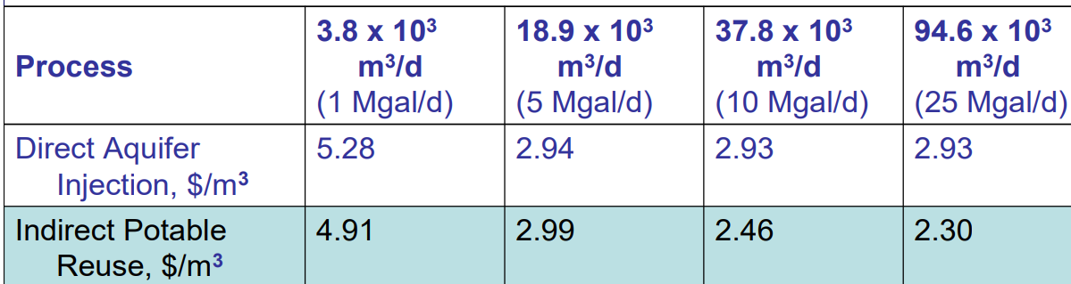 | m3/day
  94,635.29
 | SEEC DPR + DWT (considered redundant); with RO
SCE 4: Advanced treatment + conveyance (DPR)
 | SEEC DPR w/o DWT
 | SEEC FAT continuous
 | SEEC FAT batch |  | + | conveyance
 | SEEC FAT semi-batch
 | CAPEX ($) | $/m3 | OPEX ($/yr) | $/m3 | Total $/m3 | W/ RO
SCE 1 | 494,100,000.00 | 0.72 | 3,700,000.00 | 0.11 | 0.82
SCE 2
SEEC IPR RO | 243,600,000.00 | 0.35 | 9,400,000.00 | 0.27 | 0.62 | 0.73
SEEC IPR BAF | 181,600,000.00 | 0.26 | 4,400,000.00 | 0.13 | 0.39
SCE 3
SEEC DPR + DWT (considered redundant); with RO | 178,300,000.00 | 0.26 | 12,900,000.00 | 0.37 | 0.63 | 0.74
SCE 4
SEEC DPR w/o DWT | 178,300,000.00 | 0.26 | 9,200,000.00 | 0.27 | 0.52 | 0.61
*Keller et al 2022 |  | Treatments | CAPEX (€) | OPEX (€/yr) | for capacity
Advanced treatment train |  | MF+RO+UV system | 173,000,000.00 | 13,900,000.00 | 100,000.00 | m3/day
 |  | $/m3 | 0.24 | 0.38 | 0.62 | Total $/m3
 |  | MF+RO+UV system | 93,000,000.00 | 13,733,000.00
 |  |  | 0.13 | 0.38 | 0.50 | Total $/m3
*RATIO FOR CONSIDERING 85% RECOVERY IN RO |  |  | 0.854332855 | 2.94826 | (85% RO)
 |  |  |  | 2.51880 | (100% RO)

Capdetworks CAS plant for 30000 PE
4,440.00 | m3/d | 1,620,600.00 | m3/yr
8,850,000.00 | € CAPEX TOTAL
1,123,700.00 | € OPEX/YR TOTAL
30 | yr plant life
17,274,023.22 | € OPEX ALL YRS
26,124,023.22 | € 30 YR
0.54 | €/m3
ADDITIONALLY
Pumping to waterworks | included |  | €/m3
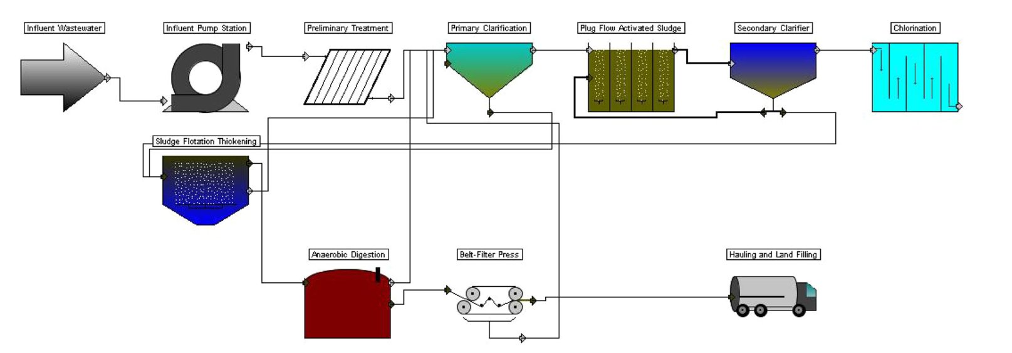 | 0.9 |  | €/m3
  Water distribution
Wastewater collection | included |  | €/m3
Total | 0.9 |  | €/m3
Capdetworks CAS plant Jafarinejad
1,752,000.00 | m3/yr
12,200,000.00 | € CAPEX TOTAL
992,600.00 | € OPEX/YR TOTAL
30 | yr plant life
15,258,694.89 | € OPEX ALL YRS
27,458,694.89 | € 30 YR
0.52 | €/m3
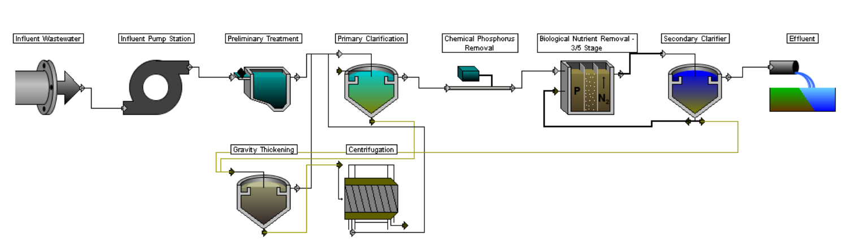

Direct / indirect potable water reuse *Tow et al., 2021
ENERGY DEMAND
Advanced treatment
Pre-treatment
MF | 0.18 | kWh/m3
UF | 0.2 | kWh/m3
RO | 0.6 | kWh/m3 permeate
*SEEC of brine disposal considered negligible
 | 0.85 | recovery ratio
 | *concordance w/ Giammar et al
Advanced oxidation processes (AOP)
UV-based | 0.11 | kWh/m3
Ozone-based
0.5 | 1.5 | (range) mg ozone/mg dissolved organic matter
6 | 18 | (range) kWh/kg ozone
UV-O3 oxidation | 0.15 | kWh/m3
Granular media filtration (GMF)
0.16 | 0.32 | (range) kWh/m3
Granular activated carbon (GAC)
0.37 | kWh/m3
Additional treatments
Soil aquifer treatment (SAT) - IPR
0.48 | kWh/m3
Distribution of potable water
0.14 | kWh/m3
0.85 | recovery ratio
Conventional drinking water treatment
0.23 | kWh/m3
Alternative augmentation techniques
RO desalinisation
3.5 | 4.5 | (range) kWh/m3
Long distance water transfer
0.5 | 1.4 | (range) kWh/m3

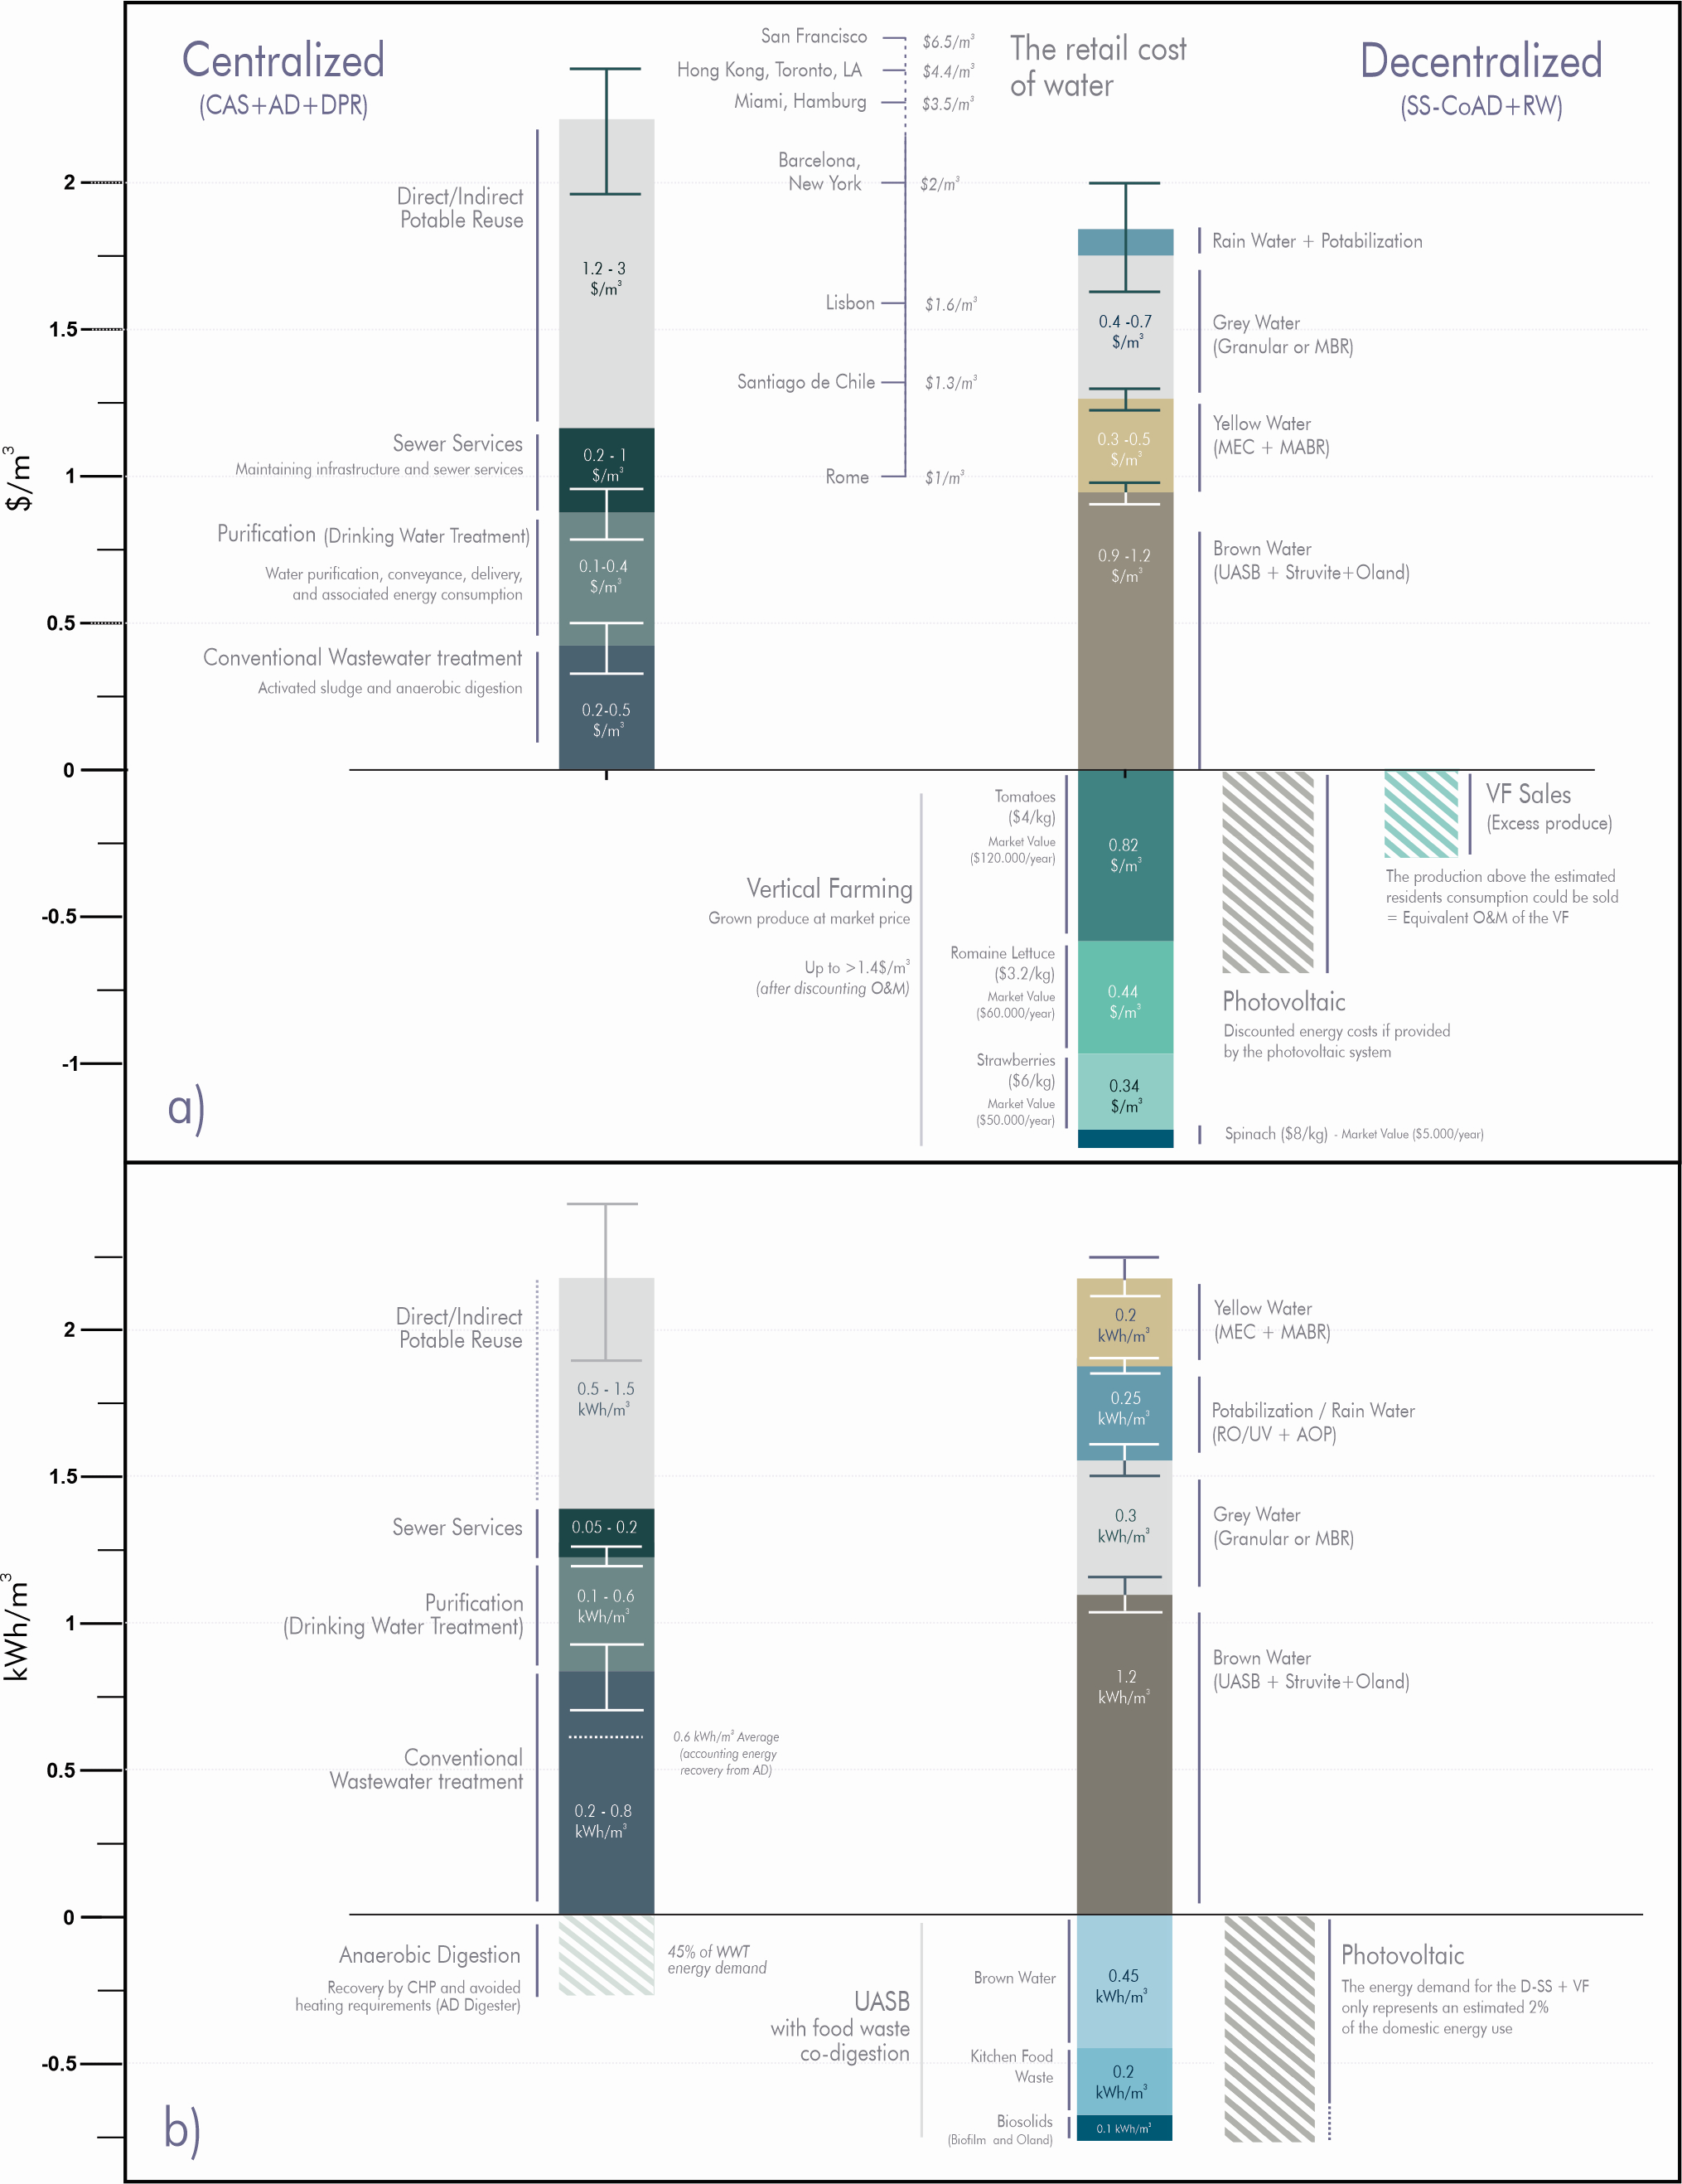
Therefore, the difference between the main water costs (i.e., treatment, potabilization, and sewer) and the billed water costs in different cities not only illustrates the complexity of water economics, but also that when excluding regional disparities and recognizing societal services as resilience or recycling, the costs between the centralized and decentralized approaches are comparable. The conventional centralized system has an approximate cost of 1.2±0.5$/m³ without considering any recycling capability and taking advantage of an already-built infrastructure and the economies of scale (SS). Even if the D-SS can lower the overall operational costs (due to higher recovery efficiencies) when compared to the conventional approach, the need to adapt the infrastructure (i.e., NoMix toilets, brown-yellow lines, remote monitoring and control, etc.) still results in higher overall costs 1.8±0.3$/m³. Nevertheless, as the D-SS approach enables the recycling of 85-95% of the water, a more realistic comparison with the centralized paradigm should also consider the cost of either direct or indirect potable reuse to account for such resilience-enhancing capability. Centralized potable reuse strategies also vary significantly in cost and type, but the most common and benchmarked alternatives are in the range of 1.2-2$/m³ (Keller et al., 2021). The addition of potable reuse would significantly increase the overall cost of water (2±0.5$/m³), but it would allow a more comprehensive comparison with the D-SS approach given they would provide the same societal service (i.e., drinking-quality water without taping on traditional supply sources). Using this comparison, the costs of the decentralized system would be lower than the combination of the conventional system when augmented with reuse potable strategies.

SIMBA model overview
We developed a series of models based on the source-separation concept to investigate the feasibility of implementing decentralized water and wastewater treatment systems. The models were built following the recommendations of the IWA Guidelines for Using Activated Sludge Models (Rieger et al. 2012a) and using the advanced modelling platform SIMBA# [v4.2]. All the models were designed with the energy-producing anaerobic co-digestion process as the main treatment with the influent flows derived from a source separation approach (i.e., organic waste and brown, yellow, and grey water) instead of using the energy-intense conventional aeration-based treatment (i.e., activated sludge), which do not follow a source separation approach. The developed models for the mainstream process were built on an adapted biokinetic model based on ADM1 (Anaerobic Digestion Model) of the International Water Association. The adapted models were specifically built to allow the solving of multiple substrates (i.e., food, agricultural, and industrial wastes), including brown and black water streams (i.e., toilet-captured flows), and it was modified to consider pH changes in the internal pH value calculation by using a specific algebraic equation solver.
The corresponding aeration system for the grey water flow (i.e., showers, faucets flows, garage, garden) and the biofilm-based nitrogen removal sub-system used the inCTRL-ASM biokinetic model developed by the Institut für Automation und Kommunikation (ifak 2017). To construct the layout of the aeration system, we included blowers, pipes, fittings, valves, and diffusers mechanistic models for each actuator. The piping system was modelled using the Darcy–Weisbach equation, with the friction factor calculated using the Swamee & Jain (1976) equation. The pressure rise across blowers and pressure drops across valves and diffusers are calculated using polynomial functions based on airflow rate, which have been calibrated using manufacturer data. More information on the aeration system models can be found in Schraa et al. (2015). Aeration control was accounted for by means of continuous feedback using proportional-integral or proportional-integral-derivative (PID) control algorithms. To model the behavior of the automatic valves, a control algorithm was implemented that fixes the valve position of the lane with the highest oxygen requirement and allows the other valve to vary to adjust the required airflow.
The sub-system for the nitrogen removal of the effluent generated in the anaerobic co-digestion mainstream process was modeled with an in-house inCTRL-ASM biofilm-based biokinetic model, which includes two-step nitrification and the growth of anammox bacteria (AMX), in addition to hydrolysis, adsorption, fermentation, and the growth of ordinary heterotrophic organisms (OHO), phosphorus accumulating organisms (PAO), and methylotrophs. The anammox biokinetic sub-model was based on the model of Koch et al. (2000), and the value of the half-saturation coefficient for oxygen was determined based on data reported by Strous et al. (1997).
Simulation results were cross-checked with an Excel-based model exclusively built for this project. The Excel-based model was used to calculate in steady-state conditions the size, cost, performance, and main technical details of all necessary equipment units and correlate, through engineering-based equations, all collected knowledge from literature, manufacturers, and specialized software (e.g., Capdetworks, etc.). The simulation results were further cross-checked with complementary software specialized in source separation modelling [Sampson; Zinati, 2021] and software to provide detailed mass and energy flow analysis [e!Sankey; Barnosell, 2023] (SS).

The SIMBA modules
The source separation-based model is applied to one of the urban development scenarios (city block). The D-SS scenario was simulated using the modeling software SIMBA#, which was augmented with manufacturing specifications and available technical literature. The separation-based model comprises five main modules: the Anaerobic Digestion Module, the Nitrogen Recovery Module, the Co-Digestion Module, the Greywater Module, and the Rainwater Harvesting Module.

- The Anaerobic Digestion Module
- The Nitrogen Recovery Module
- The Co-Digestion Module
- The Greywater Module
- The Rainwater Harvesting Module.

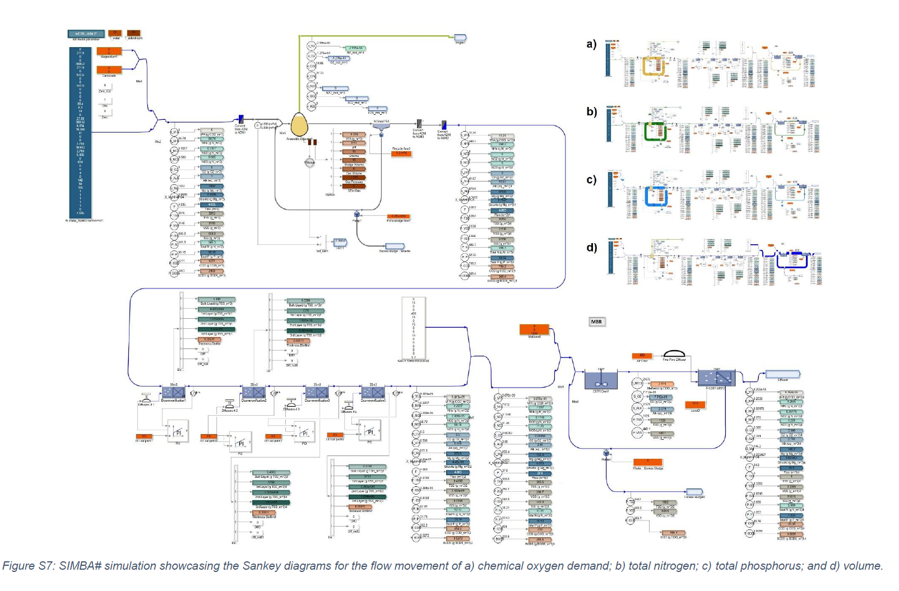
SIMBA# simulation showcasing the Sankey diagrams for the flow movement of a) chemical oxygen demand; b) total nitrogen; c) total phosphorus; and d) volume.

The Anaerobic Digestion Module
The Anaerobic Digestion (AD) module consists of an up-flow anaerobic sludge blanket reactor (UASB) with simultaneous struvite precipitation, treating approximately 10% of the system's flow, which includes brown water and organic waste. This module was constructed using an adapted biokinetic model based on ADM1 (Anaerobic Digestion Model). The UASB is designed with a hydraulic retention time (HRT) of 7.15 days and a solids retention time (SRT) of 30 days. It features a degassing membrane contactor and a reactor for gas and liquid separation. The total space requirements for this module are approximately 40 m³, encompassing the UASB (20 m³), struvite precipitation (4 m³), digestate tanks (5 m³), microturbines (3 m³), chemical dosing (1 m³), and monitoring equipment (2 m³). The produced biogas is used for energy production, contributing to approximately 60% of the energy requirements. The module also yields struvite precipitate (18% P recovery and 3% N recovery) and digestate (60% P recovery and 15% N recovery).

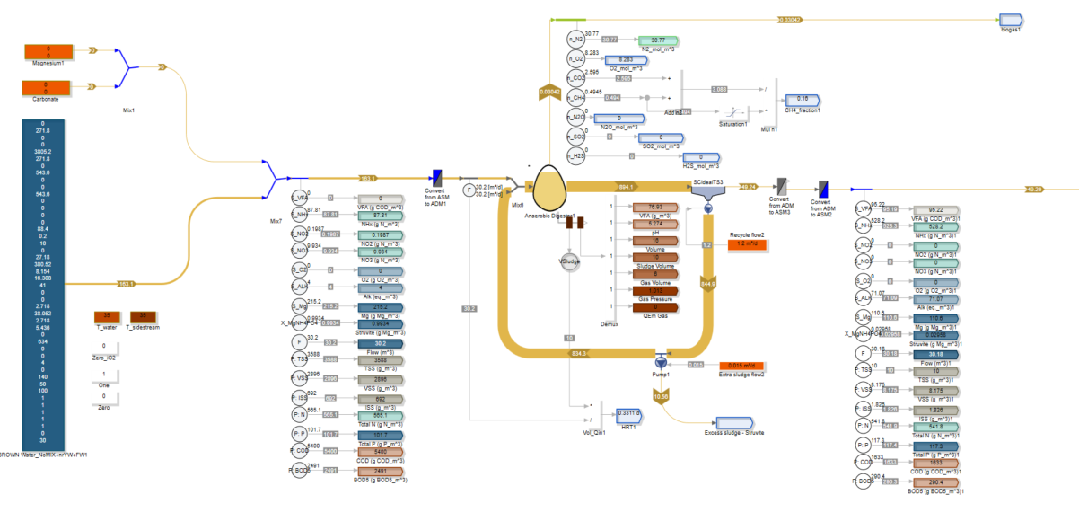

The Nitrogen Recovery Module
The nitrogen removal module, responsible for treating effluent from anaerobic co-digestion, is modeled using a single-stage OLAND process, suitable for decentralized, small-scale treatment systems with high organic matter loads. The main goal of the process is to reduce the nitrogen concentration, which is reduced by approximately 65-70%. The Oland model is constructed with an in-house inCTRL-ASM biofilm-based biokinetic model, incorporating two-step nitrification and the growth of anammox bacteria (AMX), as well as other processes like hydrolysis, adsorption, fermentation, and the growth of various organisms. To avoid algebraic issues due to the small size of the decentralized unit, the nitrogen removal module utilizes four scaled-up reactors instead of a single reactor. This module requires approximately 5 m³ of space, including a monitoring station and equipment. The aeration system for the nitrogen module is integrated with the Grey Water Module's aeration system.

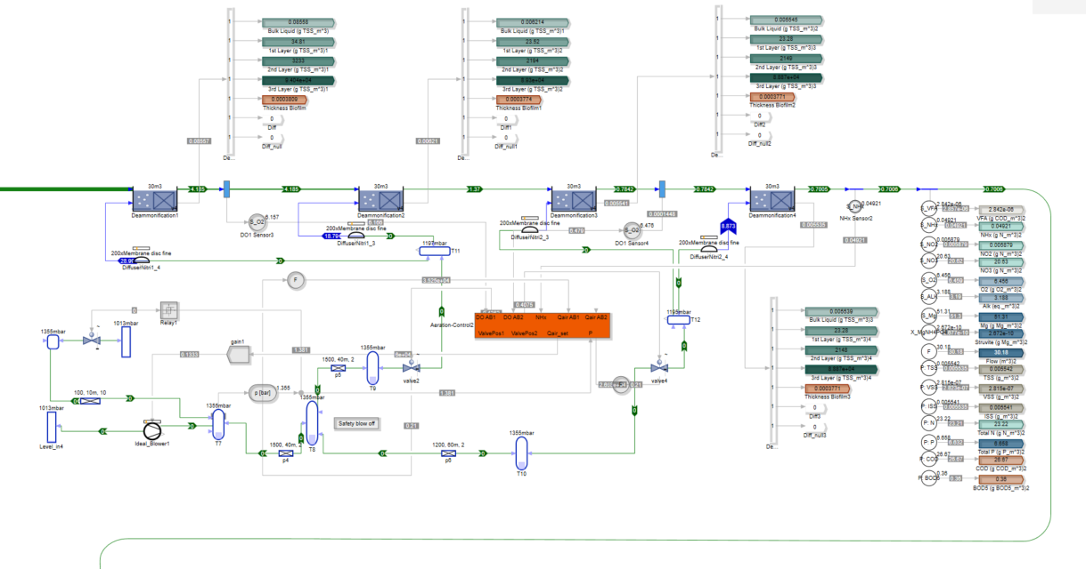

The Co-Digestion Module
The co-digestion module collects, manages, and inventories the mixture of organic waste feedstocks for the co-digestion process to achieve the desired composition. Unlike anaerobic digestion from brown water, co-digestion faces challenges due to the variability of organic waste sources from restaurants, households, stores, etc., which can vary in composition (fats, proteins, and carbs), affecting key parameters like carbon:nitrogen ratios, volatile fatty acids accumulation, alkalinity, and more. The addition of organic waste can increase the brown flow by 5-10% (up to 15% of the system's flow), depending on the number and quantity of eligible sources. The co-digestion module is integrated into the existing anaerobic digester (UASB) and employs an adapted biokinetic model based on ADM1, implemented using SIMBA#. This model can handle multiple substrates, including food, agricultural, and industrial wastes, as well as brown and black water streams (toilet-captured flows). It has been modified to consider pH changes in the internal pH value calculation using a specific algebraic equation solver. The total space requirements for the co-digestion module are estimated at approximately 10 m³, including an influent pit (5 m³), mixing area (2 m³), storage of high-strength feeds (2 m³), and all required monitoring (1 m³). Co-digestion in this scenario increases the energy recovery from anaerobic digestion from 45% to over 60%.

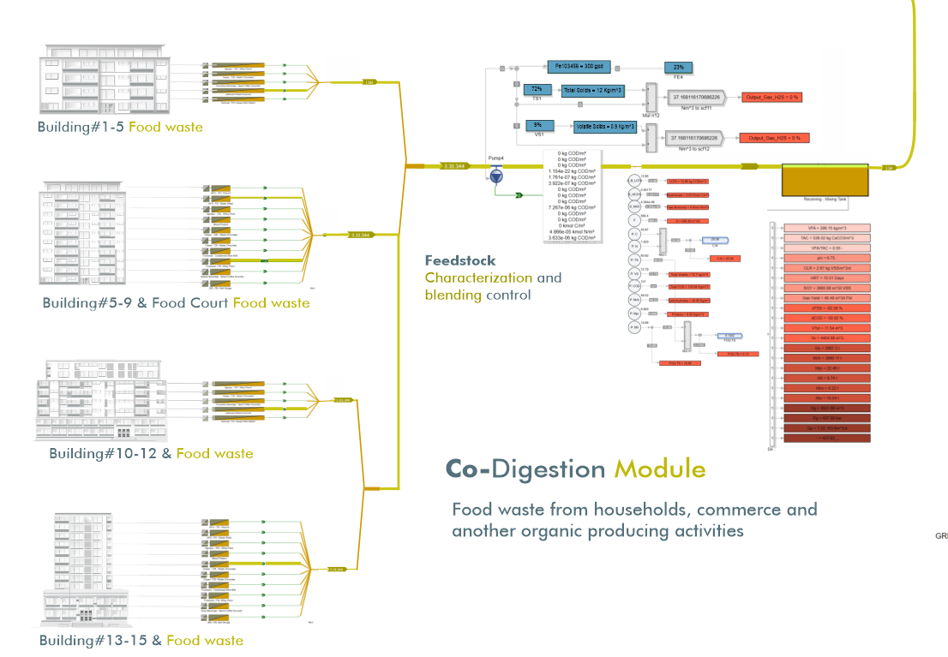

The Greywater Module
The greywater module aims to treat greywater flows (e.g., showers, faucets, garage, garden, etc.) to potable quality water, even when non-potable uses are considered. While greywater flows make up to 85% of the system's flow, their concentrations of COD, N, and P are only 15%, 2%, and 7%, respectively. To treat this low-strength stream, two main scenarios are considered: the use of a membrane bioreactor (MBR) or the Nereda Process (granular-based technology). Both processes are modeled using an inCTRL-ASM biokinetic model under the SIMBA# platform.
For the granular-based Nereda scenario, a variable volume biofilm model is employed. This model allows for the modeling of granular sequential bioreactors (GSBRs) without the need for a separate variable volume tank and a recycle stream. The model predicts biofilm thickness, allows for non-uniform biofilm geometries, and models the impact of mixing intensity on the biofilm detachment rate. The Nereda model combines existing biofilm and sequencing batch reactor (SBR) models within the SIMBA# platform. In the case of the MBR scenario, the space requirements are approximately 200 m³, which includes the main MBR system and related equipment (150 m³), equalization tanks (30 m³), and purification-related treatment (10 m³).
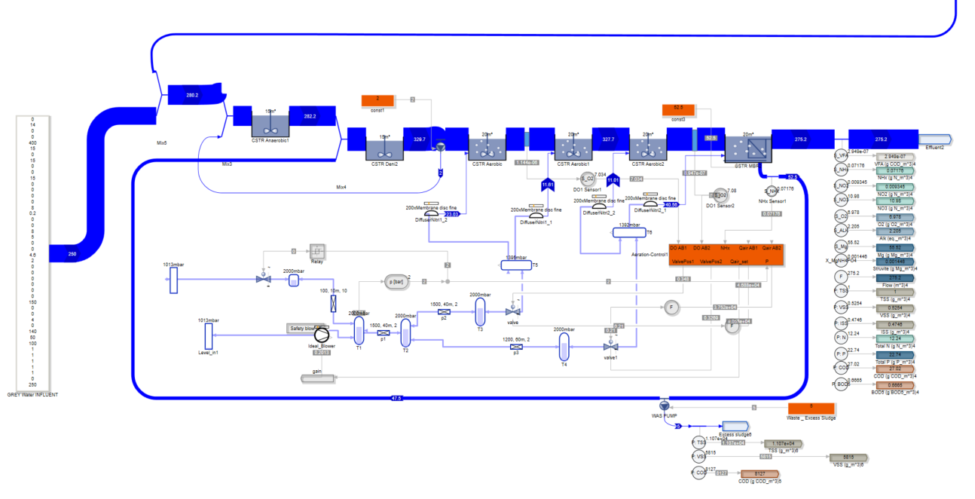
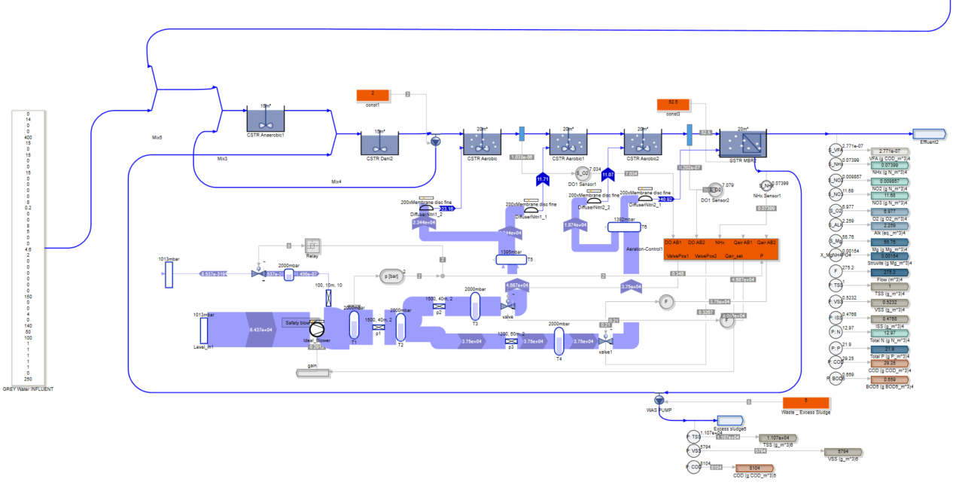

The Rainwater Harvesting Module
The rainwater treatment module, also created in SIMBA#, estimates the collection and storage of rainwater and calculates the water quality parameters. The model simulates the redirection of harvested flows into designated rain tanks, accounting for different rain patterns in various climatic regions. The harvested water is stored for later use and goes through pre-filters, in-tank filtration, reverse osmosis (RO), and a tailored UV treatment combination. The model supports the analysis of the mixing of two different potable water sources, centralized supply and treated roof-harvested water. It enables the control of drinking water quality, speciation and the calculation of parameters such as buffering capacities, ionic strength, alkalinity, hardness, and calcite saturation. The space requirements for this module are estimated at 20-40 m³, primarily due to storage tanks, which can vary based on storage goals or capabilities, along with equalization tanks (30 m³), while the required equipment occupies less than 2-3 m³.

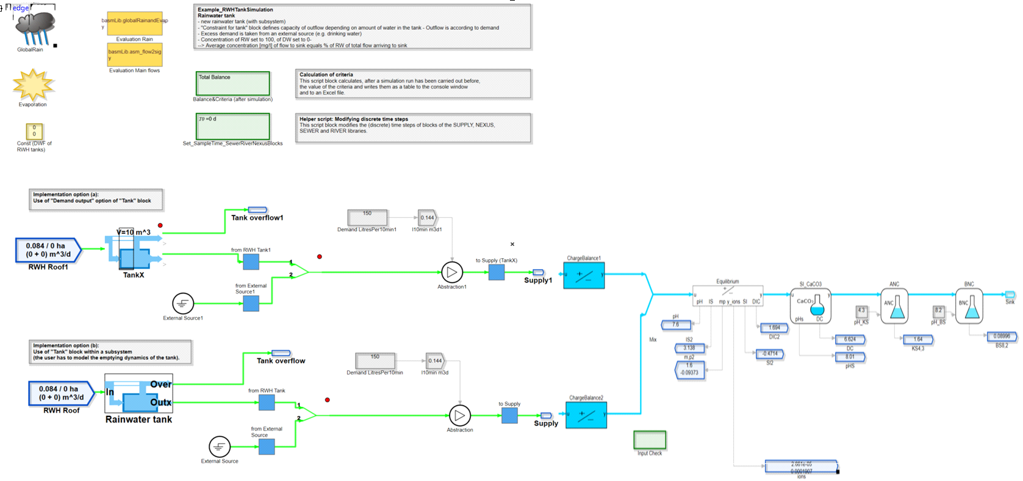
.

Material flow analysis and SIMBA# models
Complementary MFA figures showcasing the movement of the components in water and flow volumes through the system individually. Sankey diagrams obtained from the simulation program are added to showcase conformity with the flows calculated through MFA in a visual manner.
Figure S1 focuses on organics, which are the main component of BrW and are mostly eliminated in the UASB reactor, where biogas production can be observed both in the MFA and SIMBA# Sankey diagrams. The additional COD input originating from GW production is tackled in the MBR.
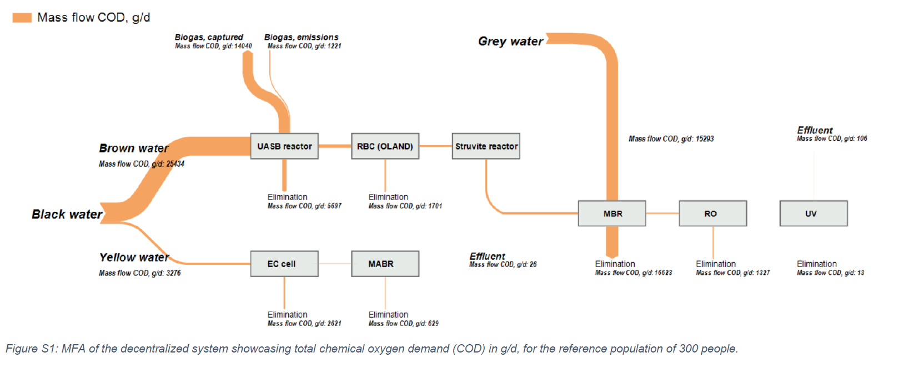

Figure S2 helps assess the efficiency of nitrogen recovery achieved in the system. The main nitrogen source is BW, including the highest presence in YW and a significant amount of pollutants in BrW. GW has a low nutrient content, but its representation helps identify losses and put in evidence how the anammox process helps eliminate almost 24% of input nitrogen, while up to 61% is recovered mostly in the MABR.
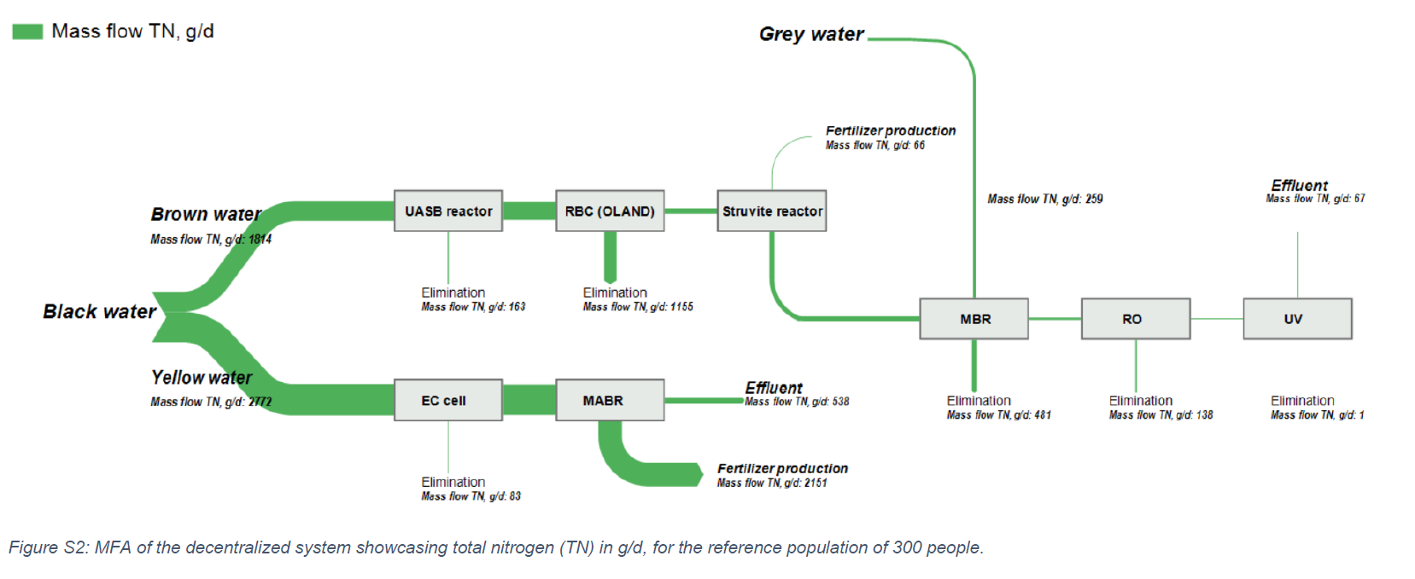

Figure S3 shows phosphorus loads in the system, which, similarly to nitrogen, is mostly found in BW. As observed, it is mainly recovered as struvite in the struvite reactor, and the MBR and MABR show high removal efficiencies of up to 80% and 70%, respectively, achieved thanks to the combination of membranes and biological treatment.
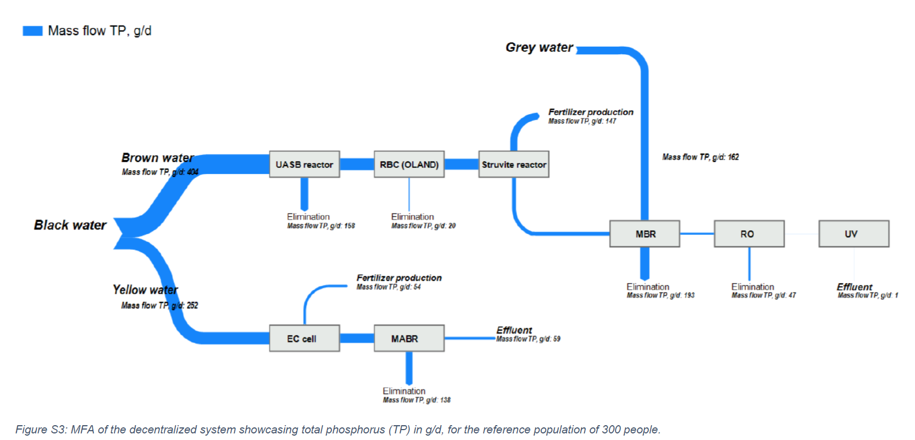

Figure S4, Figure S5, and Figure S6 showcase the decentralized system, decentralized system with sludge line, and centralized treatment MFAs elaborated for pollutant loads without flows of organics to help better understand the losses and recoveries of nutrients in the system, which are prioritized for treatment selection and for setting operation conditions.
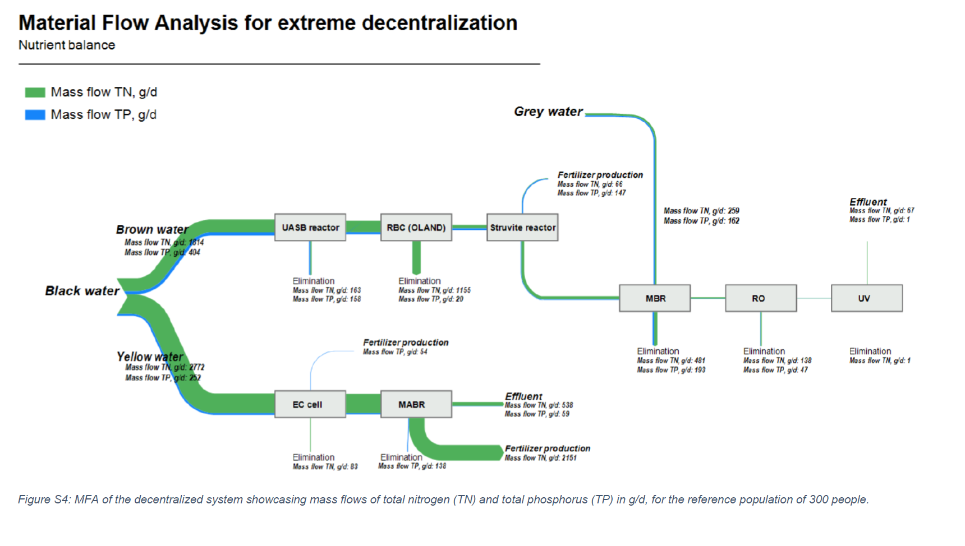

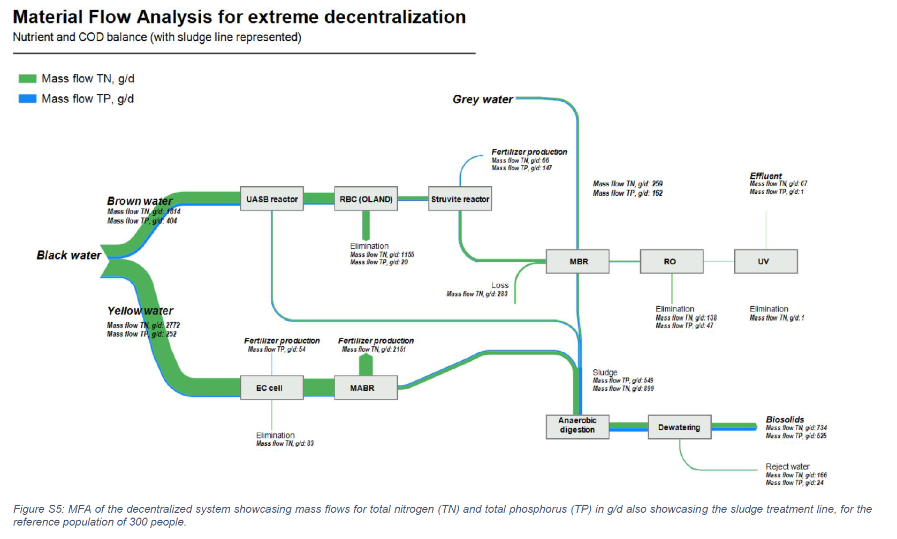

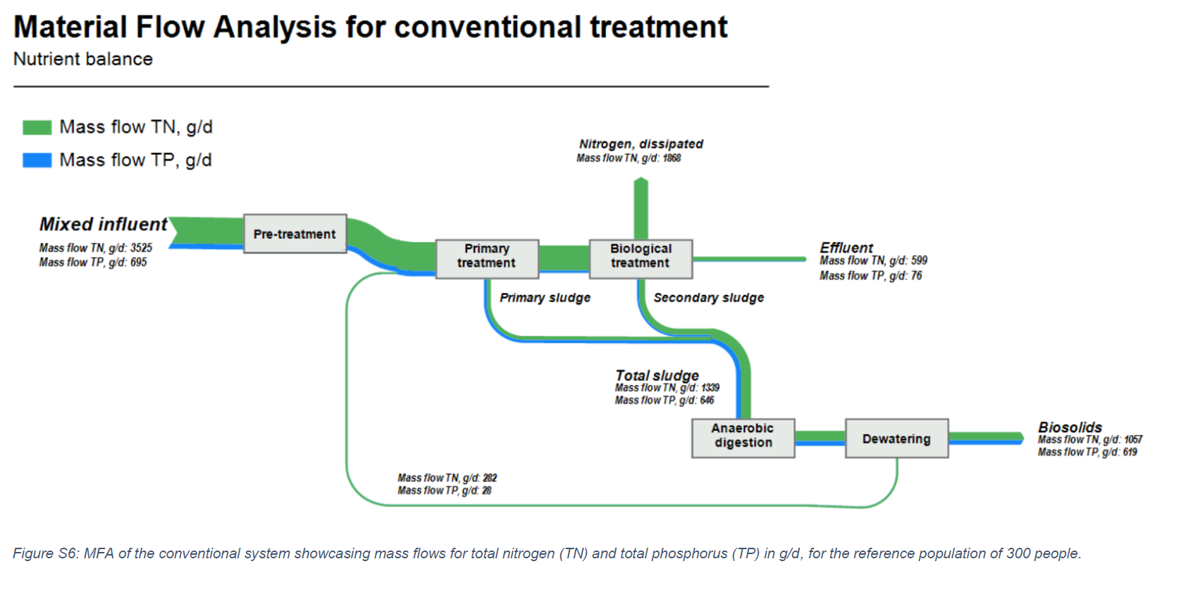

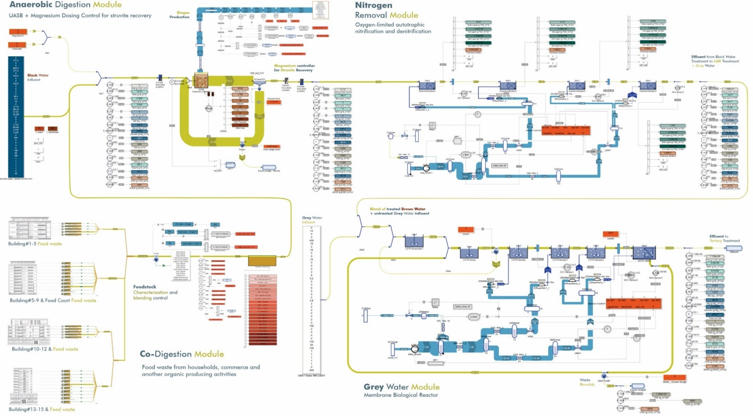
Figure. The source separation-based model in an urban cluster [city block] was obtained by the modeling software SIMBA#. The visual represents a Sankey diagram of TKN mass flow, g N /day (green), and the biogas and air flows, m3/day (light blue). The model includes three main types of controllers: a) Chemical dosing of magnesium for struvite recovery; b) Aeration controllers for both Oland and MBR/Nereda oxygen requirements; c) co-digestion module for the appropriate blending of feedstocks properties (i.e... organics from households, commerce, restaurants, etc.).
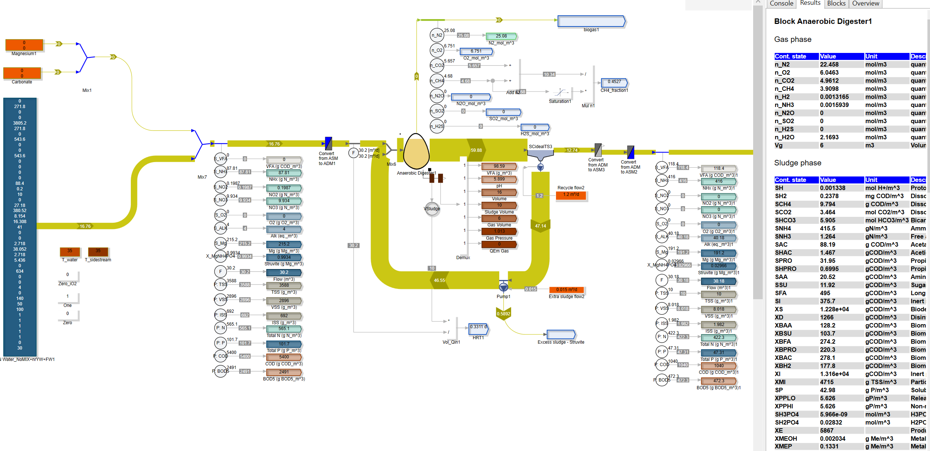
Figure. The visual represents a Sankey diagram of TKN mass flow, g N /day (green), of the main anaerobic co-digestion treatment receiving brown water and urban-derived feedstocks (i.e... organics from households, commerce, restaurants, and the anaerobic digester includes the chemical dosing of magnesium for struvite recovery;

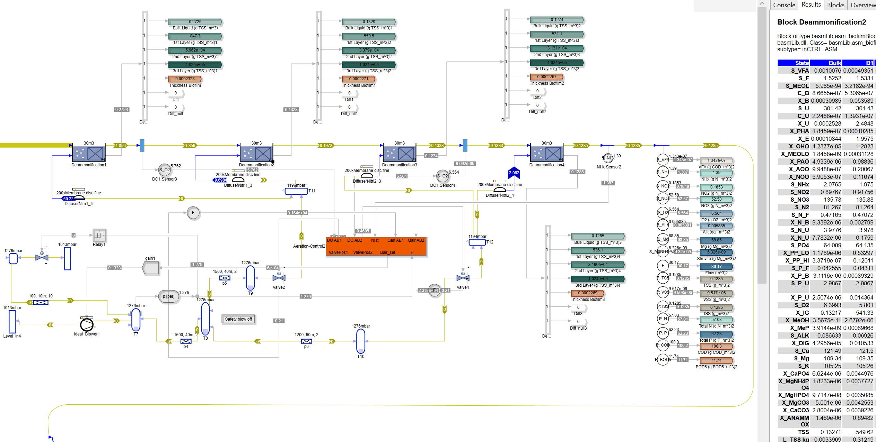
Figure. The sub-system for the nitrogen removal of the effluent generated in the anaerobic co-digestion mainstream process was modeled with an in-house inCTRL-ASM biofilm-based biokinetic model. The biofilm-based model predicts the biofilm thickness without being constrained by a maximum thickness, allows non-uniform biofilm geometries, and models the impact of mixing intensity on the biofilm detachment rate. The model combines the existing biofilm and sequencing batch reactor (SBR) models in SIMBA# (see ifak, 2017 for details). The model also allows the area and the surface of the biofilm media to facilitate the modeling of membrane-aerated biofilm reactors (MABRs).

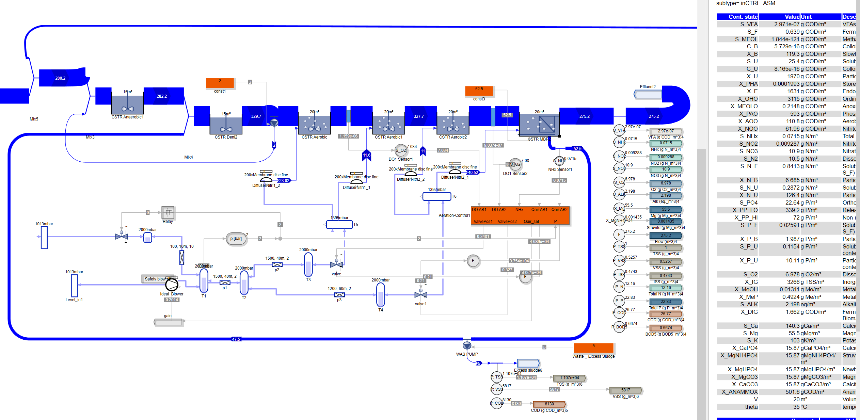
Figure. Membrane bioreactor in SIMBA#, which includes aeration controllers for both Oland and MBR oxygen requirements.

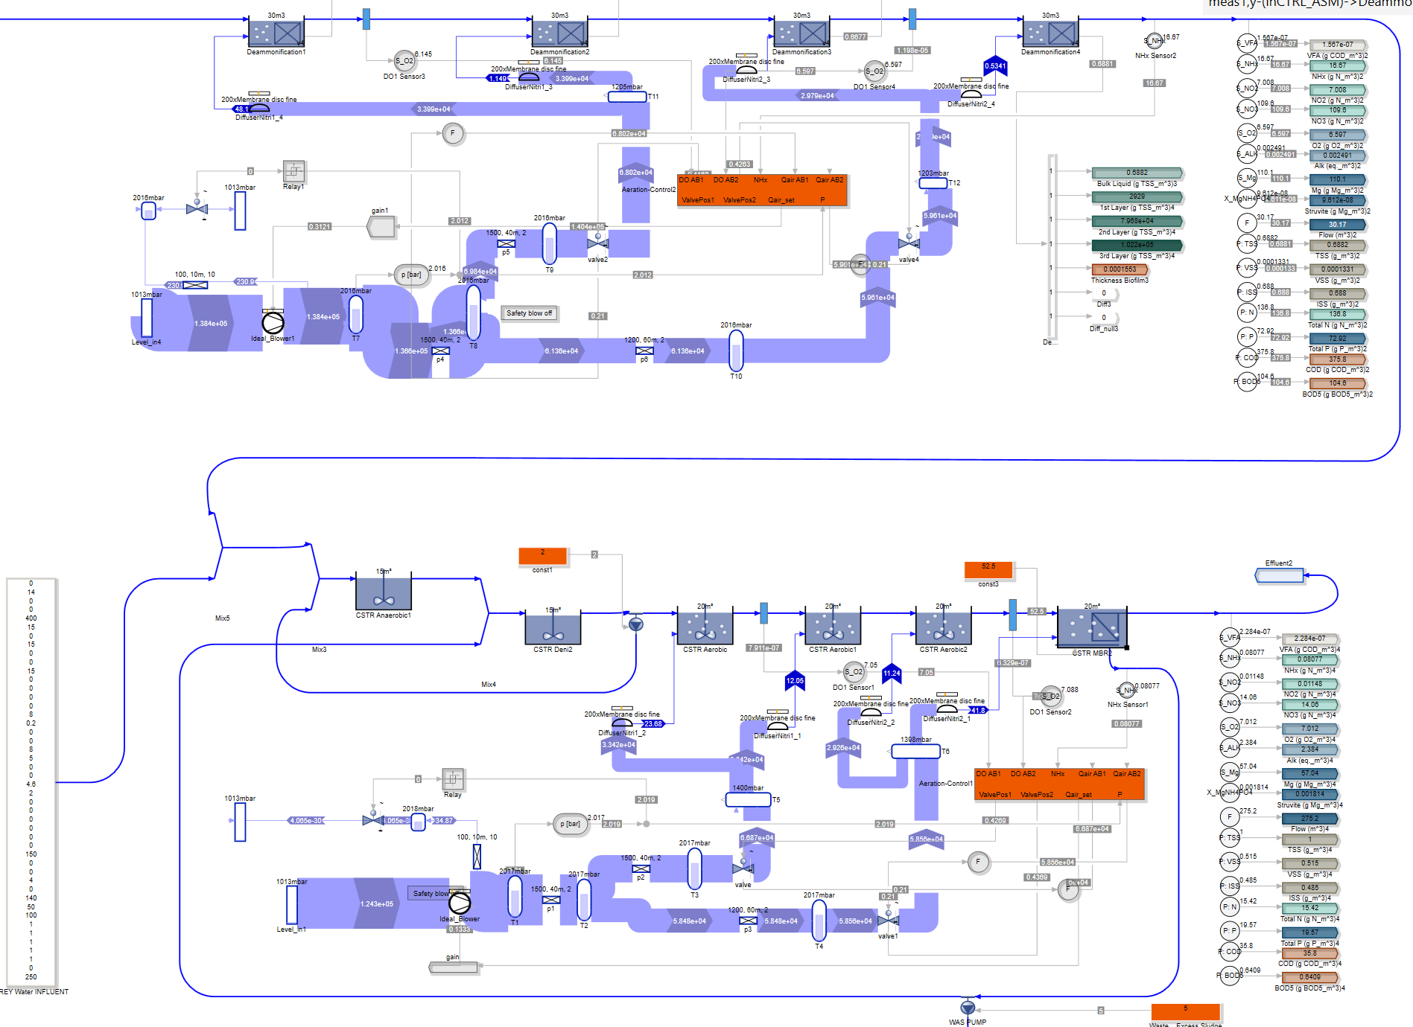
Figure. Membrane bioreactor in SIMBA#, which includes aeration controllers for both Oland and MBR oxygen requirements. To construct the layout of the aeration system, we included blowers, pipes, fittings, valves, and diffusers mechanistic models for each actuator. The piping system was modelled using the Darcy–Weisbach equation, with the friction factor calculated using the Swamee & Jain (1976) equation. The pressure rise across blowers and pressure drops across valves and diffusers are calculated using polynomial functions based on airflow rate, which have been calibrated using manufacturer data. More information on the aeration system models can be found in Schraa et al. (2015).
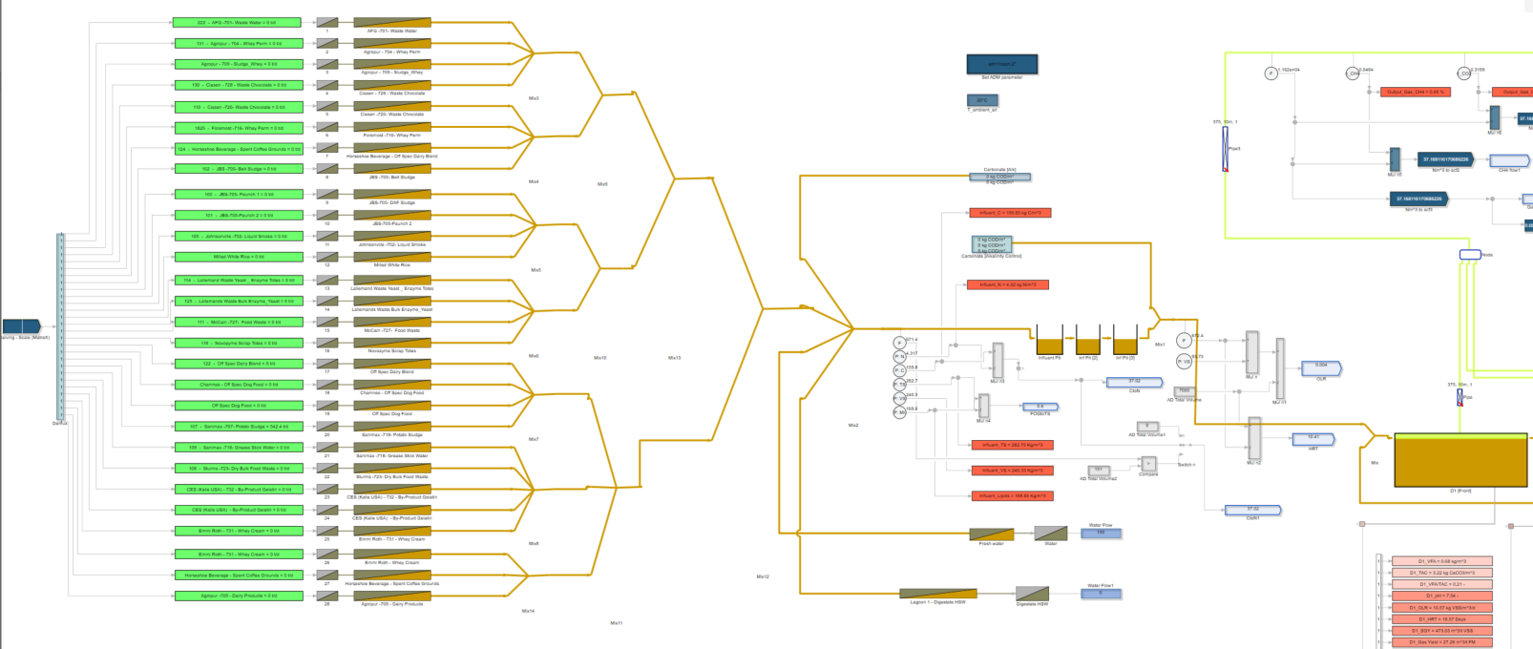
Figure. co-digestion module for the appropriate blending of feedstocks properties (i.e... organics from households, commerce, restaurants, etc.).

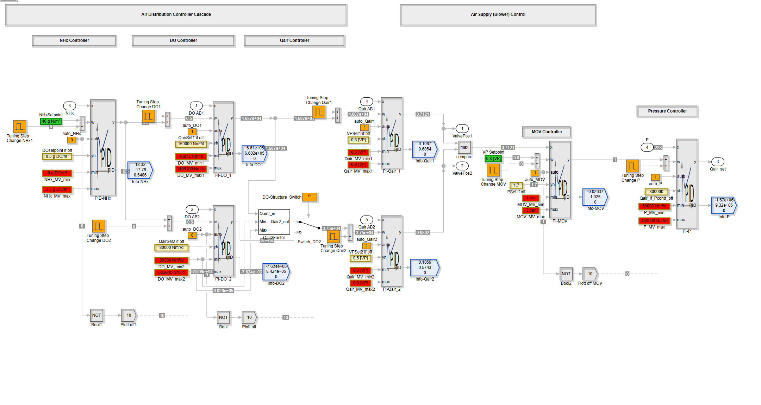
Figure. Aeration controllers for both Oland and MBR oxygen requirements. More information on the aeration system models can be found in Schraa et al. (2015). Aeration control was accounted for by means of continuous feedback using proportional-integral or proportional-integral-derivative (PID) control algorithms. To model the behavior of the automatic valves, a control algorithm was implemented that fixes the valve position of the lane with the highest oxygen requirement and allows the other valve to vary to adjust the required airflow.

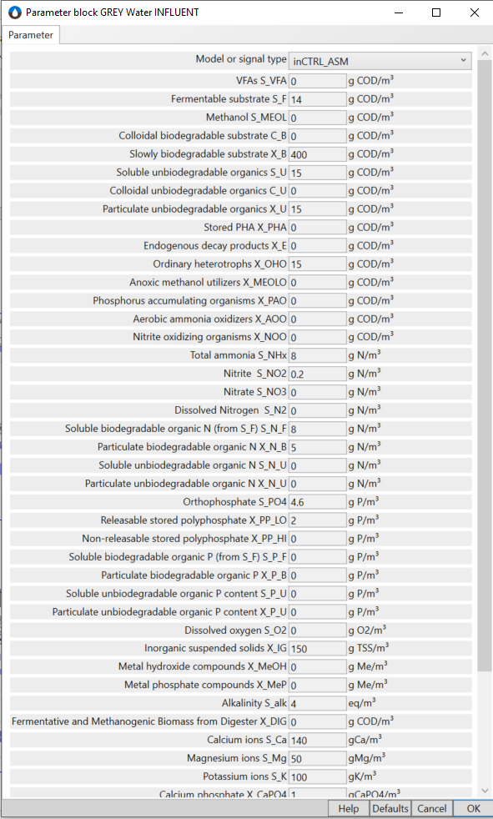 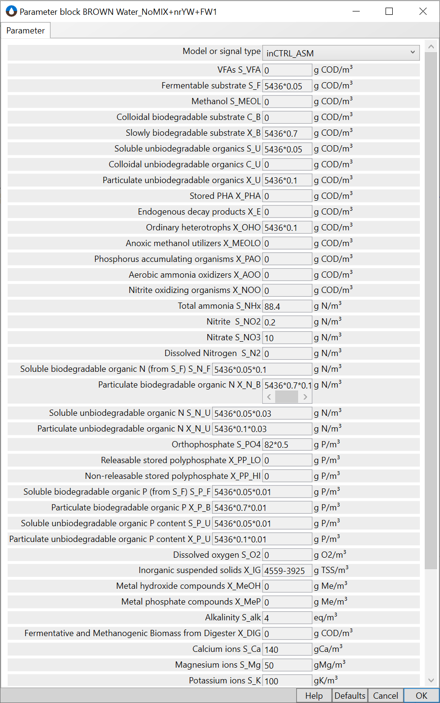:
Figure. Influent fractionation and main characteristics from the brown water stream and the grey water stream.

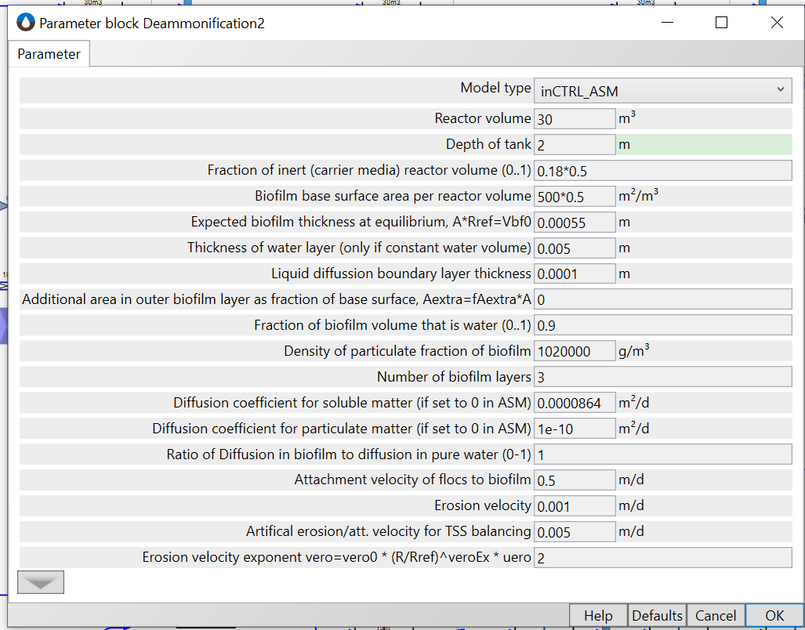
Figure. A biofilm-based block definition in SIMBA#. Biofilm thickness, without being constrained by a maximum thickness, allows non-uniform biofilm geometries and models the impact of mixing intensity on the biofilm detachment rate.

Detailed mass and energy flow analysis
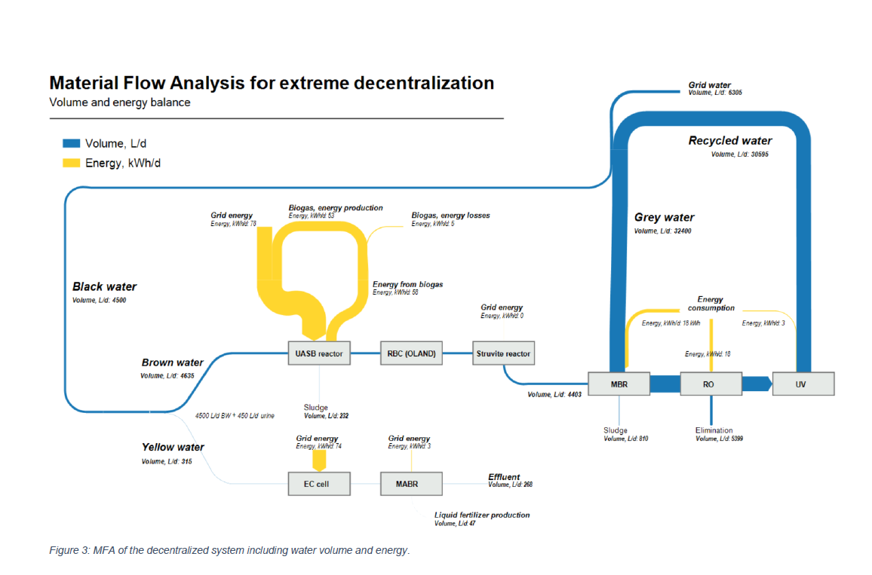

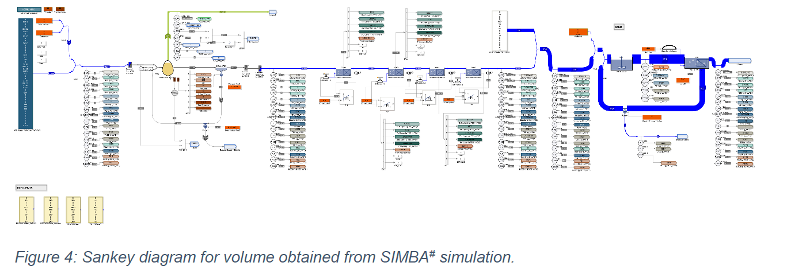
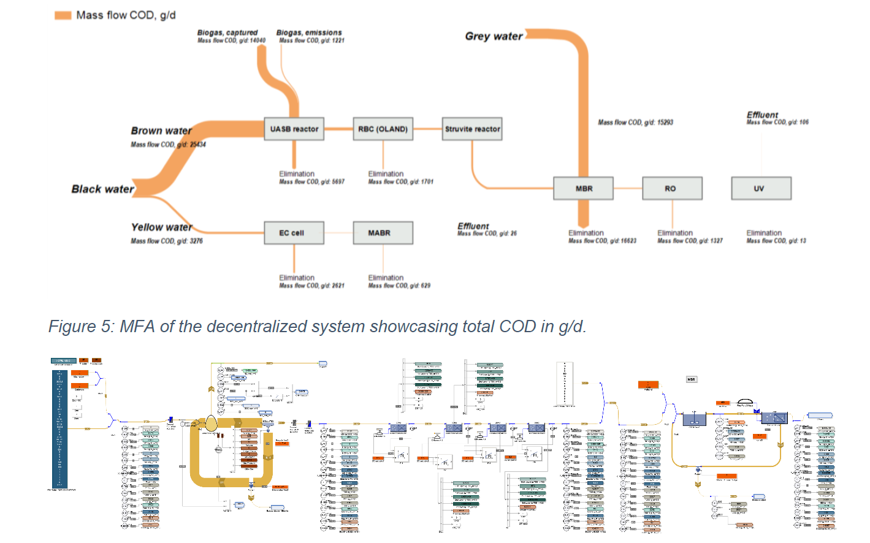

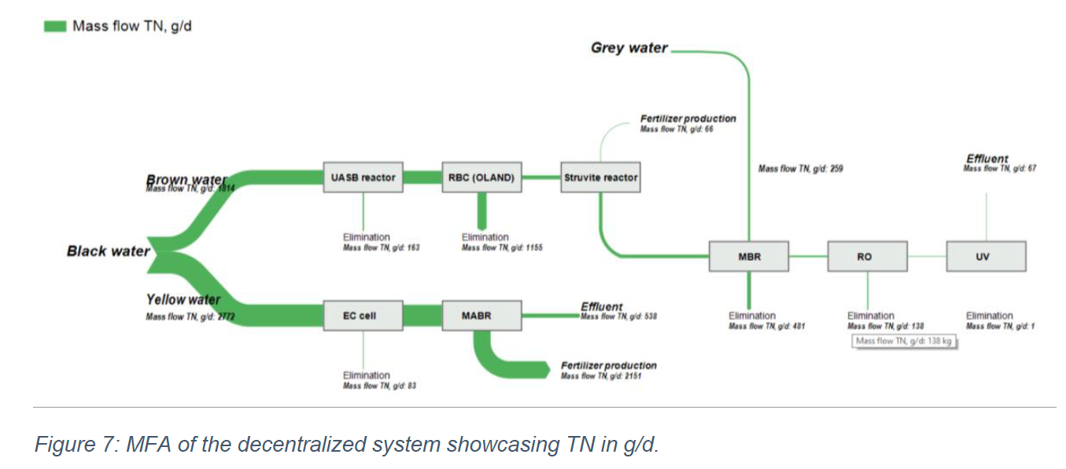

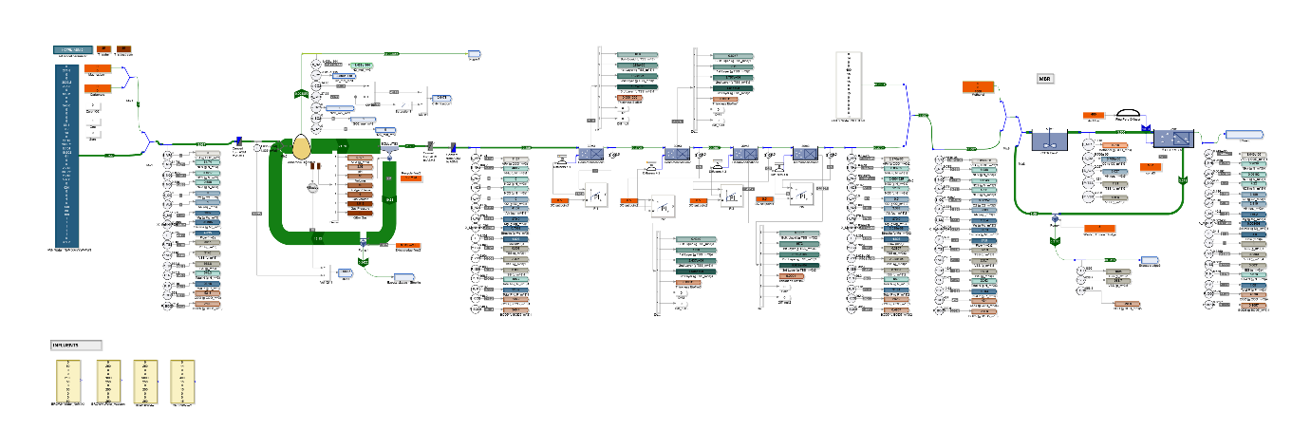

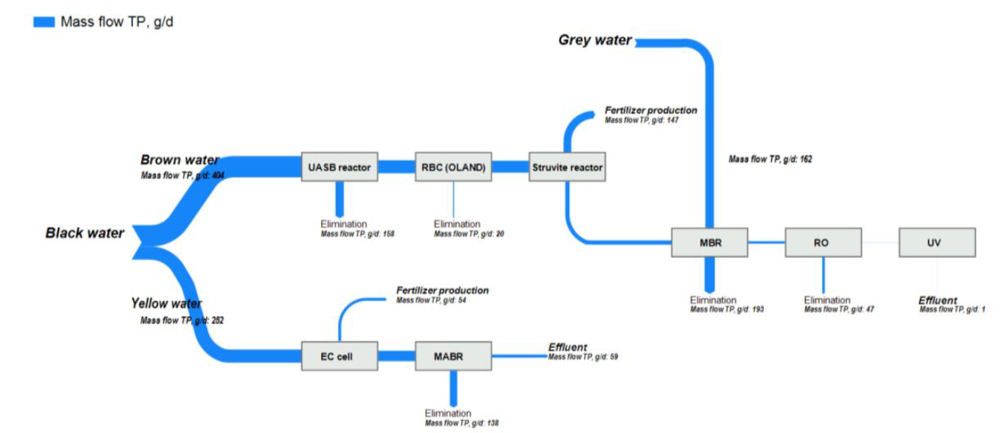

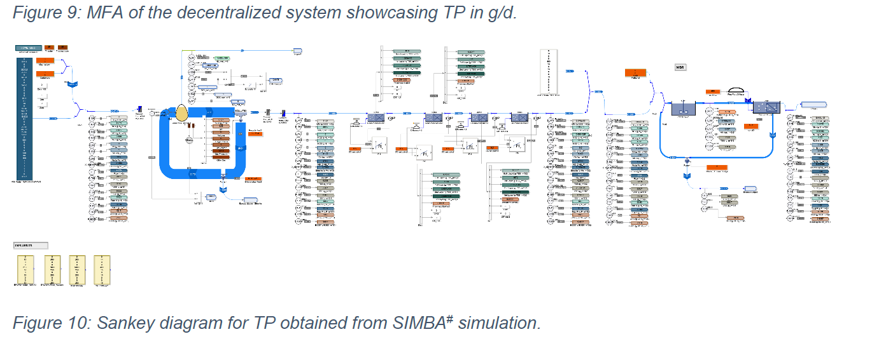
Fig. 9-1, Fig. 9-2, Fig. 9-3, and Fig. 9-4show the evolution in the water’s quality and flow as it moves through the treatment plant using figures obtained from the SIMBA after a 500 days simulation. In Fig. 9-1, the difference in flowrate between GW and BW can be observed, with the GW line requiring much higher capacity. In Fig. 9-2, Fig. 9-3, and Fig. 9-4, the evolution of the concentration of three example pollutants (those being COD, TKN, and P) in mg/L is shown. As seen in Fig. 9-2, the incorporated biologic treatments (i.e., UASB and MBR) help drastically reduce the COD concentration in both GW and BW. Specifically, the MBR is the treatment with the highest removal efficiency for this pollutant and allows to reduce the COD concentration from 1070 to 5 mg/L. As for TKN (Fig. 9-3), note how the deammonification stage (which consists of an RBC operating with the OLAND process) is capable of reducing form 2000 mg/L of nitrogen oxides to around 100 mg/L. Afterwards, while the UASB barely contributes to the removal of nitrogen, the MBR polishes the concentration of the treated BW and helps treat the additional input of TKN that the GW effluent supposes (panel c). Finally, Fig. 9-4 depicts the variation in TP concentration achieved in the circuit, with the MBR being again especially efficient and the struvite recovering process allowing for the production of 37-913 kg of the fertilizer (the lower end of the range being the production in LR buildings and the higher end being the struvite obtained in HR buildings).
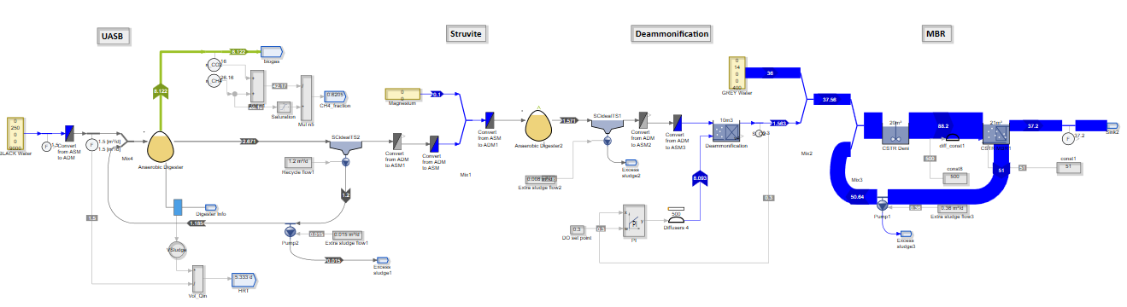
Fig. 9-1: Model of V1 layout obtained by the modelling software SIMBA#. The sanky diagram represents m3/day. Five models corresponding to the five scenarios under consideration were built and tested.
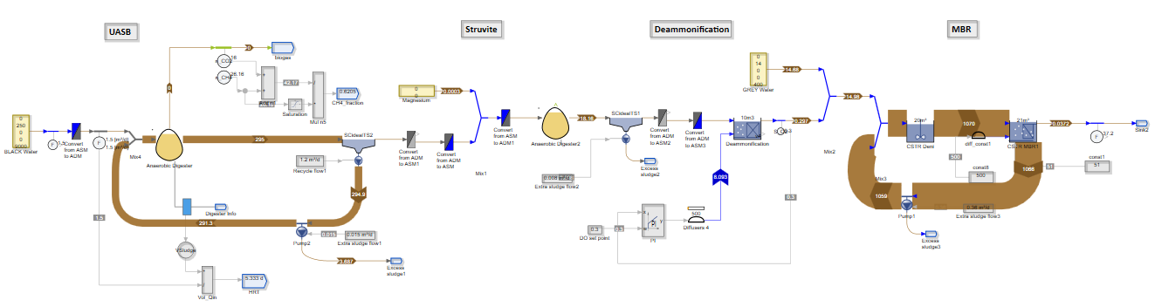
Fig. 9-2: Model of V1 layout obtained by the modelling software SIMBA#. The sanky diagram represents COD, mg COD/L. Five models corresponding to the five scenarios under consideration were built and tested.
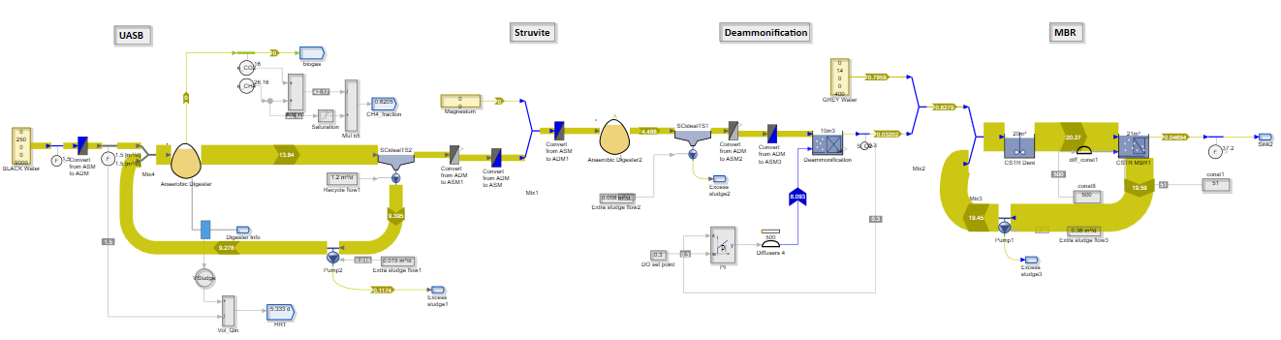
Fig. 9-3: Model of V1 layout obtained by the modelling software SIMBA#. The sanky diagram represents TKN, mg N/L. Five models corresponding to the five scenarios under consideration were built and tested.
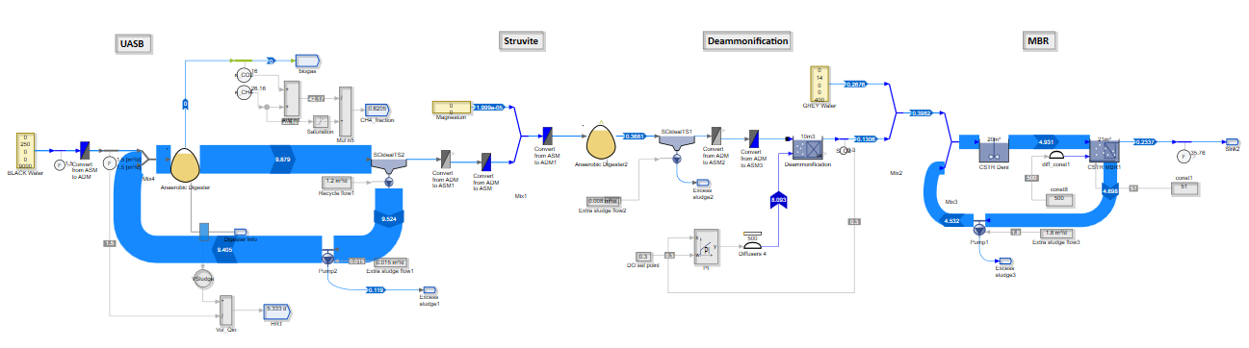
Fig. 9-4: Model of V1 layout obtained by the modelling software SIMBA#. The sanky diagram represents phosphorus, mg P/L. Five models corresponding to the five scenarios under consideration were built and tested.

Influent composition
Per capita water production is assumed 108 L/day, 15 L/day, and 1.5 L/day for grey, black, and yellow water, respectively, considering the use of urine-diverting toilets capable of recovering 70% of urine (de Graaff et al., 2010; Larsen et al., 2013; Rabaey et al., 2020). Non-recovered urine leaks to the brown water sewer. The daily average of organic food waste is 150 g/PE.
Whilst the possibility of deviations due to specific events is acknowledged, an average composition of wastewater in the system is assumed as shown in Table 1. Concentrations are calculated from daily constituent load per capita and are in concordance with previous studies (Dhadwal, 2020; Dhadwal et al., 2021; Gao et al., 2019; Garrido-Baserba et al., 2022; Kujawa-Roeleveld et al., 2006; Larsen et al., 2013; Lienert & Larsen, 2010; Rossi et al., 2009; Sun et al., 2020). Food waste composition allows to calculate the final composition of the treatment train influent (Gao et al., 2020; M. Kim et al., 2015; Rajagopal et al., 2013).
Table 10-1: Composition of blackwater, undiluted fresh urine considering urea hydrolysis, greywater, organic food waste, and the mixture of brown water, non-recovered urine, and food waste.
mg/L | BW | YW | GW | FW* | BrW | BrW+non-recovered YW+FW
COD | 10,500 | 10,400 | 472 | 286 | 2,490 | 5,437
BOD | 3,560 | 3,870 | 175 | 218 | 800 | 2,987
TN | 2,000 | 8,800 | 8 | 6 | 80 | 335
NH₄-N | 1,800 | 463 | 3 | 0.8 | 72 | 88.5
TP | 260 | 800 | 5 | 3.2 | 34 | 82.4
TSS | 8,360 | 0.0 | 175 | 189.5 | 2,790 | 4,560
VSS | 6,690 | 0.0 | 64 | 179.8 | 2,230 | 3,925
*mg/g wet basis

Concentration data |  |  |  | g/p*d
Concentrations BrW, FW, nrcYW | mg/L | mg/L | mg/g wet basis 76% w water/w | mg/L
 | BrW (15 L/p*d) | BrW + non-recovered YW (recovery efficiency of 75%; 15.45 L/p*d) | Food waste (FW) Rajagopal et al 2013; Gao et al 2020; Kim et al 2015 | Br + nrc YW + FW (150 g/p*d Rajagopal et al 2013) | g/L
COD | 2490.00 | 2660.00 | 286.00 | 5436.70 | 5.4366
BOD | 800.00 | 869.00 | 218.18 | 2987.25 | 2.9877
TN | 80.00 | 278.00 | 5.90 | 335.28 | 0.333
NH4-N (TAN: Total ammonia N, NH3+NH4+) | 72.00 | 80.90 | 0.78 | 88.48 | 0.08824
TP | 34.00 | 51.50 | 3.18 | 82.37 | 0.0826
TSS | 2790.00 | 2720.00 | 189.50 | 4559.81 | 4.55985
VSS | 2230.00 | 2180.00 | 179.77 | 3925.34 | 3.925

Figure. Influent fractionation and main characteristics of the brown water stream plus the addition of organic waste flows (co-digestion influent) as in SIMBA#

:
Figure. Influent fractionation and main characteristics of the grey water stream as in SIMBA#:
c

Effluent composition

Effluent composition shown in Table 2 is based on removal efficiencies (table 4-25 SM third route + additional UASB and MABR references) and model results from SIMBA# (ifak, 2021). Pollutant concentrations meet the guidelines established by US EPA (EPA/600/R-12/618), WHO (GDWQ, 2011 & 2006), and EU regulation 2020/741 for reuse in urban and bathing applications.
Table 10-2: Composition of treated Brown water + Grey water effluent for reuse.
mg/L | Effluent composition
COD | 1.24
BOD | 0.65
TN | 1.56
NH4-N | 0.10
N-NO3 | 0.76
TP | 0.04
TSS | 0.02
VSS | 0.01

Table 10-2: Composition of treated Brown water + Grey water effluent for reuse on the building scenarios.

Effluent concentrations (mg/l)
 | V1 | V2 | C1 | C2 | UD
COD | 1.33 | 1.91 | 1.46 | 1.46 | 1.94
BOD | 0.72 | 1.39 | 0.76 | 1.07 | 1.14
TN | 2.10 | 4.21 | 2.25 | 3.22 | 6.59
NH4-N | 0.11 | 2.21 | 0.12 | 1.69 | 1.65
N-NO₃ | 0.78 | 1.27 | 0.59 | 0.97 | 1.17
TP | 0.04 | 0.13 | 0.04 | 0.10 | 0.18
TSS | 0.02 | 0.04 | 0.03 | 0.03 | 0.05
VSS | 0 | 0.02 | 0.02 | 0.02 | 0.03

Space requirements (Extended discussion)
Regarding the space requirements of the treatment equipment, the MBRs, anMBRs, and UASB reactors are those which require higher volumes. Nevertheless, the maximum calculated sizes (for the HR buildings) are still reasonable. For example, a UASB reactor volume of 11 m3, is found in scenario V1, while anMBRs take up between 11 to 15 m3. MBRs reach considerable sizes of 20 m3 (Vacuum toilet) and 75 m3 (conventional toilet) in the V1 and C1 scenarios, respectively.
Nevertheless, considering a basement ceiling height of 3 m, equipment can be fitted for all cases. The highest floor occupancy corresponds to HR buildings and is that of 91.4% and 28.7% for the longer and shorter water holding periods, respectively. The remaining basement space could be reserved for future changes in the plant or destined to other uses such as vehicle parking or additional storage. Table 5 shows the total occupation for both approaches taken for all treatment schemes. As observed, only the V1 and V2 scenarios involving reduced BW volumes given the use of vacuum toilets can fit the necessary technology to hold the water produced in 25 days in the basement of the HR building. The rest of housing types could operate according to the second approach with no need for additional space.

Breakdown costs (Extended discussion)
In the V1 scenario, the BW line’s CAPEX account for 46-58% of total capital costs due to the necessity of vacuum pumping to evacuate the highly concentrated waters (12-22% of total CAPEX and 3-8% of total plant costs including monitoring) and the high costs of the UASB reactors (10-24% of total CAPEX and 2-9% of total costs; increasing when larger volumes are required). Nevertheless, the overall deployment of the GW sewer is more costly than that of the BW sewer since pipe diameters are larger to hold bigger volumes. In the V2 scenario where the UASB reactor is omitted causing the total treatment costs to be reduced, BW pumping accounts for 28-35% of total CAPEX and 5-16% of total costs. If conventional or urine-diverting toilets operated by gravity are used, the BW line’s high pumping costs are avoided, and pumping of BW only takes up 0.4-2% and 0.3-0.6% of total CAPEX, respectively.
In respect to the total operating costs, BW accounts for around 10-21% of total OPEX in all building facilities in scenario V1, mainly owing to the operation of the UASB reactor (2-10% of total OPEX and 2-6% of total costs including monitoring) and the OLAND process (2-5% of total OPEX and 2-3% of total plant costs). OPEX are reduced in all other scenarios, since anMBRs present lower operational costs (2-6% in V2 and 3-7% in C2). The implementation of a urine source-separation scheme offers the greatest potential to reduce operating costs out of all configurations, especially for large building blocks. For the MHR building, and compared to the V1 scenario, the UD case shows OPEX 31% lower.
The struvite recovery process proves to be highly cost-effective since it shows low CAPEX and OPEX (1-2% and 1% of total plant costs respectively, in all scenarios where a struvite reactor is used), allows for nutrient recycling and the synthesis of new fertilizers (El Diwani et al., 2007), and thus reduces the environmental impact of wastewater reuse in comparison with disposal.
The treatment of GW and pre-treated BW using side-stream crossflow MBRs has reasonable CAPEX (1-6% of total costs) and OPEX (3-10% of total costs) in the V1 scenario, while in the C1 case, since larger volumes are required CAPEX and OPEX escalate to 3-11% and 5-24% of total costs. Overall, MBRs offer great performance, making it a recommendable process to incorporate in grey water treatment plants for apartment complexes (Atanasova et al., 2017). Their simpler operation and lower CAPEX than submerged MBRs make them suitable for decentralized small-scale plants (Fletcher et al., 2007). Nevertheless, and as previously introduced, anMBRs offer great reductions in CAPEX and OPEX when compared to aerobic MBRs and UASB reactors. CAPEX reductions can be achieved at buildings > 60 PE when lower volumes of water are treated (scenarios V1 and V2), and > 12 PE if larger flows are involved (C1 and C2 scenarios). OPEX reductions of minimum 57% (ST building in V2) and maximum 87% (HR building in C2) are found for all building types.
UV disinfection and RO filtration entail low capital investment and ensure the effluent microbial and chemical quality is adequate, thus becoming critical steps of the treatment process for both GW and RW. RO filtration’s operational costs for GW refining (1.3-3% of total costs in scenario V1 and 1.9-9.8% through all other cases) are similar to those of UV disinfection (1.3-2.9% of total costs in V1 and 1.9-9.3% in other cases) and only slightly above them in all buildings due to its higher energy demand (Judd, 2017; Sanz, 2013).As for RW, since the treated homogenized volume is smaller, OPEX for RO and UV treatment are found at 1-2% of total costs through all scenarios.
Figure 7 illustrates the cost breakdown for short-top buildings (ST), which differs from that of low-rise (LR) dwellings only in its slightly lower sewer costs (V1 scenario). For 12 PE, costs of implementing the decentralized wastewater treatment plant in LR dwellings is 3% higher than in ST buildings since longer pipelines for GW and BW are required in terraced houses because dwellings are separated and floor space per capita is larger. Treatment costs are equal since the volume of water depends on the number of inhabitants. For buildings accommodating larger numbers of inhabitants, the cost distribution varies to that shown in Figure 7, which presents data for mid/high-rise buildings but is representative for mid-rise and high-rise buildings as well (the cost breakdowns for all types of buildings can be found in the supplementary information, sections 7 and 8).
OPEX dominate CAPEX in all buildings for scenarios V1, V2, C1, and C2. In the case of source-separated urine (UD), CAPEX are higher since operational costs are the lowest among all configurations, while the installation the electrochemical cells (5-35% of total costs) and the need for double pipeline for the independent collection of BrW and YW (8-11% of total costs) cause CAPEX to increase. Thus, with sufficient cost reduction and development of treatments for YW, the implementation of urine-diverting toilets could be the most cost-effective alternative.
When comparing costs between buildings, capital expenditures for every specific category show higher variances in absolute percentages in respect to total costs. Both tendencies are due to the fitting of some oversized equipment (i.e., RO, UV, BW pumping) in the smaller housing types stemming from the unavailability of smaller units. Additionally, overall per capita costs decrease when the number of PE increases, since sewer infrastructures show economies of scale and treatment sizes are optimized. Economies of scale regarding treatments are present for the MBR and UV units but can be deemed negligible at the study’s PE range

Process Monitoring
To ensure public acceptance, the highest standards on monitoring need to be satisfied. Grey water reuse should satisfy the most stringent of the quality requirements, demanding an advanced, robust, and safe treatment system able to comply with the tighter standards.
To avoid a negative perception towards this type of approach, the presented system must yield the highest water qualities (such as potable water), even if none of the reused water will be recycled as a direct potable source. A very conservative estimation of the monitoring requirements was purposely chosen to demonstrate that the most rigorous and advanced monitoring routine could be achieved, avoiding concerns about safety and control. The monitoring costs were calculated as in three main blocks (Table 6): 1) Laboratory tests (outside lab); 2) Sensors CapEx and OpEx (external service contract); 3) Real-time online monitoring (external service contract).
The laboratory test routine designed follows the guidelines from the sampling workbook "Sampling Questionnaire and Matrix" developed by the Water Environment Federation (WEF) task group on Wastewater Treatment Plant Data Collection. The workbook indicates the required sampling locations within the treatment process and the type and frequency of analyses required to meet the process control goals (including the requirements for process simulators). The compiled laboratory costs were obtained from several commercial laboratories, and costs should be updated and adapted accordingly. It must be noted that the cost of using outside laboratories is the most expensive option, and it was selected to reflect the worst economic scenario and to assume no need for further investment or space requirements.
The operating budget could be significantly reduced by analyzing in situ some of them and, especially, decreasing the number of lab tests from the recommended sampling routine once a stable performance is obtained. In parallel, some service contracts could be reduced depending on process performance, maintenance routine, etc.
Nevertheless, we anticipate monitoring costs to further decrease in upcoming years with cheaper and better sensors capabilities, new development of reliable soft sensors, and more breakthroughs in control theory (Vanrolleghem and Lee, 2003).

Table 13-1: Summary of the annual cost related to process performance and effluent quality monitoring.
Annual Sensor Costs
Yearly investment costs (including taxes, 5% interest rate) |  | $3,700/y
 | 4 ISE probes with control box (10 years) | $18,000
 | Misc., Sensor installation, compressed air piping | $3,500
 | Connection of sensor to PLC, Implementation control strategies | $3,500
 | Yearly O&M costs | $2,800/y
 | 4 Measuring electrodes, 2 Reference electrodes ($500 per electrode), | $1,500
 | Calibration Standards and cleaning solution ($100 per sensor) | $300
 | Test kit, Consumable costs for QA/QC, Other Consumables ($50 per sensor) | $400
 | Service Contract with Supplier (per sensor) | $500
Annual Lab Tests Costs
Preliminary costs for analyses, assuming the use of outside laboratories |  | $15,360/y
 | VSS, COD, sCOD,, ffCOD, TKN, sTKN, NH₃, NO₃, TP, sTP, PO₄-P.  VFA, Alkalinity, pH, temp, turbidity. | 340/ week
On-line Monitoring System (BW, GW and RW) |  | $9,300
 | Project mobilization | $1,250
 | Process control solutions, model development, and delivery | $1,500
 | Sensor initialization and monitoring | $2,250
 | Implementation of customized control solutions | $2,650
 | Monitoring and Assessment of Control Solutions | $1,650/y
Essential Packages for Monitoring |  | $3,600/y
 | Controller status module, soft sensor module, equipment monitoring, and process monitoring module ($1,200 per module) | $1,200/y

Vertical farming
Market for nitrogen- and phosphate- based fertilizers recovered from the wastewater treatment and urine-diversion systems including (i) K-struvite, (ii) urine precipitate-Ca and (iii) urine liquid concentrate to be sold at prices comparable to other commercially available fertilizers is limited (Chipako & Randall, 2020). In the present study the wastewater reuse infrastructure integrates a vertical farm based on hydroponic soil-less culture allowing for the application of the fertilizers to produce vegetables in the urban environment. Hydroponic systems are capable of drastically reducing water consumption in comparison to open field agriculture, as well as cutting supply chain emissions, and facilitating cultivation in all environments (Al-Kodmany, 2018; Avgoustaki & Xydis, 2020; Bafort et al., 2022; Burak & Margat, 2016; Clark & Mousavi-Avval, 2022; Donnell et al., 2011; Joseph & Muthuchamy, 2014; Kahu et al., s.d.; Kalantari et al., 2018; Kawser et al., 2017; Lam et al., 2015; Linsley-Noakes et al., 2006; Maboko, 2013; Magwaza, 2020; P. Hilton et al., s.d.; Son et al., 2020, p. 20; Van Gerrewey et al., 2021). The proposed vertical farm is based on a closed-loop concept where water and nutrients are recycled, allowing to further reduce input requirements, and employs a nutrient film technique (NFT) configuration (Asgarov et al., 2021; Christie, 2014; Guzmán-Valdivia et al., 2019; Van Gerrewey et al., 2021).
The combination of wastewater treatment and hydroponics has been backed by numerous studies as urine-diverted fertilizers and struvite have been proved to be suitable for the cultivation of leafy greens (Asaduzzaman et al., 2022; Avgoustaki & Xydis, 2020; El-Nakhel et al., 2021; Halbert-Howard et al., 2021; Magwaza, 2020). In the studied system all P and Mg demand from the vertical farm can be supplied solely by the wastewater treatment system, as well as 56% and 31% of N and Ca, respectively. To provide the plants with the missing nutrients and to ensure optimal growth, fertilizer supplements (Rolfes Agri, Gauteng, South Africa) are assumed to be incorporated in the mix (Magwaza, 2020). The vertical farm is destined to the cultivation of lettuce (Lactuca sativa), strawberries (Fragaria × ananassa), and cherry tomatoes (Solanum lycopersicum). The possibility to include spinach as a fourth crop was studied but discarded since the economic analysis showed a negative contribution margin (Al-Kodmany, 2018; El-Nakhel et al., 2021; Van Gerrewey et al., 2021). The distribution of production area per crop is obtained from an optimization model considering capital and operational costs, marketable weight per plant and harvest cycle for each crop, consumer price, and per capita consumption (Ali et al., 2013; Asgarov et al., 2021; Cardoso et al., 2018; Donnell et al., 2011; Favaro et al., 2011; Hwang et al., 2021; Joseph & Muthuchamy, 2014; Kahu et al., s.d.; Lages Barbosa et al., 2015; Ors & Suarez, 2016, 2004, 2019a, 2019b, 2019c, 2022). The operation of the farm can meet the per total consumption of all cultivated vegetables for the block and produce an additional annual 29,000 kg of cherry tomatoes which could be destined for sale. If sold at a market price of 4$/kg the operational costs of the farm could be offset.
Total cultivation area is that of 913 m² distributed across two facades of the block in a greenhouse-like structure, and divided into four areas, each of which with an independent recirculation loop to facilitate pumping and nutrient uptake (fig X). The positioning of the vertical farm is subject to the local sun path in each location (e.g., in Barcelona the two facades of the block where to place the installation should be those facing NE to SW). The closed-loop system solution based on RO-demineralized tap water is to be replaced every 10 days (Christie, 2014) and is pumped at a flowrate of 1.5 L/min from supply tanks located within the shared basement together with wastewater treatment and germination area.

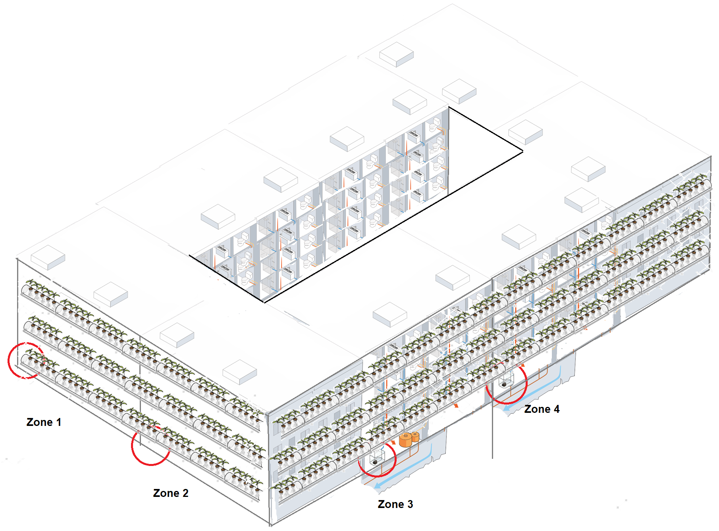

Capital and operational costs are calculated based on literature and supplier data. Eighteen levels of rowing racks (1 m high) containing three rows of trays (e.g., NatureHydro, Shanghai, China) contiguous to glass windows equipped with irrigation and runoff drainpipes for a closed-loop water circulation system, artificial LED lightning (e.g., ChilLED Tech, USA), and recirculating pumps are considered. Additional elements include pH and EC sensors and a control unit for independent system operation (European horticulture, Prague, Czech Republic), HVAC system (Asgarov et al., 2021), air pumps to minimize aerobic zones responsible for undesired increases in N₂O emissions and nitrogen losses (Magwaza, 2020), nutrient collection and mixing tanks (Mixer Direct, Jeffersonvill, IN, USA), valves, and RO + UV disinfection to prevent microbial growth within the circuit (Son et al., 2020; DuPont, Wilmington, DE, USA; Applied Membranes Inc., Vista, CA). Crop harvesting is assumed to be carried out by building inhabitants. Daylight sensors (e.g., Lutron, Coopersburg, PA, USA) are installed to adjust artificial lightning to complement sunlight, allowing for 20% reductions in electricity consumption for the hydroponic system (Asgarov et al., 2021; Halbert-Howard et al., 2021). Resulting CAPEX of 2,500,000 $ are elevated as expected in hydroponic installations (Harris & Kountouris, 2020; Magwaza, 2020). A life span of 30 years is assumed. OPEX consider supplementary nutrient mix purchase, UV, and RO operation, electrical consumption for the complete system, and seed purchase. Resulting costs of production are those of 2.2 $/kg, 3.70 $/kg, and 1.68 $/kg for lettuce, strawberry, and tomatoes, respectively.
Besides creating an on-site application for urine-diverted fertilizers and offering an optimized and sustainable cultivation option, vertical farming has been discussed as a BioEnergy with Carbon Capture and Storage (BECCS) deployment enabler (Harris & Kountouris, 2020). Lower land footprint of vertical farms compared to conventional horizontal farming allows to reduce land destined for open field agriculture. Among all climate change forest mitigation options (incl. reforestation, afforestation, landscape restoration), preventing deforestation and ecosystem degradation offers the highest short-term potential (IPCC, 2007).
As calculated from open field cultivation yields and the total annual harvest mass of each crop for the proposed system, 0.085 km² would be required to produce the same amount through conventional agriculture (Clark & Mousavi-Avval, 2022; Gonzaga et al., 2017; Maureira et al., 2022; Molin & Martin, 2018). Two scenarios are considered where the environmental benefits of the vertical farm are calculated considering (i) the spare land avoids the conversion of the equivalent surface area of a selection of natural ecosystems to agricultural fields, and (ii) the land is employed for bioenergy supply.

Table 14-1: Vertical farming.

Height of storey | 3.00 | m
Height of building | 36.00 | m
Surface of façade 1 (front) | 2,282.54 | m2
Surface of façade 2 (side) | 3,804.31 | m2
2 façades (one each): surface | 6,086.85 | m2
% surface of façade occupied by VF | 0.70
Total VF surface | 4,260.80 | m2
Fertilizers available from WWT
kg Ca3(PO4)2/yr | 663.28
 |  | 6,415,137.23 | mmol Ca/yr
 |  | 4,276,758.15 | mmol P/yr
Struvite production (kg/yr); (NH4)MgPO4 | 2677.11
 |  | 19,496,158.45 | mmol Mg/yr
 |  | 19,496,158.45 | mmol N/yr
 |  | 19,496,158.45 | mmol P/yr
Concentrate (L/yr) | 114,975.00
NO3-N (mg/l) | 3,885.50 | 62.66 | mmol/l
PO43-P (mg/l) | 74.80 | 0.79 | mmol P/l
Volume needed
1.50 | L/min | 0.000025 | m3/s
4.12E-03 | Area tube m2 | 36.5 | 10 day periods in a year
0.01 | m/s | 10 | days
864,000.00 | s in chosen period | 3 | number of rows of trays
 | s full loop | Volume in trays (m3) | Loops in 10 days
Larger façade | 168,603.06 | 11.76 | 5.12
Smaller façade | 105,906.41 | 7.05 | 8.16
Dilutions/weekly
 | Required nutrients all façades (mmol total/week) | mmol fertilizer available from WWT | Surplus (+) or lack (-) of fertilizer
P | 56,425.11 | 23,863,471.58 | 21,803,955.04
NO3-N | 1,297,777.54 | 26,700,998.11 | -20,667,882.26
Ca | 564,251.11 | 6,415,137.23 | -14,180,028.15
Mg | 253,913.00 | 19,496,158.45 | 10,228,334.03
Fruit growth
Total production area | 913.03 | m2 | Total trays (1 m lenght per tray)
Plants/m2 | 25.00 | 45 | 25
Plants/tray | 3 | 4 | 3

Table 14-2: Vertical farming.

 | Romaine lettuce | Strawberries | Spinach | Tomatoes (cherry) | Total
% of plants | 0.36 | 0.25 | 0.01 | 0.39 | 1.00
Total plants per type | 9,784.74 | 9,086.76 | 273.91 | 7,194.02
Harvest cycle (days) | 25.00 | 120.00 | 35 | 150
Fruit/plant (g/lettuce;strawberries/plant) | 140.00 | 300.00 | 40 | 1650
Harvest kg/yr | 20,000.00 | 8,291.67 | 114.26 | 28,883.98
Per capita consumption (kg/yr) | 10.00 | 4.15 | 1.08 | 9.40
All PE consumption (kg/yr) | 20,000.00 | 8,291.67 | 2,168.17 | 18,800.00 | 231,184.79
Consumer price (€/kg) | 3.20 | 6.02 | 8.4 | 4.06
Sales (€/yr) | 0.00 | 0.00 | -17,252.87 | 40,940.95
mcu | 1.00 | 2.32 | 5.93 | 2.38
Savings vegetables/fruit per capita/yr | 32.00 | 24.96 | 9.11 | 38.16
MCT (€/yr) | 107,979.38 | OBJ CELL |  | Total sales (€/yr) | 40,940.95
 | Romaine lettuce | Strawberries | Spinach | Tomatoes (cherry)
m2 | 27,557 | 11,425 | 157 | 39,797 | 1,984
Acres | 6.81084029 | 2.823661324 | 0.038909953 | 9.836207932 | 0.490380501
container eq. | 5.45 | 2.26 | 0.03 | 7.87 | 0.39
 | 55,555.56 | 23,032.41 | 317.39 | 80,233.27 | 4000
 |  |  |  |  | TOTAL
If SOLD ($/year) | 64,000.00 | 49,915.84 | 959.77 | 117,268.95 | 232,144.57
% | 27.57 | 21.50 | 0.41 | 50.52
$/m3 | 0.827070837 | 0.645061511 | 0.012403151 | 1.5154645

16 Photovoltaic Energy
Energy consumption from the block is divided into three categories according to demand source: (i) water reuse system, (ii) vertical farm, and (iii) domestic energy. The installation of solar panels can offset a geographically dependant fraction of the total requirements and is found to be capable of supplying the necessary electricity for the operation of the water reuse system and the vertical farm for all the studied cities (i.e., Barcelona, Amsterdam, Santiago de Chile, Hong Kong, Seoul, Toronto, and Miami, in representation of a range of Köppen-Geiger climates).
DC monocrystalline 425W panels (SunPower, Silicon Valley, CA, US) with a 20% efficiency distributed across 75% of block roof surface are assumed. Calculations for yearly electricity output from solar installation are based on average available sun hours per country and solar panel performance (H. Chen et al., 2022; Fthenakis et al., 2012; Huld et al., 2012; Oyedepo et al., 2019; Santamouris et al., 2015; Taşçıoğlu et al., 2016; H. Walker et al., 2020; Zaini et al., 2015). Domestic demands are estimated according to electric load sizing and verified by comparison to existent per capita electricity consumption per country (International Energy Agency, 2014). Size of solar system is that of 900 kW and occupied area on roof is of around 4,000 m².
Lithium batteries (Dragonfly energy, Reno, NV, US) are assumed and sizing accounts for 1.5 backup days. Power demand of the facility and sizing of DC to AC inverters is dependent on the maximum expected load size considering coincidence factors per household and between all dwellings in block. The power requirement of the selected inverters is calculated with an oversizing factor of 1.25 (Oyedepo et al., 2019),
CAPEX and OPEX include the described elements plus maintenance costs (H. Walker et al., 2020). It is expected that the installation can cover up to 12% of the total annual electricity demand including domestic consumption. Environmental benefits minus solar system impacts are included in the environmental analysis.
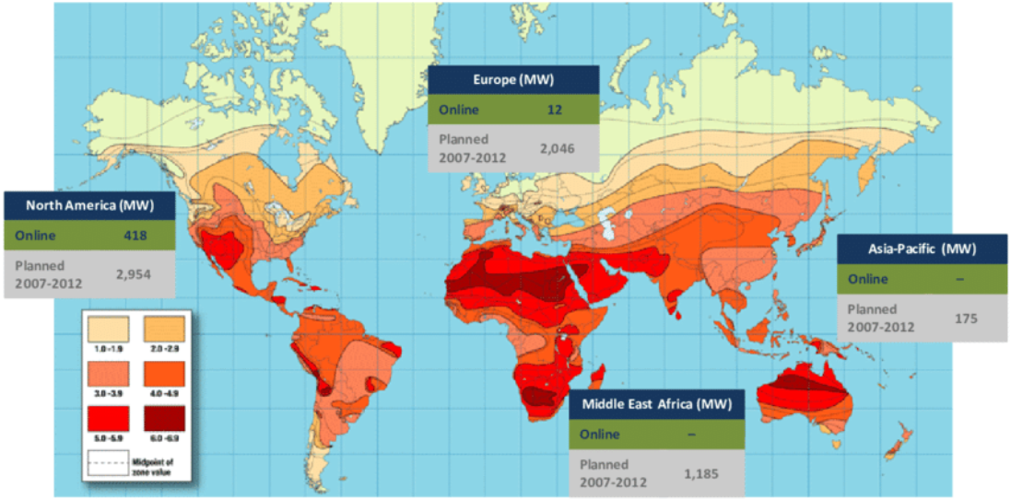

Table 14-2: Vertical farming.

BATTERY SIZING
1.5 | backup days
Electric load 1 hh | W | h | LOAD kWh/d
Lights+fan+TV | 205 |  | 0.99
Air conditioner | 1100 | 1.00 | 1.10
Coffee maker | 900 | 0.17 | 0.15
Fridge | 140 | 24 | 3.36
Hair blow dryer | 2200 | 0.08 | 0.18
Freezer | 100 | 24.00 | 2.40
Dehumidifier | 240 | 4.00 | 0.96
Desktop computer | 450 | 3.00 | 1.35
Stove | 2000 | 0.50 | 1.00
Automatic garage door | 350 | 0.08 | 0.03
Printer | 25 | 0.08 | 0.00
Extractor fan | 200 | 1.00 | 0.20
Microwave | 800 | 0.13 | 0.11
Oven | 2150 | 0.75 | 1.61
Phone charger | 6 | 2.00 | 0.01
Vacuum cleaner | 600 | 1.00 | 0.60
Washing machine | 500 | 2.00 | 1.00
WiFi router | 6 | 14.00 | 0.08
Additional | 600 | 5.00 | 3.00
Inverter
Total load W/kWh | 12,572.00 |  | 18.14
Total battery size Wh |  |  | 27,203.63
Coef. simultaneitat | 0.39
Load w coef | 4897

Electricity consumption per capita (average) |  |  | For All (2000 PE) kWh/yr | Monthly req (kWh) | Sun hours/month | kWh system/hh according to electric load sizing | kW system/hh according to consumption | Total kW system | Nº 400Wp panels | Nº 425Wp panels | kwh/yr produced by system according to PSH
World | 3,128.00 | kWh/yr | 6,256,000.00 | 521,333.33
EU | 6,022.00 | kWh/yr | 12,044,000.00 | 1,003,666.67
Barcelona | 5,356.00 | kWh/yr | 10,712,000.00 | 892,666.67 | 105 | 7.77 | 10.20 | 1,062.70 | 2,657.00 | 2,501.00 | 1,135,260.00 | 268,943.09
Amsterdam | 6,713.00 | kWh/yr | 13,426,000.00 | 1,118,833.33 | 45 | 18.14 | 29.84 | 3,107.87 | 7,770.00 | 7,313.00 | 486,540.00 | 115,261.33
Chile (Santiago) | 3,880.00 | kWh/yr | 7,760,000.00 | 646,666.67 | 90 | 9.07 | 8.62 | 898.15 | 2,246.00 | 2,114.00 | 973,080.00 | 230,522.65
Hong Kong | 6,083.00 | kWh/yr | 12,166,000.00 | 1,013,833.33 | 105 | 7.77 | 11.59 | 1,206.94 | 3,018.00 | 2,840.00 | 1,135,260.00 | 268,943.09
Seoul | 10,497.00 | kWh/yr | 20,994,000.00 | 1,749,500.00 | 165 | 4.95 | 12.72 | 1,325.38 | 3,314.00 | 3,119.00 | 1,783,980.00 | 422,624.86
Toronto | 15,588.00 | kWh/yr | 31,176,000.00 | 2,598,000.00 | 75 | 10.88 | 41.57 | 4,330.00 | 10,825.00 | 10,189.00 | 810,900.00 | 192,102.21
Miami | 12,994.00 | kWh/yr | 25,988,000.00 | 2,165,666.67 | 262.5 | 3.11 | 9.90 | 1,031.27 | 2,579.00 | 2,427.00 | 2,838,150.00 | 672,357.74
 |  |  |  |  |  |  |  |  |  |  | 1,309,024.29 | 310,107.85

Total demand (kWh/yr) | Water reuse system | VF | Domestic energy use | Total | % covered off grid
Barcelona | 263,741.83 | 15,521.47 | 10,712,000.00 | 10,991,263.30 | 10.33
Amsterdam | 263,741.83 | 15,521.47 | 13,426,000.00 | 13,705,263.30 | 3.55
Chile (Santiago) | 263,741.83 | 15,521.47 | 7,760,000.00 | 8,039,263.30 | 12.10
Hong Kong | 263,741.83 | 15,521.47 | 12,166,000.00 | 12,445,263.30 | 9.12
Seoul | 263,741.83 | 15,521.47 | 20,994,000.00 | 21,273,263.30 | 8.39
Toronto | 263,741.83 | 15,521.47 | 31,176,000.00 | 31,455,263.30 | 2.58
Miami | 263,741.83 | 15,521.47 | 25,988,000.00 | 26,267,263.30 | 10.80
kWh saved/m3 REUSE | kWh saved/m3 TREATED | kg CO2 eq/kWh to add | kg CO2 eq/kWh avoided | Net kg eq CO2/m3 REUSE | Net kg eq CO2/m3 TREATED
15.35 | 12.49 | 0.87 | 8.54 | -7.67 | -6.24
6.58 | 5.35 | 0.37 | 3.66 | -3.29 | -2.67
13.16 | 10.71 | 0.75 | 7.32 | -6.57 | -5.35
15.35 | 12.49 | 0.87 | 8.54 | -7.67 | -6.24
24.12 | 19.63 | 1.37 | 13.42 | -12.05 | -9.81
10.96 | 8.92 | 0.62 | 6.10 | -5.48 | -4.46
38.37 | 31.23 | 2.19 | 21.36 | -19.17 | -15.60
*not considering demand in buildings, if all electricity produced is destined to WWT system
**solar could offset the WWT system's demand in all cases

Bibliography

Ariunbaatar, J., Bair, R., Ozcan, O., Ravishankar, H., Esposito, G., Lens, P.N.L., Yeh, D.H., 2021. Performance of AnMBR in Treatment of Post-consumer Food Waste: Effect of Hydraulic Retention Time and Organic Loading Rate on Biogas Production and Membrane Fouling. Front. Bioeng. Biotechnol. 8, 1–15. https://doi.org/10.3389/fbioe.2020.594936
Casey, E., Syron, E.;, Shanahan, J.W.;, Semmens, M.J., Syron, E., Shanahan, J.W., 2008. Comparative economic analysis of full scale MABR configurations Comparative economic analysis of full scale MABR configurations. IWA North Am. Membr. Res. Conf. Univ. Massachusetts, Amherst, USA 1–7.
Chipako, T.L., Randall, D.G., 2020. Investigating the feasibility and logistics of a decentralized urine treatment and resource recovery system. J. Water Process Eng. 37, 101383. https://doi.org/10.1016/j.jwpe.2020.101383
Courtens, E.N.P., Meerburg, F., Mausen, V., Vlaeminck, S.E., 2014. When the smoke disappears: dealing with extinguishing chemicals in firefighting wastewater. Water Sci. Technol. 69, 1720–1727. https://doi.org/10.2166/wst.2014.081
de Graaff, Temmink, H., Zeeman, G., Buisman, C.J.N., 2010. Anaerobic Treatment of Concentrated Black Water in a UASB Reactor at a Short HRT. Water 2, 101–119. https://doi.org/10.3390/w2010101
De Paepe, J., Lindeboom, R.E.F., Vanoppen, M., De Paepe, K., Demey, D., Coessens, W., Lamaze, B., Verliefde, A.R.D., Clauwaert, P., Vlaeminck, S.E., 2018. Refinery and concentration of nutrients from urine with electrodialysis enabled by upstream precipitation and nitrification. Water Res. 144, 76–86. https://doi.org/10.1016/j.watres.2018.07.016
De Paepe, J., Pryck, L. De, Verliefde, A.R.D., Rabaey, K., Clauwaert, P., 2020. Electrochemically Induced Precipitation Enables Fresh Urine Stabilization and Facilitates Source Separation. https://doi.org/10.1021/acs.est.9b06804
Etter, B., Tilley, E., Khadka, R., Udert, K.M., 2011. Low-cost struvite production using source-separated urine in Nepal. Water Res. 45, 852–862. https://doi.org/10.1016/j.watres.2010.10.007
Fletcher, H., Mackley, T., Judd, S., 2007. The cost of a package plant membrane bioreactor. Water Res. 41, 2627–2635. https://doi.org/10.1016/j.watres.2007.02.038
Foglia, A., Akyol, Ç., Frison, N., Katsou, E., Eusebi, A.L., Fatone, F., 2020. Long-term operation of a pilot-scale anaerobic membrane bioreactor (AnMBR) treating high salinity low loaded municipal wastewater in real environment. Sep. Purif. Technol. 236, 116279. https://doi.org/10.1016/j.seppur.2019.116279
Fraunhofer Institute for Interfacial Engineering and Biotechnology IGB, 2016. Guideline: Vacuum sewer systems.
Gouveia, J., Plaza, F., Garralon, G., Fdz-Polanco, F., Peña, M., 2015. Long-term operation of a pilot scale anaerobic membrane bioreactor (AnMBR) for the treatment of municipal wastewater under psychrophilic conditions. Bioresour. Technol. 185, 225–233. https://doi.org/10.1016/j.biortech.2015.03.002
Gritti, M.C., 2019. From Earth To Space and Back - Nutrient Recovery From Urine for a Circular Economy 2018–2019.
Kujawa-Roeleveld, K., Zeeman, G., 2006. Anaerobic Treatment in Decentralised and Source-Separation-Based Sanitation Concepts. Rev. Environ. Sci. Bio/Technology 5, 115–139. https://doi.org/10.1007/s11157-005-5789-9
Lema, J.M., Martinez, S.S. (Eds.), 2017. Innovative wastewater treatment & resource recovery technologies: impacts on energy, economy and environment. International Water Association publishing.
Lin, H., Chen, J., Wang, F., Ding, L., Hong, H., 2011. Feasibility evaluation of submerged anaerobic membrane bioreactor for municipal secondary wastewater treatment. Desalination 280, 120–126. https://doi.org/10.1016/j.desal.2011.06.058
Liu, R., Huang, X., Chen, L., Wen, X., Qian, Y., 2005. Operational performance of a submerged membrane bioreactor for reclamation of bath wastewater. Process Biochem. 40, 125–130. https://doi.org/10.1016/j.procbio.2003.11.038
Lo, C.H., McAdam, E., Judd, S., 2015. The cost of a small membrane bioreactor. Water Sci. Technol. 72, 1739–1746. https://doi.org/10.2166/wst.2015.394
Lozano, J., Sabaté, F., Subiranas, J., 2007. Anàlisi comparativa dels processos emergents SHARON i ANAMMOX pel tractament d’aigües amb una alta càrrega de nitrogen 1–116.
Maurer, Scheidegger, A., Herlyn, A., 2013. Quantifying costs and lengths of urban drainage systems with a simple static sewer infrastructure model. Urban Water J. 10, 268–280. https://doi.org/10.1080/1573062X.2012.731072
Maurer, Wolfram, M., Anja, H., 2010. Factors affecting economies of scale in combined sewer systems. Water Sci. Technol. 62, 36–41. https://doi.org/10.2166/wst.2010.241
Mazuki, N.I., Teow, Y.H., Ho, K.C., Mohammad, A.W., 2020. Techno-economic analysis of single disinfection units and integrated disinfection systems for sewage effluent reclamation. J. Water Process Eng. 36, 101398. https://doi.org/10.1016/j.jwpe.2020.101398
Metcalff, Eddy, 2013. Wastewater Engineering: Treatment and Resource Recove.
Pretel, R., Robles, A., Ruano, M. V., Seco, A., Ferrer, J., 2014. The operating cost of an anaerobic membrane bioreactor (AnMBR) treating sulphate-rich urban wastewater. Sep. Purif. Technol. 126, 30–38. https://doi.org/10.1016/j.seppur.2014.02.013
Ribera-Pi, J., Campitelli, A., Badia-Fabregat, M., Jubany, I., Martínez-Lladó, X., McAdam, E., Jefferson, B., Soares, A., 2020. Hydrolysis and Methanogenesis in UASB-AnMBR Treating Municipal Wastewater Under Psychrophilic Conditions: Importance of Reactor Configuration and Inoculum. Front. Bioeng. Biotechnol. 8. https://doi.org/10.3389/fbioe.2020.567695
Roefs, I., Meulman, B., Vreeburg, J.H.G., Spiller, M., 2017. Centralised, decentralised or hybrid sanitation systems? Economic evaluation under urban development uncertainty and phased expansion. Water Res. 109, 274–286. https://doi.org/10.1016/j.watres.2016.11.051
S. Puig, personal communication, 2017, n.d.
Shin, C., McCarty, P.L., Kim, J., Bae, J., 2014. Pilot-scale temperate-climate treatment of domestic wastewater with a staged anaerobic fluidized membrane bioreactor (SAF-MBR). Bioresour. Technol. 159, 95–103. https://doi.org/10.1016/j.biortech.2014.02.060
Shoener, B.D., Zhong, C., Greiner, A.D., Khunjar, W.O., Hong, P.Y., Guest, J.S., 2016. Design of anaerobic membrane bioreactors for the valorization of dilute organic carbon waste streams. Energy Environ. Sci. 9, 1102–1112. https://doi.org/10.1039/c5ee03715h
Siciliano, A., Limonti, C., Curcio, G.M., Molinari, R., 2020. Advances in struvite precipitation technologies for nutrients removal and recovery from aqueous waste and wastewater. Sustain. 12. https://doi.org/10.3390/su12187538
Tarragó, E., Puig, S., Ruscalleda, M., Balaguer, M.D., Colprim, J., 2016. Controlling struvite particles’ size using the up-flow velocity. Chem. Eng. J. 302, 819–827. https://doi.org/10.1016/j.cej.2016.06.036
Van Voorthuizen, E.M., Zwijnenburg, A., Wessling, M., 2005. Nutrient removal by NF and RO membranes in a decentralized sanitation system. Water Res. 39, 3657–3667. https://doi.org/10.1016/j.watres.2005.06.005
Verrecht, B., Maere, T., Nopens, I., Brepols, C., Judd, S., 2010. The cost of a large-scale hollow fibre MBR. Water Res. 44, 5274–5283. https://doi.org/10.1016/j.watres.2010.06.054
Wang, K.M., Cingolani, D., Eusebi, A.L., Soares, A., Jefferson, B., McAdam, E.J., 2018a. Identification of gas sparging regimes for granular anaerobic membrane bioreactor to enable energy neutral municipal wastewater treatment. J. Memb. Sci. 555, 125–133. https://doi.org/10.1016/j.memsci.2018.03.032
Wang, K.M., Jefferson, B., Soares, A., McAdam, E.J., 2018b. Sustaining membrane permeability during unsteady-state operation of anaerobic membrane bioreactors for municipal wastewater treatment following peak-flow. J. Memb. Sci. 564, 289–297. https://doi.org/10.1016/j.memsci.2018.07.032
Wen, X. hua, Xing, C. hong, Qian, Y., 1999. A kinetic model for the prediction of sludge formation in a membrane bioreactor. Process Biochem. 35, 249–254. https://doi.org/10.1016/S0032-9592(99)00058-8
Xing, Wen, X.-H., Qian, Y., Tardieu, E., 2001. Microfiltration-membrane-coupled bioreactor for urban wastewater reclamation. Desalination 141, 63–73. https://doi.org/10.1016/S0011-9164(01)00389-7
Xing, Wu, W.-Z., Qian, Y., Tardieu, E., 2003. Excess Sludge Production in Membrane Bioreactors: A Theoretical Investigation. J. Environ. Eng. 129, 291–297. https://doi.org/10.1061/(ASCE)0733-9372(2003)129:4(291)

