Text S1 Mass and energy budget in the North Pit Hole on September 23, 2021
We estimate the HDR of volcanic gas injected into the floor of the North Pit Hole (NP) hosting hot water on September 23, 2021, using a box model of the mass and energy balance of the water in the crater. We employed the procedure proposed by Terada et al. (2012) for all calculations presented here. Total heat flux of a crater lake $Φ$(W/m²) consists of three forms; evaporative heat flux from the water surface $Φ_{e}$, convective heat flux $Φ_{c}$, and radiant heat flux $Φ_{r}$;

$$\begin{aligned}Φ=Φ_{e}+Φ_{c}+Φ_{r}. \#(S1)\end{aligned}$$

The evaporative heat is expressed as a sum of free and forced convection terms (Ryan et al. 1974):

$$\begin{aligned}Φ_{e}=λ{\left(T_{vs}-T_{va}\right)}^{\frac{1}{3}}\left(e_{s}-e_{a}\right)+b_{0}u\left(e_{s}-e_{a}\right).\#(S2)\end{aligned}$$

The definitions of each model parameter and constant are presented in Table S2. The convective heat depends on the evaporative heat and ambient air parameters:

$$\begin{aligned}Φ_{c}=C\frac{T_{s}-T_{a}}{e_{s}-e_{a}}Φ_{e}.\#(S3)\end{aligned}$$

The net radiant heat of a crater lake is defined as:

$$\begin{aligned}Φ_{r}={R_{lake}-(R}_{sun}+R_{atm}), \#(S4)\end{aligned}$$

where $R_{lake}$ is the radiance of the hot water surface, $R_{sun}$ is the short-wavelength solar radiance, and $R_{atm}$ is the long-wavelength ambient air radiance. To calculate $Φ$, the area of the hot water surface in the pit hole is required. Although we did not accurately measure the surface area on September 23, 2021, we measured the area using UAS-based photogrammetry. Here we assumed no change in the surface area from September 9 to 23 and used the area measured on September 9 to calculate the heat flux on September 23. The temperature of the hot water surface on September 23 was 72 ℃ without any correction (default parameter setting of FLIR Systems’ camera), 82 ℃ with the correction proposed by Yokoo and Ishii (2021), and 89 ℃ with the correction of the temperature difference (7 ℃) between XT2 and G120EX. Calculation of Eq. (S1) to (S4) using these parameters (Table S2) yields $Φ$ of 17–22 kW/m² where $Φ_{e}$ = 15.6-20.0 kW/m², $Φ_{c}$ = 0.8-1.0 kW/m², and $Φ_{r}$ = 0.5 kW/m². Multiplying by the surface area $S$ of 1,800 m², we obtained the HDR from the hot water in the pit hole of 30–39 MW. Using these estimates, we can estimate HDR of volcanic gas injected into the pit crater bottom based on the mass and energy balance in the crater. Following Terada et al. (2012), in a steady state where temporal changes in the water level and temperature in the pit hole are negligible, the mass and energy balance can be expressed as:

$$\begin{aligned}m=\frac{Φ_{e}S}{L}+m_{b}-pS_{c},\#(S5)\end{aligned}$$

and
$$\begin{aligned}hm=ΦS+m_{b}c_{w}T-pS_{c}c_{w}T_{a}.\#(S6)\end{aligned}$$

In Eq. (S5), $m$ is mass flux of volcanic gas injected into the pit hole bottom (kg/s). The first, second, and third terms on the right-hand side of Eq. (S5) correspond to mass fluxes of evaporative outflow, seepage outflow, and meteoric water inflow, respectively. In Eq. (S6), $h$ is specific enthalpy of volcanic gas and $hm$ corresponds to HDR of the injected volcanic gas. The first, second, and third terms on the right-hand side of Eq. (S6) correspond to evaporative heat loss, seepage heat loss, and heat inflow of meteoric water, respectively. From calculation of Eqs. (S5) and (S6) based on the parameter values in Table S2, $m$= 8-25 kg/s, $h$ = 1600-3900 kJ/kg (not uniquely constrained), and HDR of the injected volcanic gas is estimated to be 32-42 MW. This is only 10 % of the total HDR of plumes from the 191 vent and the southern wall of the pit hole (~ 400 MW).

References

Farnebäck G (2003) Two-frame motion estimation based on polynomial expansion. In: Bigun J, Gustavsson T (eds.) Image Analysisnumber 2749 in Lecture Notes in Computer Sciences. Springer Berlin Heidelberg, pp 363–370.
Gliß J, Stebel K, Kylling A, Sudbø A (2018) Improved optical flow velocity analysis in SO2 camera images of volcanic plumes - Implications for emission-rate retrievals investigated at Mt Etna, Italy and Guallatiri, Chile. Atmos Meas Tech 11:781–801. https://doi.org/10.5194/amt-11-781-2018
Hashimoto T, Terada A, Tanaka R (2018) Volcanic smoke reduction in visible and thermal infrared imagery. Earth Planets Space 70:109. https://doi.org/10.1186/s40623-018-0886-5
Koutsoyiannis D (2012) Clausius-Clapeyron equation and saturation vapour pressure: Simple theory reconciled with practice. Eur J Phys, 33:295–305. doi:10.1088/0143-0807/33/2/295.
Minkina W, Dudzik S (2009) Infrared thermography: Errors and uncertainties. John Wiley & Sons, UK.

Peters N, Hoffmann A, Barnie T, Herzog M, Oppenheimer C (2015) Use of motion estimation algorithms for improved flux measurements using SO2 cameras. J Volcanol Geotherm Res 300:58–69. https://doi.org/10.1016/j.jvolgeores.2014.08.031
Ryan PJ, Harleman DR, Stolzenb KD (1974) Surface heat loss from cooling ponds. Water Resour Res 10:930-938.

Terada A, Hashimoto T, Kagiyama T (2012) A water flow model of the active crater lake at Aso volcano, Japan: Fluctuations of magmatic gas and groundwater fluxes from the underlying hydrothermal system. Bull Volcanol 74:641–655. https://doi.org/10.1007/s00445-011-0550-4
Yokoo Akihiko, Ishii Kyoka (2021) Process to analyze radiometric JPEG files taken by a thermal infrared camera. Bull Volcanol Soc Japan 66:229–240. https://doi.org/10.18940/kazan.66.3_229

Table S1 Parameters for material balance calculation of hot water in the North Pit Hole
Parameter | Definition, value | Note
b | Empirical constant, 0.032 W s m⁻³ Pa⁻¹
C | Bowen constant, 61
c_{w} | Specific heat of water, 4 kJ kg⁻¹ K⁻¹
e_{s} | Saturation vapor pressure, Pa | Based on the equation of Koutsoyiannis (2012)
e_{a} | Vapor pressure of ambient air, Pa
L | Latent heat of water vapor, 2300 kJ/kg
m_{b} | Seepage flux, 10 kg/s | Calculated from an empirical relation between equivalent lake volume (54,000 m³) and seepage flux, as suggested in Terada et al. 2012.
p | Precipitation, 4-30 mm/day | Records at Aso-Otohime meteorological station of JMA
R_{sun} | Radiance of Sun, 115 W/m² | Terada et al. (2012)
R_{atm} | Radiance of atmosphere, 370 W/m²
R_{lake} | Radiance of lake surface, 875 W/m²
S | Lake surface area, 1800 m² | Measurement on Sep. 9, 2021
S_{c} | Catchment area, 100×100 - 200×200 m²
T_{a} | Ambient air temperature, 25 ℃ | Record at Hondo station
T_{s} | Lake surface temperature, 89 (82) ℃ | Value after temperature offset correction (before)
T_{va} | Virtual temperature of ambient air, ℃
T_{vs} | Virtual temperature of lake water, ℃
u | Wind velocity on lake surface, 0.9-2.7 m/s | Record at Hondo station
λ | Empirical constant, 0.027 W m⁻² Pa⁻¹ K^{-1/3}

Table S2 Temperature of Yudamari lake in 2022
Date | Camera | T (℃)¹
04/03/2022 | G120EX | 84±4
16/03/2022 | XT2 | 71±2
25/03/2022 | G120EX | 78±3
22/04/2022 | G120EX | 71±2
17/05/2022 | G120EX | 76±4
03/08/2022 | G120EX | 86±2
28/08/2022 | G120EX | 86±2
30/08/2022 | XT2 | 79±2
The temperature difference between G120EX and XT2 (7-11 ℃) was calculated from the measurements in March and August. The difference in March was calculated by the XT2-based value on March 16 and the G120EX-based values on March 4 and 25. The difference in August was calculated by the XT2-based value on August 30 and the G120EX-based value on August 28.
¹ To remove the effect of low-temperature condensed droplets masking the lake surface, lake temperatures are obtained as follows; calculate a temporal maximal temperature at each pixel of the lake surface (Hashimoto et al. 2018), and then extract the top 10 % values from profile lines along the temperature field of temporal maximum. Note that before the extraction, we discarded pixels with hot fumarolic emission ( >100 ℃).

Table S3 Parameter setting of Farnebäck optical flow
Parameter | Value
pyr_scale | 0.5
levels | 4
window size | 15, 20, 25
iterations | 10
poly_n | 5
poly_sigma | 1.1
flags | OPTICALFLOW_FARNEBACK_GAUSSIAN
Refer to Farnebäck (2003) and Peters et al. (2015) for explanations of an individual parameter. The above setting is almost identical to Peters et al. (2015) and Griß et al. (2018).

Table S4 Estimated results and observation information
Date  dd/mm/yyyy | Site¹ | Camera² | HDR (MW)³ | Mass (kt/d)³ | Plume source⁴ | Observation time
13/05/2020 | S | V | 2998 ± 2302 | 94.69 ± 73.79 | 191 |  | daytime
22/05/2020 | S | V | 2375 ± 795 | 75.17 ± 25.49 | 191 |  | daytime
27/05/2020 | B | G | 2180 ± 430 | 69.09 ± 13.59 | 191 |  | daytime
08/06/2020 | B | G | 3130 ± 406 | 97.53 ± 12.65 | 191 |  | daytime
16/06/2020 | B | G | 704 ± 91 | 22.34 ± 2.86 | 191 |  | daytime
31/07/2020 | A, B | G | 568 ± 111 | 18.05 ± 3.53 | 191 |  | daytime
29/09/2020 | B | G | 565 ± 90 | 17.95 ± 2.86 | 191 |  | night
15/10/2020 | B | G | 600 ± 69 | 18.68 ± 2.25 | 191 |  | night
26/10/2020 | B | G | 611 ± 77 | 19.70 ± 2.44 | 191 |  | night
04/11/2020 | B  S | G  V | 582 ± 58  995 ± 493 | 18.76 ± 1.86  31.80 ± 15.81 | 191  191 |  | night  daytime
05/11/2020 | S | V | 712 ± 534 | 22.90 ± 17.19 | 191 |  | daytime
09/11/2020 | S | V | 1407 ± 289 | 45.19 ± 9.24 | 191 |  | daytime
15/11/2020 | S | V | 571 ± 353 | 18.30 ± 11.30 | 191 |  | daytime
01/12/2020 | S | V | 427 ± 236 | 13.70 ± 7.54 | 191 |  | daytime
06/12/2020 | S | V | 755 ± 544 | 24.20 ± 17.40 | 191 |  | daytime
09/12/2020 | B  S | G  V | 648 ± 58  761 ± 252 | 20.62 ± 1.70  24.50 ± 8.12 | 191  191 |  | night  daytime
23/12/2020 | B | G | 690 ± 54 | 21.96 ± 2.88 | 191 |  | night
14/01/2021 | S | V | 422 ± 242 | 13.50 ± 7.75 | 191 |  | daytime
20/01/2021 | W | G | 359 ± 46 | 11.58 ± 1.48 | 191 |  | night
03/02/2021 | S | V | 324 ± 186 | 10.40 ± 5.96 | 191 |  | daytime
12/02/2021 | S | V | 463 ± 124 | 14.80 ± 3.98 | 191 |  | daytime
24/02/2021 | B, W | G | 357 ± 33 | 11.45 ± 1.05 | 191 |  | daytime, night
25/02/2021 | W | G | 403 ± 63 | 13.01 ± 2.02 | 191 |  | dawn
23/03/2021 | B | G | 358 ± 48 | 11.54 ± 1.53 | 191 |  | night
047/04/202 | B, W | G | 422 ± 38 | 13.59 ± 1.22 | 191 |  | night, night
21/04/2021 | B, W | G | 418 ± 38 | 13.51 ± 1.23 | 191 |  | night, night
06/05/2021 | A, W | G | 515 ± 34 | 16.65 ± 1.08 | 191 |  | night, night
19/05/2021 | W | G | 357 ± 62 | 11.56 ± 1.98 | 191 |  | night
29/05/2021 | A, B | G | 279 ± 24 | 9.05 ± 0.77 | 191 |  | night, night
01/06/2021 | W | G | 495 ± 35 | 15.98 ± 1.13 | 191 |  | night
23/06/2021 | A | G | 504 ± 36 | 16.56 ± 1.16 | 191 |  | daytime
24/09/2021 | A, W | G | 81 ± 11 | 2.66 ± 0.35 | 191 |  | night, night
 | - | X | 134 ± 18 | 4.34 ± 0.58 | 191 |  | night
 | - | X | 299 ± 27 | 9.68 ± 0.88 | N |  | night
 |  | X + G | 380 ± 29 | 12.33 ± 0.95 | 191 and N |  | night
 |  | X + X | 433 ± 33 | 14.02 ± 1.06 | 191 and N |  | night
14/10/2021 | S | V | 788 ± 444 | 25.19 ± 14.19 | 191 and/or N |  | daytime
15/10/2021 | A | G | 1188 ± 105 | 37.80 ± 3.34 | 191 |  | daytime
19/10/2021 | S | V | 3950 ± 1340 | 126.66 ± 42.94 | 191 and/or N |  | daytime
20/10/2021 | S | V | 3070 ± 1370 | 98.11 ± 43.74 | CC |  | daytime
28/10/2021 | K | V | 1730 ± 661 | 55.56 ± 21.25 | CC |  | daytime
28/11/2021 | S | V | 2590 ± 1100 | 83.00 ± 35.04 | CC |  | daytime
29/11/2021 | S | V | 919 ± 482 | 29.38 ± 15.38 | CC |  | daytime
09/12/2021 | S | V | 844 ± 398 | 27.00 ± 12.70 | CC |  | daytime
11/12/2021 | S | V | 945 ± 653 | 30.20 ± 20.90 | CC |  | daytime
15/12/2021 | S | V | 1060 ± 461 | 32.20 ± 11.90 | CC |  | daytime
12/01/2022 | P | V | 1280 ± 420 | 41.09 ± 13.50 | CC |  | daytime
18/02/2022 | K | V | 1198 ± 573 | 38.45 ± 18.40 | CC |  | daytime
24/02/2022 | K | V | 2430 ± 1790 | 77.85 ± 57.20 | CC |  | daytime
¹ Camera site names. Their locations are shown in Fig. 1.
² X: XT2 camera. G: G120EX camera. V: Visible camera.
³ Error values correspond to standard deviations.
⁴ 191: the 191 vent. N: the North pit hole. CC: the crater center (after the October 20, 2021 eruption).

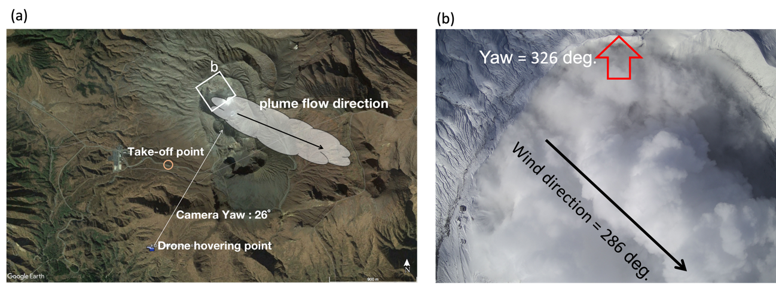
Figure S1 Summary of the aerial observation on January 12, 2022. (a) Location map of the UAS observation. After checking the wind direction (the black arrow), the UAS moved to the hovering point, perpendicular to the wind direction. (b) Flight view over the crater, as shown in an inset in (a). From a yaw angle of a UAS camera (clockwise from north), the wind direction was estimated to be 286 degrees (WNW).

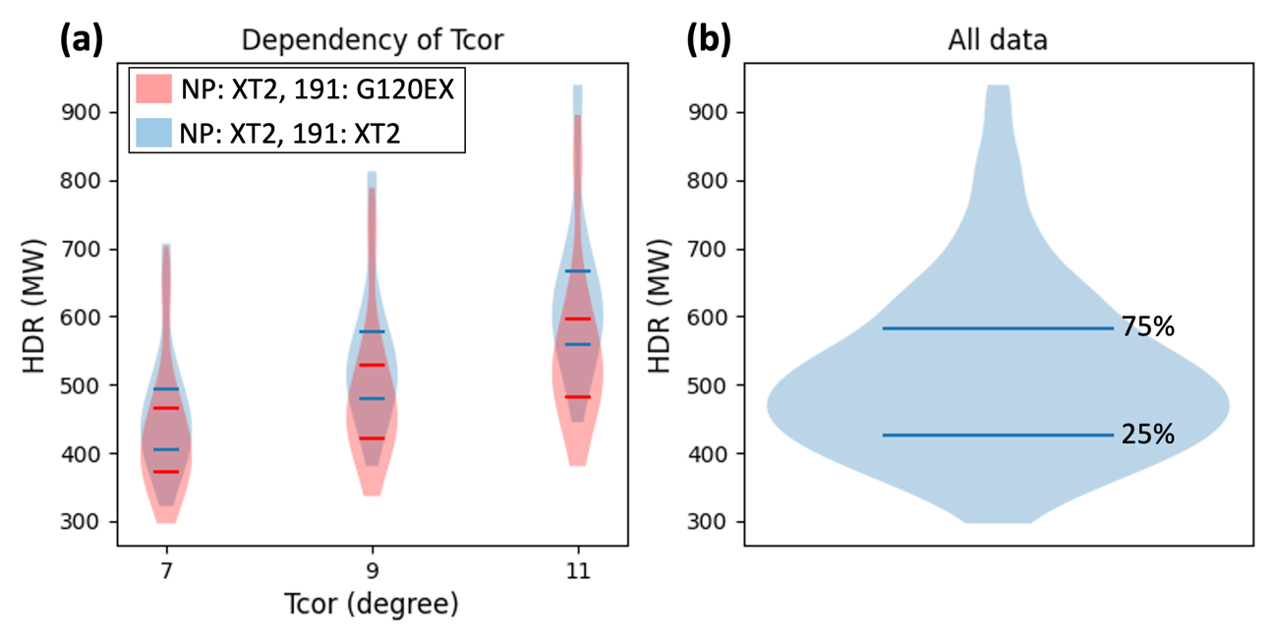
Figure S2 The dependency of estimated HDR on temperature correction of a plume taken by XT2 camera on September 23, 2021. Horizontal ticks in violin plots indicate 25 and 75 % percentiles. (a) Comparison of total HDR of the NP- and 191-vent-plumes, depending on the temperature correction (T_{cor}) of 7, 9, and 11 ℃ (Table S2). The blue violin plots correspond to the sum of the NP-plume (estimated by XT2) and the 191-vent-plume HDR (estimated by XT2). The red violin plots correspond to the sum of the NP-plume (estimated by XT2) and the 191-vent-plume HDR (estimated by G120EX). (b) A violin plot derived from all HDR values in (a). Total HDR ranges from 400 to 600 MW over the temperature correction of 7-11 ℃, referring to 25-75 % percentiles.

