Supplementary information
Protective role of native root-associated bacterial consortium against root-knot nematode infection in susceptible plants

Shikai La^{1,2,3}, Jiafan Li^{1,3}, Si Ma¹, Xingqun Liu¹, Lihong Gao¹, Yongqiang Tian¹

¹College of Horticulture, China Agricultural University, Yuanmingyuan West Road No. 2, Haidian District, Beijing, 100193, China.
²Institute of Economic Crops, Hebei Academy of Agricultural and Forestry Sciences, Heping West Road No. 598, Shijiazhuang, 050051, China
³These authors contributed equally: Shikai La, Jiafan Li.
email: tianyq1984@cau.edu.cn; gaolh@cau.edu.cn

The following files include:
Figs. S1 to S9
Tables S1 to S4

Fig. S1 The efficiency of soil sterilization by γ-irradiation. a Quantitative PCR (qPCR). qPCR was performed using iQ SYBR Green Supermix (BioRad), template DNA (5 ng) and universal primers for bacterial 16S rRNA and fungal ITS genes. Three technical replicates showed high reproducibility (mean SEM< 0.6% of mean), so only biological replicates (n = 3) were run. The proportions of bacteria and fungi were calculated based on their Ct values. Error bars represent the standard errors of the means. b The polymerase chain reaction (PCR) with the universal primers for bacterial 16S rRNA gene and fungal ITS gene amplifications. The PCR was performed under the following conditions: an initial denaturation step at 95 °C for 3 min, followed by 35 cycles of 95°C for 30 s, 55 °C for 30 s and 72 °C for 45 s, and a final extension at 72 °C for 3 min. H₂O, no DNA control. Escherichia coli DH5α and yeast strain Y187 were included as positive controls for bacteria and fungi, respectively. Soils were collected from sites located in three Chinese provinces. BJ, Beijing; SD, Shandong; SX, Shanxi.

Fig. S2 Plant response to soil sterilization and nematode infection in three distince soils. a Shoot fresh weight per plant. b Shoot dry weight per plant. c Root fresh weight per plant. d Root dry weight per plant. e The number of galls per plant. f The number of egg masses per plant. g Number of nematodes in deffierent stages. Data bars represent means and error bars represent the standard error of the mean. Different letters indicate statistically significant differences between treatments as determined by one-way ANOVA (analysis of variance) with post hoc Tukey HSD test (P < 0.05). Plants were grown in unsterilized or γ-sterilized soils and then infected or not infected (healthy) with Meloidogyne incognita. Soils were collected from sites located in three Chinese provinces. BJ, Beijing; SD, Shandong; SX, Shanxi.

Fig. S3 Root microbiome response to nematode infection in different soils. a Bacterial community composition in rhizopshere (RS). b Fungal community composition in RS. c Bacterial community composition in root endosphere (RE). d Fungal community composition in RE. Stacked bar plot shows the bacterial or fungal community composition at the family level. Plants were grown in unsterilized soils and then infected or not infected (healthy) with Meloidogyne incognita. Soils were collected from sites located in three Chinese provinces. BJ, Beijing; SD, Shandong; SX, Shanxi.

Fig. S4 Plant response to soil sterilization and nematode infection at the temporal scale. a Shoot fresh weight per plant. b Shoot dry weight per plant. c Root fresh weight per plant. d Root dry weight per plant. e The number of galls per gram root. f The number of egg masses per gram root. g Number of nematodes in deffierent stages. Data bars represent means and error bars represent the standard error of the mean. Different letters indicate statistically significant differences between treatments as determined by one-way ANOVA (analysis of variance) with post hoc Tukey HSD test (P < 0.05). Plants were grown in unsterilized or γ-sterilized soils and then infected or not infected (healthy) with Meloidogyne incognita. Samples collected on 3, 7, 14, 20, 28 and 35 days after inoculation (dai) with M. incognita were recognized as invasion by second-stage juveniles (J2s, initiation of feeding sites), parasitic J2s (formation of feeding sites), feeding third-stage juveniles (J3s, expansion of feeding sites), fourth-stage juveniles (J4s, expansion of feeding sites), adult females (maintenance of feeding sites) and females with egg masses, respectively. For Fig. S4e, lights highlight trends in the changes in the number of galls per plant or gram root along the increasing gradient of incolation time. ns, no significant.

Fig. S5 The responses of microbes and plants to nematode infection under conditons with a gradient of mirobial diversity. a Microbial abundance (based on quantitative PCR) at different dilution levels. A higher dilution level represents a lower diversity. b Chord diagram showing changes in the relative abundance of bacterial root-associated microbes (RAMs) in root endosphere (RE) at the phylum level under serial dilution treatments. c Changes in bacterial α-diversity (observed species richness) of RE with increasing simplification of microcosms. d Principal coordinate analyses (PCoA) based on Bray-Curtis distance showing the distinction of RE bacterial RAMs of M. incognita-infected plants at different dilution levels. e Changes in bacterial β-diversity (expressed by PCoA 1) of RE with increasing simplification of microcosms. f The number of galls per gram root. g The number of egg masses per gram root. h Number of nematodes in deffierent stages. Data bars represent means and error bars represent the standard error of the mean. Different letters indicate statistically significant differences between treatments as determined by one-way ANOVA (analysis of variance) with post hoc Tukey HSD test (P < 0.05). Plants were grown in soils with a gradient of mirobial diversity and then infected or not infected (healthy) with M. incognita. The shaded area in Fig. S5c,e indicates 95% regression confidence interval.

Fig. S6 Changes in metabolic and ecological functions of root bacterial microbiome under serial dilution treatments. a Bacterial funcationality in rhizosphere (RS). b Bacterial funcationality in root endosphere (RE). A higher dilution level represents a lower microbial diversity.

Fig. S7 Plant performance based on comprehensively evaluation of plant growth traits. a Principal component analysis (PCA) plots visualizing data associated with plant growth traits. b The relationships between plant growth traits and plant performance (PC1). Shading indicates 95% confidence interval.

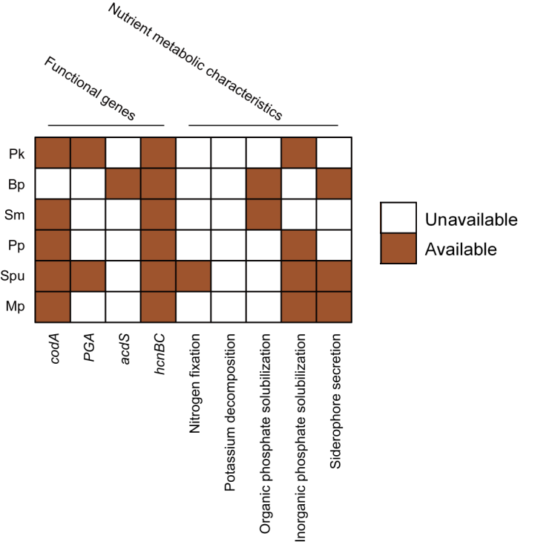

Fig. S8 Plant growth promotion (PGP)-related characteristics of the six high-performance functional strains (HFSs) of synthetic community (SynCom) C. Pk, Pseudomonas knackmussii; Bp, Bacillus proteolyticus; Sm, Stenotrophomonas maltophilia; Pp, Pseudomonas protegens; Spu, Sphingobacterium puteale; Mp, Microbacterium paraoxydans.

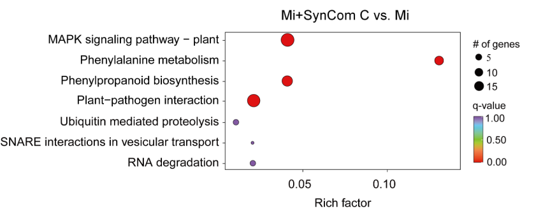

Fig. S9 KEGG term enrichment analysis of ‘core’ enriched genes-induced by synthetic community (SynCom) C inoculation under M. incognita infection. Top enriched KEGG terms displayed, ranked by significance (FDR < 0.05 cut-off). Mi, M. incognita infection; SynCom C, SynCom C inoculation.

Table S1 Physicochemical and microbial properties of the soils used in this study.
Properties |  | Site1-BJ | Site2-SD | Site3-SX | P-value
Clay (%) |  | 7.04±0.16 | 6.71±0.15 | 8.02±0.07 | 0.001 **
Silt (%) |  | 29.35±0.65 | 28.87±0.51 | 26.79±0.18 | 0.022 *
Sand (%) |  | 63.61±0.81 | 64.41±0.67 | 65.19±0.25 | 0.276
Soil texture |  | Sandy loam | Sandy loam | Sandy loam
pH |  | 7.09±0.03 | 6.92±0.06 | 7.37±0.01 | <0.001 ***
Electrical conductivity (μS·cm⁻¹) |  | 766.33±2.91 | 169.4±0.69 | 572.33±15.51 | <0.001 ***
Organic matter (g·kg⁻¹) |  | 26.17±0.26 | 19.98±0.49 | 26.87±0.66 | <0.001 ***
Available nitrogen (mg·kg⁻¹) |  | 4.08±0.07 | 34.44±1.97 | 4.06±0.13 | <0.001 ***
Available phosphorus (mg·kg⁻¹) |  | 13.18±2.10 | 5.45±1.00 | 6.61±0.73 | 0.016 *
Available potassium (mg·kg⁻¹) |  | 230.51±2.11 | 131.06±0.93 | 265.87±0.60 | <0.001 ***
Nitrogen (%) |  | 0.14±0.00 | 0.13±0.00 | 0.1±0.00 | <0.001 ***
Carbon (%) |  | 1.75±0.01 | 1.48±0.01 | 2.52±0.00 | <0.001 ***
Carbon/nitrogen ratio |  | 12.43±0.20 | 11.56±0.11 | 24.93±0.47 | <0.001 ***
Total P (mg·kg⁻¹) |  | 1.73±0.08 | 1.84±0.03 | 1.27±0.04 | <0.001 ***
Total K (mg·kg⁻¹) |  | 29.34±1.45 | 28.22±0.9 | 31.75±0.76 | 0.138
Total Ca (mg·kg⁻¹) |  | 19.74±1.66 | 42.39±0.87 | 66.5±2.12 | <0.001 ***
Total Mg (mg·kg⁻¹) |  | 5.21±0.95 | 5.71±0.28 | 11.18±0.42 | <0.001 ***
Total S (mg·kg⁻¹) |  | 0.52±0.02 | 1.01±0.02 | 1.18±0.04 | <0.001 ***
Total B (mg·kg⁻¹) |  | 1.52±0.43 | 2.85±1.18 | 1.38±0.11 | 0.353
Total Cu (mg·kg⁻¹) |  | 0.04±0 | 0.04±0 | 0.04±0 | 0.011 *
Total Fe (mg·kg⁻¹) |  | 38.42±1.44 | 40.71±0.38 | 49.19±1.57 | 0.002 **
Total Mn (mg·kg⁻¹) |  | 0.62±0.04 | 0.72±0.01 | 0.88±0.02 | 0.002 **
Total Mo (mg·kg⁻¹) |  | 0.00±0.00 | 0.00±0.00 | 0.00±0.00 | 0.009 **
Plant-parasitic nematode (No. g⁻¹ soil) |  | 0 | 0 | 0
Root-knot nematode (No. g⁻¹ soil) |  | 0 | 0 | 0
Bacteria | Absolute abundance | 1.08×10⁷±1.17×10⁶ | 1.05×10⁷±4.16×10⁵ | 7.78×10⁶±1.01×10⁶ | 0.002 **
Bacteria | Observed species | 2461.75±4.46 | 2112.25±3.09 | 2200±10.93 | <0.001 ***
Bacteria | Chao 1 index | 2505.76±9.16 | 2142.49±1.80 | 2259.09±6.64 | <0.001 ***
Fungi | Absolute abundance | 9.90×10⁴±2.77×10³ | 5.57×10⁴±9.46×10³ | 6.93×10⁴±5.54×10³ | 0.058
Fungi | Observed species | 101.25±2.66 | 187.25±4.27 | 188.75±16.44 | <0.001 ***
Fungi | Chao 1 index | 106.92±3.04 | 191.22±4.41 | 200.87±14.20 | <0.001 ***
Bacterial phylum | Proteobacteria | 27.65%±2.09% | 34.91%±0.14% | 24.63%±2.38% | 0.009 **
Bacterial phylum | Bacteroidota | 14.04%±1.71% | 17.63%±0.96% | 10.06%±1.84% | 0.023 *
Bacterial phylum | Acidobacteriota | 14.68%±1.65% | 6.21%±0.37% | 19.01%±3.25% | 0.006 **
Bacterial phylum | Gemmatimonadota | 7.15%±0.06% | 8.31%%±0.18% | 11.11%±0.55% | 0.001 ***
Bacterial phylum | Planctomycetota | 7.81%%±1.54% | 5.20%±0.47% | 7.33%±1.18% | 0.287
Bacterial phylum | Actinobacteriota | 6.88%%±0.56% | 6.66%±0.74% | 4.56%±0.36% | 0.034 *
Bacterial phylum | Chloroflexi | 5.11%±0.67% | 6.24%±1.08% | 6.23%±0.92% | 0.617
Bacterial phylum | Verrucomicrobiota | 4.95%±0.58% | 3.16%±0.34% | 4.98%±0.46% | 0.036 *
Bacterial phylum | Myxococcota | 3.15%±0.31% | 2.25%±0.22% | 5.24%±0.37% | <0.001 ***
Fungal phylum | Ascomycota | 23.98%±3.02% | 66.69%±2.13% | 27.44%±10.87% | 0.002 **
Fungal phylum | Olpidiomycota | 6.88%±3.84% | 0.17%±0.15% | 39.93%±12.68% | 0.011 *
Fungal phylum | Basidiomycota | 66.83%±3.26% | 10.08%±1.19% | 4.29%±2.2% | <0.001 ***
Fungal phylum | Mortierellomycota | 2.16%±0.51% | 18.16%±2.97% | 6.27%±1.15% | <0.001 ***
Fungal phylum | Chytridiomycota | 0.08%±0.02% | 4.03%±0.47% | 9.20%±2.42% | 0.004 **
*p < 0.05; **p < 0.01; ***p < 0.001
Table S2 The primers used in this study.
 | Primer Name | Sequence (5′-3′)
16S rRNA (bacteria) for q-PCR | EUB338 | ACTCCTACGGGAGGCAGCA
 | 806R | GGACTACHVGGGTWTCTAAT
ITS (fungi) for q-PCR | Arch-amoAF | STAATGGTCTGGCTTAGACG
 | Arch-amoAR | GCGGCCATCCATCTGTATGT
16s RNA (bacteria) for amplicon sequencing | 515F | GTGCCAGCMGCCGCGGTAA
 | 806R | GGACTACHVGGGTWTCTAAT
 | 799F | AACMGGATTAGATACCCKG
 | 1193R | ACGTCATCCCCACCTTCC
ITS (fungi) for amplicon sequencing | ITS1 F | CTTGGTCATTTAGAGGAAGTAA
 | ITS2 R | GCTGCGTTCTTCATCGATGC

Table S3 Characteristics of differentially expressed genes (DEGs) induced by synthetic community (SynCom) C inoculation and/or M. incognita infection.
Gene ID | NR | Pfam | Supplementary references  (plant defense responses)
CsaV3_2G019810 | hypothetical protein Csa_016920 [Cucumis sativus] | PF00304.23:Gamma-thionin family
CsaV3_3G021490 | MLP-like protein 28 [Cucumis sativus] | PF00407.22:Pathogenesis-related protein Bet v 1 family
CsaV3_3G021430 | kirola [Cucumis sativus] | PF00407.22:Pathogenesis-related protein Bet v 1 family
CsaV3_2G024320 | expansin-A11-like precursor [Cucumis sativus] | PF01357.24:Expansin C-terminal domain
CsaV3_3G028700 | probable pectate lyase 8 [Cucumis sativus] | PF00544.22:Pectate lyase
CsaV3_4G000960 | endoglucanase 17 [Cucumis sativus] | PF00759.22:Glycosyl hydrolase family 9
CsaV3_5G005910 | acid beta-fructofuranosidase 1, vacuolar [Cucumis sativus] | PF00251.23:Glycosyl hydrolases family 32 N-terminal domain
CsaV3_1G031420 | hypothetical protein Csa_019870 [Cucumis sativus] | PF00722.24:Glycosyl hydrolases family 16
CsaV3_4G008020 | hypothetical protein Csa_014414 [Cucumis sativus] | PF01453.27:D-mannose binding lectin | Eddie Ip et al., 2009
CsaV3_1G002240 | transcription factor PRE3-like [Cucumis sativus] | PF00010.29:Helix-loop-helix DNA-binding domain
CsaV3_1G007820 | hypothetical protein Csa_014090 [Cucumis sativus] | --
CsaV3_7G035390 | GATA transcription factor 9 [Cucumis sativus] | PF00320.30:GATA zinc finger
CsaV3_3G003710 | ethylene-responsive transcription factor ERF026-like [Cucumis sativus] | PF00847.23:AP2 domain | Bailey et al., 2018
CsaV3_5G040030 | hypothetical protein Csa_009288 [Cucumis sativus] | PF00847.23:AP2 domain | Bailey et al., 2018
CsaV3_3G012100 | transcription factor MYB30 [Cucumis sativus] | PF00249.34:Myb-like DNA-binding domain | Mabuchi et al., 2018
CsaV3_3G013680 | probable aspartic proteinase GIP2 [Cucumis sativus] | PF14541.9:Xylanase inhibitor C-terminal | Bajay et al., 2021
CsaV3_6G003120 | cysteine proteinase inhibitor B [Cucumis sativus] | PF16845.8:Aspartic acid proteinase inhibitor | Habib and Fazili, 2007
CsaV3_7G006370 | peroxidase N1 [Cucumis sativus] | PF00141.26:Peroxidase | Montebianco et al., 2020
CsaV3_7G028800 | hypothetical protein Csa_015602 [Cucumis sativus] | PF00462.27:Glutaredoxin
CsaV3_7G006280 | hypothetical protein Csa_017196 [Cucumis sativus] | PF00201.21:UDP-glucoronosyl and UDP-glucosyl transferase | Jeong et al., 2023
CsaV3_1G007760 | zerumbone synthase [Cucumis sativus] | PF13561.9:Enoyl-(Acyl carrier protein) reductase
CsaV3_1G009460 | 4-coumarate--CoA ligase-like 9 [Cucumis sativus] | PF00501.31:AMP-binding enzyme
CsaV3_3G030410 | 4-coumarate--CoA ligase-like 6 [Cucumis sativus] | PF00501.31:AMP-binding enzyme
CsaV3_7G031620 | 4-coumarate--CoA ligase 2 [Cucumis sativus] | PF00501.31:AMP-binding enzyme | Li et al., 2022

Table S4 Compounds of differentially metabolites (DMs) induced by synthetic community (SynCom) C inoculation and/or M. incognita infection.
Metabolite ID | Compounds
Lmhp008833 | LysoPC 16:1(2n isomer)
pmp001273 | LysoPC 18:2
Hmyn006303 | LysoPI 18:3
pmp001270 | LysoPC 16:1
Lmyn006011 | Gingerglycolipid B
Lmhp009590 | LysoPC 17:1
Waln010743 | 1-(2,3-dihydroxypropoxy)-3-(((2-(dimethylamino)ethoxy)(hydroxy)phosphoryl)oxy)propan-2-yl (11Z,14Z)-octadeca-11,14-dienoate
Lmbn004240 | 9,10-Dihydroxy-12,13-epoxyoctadecanoic acid
Waln010449 | 1-(2,3-dihydroxypropoxy)-3-(((2-(dimethylamino)ethoxy)(hydroxy)phosphoryl)oxy)propan-2-yl (E)-hexadec-9-enoate
Lmhp009769 | LysoPE 17:1
Lmhp009464 | LysoPE 17:1(2n isomer)
Lmhp008763 | LysoPE 16:1(2n isomer)
Lmhp010908 | LysoPC 19:1
Lmhp010190 | LysoPC 18:1(2n isomer)
WaYn011395 | 2-(2,3-dihydroxypropoxy)-3-(((2-(dimethylamino)ethoxy)(hydroxy)phosphoryl)oxy)propan-2-yl (Z)-14-Octadecenoic Acid
pmp001281 | LysoPC 18:1
Waln011704 | 1-(2,3-dihydroxypropoxy)-3-(((2-(dimethylamino)ethoxy)(hydroxy)phosphoryl)oxy)propan-2-yl (Z)-14-Octadecenoic Acid
Lmyn008503 | Octanoic acid
pmb1562 | 1-Stearidonoyl-Glycerol
Hmgp004006 | 3,5,3'-Trihydroxy-7,4'-dimethoxyflavone (Ombuin)
mws1174 | 3-O-Acetylpinobanksin
Lamn006359 | 4'-demethyl-3,9-dihydroeucomin glucoside
Zmhn001036 | Choerospondin
pmb0542 | Cyanidin-3-O-(6''-O-malonyl)glucoside
MWStz191 | Taxifolin-3'-O-glucoside
WaYn005089 | Neosakuranin
Hmhp005160 | Rehderianin I
pmp000004 | 4',5,7-Trihydroxy-3',6-dimethoxyflavone (Jaceosidin)
Lmnp002413 | Luteolin-6-C-glucoside-7-O-rhamnoside
mws1073 | Apigenin-6,8-di-C-glucoside (Vicenin-2)
Rfmb25702 | Pinoresinol-4-O-(6''-acetyl)glucoside
Lcsn000192 | indigoticoside A
Jmzn003343 | Saikolignanoside A
pmn001378 | Pinoresinol-4-O-glucoside
Yarn004381 | Tortoside B
Lcsn000194 | isatindigosesquilignan B
Lmsp003655 | Dehydrodiconiferyl alcohol-gamma'-O-glucoside
Lhmp121004 | Symplocosin

Supplementary references
Bailey, P. C., Schudoma, C., Jackson, W., Baggs, E., Dagdas, G., Haerty, W., Moscou, M., Krasileva, K. V. Dominant integration locus drives continuous diversification of plant immune receptors with exogenous domain fusions. Genome Biol. 19, 1-18 (2018).
Bajay, S. K., Aono, A. H., Kirst, M., de Souza, A. P. Unravelling complex molecular mechanisms in pine with genome-wide association analysis and gene co-expression networks. bioRxiv, 2021-10 (2021).
Eddie Ip, W. K., Takahashi, K., Alan Ezekowitz, R., Stuart, L. M. Mannose‐binding lectin and innate immunity. Immunol. Rev. 230, 9-21 (2009).
Habib, H., Fazili, K. M. Plant protease inhibitors: a defense strategy in plants. Biotechnol. Mol. Biol. Rev. 2, 68-85 (2007).
Jeong, E., Kim, W., Son, S., Yang, S., Gwon, D., Hong, J., Cho, Y., Jang, C. Y., Steinegger, M., Lim, Y. W., Kang, K. B. Qualitative metabolomics-based characterization of a phenolic UDP-xylosyltransferase with a broad substrate spectrum from Lentinus brumalis. Proc. Natl. Acad. Sci. USA 120, e2301007120 (2023).
Li, M., Guo, L., Wang, Y., Li, Y., Jiang, X., Liu, Y., Xie, D. Y., Gao, L., Xia, T. Molecular and biochemical characterization of two 4-coumarate: CoA ligase genes in tea plant (Camellia sinensis). Plant Mol. Biol. 109, 579-593 (2022).
Mabuchi, K., Maki, H., Itaya, T., Suzuki, T., Nomoto, M., Sakaoka, S., Morikami, A., Higashiyama, T., Tada, Y., Busch, W., Tsukagoshi, H. MYB30 links ROS signaling, root cell elongation, and plant immune responses. Proc. Natl. Acad. Sci. USA 115, E4710-E4719 (2018).
Montebianco, C. de B., Mattos, B. B., da F Silva, T., Barreto-Bergter, E., Vaslin, M. F. Cladosporium herbarum peptidogalactomannan triggers significant defense responses in whole tobacco plants. bioRxiv 2020-11 (2020).

