1. Loading AS1411 on NEX
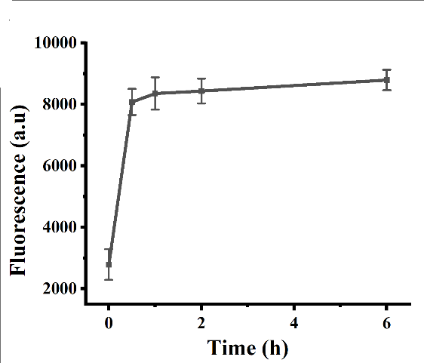

Figure S1. The optimal incubation time for NEX binding to B-Chol, as determined by changes in fluorescence.

  - Stability of B-Chol and M-Chol binding to NEX
First, we combined B-Chol and M-Chol separately with NEX under the same conditions and determine which structure has a higher binding efficiency by measuring the fluorescence change of the purified NEX.
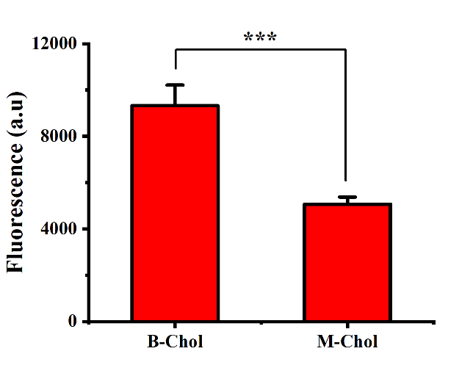
Figure S2. Verification of the binding efficiency of B-Chol and M-Chol to NEX by measuring the fluorescence of purified NEX. Data are presented as mean ± SD; n = 3. *** p < 0.001.

2. Stability testing of A-P-NEX
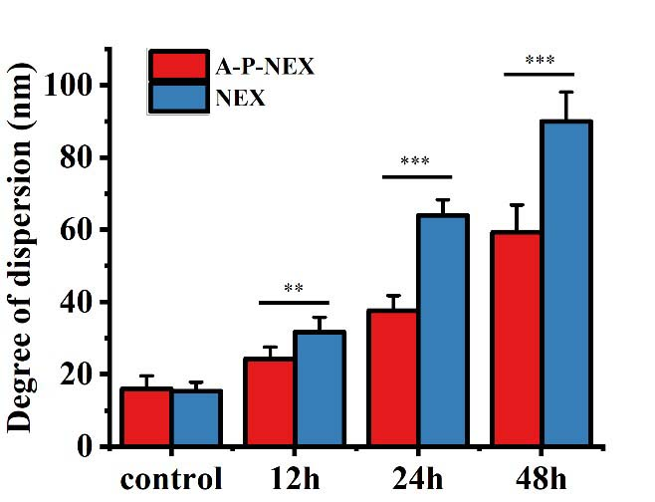
Figure S3. NEX stability as determined by measuring the change in NEX particle size dispersion over 48 h (DLS measures the size of NEX particles and quantifies the degree of dispersion by calculating variance). Data are presented as mean ± SD; n = 3. ** p < 0.01 and *** p < 0.001.

3. Uptake efficiency of A-P-NEX
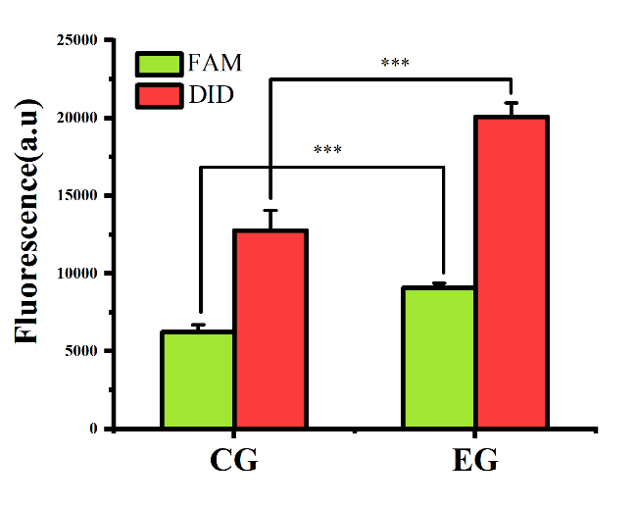
Figure S4. Quantitative flow cytometric analysis of HepG2 cells incubated under experimental (EG) and control group (CG) conditions. The experimental group (EG) was NEX pre-combined with AS1411, and the control group (CG) was not combined. Data are presented as mean ± SD; n = 3. ** p < 0.01 and *** p < 0.001.

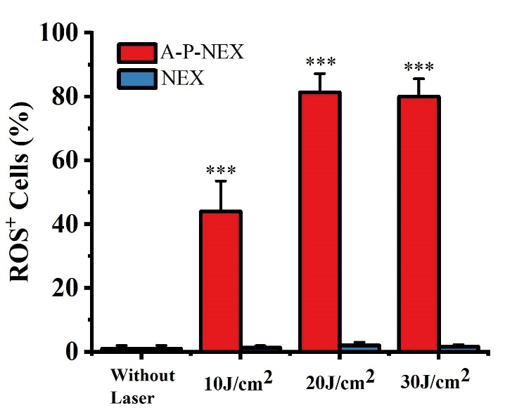
Figure S5. Effect of different laser intensities on ROS production. Data are presented as mean ± SD; n = 3. ** p < 0.01 and *** p < 0.001.

4. Singlet Oxygen Generation test
The present study aimed to investigate the singlet oxygen generation from ZnPc-loaded DNA. Three samples were prepared for this purpose, including free ZnPc, ZnPc-loaded AS1411 sequence, and ZnPc-loaded AS1411 complementary (cDNA) sequence. The samples were made in a phosphate buffer solution containing 0.1 M Na⁺, 25 mM K⁺, and 10 mM Mg²⁺ at pH 7.4. The concentration of ZnPc was 600 nM, and the DNA concentration was 1.8 μM. The singlet oxygen sensor green (SOSG) was added to each sample with a final concentration of 200 nM. A 660 nm laser was used at a power density of 20 J/cm⁻² for laser irradiation. The fluorescence of the samples was measured at an excitation wavelength of 504 nm and an emission wavelength of 525 nm after laser irradiation.

Figure S6. Singlet oxygen generation from free ZnPc, ZnPc-loaded AS1411 sequence, and ZnPc-loaded AS1411 complementary (cDNA) sequence. Data are presented as mean ± SD; n = 3. *** p < 0.001.

5. Cytotoxic ability test of A-P-NEX
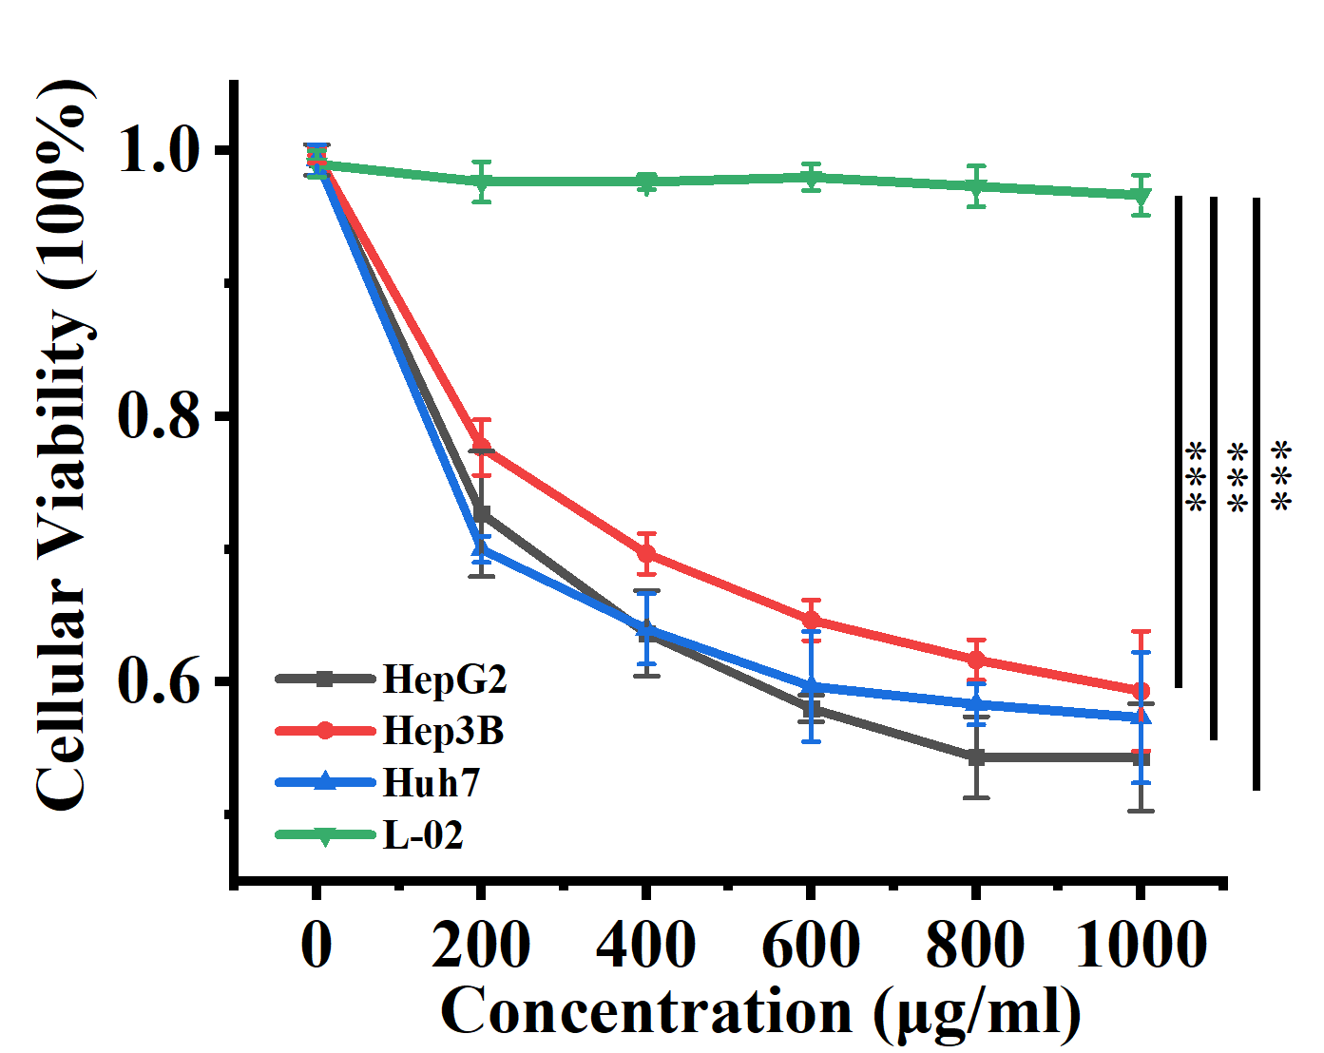
Figure S7. Different types of cells (HepG2, Hep3B, Huh7, and L-02) were co-incubated with different concentrations (200, 400, 600, 800, 1000 µg/mL) of NEX for 12 h and CCK-8 cytotoxicity assays were performed. Data are presented as mean ± SD; n = 3. *** p < 0.001.

Figure S8. Hep G2 was incubated with AS1411 (1.8 μM) or un-/modified NEX (NEX 600 μg/mL, A-P-NEX 600 μg/mL; laser intensity: 20 J/cm²) for 24 h. Cytotoxicity was then determined by CCK-8 assays. Data are presented as mean ± SD; n = 3. *** p < 0.001.

6. Apoptosis induction test with A-P-NEX
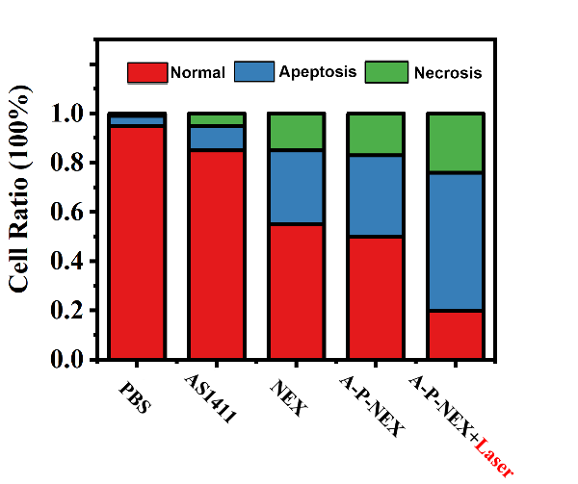
Figure S9. FACS results showing apoptosis in HepG2 cells after treatment using NEX with different modifications (AS1411: 600 nM; NEX: 600 μg/mL; A-P-NEX: 600 μg/mL; A-P-NEX+L: 600 μg/mL with 20 J/cm² laser irradiation. The cells were stained with Annexin V-FITC and PI.

