Comparison of the demographics of residential rooftop and community solar adopters

Supplementary Information

Supplementary Table 1. Numerical results for Figure 1

 | Median income (x$1,000) |  | % Renters |  | % Multifamily |  | % Non-White or Hispanic
State | Rooftop | Community | Rooftop | Community | Rooftop | Community | Rooftop | Community
CO | 123 | 117 | 2.5 | 22.4 | 1.6 | 30.2 | 24 | 8
DC | 145 | 144.5 | 5.3 | 28.7 | 11.9 | 75.5 | 65.4 | 67.7
IL | 96 | 84 | 3 | 18.7 | 5.4 | 37.7 | 44.5 | 28.5
MA | 127 | 97 | 5.6 | 36.3 | 11.4 | 48.8 | 27.7 | 26.7
MD | 142 | 99 | 1.9 | 30.1 | 1.9 | 36.8 | 55.7 | 22.4
ME | 107 | 78 | 5 | 8.5 | 5.3 | 16.9 | 0.7 | 1.5
MN | 122 | 94 | 1.6 | 5.3 | 1.9 | 5.8 | 8.5 | 10.3
NJ | 123 | 99 | 4.3 | 13.5 | 5.5 | 6 | 43.2 | 5
NY | 124 | 66 | 10.8 | 27 | 29.2 | 29.3 | 51.9 | 13.9
OR | 113 | 94 | 3.2 | 18.1 | 1.5 | 23.4 | 10.1 | 11.3
RI | 96 | 97 | 6 | 10.5 | 13.5 | 26.9 | 27.7 | 5.6

Supplementary Figure 1. Analysis of customer demographics below and above imputed LMI carveouts as a robustness check for policy impacts
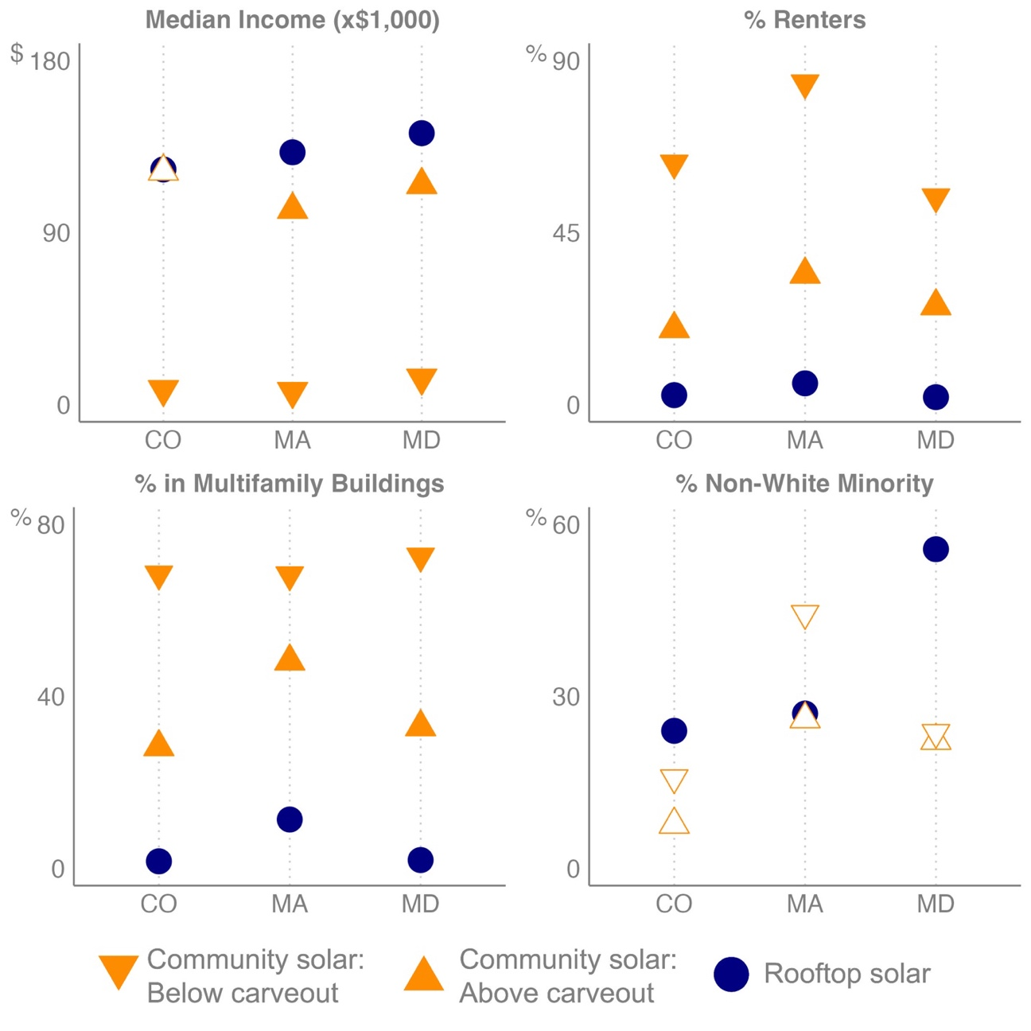

Supplementary Figure 2. Predictions for % Non-White or Hispanic based on full sample (including predictions based only on Census tracts) and restricted sample for records with surnames
