Layer-dependent effect of Aβ-pathology on cortical microstructure with ex-vivo human brain diffusion MRI at 7 Tesla

Supplementary Methods
Immunohistochemistry
The brain tissue sections were dewaxed in xylene, rehydrated through the decreasing concentration series of ethanol, and washed in 1× phosphate-buffered saline (PBS). Then, slices were blocked with 3% H₂O₂ for 10 min and immerged in boiling citrate buffer (pH 6.0) for 15 mins, and washed twice in PBS. The slices were immunolabeled with the primary antibodies (AT8 or Aβ as listed in Table S1) that were diluted in blocking buffer (1× PBS+0.1% Triton +3% normal goat serum) and incubated at 4°C overnight. After being transported to 37 °C for 60 mins, slices were treated with a secondary antibody (goat anti-mouse IgG) at 37 °C for 60 mins and washed in 1× PBS. The slices were immersed with 3, 3’-diaminobenzidin (DAB), kept at room temperature for 3 mins. Finally, the sections were dehydrated, cleared and mounted with neutral gums.
Table S1 Primary antibodies used for immunohistochemistry staining.
Primary Antibodies | Abbreviation | Host | Dilution | Vendor
Anti-Hyperphosphorylated-tau | AT8 | Mouse | 1:200 | Thermo Fisher Scientific
Anti-amyloid β protein | Aβ | Mouse | 1:200 | Sigma-Aldrich

Gray and White Matter Segmentation
nnU-Net is an open-source deep learning framework that has been specifically designed for medical image segmentation¹, which is based on an encoder-decoder design to learn hierarchical representations of input images and generate corresponding segmentation maps^{2,3}. In this study, we labeled a subset of slices along the sagittal axis to train our model using the 2D approach. Specifically, for each ex-vivo hemisphere, in the same locations, we manually labeled gray and white matter (GM/WM) on five slices per brain with a 3 mm interval between adjacent slices. Then, ten of fifteen hemispheres were used as the training dataset, and the remaining five ones were used as the test dataset. The 2D U-Net was trained using PyTorch 1.8.1 and Nvidia GeForce RTX3090 with a batch size of 8, patch size of 448×256, depth of 7, and base channel number of 32. The model was optimized using a loss function based on dice coefficient (DC) and cross-entropy (CE), and five-fold cross-validation was employed during training. The test results showed that our trained model had a high predicting accuracy with an averaged DC > 0.8 in five samples. Finally, the trained model was used to segment all slices of all samples to generate the cortical GM and WM labels.

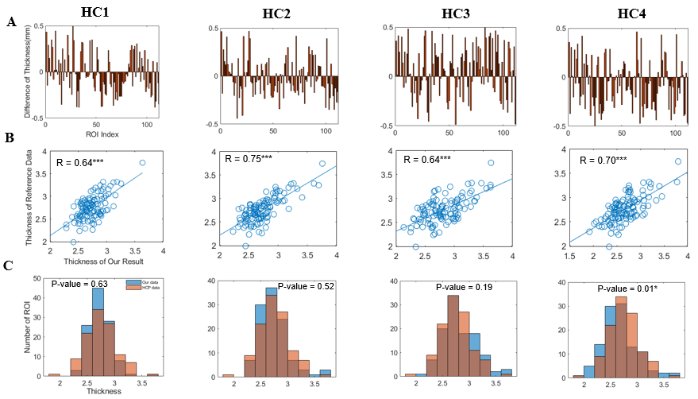
Supplementary Results
Fig. S1 Comparison of Thickness between Our Results and HCP. (A) shows the thickness differences (< 0.5mm) between our results and HCP in 112 brain regions of four HC cases. (B) shows significant positive correlations between our results and HCP across the 112 regions. (C) shows that, using a two-sample Kolmogorov-Smirnov test, the thickness of the 112 regions in our results did not significantly differ from those in HCP for all HC cases except for case 4. The findings in (B) and (C) suggest a commonly reliable registration in selected ROIs for four HC samples. ***: P < 0.001.

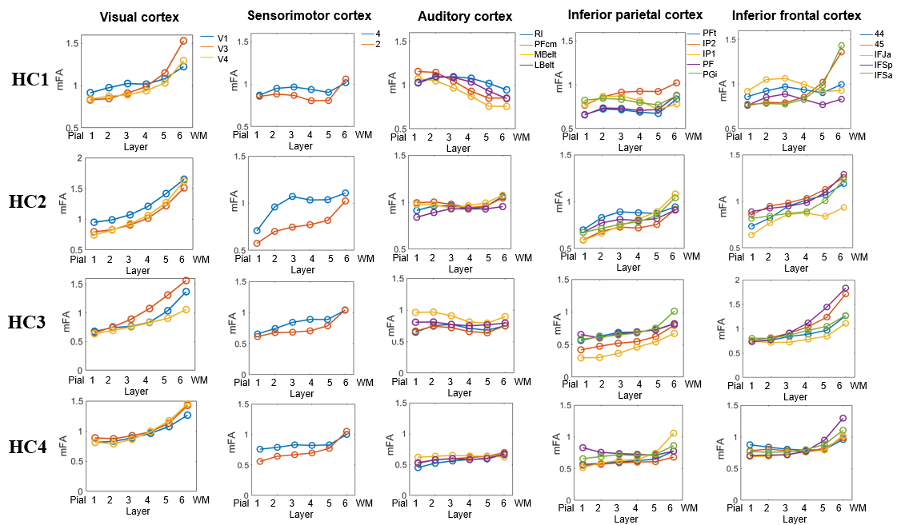
Fig. S2 Laminar-specific fractional anisotropy (FA, normalized) in different cortical regions of four HC cases
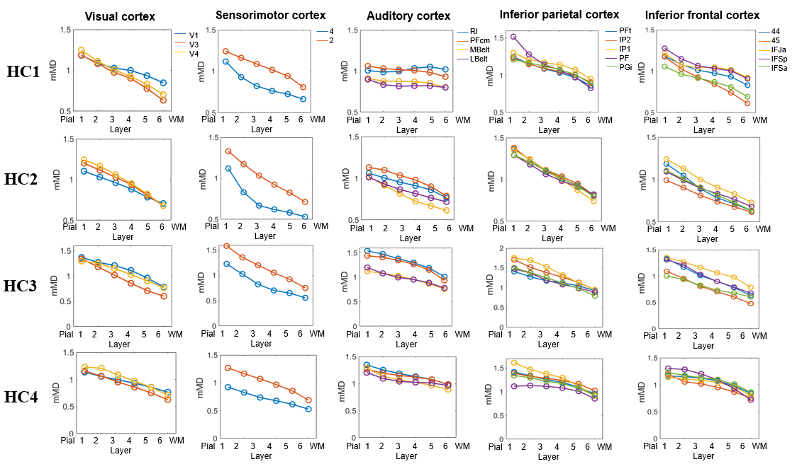
Fig. S3 Laminar-specific mean diffusivity (MD, normalized) in different cortical regions of four HC cases. Note that the axial and radial diffusivity showed similar patterns with mean diffusivity, and therefore are not displayed here
Fig. S4 Relationships between dMRI measurements and cell/myelin density. (A) shows manual matching of MRI sections with histological images. The regions within red circles in the MRI are most similar to histological images. (B) displays changes in myelin density based on Klüver-Barrera staining and H&E-based cell density with laminar depth from the pial to WM surface in four cortical regions. Note here the cortex in the histological images are divided into 30 layers for more detailed depiction. (C) shows significant correlations between FA and myelin density and between MD and cell density in several cortical regions. *: 0.01 < P < 0.05; **: 0.001 < P < 0.01; ***: P < 0.001

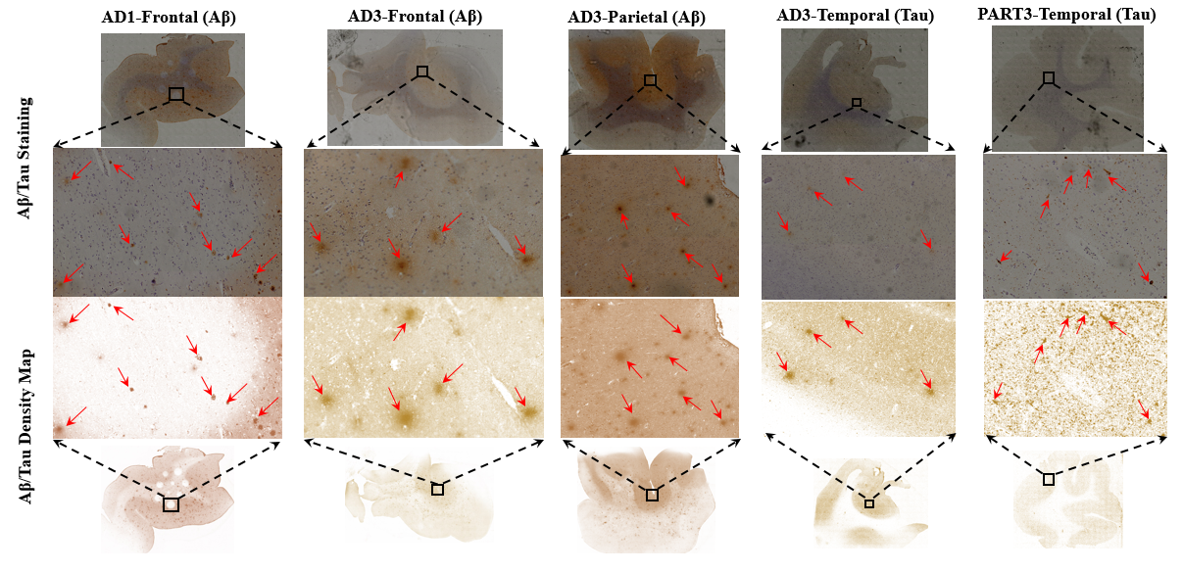
Fig. S5 Aβ/Tau plaque deposotion in two Aβ-positive and one PART samples. The top panel shows original staining images and the bottom panel shows corresponding Aβ/Tau density maps obtained after color deconvolution and their local close-up images. Aβ or Tau plaques are highlighted with red arrows.

Table S2. Comparisons of FA values in all paired samples in six cortical layers.
Paired Samples | Layer-I | Layer-II | Layer-III | Layer-IV | Layer-V | Layer-VI
PART3 vs HC2 | 4.34*** | 2.91** | 1.61 | 1.41 | 0.33 | 0.19
PART3 vs HC1 | -1.50 | -2.81** | -2.62* | -1.26 | 2.01 | 4.73***
AD1 vs HC3 | -0.34 | 1.01 | 0.52 | -0.34 | -1.03 | -0.29
AD2 vs HC2 | 5.39*** | 5.33*** | 5.94*** | 5.82*** | 3.42** | 2.70**
AD3 vs HC2 | 2.85** | 0.56 | -1.23 | -2.02 | -2.75** | -3.50**
AD2 vs PART3 | 0.84 | 2.67* | 3.98*** | 4.21*** | 3.06** | -0.77
AD3 vs PART3 | -1.91 | -2.00 | -2.42* | -3.13** | -3.89*** | -5.70***
AD5 vs PART2 | -5.38*** | -4.84*** | -4.24*** | -4.18*** | -5.21*** | -6.60***
AD6 vs PART2 | -2.82** | -3.62*** | -3.83*** | -4.30*** | -5.23*** | -6.99***
AD7 vs PART2 | -7.08*** | -5.86*** | -4.99*** | -4.50*** | -4.17*** | -3.63***
Note that the T values presented in the table represent the results of a paired t-test conducted between paired samples across brain regions in each cortical layer. Positive and negative T values indicate higher and lower FA values in the former sample compared to the latter, respectively. *: 0.01 < P < 0.05; *: 0.001 < P < 0.01; ***: P < 0.001.

Table S3. Comparisons of MD values in all paired samples in six cortical layers.
Paired Samples | Layer-I | Layer-II | Layer-III | Layer-IV | Layer-V | Layer-VI
PART3 vs HC2 | -3.12** | -0.56 | 2.94** | 5.01*** | 5.48*** | 5.86***
PART3 vs HC1 | -0.36 | 0.24 | -0.42 | -1.85 | -3.42** | -4.28***
AD1 vs HC3 | -2.04 | -1.33 | -0.14 | 0.59 | 1.08 | 1.55
AD2 vs HC2 | 11.81*** | 14.51*** | 16.42*** | 16.73*** | 16.01*** | 15.34***
AD3 vs HC2 | 1.57 | 5.86*** | 10.73*** | 15.04 | 16.26 | 17.25
AD2 vs PART3 | 11.71*** | 13.92*** | 14.80*** | 14.07*** | 13.68*** | 12.54***
AD3 vs PART3 | 3.86*** | 5.97*** | 7.74*** | 9.38*** | 10.26*** | 11.56***
AD5 vs PART2 | -6.54*** | -4.04*** | -2.76* | -2.05 | -1.00 | -0.41
AD6 vs PART2 | 2.68* | 5.02*** | 5.72*** | 5.79*** | 5.61*** | 5.75***
AD7 vs PART2 | -0.74 | 0.60 | 0.62 | -0.07 | -1.16 | -2.54*
Note that the T values presented in the table represent the results of a paired t-test conducted between paired samples across brain regions in each cortical layer. Positive and negative T values indicate higher and lower MD values in the former sample compared to the latter, respectively. *: 0.01 < P < 0.05; *: 0.001 < P < 0.01; ***: P < 0.001.

Reference
1. Isensee, F., Petersen, J., Klein, A., Zimmerer, D., Jaeger, P. F., Kohl, S., ... & Maier-Hein, K. H. (2021). nnU-Net: a self-configuring method for deep learning-based biomedical image segmentation. Nature Methods, 18(2), 203-211.
2. Zhou, Z., Siddiquee, M. M. R., Tajbakhsh, N., & Liang, J. (2019). UNet++: A Nested U-Net Architecture for Medical Image Segmentation. In Deep Learning in Medical Image Analysis and Multimodal Learning for Clinical Decision Support (pp. 3-11). Springer.
3. Çiçek, Ö., Abdulkadir, A., Lienkamp, S. S., Brox, T., & Ronneberger, O. (2016). 3D U-net: learning dense volumetric segmentation from sparse annotation. In International conference on medical image computing and computer-assisted intervention (pp. 424-432). Springer.

