0-26 cm depth 26-44 cm depth 44-65 cm depth
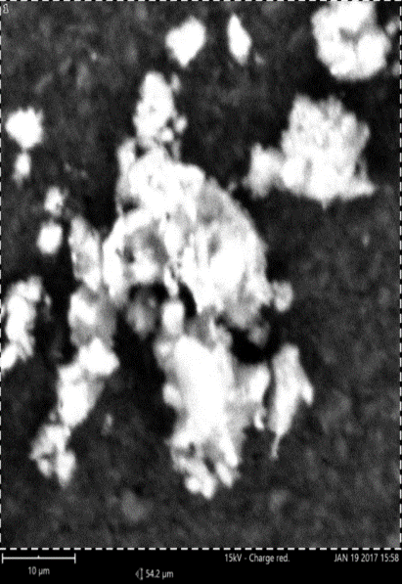
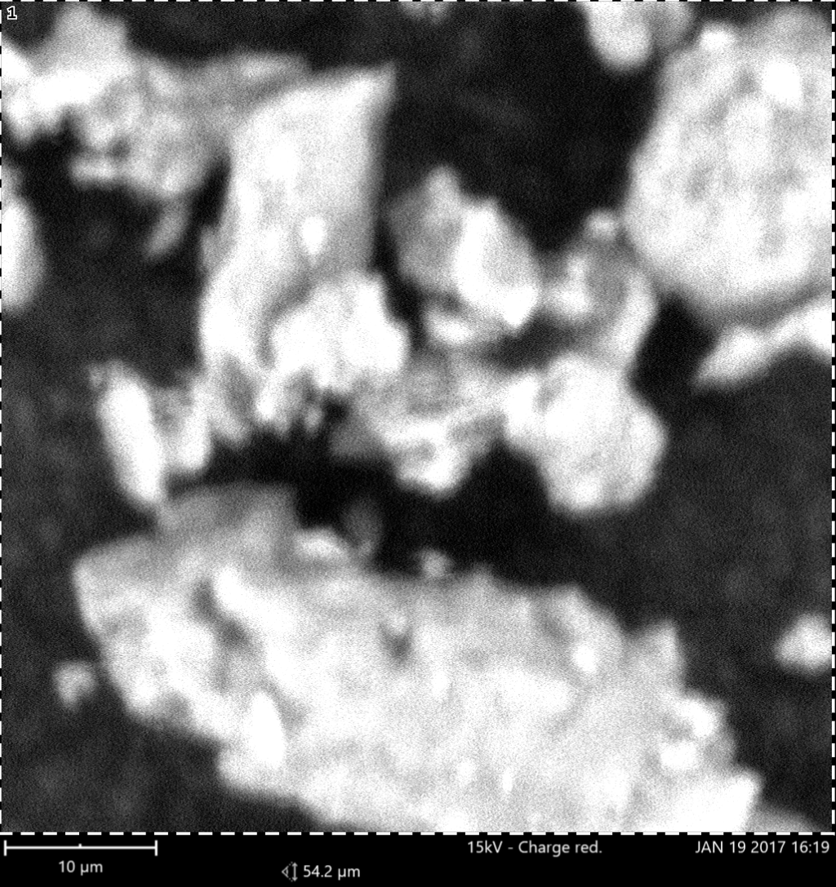
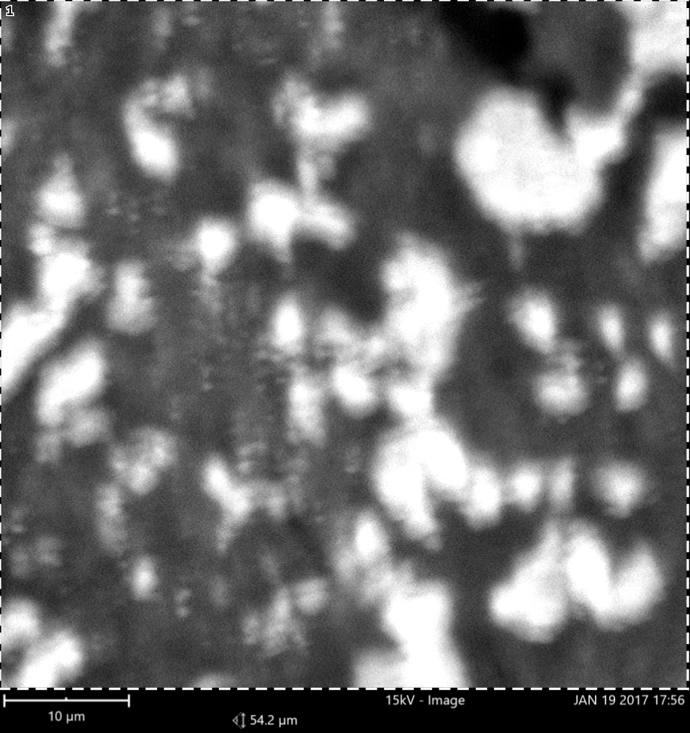

Plate 1: Scanning electron micrographs of soil samples from Basement Complex rock

0-40 cm depth 40-55 cm depth 55-82 cm depth
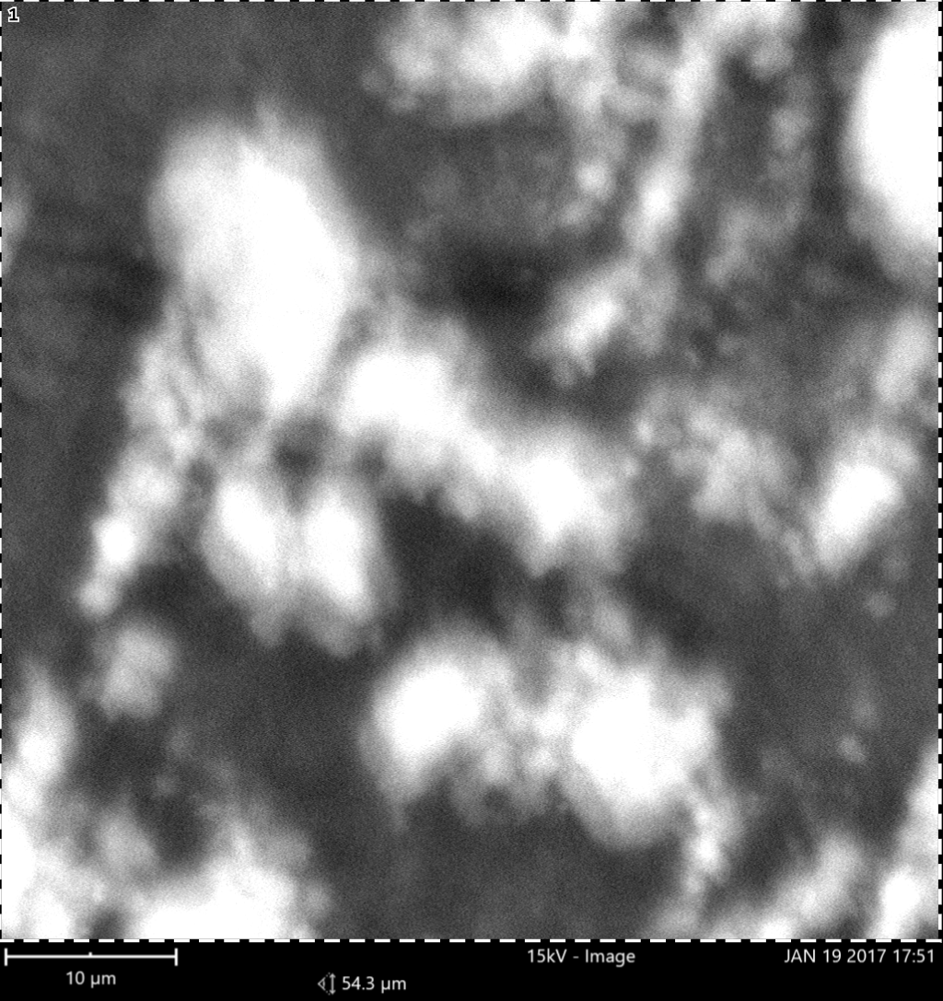
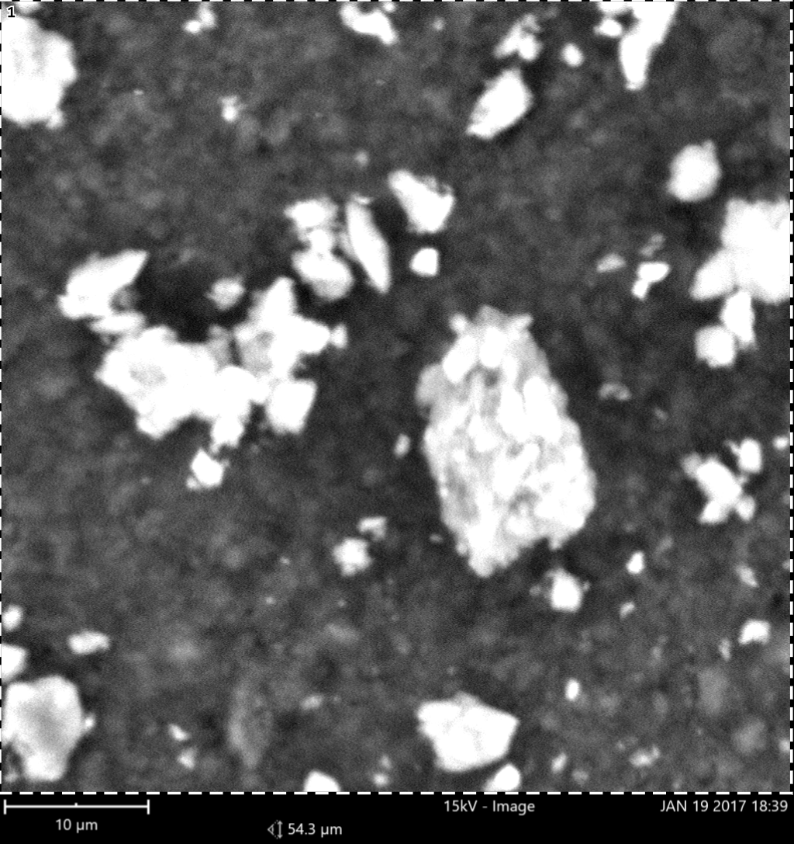
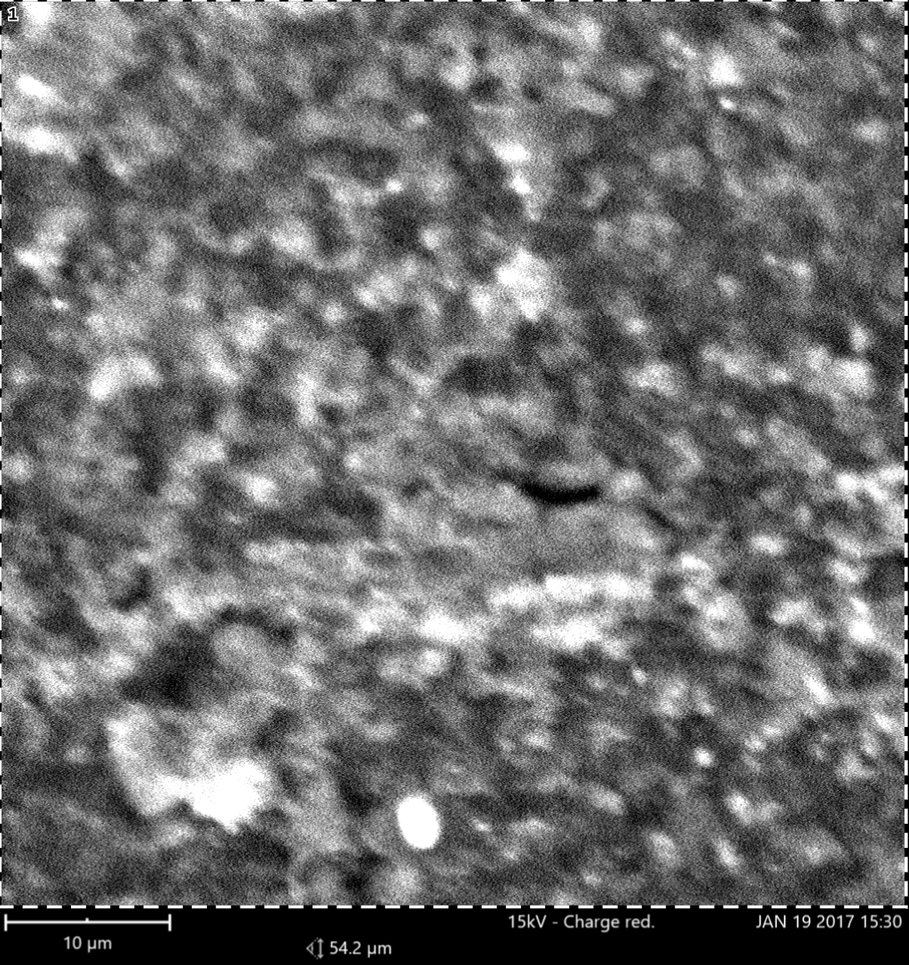

Plate 2: Scanning electron micrographs of soil developed over Coastal plain sand

0-18 cm depth 18-38 cm depth 38-69 cm depth
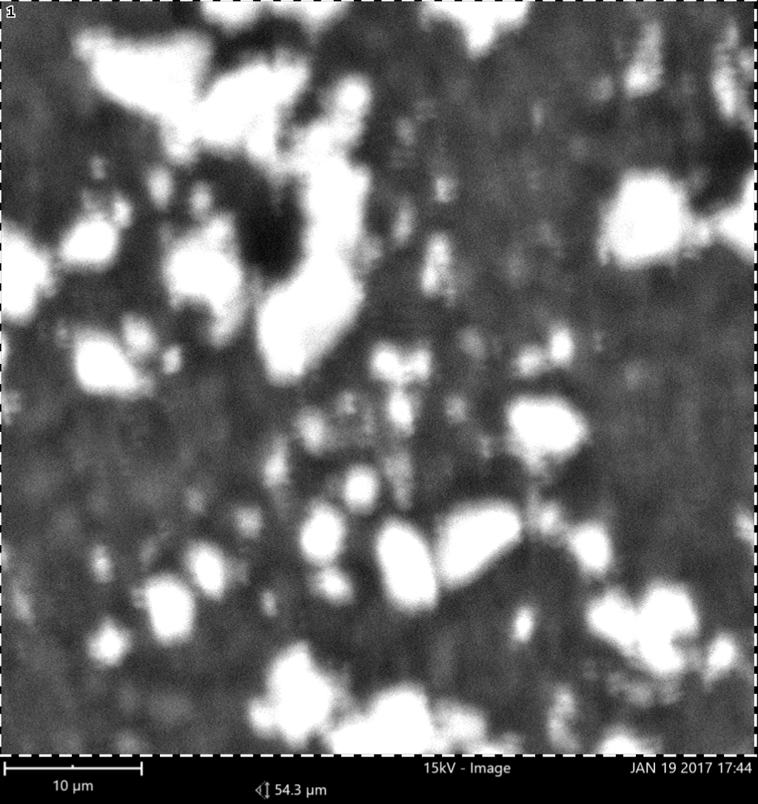
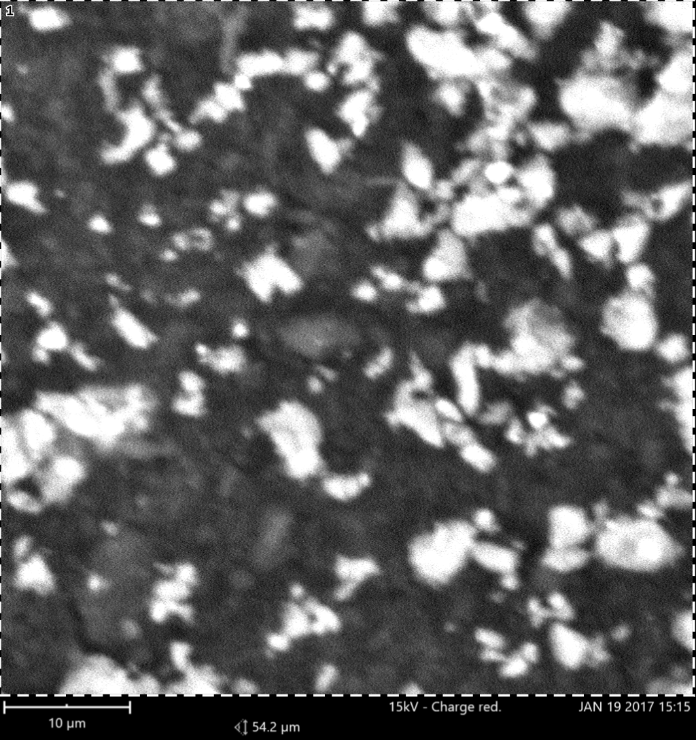
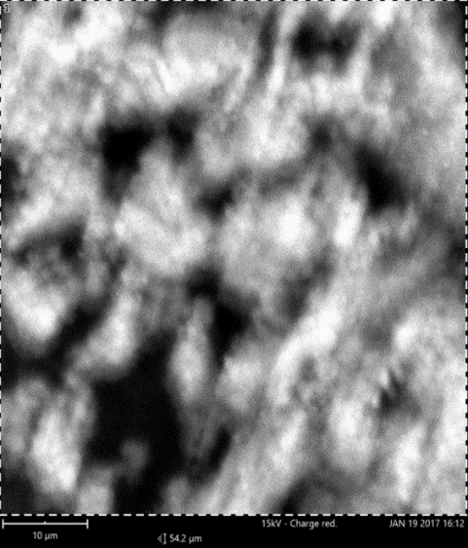

Plate 3: Scanning electron micrographs of soil developed over Ewekoro Formation

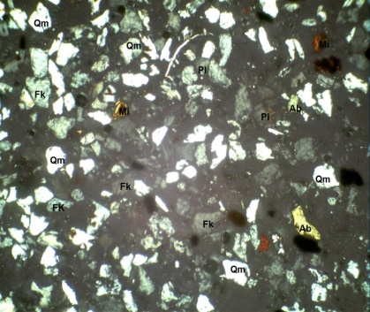
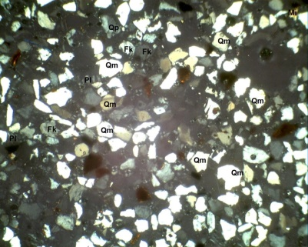
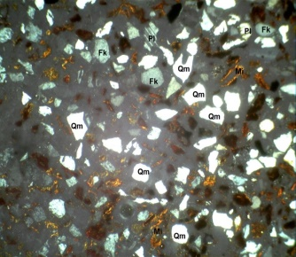
0-26 cm depth 26-44 cm depth 44-65 cm depth

Plate 4: Petrographic images of fine sand fraction of pedon developed on Basement Complex rock
Qm =Monocrystalline quartz, HM =Heavy minerals , Fk =Potassium feldspar ,Rf =Rock fragments, Pl =Plagiosclase feld

0-40 cm depth 40-55 cm depth 55-82 cm depth
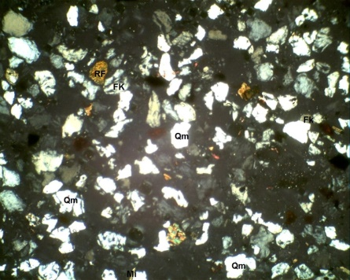
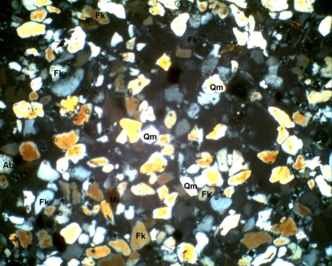
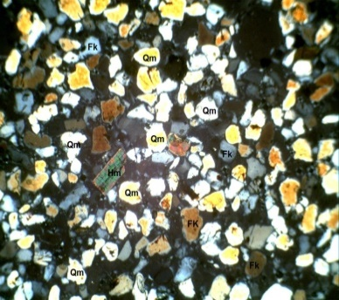

Plate 5: Petrographic images of fine sand fraction of pedon developed on Coastal plain sand
Qm =Monocrystalline quartz, HM =Heavy minerals , Fk =Potassium feldspar ,Rf =Rock fragments, Pl =Plagiosclase feldpar

0-18 cm depth 18-38 cm depth 38-69 cm depth
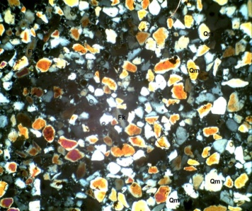
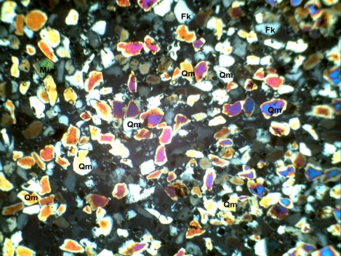

Plate 6: Petrographic images of fine sand fraction of pedon developed on Ewekoro Formation
Plate 6: Petrographic images of fine sand fraction of pedon developed on Ewekoro Formation
Qm =Monocrystalline quartz, HM =Heavy minerals , Fk =Potassium feldspar ,Rf =Rock fragments, Pl =Plagiosclase feldpar

0-26 cm depth 26-44 cm depth 44-65 cm depth
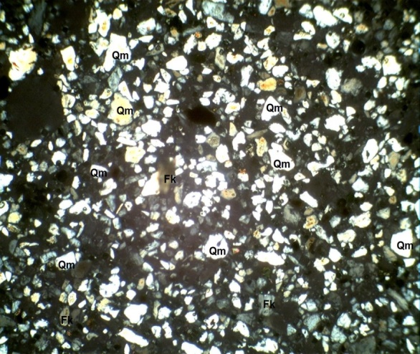
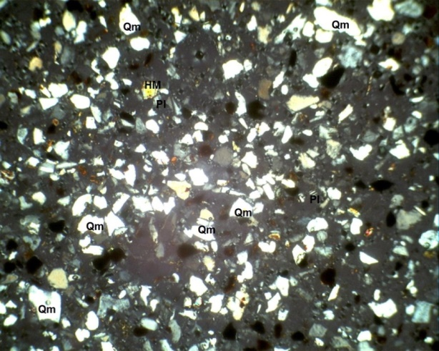

Plate 7: Petrographic images of coarse silt fraction of pedon developed on Basement Complex rock.
Qm =Monocrystalline quartz, Pl = Plagiosclase feldspar, Fk=Potassium feldspar, Rf =Rock fragments,Hm =Heavy minerals

0-40 cm depth 40-55 cm depth 55-82 cm depth
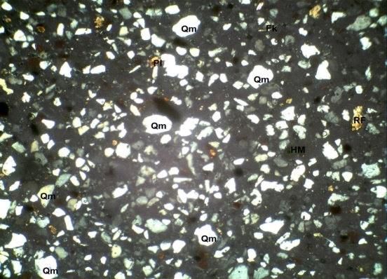
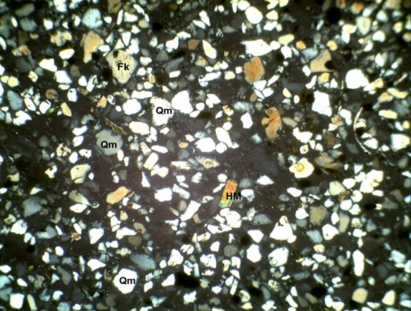
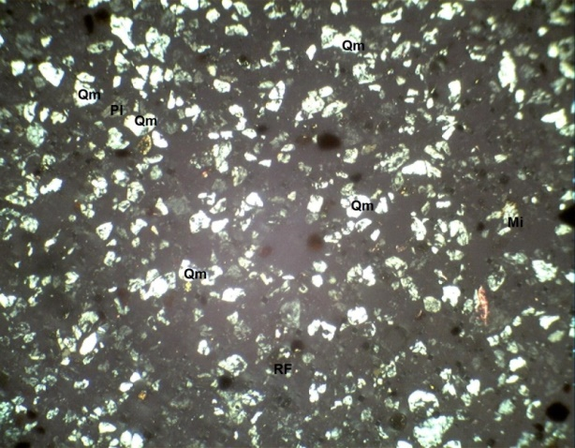

Plate 8: Petrographic images of coarse silt fraction of pedon developed on Coastal plain sand
Qm =Monocrystalline quartz, HM =Heavy minerals , Fk =Potassium feldspar ,Rf =Rock fragments, Pl =Plagiosclase feldpar

0-18 cm depth 18-38 cm depth 38-69 cm depth
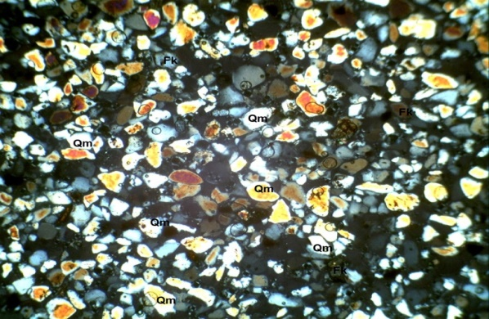
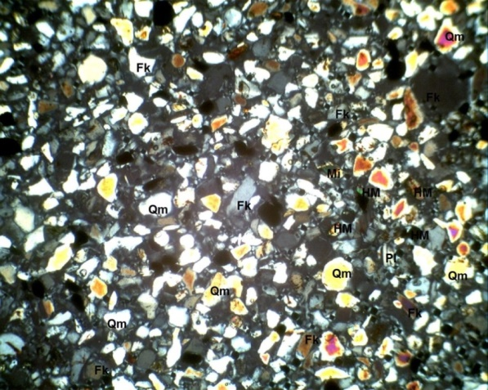
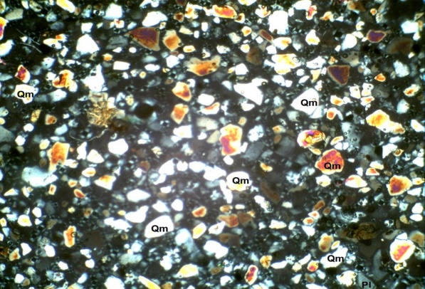

Plate 9: Petrographic images of coarse silt fraction of pedon developed on Ewekoro Formation
Qm =Monocrystalline quartz, HM =Heavy minerals , Fk =Potassium feldspar ,Rf =Rock fragments, Pl =Plagiosclase feldpar

