Supplementary material

Supplementary Video 1. Representative video of a UNO section (20 µm). Note the astrocyte-rich areas (GFAP, red) and neuron-rich areas (MAP2, magenta) located outside the ventricular zones, high in neural progenitor cells (SOX2, yellow).

Supplementary Video 2. Representative video of PeV-A1 infected UNOs and stained for nuclei (cyan), and immunolabelled for PeV-A1 VP1 (magenta) and dsRNA (yellow).

Supplementary Video 3. Representative video of PeV-A3 infected UNOs and stained for nuclei (cyan), and immunolabelled for PeV-A3 VP1 (magenta) and dsRNA (yellow).

Supplementary Text 1. Complete list of DEPs from the differential expression analysis (adjusted P-value < 0.1) of UNO infection with the lab-adapted strains of PeV-A1, PeV-A3 and E11, compared to the mock-infected samples.

Supplementary Text 2. Complete list of DEPs from the differential expression analysis of UNO infection with the Clinical isolates of PeV-A1 and PeV-A3 (P-value <0.05) and lab-adapted strain of E11 (adjusted P-value < 0.1), compared to the mock-infected samples.

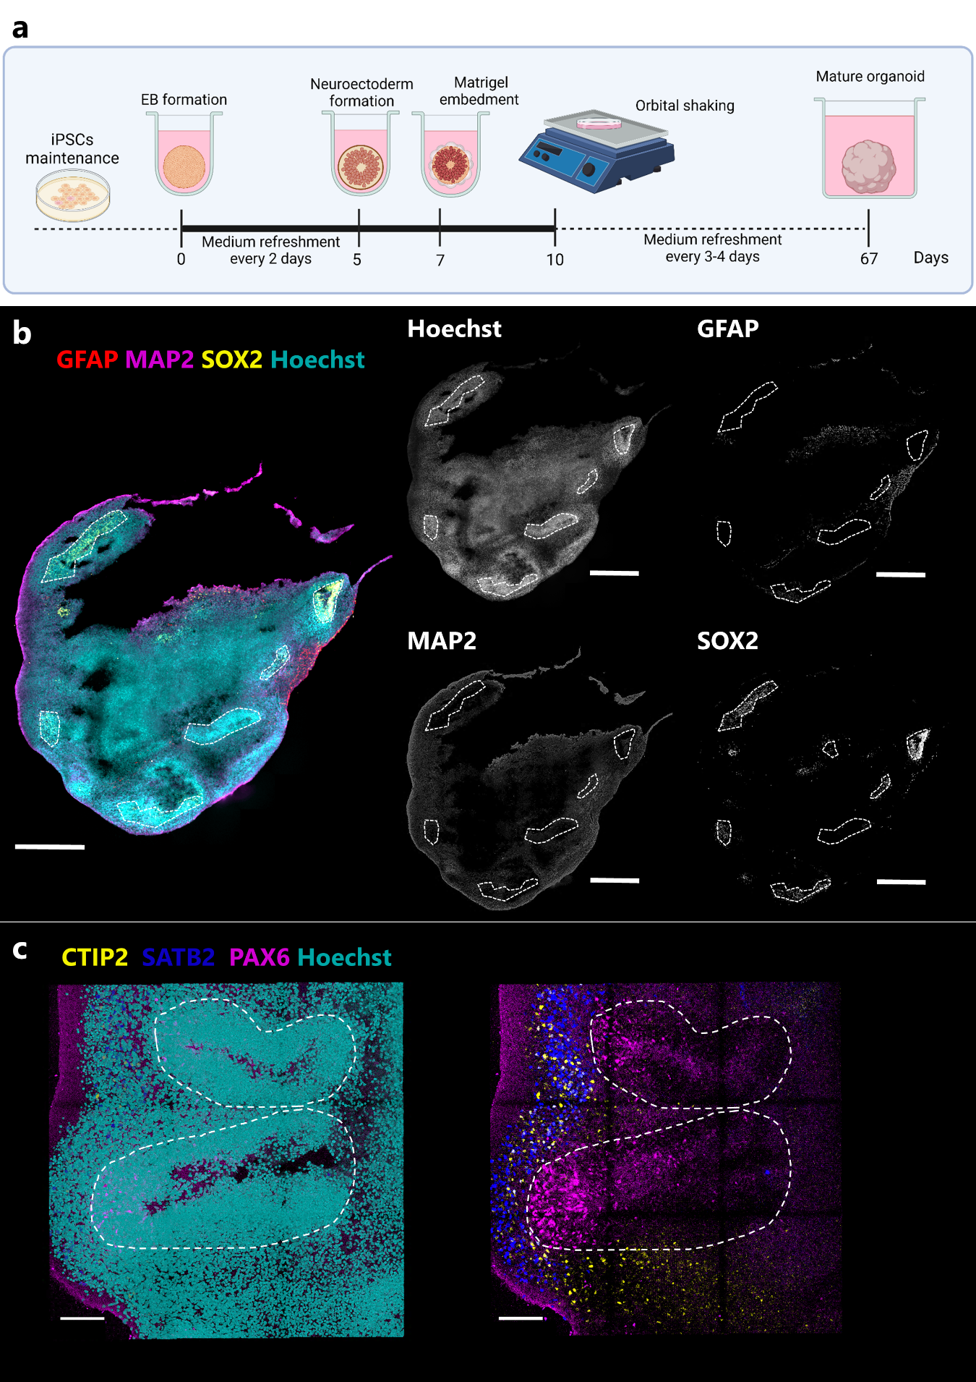
Supplementary Figure 1. Characterization of unguided neural organoids (UNO) by immunofluorescence staining.
a, Schematic representation of the protocol followed to obtain UNOs. b, Representative image of an UNO section with the expected cytoarchitecture. Astrocyte-rich areas (GFAP, red) and neuron-rich areas (MAP2, magenta) are located outside the ventricular-like zones (VZs) that are high in neural progenitor cells (SOX2, yellow). Dashed lines are marked around VZs. Scale bar 500 µm. c, Representative image of cortical neuron layering in UNOs. PAX6 staining (magenta) show neural progenitor cells in the VZs surrounded by early born deep-layer neurons (CTIP2, yellow), and late-born superficial layer neurons (SATB2, blue). Scale bar 100µm. In both cases nuclei were stained with Hoechst (cyan).

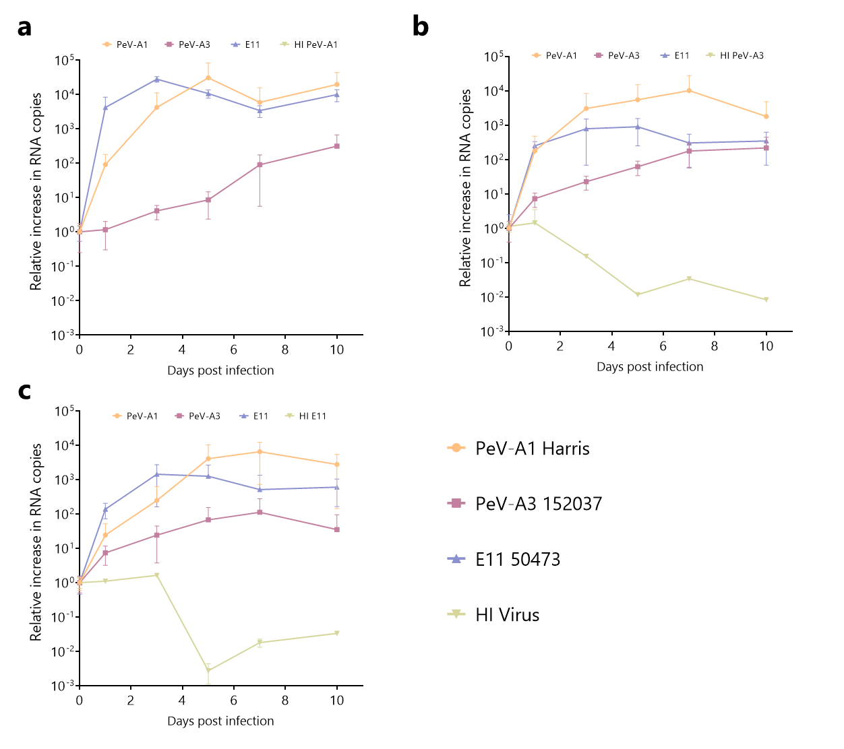
Supplementary Figure 2. a, Relative increase in viral RNA copies in samples collected from supernatant at different time points for PeV-A1, PeV-A3, E11, heat-inactivated PeV-A1, b, heat-inactivated PeV-A3, c, and heat-inactivated E11 on UNOs. In all cases, data represents the mean ± SEM of three technical replicates in one batch of organoids. HI = heat inactivated. HI PeV-A1 RNA copies were undetectable.

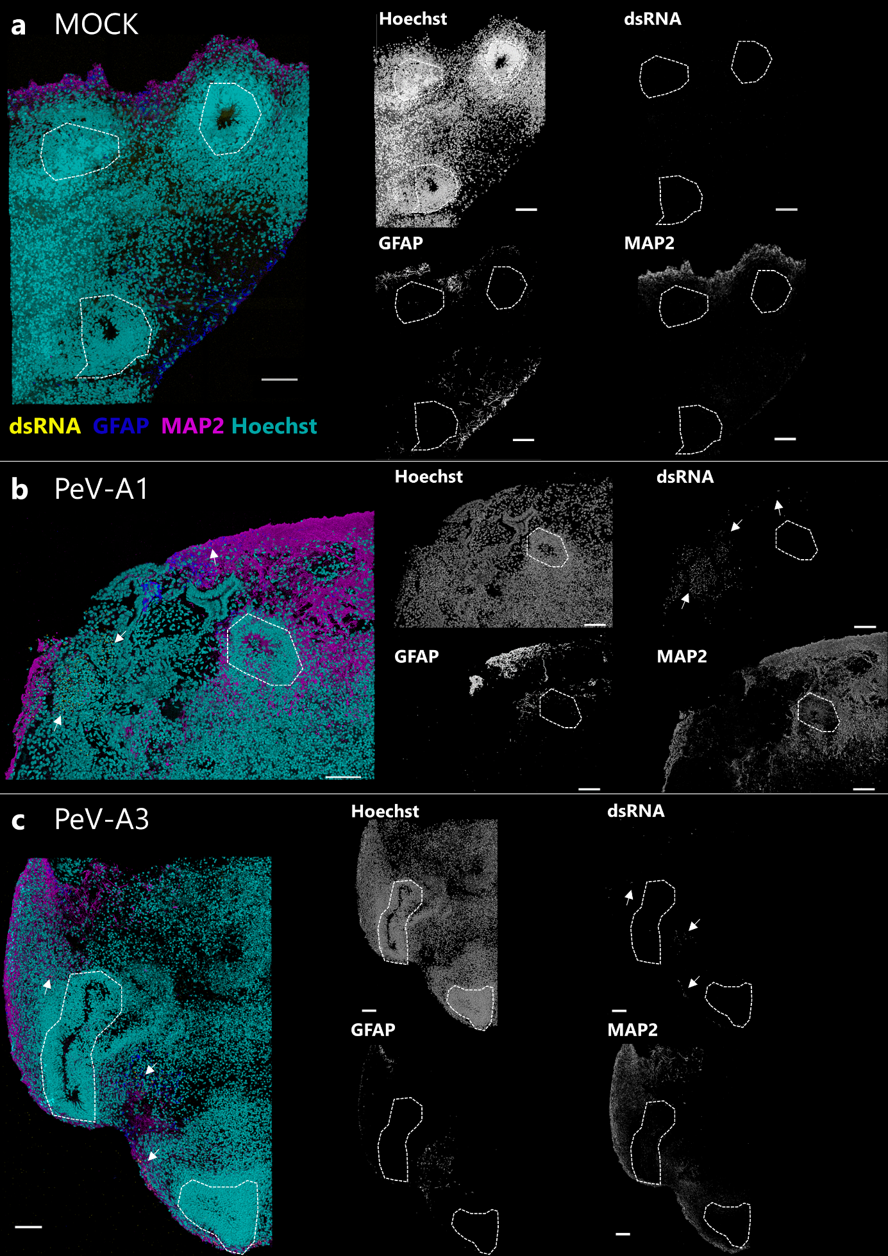
Supplementary Figure 3. Representative confocal z-stacks from a, MOCK, b, PeV-A1, and c, PeV-A3 infected UNOs at 10 dpi. Stained for nuclei (cyan), and immunolabelled for dsRNA (yellow), astrocytes (GFAP, blue) and neurons (MAP2,magenta). Dashed lines are around VZs. Scale bar 100 µm. Arrows indicate regions with positive dsRNA staining.
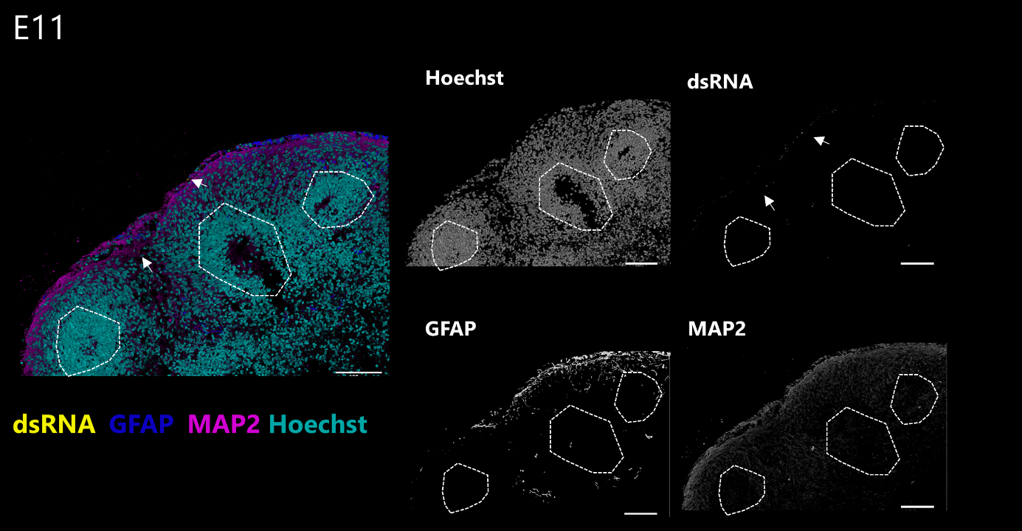
Supplementary Figure 4. Confocal z-stacks from E11 infected UNOs at 10 dpi. Labelled for nuclei (cyan), dsRNA (yellow), GFAP (blue) and MAP2 (magenta). Arrows indicate regions with positive dsRNA staining.
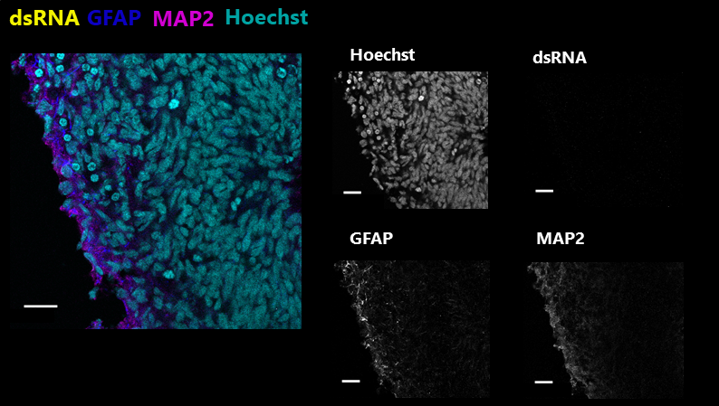
Supplementary Figure 5. Confocal image of MOCK infected UNOs. Labelled for nuclei (cyan), and immunolabelled for dsRNA (yellow), GFAP (blue), and MAP2 (magenta). Scale bars 20 µm.
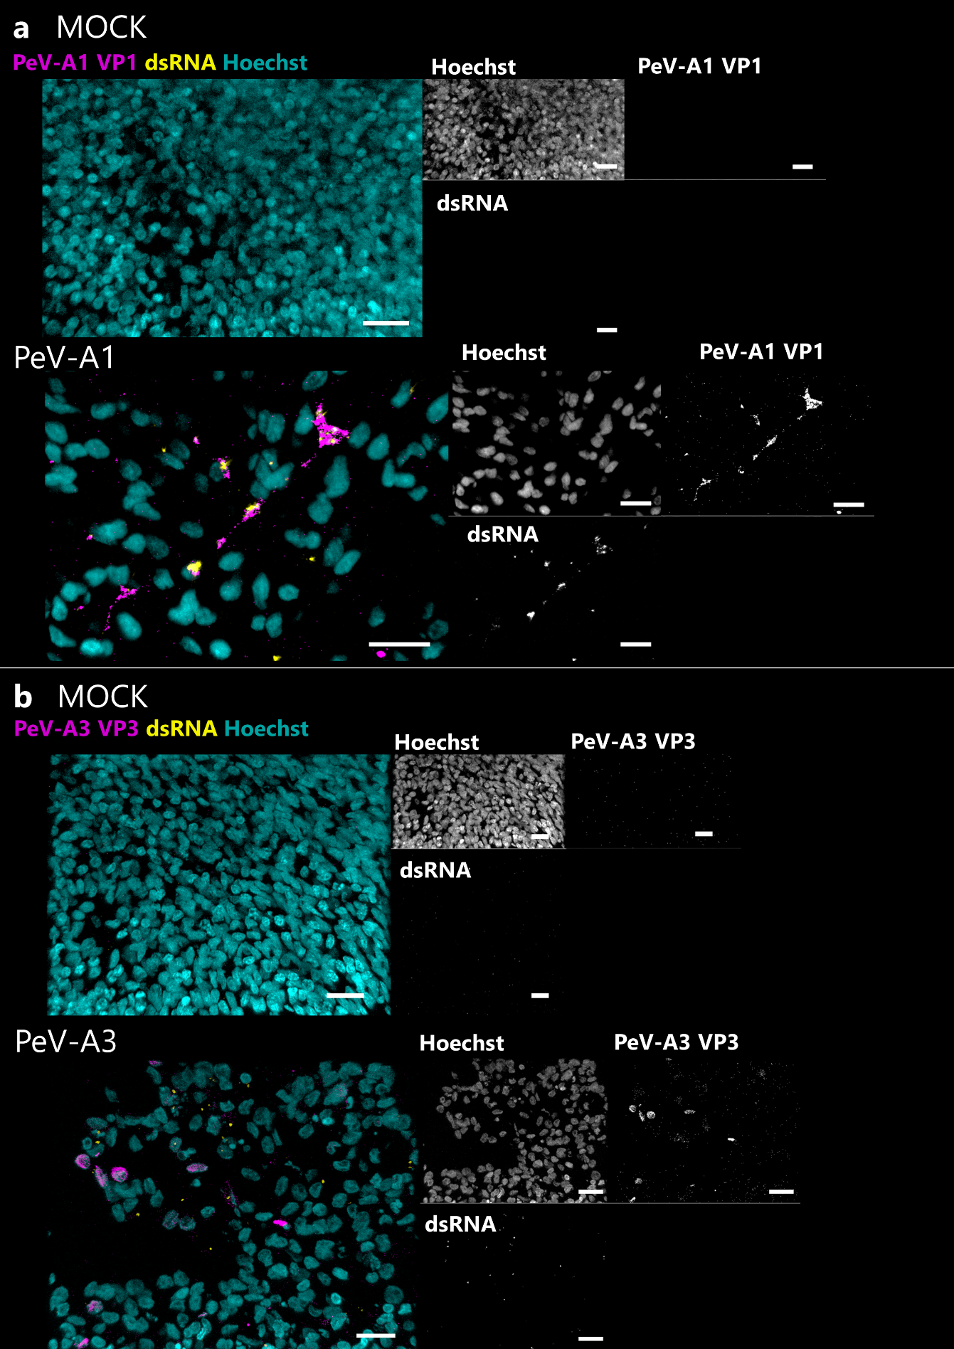
Supplementary Figure 6. Representative confocal images from a, MOCK and PeV-A1 infected UNOs and stained for nuclei (cyan), and immunolabelled for PeV-A1 VP1 (magenta) and dsRNA (yellow). b, MOCK and PeV-A3 infected UNOs and stained for nuclei (cyan), and immunolabelled for PeV-A3 VP3 (magenta) and dsRNA (yellow). Scale bar 20 µm.

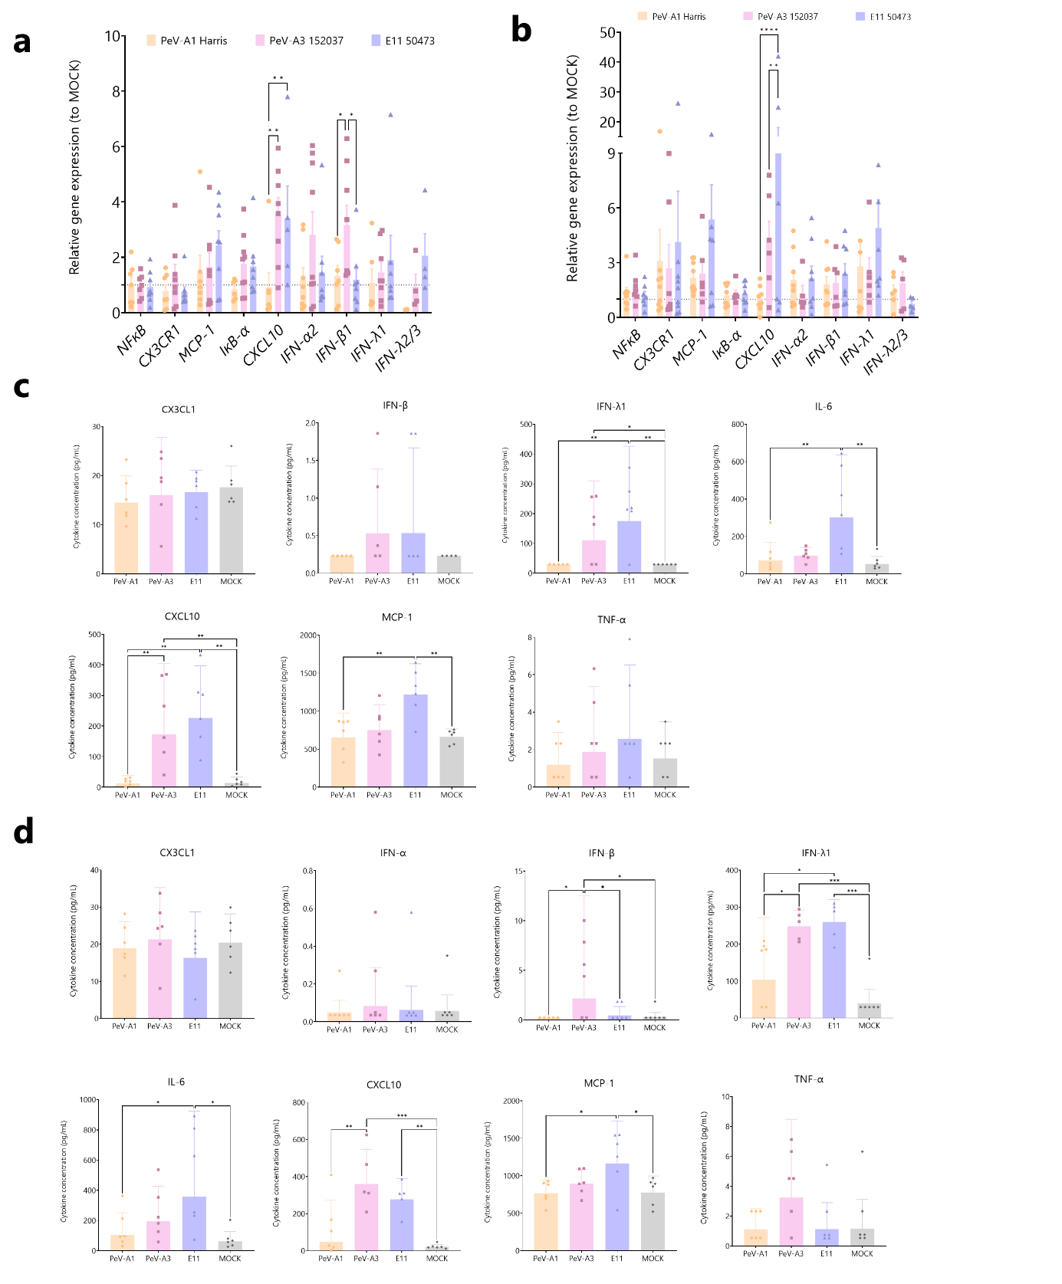
Supplementary Figure 7. PeV-A3 leads to upregulation of the inflammatory response. a, Quantification of relative expression of cytokines to MOCK infected organoids at a, 5 dpi and b, 10 dpi by RT-qPCR. All data represents the geometric mean ± geometric SD of three technical replicates for three batches of organoids. Values above the dashed line represent an upregulation of the gene expression relative to the MOCK. Statistical significance was analysed by two-way ANOVA with Šídák’s multiple comparisons tests for each specific cytokine. c-d Quantification of cytokines by Luminex present in supernatant of UNOs infected with PeV-A1, PeV-A3, E11, or MOCK infected at c, 5 dpi and d, 10 dpi. For c, cytokines for which most values were below the LOD were removed. All data represents the geometric mean ± geometric SD of two technical replicates in three batches of organoids. Statistical significance was assessed using a One-way ANOVA with Tukey’s multiple comparisons for each cytokine individually, * P-value < 0.05; ** P-value <0.01; *** P-value <0.001; **** P-value <0.0001.

Supplementary Figure 8. Hierarchical clustering of DEPs involved in the regulation of interferon pathways. ISG and IFN-related DEPs upregulated in UNOs upon infection with PeV-A1, PeV-A3 and E11 using either a, Lab-adapted strains of PeV-A. c, Clinical isolates. The four columns in the heatmap represent protein expression levels in each sample of PeV-A1, PeV-A3, E11 and Mock infected UNOs. Z-scores represented by purple and yellow indicate the higher and lower expression levels, respectively. The colums on the right represent the significantly DEPs when normalized to the Mock. Up and downregulation of genes is indicated by green or red respectively. DEPs, differentially expressed proteins. LFC, log-fold change.

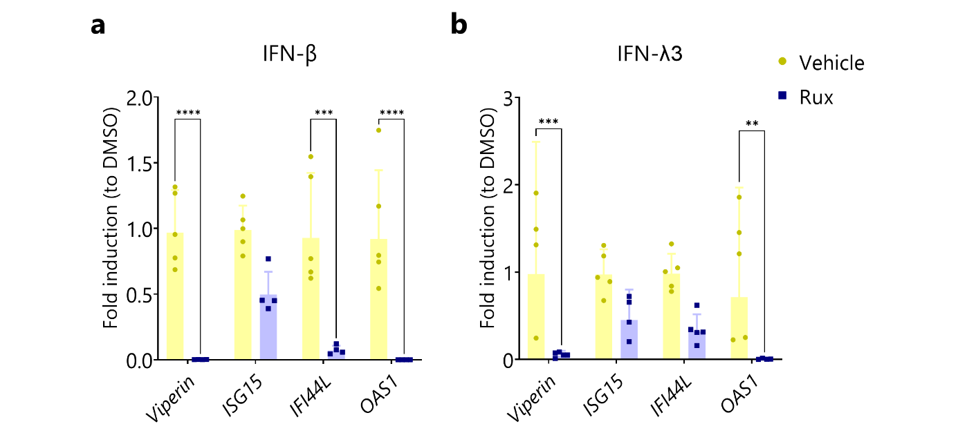
Supplementary Figure 9. Rux inhibition of IFN-stimulated ISG induction in UNOs. RT-qPCR analysis of ISGs upon stimulation with a, 500 ng of IFN-β, or b, 500 ng of IFN-λ3 and treated with Rux or vehicle control (DMSO). Data represents the geometric mean fold induction from vehicle treated organoids ± geometric SD of five different organoids. Statistical significance was analyzed by two-way ANOVA with Šídák’s multiple comparisons tests for each specific cytokine, ** P-value <0.01; *** P-value <0.001; **** P-value <0.0001.
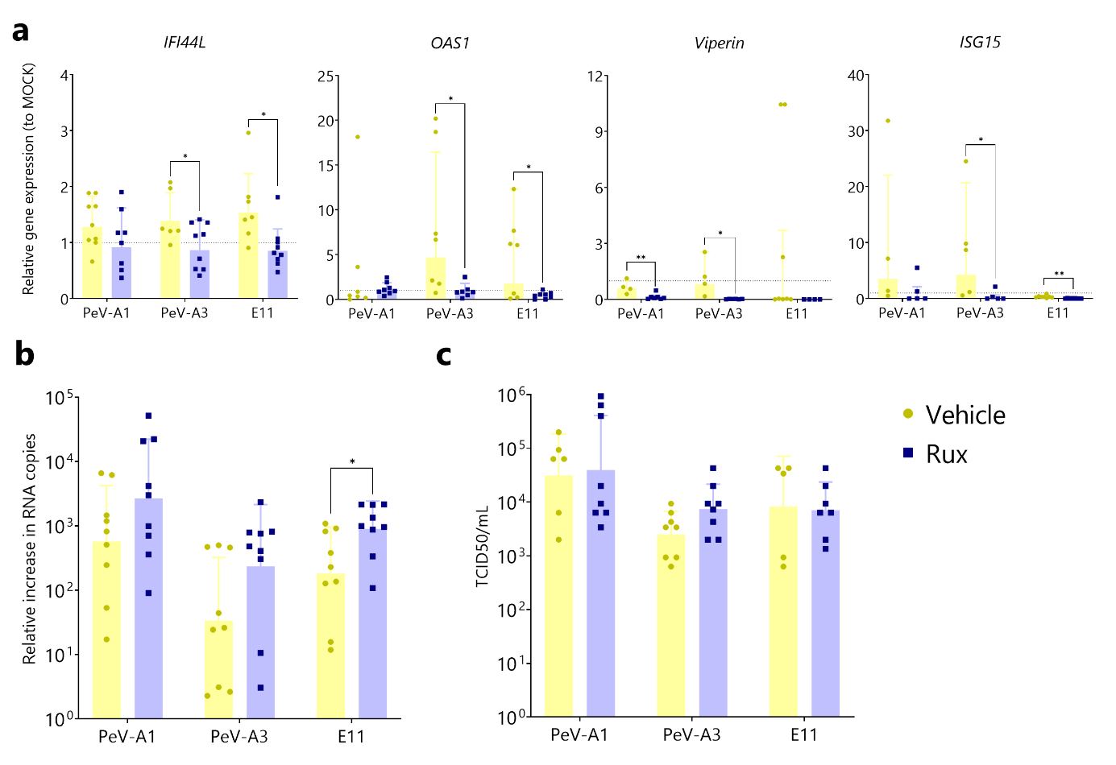
Supplementary Figure 10. a, Relative gene expression of ISGs in Rux or vehicle (DMSO) treated organoids. b, Relative increase in RNA copies at 10 dpi for Rux or vehicle treated organoids from supernatant samples. c, Virus titer at 10 dpi from supernatant collected samples of Rux or vehicle treated organoids. Titers were determined by TCID50. In all cases, data represents the geometric mean ± geometric SD of three technical replicates in three biological replicates. Statistical significance was determined using a Student’s t-test, * P-value < 0.05. For a values above the dashed line represent an upregulation of the gene expression relative to the MOCK.

Supplementary Table 1. List of primers used in this study with forward and reverse sequences.
Target | Forward sequence (5’-3’) | Reverse sequence (5’-3’)
PeV-A | CTGGGGGCCAAAAGCCA | GGTACCTTCTGGGCATCCTTC
PeV-A Probe | (6’FAM)-AAACACTAGTTGTAWGGCCC | ---
Pan-EV | GGCCCTGAATGCGGCTAAT | GGGATTGTCACCATAAGCC
CXCL10 | GGTGAGAAGAGATGTCTGAATCC | GTCCATCCTTGGAAGCACTGCA
CX3CR1 | GTGGTGCTGACAAAGCTTGGAA | TCACTGGGTGCCATCGTAAGAA
IFI44L | TGCACTGAGGCAGATGCTGCG | TCATTGCGGCACACCAGTACAG
IFN-α2 | TGGGCTGTGATCTGCCTCAAAC | CAGCCTTTTGGAACTGGTTGCC
IFN-β1 | CTTGGATTCCTACAAAGAAGCAGC | TCCTCCTTCTGGAACTGCTGCA
IFN-λ1 | AACTGGGAAGGGCTGCCACATT | GGAAGACAGGAGAGCTGCAACT
IFN-λ2/3 | TCGCTTCTGCTGAAGGACTGCA | CCTCCAGAACCTTCAGCGTCAG
IκB-α | GCTGAAGAAGGAGCGGCTACT | TCGTACTCCTCGTCTTTCATGGA
ISG15 | CTCTGAGCATCCTGGTGAGGAA | AAGGTCAGCCAGAACAGGTCGT
MCP-1 | CCTTCATTCCCCAAGGGCTC | GGTTTGCTTGTCCAGGTGGT
NFκB | GCAGCACTACTTCTTGACCACC | TCTGCTCCTGAGCATTGACGTC
OAS1 | AGGAAAGGTGCTTCCGAGGTAG | GGACTGAGGAAGACAACCAGGT
RPLP0 | TGGTCATCCAGCAGGTGTTCGA | ACAGACACTGGCAACATTGCGG
RPLP2 | TCTTGGACAGCGTGGGTATCGA | CAGCAGGTACACTGGCAAGCTT
Viperin | CCAGTGCAACTACAAATGCGGC | CGGTCTTGAAGAAATGGCTCTCC

Supplementary Table 2. List of antibodies used in this study.
Antigen (abbreviation) | Host | Dilution factor | Company | Catalogue #
Special AT-rich sequence-binding protein 2 (SATB2) | Mouse | 1:400 | Abcam | Ab51502
Chicken ovalbumin upstream promoter transcription factor-interacting protein 1 (CTIP2) | Rat | 1:500 | Abcam | Ab18465
Paired box protein 6 (PAX6) | Rabbit | 1:300 | Stemcell Technologies | STC60094
Glial fibrillary acidic protein (GFAP) | Goat | 1:500 | Abcam | Ab53554
Sex determining region Y-box 2 (SOX2) | Rabbit | 1:400 | Cell Signaling Technologies | 34516
Microtubule-associated protein 2 (MAP2) | Mouse | 1:500 | Thermo Fisher | MA5-12826
PeV-A1 VP1 | Rabbit | 1:300 | Thermo Fisher | Custom made
PeV-A3 VP3 | Rabbit | 1:300 | Thermo Fisher | Custom made
dsRNA clone rJ2 | Mouse | 1:60 | Sigma-Aldrich | MABE1134
Secondary Antibody | Host | Dilution factor | Company | Catalogue #
Anti-mouse Alexa Fluor 546 | Donkey | 1:750 | Thermo Fisher | A10036
Anti-rat Alexa Fluor 488 (donkey) | Donkey | 1:750 | Thermo Fisher | A48268
Anti-rabbit Alexa Fluor 680 (donkey) | Donkey | 1:750 | Abcam | Ab175772
Anti-goat Alexa Fluor 594 (donkey) | Donkey | 1:750 | Thermo Fisher | A11058

