Supplementary Information for “Integrating agronomy and machine learning to generate high-resolution global maps of yield potential with local relevance”

Contents
Supplementary Table 1. 1
Supplementary Table 2. 2

Supplementary Fig. 1. 3
Supplementary Fig. 2. 4
Supplementary Fig. 3. 6
Supplementary Fig. 4. 5

Supplementary Table 1. Global-gridded variables, source, type, and original spatial resolution used in the metamodel.
Type | Variable | Source | Spatial Resolution
Bioclimatic | Annual growing degree days (base 0°C) | Worldclim | 30 arc-seconds*
Bioclimatic | Temperature seasonality (standard deviation of monthly averages) | Worldclim | 30 arc-seconds*
Bioclimatic | Mean diurnal range (mean of monthly max temp - min temp) | Worldclim | 30 arc-seconds*
Bioclimatic | Maximum temperature of the warmest month of the year | Worldclim | 30 arc-seconds*
Bioclimatic | Mean temperature of the wettest month of the year | Worldclim | 30 arc-seconds*
Bioclimatic | Annual aridity index (precipitation over potential evapotranspiration) | Worldclim | 30 arc-seconds*
Bioclimatic | Precipitation seasonality (coefficient of variation of monthly rainfall)# | Worldclim | 30 arc-seconds*
Bioclimatic | Precipitation of the wettest month# | Worldclim | 30 arc-seconds*
Bioclimatic | Precipitation of the warmest quarter# | Worldclim | 30 arc-seconds*
Bioclimatic | Precipitation of the coldest quarter# | Worldclim | 30 arc-seconds*
Bioclimatic | Precipitation of the driest quarter# | Worldclim | 30 arc-seconds*
Soil | Plant-available soil water holding capacity between 0 and 1 meter of depth# | ISRIC | 250 m
Soil | Plant-available soil water holding capacity between 1 and 2 meters of depth# | ISRIC | 250 m
Cropping System – Specific⁺ | Crop cycle length (days between planting and harvest) | Sacks et al. (2010)  RiceAtlas  Crop Monitor  Worldclim | 0 or 1**  1 or 2**  1 or 2**  30 arc-seconds*
Cropping System – Specific⁺ | Accumulated precipitation in each third of the crop cycle# | Sacks et al. (2010)  RiceAtlas  Crop Monitor  Worldclim | 0 or 1**  1 or 2**  1 or 2**  30 arc-seconds*
Cropping System – Specific⁺ | Accumulated photosynthetic active radiation in each third of the crop cycle | Sacks et al. (2010)  RiceAtlas  Crop Monitor  Worldclim | 0 or 1**  1 or 2**  1 or 2**  30 arc-seconds*
Cropping System – Specific⁺ | Average temperature in each third of the crop cycle | Sacks et al. (2010)  RiceAtlas  Crop Monitor  Worldclim | 0 or 1**  1 or 2**  1 or 2**  30 arc-seconds*
*30 arc seconds is 930 meters at the equator and 750 meters at 36° latitude.
** Administrative division levels: 0. country; 1. state, region, province, etc.; 2. county, district, municipality, etc.
# Variable only used for rainfed yield potential prediction.
⁺ Variables derived from crop calendar information and monthly climatic data. We used the RiceAtlas crop calendar database for rice and, when available, the “Crop Monitor for Early Warning Calendars” for wheat and maize or Sacks et al. (2010) data otherwise. The fraction of each month within the crop cycle was considered to compute these variables.

Supplementary Table 2. Performance metrics of two methods for global gridded yield potential (Ypot). Comparison of gridded Ypot predictions based on metamodel and country-blind climate zones extrapolation versus site-level Ypot from the Global Yield Gap Atlas (GYGA Ypot) for three crops and two water regimes. Performance metrics were derived with the Nearest-Neighbor-Distance-Matching Leave-One-Out Cross-Validation method. The reported metrics are the root mean square error (RMSE), which is expressed in absolute terms (t ha⁻¹) and relative to GYGA Ypot average (%), concordance correlation coefficient (CCC), coefficient of determination (R²), and mean bias error (MBE, difference between gridded Ypot and GYGA Ypot averages). The percentage of the mean square error (MSE) related to lack of accuracy and precision (i.e., systematic and unsystematic differences) is also shown.
Crop | Water regime | Method | RMSE |  | CCC | R² | MBE | MSE(%) Lack of
Crop | Water regime | Method | (t ha⁻¹) | (%) | CCC | R² | MBE | accuracy | precision
maize | rainfed | CZ | 3.19 | 30 | 0.28 | 0.08 | 0.04 | 4 | 96
maize | rainfed | metamodel | 2.13 | 21 | 0.65 | 0.52 | 0.04 | 28 | 72
maize | irrigated | CZ | 2.62 | 18 | 0.15 | 0.02 | 0.2 | 3 | 97
maize | irrigated | metamodel | 1.82 | 12 | 0.54 | 0.37 | -0.03 | 25 | 75
wheat | rainfed | CZ | 1.57 | 23 | 0.81 | 0.65 | -0.13 | 1 | 99
wheat | rainfed | metamodel | 1.14 | 17 | 0.89 | 0.81 | 0.02 | 13 | 87
wheat | irrigated | CZ | 1.62 | 17 | 0.6 | 0.37 | -0.06 | 0 | 100
wheat | irrigated | metamodel | 1.07 | 12 | 0.81 | 0.71 | -0.05 | 24 | 76
rice | rainfed | CZ | 1.98 | 26 | 0.25 | 0.08 | 0.39 | 13 | 87
rice | rainfed | metamodel | 1.46 | 20 | 0.57 | 0.44 | -0.02 | 31 | 69
rice | irrigated | CZ | 1.92 | 19 | 0.52 | 0.28 | 0.02 | 2 | 98
rice | irrigated | metamodel | 1.00 | 10 | 0.85 | 0.78 | -0.08 | 23 | 77

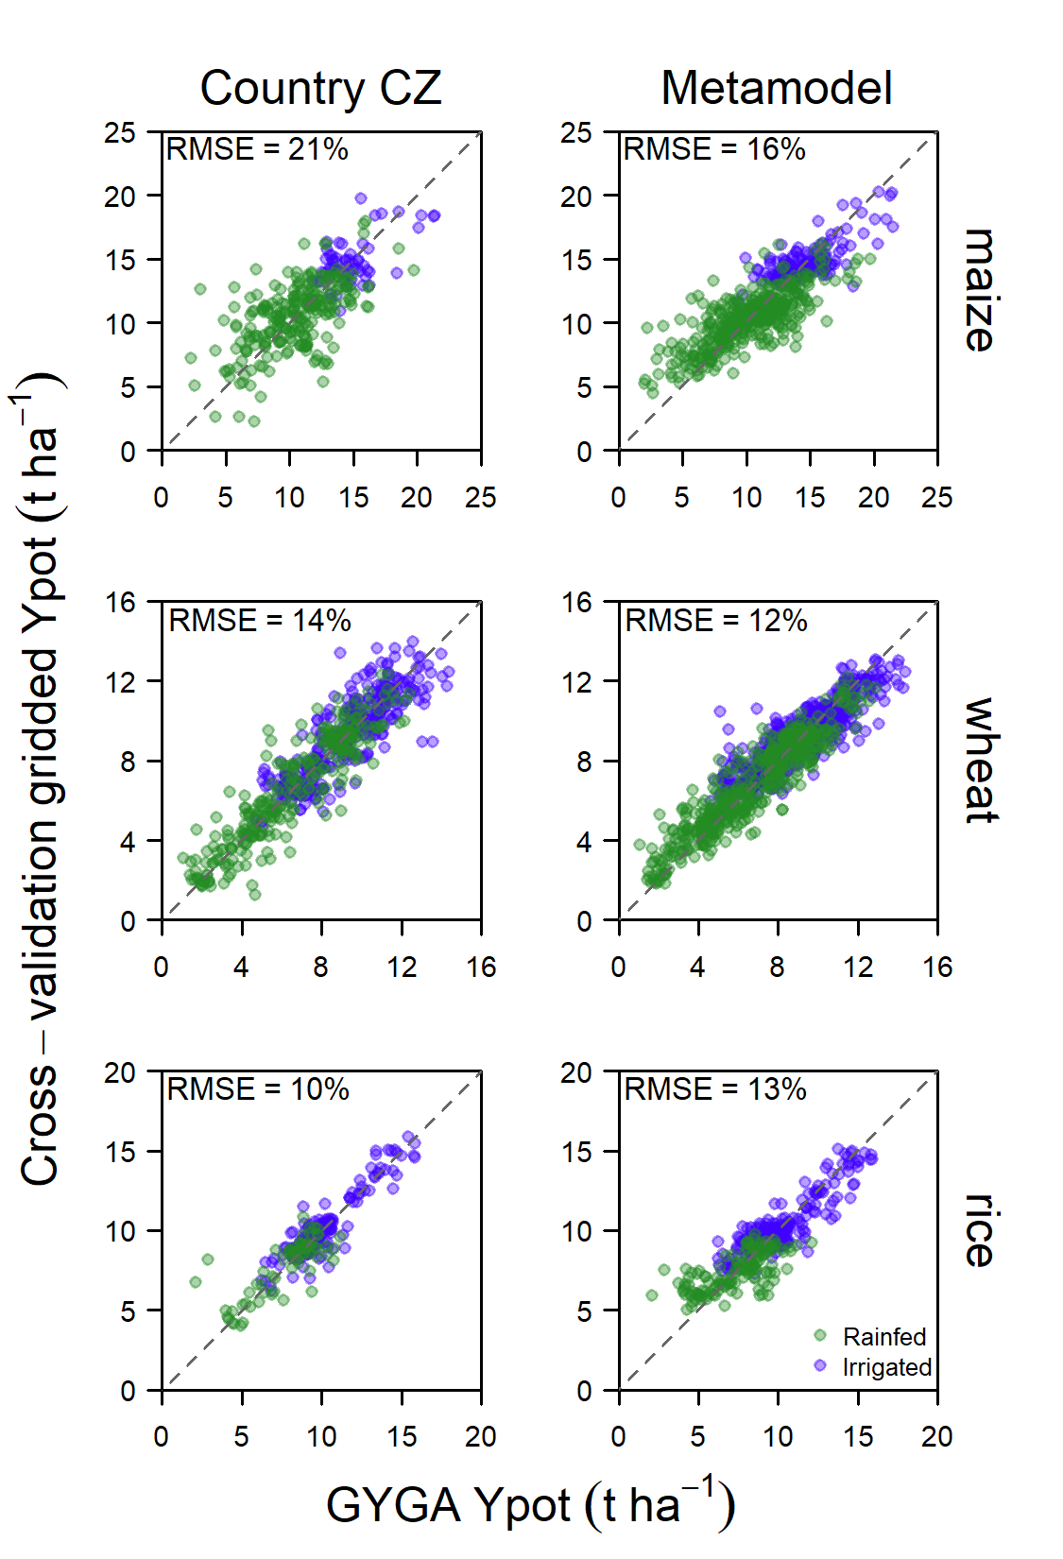
Supplementary Fig. 1. Comparison of two approaches for national gridded yield potential (Ypot) Comparison of Ypot predictions based on country-specific climate zones interpolation (country CZ, left panels) and the metamodel (right panels) versus site-level Ypot from the Global Yield Gap Atlas (GYGA Ypot) for three crops and two water regimes. Each point represents a site (reference weather station). Predictions were derived following the Nearest-Neighbor-Distance-Matching Leave-One-Out Cross-Validation method, with crop harvested area of countries included in GYGA as target prediction area. The root mean square error relative to GYGA Ypot average (RSME, %) is shown for each method and crop combination.

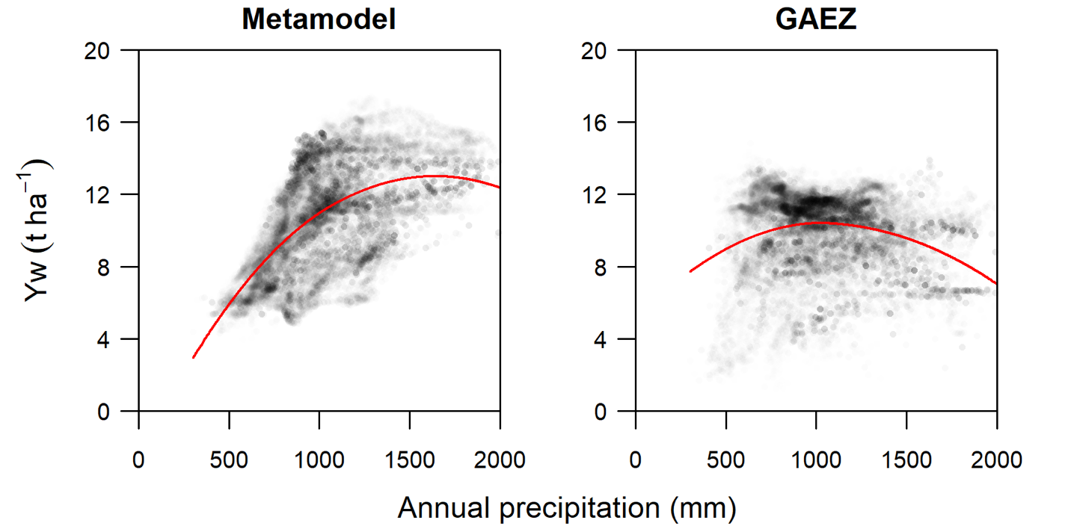
Supplementary Fig. 2. Water-limited yield potential (Yw) of rainfed maize as a function of annual precipitation in East Africa for two yield potential prediction approaches: a metamodel that integrates a bottom-up approach with machine learning (Metamodel) and a top-down approach (GAEZ, gaez.fao.org). Each point represents a 5-arc-minute resolution grid with rainfed maize in East Africa. The red lines are local regression lines.

Supplementary Fig. 3. Site-specific yield potential. Yield potential (Yp) of irrigated crops and water-limited yield potential (Yw) of rainfed crops reported in the Global Yield Gap Atlas (GYGA, www.yieldgap.org)¹ at reference weather station level for the three main cereal crops.
¹ Last access: July 10th, 2023.

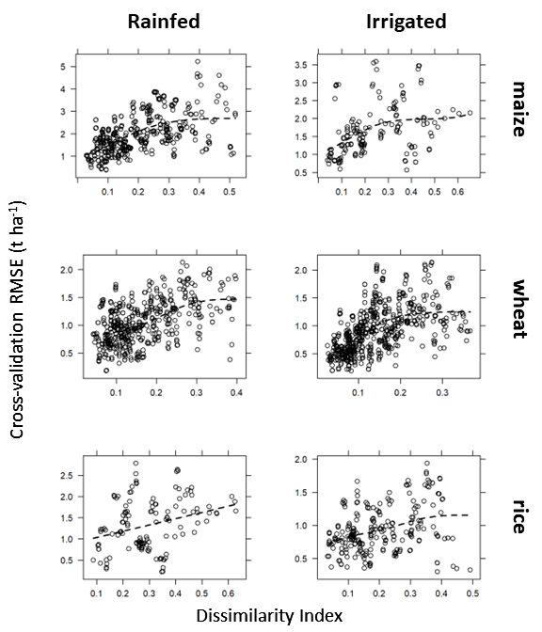
Supplementary Fig. 4. Relationship between spatial cross-validation root mean square errors (RMSE) and dissimilarity indexes between testing and training sites for each crop and water regime. This association was used to estimate the expected RMSE of yield potential predictions from the dissimilarity index between the prediction area and the training sites.

