Extended Data Figures
Extended Data Fig. 1. Area of applicability of metamodel. The metamodel area of applicability is shown in shades of gray. Red areas were excluded from metamodel predictions due to their high dissimilarity with the environments explored by data used to train the metamodel. White areas have < 0.5% of given crop and water regime and were not considered.
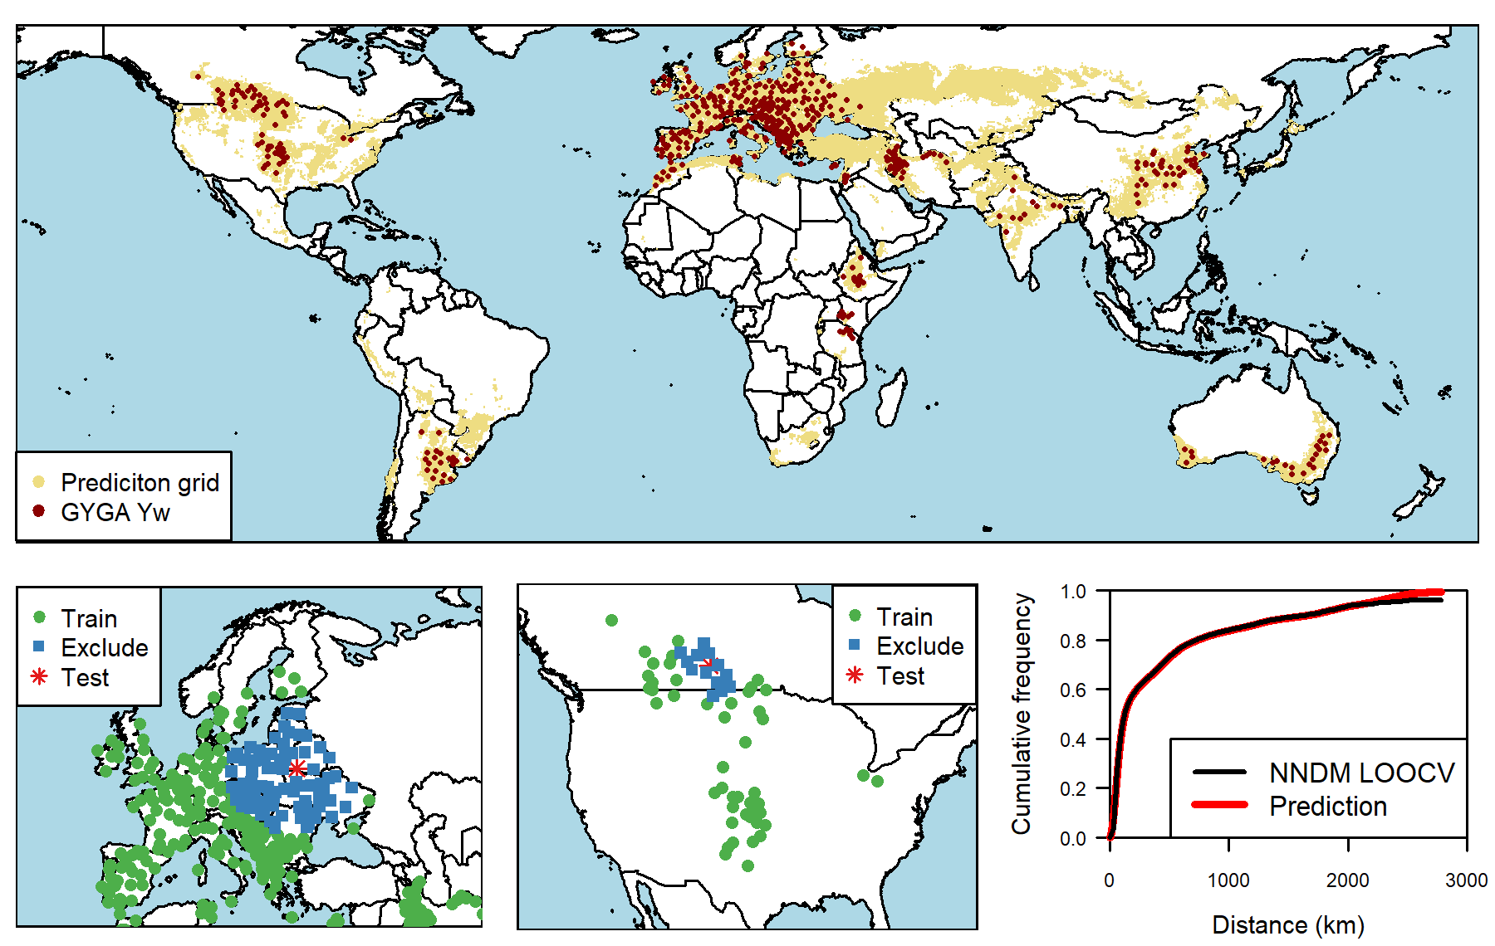
Extended Data Fig. 2. Nearest-neighbor-distance-matching leave-one-out cross-validation (NNDM LOO CV) examples for rainfed wheat. The top panel shows the distribution of site-specific water-limited yield potential (Yw) of rainfed wheat from the Global Yield Gap Atlas (GYGA) and the prediction grid (lands harvested with rainfed wheat as reported by SPAM). The lower left and middle panels show the GYGA Yw sites used for model testing and training and excluded sites due to their proximity to the testing site for two iterations of the NNDM LOO CV. The neighbors to be excluded are defined so that the cumulative frequency of distances between testing sites and their nearest training site in the NNDM LOO CV procedure matches the cumulative frequency of distances between the prediction grid cells and their nearest GYGA Yw, as shown in the lower right panel.

Extended Data Fig. 3. Metamodel prediction uncertainty. Expected root mean square error (RMSE) of global gridded yield potential estimates derived from the metamodel, expressed as percentage of the predicted yield potential.

Extended Data Fig. 4. Yield potential derived from different approaches. Comparison of maize water-limited yield potential (Yw) derived from a top-down approach (GAEZ, gaez.fao.org), a bottom-up approach (GYGA CZ, www.yieldgap.org), and a metamodel that integrates a bottom-up approach with machine learning (Metamodel) in East Africa.
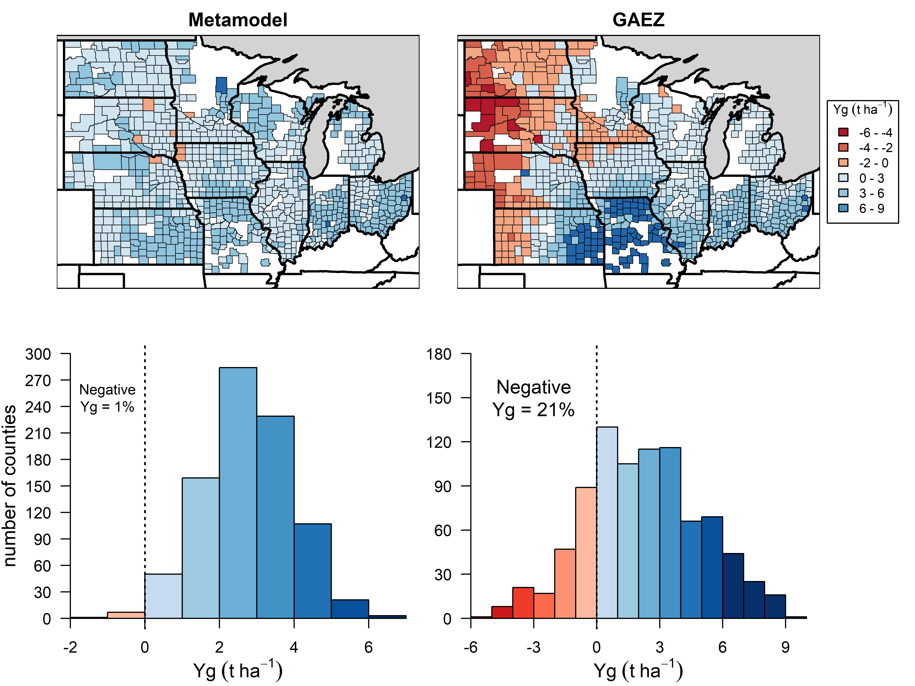
Extended Data Fig. 5. Yield gaps (Yg) between water-limited yield potential and farmers’ actual yield for rainfed maize in the US Midwest at county level for two yield potential prediction approaches: a metamodel that integrates a bottom-up approach with machine learning (Metamodel) and a top-down approach (GAEZ, gaez.fao.org). Average county-level farmers’ yield for rainfed maize between 2005 and 2015 was retrieved from USDA-NASS Quick Stats (quickstats.nass.usda.gov). Only counties with less than 5% of irrigated area or reporting non-irrigated yields in 3 or more years were considered. In the histograms, the dashed vertical line indicates Yg = 0, that is, no difference between yield potential and actual yield, and the percentage of counties presenting negative Yg for each method is shown.

