Appendix 1. Internal Consistency Reliability, Stage 1
Construct | Cronbach's Alpha | Rho A | Composite Reliability (rho C) | AVE
System Quality | 0,908 | 0,910 | 0,926 | 0,610
Hedonic Motivation | 0,873 | 0,874 | 0,940 | 0,888
Personal Innovativeness | 0,889 | 0,890 | 0,931 | 0,819
Source: PLS SEM analysis (Primary data, 2023)

Appendix 2. Heterotrait-monotrait Ratio of Correlations (HTMT) Matrix, Stage 1
Construct | Personal Innovativeness | System Quality | Hedonic Motivation
Personal Innovativeness | -
System Quality | 0,766
Hedonic Motivation | 0,827 | 0,801 | -
Source: PLS SEM analysis (Primary data, 2023)

Appendix 3. Internal Consistency Reliability, stage 2
Construct | Cronbach's Alpha | Rho A | Composite Reliability (rho C) |  | AVE
Behavioural Intention | 0,881 | 0,900 | 0,926 | 0,806
Usage Behaviour | 0,745 | 0,755 | 0,887 | 0,796
User Satisfaction | 0,892 | 0,893 | 0,925 | 0,756
Net Impact | 0,934 | 0,938 | 0,947 | 0,719
Source: PLS SEM analysis (Primary data, 2023)

Appendix 4. Heterotrait-monotrait Ratio of Correlations (HTMT) Matrix, Stage 2
Construct | Net Impact | User Satisfaction | Behavioural Intention | Usage Behaviour
Net Impact | -
User Satisfaction | 0,806
Behavioural Intention | 0,867 | 0,894
Usage Behaviour | 0,651 | 0,485 | 0,701 | -
Source: PLS SEM analysis (Primary data, 2023)

Appendix 5. Variance Inflation Factor (VIF) value
Construct | Net Impact | User Satisfaction | Behavioural Intention | Usage Behaviour
Net Impact
User Satisfaction | 1,185
Behavioural Intention |  |  |  | 1,000
Usage Behaviour | 1,185 | 1,000
Source: PLS SEM analysis (Primary data, 2023)

Appendix 6. PLS Algorithm Running Results Evaluating the Outer Model Stage 1
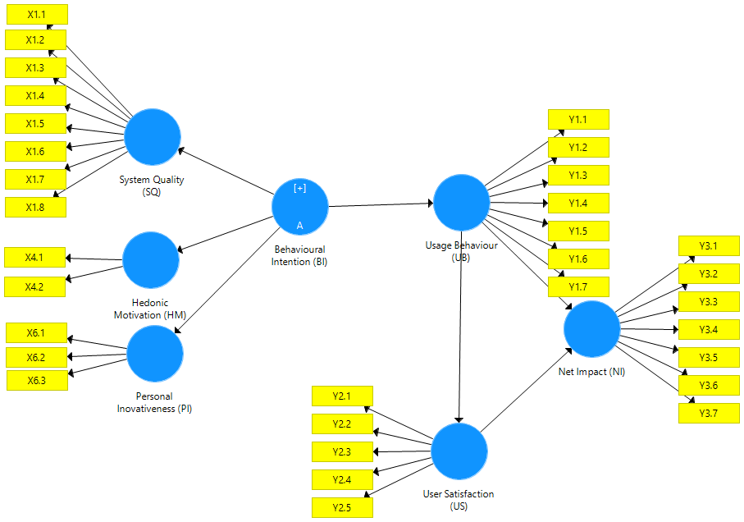

Appendix 7. PLS Algorithm Running Results Evaluating the Outer Model Stage 2
