[Climate Dynamics]
Supplementary materials for
[Local and Remote Forcing Effects of Oceanic Eddies in the Subtropical Front Zone on the Mid-latitude Atmosphere in Winter]

[Haibo Hu#, *, ², Zhao Yihang*, Ning Zhang*, Haokun Bai*, Feifei Chen*]

*CMA-NJU Joint Laboratory for Climate Prediction Studies, Instituted for Climate and Global Change Research, School of Atmospheric Science, Nanjing University, Nanjing 210093, China
²Key Laboratory of Meteorological Disaster of Ministry of Education, Nanjing University of Information Science and Technology, Nanjing 210044, China
#Corresponding author: H.-B. Hu (huhaibo@nju.edu.cn)

Contents of this file
Figure S1 to S6

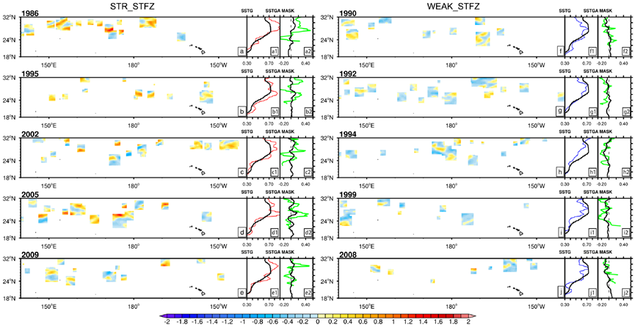
Figure S1. Comparison of all eddy occurrences in stronger (a-e) and weaker (f-j) years. Meridional SST gradient anomaly (shadings, units: ℃/°) are masked out in eddy positions. (a1-j1) present zonal means of meridional SST gradient from 140°E to 140°W, black solid line is average from all 31 years, red and blue lines are average of the stronger or weaker STFZ year. (a2-j2) present zonal means of meridional SST gradient anomaly caused by all eddies (green), SST gradient anomaly over the other areas without eddy positions (black).
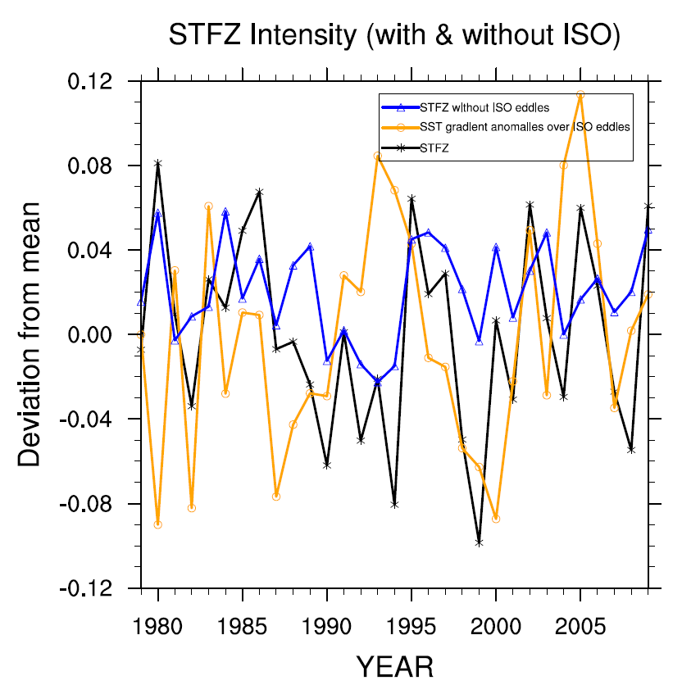
Figure S2. Time series of anomalous SST gradient which is spatial average in the STFZ region (24°N-32 °N & 140° E-140 °W), the total value (black), the averaged value just over the ISO eddies (orange), the SST gradient in the STFZ without ISO eddies (blue).
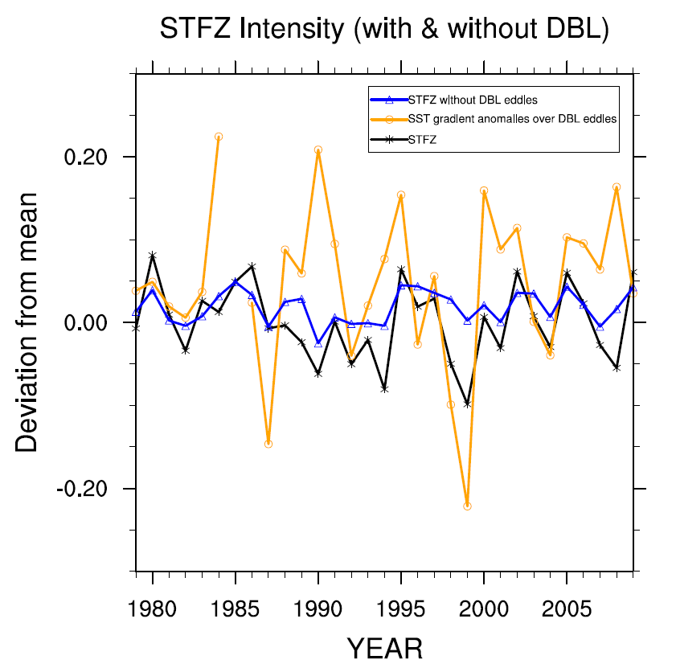
Figure S3. As same as Figure S4, but for DBL.

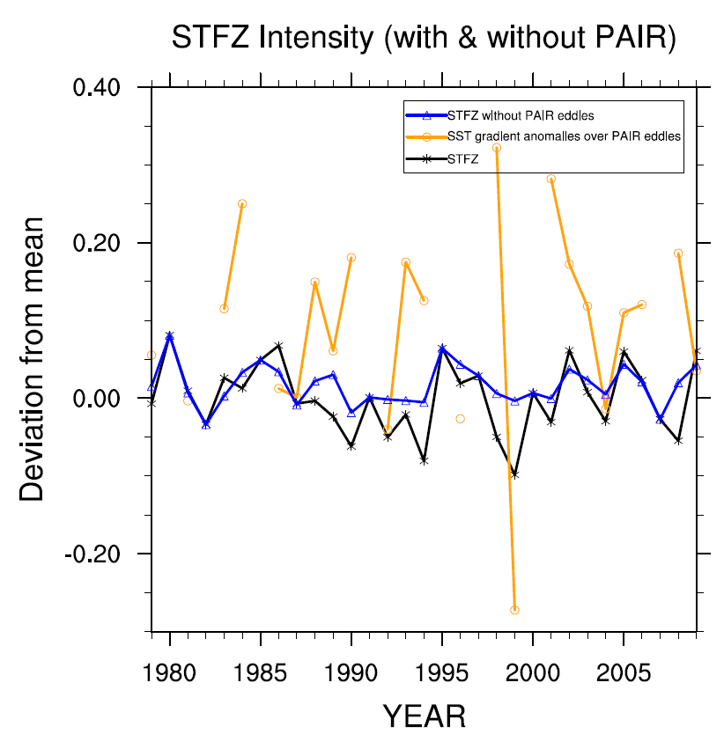
Figure S4. As same as Figure S4, but for PAIR.
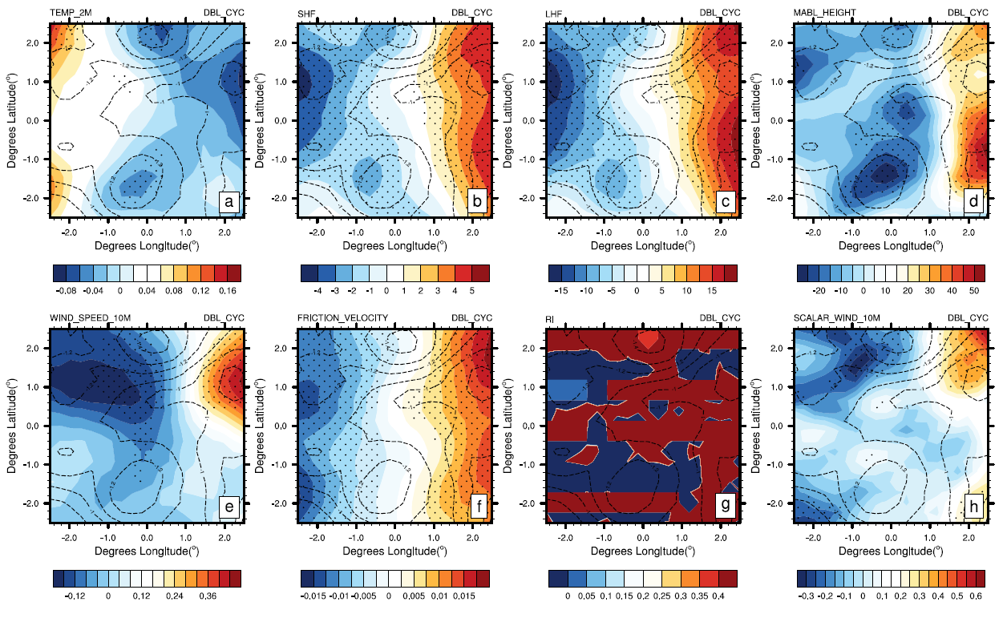
Figure S5. Composite analysis of DBL_CYC samples including SST anomaly (contour, units: ℃) and (a) 2-meter air temperature (shadings, units: ℃), (b) SHF (units: W·m-2), (c) LHF (units: W·m-2), (d) MABL height (units: m), (e) 10-meter wind speed (units: m·s-1), (f) surface frictional velocity (units: m·s-1), (h) 10-meter scalar wind (units: m·s-1) anomalies and (g) the gradient Richardson number at 950hPa. Dotted areas have passed 95% t-test significant level.

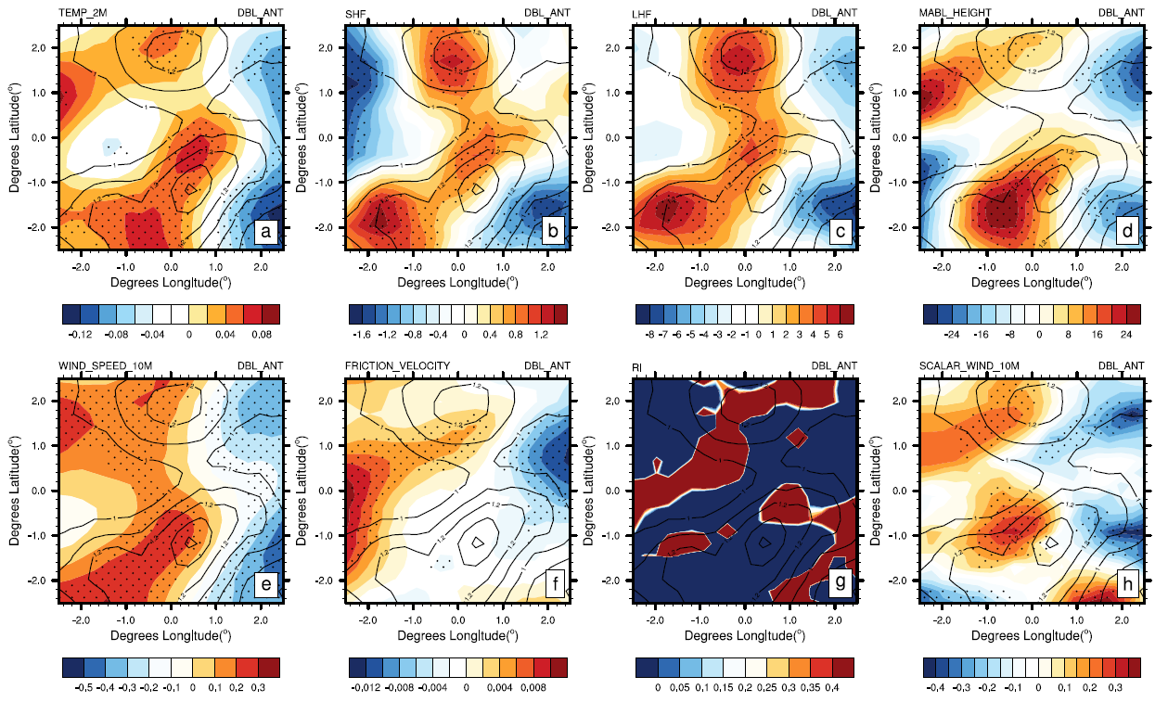
Figure S6. Composite analysis of DBL_ANT samples including SST anomaly (contour, units: ℃) and (a) 2-meter air temperature (shadings, units: ℃), (b) SHF (units: W·m-2), (c) LHF (units: W·m-2), (d) MABL height (units: m), (e) 10-meter wind speed (units: m·s-1), (f) surface frictional velocity (units: m·s-1), (h) 10-meter scalar wind (units: m·s-1) anomalies and (g) the gradient Richardson number at 950hPa. Dotted areas have passed 95% t-test significant level.

