Supplementary information Laser-Induced Graphene Electrochemical Sensor for Quantitative Detection of Phytotoxic Aluminum Ions (Al³⁺) in Soils Extracts

Vanessa Reyes-Loaizaª, Jhonattan De La Rocheª, Erick Hernandez Renjifoª, Orlando Idárraga^{b,c}, Mayesse Da Silva^{b}, Drochss P. Valenciaª, Thaura Ghneim-Herrera^{d,a} and Andres Jaramillo-Botero^{e,a}*
ª Omicas Alliance, Pontificia Universidad Javeriana, Cali, Valle del Cauca 760031, Colombia
^{b} Multifunctional landscapes, Alliance Bioversity-CIAT, Cali-Palmira, Valle del Cauca 763537, Colombia
^{c} Department of Natural and Exact Sciences, Universidad del Valle, Cali, Valle del Cauca 760031, Colombia
^{d} Department of Biological Sciences, Universidad ICESI, Cali, Valle del Cauca 760031, Colombia
^{e} Chemistry and Chemical Engineering Division, California Institute of Technology, 1200 E California Blvd, Pasadena, CA 91125, USA.

Figure S1. Schematic process of BiE-LIG electrode fabrication.

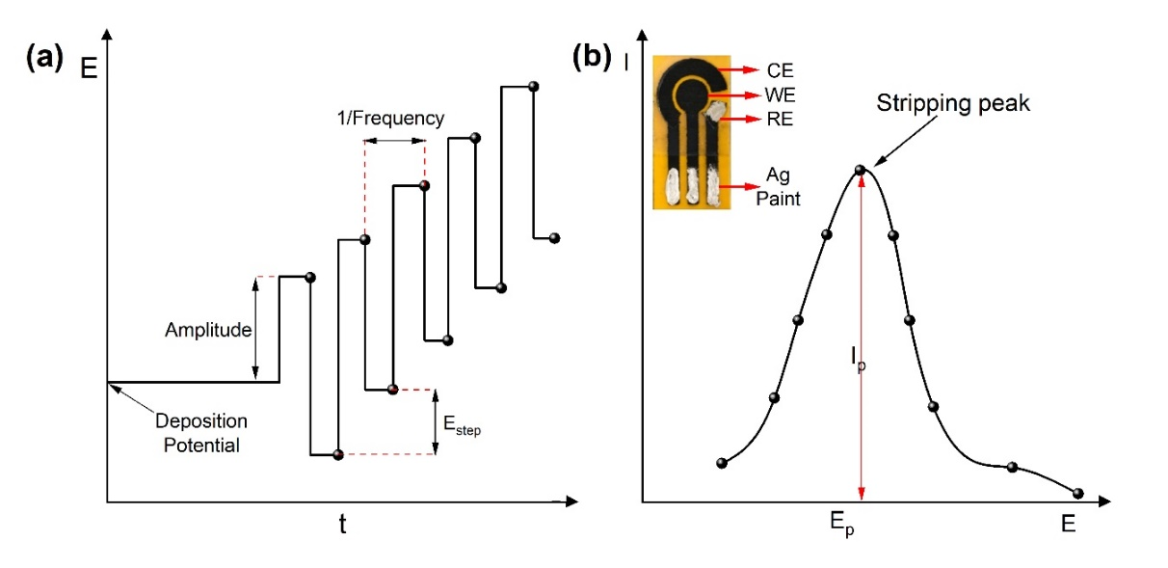
Figure S2. a) General waveform for the Square Wave Anodic Stripping Voltammetry (SWAVS) used in this work. b) Stripping peak in the IV characteristic response to the SWAVS. Inset shows the picture of our LIG electrochemical cell design, based on three interdigitated electrodes, namely a working electrode (WE), a counter electrode (CE), and an Ag/AgCl casted pseudo reference electrode (RE), and the Ag-coated contacts, over a Polyimide tape substrate. Figures were adapted and modified from [1,2]
S. E. Jeong, S. Kim, J. H. Han, and J. J. Pak, “Simple laser-induced graphene fiber electrode fabrication for high-performance heavy-metal sensing,” Microchem. J., vol. 172, no. PA, p. 106950, 2022.
G. Zhao and G. Liu, “A portable electrochemical system for the on-site detection of heavy metals in farmland soil based on electrochemical sensors,” IEEE Sens. J., vol. 18, no. 14, pp. 5645–5655, 2018.

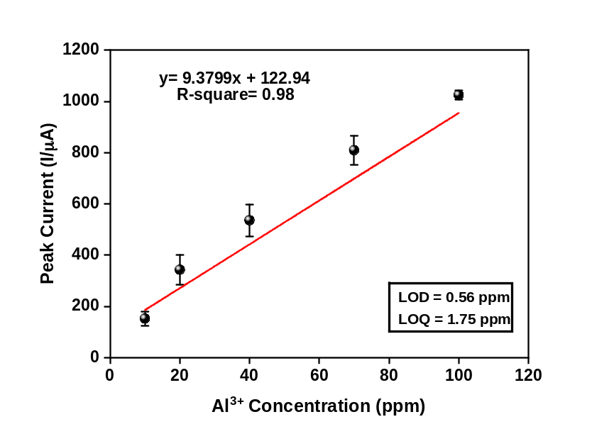
Figure S3. Calibration curve for incremental measurements for Al³⁺ from 10 to 100 ppm.

Figure S4. a) Percentage distribution of aluminum species in an acetate solution relative to pH.b) Correction curve for the determination of Al3+ at pH 3.7 as a function of soil pH. To use it, any value obtained at 3.7 is multiplied by 100 and divides by the correction percentage by extrapolation dependent on soil pH. The dotted blue line indicates pH 3.7

Figure S5. Porosity results from the analysis of the Bismuth network deposited into graphene edges. Images show the FE-SEM and the binarization using ImageJ.

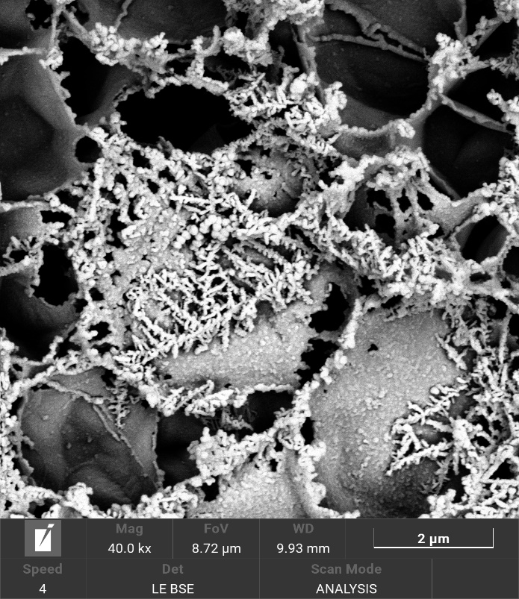
Figure S6. FE-SEM image of the dendritic growth with a concentration Al³⁺ of 200 ppm. Nucleation initiates at the edges and extents over graphene surface.
Figure S7. Influence of the deposition time in the peak current for simultaneous detection of Cadmium and Aluminum ions at a concentration of 100 ppm.

Figure S8. Quantification of Al³⁺ in the presence of other metal ions at a low (1ppm) and a high concentration (100ppm). a) SWASV of Al³⁺ in the presence of Cu²⁺. Inset shows the deconvolution of the stripping response for the Al³⁺ and Cu²⁺ mixture, individual peaks for each ion are represented in the dashed lines, blue for Al³⁺ and dark red for Cu²⁺. b) Comparison of the peak current of Al³⁺ alone in solution and in the presence of other metal ions.

Figure S9. Stripping voltammograms for the detection of Al³⁺ in soil samples from regions in Colombia a) Cauca b) Carimagua c) Santander and reference soil sample ISE-2020-3-3.1 (WEPAL). Inset shows the calibration curve obtained from the standard addition method (data points correspond to mean and standard deviation of three replicates).

Figure S10. Standard addition curve for Al³⁺ detection in soil extract. Aluminum concentration in the sample is determined when peak current=0.

