Supplementary Files
Title
Evidence from Temperature Analog for Traditional and Economic Cities in Nigeria: Implications for Sustainable City-Related Actions
Journal Name
Springer Nature: Discover Environment
Author Information
Asonibare Femi Oluwatosin^{1*}, Emmanuel Tanko Umaru^{1,2}, Francis A. Adesina³, Adenle A. Ademola ^{1,4,5,6}, A.A. Okhimamhe^{1,4}
- West African Science Service Center on Climate Change and Adapted Land Use
- Department of Urban and Regional Planning, Federal University of Technology Minna, Nigeria.
- Department of Geography, Obafemi Awolowo University, Ile-Ife, Nigeria.
- Department of Geography, Federal University of Technology Minna, Nigeria
- Institute of Geography, University of Bern, Switzerland.
- Department of Geography, University of Bergen, Norway.
Corresponding Author
Asonibare Femi Oluwatosin
tosinasonibare@gmail.com

Temperature Analog Surface for the selected cities
(a) Kano city
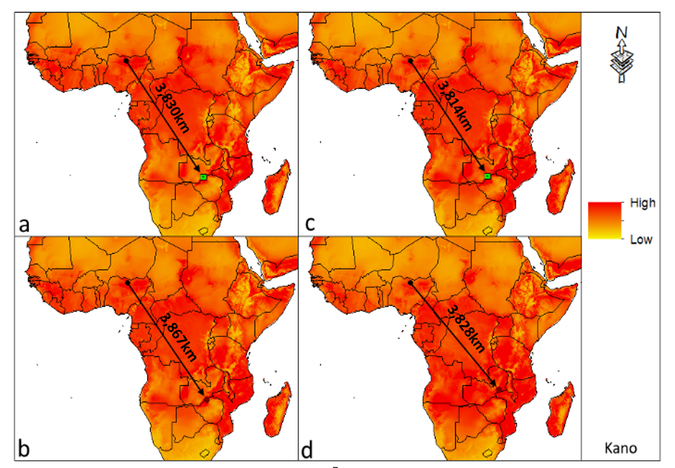
Supplementary Figure (SF) 1: Temperature Analog Surface of Kano city
2030s (a = RCP4.5, b = RCP 8.5). 2050s (c = RCP4.5) and (d = RCP 8.5)

(b) Abuja city
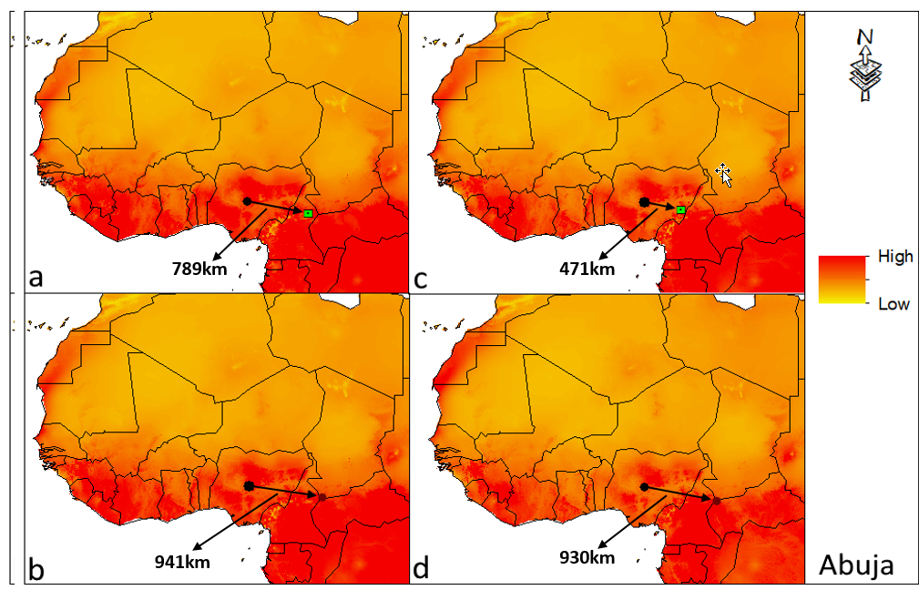
Supplementary Figure (SF) 2: Temperature Analog Surface of Abuja city
2030s (a = RCP4.5, b = RCP 8.5). 2050s (c = RCP4.5) and (d = RCP 8.5)
(c) Makurdi
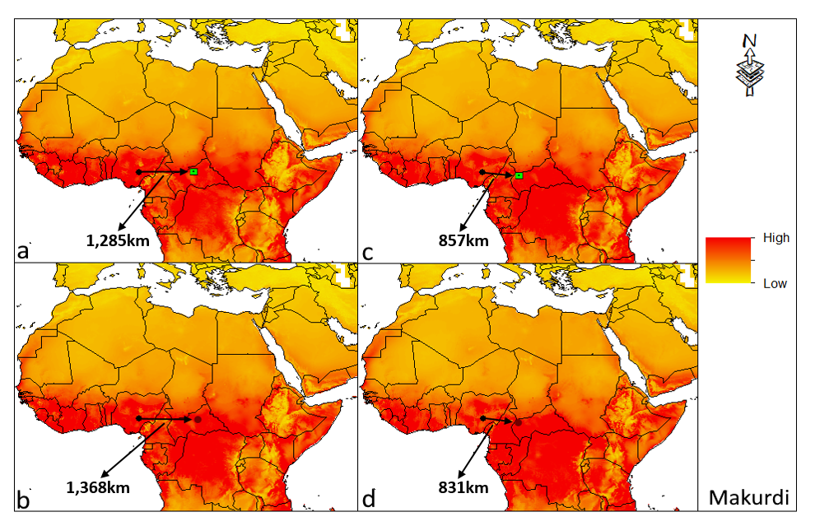

Supplementary Figure (SF) 3: Temperature Analog Surface of Makurdi city
2030s (a = RCP4.5, b = RCP 8.5). 2050s (c = RCP4.5) and (d = RCP 8.5).

(D) Benin city
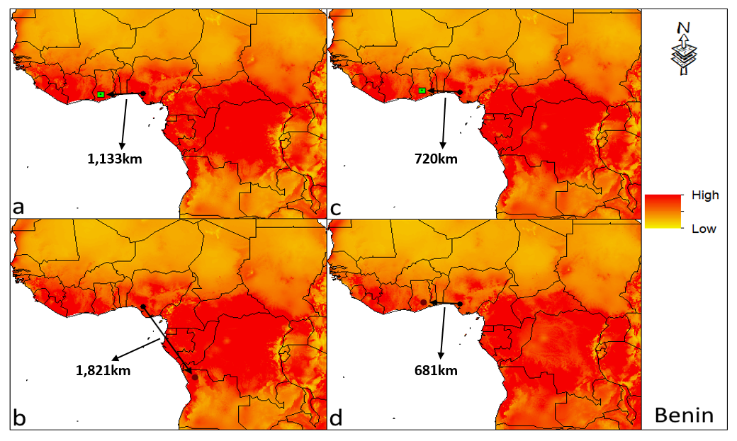
Supplementary Figure (SF) 4: Temperature Analog Surface of Benin City
2030s (a = RCP4.5, b = RCP 8.5). 2050s (c = RCP4.5) and (d = RCP 8.5)
(E) Lagos city
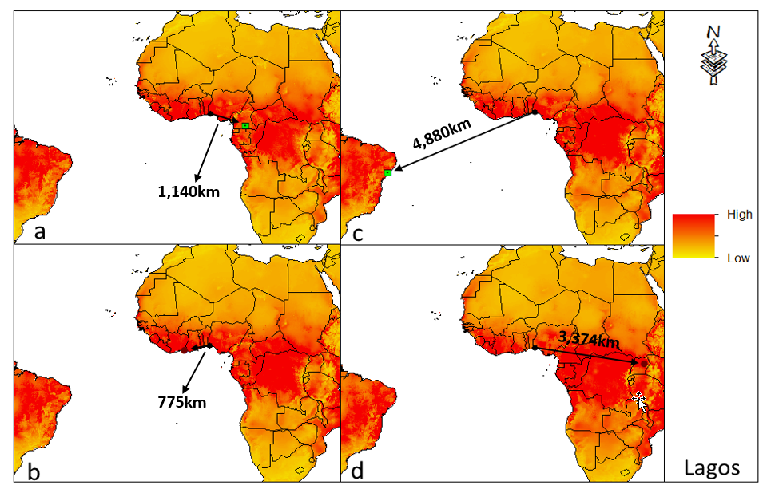
Supplementary Figure (SF) 5: Similarity Surface maps of Lagos
2030s (a = RCP4.5, b = RCP 8.5). 2050s (c = RCP4.5) and (d = RCP 8.5)

(F) Port Harcourt city
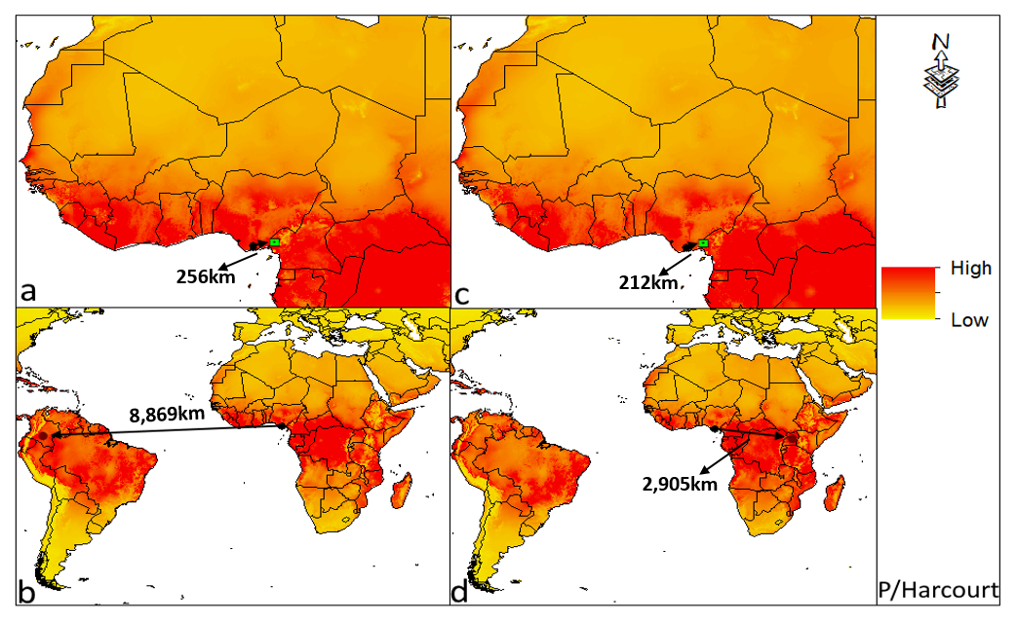
Supplementary Figure (SF) 6: Similarity Surface maps of Port Harcourt
2030s (a = RCP4.5, b = RCP 8.5). 2050s (c = RCP4.5) and (d = RCP 8.5).

