Coronavirus in the Skin of the Pangolin: Implications for SARS-CoV-2 Transmission?

Supplementary Figures

Figure S1. Reads mapped to pCoV genome. Most of the reads mapped to the 3’ region. However, the current library preparation protocols based on poly-A selection for short-read sequencing could lead to the cDNA fragments not uniformly distributed within transcripts and 3’ bias¹, which may cause the low coverage of the 5’ of the transcripts. The length of the 5’ leader sequence of each CoV mRNA is only about 70 nucleotides², so the mRNA formed from the long-distance fusion between sequences can be better detected by long-read sequencers. pCoV, pangolin coronavirus.
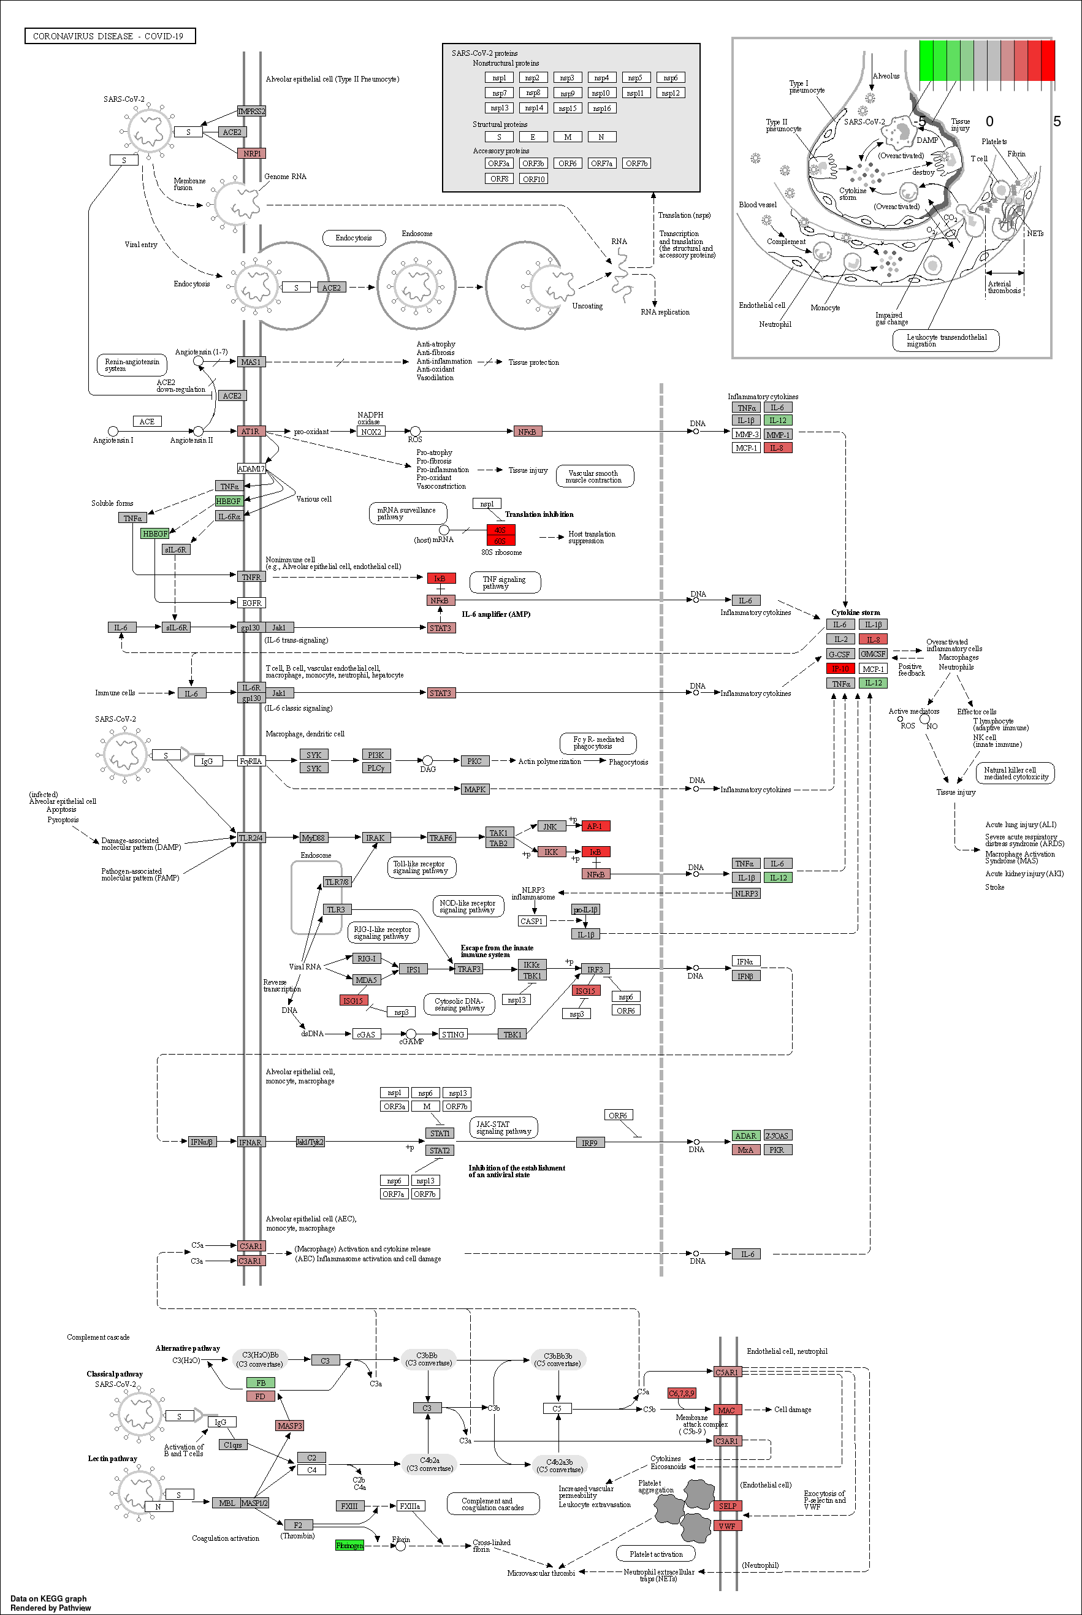 Figure S2. Genes associated with COVID-19 pathway. Red and green indicates up- and down-regulated in Dahu skin. Legend is shown in log2 fold change scale.
Figure S3. The up-regulation of ribosomal proteins in Dahu skin. (A) The expression profile of all the ribosomal proteins in Dahu skin, and (B) Dahu skin-specific DEGs are highlighted. Legend is shown in log2 fold change scale.
Figure S4. Examples of differentially expressed viral genes found in Dahu skin with pCoV infection. (A) virus|sp|P07572|POL_MPMV_3170, which is a gag-pro-pol gene, encoding Gag-Pro-Pol polyprotein. It is originated from a Mason-Pfizer monkey virus (UniProt ID P07572) (B) virus|sp|Q9TTC0|ENV_KORV_5205, which is an env gene, encoding Envelope glycoprotein. It is originated from a Koala retrovirus (UniProt ID Q9TTC0) (C) virus|sp|P03364|POL_SMRVH_3687, which is a pol gene, encoding Gag-Pro-Pol polyprotein. It is originated from a Squirrel monkey retrovirus (UniProt ID P03364). (D) virus|sp|P03340|GAG_FSVMD_4468, which is a gag gene, encoding Gag polyprotein. It is originated from a Feline sarcoma virus (UniProt ID P03340). Each plot has six tracks. The top track shows the genome coordinates. The non-infected and infected pangolin skin read mapping is underneath. The blue and red alignments indicates forward and reverse directions. The ERV gene is shown on the bottom.
Figure S5. Compositions of ERV genes in the pangolin genome. (A) Breakdown of ERV gene types. (B) Breakdown of ERV.

Supplementary Methods

Animal ethics approval
This work was approved (reference number: GF(2019)BASE08) by the Biology and Science Ethics Committee of the China Biodiversity Conservation and Green Development Foundation (CBCGDF).

Sample preparation, RNA extraction, and sequencing
Total RNA of Dahu skin sample with pCoV infection was extracted using Qiagen RNeasy Mini Kit (QIAGEN, Netherlands). A limitation of this study is that we only have one pCoV infected skin sample since it is extremely difficult to find the CoV-infected pangolin samples particularly they are endangered species. However, the quality and quantity of the RNA were examined using Agilent 2100 Bioanalyzer (Agilent Technologies, CA, USA), NanoDrop (Thermo Fisher Scientific, MA, USA), and 1% agarose gel. Then, 1 μg of total RNA with an RNA integrity number (RIN) above 6.5 was used for library preparation. mRNA with poly-A tail was isolated using Poly-A mRNA Magnetic Isolation Module or rRNA removal kit (New England Biolabs, MA, USA). Then, the isolated mRNA was fragmented, and priming was performed using random primers and First-Strand Synthesis Reaction Buffer (New England Biolabs, MA, USA). First-strand cDNA was synthesised using ProtoScript II Reverse Transcriptase (New England Biolabs, MA, USA) and the second-strand cDNA was synthesised using Second Strand Synthesis Enzyme Mix (New England Biolabs, MA, USA). Then, the purified double-stranded cDNA was end-repaired using End Prep Enzyme Mix (New England Biolabs, MA, USA). A dA-tail was added on each end of cDNA to ligate adapters. Size selection of adaptor-ligated cDNA was then performed using beads, and fragments of around 420 bp (with the approximate insert size of 300 bp) were retained.
The sample was then amplified by polymerase chain reaction (PCR) for 13 cycles using P5 and P7 primers, with both primers carrying sequences which can attach to flow cell to perform bridge amplification and P7 primer carrying a six-base index allowing for multiplexing. The PCR products were purified, before being validated using Qsep100 (Bioptic, Taiwan, China) and quantified by Qubit3.0 Fluorometer (Invitrogen, CA, USA). Libraries with different indices were multiplexed and loaded on an Illumina HiSeq instrument according to manufacturer’s instructions (Illumina, CA, USA). Sequencing was carried out using 2 × 150bp paired-end mode on a Illumina HiSeq instrument. The sequencing yielded approximately 22 million paired end reads.

Raw data pre-processing and mapping
Qualities of raw reads in FASTQ format were checked using FastQC v0.11.9³. Low-quality bases with Phred score lower than 20, adapter sequences, and PCR primers were trimmed using Cutadapt v1.9.1⁴. 21,956,237 pairs of reads of length 150 bp generated from Dahu skin passed the quality check.
The healthy Malayan pangolin skin sample was downloaded from our previous study (project accession PRJNA283328; run SRR3923846) and quality checked. Malayan pangolin (Manis javanica) primary genome assembly (ManJav1.0; accession: GCF_001685135.1) and the corresponding GTF annotation were downloaded from National Centre for Biotechnology Information (NCBI). 24,805,754 pairs of reads of length 150 bp from normal pangolin skin passed the quality check. Then, the primary genome assembly was indexed using Bowtie2 v2.4.2⁵ and the trimmed reads from the healthy and Dahu skin samples were mapped to the genome using TopHat v2.1.1^{6–8}. The overall mapping rates for Dahu skin and healthy pangolin skin were 76.2% and 67.4%, respectively.
We also downloaded the data of human lung biopsies from the study of Blanco-Melo et al.⁹ (project accession PRJNA615032), including healthy human lung biopsies from a 72-year-old male and a 60-year-old female (runs SRR11517725, SRR11517726, SRR11517727, SRR11517728, SRR11517729, SRR11517730, SRR11517731, and SRR11517732), and SARS-CoV-2 infected lung biopsies from a deceased 74-year-old male (runs SRR11517733, SRR11517734, SRR11517735, SRR11517736, SRR11517737, SRR11517738, SRR11517739, and SRR11517740). The reads were quality-checked, indexed, and mapped using the same approaches as above. Technical replicates were merged before being analysed. The overall mapping rate for healthy and human lung samples were 87.7% and 85.0%, respectively, and for SARS-CoV-2 infected human lung samples, the overall mapping rates were 61.0% and 71.0%, respectively.

Examination of the presence of SARS-CoV-2 RNA
All reads were mapped to pCoV genome to confirm the presence of pCoV RNA in Dahu skin transcriptome. The pCoV genome was obtained from Xiao et al.¹⁰. To perform gapped local read alignment, we indexed the trimmed reads using Burrows-Wheeler transformation (BWA) aligner v0.7.17-r1188¹¹ and mapped using BWA MEM with the option -T 45. For visualisation purposes, the genomes and mapped reads (sorted BAM files) were indexed using SAMtools v1.11^{12,13}, and visualised using Integrative Genomics Viewer (IGV) v2.4.9^{14–16}.

Phylogenetic analysis
The pCoV partial genome or gene sequences from the mapped reads were extracted from IGV v2.4.9^{14–16}. Phylogenetic trees were constructed using MEGA-X¹⁷. Sequences were initially aligned using Multiple Sequence Comparison by Log-Expectation (MUSCLE) aligner¹⁸. The alignments were manually curated to ensure accuracy. Maximum-likelihood trees were inferred using the Tamura-Nei DNA substitution model and nodal support was estimated using 1,000 replicates.

Differential expression (DE) analysis
The read counts and normalised Fragments Per Kilobase Million (FPKM) for each gene were generated according to the Cufflinks pipeline¹⁹. The genes of FPKM less than one were considered as low expression or noise and being filtered. The remaining genes were considered as up-regulated differentially expressed genes (DEGs) if log2 fold change (FC) were higher than one, and down-regulated DEGs if log2 FC were lower than one (coronavirus versus control). For human samples, we used the differential expression (DE) analysis results provided by Blanco-Melo et al.⁹. To compare the human gene expression with pangolin, we generated the normalised read counts for each human sample using the same approaches as above.

Functional enrichment analysis
Gene set enrichment analysis (GSEA) and over-representation analysis (ORA) were performed using clusterProfiler v3.18.0²⁰. GSEA was done using all the pangolin genes or human genes using fgsea method²¹.
We performed ORA using pangolin skin-specific or human lung-specific DEGs, compared against all the genes in pangolin or human (as background). Gene sets used in ORA and GSEA were based on human, including gene ontology (GO) biological process (BP) gene sets²² queried using AnnotationHub v2.22.0²³ and Kyoto Encyclopedia of Genes and Genomes (KEGG) pathway gene sets²⁴. For ORA, we defined an enrichment score for each enriched term as below
$$\frac{{F_{in}}/{F_{all}}}{{B_{in}}/{B_{all}}}$$
, where $F_{in}$ and $B_{in}$ are number of genes belonging to the term in the foreground (test) gene set and background gene set, and $F_{all}$ and $B_{all}$ are the number of all the genes in the foreground (test) and background gene set. The results with false discovery rate (FDR) adjusted p-values lower than 0.05 were considered as significant.

Analysing the expression of ERV genes
3,162 common viral proteins in the UniProt database were downloaded using the criteria: "Viruses [10239]" (name:helicase OR gene:gag OR gene:c OR gene:pol OR gene:env OR gene:tat OR gene:s OR gene:rev OR gene:rep OR name:polymerase OR gene:nef) AND reviewed:yes. The endogenous viral genes were explored using the TBLASTN²⁵ output by querying common viral proteins against unmasked host genome. We retained hits with more than 40% identity, e-value lower than 1 × 10-6, and bitscore higher than 60. Then, among the retained hits, we selected one representative sequence among overlapping results by selecting the highest completeness hit. We removed all non-retroviruses and genes that have overlap coordinates with known exons. The filtered results were considered as ERV genes in the pangolin genome.

References
1. Roberts, A., Trapnell, C., Donaghey, J., Rinn, J. L. & Pachter, L. Improving RNA-Seq expression estimates by correcting for fragment bias. Genome Biol. 12, R22 (2011).
2. Kim, D. et al. The Architecture of SARS-CoV-2 Transcriptome. Cell 181, 914-921.e10 (2020).
3. Andrews, S. FastQC: A quality control tool for high throughput sequence data. http://www.bioinformatics.babraham.ac.uk/projects/fastqc/ (2010).
4. Martin, M. Cutadapt removes adapter sequences from high-throughput sequencing reads. EMBnet J 17, 10–12 (2011).
5. Langmead, B. & Salzberg, S. L. Fast gapped-read alignment with Bowtie 2. Nat. Methods 9, 357–359 (2012).
6. Kim, D. & Salzberg, S. L. TopHat-Fusion: an algorithm for discovery of novel fusion transcripts. Genome Biol. 12, R72 (2011).
7. Kim, D. et al. TopHat2: accurate alignment of transcriptomes in the presence of insertions, deletions and gene fusions. Genome Biol. 14, R36 (2013).
8. Langmead, B., Trapnell, C., Pop, M. & Salzberg, S. L. Ultrafast and memory-efficient alignment of short DNA sequences to the human genome. Genome Biol. 10, R25 (2009).
9. Blanco-Melo, D. et al. Imbalanced host response to SARS-CoV-2 drives development of COVID-19. Cell 181, 1036-1045.e9 (2020).
10. Xiao, K. et al. Isolation of SARS-CoV-2-related coronavirus from Malayan pangolins. Nature 583, 286–289 (2020).
11. Li, H. & Durbin, R. Fast and accurate short read alignment with Burrows-Wheeler transform. Bioinformatics 25, 1754–1760 (2009).
12. Li, H. et al. The Sequence Alignment/Map format and SAMtools. Bioinformatics 25, 2078–2079 (2009).
13. Li, H. A statistical framework for SNP calling, mutation discovery, association mapping and population genetical parameter estimation from sequencing data. Bioinformatics 27, 2987–2993 (2011).
14. Robinson, J. T. et al. Integrative genomics viewer. Nat. Biotechnol. 29, 24–26 (2011).
15. Robinson, J. T., Thorvaldsdóttir, H., Wenger, A. M., Zehir, A. & Mesirov, J. P. Variant review with the Integrative Genomics Viewer. Cancer Res. 77, e31–e34 (2017).
16. Thorvaldsdóttir, H., Robinson, J. T. & Mesirov, J. P. Integrative Genomics Viewer (IGV): high-performance genomics data visualization and exploration. Brief. Bioinform. 14, 178–192 (2013).
17. Kumar, S., Stecher, G., Li, M., Knyaz, C. & Tamura, K. MEGA X: Molecular Evolutionary Genetics Analysis across Computing Platforms. Mol. Biol. Evol. 35, 1547–1549 (2018).
18. Edgar, R. C. MUSCLE: a multiple sequence alignment method with reduced time and space complexity. BMC Bioinformatics 5, 113 (2004).
19. Trapnell, C. et al. Differential gene and transcript expression analysis of RNA-seq experiments with TopHat and Cufflinks. Nat. Protoc. 7, 562–578 (2012).
20. Yu, G., Wang, L.-G., Han, Y. & He, Q.-Y. clusterProfiler: an R package for comparing biological themes among gene clusters. Omics J. Integr. Biol. 16, 284–287 (2012).
21. Sergushichev, A. A. An algorithm for fast preranked gene set enrichment analysis using cumulative statistic calculation. bioRxiv 060012 (2016) doi:10/gfpqhm.
22. Ashburner, M. et al. Gene Ontology: tool for the unification of biology. Nat. Genet. 25, 25–29 (2000).
23. Morgan, M. et al. AnnotationHub: Client to access AnnotationHub resources. (Bioconductor version: Release (3.12), 2020). doi:10.18129/B9.bioc.AnnotationHub.
24. Kanehisa, M. & Goto, S. KEGG: kyoto encyclopedia of genes and genomes. Nucleic Acids Res. 28, 27–30 (2000).
25. Altschul, S. F., Gish, W., Miller, W., Myers, E. W. & Lipman, D. J. Basic local alignment search tool. J. Mol. Biol. 215, 403–410 (1990).

