Supplementary data

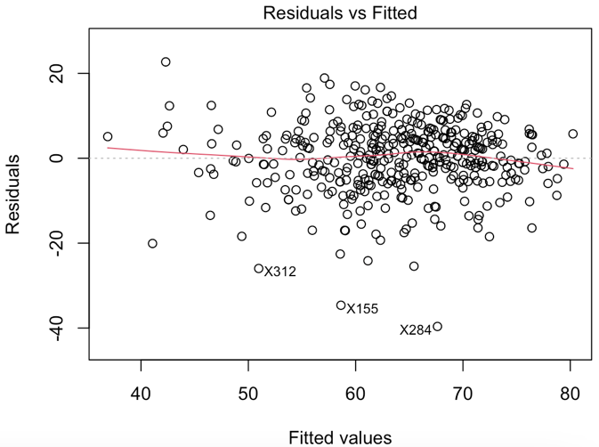

Figure 1: Residual vs fitted plot of the linear regression model

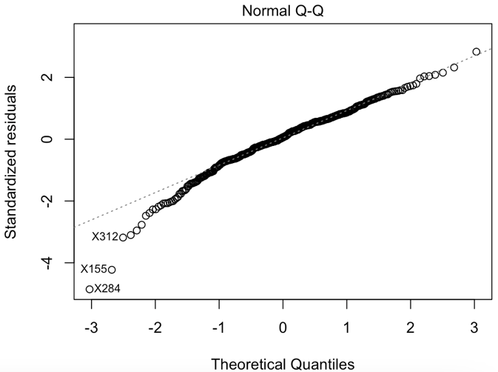

Figure 2: Standardized residuals vs theoretical quantile plot of the linear regression model

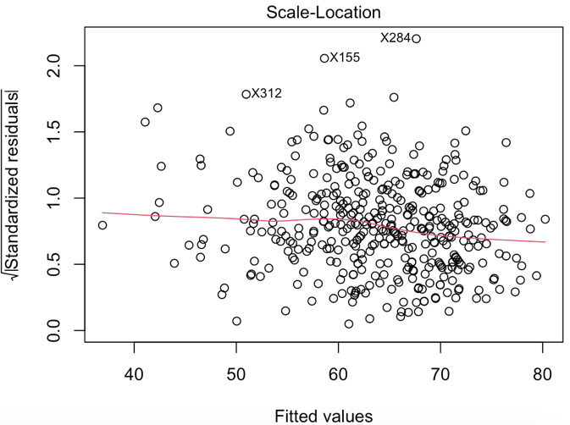
Figure 3: Scale location analysis of the linear regression model

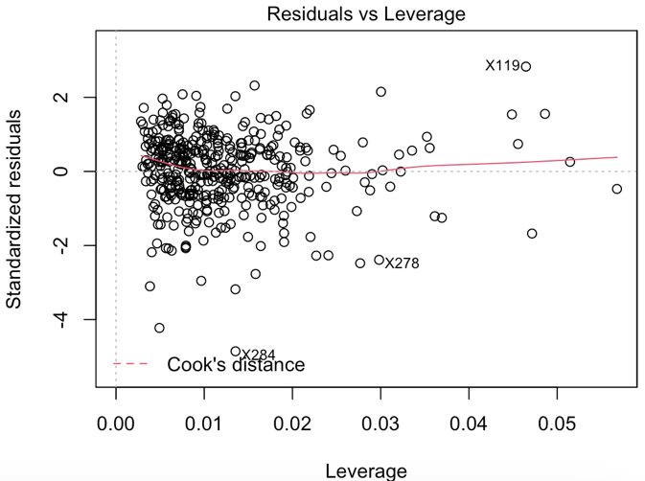
Figure 3: Influential observation analysis of the linear regression model

Table 1: Resampling results across tuning parameters of random forest model. RMSE – Root of the mean squared error, MAE – mean absolute error, SD – standard deviation.

Number of variables to randomly sample | RMSE | Rsquared | MAE | RMSE - SD | Rsquared - SD | MAE -SD
2 | 8.637999 | 0.4103038 | 6.676445 | 1.229486 | 0.1089745 | 0.8821591
3 | 8.740468 | 0.4017197 | 6.742842 | 1.233008 | 0.1110944 | 0.8909781
4 | 8.766682 | 0.4004018 | 6.756777 | 1.246021 | 0.110975 | 0.9027098

Table 2: Resampling results across tuning parameters of k-nearest neighbours model. k – number of nearest neighbours, RMSE – Root of the mean squared error, MAE – mean absolute error, SD – standard deviation.

k | RMSE | Rsquared | MAE | RMSE - SD | Rsquared - SD | MAE - SD
5 | 8.889837 | 0.3765809 | 6.807381 | 1.203997 | 0.1032215 | 0.8283155
7 | 8.659865 | 0.39998 | 6.608355 | 1.212547 | 0.1050915 | 0.7970627
9 | 8.487852 | 0.4213994 | 6.473634 | 1.221146 | 0.1083725 | 0.7870939

