Additional file information for

Multifunctional nano-bomb based on Fe-COF for targeted tumor dual chemodynamic therapy and bioimaging with enhanced ferroptosis and H₂O₂ self-supply
Pan Zhao ¹, Liyang Gong ¹, Le Chang ², Meijuan Geng ¹, Huiping Du ¹, Siyu Meng ¹, Liangliang Dai ^{1*}
¹ Xi’an Key Laboratory of Stem Cell and Regenerative Medicine, Institute of Medical Research, Northwestern Polytechnical University, Xi’an 710072, China
² Shaanxi Provincial Key Laboratory of Infection and Immune Diseases, Shaanxi Provincial People’s Hospital, Xi’an 710068, China
*Corresponding author: liangliangdai@nwpu.edu.cn (L.L. Dai)

Lift of Contents

Fig. S1 Particle size changes of FeCOF and HCF nanosystem. S3
Fig. S2 The amount of GSH. S3
Fig. S3 CLSM images of hypoxia level in 4T1 cells. S4
Fig. S4 Relaxation rates r1 and r2 of solutions of the HCF@β-lap. S4
Fig. S5 4T1 cell live/dead staining after various treatments. S5
Fig. S6 Quantitative apoptosis statistics of 4T1 cells induced by difference treatments. S5
Fig. S7 Corresponding quantitative analysis of intracellular Ca²⁺ concentration. S6
Fig. S8 The relative fluorescence density analysis of 4T1 cells on mitochondrial damage. S6
Fig. S9 Changes in mice body weight during administration. S7
Fig. S10 Tumor-related quantitative analysis of TUNEL and Ki67 immunofluorescence images. S8

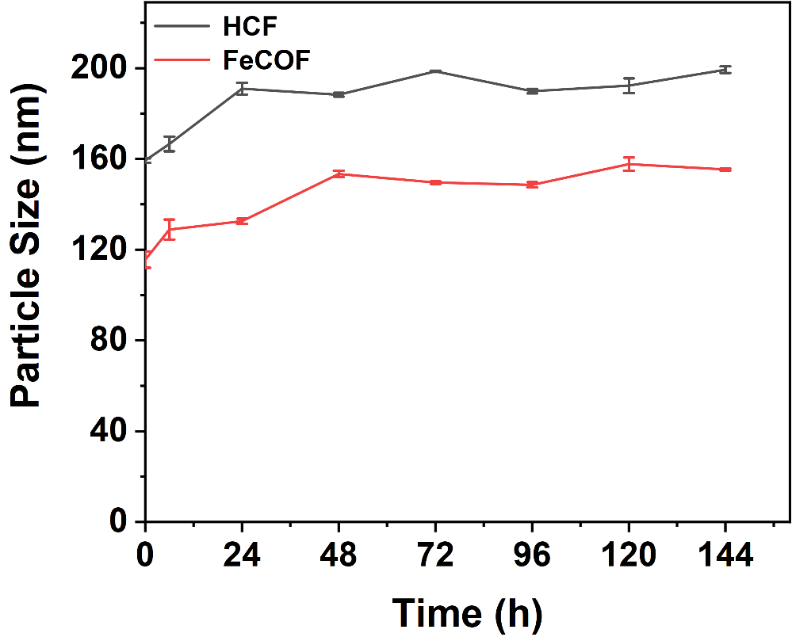

Fig. S1 Particle size changes of FeCOF and HCF nanosystem incubated in serum at pH 7.4 for 6 days, detected by DLS.

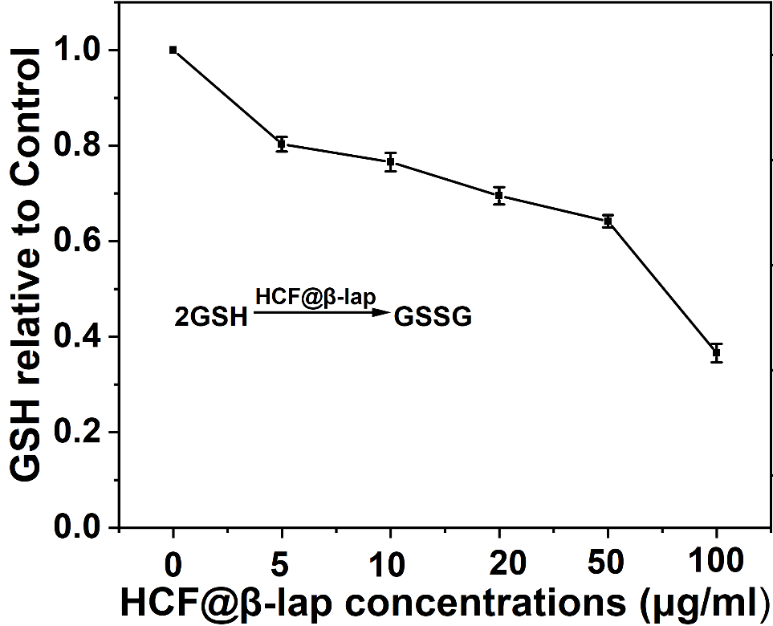

Fig. S2 The amount of GSH in the supernatant after 24 hours of reaction between HCF@β-lap at different concentrations and 10 mM GSH in mixed solution.

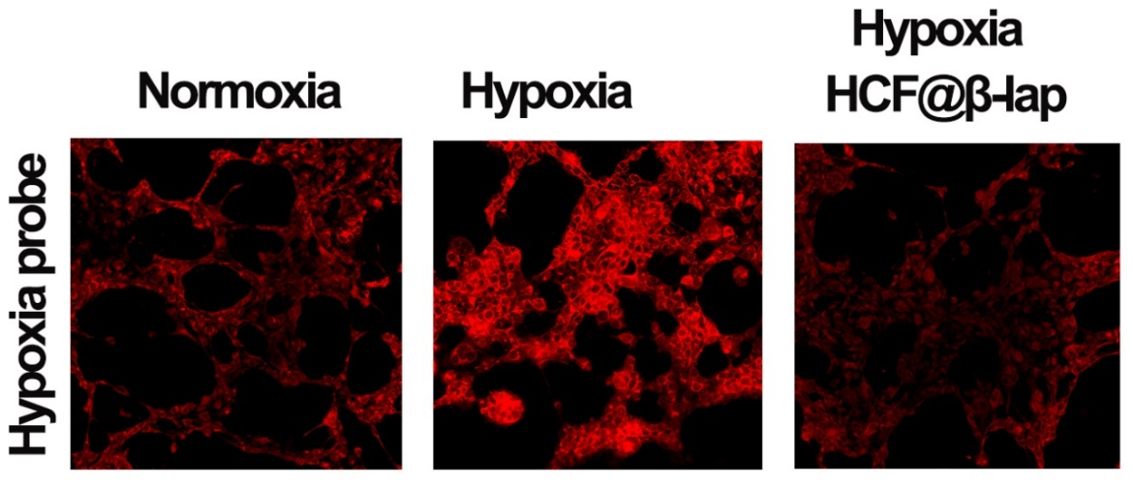

Fig. S3 CLSM images of hypoxia level in 4T1 cells after PBS and HCF@β nanosystem treatment for 4 h.

Fig. S4 Relaxation rates r1 and r2 of solutions of the HCF@β-lap.

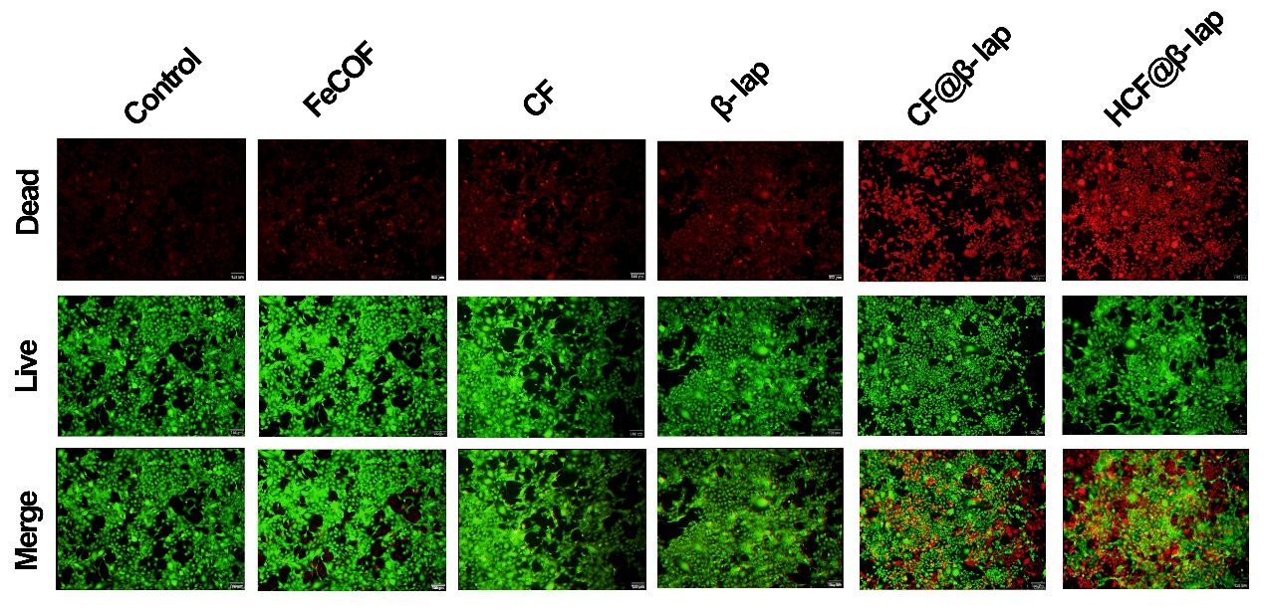
Fig. S5 4T1 cell live/dead staining after various treatments. The red signal denoted dead cells, while the green signal denoted live cells. 100 m is the scale bar.

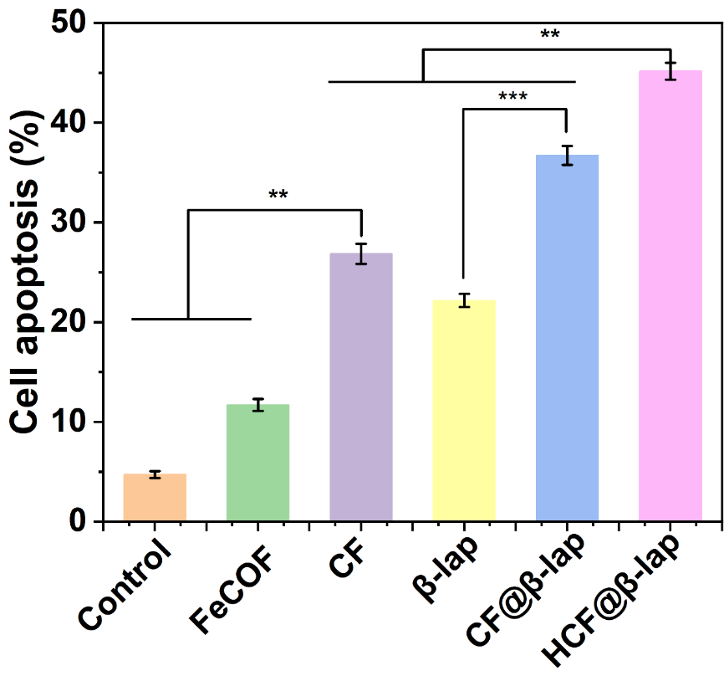

Fig. S6 Quantitative apoptosis statistics of 4T1 cells induced by difference treatments after 24 h of incubation (n=4).

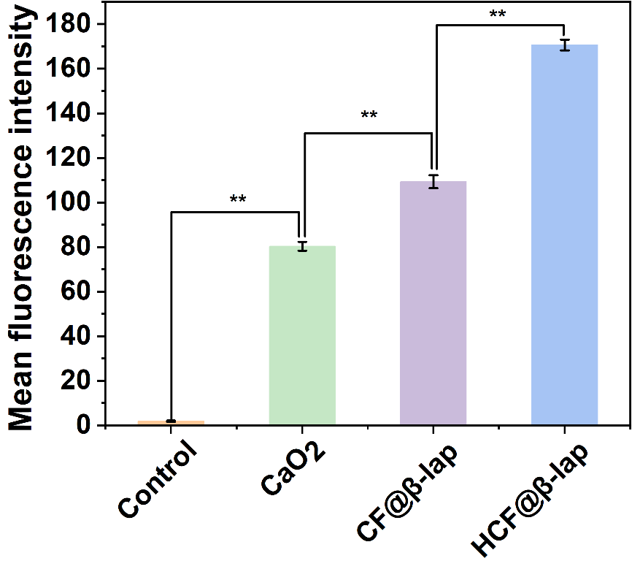
Fig. S7 The corresponding quantitative analysis of intracellular Ca²⁺ concentration via Fluo-4, AM staining.

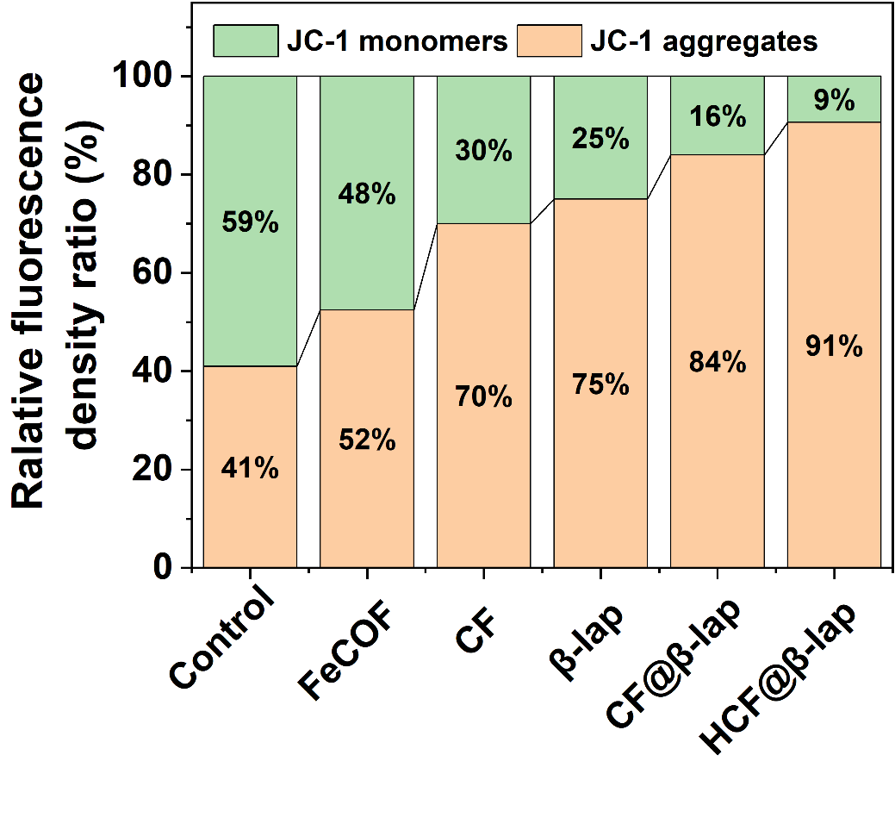
Fig. S8 The relative fluorescence density analysis of 4T1 cells on mitochondrial damage after administration for 12 h using JC-1 probe.

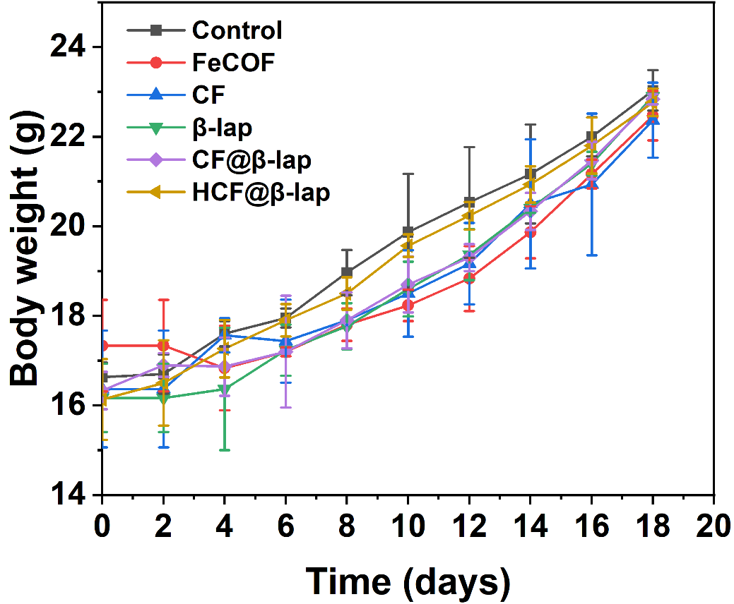

Fig. S9 Changes in mice body weight during administration.

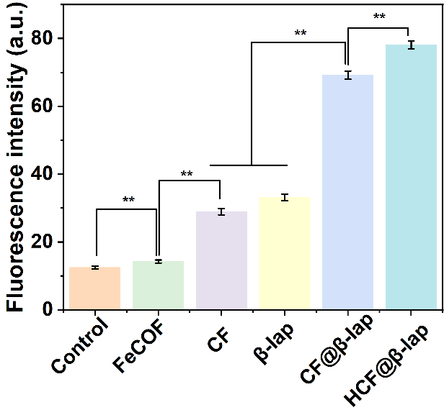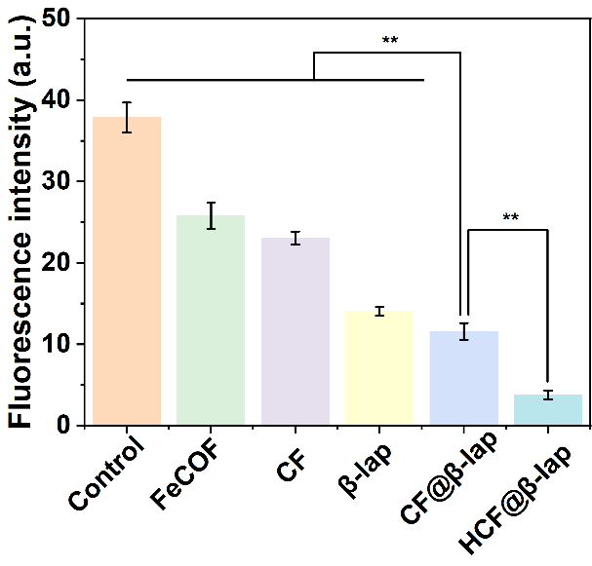

Fig. S10 Tumor-related quantitative analysis of TUNEL and Ki67 immunofluorescence images, Significance analysis was performed using a one-way ANOVA, **p < 0.01 and ***p < 0.001.

