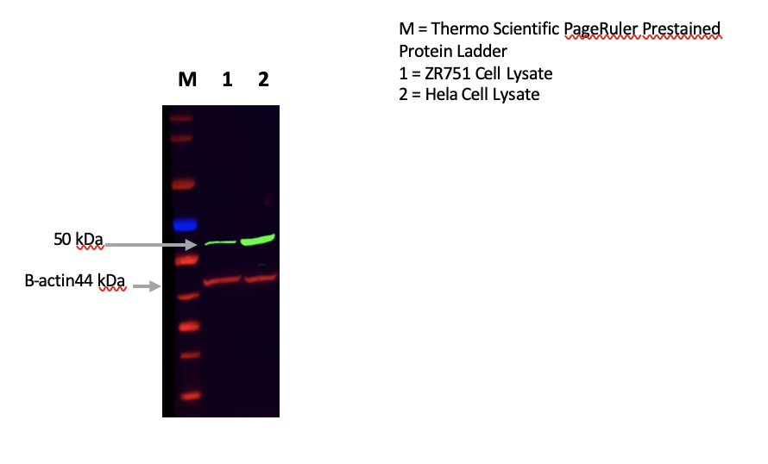
M= PageRuler Prestained Protein Ladder (Thermofisher Scientific, UK)
1 = ZR751 Cell Lysate
2 = HeLa Cell Lysate

Supplementary Fig 1 Western Blot Image

A)
B)
C)
D)
E)
F)
G)

Supplementary Fig 2 ATF4 mRNA expression in relation to different clinicopathological parameters and BC subtypes within the Breast Cancer Gene Miner v4.0 dataset. A) ATF4 and age. B) ATF4 and lymph node status. C) ATF4 and NPI. D) ATF4 and ER status E) ATF4 and PR status F) ATF4 and HER2 status. G) ATF4 mRNA expression in relation to PAM50 subtypes

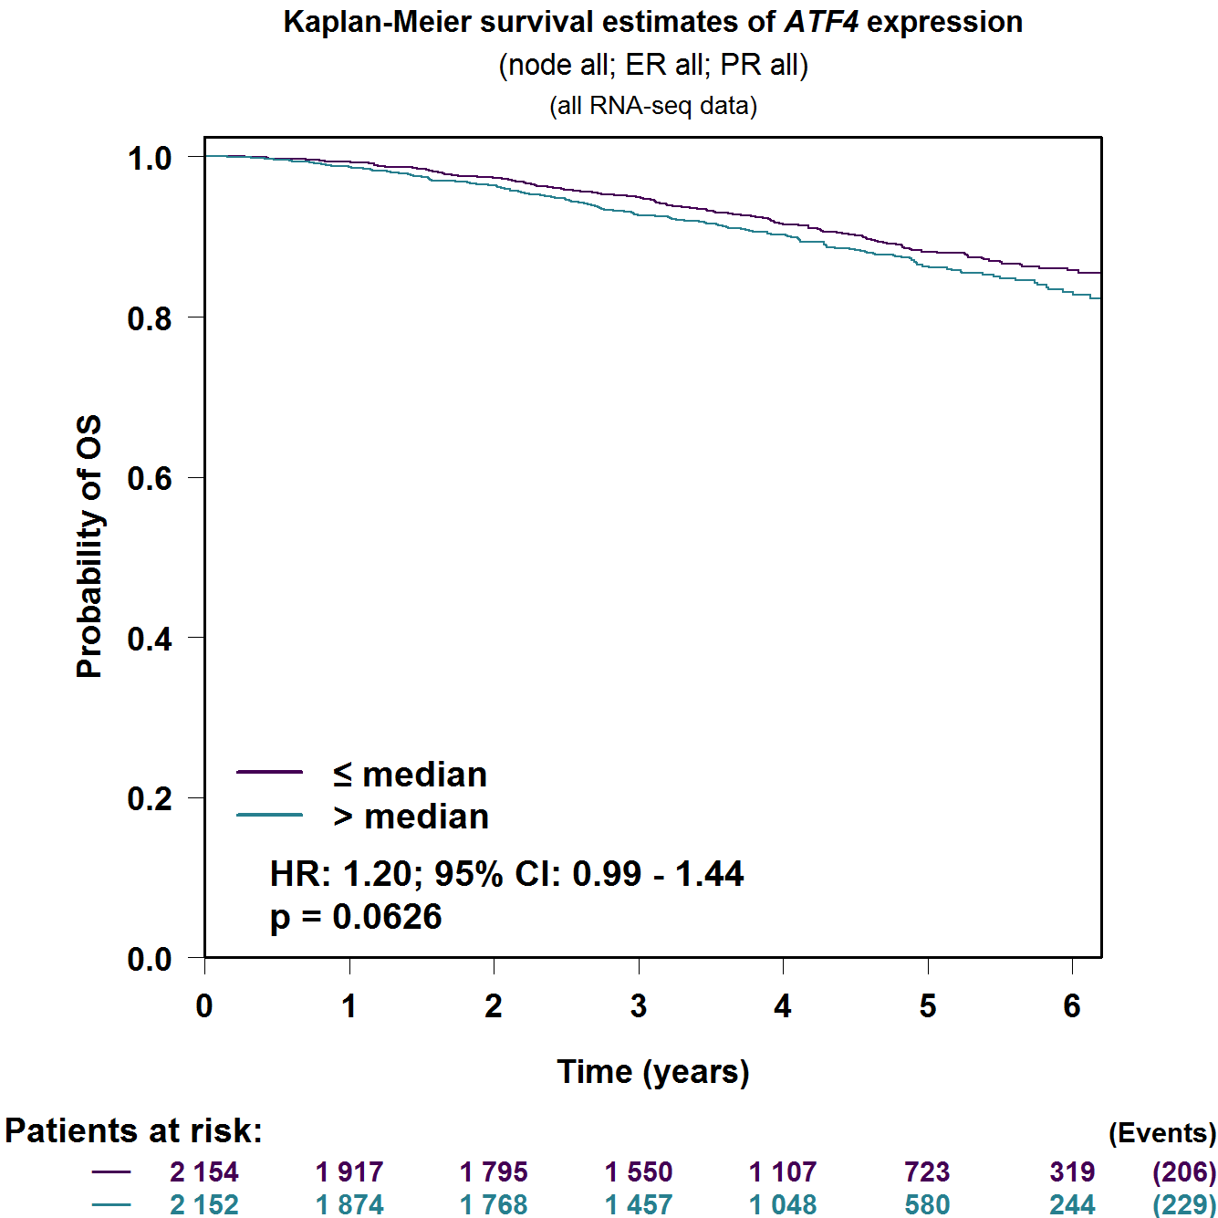
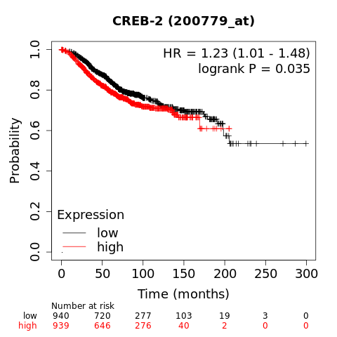
A)
B)

Supplementary Fig 3 ATF4 mRNA expression in breast cancer related to patient overall survival in the following datasets: A) Breast Cancer Gene Miner B) Kaplan-Meier Plotter

