Graphs:

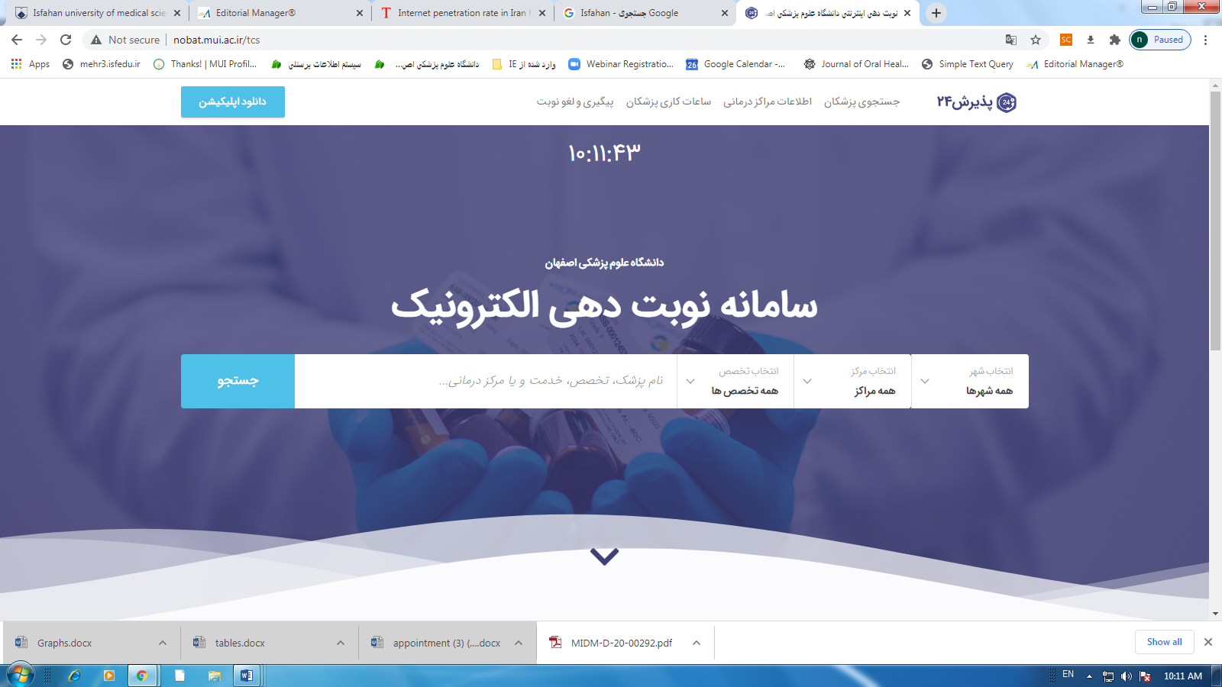
Booking appointment system
Search
Graph 1. The Screenshot of the booking appointment website

Graph 2. Percentage of frequency distribution of overall satisfaction with booking appointment services

Graph 3. Average patient satisfaction scores on behavior of staff and satisfaction with waiting time by patient location

