SUPPLEMENTARY TABLES
Supplementary Table S1: Identified cord blood mitochondrial mutations (n = 42). RefSNP: dbSNP Reference SNP (the National Center for Biotechnology Information database of genetic variation); CDS: Coding Sequence; VAF: Variant Allele Frequency.
 | RefSNP | CDS | Prevalence (%) in study population (n = 200) | VAF  (%; mean ± SD)
D-Loop
MT-D-Loop_{263A>G} | - | No | 10 (5.0) | 5.0 ± 21.8
MT-D-Loop_{310T>C} | - | No | 72 (36.0) | 5.4 ± 8.3
MT-D-Loop_{462C>T} | - | No | 18 (9.0) | 9.0 ± 28.5
MT-D-Loop_{489T>C} | - | No | 23 (11.5) | 11.5 ± 31.9
MT-D-Loop_{16126T>C} | - | No | 27 (13.5) | 13.5 ± 34.1
MT-D-Loop_{16172T>C} | - | No | 14 (7.0) | 6.0 ± 23.7
MT-D-Loop_{16189T>C} | - | No | 23 (11.5) | 11.0 ± 31.1
MT-D-Loop_{16223C>T} | - | No | 19 (9.5) | 9.0 ± 28.4
MT-D-Loop_{16270C>T} | - | No | 16 (8.0) | 8.0 ± 27.1
MT-D-Loop_{16278C>T} | - | No | 11 (5.5) | 5.3 ± 22.2
MT-D-Loop_{16294C>T} | - | No | 19 (9.5) | 9.4 ± 29.2
MT-D-Loop_{16304T>C} | - | No | 17 (8.5) | 8.4 ± 27.5
MT-D-Loop_{16311T>C} | - | No | 25 (12.5) | 11.9 ± 32.3
MT-D-Loop_{16362T>C} | - | No | 12 (6.0) | 5.5 ± 22.8
MT-D-Loop_{16519T>C} | - | No | 58 (29.0) | 28.9 ± 45.4
Mitochondrially Encoded 16S RRNA (MT-RNR2)
MT-RNR2_{1888G>A} | rs2897260 | No | 21 (10.5) | 10.4 ± 30.6
MT-RNR2_{2706A>G} | rs2854128 | No | 116 (58.0) | 57.4 ± 49.4
MT-RNR2_{3010G>A} | rs3928306 | No | 50 (25.0) | 24.9 ± 43.2
Mitochondrially Encoded NADH Dehydrogenase 1 (MT-ND1)
MT-ND1_{4216T>C} | rs1599988 | Yes | 43 (21.5) | 21.5 ± 41.1
Mitochondrially Encoded NADH Dehydrogenase 2 (MT-ND2)
MT-ND2_{4917A>G} | rs28357980 | Yes | 17 (8.5) | 8.5 ± 27.9
MT-ND2_{5147G>A} | rs367778601 | Yes | 13 (6.5) | 6.1 ± 23.7
MT-ND2_{5460G>A} | rs3021088 | Yes | 11 (5.5) | 5.2 ± 21.9
Mitochondrially Encoded Cytochrome C Oxidase I (MT-COX1)
MT-COX1_{7028C>T} | rs2015062 | Yes | 115 (57.5) | 56.7 ± 49.3
Mitochondrially Encoded ATP Synthase Membrane Subunit 6 (MT-ATP6)
MT-ATP6_{8697G>A} | rs879233543 | Yes | 20 (10.0) | 10.0 ± 30.0
MT-ATP6_{8860A>G} | rs2001031 | Yes | 168 (84.0) | 83.8 ± 36.7
Mitochondrially Encoded Cytochrome C Oxidase III (MT-COX3)
MT-COX3_{9477G>A} | rs2853825 | Yes | 13 (6.5) | 6.5 ± 24.6
Mitochondrially Encoded NADH Dehydrogenase 3 (MT-ND3)
MT-ND3_{10398A>G} | rs2853826 | Yes | 34 (17.0) | 17.0 ± 37.6
Mitochondrially Encoded TRNA-Arg (MT-TRNR)
MT-TRNR_{10463T>C} | rs28358279 | No | 24 (12.0) | 11.9 ± 32.4
Mitochondrially Encoded NADH Dehydrogenase 4 (MT-ND4)
MT-ND4_{11467A>G} | rs2853493 | Yes | 33 (16.5) | 16.4 ± 37.0
MT-ND4_{11719G>A} | rs2853495 | Yes | 101 (50.5) | 50.2 ± 49.8
MT-ND4_{11812A>G} | rs3088053 | Yes | 20 (10.0) | 9.9 ± 29.9
Mitochondrially Encoded TRNA-Leu (CUN) 2 (MT-TRNL2)
MT-TRNL2_{12308A>G} | rs2853498 | No | 31 (15.5) | 15.5 ± 36.2
Mitochondrially Encoded NADH Dehydrogenase 5 (MT-ND5)
MT-ND5_{12372G>A} | rs2853499 | Yes | 33 (16.5) | 16.4 ± 37.1
MT-ND5_{12612A>G} | rs28359172 | Yes | 26 (13.0) | 13.0 ± 33.6
MT-ND5_{12705C>T} | rs193302956 | Yes | 18 (9.0) | 9.0 ± 28.5
MT-ND5_{13368G>A} | rs3899498 | Yes | 21 (10.5) | 10.4 ± 30.5
Mitochondrially Encoded NADH Dehydrogenase 6 (MT-ND6)
MT-ND6_{14233A>G} | rs3915611 | Yes | 20 (10.0) | 9.9 ± 29.9
Mitochondrially Encoded Cytochrome B (CYTB)
MT-CYTB_{14766C>T} | rs193302980 | Yes | 58 (29.0) | 28.4 ± 44.9
MT-CYTB_{14798T>C} | rs28357681 | Yes | 21 (10.5) | 10.5 ± 30.6
MT-CYTB_{14905G>A} | rs193302983 | Yes | 15 (7.5) | 7.4 ± 26.2
MT-CYTB_{15452C>A} | rs193302994 | Yes | 40 (20.0) | 19.9 ± 39.8
MT-CYTB_{15607A>G} | rs193302996 | Yes | 21 (10.5) | 10.5 ± 30.6

Supplementary Table S2: Sensitivity analyses for the association between cord blood MT-D-Loop_{16362T>C} heteroplasmy and rapid growth at six months. Models were adjusted for maternal age, maternal education, pre-pregnancy BMI, parity, smoking during pregnancy, gestational age, newborn’s sex, ethnicity, birth weight, and cord blood mtDNA content. Estimates were provided as OR with 95% CI of developing rapid growth per % increase in VAF.
 | n | OR (95% CI) | p-value
Additionally adjusted for leukocyte and platelet count | 200 | 1.02 (1.01 to 1.03) | 0.005
Only girls | 104 | 1.02 (1.01 to 1.04) | 0.006
Only boys | 96 | 1.03 (1.00 to 1.06) | 0.05

Supplementary Table S3: The association between cord blood mtDNA content and rapid growth at six and 12 months (n = 200). Models were adjusted for maternal age, maternal education, pre-pregnancy BMI, parity, smoking during pregnancy, gestational age, newborn’s sex, ethnicity, birth weight, cord blood leukocyte count, and cord blood platelet count. Estimates were provided as OR with 95% CI of developing rapid growth per unit increase in cord blood mtDNA content.
Rapid growth | OR (95% CI) | p-value
At six months | 0.93 (0.55 to 1.48) | 0.77
At 12 months | 0.99 (0.67 to 1.43) | 0.95

SUPPLEMENTARY FIGURES
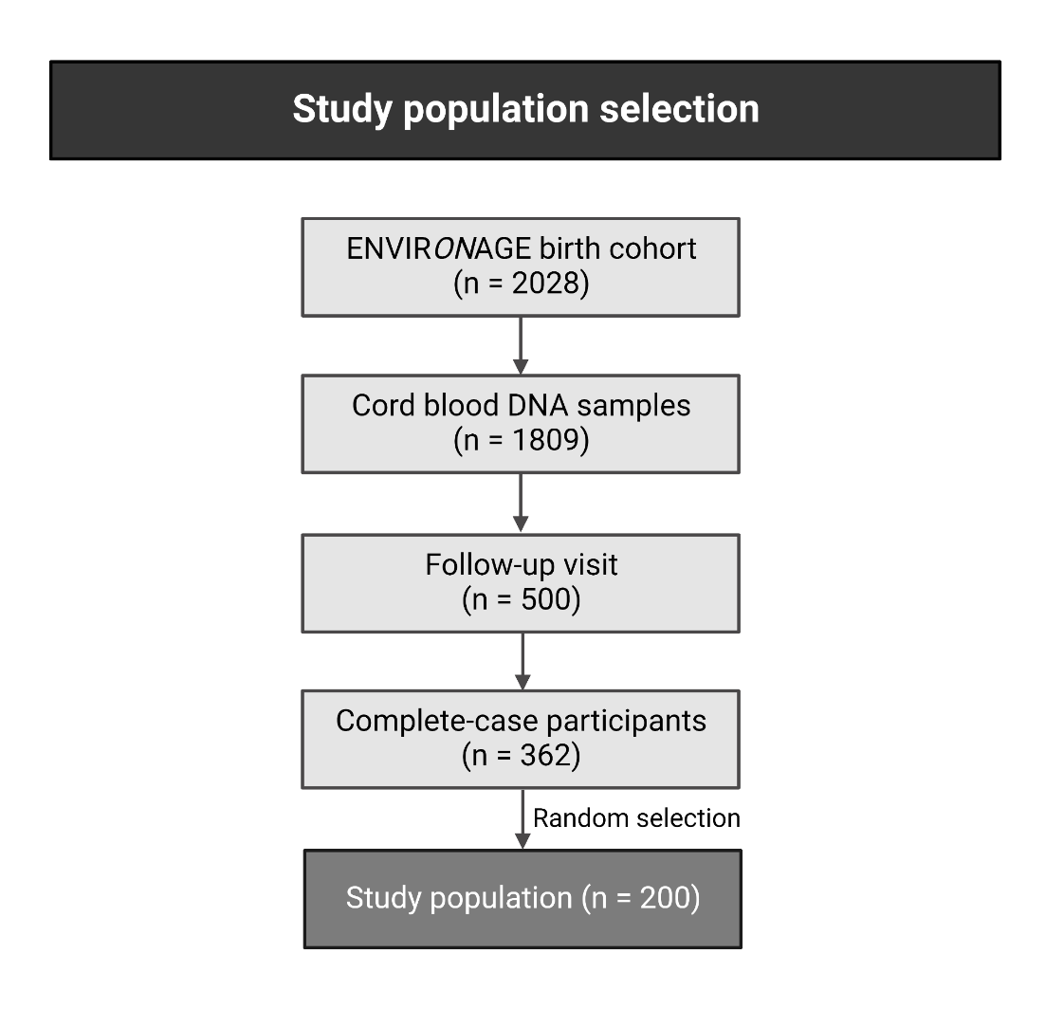
Supplementary Figure S1: Flowchart study population selection. The ENVIRONAGE birth cohort recruited 2028 mother-child pairs until May 2021. For this study, only complete-case participants were eligible (n = 362), of which 200 participants were randomly selected. This subpopulation was recruited between February 2010 and September 2013.

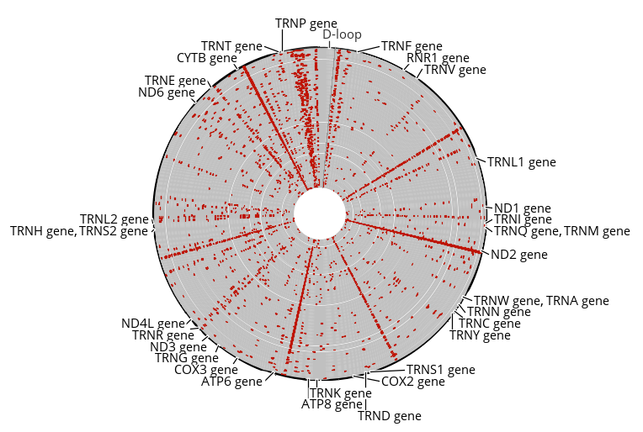
Supplementary Figure S2: In total, 2,928 cord blood mitochondrial variants (red dots) were identified in our study population (n = 200). These variants included single nucleotide polymorphisms (n = 2866), insertions (n = 18), deletions (n = 33), and substitutions (n = 11).

