Sub-Basin | Method | HSPF 1995, 90th Percentile Precip., AMC | LP3 | PL Linear Regression | PL Nonlinear  Regression | FEMA FIS | HSPF 1995, Median Precip., AMC
Sub-Basin | Reach Location
Black Creek | Reach 3 | 233 | 177 | 195 | 179 | 234 | 174
Black Creek | South Fork Gage | NA | 171 | 177 | 147 | NA | NA
Black Creek | Reach 6 | 244 | 249 | 278 | 225 | 247 | 178
Black Creek | North Fork Gage | NA | 237 | 276 | 204 | NA | NA
Black Creek | Reach 12 | 511 | 357 | 387 | 347 | 590 | 347
Julington Creek | Reach 2 | 44 | 48 | 53 | 50 | 72 | 34
Julington Creek | Reach 5 | 13 | 18 | 21 | 19 | 63 | 10
Durbin Creek | Reach 1 | 30 | 30 | 34 | 24 | 77 | 24
Big Davis Creek | Reach 6 | 11 | 20 | 22 | 19 | 13 | 8
Big Davis Creek | Synth Gage | 10 | 12 | 14 | 12 | NA | 7
Big Davis Creek | Real Gage | NA | 19 | 21 | 18 | 32 | NA
Ortega River | Reach 3 | 93 | 163 | 174 | 159 | 78 | NA
Ortega River | 103rd St. Synth Gage | 61 | 60 | 62 | 54 | 46 | NA
Ortega River | Kirwin Real |  | 56 | 56 | 52 | 78 | NA
Ortega River | Kirwin Rd. Synth Gage | 91 | 78 | 79 | 73 | NA | NA
Pablo Creek | Reach 8 | 59 | 56 | 88 | 56 | 110 | NA
Pablo Creek | Pablo Real Gage | NA | 28 | 33 | 28 | 108 | NA
Supplemental Data Table 1. All 10-year return frequency results (Kovalenko 2020) in cubic meters per second.

Supplemental Data Table 2. All 50-year return frequency results (Kovalenko 2020) in cubic meters per second.
Sub-Basin | Method | HSPF 1995, 90th Percentile Precip., AMC | LP3 | PL Linear Regression | PL Nonlinear  Regression | FEMA FIS | HSPF 1995, Median Precip., AMC
Sub-Basin | Reach Location
Black Creek | Reach 3 | NA | 281 | 485 | 374 | 429 | NA
Black Creek | South Fork Gage | NA | 290 | 629 | 322 | 487 | NA
Black Creek | Reach 6 | NA | 387 | 932 | 474 | 419 | NA
Black Creek | North Fork Gage | NA | 395 | 1,020 | 459 | 443 | NA
Black Creek | Reach 12 | NA | 434 | 836 | 615 | 1,053 | NA
Julington Creek | Reach 2 | 95 | 75 | 148 | 122 | 108 | 62
Julington Creek | Reach 5 | 28 | 34 | 65 | 46 | 88 | 21
Durbin Creek | Reach 1 | 60 | 48 | 119 | 84 | 131 | 40
Big Davis Creek | Reach 6 | 25 | 32 | 71 | 44 | 25 | 17
Big Davis Creek | Synth Gage | 24 | 20 | 51 | 28 | 53 | 14
Big Davis Creek | Real Gage | NA | 32 | 72 | 44 | NA | NA
Ortega River | Reach 3 | 169 | 216 | 336 | 264 | 144 | NA
Ortega River | 103rd St. Synth Gage | 103 | 117 | 216 | 136 | 88 | NA
Ortega River | Kirwin Real | NA | 80 | 120 | 106 | 153 | NA
Ortega River | Kirwin Rd. Synth Gage | 158 | 117 | 174 | 150 | NA | NA
Pablo Creek | Reach 8 | 86 | 91 | 128 | 138 | 213 | NA
Pablo Creek | Pablo Real Gage | NA | 43 | 115 | 70 | 171 | NA
Supplemental Data Table 3. Black Creek 10-year Return Frequency Flood Estimates (cms).
Data Analysis | Reach 3 | Reach 6 | Reach 12
2030 Average Wet Season | 278 | 331 | 671
2030 Median Wet Season | 280 | 336 | 678
2030 Average Dry Season | 265 | 311 | 640
2030 Median Dry Season | 281 | 334 | 684
2030 Total Median | 281 | 335 | 681
2030 Total Average | 271 | 321 | 656
1995 Total Average | 233 | 244 | 511
Total Average Difference | 38 | 77 | 144
FEMA | 234 | 247 | 590

Supplemental Data Table 4. Ortega River 10-year Return Frequency Flood Estimates (cms).
Data Analysis | 103rd St. Synth Gage | Kirwin Rd. Synth Gage | Reach 3
2030 Average Wet Season | 69 | 102 | 102
2030 Median Wet Season | 70 | 102 | 101
2030 Average Dry Season | 73 | 107 | 112
2030 Median Dry Season | 73 | 106 | 107
2030 Total Median | 71 | 104 | 105
2030 Total Average | 71 | 104 | 107
1995 Total Average | 61 | 91 | 93
Total Average Difference | 10 | 13 | 14
FEMA | 46 | 78 | 79

Supplemental Data Table 5. Ortega River 50-year Return Frequency Flood Estimates (cms).
Data Analysis | 103rd St. Synth Gage | Kirwin Rd. Synth Gage | Reach 3
2030 Average Wet Season | 111 | 168 | 177
2030 Median Wet Season | 111 | 168 | 178
2030 Average Dry Season | 113 | 172 | 190
2030 Median Dry Season | 113 | 172 | 186
2030 Total Median | 112 | 170 | 183
2030 Total Average | 112 | 170 | 184
1995 Total Average | 103 | 158 | 169
Total Average Difference | 9 | 12 | 15
FEMA | 88 | 153 | 145

Supplemental Data Table 6. Pablo Creek Results Flood Estimates (cms).
Data Analysis | 10-year | 25-year | 50-year | 100-year
Data Analysis | Reach 8 | Reach 8 | Reach 8 | Reach 8
2030 Average Wet Season | 60 | 77 | 88 | 99
2030 Median Wet Season | 60 | 77 | 88 | 100
2030 Average Dry Season | 60 | 77 | 88 | 100
2030 Median Dry Season | 61 | 77 | 88 | 100
2030 Total Median | 60 | 77 | 88 | 100
2030 Total Average | 60 | 77 | 88 | 99
1995 Total Average | 59 | 76 | 86 | 99
Total Average Difference | 1 | 1 | 2 | 1
FEMA | 110 | 167 | 213 | 249
Supplemental Data Table 7. Julington Creek Results (From Kovalenko 2020) Flood Estimates (cms).
Data Analysis | 10-year |  | 25-year |  | 50-year |  | 100-year
Data Analysis | Reach 2 | Reach 5 | Reach 2 | Reach 5 | Reach 2 | Reach 5 | Reach 2 | Reach 5
2030 Total Average | 68 | 20 | 104 | 29 | 135 | 38 | 178 | 50
1995 Total Average | 44 | 13 | 69 | 23 | 95 | 28 | 132 | 41
Total Average Difference | 24 | 7 | 35 | 6 | 40 | 10 | 46 | 9
FEMA | 72 | 63 | 93 | 72 | 108 | 88 | 125 | 97

Supplemental Data Table 8. Durbin Creek Results (From Kovalenko 2020) Flood Estimates (cms).
Data Analysis | 10-year | 25-year | 50-year | 100-year
Data Analysis | Reach 1 | Reach 1 | Reach 1 | Reach 1
2030 Total Average | 43 | 64 | 85 | 115
1995 Total Average | 30 | 44 | 60 | 86
Total Average Difference | 12 | 20 | 25 | 28
FEMA | 77 | 109 | 131 | 160

Supplemental Data Table 9. Big Davis Creek Results (From Kovalenko 2020) Flood Estimates (cms).
Data Analysis | 10-year | 25-year | 50-year | 100-year
Data Analysis | Reach 6 | Reach 6 | Reach 6 | Reach 6
2030 Total Average | 23 | 30 | 34 | 40
1995 Total Average | 11 | 20 | 25 | 30
Total Average Difference | 12 | 10 | 9 | 11
FEMA | 13 | 17 | 25 | 32

Supplemental Figure 1. Comparison of Results at Ortega River 103rd St. Synthetic Gage
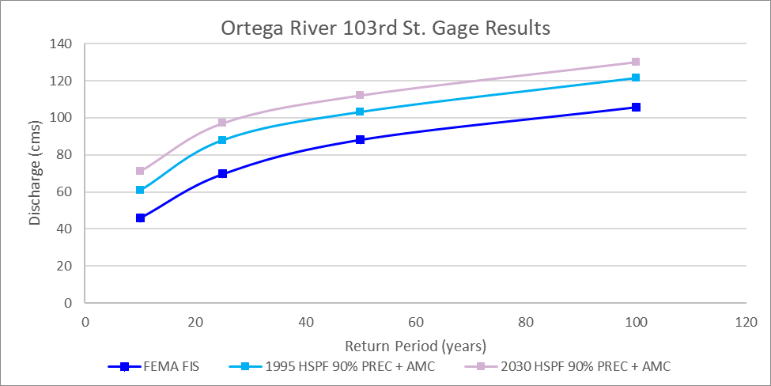

Supplemental Figure 2. Comparison of Results Ortega River Kirwin Rd. Synthetic Gage
