Appendix Table: The meanings of 46 SDG indicators and their trends from 2010 to 2021.
SDGs | Index | Indicator interpretation | Specific sources | Tend
SDG1 | 1.1.1b | Per capita disposable income in cities and towns | Hainan Provincial Bureau of Statistics | 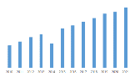
SDG1 | 1.1.1c | Rural per capita disposable income | Hainan Provincial Bureau of Statistics | 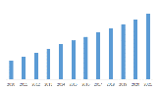
SDG1 | 1.a.1a | Medical expenditure | The Departments of Hainan Province/Hainan Provincial Tax Service , State Taxation Administration | 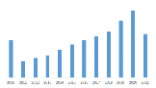
SDG1 | 1.a.1b | Social security expenditure | The Departments of Hainan Province/Hainan Provincial Tax Service , State Taxation Administration | 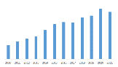
SDG1 | 1.a.1c | Education expenditure | The Departments of Hainan Province/Hainan Provincial Tax Service , State Taxation Administration | 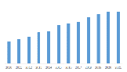
SDG2 | 2.1.2a | Total grain output | Hainan Provincial Bureau of Statistics | 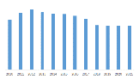
SDG2 | 2.1.2b | Per capita grain output | Hainan Provincial Bureau of Statistics | 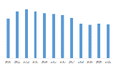
SDG2 | 2.4.1a | Per capita cultivated land area | Hainan Provincial Bureau of Statistics | 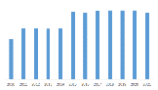
SDG2 | 2.4.1c | Fertilizer utilization rate of grain crops (%)(Negative direction) | Hainan Provincial Bureau of Statistics | 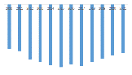
SDG2 | 2.4.1e | Grain sown area | Hainan Provincial Bureau of Statistics | 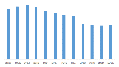
SDG2 | 2.4.1f | Planting area of melon and vegetable in winter | Hainan Provincial Bureau of Statistics | 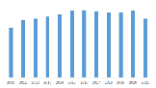
SDG2 | 2.4.1i | Newly increased paddy field area | Hainan Provincial Bureau of Statistics | 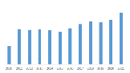
SDG2 | 2.4.1j | Pesticide usage(Negative direction) | Hainan Provincial Bureau of Statistics | 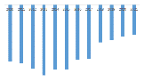
SDG2 | 2.4.1k | Effective irrigation rate of farmland | Hainan Provincial Bureau of Statistics | 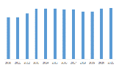
SDG3 | 3.6.1 | Traffic casualties(Negative direction) | Hainan Provincial Administration of Work Safety | 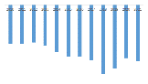
SDG3 | 3.b.2 | Government health expenditure | The Departments of Hainan Province/Hainan Provincial Tax Service , State Taxation Administration | 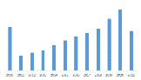
SDG3 | 3.c.1 | Professional physician | Health and Family Planning Commission of Hainan Province | 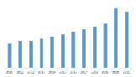
SDG4 | 4.1.1b | Number of pupils in school per 10000 | The Education Department of Hainan Province | 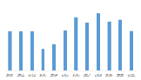
SDG4 | 4.1.2 | Number of secondary school students per 10000 | The Education Department of Hainan Province | 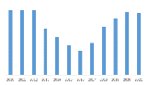
SDG4 | 4.b.1a | Proportion of education expenditure in GDP | The Departments of Hainan Province/Hainan Provincial Tax Service , State Taxation Administration | 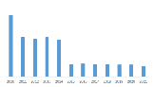
SDG6 | 6.1.1b | Urban water penetration rate | "Urban (County) Construction Statistical Report Form System" | 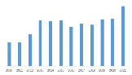
SDG6 | 6.2.1a | Public toilets per 10000 people | "Urban (County) Construction Statistical Report Form System" | 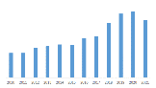
SDG7 | 7.1.2b | Urban gas penetration rate | "Urban (County) Construction Statistical Report Form System" | 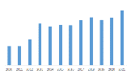
SDG7 | 7.3.1 | GDP energy intensity | Annual Report on Energy Statistics | 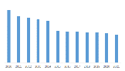
SDG7 | 7.a.1 | Proportion of energy conservation and environmental protection | The Departments of Hainan Province/Hainan Provincial Tax Service , State Taxation Administration | 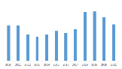
SDG8 | 8.1.1 | GDP per capita | Hainan Provincial Bureau of Statistics | 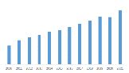
SDG8 | 8.5.2 | Unemployment rate of cities and counties(Negative direction) | Department of Human Resources and Social Security of Hainan Province | 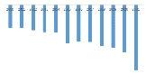
SDG8 | 8.9.1 | Tourism income | Tourism Development Commission of Hainan Province | 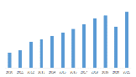
SDG9 | 9.2.2 | Proportion of manufacturing employment in total employment | Hainan Provincial Bureau of Statistics | 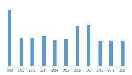
SDG9 | 9.3.1 | Proportion of output value of secondary and tertiary industries | Hainan Provincial Bureau of Statistics | 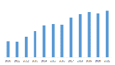
SDG9 | 9.5.1 | Proportion of science and technology expenditure in GDP | The Departments of Hainan Province/Hainan Provincial Tax Service , State Taxation Administration | 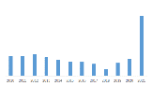
SDG10 | 10.2.1a | Urban-rural ratio(Negative direction) | Hainan Provincial Bureau of Statistics | 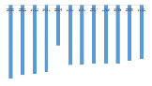
SDG11 | 11.1.1a | Proportion of people living in shantytowns(Negative direction) | Hainan Provincial Bureau of Statistics | 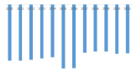
SDG11 | 11.1.1b | Proportion of housing security expenditure in financial expenditure | The Departments of Hainan Province/Hainan Provincial Tax Service , State Taxation Administration | 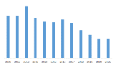
SDG11 | 11.2.1a | Per capita urban road area | Hainan Provincial Bureau of Statistics | 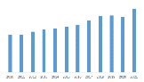
SDG11 | 11.6.1a | PM2.5 | Department of Ecology and Environment of Hainan Province | 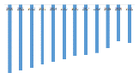
SDG11 | 11.6.2a | PM10 | Department of Ecology and Environment of Hainan Province | 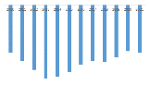
SDG11 | 11.6.2b | Proportion of days with good air quality in cities at prefecture level and above | Department of Ecology and Environment of Hainan Province | 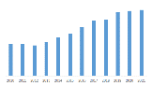
SDG11 | 11.6.2c | Green space ratio | "Urban (County) Construction Statistical Report Form System" | 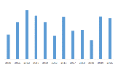
SDG11 | 11.7.1a | Park green area per capita | "Urban (County) Construction Statistical Report Form System" | 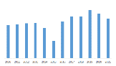
SDG11 | 11.7.1b | Domestic garbage harmless treatment capacity | "Urban (County) Construction Statistical Report Form System" | 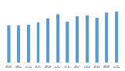
SDG12 | 12.5.1 | Treatment rate of harmful wastewater | Statistical Survey System for Agriculture, Forestry, Animal Husbandry and Fishery | 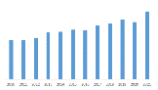
SDG14 | 14.7.1 | Domestic garbage harmless treatment capacity | Statistical Survey System for Agriculture, Forestry, Animal Husbandry and Fishery | 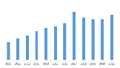
SDG14 | 14.7.2 | Treatment rate of harmful wastewater | Statistical Survey System for Agriculture, Forestry, Animal Husbandry and Fishery | 