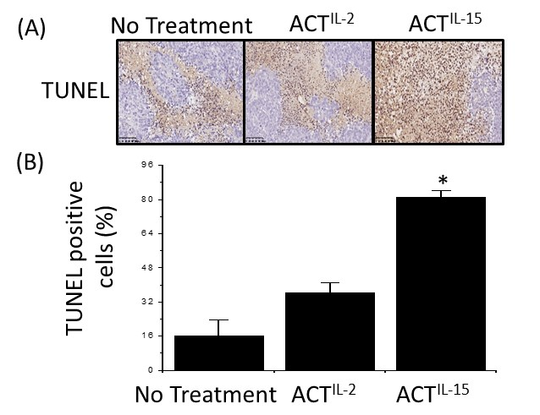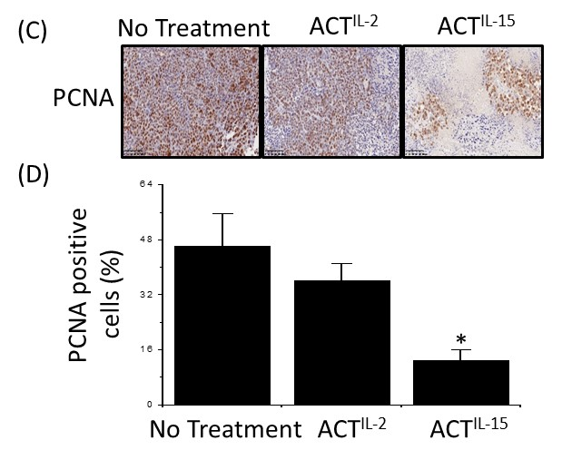

Figure S1
The effect of ACT^{IL-15} cells on the proliferation of MKN-45 cells. (A) TUNEL staining of MKN-45 subcutaneous xenografts. Paraffin sections were stained with the TUNEL technique using the Apoptag kit. (C) Immunohistochemistry of MKN-45 subcutaneous xenografts. Paraffin sections were immunostained with a monoclonal antibody to PCNA. Quantification of apoptosis following TUNEL staining (B) or PCNA immunohistochemistry (D). Adoptively transferred ACT^{IL-15} cells produced more apoptosis and less proliferation of MKN-45 cells than did adoptively transferred ACT^{IL-2}. *P < 0.05. ACT, adoptive cell therapy.

