Electronic supplementary file

Eggshell membrane promotes homeostasis of elastic skin and lung tissue associated with type III collagen and decorin expression and ameliorates pulmonary fibrosis in a bleomycin mouse model

Cell and Tissue Research

Eri Ohto-Fujita^{1#}, Miho Shimizu^{1#}, Aya Atomi¹, Nozomi Hatakeyama¹, Shinya Horinouchi¹, Natsumi Shibayama¹, Ryota Hosoda¹, Tomoaki Murakami², Shinya Miyazaki², Masashi Kurimoto¹, Shunsuke Yasuda¹, Shoki Kodama¹, Tomoaki Atomi⁴, Kazuya Tanaka⁵, Noboru Hirose⁵, Kenji Harada⁶, Yoshihide Asano⁷, Toshiyuki Watanabe⁸, Yukio Hasebe⁹, Yoriko Atomi¹*#

¹Material Health Science, Tokyo University of Agriculture and Technology (TUAT), ² Cooperative Dep. Veterinary Medicine, TUAT, ³Faculty of Health Sciences, Kyorin University, ⁴Faculty of Medical Sciences, Teikyo University of Science, ⁵Health Service Center, TUAT, ⁶Department of Dermatology, Graduate School of Medicine, The University of Tokyo, ⁷Division of Applied Chemistry, Graduate School of Engineering, TUAT, ⁸Almado, Inc.

*Corresponding author E-mail：yatomi@m2.tuat.ac.jp

Online resource 1 Primer sequences (5’-3’)
For amplification in human IMR-90

Gene | Forward primer | Reverse primer
GAPDH^{*1}  COL3A1^{*2}  COL1A1^{*2}  DCN^{*2}  MMP2^{*3}  PRRX1^{*4} | CGACAGTCAGCCGCATCTTC  GGACCTCCTGGTGCTATAGGT  GGGATTCCCTGGACCTAAAG  GGAGACTTTAAGAACCTGAAGAACC  CCCACTGCCGTTTTCTCGAAT  TGATGCTTTTGTGCGAGAAGA | CGCCCAATACGACCAAATCCG  CGGGTCTACCTGATTCTCCAT  GGAACACCTCGCTCTCCA  CGTTCCAACTTCACCAAAGG  CAAAGGGGTATCCATCGCCAT  AGGGAAGCGTTTTTATTGGCT
AEBP1^{*5} | GGTTACGTGATCCCCAACTACG | CTGCCCACTTGTCGGTCTC
LBH^{*6} | GCCCCGACTATCTGAGATCG | GCGGTCAAAATCTGACGGGT
TCF21^{*7} | TCCTGGCTAACGACAAATACGA | TTTCCCGGCCACCATAAAGG

^{*1}Designed by Sigma-Genosys, Japan; ^{*2} (Ohto-Fujita, et. al., 2011); ^{*3}(Zhao, et al., 2017); ^{*4}(Loh, et al., 2016); ^{*5} PrimerBank ID 53692188c2 (Spandidos, et al., 2009); ^{*6}(Jiang, et al., 2019); ^{*7}PrimerBank ID 208609971c1 (Spandidos, et al., 2009)

For amplification in mouse lung and skin

Gene | Forward primer |  | Reverse primer
GAPDH^{*8} | agcttgtcatcaacgggaag | tttgatgttagtggggtctcg
COL3A1^{*8} | tcccctggaatctgtgaatc |  | tgagtcgaattggggagaat
MMP2^{*8} | ggagaaggctgtgttcttcg |  | aggctggtcagtggcttg
DCN^{*8} | gaggagaagtgaggggagaca |  | gattatctcatgtattttcacgacctt
ELN^{*8} | tggagcaggacttggaggt |  | cctccagcaccatacttagca

^{*8} (Ohto-Fujita E, et al., 2019)

Online resource references
Jiang Y, Zhou J, Zou D, Hou D, Zhang H, Zhao J, Li L, Hu J, Zhang Y, Jing Z (2019) Overexpression of Limb-Bud and Heart (LBH) promotes angiogenesis in human glioma via VEGFA-mediated ERK signalling under hypoxia. EBioMedicine 48:36-48
Loh KM, Chen A, Koh PW, Deng TZ, Sinha R, Tsai JM, Barkal AA, Shen KY, Jain R, Morganti RM, Shyh-Chang N, Fernhoff NB, George BM, Wernig G, Salomon REA, Chen Z, Vogel H, Epstein JA, Kundaje A, Talbot WS, Beachy PA, Ang LT, Weissman IL (2016) Mapping the Pairwise Choices Leading from Pluripotency to Human Bone, Heart, and Other Mesoderm Cell Types. Cell 166:451-467
Ohto-Fujita E, Konno T, Shimizu M, Ishihara K, Sugitate T, Miyake J, Yoshimura K, Taniwaki K, Sakurai T, Hasebe Y, Atomi Y (2011) Hydrolyzed eggshell membrane immobilized on phosphorylcholine polymer supplies extracellular matrix environment for human dermal fibroblasts. Cell Tissue Res 345:177-190
Ohto-Fujita E, Shimizu M, Sano S, Kurimoto M, Yamazawa K, Atomi T, Sakurai T, Murakami Y, Takami T, Murakami T, Yoshimura K, Hasebe Y, Atomi Y (2019) Solubilized eggshell membrane supplies a type III collagen-rich elastic dermal papilla. Cell Tissue Res 376:123-135
Spandidos A, Wang X, Wang H, Seed B (2009) PrimerBank: a resource of human and mouse PCR primer pairs for gene expression detection and quantification. Nucleic Acids Research 38:D792-D799
Zhao S, Zhao Y, Guo J, Fei C, Zheng Q, Li X, Chang C (2017) Downregulation of MMP1 in MDS-derived mesenchymal stromal cells reduces the capacity to restrict MDS cell proliferation. Sci Rep 7:43849

Online resource 2 Quantification of the number of alveolar stromal decorin-positive cells by Image J.

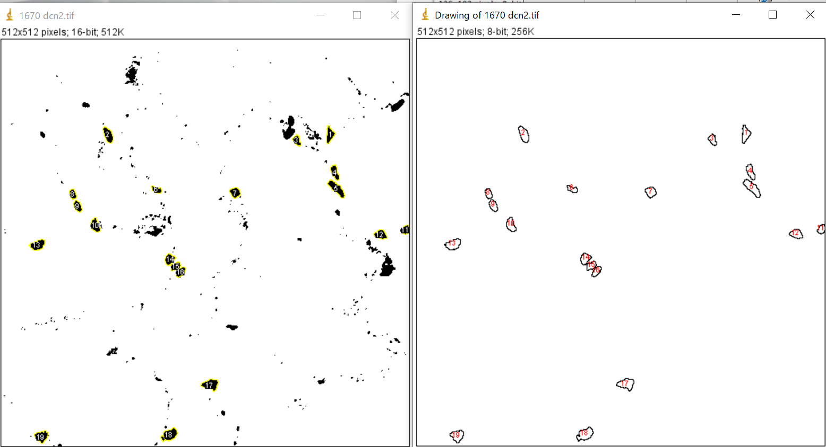
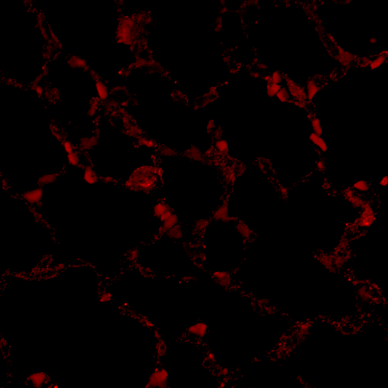
20 μm
a
b

The number of decorin-positive cells in the alveolar interstitium was measured using Image J. Lung paraffin sections immunostained with anti-decorin-Alexa546 were observed with a confocal microscope, and the acquired images (a) were converted to 16 bit by Image J. After binarization, the size was set to 70-350 pixel² (4.5-22.6 μm²) and the circularity was set to (0.5-1.0), and the number of extracted objects was counted (b).

Online resource 3 Large view of Figure 5 (picrosirius red staining images).
Bar is 10 mm.
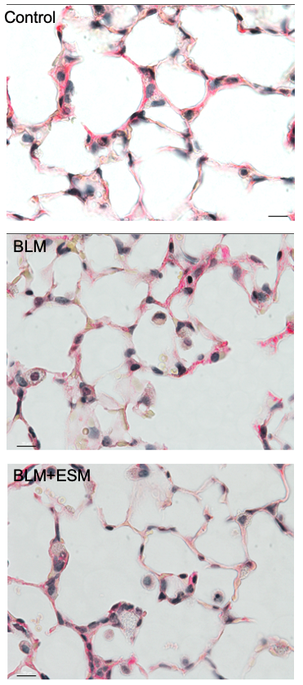

Online resource 4. Alveolar staining of decorin (a, c) and Col4 (basement membrane) (b, d).
(e) Illustration of cells and basement membrane in alveolar area.
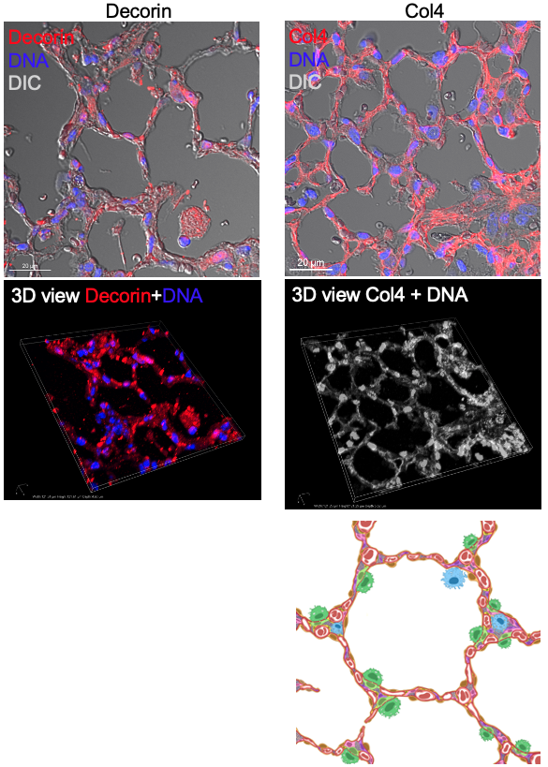
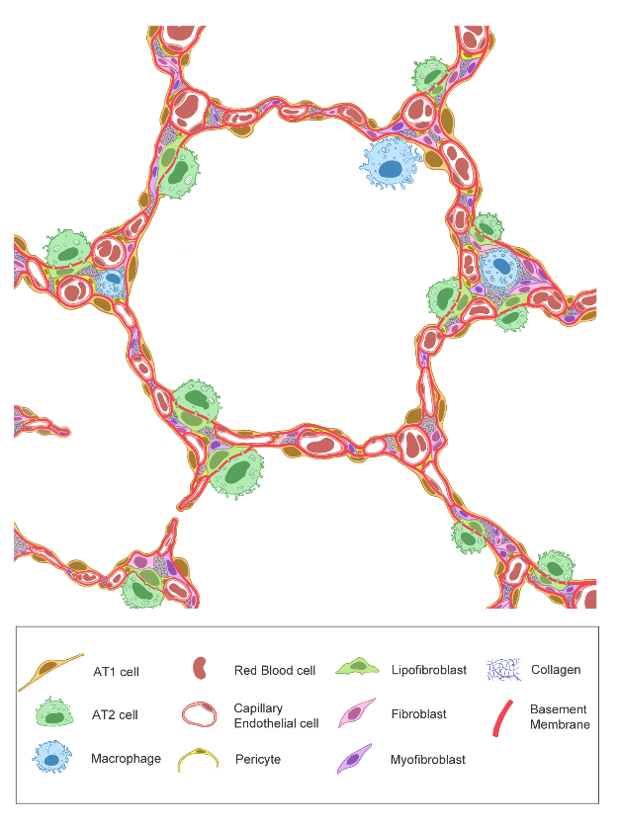
c
b
a
d
Basement
membrane
e

Online resource 5 Quantification of fluorescence intensity of type III collagen-stained area around bronchi in lung tissue sections

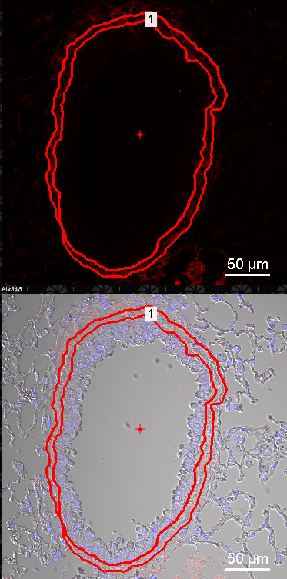

Interstitial fluorescence of type III collagen-Alexa546 around bronchioles (size: about 200 µm in diameter/ µm²) was obtained from two bronchioles per individual using a Nikon A1 RMP equipped with NIS-Elements software

