Table S1. Primers used in this study

Primer | Accession No. | Sequence (5'-3') | Amplicon  size (bp)
tlr4-F | AY388400.1 | ACAGATCACCTGGACAGCAAGA | 153
tlr4-R | AY388400.1 | CGGCTTGAAAGTCCCGCAT | 153
myd88-F | DQ100359.1 | GGGACTGACACCTGAGACCTT | 176
myd88-R | DQ100359.1 | CGATAAGCTCACTGGCGATGG | 176
nfκb-F | DQ066717 | AAGGAATCATGGCTGGCGAG | 156
nfκb-R | DQ066717 | GTAAGCAAGGCCCATCAACTGC | 156
il1β-F | BC098597 | CGGCAGCTCCATAAACACCTTC | 108
il1β-R | BC098597 | CGCTCGGTGTCTTTCCTGT | 108
il6-F | NM_001261449 | CAGCTGCAGGTGAGAGACG | 132
il6-R | NM_001261449 | GCAGGCGTCGATCATCACG | 132
tnfα-F | AY427649.1 | GCTTTTCTGAATCCTACGGAGGC | 155
tnfα-R | AY427649.1 | CGTGTCTGTGCCCAGTCTG | 155
sod1-F | NM_131294.1 | AGACCTGGGTAATGTGACCGC | 145
sod1-R | NM_131294.1 | GCCACCCTTCCCCAAGT | 145
sod2-F | NM_199976.1 | TGCAGAGTCGGATATGTTCGGAG | 123
sod2-R | NM_199976.1 | GTGAGGCTCAAGTGCACCAT | 123
hsp90-F | L35587.1 | CCAAACTGGACAGCGGCAA | 106
hsp90-R | L35587.1 | AGATCGGCTTTGGTCATCCCA | 106
cat-F | NM_130912.2 | GATCGCTGTCCGCTTTTCCA | 105
cat-R | NM_130912.2 | CAGTTGCCCTCATCGGTGT | 105
gpx-F | AY216589.1 | TGGCGTCGCTTTGAGGC | 121
gpx-R | AY216589.1 | TCCTGGTGCCCGAACTG | 121
muc2.2-F | XM 002667543 | ACACGCTCAAGTAATCGCACAGTC | 137
muc2.2-R | XM 002667543 | TCAGCGAGTGTTTGGCTCACTT | 137
mmp9-F | NM 213123.1 | CCAACATTAAAGATGCCCTGATGTATCCC | 146
mmp9-R | NM 213123.1 | AGTGGTGGTCCGTGGTTGA | 146
β-def-1-F | NM 001081553.1 | TGTCCTTGTCGTACTAGCATTGCAC | 100
β-def-1-R | NM 001081553.1 | ACACACTCCTTGTCTGCAAACACC | 100
β-actin-F | AF057040.1 | AGGCTCCCCTGAATCCCAAA | 160
β-actin-R | AF057040.1 | GTCACACCATCACCAGAGTCC | 160

Table S2. Relative abundance of zebrafish gut microbiome in phylum level

Phylum^{a)} | Relative abundance (%)
Phylum^{a)} | Ctrl. | Otc | Smx/Tmp | Ery
Fusobacteria | 57.11±2.6 | 55.72±4.3 | 52.09±6.4 | 52.83±4.6
Proteobacteria | 18.89±2.5 | 22.02±2.7 | 27.77±10.5 | 36.02±3.7
Firmicutes | 13.26±1.5 | 11.91±2.1 | 13.78±5.7 | 5.01±2.3
Bacteroidetes | 10.25±0.9 | 8.28±3.5 | 5.61±1.6 | 5.55±2.8
Actinobacteria | 0.36±0.1 | 1.63±1.2 | 0.40±0.3 | 0.10±0.0
Planctomycetes | 0.02±0.0 | 0.13±0.1 | 0.16±0.1 | 0.19±0.1
Verrucomicrobia | 0.01±0.0 | 0.08±0.1 | 0.12±0.0 | 0.25±0.2
Tenericutes | 0.09±0.1 | 0.22±0.4 | 0.02±0.0 | 0.001±0.0
Chlamydiae | 0.00±0.0 | 0.001±0.0 | 0.03±0.0 | 0.03±0.0
Armatimonadetes | 0.00±0.0 | 0.00±0.0 | 0.02±0.0 | 0.00±0.0
Deinococcus-Thermus | 0.003±0.0 | 0.00±0.0 | 0.006±0.0 | 0.00±0.0
Acidobacteria | 0.00±0.0 | 0.001±0.0 | 0.002±0.0 | 0.002±0.0
Spirochaetes | 0.00±0.0 | 0.00±0.0 | 0.005±0.0 | 0.00±0.0
Cyanobacteria | 0.00±0.0 | 0.00±0.0 | 0.00±0.0 | 0.004±0.0
Other | 0.00±0.0 | 0.00±0.0 | 0.00±0.0 | 0.007±0.0
^{a)} Values are presented ad means±SD.

Table S3. Relative abundance of zebrafish gut microbiome in species level

Species^{a)} | Relative abundance (%)
Species^{a)} | Ctrl. | Otc | Smx/Tmp | Ery
Cetobacterium somerae | 57.10±2.6 | 55.72±4.3 | 52.08±6.4 | 52.83±4.6
Aeromonas veronii | 10.06±0.6 | 10.02±3.3 | 9.24±1.5 | 25.57±1.4
KM585593 | 9.47±1.0 | 9.23±2.1 | 9.10±4.6 | 3.41±1.6
Cellvibrio fibrivorans | 1.27±0.8 | 1.23±0.3 | 9.63±9.1 | 2.65±3.3
Shewanella xiamenensis | 2.75±0.5 | 4.25±2.1 | 3.88±0.4 | 0.66±0.2
KM585593_g_uc^{b)} | 3.61±0.3 | 2.04±0.9 | 3.74±2.0 | 1.44±0.7
Bacteroides_uc | 4.36±3.6 | 2.46±1.5 | 1.28±0.6 | 0.06±0.0
Bacteroidaceae_uc | 3.75±2.1 | 0.72±0.6 | 0.30±0.1 | 0.01±0.0
Flavobacterium ginsenosidimutans | 0.07±0.0 | 0.24±0.2 | 0.03±0.0 | 3.30±1.8
Flavobacterium granuli | 0.18±0.0 | 2.13±2.2 | 0.30±0.2 | 0.41±0.2
GQ360021_g_uc | 1.55±0.7 | 0.75±0.2 | 0.56±0.2 | 0.02±0.0
Gemmobacter fontiphilus | 0.75±0.4 | 0.65±0.5 | 0.56±0.2 | 0.72±0.4
Rhodobacteraceae_uc | 0.02±0.0 | 2.13±1.7 | 0.25±0.2 | 0.25±0.3
Flavobacterium succinicans | 0.05±0.0 | 0.73±0.9 | 1.13±0.8 | 0.66±0.5
Aeromonas caviae | 1.60±0.3 | 0.01±0.0 | 0.00±0.0 | 0.004±0.0
Flavobacterium cutihirudinis | 0.002±0.0 | 0.01±0.0 | 1.44±0.8 | 0.01±0.0
Rhodococcus erythropolis | 0.01±0.0 | 1.39±1.1 | 0.01±0.0 | 0.00±0.0
Rhizobium arenae | 0.11±0.1 | 0.003±0.0 | 0.003±0.0 | 1.28±0.2
Kinneretia asaccharophila | 0.96±0.4 | 0.01±0.0 | 0.29±0.1 | 0.03±0.0
Plesiomonas shigelloides | 0.002±0.0 | 0.07±0.1 | 0.06±0.1 | 0.90±1.5
Flavobacterium notoginsengisoli | 0.16±0.1 | 0.37±0.2 | 0.003±0.0 | 0.35±0.3
Hyphomicrobium_uc | 0.002±0.0 | 0.35±0.2 | 0.042±0.3 | 0.08±0.0
EU234324 | 0.001±0.0 | 0.35±0.2 | 0.25±0.1 | 0.19±0.1
Pseudomonas alcaligenes | 0.002±0.0 | 0.00±0.0 | 0.00±0.0 | 0.77±0.6
Bacteroides vulgatus | 0.02±0.0 | 0.61±1.0 | 0.08±0.1 | 0.05±0.0
^{a)} Values are presented as means±SD.
^{b)} ‘uc’ means unclassified.

Table S4. Number of goblet cells per villus

Number of goblet cells (n = 10)^{a)} |  |  |  | p value^{b)}
Ctrl. | Otc | Smx/Tmp | Ery | Ctrl.-Otc | Ctrl.-Smx/Tmp | Ctrl.-Ery
2.5±1.3 | 3.9±1.9 | 5.6±2.3 | 4.9±1.6 | 0.0696 | 0.0016 | 0.0016
^{a)} Values are presented as means±SD.
^{b)} Significance was determined by t-test.

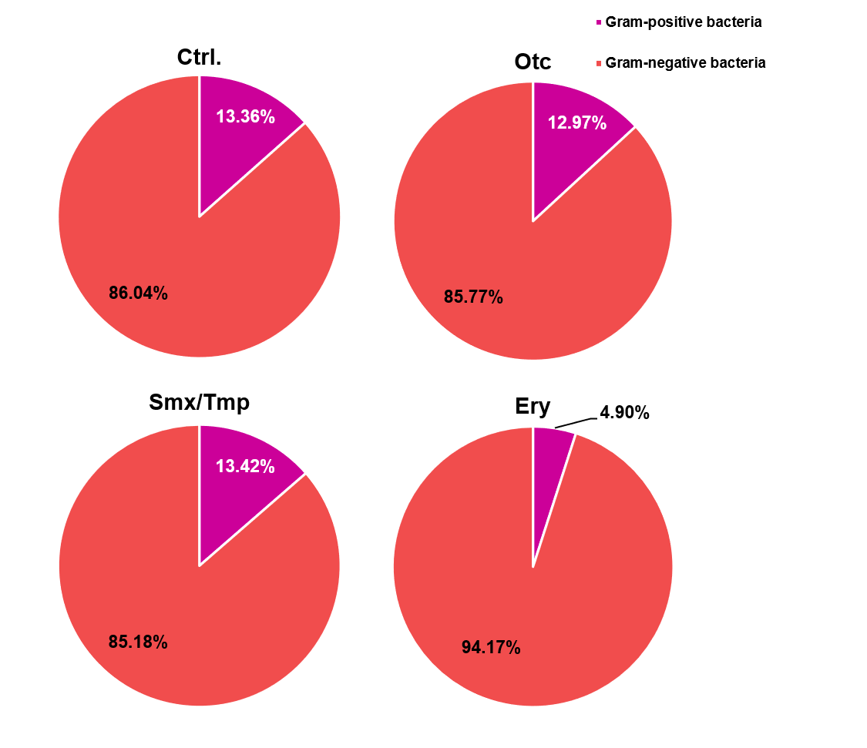
Figure S1. Relative abundance of Gram-positive bacteria and Gram-negative bacteria in zebrafish gut microbiome.

