Supplementary Information
Table S1: Summary of selected (‘delta’, ‘minimum’ and ‘maximum’) cox regression models (concordance=0.69, 0.79 and 0.84 respectively)
 | coef | Exp(coef) | Se(coef) | Chisq | DF | P
‘delta’
Delta temperature | -0.04 | 0.05 | 0.05 | 0.65 | 1 | 0.42
Delta halophila N | 0.11 | 0.06 | 0.06 | 4.11 | 1 | 0.04
Delta temperature*delta halophila N | 0.12 | 0.03 | 0.03 | 11.96 | 1 | <0.001
Frailty(id) |  |  |  | 22.17 | 15.4 | 0.12
Minimum
Minimum Secchi depth | -0.40 | 0.09 | 0.08 | 19.95 | 1 | <0.001
Minimum zostera N | 0.27 | .008 | 0.07 | 12.56 | 1 | <0.001
Minimum depth | -0.60 | 0.07 | 0.07 | 64.51 | 1 | <0.001
Minimum significant wave height | 0.47 | 0.08 | 0.07 | 32.68 | 1 | <0.001
Minimum tide height | 0.36 | 0.08 | 0.08 | 20.73 | 1 | <0.001
Frailty(id) |  |  |  | 63.23 |  | <0.001
Maximum
Maximum Secchi depth | 0.48 | 0.08 | 0.07 | 33.60 | 1 | <0.001
Maximum depth | 0.44 | 0.10 | 0.09 | 21.02 | 1 | <0.001
Maximum significant wave height | -0.27 | 0.07 | 0.07 | 13.24 | 1 | <0.001
Maximum tide height | -0.34 | 0.07 | 0.07 | 22.41 | 1 | <0.001
Maximum depth*maximum tide height | 0.15 | 0.09 | 0.09 | 2.45 | 1 | 0.11
Frailty(id) |  |  |  | 63.04 | 28.5 | <0.001

Table S2: Results of mixed effects linear regression model to assess the influence of change in Secchi depth, change in depth and delta temperature on the probability of a turtle transitioning from ARS to non-ARS compared to non-ARS to ARS. Turtle id was included as a random effect.
 | Estimate | SE | z | P
Intercept | -0.01 | 0.08 | -0.07 | 0.95
Change in Secchi depth | 0.45 | 0.21 | 2.10 | 0.04
Change in halophila N | 0.19 | 0.21 | 0.92 | 0.36
Change in depth | 0.52 | 0.19 | 2.84 | <0.01
Delta temperature | -0.69 | 0.19 | -3.70 | <0.001

Table S3: results of F-tests performed separately on each covariate comparing the variance in that covariate at ARS to non-ARS, and non-ARS to ARS transition points. Random effects were ignored
Covariate | F | Df1, df2 | p
Change in temp | 0.77 | 290,291 | 0.03
Change in Secchi depth | 0.55 | 290,291 | <0.0001
Change in salinity | 0.48 | 290,291 | <0.0001
Change in zostera N | 0.42 | 290,291 | <0.0001
Change in depth | 0.73 | 290,291 | <0.0001
Change in wave height | 1.05 | 290,291 | 0.66
Change in halophila N | 0.52 | 290,291 | <0.0001
Change in deep seagrass N | 0.55 | 290,281 | <0.0001
Change in chla | 0.60 | 290,291 | <0.0001
Delta temperature | 0.34 | 290,291 | <0.0001
Delta Secchi depth | 0.44 | 290,291 | <0.0001
Delta salinity | 0.31 | 290,291 | <0.0001
Delta zostera N | 0.25 | 290,291 | <0.0001
Delta depth | 0.18 | 290,291 | <0.0001
Delta wave height | 0.61 | 290,291 | <0.0001
Delta halophila N | 0.25 | 290,291 | <0.0001
Delta deep seagrass N | 0.24 | 290,281 | <0.0001
Delta chla | 0.72 | 290,291 | <0.01

Table S4: Results of generalised linear mixed effects model to compare the probability of ARS-non-ARS and non-ARS-ARS across time of day and tidal phase. Results are shown in comparison to the reference categories ‘sunrise’ and ‘high tide’
 | Estimate | SE | z | P
Intercept | 0.67 | 0.32 | 2.05 | 0.04
Daylight | -1.08 | 0.28 | -3.77 | <0.01
Sunset | -0.87 | 0.39 | -2.24 | <0.03
Night | -0.41 | 0.29 | -1.44 | 0.15
Low tide | 0.13 | 0.28 | 0.47 | 0.64
Outgoing tide | 0.02 | 0.25 | 0.09 | 0.92
Incoming tide | -0.00 | 0.25 | -0.01 | 0.99

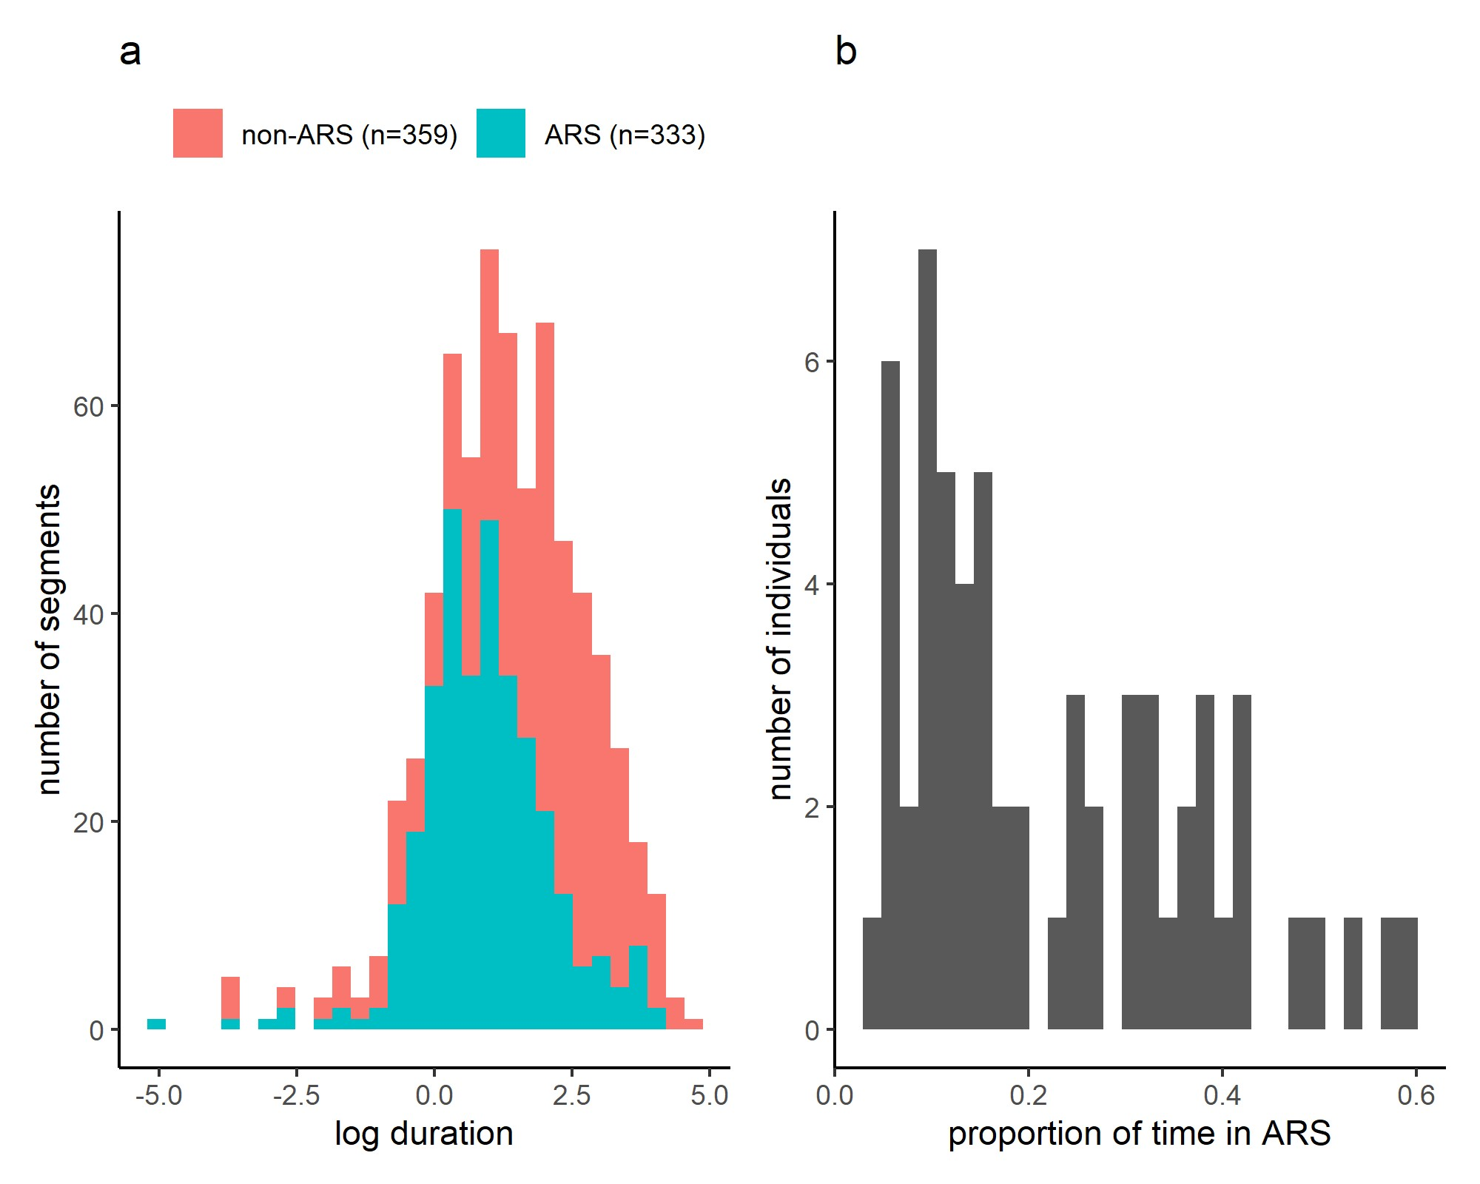
Fig S1 a frequency distribution of durations of ARS and non-ARS segments as determined by track partitioning, b frequency distribution of the proportion of the total track of individuals classified as ARS according to the track partitioning.

