Supplemental Material

Choice of spatial accessibility measure
There are various measures for evaluating spatial accessibility. Different measures have been used in previous studies to evaluate accessibility to pharmacies, such as distance to the nearest pharmacy¹, presence of pharmacies within a certain radius ², and the two-step ﬂoating catchment area (2SFCA) method ³.

Different types of measures capture different dimensions of how easy it is to reach services. A simple accessibility indicator is the shortest distance or travel time to the nearest (or the m^{th} nearest) potential service provider. This is most useful when the proximity of services is the primary concern. It is also straightforward and does not require additional data to calibrate the parameters. Another type of accessibility indicator measures the cumulative opportunities reachable from a location, including the presence of the number of opportunities reachable within a certain threshold by radius d or travel time t, and gravity indicators that capture the attractiveness of opportunities weighted by distance impedance ⁴. Such indicators require additional information from the study area (typically travel data) to determine parameters such as the threshold radius d or the distance decay function ⁵. Since people living in different places have different travel patterns, the parameters determined are specific to the study area. Furthermore, since some services are competitive, such as physicians or hospital beds, accessibility indicators such as the two-step ﬂoating catchment area (2SFCA) method were developed to account for the ratio of the supply of services and the demand by the population within a typical threshold of travel time ⁶. To minimize the healthcare-demand overestimation problem in 2SFCA method, a three-step ﬂoating catchment area (3SFCA) method was also developed ⁷.

In our study, there were a few considerations in choosing the shortest distance measure for spatial accessibility. First, this measure is easy to interpret. It does not require parameter inputs that are typically calibrated from travel data, is directly comparable across different places, and reflects the nature of pharmaceutical service utilization – a tendency to use nearby pharmacies (at least in most cases). Second, access as the shortest distance is easy to interpret when compared with travel outcomes, such as one-way trip distance. We computed 3SFCA access and compared it with access by shortest distance and actual trip distance and found that shortest distance is also the best predictor of actual trip distance. Third, measures that capture the competition for services from the population (e.g., ratio of supply and demand and the two-step ﬂoating catchment area method) are typically applied to scarce resources such as primary care physicians, whose time for appointments are limited, or hospital beds. While some of the pharmacy services (e.g., consultation or appointments for covid testing or vaccination) could be considered limited in the number of customers served, some other services (e.g., purchases of OTC drugs and medical devices) are not competitive. Measures that consider competition or not emphasize different dimensions of access to pharmacies. Our study looks at the general availability of pharmacies to local communities, and competition is not a major concern in this work. Thus, we chose not to go with this type of access measure.

Who visited pharmacies?

Out of 997 respondents, 278 (27.9%) reported making at least one pharmacy trip in a typical week (including trips without destination addresses reported). Low-density Suburbs had the highest percentage of respondents who used pharmacies (37.8%), while High-density Suburbs had the lowest percentage (19.9%) (Figure 4).

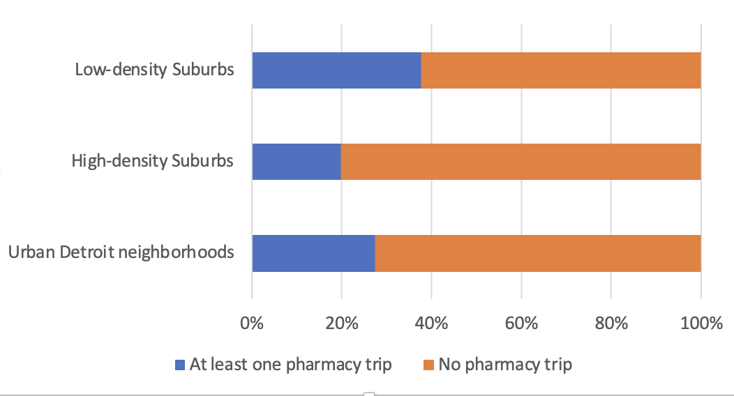

Fig. S1 The percentage of respondents who reported pharmacy trips, by neighborhood type
Logistic regression was performed to evaluate factors that impact the likelihood of making any trip to a pharmacy (including reported pharmacy trips without verified destination information). Three types of predictors were included – accessibility to pharmacies (all types of pharmacies considered), neighborhood type, and individual-level sociodemographic variables.

The logistic regression results on the likelihood of making any trip to a pharmacy (Table S1) showed that, first, the likelihood of visiting pharmacies was influenced by the spatial accessibility to pharmacies, as measured by the distance to the nearest pharmacy of any type. This suggested that when they had a pharmacy near home, people were more likely to use pharmaceutical services. It could be considered as an exposure effect to pharmacies. For a one-mile reduction in the distance to the nearest pharmacy, the likelihood of a resident to visit a pharmacy increased by 2.4 times (1/e^{-0.87}).

Second, the likelihood of using pharmacies varied significantly across neighborhood types. Residents in the High-density Suburbs were the least likely to use a pharmacy, even after controlling for accessibility and individual-level sociodemographic characteristics. The odds of visiting at least one pharmacy in a typical week was 2.7 times (e^{0.986}) higher for residents in the Low-density Suburbs than residents in the High-density Suburbs. A possible explanation of this difference is that residents in the High-density Suburbs are in better health than the residents from the other neighborhoods. This was suggested by their healthier lifestyles (lowest BMI values, most trips for physical activities and least visits to fast foods) compared to residents in other neighborhoods, as reported in the survey.

It is worth noting that, while Urban Detroit residents likely had the least favorable health conditions – given the highest BMI values, the most fast-food restaurant trips, and the least trips for physical activities on average – they were no more likely to visit pharmacies than residents in the High-density Suburbs, even after controlling for individual-level factors of age, gender, income and car ownership. This suggests that the demands for pharmaceutical services may be suppressed in Urban Detroit neighborhoods with a high concentration of lower-income African Americans. Residents in segregated and disadvantaged minority communities face various barriers to access health care, including a lower density of health care providers, lack of health insurance coverage, inadequate access to medical information through social networks, and cultural norms and values that discourage people from utilizing health care services ⁸.

Third, age and gender affected whether a respondent visited a pharmacy. The odds of visiting pharmacies versus visiting no pharmacy at all in a typical week was 1.1 (e^{0.013*10}) times higher for every ten-year increase in age, and 1.9 (e^{0.644}) times higher for women than men. This reflects, in part, a greater need for medications by seniors and women. Additional analysis that controlled for household size, presence of children under 18, and marital status indicated that gender was significant and independent from household structure (results not shown). This was expected because women tend to utilize significantly more services and spend more on health care than men ⁹. However, when controlling for the residential environment (neighborhood type) and accessibility, neither income, race, nor car access of an individual affected the likelihood of visiting pharmacies.

Table S1. Logistic regression of the likelihood of visiting a pharmacy in a typical week
 | Coefficient | SE | p-value
Intercept | -1.882 | 0.396 | 0.001 | ***
Spatial accessibility | -0.870 | 0.243 | 0.000 | ***
Neighborhood type
High-density Suburbs (reference)
Urban Detroit neighborhoods | 0.608 | 0.433 | 0.161
Low-density Suburbs | 0.986 | 0.197 | 0.000 | ***
Age | 0.013 | 0.005 | 0.021 | *
Female | 0.644 | 0.186 | 0.001 | ***
Race
white (reference)
black | -0.230 | 0.404 | 0.568
other | 0.030 | 0.379 | 0.937
Household income
>50k (reference)
0~20k | 0.360 | 0.294 | 0.220
20~50k | 0.205 | 0.243 | 0.398
Car ownership
no car | -0.204 | 0.355 | 0.566
Efron's R2 = 0.071
N = 784 respondents
Note: Spatial accessibility was measured as the distance to the nearest pharmacy of any type

About log transformation of trip distance for OLS regression
One-way trip distances to pharmacies were not log-transformed in the OLS regressions shown in Figures 9-10, despite that the error terms were not normally distributed. This showed the relationship between trip distance and access intuitively. Access maintained a similarly significant effect on log-transformed trip distances, with much higher R2 values. Therefore, the results with log-transformed trip distances were not reported.

References
1. Pednekar P, Peterson A. Mapping pharmacy deserts and determining accessibility to community pharmacy services for elderly enrolled in a State Pharmaceutical Assistance Program. PLoS One. 2018;13(6):1-19. doi:10.1371/journal.pone.0198173
2. Qato DM, Daviglus ML, Wilder J, Lee T, Qato D, Lambert B. “Pharmacy deserts” are prevalent in chicago’s predominantly minority communities, raising medication access concerns. Health Aff. 2014;33(11):1958-1965. doi:10.1377/hlthaff.2013.1397
3. Ikram SZ, Hu Y, Wang F. Disparities in Spatial Accessibility of Pharmacies in Baton Rouge, Louisiana. Geogr Rev. 2015;105(4):492-510. doi:10.1111/j.1931-0846.2015.12087.x
4. Miller EJ. Accessibility: measurement and application in transportation planning. Transp Rev. 2018;38(5):551-555. doi:10.1080/01441647.2018.1492778
5. Páez A, Scott DM, Morency C. Measuring accessibility: Positive and normative implementations of various accessibility indicators. J Transp Geogr. 2012;25:141-153. doi:10.1016/j.jtrangeo.2012.03.016
6. Wang F. Measurement, Optimization, and Impact of Health Care Accessibility: A Methodological Review. Annals of the Association of American Geographers. 2012;102(5):1104-1112. doi:10.1080/00045608.2012.657146
7. Wan N, Zou B, Sternberg T. A three-step floating catchment area method for analyzing spatial access to health services. International Journal of Geographical Information Science. 2012;26(6):1073-1089. doi:10.1080/13658816.2011.624987
8. Gaskin DJ, Dinwiddie GY, Chan KS, McCleary R. Residential segregation and disparities in health care services utilization. Medical Care Research and Review. 2012;69(2):158-175. doi:10.1177/1077558711420263
9. Owens GM. Gender differences in health care expenditures, resource utilization, and quality of care. Journal of Managed Care Pharmacy. 2008;14(3 SUPPL.):2-6. doi:10.18553/jmcp.2008.14.s3-a.2

