Legends of Additional material
Additional material 1: File 1. Dataset with the unique sequences of Pfs47 and P47Rec downloaded from GenBank.
https://unahedu-my.sharepoint.com/:u:/r/personal/aortizm_unah_edu_hn/Documents/PLASMODIUM-ANOPHELES/Figuras%20para%20el%20paper/FIGURAS%20EDITADAS%20Y%20MATERIAL%20SUPLEMENTARIO/Suppl_Mat_1_Data_Sets_Pfs47_and_P47.fasta?csf=1&web=1&e=GZFTH1
Additional material 1: File 2. Results of motif analysis in MEME of Pfs47.
https://unahedu-my.sharepoint.com/:t:/r/personal/aortizm_unah_edu_hn/Documents/PLASMODIUM-ANOPHELES/Figuras%20para%20el%20paper/FIGURAS%20EDITADAS%20Y%20MATERIAL%20SUPLEMENTARIO/Suppl_Mat_2_Pfs47_motifs.text?csf=1&web=1&e=NFw2oA
Additional material 3: File 3. Results of motif analysis in MEME of P47Rec.
https://unahedu-my.sharepoint.com/:t:/r/personal/aortizm_unah_edu_hn/Documents/PLASMODIUM-ANOPHELES/Figuras%20para%20el%20paper/FIGURAS%20EDITADAS%20Y%20MATERIAL%20SUPLEMENTARIO/Suppl_Mat_3_P47_motifs.txt?csf=1&web=1&e=Pcbu6H
Additional material 4: PDB files with the individual structures of Pfs47 and P47Rec. Molecular Docking and summary table of the best molecular docking.

(https://unahedu-my.sharepoint.com/:f:/g/personal/aortizm_unah_edu_hn/EqbaKNoXTV1Il1uBa7iQymMBzaEQkjJPxK5r65km9nbmYA?e=bTVB0a

Additional Table: Summary of the most relevant statistical data of the molecular docking of Pfs47-P47Rec with the best interaction scores

Receptor | Ligand | Best model | Best model RMSD | Best model Score | 35-40 Å Models | 30-35 Å Models | <30 Å Models | RMSD Aver. 35-40 Å | RMSD Aver. 30-35 Å | RMSD Aver. <30 Å | Best models RMSD Aver.
3D7 | An. albimanus | 79 | 28.27 | -228.11 | 4 | 2 | 1 | 38.35 | 33.05 | 28.27 | 35.4
3D7 | An. arabiensis | 35 | 31.32 | -240.68 | 9 | 3 | 0 | 36.78 | 32.1 | 0 | 35.66
3D7 | An. atroparvus | 65 | 29.39 | -236.53 | 7 | 4 | 1 | 37.83 | 32.66 | 29.39 | 35.4
3D7 | An. culicifacies | 70 | 33.56 | -233.08 | 12 | 1 | 0 | 37.67 | 33.56 | 0 | 37.35
3D7 | An. darlingi_HN | 73 | 30.28 | -225.14 | 13 | 4 | 0 | 37.42 | 31.8 | 0 | 36
3D7 | An. darlingi_SA | 28 | 30.28 | -251.28 | 5 | 5 | 0 | 37.03 | 31.85 | 0 | 34.42
3D7 | An. dirus | 88 | 29.08 | -227.99 | 7 | 3 | 1 | 37.62 | 33.62 | 29.08 | 35.75
3D7 | An. farauti | 81 | 31.44 | -229.37 | 4 | 3 | 0 | 37.81 | 32.93 | 0 | 35.72
3D7 | An. funestus | 15 | 30.84 | -258.61 | 9 | 3 | 0 | 37.05 | 31.77 | 0 | 35.73
3D7 | An. gambiae | 35 | 31.39 | -241.55 | 6 | 3 | 0 | 37.6 | 31.91 | 0 | 35.7
3D7 | An. merus | 37 | 28.52 | 3245.6 | 7 | 3 | 0 | 38.29 | 31.98 | 0 | 36.4
3D7 | An. minimus | 30 | 28.6 | -250.06 | 9 | 3 | 0 | 37.97 | 31.97 | 0 | 36.47
3D7 | An. sinensis | 76 | 28.3 | -234.14 | 7 | 4 | 1 | 36.77 | 32.16 | 28.3 | 34.53
3D7 | An. stephensi | 97 | 32.47 | -224.71 | 8 | 2 | 0 | 38.1 | 33.12 | 0 | 37.1
7G8 | An. albimanus | 83 | 32.16 | -226.95 | 6 | 1 | 0 | 37.77 | 32.16 | 0 | 36.97
7G8 | An. arabiensis | 52 | 29.24 | -236.68 | 5 | 1 | 1 | 36.24 | 33.04 | 29.24 | 34.78
7G8 | An. atroparvus | 80 | 29.13 | -233.4 | 9 | 2 | 1 | 38.09 | 33.07 | 29.13 | 36.51
7G8 | An. culicifacies | 80 | 35.25 | -227.17 | 9 | 0 | 0 | 37.05 | 0 | 0 | 37.05
7G8 | An. darlingi_HN | 61 | 32.4 | -238.15 | 5 | 2 | 0 | 38.42 | 32.92 | 0 | 36.85
7G8 | An. darlingi_SA | 18 | 32.29 | -261.44 | 2 | 3 | 0 | 38.57 | 33.03 | 0 | 35.25
7G8 | An. dirus | 72 | 30.51 | -233.91 | 7 | 2 | 0 | 38 | 32.47 | 0 | 36.77
7G8 | An. farauti | 23 | 33.28 | -256.28 | 5 | 2 | 0 | 36.87 | 33.93 | 0 | 36.07
7G8 | An. funestus | 10 | 28.72 | -261.13 | 5 | 5 | 1 | 36.99 | 31.88 | 28.72 | 33.91
7G8 | An. gambiae | 34 | 31.14 | -245.14 | 4 | 3 | 0 | 37.63 | 32.66 | 0 | 35.5
7G8 | An. merus | 47 | 35.64 | -242.21 | 6 | 0 | 0 | 37.62 | 0 | 0 | 37.62
7G8 | An. minimus | 74 | 31.74 | -232.98 | 7 | 1 | 0 | 37.62 | 31.74 | 0 | 36.89
7G8 | An. sinensis | 34 | 31.96 | -258.9 | 5 | 5 | 0 | 37.45 | 32.7 | 0 | 35.07
7G8 | An. stephensi | 75 | 33.89 | -232.08 | 3 | 1 | 0 | 36.69 | 33.89 | 0 | 35.99
HB3 | An. albimanus | 78 | 32.08 | -232.1 | 7 | 2 | 0 | 38.17 | 32.51 | 0 | 36.91
HB3 | An. arabiensis | 95 | 31.24 | -226.43 | 3 | 4 | 0 | 36.77 | 32.93 | 0 | 34.58
HB3 | An. atroparvus | 14 | 32.65 | -263.45 | 11 | 4 | 0 | 37.67 | 33.87 | 0 | 36.66
HB3 | An. culicifacies | 72 | 34.96 | -229.87 | 5 | 1 | 0 | 37.19 | 34.96 | 0 | 36.82
HB3 | An. darlingi_HN | 47 | 33.04 | -245.27 | 5 | 1 | 0 | 38.02 | 33.04 | 0 | 37.19
HB3 | An. darlingi_SA | 41 | 32.29 | -251.12 | 3 | 3 | 0 | 38.19 | 32.78 | 0 | 35.49
HB3 | An. dirus | 95 | 30.49 | -230.79 | 3 | 1 | 0 | 38.35 | 30.49 | 0 | 36.39
HB3 | An. farauti | 27 | 35.27 | -257.13 | 4 | 0 | 0 | 35.76 | 0 | 0 | 35.76
HB3 | An. funestus | 88 | 31.72 | -229.49 | 5 | 5 | 0 | 37.72 | 32.95 | 0 | 35.34
HB3 | An. gambiae | 61 | 31.52 | -231.84 | 5 | 4 | 0 | 37.32 | 33.12 | 0 | 35.45
HB3 | An. merus | 75 | 31.44 | -235.19 | 5 | 1 | 0 | 37.94 | 31.44 | 0 | 36.86
HB3 | An. minimus | 75 | 31.87 | -234.47 | 5 | 1 | 0 | 37.8 | 31.87 | 0 | 36.82
HB3 | An. sinensis | 79 | 30.41 | -325.04 | 6 | 6 | 0 | 37.21 | 32.01 | 0 | 34.61
HB3 | An. stephensi | 43 | 34.97 | -247.35 | 4 | 1 | 0 | 38.16 | 34.97 | 0 | 37.52
Palo_Alto | An. albimanus | 17 | 31.26 | -249.46 | 5 | 2 | 0 | 38.08 | 31.29 | 0 | 36.14
Palo_Alto | An. arabiensis | 70 | 29.03 | -225.94 | 5 | 4 | 0 | 37.78 | 31.96 | 0 | 35.19
Palo_Alto | An. atroparvus | 79 | 29.79 | -227.5 | 4 | 4 | 0 | 37.73 | 32.41 | 0 | 35.07
Palo_Alto | An. culicifacies | 46 | 34.2 | -236.54 | 6 | 2 | 0 | 37.7 | 34.57 | 0 | 36.92
Palo_Alto | An. darlingi_HN | 10 | 34.28 | -275.56 | 5 | 2 | 0 | 37.37 | 34.54 | 0 | 36.56
Palo_Alto | An. darlingi_SA | 23 | 29.95 | -266.05 | 3 | 3 | 0 | 38.18 | 32.55 | 0 | 35.36
Palo_Alto | An. dirus | 48 | 33.07 | -240.29 | 8 | 2 | 0 | 38.15 | 34 | 0 | 37.32
Palo_Alto | An. farauti | 62 | 34.35 | -236.11 | 6 | 2 | 0 | 32.22 | 34.6 | 0 | 32.81
Palo_Alto | An. funestus | 42 | 30.48 | -239.39 | 3 | 3 | 0 | 37.82 | 30.78 | 0 | 34.3
Palo_Alto | An. gambie | 6 | 32.61 | -277.8 | 3 | 1 | 0 | 35.65 | 32.61 | 0 | 34.89
Palo_Alto | An. merus | 49 | 27.49 | -238.04 | 6 | 1 | 0 | 37.09 | 27.49 | 0 | 35.72
Palo_Alto | An. minimus | 35 | 27.28 | -245.39 | 5 | 2 | 0 | 37.69 | 31.14 | 0 | 35.81
Palo_Alto | An. sinensis | 35 | 30.73 | -252.62 | 5 | 6 | 0 | 36.93 | 33.06 | 0 | 34.82
Palo_Alto | An. stephensi | 32 | 32.24 | -248.18 | 3 | 2 | 0 | 36.92 | 33.04 | 0 | 35.37
RO33 | An. albimanus | 50 | 31.78 | -236.98 | 4 | 5 | 0 | 37.67 | 32.87 | 0 | 35
RO33 | An. arabiensis | 75 | 31.5 | -228.98 | 4 | 2 | 0 | 37.33 | 32.73 | 0 | 35.8
RO33 | An. atroparvus | 57 | 33.1 | -234.35 | 12 | 2 | 0 | 37.12 | 33.62 | 0 | 36.62
RO33 | An. culicifacies | 15 | 34.88 | -255.96 | 7 | 1 | 0 | 37.8 | 34.88 | 0 | 37.43
RO33 | An. darlingi_HN | 52 | 30.99 | -235.49 | 7 | 3 | 0 | 37.92 | 31.1 | 0 | 35.87
RO33 | An. darlingi_SA | 14 | 30.79 | -272.29 | 5 | 3 | 0 | 37.28 | 31.39 | 0 | 35.07
RO33 | An. dirus | 79 | 29.16 | -233.76 | 4 | 2 | 0 | 37.72 | 31.07 | 0 | 35.5
RO33 | An. farauti | 77 | 31.22 | -232.76 | 5 | 3 | 0 | 38.42 | 33.6 | 0 | 36.62
RO33 | An. funestus | 34 | 27.91 | -244.28 | 6 | 6 | 0 | 37.72 | 32.64 | 0 | 35.18
RO33 | An. gambiae | 36 | 30.7 | -241.49 | 6 | 4 | 0 | 37.33 | 32.76 | 0 | 35.5
RO33 | An. merus | 59 | 32 | -238.05 | 7 | 2 | 0 | 38.18 | 32.65 | 0 | 36.95
RO33 | An. minimus | 87 | 36.07 | -228.1 | 7 | 0 | 0 | 38.26 | 0 | 0 | 38.26
RO33 | An. sinensis | 19 | 31.38 | -262.18 | 6 | 6 | 0 | 36.85 | 32.87 | 0 | 34.86
RO33 | An. stephensi | 90 | 34.23 | -224.77 | 7 | 1 | 0 | 38.34 | 34.23 | 0 | 37.83
T9-102 | An. albimanus | 63 | 30.98 | -233.08 | 4 | 5 | 0 | 38.67 | 33.39 | 0 | 35.74
T9-102 | An. arabiensis | 100 | 29.83 | -223.32 | 0 | 2 | 1 | 0 | 32.07 | 29.83 | 31.32
T9-102 | An. atroparvus | 18 | 34.87 | -258.09 | 9 | 2 | 0 | 37.89 | 34.89 | 0 | 37.35
T9-102 | An. culicifacies | 66 | 35.02 | -232.29 | 4 | 0 | 0 | 36.8 | 0 | 0 | 36.8
T9-102 | An. darlingi_HN | 42 | 34.03 | -247.62 | 3 | 2 | 0 | 38.26 | 34.1 | 0 | 36.6
T9-102 | An. darlingi_SA | 35 | 33.5 | -254.87 | 4 | 2 | 0 | 37.62 | 33.79 | 0 | 36.34
T9-102 | An. dirus | 91 | 32.58 | -229 | 6 | 2 | 0 | 38.78 | 33.55 | 0 | 37.47
T9-102 | An. farauti | 63 | 30.64 | -238.23 | 4 | 1 | 0 | 37.79 | 32.58 | 0 | 36.36
T9-102 | An. funestus | 24 | 34.19 | -253.27 | 4 | 2 | 0 | 37.18 | 34.57 | 0 | 36.31
T9-102 | An. gambiae | 50 | 33.16 | -237.55 | 1 | 3 | 0 | 36.1 | 33.97 | 0 | 34.51
T9-102 | An. merus | 19 | 32.61 | -253.42 | 2 | 1 | 0 | 38.36 | 32.61 | 0 | 36.44
T9-102 | An. minimus | 34 | 37.16 | -244.81 | 4 | 0 | 0 | 38.57 | 0 | 0 | 38.57
T9-102 | An. sinensis | 75 | 31.98 | -238.45 | 6 | 4 | 0 | 37.7 | 33.67 | 0 | 36.09
T9-102 | An. stephensi | 53 | 32.93 | -233.72 | 3 | 1 | 0 | 37.94 | 32.93 | 0 | 36.69
3D7 | Consensus | 49 | 30.25 | -235.04 | 5 | 6 | 0 | 37.15 | 32.11 | 0 | 34.4
7G8 | Consensus | 1 | 30.85 | -320.29 | 1 | 2 | 0 | 36.49 | 31.53 | 0 | 33.18
HB3 | Consensus | 1 | 30.56 | -313.16 | 4 | 2 | 0 | 37.68 | 32.71 | 0 | 34.36
Palo_Alto | Consensus | 1 | 30.08 | -304.89 | 6 | 3 | 0 | 37.73 | 31.67 | 0 | 35.71
RO33 | Consensus | 1 | 31.47 | -306.56 | 7 | 5 | 0 | 38.04 | 33.06 | 0 | 35.96
T9-102 | Consensus | 52 | 31.96 | -236.39 | 2 | 2 | 0 | 36.03 | 32.11 | 0 | 34.07

Additional figure 1: Results generated by Jpred from the secondary structure alignment of Pfs47.
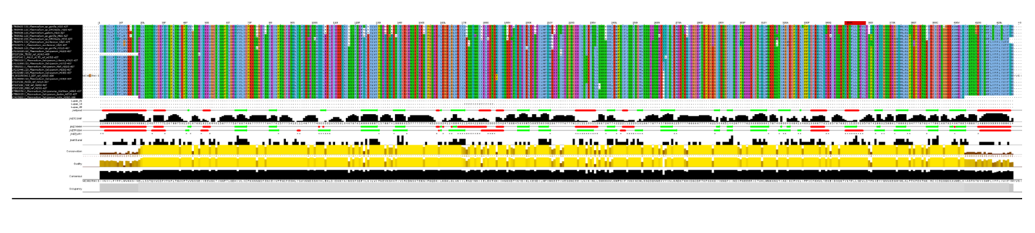

Additional figure 2: Results generated by Jpred from the secondary structure alignment of P47Rec.
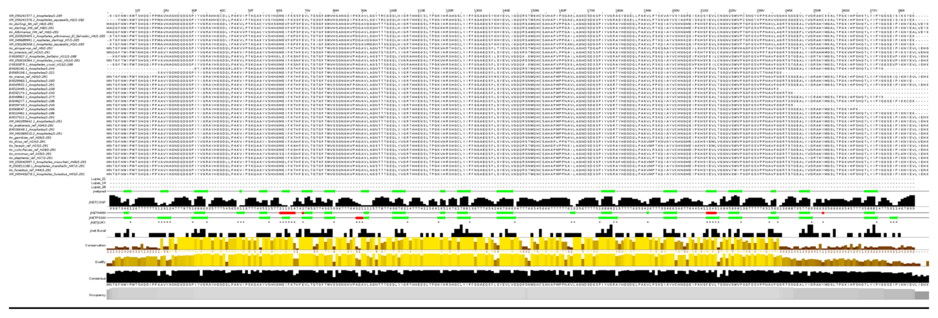
Additional figure 3. A and C: Location of cysteine ​​residues in the structures of the Pfs47 and P47Rec consensus proteins. B and D: Ramachandran plots of the consensus proteins of Pfs47 and P47Rec.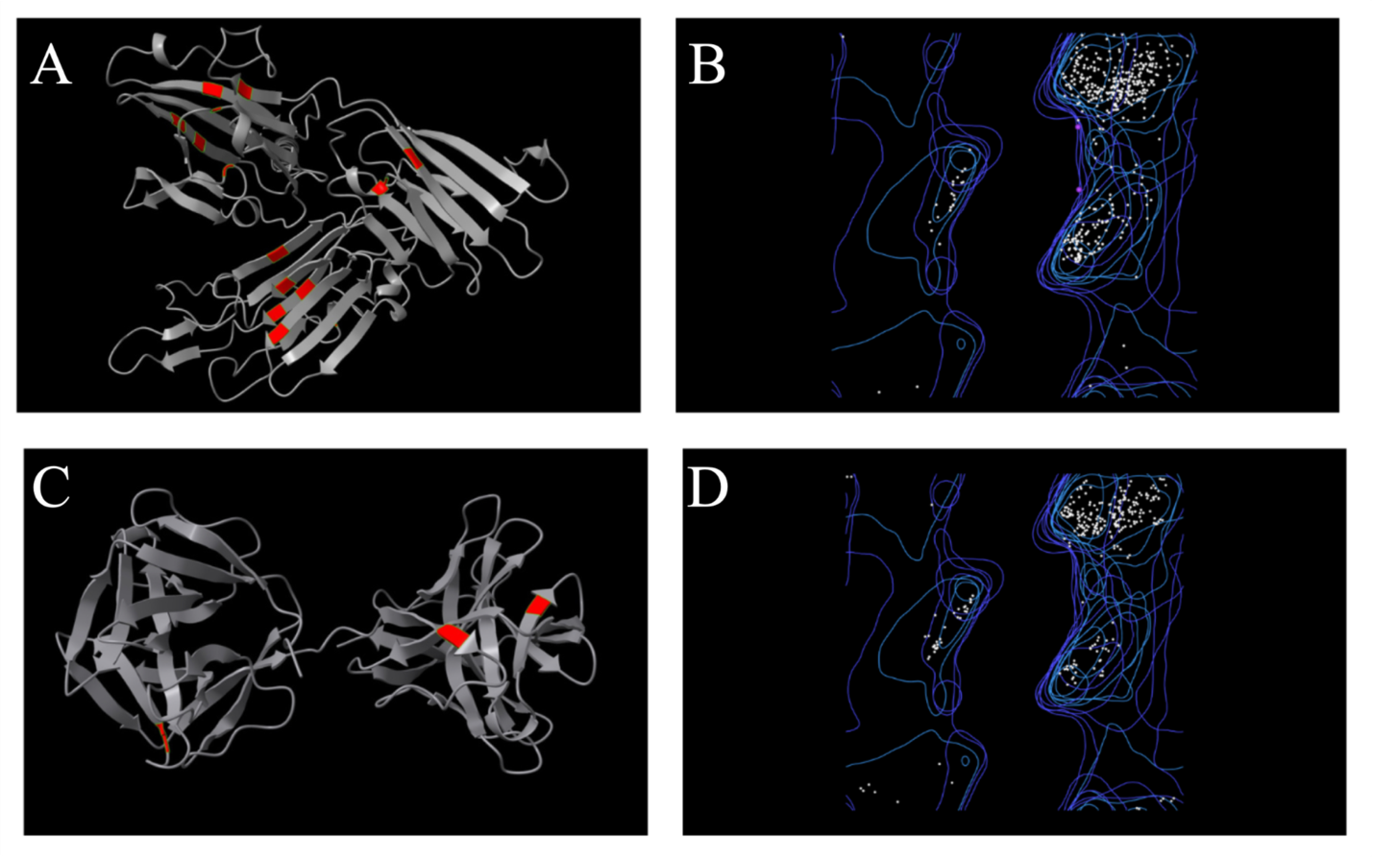

Additional figure 4. Results of the functional annotations of the consensus proteins of Pfs47 and P47Rec.
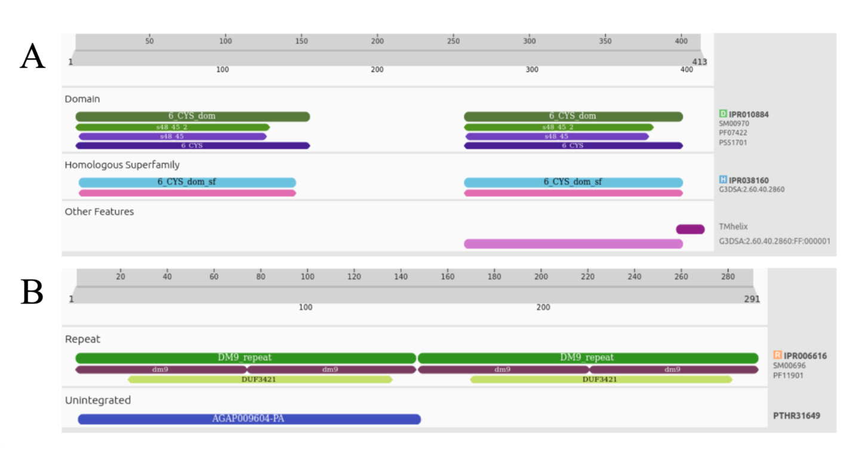

Additional figure 5. Location of sites with residues with antigenic potential in the primary structure of the (A) Pfs47 and (B) P47Rec proteins.
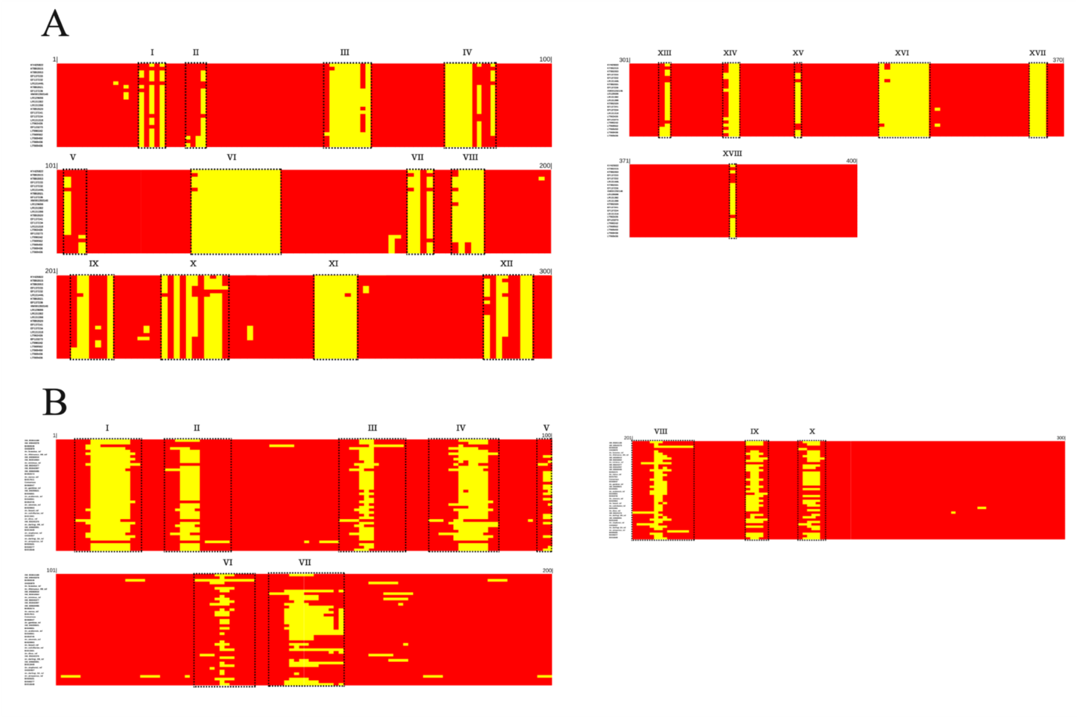

Additional figure 6. Location of sites with amino acids with antigenic potential on the surface of Pfs47 and P47Rec proteins. The regions highlighted in blue show the locations of amino acids with antigenic potential. (A) and (B) show the antigenic regions on the lateral faces of Pfs47 and P47Rec. (C) Antigenic regions of the front and back faces of Pfs47. (D) Front faces of the N- and C-terminal domains of P47Rec.

