Genetic determinants of COVID-19 vaccine response: genome-wide association studies of immunogenicity and breakthrough infection in UK biobank"

  - Supplementary material

Authors: Marta Alcalde-Herraiz¹, BA; Martí Català¹, PhD; Albert Prats-Uribe¹, MD, MPH, DPhil; Roger Paredes^{2,3} MD, PhD; Junqing Xie¹*, BSMed, MSc, PhD; and Daniel Prieto-Alhambra^{1,4}* MD, PhD
¹ Centre for Statistics in Medicine and NIHR Biomedical Research Centre Oxford, NDORMS, University of Oxford, Oxford, UK
² Department of Infectious Diseases and Institut de Recerca de la Sida IrsiCaixa. Hospital Universitari Germans Trias i Pujol, Badalona, Catalonia, Spain
³ Center for Global Health and Diseases, Department of Pathology, Case Western Reserve University School of Medicine, Cleveland, OH, USA
⁴ Department of Medical Informatics, Erasmus University Medical Centre, Rotterdam, The Netherlands
*Joint senior authors
Correspondence to:
Prof. Daniel Prieto-Alhambra, daniel.prietoalhambra@ndorms.ox.ac.uk
Botnar Research Centre, Windmill Road, OX37LD, Oxford, UK

  - Supplementary notes
Supplementary note 1. ICD-10 codes.
The International Classification of Diseases (ICD) 10th Revision code is used to identify the coded clinical entry. In particular:
- U07.1: COVID-19, virus identified.
Code used when COVID-19 has been confirmed by laboratory testing.
- U07.2: COVID-19, virus not identified.
Code used when COVID-19 is diagnosed clinically or epidemiologically, but without laboratory testing.

  - Supplementary figures
Supplementary figure 1. Flow chart of the quality control performed by PLINK2 on genotype calls and imputed variants. ··························································································································· 4

Supplementary figure 1. Flow chart of the quality control performed by PLINK2 on genotype calls and imputed variants. (A) Flow chart for immune response - one dose cohort. (B) Flow chart for immune response - two dose cohort. (C) Flow chart for breakthrough infection. (D) Flow chart for breakthrough susceptibility.

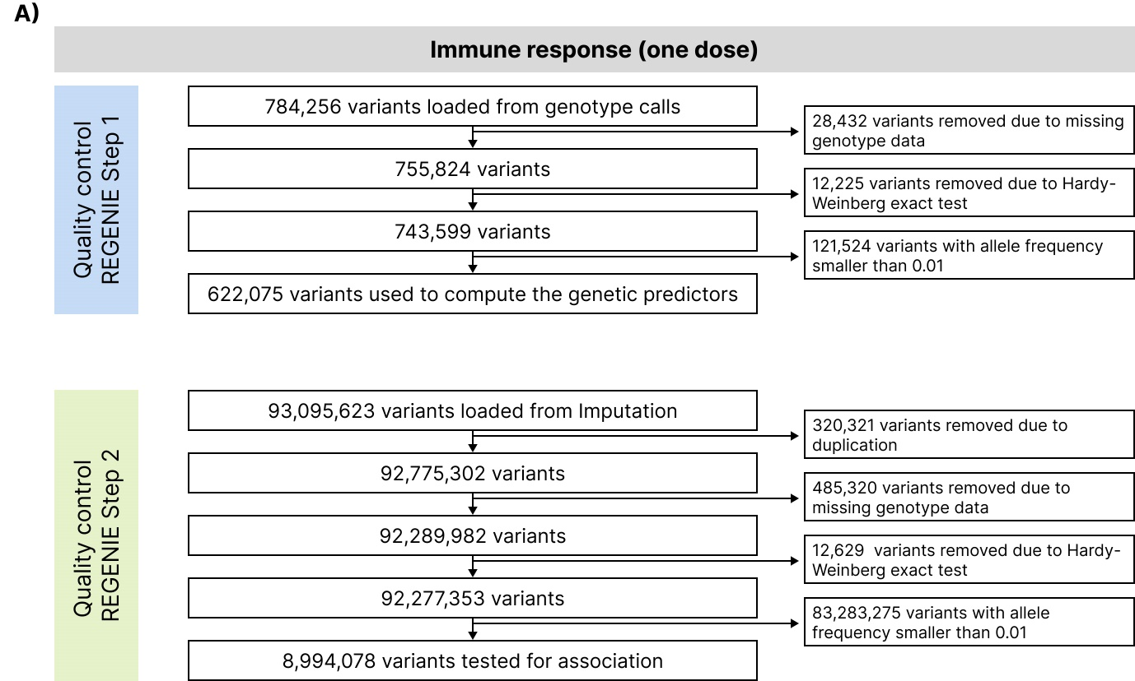

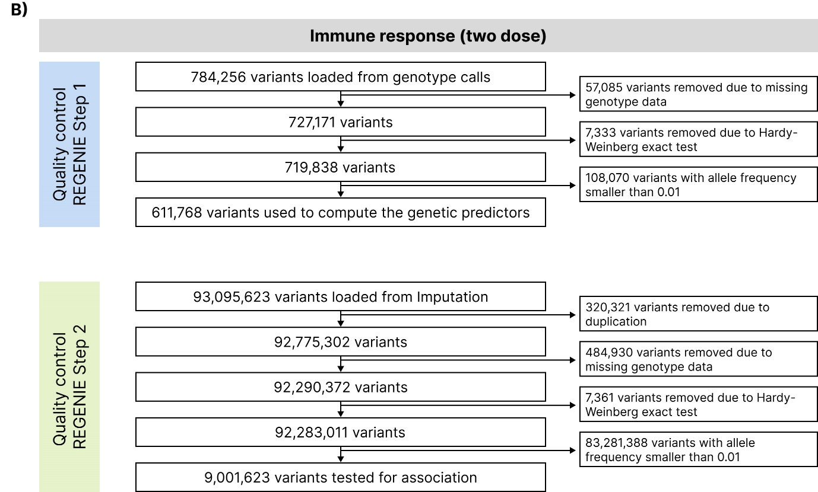
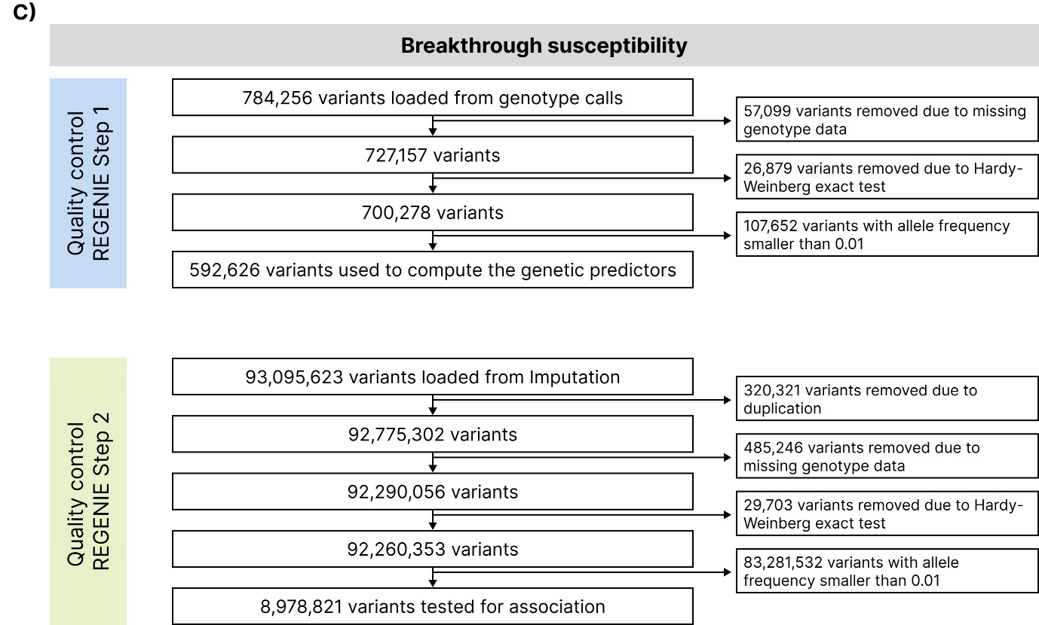

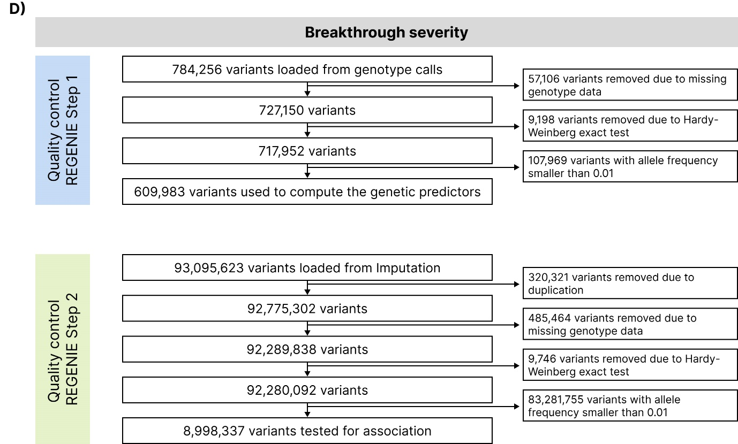
  - Supplementary tables
Supplementary table 1. Population characteristics of each one of the cohorts ································· 7
Supplementary table 2. Validation results for the variants associated with each one of the traits ··· 8
Supplementary table 3. Study of the overlap between the different traits ······································· 10
Supplementary table 4. Colocalization analysis of the different traits to study the shared causal variant assumption ····························································································································· 13
Supplementary table 5. Previously reported variants associated with genomic loci also founded in our study ············································································································································· 15

Supplementary table 1. Population characteristics of each one of the cohorts.
Variables |  | Immune response |  | Breakthrough
Variables |  | One dose | Two dose | Susceptibility | Severity
N |  | 64,060 | 39,129 | 202,596 | 48,067
Baseline characteristics
Sex (%) | Female | 35,123 (54.8) | 22,267 (56.9) | 110,186 (54.4) | 25,920 (53.9)
 | Male | 28,937 (45.2) | 16,862 (43.1) | 92,410 (45.6) | 22147 (46.1)
Age (Mean (SD)) |  | 67.42 (7.53) | 71.25 (6.24) | 69.53 (7.90) | 67.69 (7.98)
Body mass index (Mean (SD)) |  | 26.61 (4.43) | 27.05 (4.51) | 27.24 (4.66) | 27.20 (4.66)
Indices of multiple deprivation
Index of multiple deprivation (Mean (SD)) |  | 13.63 (11.22) | 14.43 (11.80) | 16.00 (12.90) | 15.34 (12.23)
Income score (Mean (SD)) |  | 1.07 (4.53) | 1.28 (5.57) | 0.13 (1.00) | 0.13 (0.87)
Employment score Mean (SD)) |  | 0.45 (3.24) | 0.77 (4.56) | 0.10 (0.79) | 0.10 (0.63)
Health score (Mean (SD)) |  | 0.15 (4.10) | 0.49 (5.00) | -0.14 (1.32) | -0.19 (1.13)
Education score (Mean (SD)) |  | 10.73 (13.06) | 11.65 (13.73) | 14.34 (15.28) | 13.43 (14.40)
Housing score (Mean (SD)) |  | 19.03 (10.69) | 19.17 (10.80) | 19.40 (9.99) | 19.43 (9.90)
Crime score (Mean (SD)) |  | 27.49 (170.47) | 20.47 (118.86) | 0.16 (15.80) | 0.06 (15.71)
Living environment score (Mean (SD)) |  | 16.22 (13.56) | 17.08 (14.04) | 17.21 (14.34) | 17.03 (14.20)

Supplementary table 2. Validation results for the variants associated with each one of the traits. Validation cohort is non-European ancestry in UK Biobank. SNPs in red were validated. P-Value threshold to determine statistical significance was set to 0.05.
1 | ID | Main analysis |  |  | Validation
1 | ID | N | OR | P Value | N | OR | P Value
Immune response - One dose | 6:32419074_CT_C | 63,914 | 0.86 | 1.3e-25 | 11,016 | 0.89 | 9.5e-04
Immune response - One dose | 6:32255712_CAGTT_C | 64,027 | 0.84 | 3.0e-14 | 11,041 | 0.97 | 5.2e-01
Immune response - One dose | rs9268465 | 63,548 | 1.09 | 5.9e-09 | 10,926 | 1.14 | 4.4e-04
Immune response - One dose | rs9268847 | 63,672 | 0.86 | 1.1e-20 | 10,950 | 0.85 | 6.2e-06
Immune response - One dose | 6:32440321_CTG_C | 63,231 | 1.26 | 9.2e-09 | 10,915 | 1.21 | 4.0e-02
Immune response - One dose | rs565122319 | 63,688 | 0.78 | 3.3e-08 | 10,953 | 0.89 | 1.4e-01
Immune response - One dose | rs145945003 | 63,532 | 1.32 | 2.8e-15 | 10,909 | 1.22 | 1.8e-02
Immune response - One dose | rs7763805 | 62,686 | 1.11 | 2.7e-08 | 10,686 | 1.08 | 1.3e-01
Immune response - One dose | rs17205528 | 60,513 | 0.86 | 1.3e-12 | 10,168 | 0.87 | 2.6e-03
Immune response - One dose | rs9501184 | 63,375 | 0.88 | 5.7e-15 | 10,957 | 0.95 | 1.5e-01
Immune response - One dose | rs2071474 | 64,058 | 0.91 | 1.0e-09 | 11,053 | 0.92 | 2.9e-02
Immune response - One dose | rs3130216 | 64,058 | 0.93 | 8.0e-09 | 11,053 | 0.97 | 3.9e-01
Immune response - One dose | rs9461694 | 59,088 | 0.87 | 1.4e-08 | 10,188 | 0.95 | 3.5e-01
Immune response - One dose | rs2523496 | 63,729 | 0.93 | 5.0e-08 | 10,991 | 0.95 | 1.6e-01
Immune response - Two dose | rs114903158 | 37,649 | 0.86 | 3.9e-11 | 6,569 | 0.94 | 2.1e-01
Immune response - Two dose | rs3094106 | 39,055 | 0.89 | 8.4e-09 | 6,946 | 1.09 | 1.4e-01
Breakthrough susceptibility | rs73062389 | 202,596 | 1.22 | 4.1e-38 | 43,341 | 1.22 | 1.7e-07
Breakthrough susceptibility | rs59776512 | 202,018 | 1.11 | 3.9e-12 | 43,126 | 1.10 | 4.3e-03
Breakthrough susceptibility | rs16861415 | 202,133 | 0.84 | 4.4e-33 | 43,130 | 0.88 | 3.4e-04
Breakthrough susceptibility | rs71322420 | 197,848 | 0.93 | 8.1e-12 | 41,981 | 0.96 | 9.2e-02
Breakthrough susceptibility | rs13097481 | 191,584 | 1.04 | 1.7e-08 | 40,657 | 1.04 | 3.0e-02
Breakthrough susceptibility | rs11673136 | 202,596 | 1.08 | 5.0e-26 | 43,341 | 1.06 | 9.8e-04
Breakthrough susceptibility | rs778809 | 202,596 | 1.07 | 1.3e-18 | 43,341 | 1.06 | 9.0e-04
Breakthrough susceptibility | rs681343 | 202,596 | 0.94 | 4.6e-14 | 43,341 | 0.94 | 5.2e-04
Breakthrough susceptibility | rs1977830 | 199,284 | 0.94 | 1.2e-11 | 42,134 | 0.98 | 2.9e-01
Breakthrough severity | rs62038344 | 47,791 | 0.57 | 1.2e-10 | 9,331 | 0.98 | 8.8e-01

Supplementary table 3. Study of the overlap between the different traits. When OR, SE and the P-Value are coloured red, it means that the P-Value is smaller than 5·10⁻⁸. Note: CHR = Chromosome, OR = Odds Ratio, SE = Standard error.
Phenotype | CHR | SNP | Gene / Nearest gene | Immune response |  |  |  |  |  | Breakthrough
 |  |  |  | One dose |  |  | Two dose |  |  | Susceptibility |  |  | Severity
 |  |  |  | OR | SE | P Value | OR | SE | P Value | OR | SE | P Value | OR | SE | P Value
Immune response - One dose | 6 | 6:32419074_CT_C | HLA-DRA - HLA-DRB9 | 0.86 | 0.01 | 1.3e-25 | 0.95 | 0.02 | 1.6e-03 | 1.01 | 0.01 | 5.1e-01 | 1.00 | 0.03 | 9.3e-01
Immune response - One dose | 6 | 6:32255712_CAGTT_C | C6orf10 | 0.84 | 0.02 | 3.0e-14 | 0.98 | 0.03 | 3.8e-01 | 1.00 | 0.01 | 9.5e-01 | 1.03 | 0.05 | 6.4e-01
Immune response - One dose | 6 | rs9268465 | C6orf10 - HCG23 | 1.09 | 0.01 | 5.9e-09 | 1.05 | 0.02 | 8.8e-03 | 0.99 | 0.01 | 4.8e-01 | 1.03 | 0.04 | 4.3e-01
Immune response - One dose | 6 | rs9268847 | HLA-DRB9 | 0.86 | 0.02 | 1.1e-20 | 0.91 | 0.02 | 7.5e-08 | 1.01 | 0.01 | 2.0e-01 | 0.98 | 0.04 | 6.7e-01
Immune response - One dose | 6 | 6:32440321_CTG_C | HLA-DRB9 | 1.26 | 0.04 | 9.2e-09 | 1.13 | 0.05 | 8.9e-03 | 0.97 | 0.02 | 1.5e-01 | 0.98 | 0.10 | 8.2e-01
Immune response - One dose | 6 | rs565122319 | HLA-DRB1 | 0.78 | 0.04 | 3.3e-08 | 0.85 | 0.05 | 3.8e-04 | 0.98 | 0.02 | 3.7e-01 | 0.95 | 0.10 | 6.6e-01
Immune response - One dose | 6 | rs145945003 | HLA-DRB1 - HLA-DQA1 | 1.32 | 0.04 | 2.8e-15 | 1.09 | 0.04 | NA | 0.98 | 0.02 | 3.0e-01 | 1.05 | 0.09 | 5.5e-01
Immune response - One dose | 6 | rs7763805 | HLA-DQA1 | 1.11 | 0.02 | 2.7e-08 | 1.03 | 0.02 | 1.7e-01 | 1.01 | 0.01 | 5.0e-01 | 1.02 | 0.05 | 7.3e-01
Immune response - One dose | 6 | rs17205528 | HLA-DQB1 | 0.86 | 0.02 | 1.3e-12 | 0.97 | 0.02 | 2.0e-01 | 0.98 | 0.01 | 5.9e-02 | 1.01 | 0.05 | 8.2e-01
Immune response - One dose | 6 | rs9501184 | MTCO3P1 - XXbac-BPG254F23.7 | 0.88 | 0.02 | 5.7e-15 | 1.01 | 0.02 | 4.8e-01 | 1.00 | 0.01 | 8.3e-01 | 1.04 | 0.04 | 3.6e-01
Immune response - One dose | 6 | rs2071474 | HLA-DOB - TAP2 | 0.91 | 0.02 | 1.0e-09 | 0.96 | 0.02 | 8.0e-03 | 1.00 | 0.01 | 9.0e-01 | 1.03 | 0.04 | 4.3e-01
Immune response - One dose | 6 | rs3130216 | COL11A2P1 - HLA-DPB2 | 0.93 | 0.01 | 8.0e-09 | 0.98 | 0.02 | 1.2e-01 | 1.00 | 0.01 | 5.3e-01 | 1.01 | 0.03 | 8.0e-01
Immune response - One dose | 6 | rs9461694 | XXbac-BPG248L24.10 - HLA-B | 0.87 | 0.03 | 1.4e-08 | 1.00 | 0.03 | 8.9e-01 | 1.00 | 0.01 | 8.2e-01 | 0.87 | 0.06 | 2.4e-02
Immune response - One dose | 6 | rs2523496 | HCP5 | 0.93 | 0.01 | 5.0e-08 | 1.00 | 0.02 | 9.5e-01 | 1.01 | 0.01 | 3.5e-01 | 0.94 | 0.03 | 7.0e-02
Immune response - Two dose | 6 | rs114903158 | HLA-DQB1 | 0.88 | 0.02 | 6.6e-11 | 0.86 | 0.02 | 3.9e-11 | 1.02 | 0.01 | 1.6e-01 | 1.01 | 0.05 | 9.0e-01
Immune response - Two dose | 6 | rs3094106 | ATAT1 | 1.00 | 0.02 | 8.1e-01 | 0.89 | 0.02 | 8.4e-09 | 1.00 | 0.01 | 6.5e-01 | 0.91 | 0.04 | 3.3e-02
Breakthrough susceptibility | 3 | rs73062389 | SLC6A20 | 0.97 | 0.03 | 3.4e-01 | 1.03 | 0.03 | 2.9e-01 | 1.22 | 0.02 | 4.1e-38 | 0.93 | 0.07 | 3.0e-01
Breakthrough susceptibility | 3 | rs59776512 | SLC6A20 | 0.99 | 0.03 | 6.6e-01 | 0.94 | 0.03 | 4.8e-02 | 1.11 | 0.02 | 3.9e-12 | 0.92 | 0.07 | 1.9e-01
Breakthrough susceptibility | 3 | rs16861415 | ST6GAL1 | 1.03 | 0.02 | 2.8e-01 | 0.99 | 0.03 | 6.8e-01 | 0.84 | 0.01 | 4.4e-33 | 1.14 | 0.06 | 3.6e-02
Breakthrough susceptibility | 3 | rs71322420 | RPS20P14 - RP11-42D20.1 | 1.04 | 0.02 | 2.6e-02 | 1.00 | 0.02 | 9.0e-01 | 0.93 | 0.01 | 8.1e-12 | 1.01 | 0.04 | 9.0e-01
Breakthrough susceptibility | 3 | rs13097481 | ST6GAL1 | 1.01 | 0.01 | 6.2e-01 | 1.00 | 0.02 | 8.5e-01 | 1.04 | 0.01 | 1.7e-08 | 0.95 | 0.03 | 1.3e-01
Breakthrough susceptibility | 19 | rs11673136 | MUC16 | 1.03 | 0.01 | 3.4e-02 | 1.01 | 0.02 | 6.1e-01 | 1.08 | 0.01 | 5.0e-26 | 0.98 | 0.03 | 5.8e-01
Breakthrough susceptibility | 19 | rs778809 | FUT6 | 1.00 | 0.01 | 8.6e-01 | 0.99 | 0.02 | 5.8e-01 | 1.07 | 0.01 | 1.3e-18 | 0.99 | 0.04 | 8.6e-01
Breakthrough susceptibility | 19 | rs681343 | FUT2 | 0.95 | 0.01 | 7.8e-05 | 0.97 | 0.02 | 7.9e-02 | 0.94 | 0.01 | 4.6e-14 | 1.04 | 0.03 | 2.8e-01
Breakthrough susceptibility | 10 | rs1977830 | MXI1 | 1.03 | 0.02 | 1.1e-01 | 0.98 | 0.02 | 3.4e-01 | 0.94 | 0.01 | 1.2e-11 | 1.01 | 0.04 | 8.5e-01
Breakthrough severity | 16 | rs62038344 | AC024590.1 - RP11-481E4.1 | 0.97 | 0.03 | 3.5e-01 | 1.03 | 0.03 | 3.8e-01 | 1.01 | 0.02 | 5.3e-01 | 0.57 | 0.09 | 1.2e-10

Supplementary table 4. Colocalization analysis of the different traits to study the shared causal variant assumption. If P(H4) is higher than 50%, the N and the P(H4) value are highlighted in red. Note: SNP: Single nucleotide polymorphism; CHR = Chromosome; N = Number of variants within ±250kb from the reference variants and hence, used for the colocalization analysis; P(H4): Probability of a shared causal variant.
Phenotype | SNP | CHR | POS | Immune response |  |  |  | Breakthrough
 |  |  |  | One dose |  | Two dose |  | Susceptibility |  | Severity
 |  |  |  | N | P(H4) (%) | N | P(H4) (%) | N | P(H4) (%) | N | P(H4) (%)
Immune response - One dose | 6:32419074_CT_C | 6 | 32,419,074 |  |  | 10,624 | 0.00 | 10,199 | 0.67 | 10,630 | 1.48
Immune response - One dose | rs9461694 | 6 | 31,292,104 |  |  | 9,716 | 0.80 | 9,559 | 1.33 | 9,722 | 5.12
Immune response - Two dose | rs114903158 | 6 | 32,630,824 | 11,846 | 0.00 |  |  | 11,446 | 1.71 | 12,099 | 2.14
Immune response - Two dose | rs3094106 | 6 | 30,599,176 | 3,036 | 0.87 |  |  | 3,030 | 0.60 | 3,039 | 9.07
Breakthrough susceptibility | rs73062389 | 3 | 45,835,417 | 1,633 | 2.08 | 1,629 | 2.54 |  |  | 1,631 | 4.19
Breakthrough susceptibility | rs16861415 | 3 | 186,696,364 | 1,877 | 2.00 | 1,880 | 1.28 |  |  | 1,880 | 16.64
Breakthrough susceptibility | rs11673136 | 19 | 9,007,748 | 1,930 | 5.59 | 1,929 | 0.78 |  |  | 1,930 | 1.67
Breakthrough susceptibility | rs778809 | 19 | 5,830,302 | 1,491 | 0.70 | 1,487 | 0.89 |  |  | 1,490 | 1.61
Breakthrough susceptibility | rs681343 | 19 | 49,206,462 | 1,861 | 84.06 | 1,869 | 1.91 |  |  | 1,863 | 2.46
Breakthrough susceptibility | rs1977830 | 10 | 111,975,040 | 1,332 | 2.20 | 1,328 | 1.64 |  |  | 1,329 | 2.08
Breakthrough severity | rs62038344 | 16 | 82,390,090 | 2,925 | 2.05 | 2,929 | 2.20 | 2,931 | 1.10

Supplementary table 5. Previously reported variants associated with genomic loci also founded in our study. Phenotypes can either be risk of susceptibility or severity of COVID-19.

Genomic loci | Reported | Study/Company | Cases | Controls | Population | Lead variant (Effect allele) | OR (95% CI) | P-Value
SLC6A20 | Severe Covid-19 GWAS group¹ | The Severe Covid-19 GWAS group | 1,610 (COVID-19 positive, hospitalized with respiratory support) | 2,205 (Population controls, unknown COVID-19 status) | Italy, Spain | rs11385942 (GA) | 1.77 (1.48, 2.11) | 1.15·10⁻¹⁰
SLC6A20 | Kousathanas et al., 2022² | The GenOMICC (Genetics of Mortality in Critical Care) initiative | 7,491 (Critically ill patients from ICUs) | 48,400 (Controls were from the 100,000 Genomes Project cohort, n = 46,770; and mild COVID-19, n = 1630) | Europeans, South Asians, Africans, East Asians | rs2271616 (T) | 1.3 (1.21, 1.37) | 9.9·10⁻¹⁰
SLC6A20 | Thibord F et al., 2022³ | GRASP portal | 16,551 European ancestry cases, 557 African ancestry cases, 810 South Asian ancestry cases, 563 OTHER cases | 442,669 European ancestry controls, 7,087 African ancestry controls, 8,607 South Asian ancestry controls, 10,446 OTHER controls. | Mixed | rs73062389 (A) | 1.21 (1.15, 1.27) | 4.3·10⁻¹⁵
SLC6A20 | Shelton J., et al., 2021⁴ |  | 1,128 European ancestry cases, 245 Hispanic or Latin American cases, 74 Black or African American cases | 679,531 European ancestry controls, 94,237 Hispanic or Latin American controls, 22,383 Black or African American controls | Mixed | rs13078854 (G) | 0.6 (0.53, 0.67) | 2.0·10⁻¹⁸
SLC6A20 | Shelton J., et al., 2021 |  | 9,913 European ancestry cases | 85,072 European ancestry controls | Mixed | rs2531743 (G) | 0.92 (0.89, 0.95) | 3·10⁻¹²
SLC6A20 | COVID-19 Host Genetic Initiative, 2021⁵ | The COVID-19 Host Genetics Initiative | 13,641 (COVID-19 positive test and hospitalization), 49,562 (Reported SARS-CoV-2 infection),  52,630 (COVID-19 positive),  52,630 (COVID-19 positive),  45,641 (COVID-19 positive and not hospitalized) | 2,070,709 (Population-based controls with unknown COVID-19 status),  1,770,206 (Population-based controls with unknown COVID-19 status),  704,016 (COVID-19 negative or unknown),  109,605 (COVID-19 negative),  704,016 (COVID-19 negative or unknown) | Mixed | rs2271616 (T) | 1.15 | 1.8·10⁻³⁴
SLC6A20 | Horowitz et al, 2022⁶ | AncestryDNA COVID-19 research study, GHS, PMBB, UK Biobank | 45,006 European ancestry cases, 2,710 African ancestry cases, 830 South Asian ancestry cases, 174 East Asian ancestry cases, 3,832 Hispanic or Latin American cases | 651,358 European ancestry controls, 26,106 African ancestry controls, 10,143 South Asian ancestry controls, 2,779 East Asian ancestry controls,  14,630 Hispanic or Latin American controls | Mixed | rs2531743 (G) | 0.96 (0.95, 0.97) | 1.0·10⁻⁹
HLA-B | COVID-19 Host Genetic Initiative, 2022⁷ | The COVID-19 Host Genetics Initiative | 25,027 (Moderate or severe COVID-19, defined as those hospitalized due to symptoms associated with infection) | 2,836,272 (control individuals) | Europeans, Americans, Africans, Middle Eastern, South Asians, East Asians (25 countries) | rs111837807 | 1.13 (1.09, 1.17) | 2.33·10⁻¹¹
HLA-DRB1 | Kousathanas et al., 2022² | The GenOMICC (Genetics of Mortality in Critical Care) initiative | 7,491 (Critically ill patients from ICUs) | 48,400 (Controls were from the 100,000 Genomes project cohort, n = 46,770; and mild COVID-19, n = 1,630) | Europeans, South Asians, Africans, East Asians | rs9271609 | 1.1 (1.09, 1.19) | 3.26·10⁻⁹
FUT2 | Kousathanas et al., 2022² | The GenOMICC (Genetics of Mortality in Critical Care) initiative | 7,491 (Critically ill patients from ICUs) | 48,400 (Controls were from the 100,000 Genomes project cohort, n = 46,770; and mild COVID | Europeans, South Asians, Africans, East Asians | rs368565 | 1.1 (1.1, 1.2) | 3.55·10⁻¹¹
FUT2 | Kousathanas et al., 2022² | The GenOMICC (Genetics of Mortality in Critical Care) initiative | 7,491 (Critically ill patients from ICUs) | 48,400 (Controls were from the 100,000 Genomes project cohort, n = 46,770; and mild COVID | Europeans, South Asians, Africans, East Asians | rs516246 (T) | 0.9 (0.88, 0.93) | 1.4·10⁻¹⁵
HLA-DQA1 | Kousathanas et al., 2022² | The GenOMICC (Genetics of Mortality in Critical Care) initiative | 7,491 (Critically ill patients from ICUs) | 48,400 (Controls were from the 100,000 Genomes project cohort, n = 46,770; and mild COVID | Europeans, South Asians, Africans, East Asians | rs2858305 (T) | 0.93 (0.9, 0.95) | 2.1·10⁻⁹

References
1. D, E. et al. Genomewide Association Study of Severe Covid-19 with Respiratory Failure. New England Journal of Medicine 383, (2020).
2. Kousathanas, A. et al. Whole-genome sequencing reveals host factors underlying critical COVID-19. Nature 607, (2022).
3. Thibord, F., Chan, M. V., Chen, M. H. & Johnson, A. D. A year of COVID-19 GWAS results from the GRASP portal reveals potential genetic risk factors. Human Genetics and Genomics Advances 3, (2022).
4. Shelton, J. F. et al. Trans-ancestry analysis reveals genetic and nongenetic associations with COVID-19 susceptibility and severity. Nat Genet 53, (2021).
5. Niemi, M. E. K. et al. Mapping the human genetic architecture of COVID-19. Nature 600, (2021).
6. Horowitz, J. E. et al. Genome-wide analysis provides genetic evidence that ACE2 influences COVID-19 risk and yields risk scores associated with severe disease. Nat Genet 54, (2022).
7. Pathak, G. A. et al. A first update on mapping the human genetic architecture of COVID-19. Nature vol. 608 Preprint at https://doi.org/10.1038/s41586-022-04826-7 (2022).

