SUPPLEMENTARY FIGURES
Supplementary Figure 1: Value set for Fabry Disease
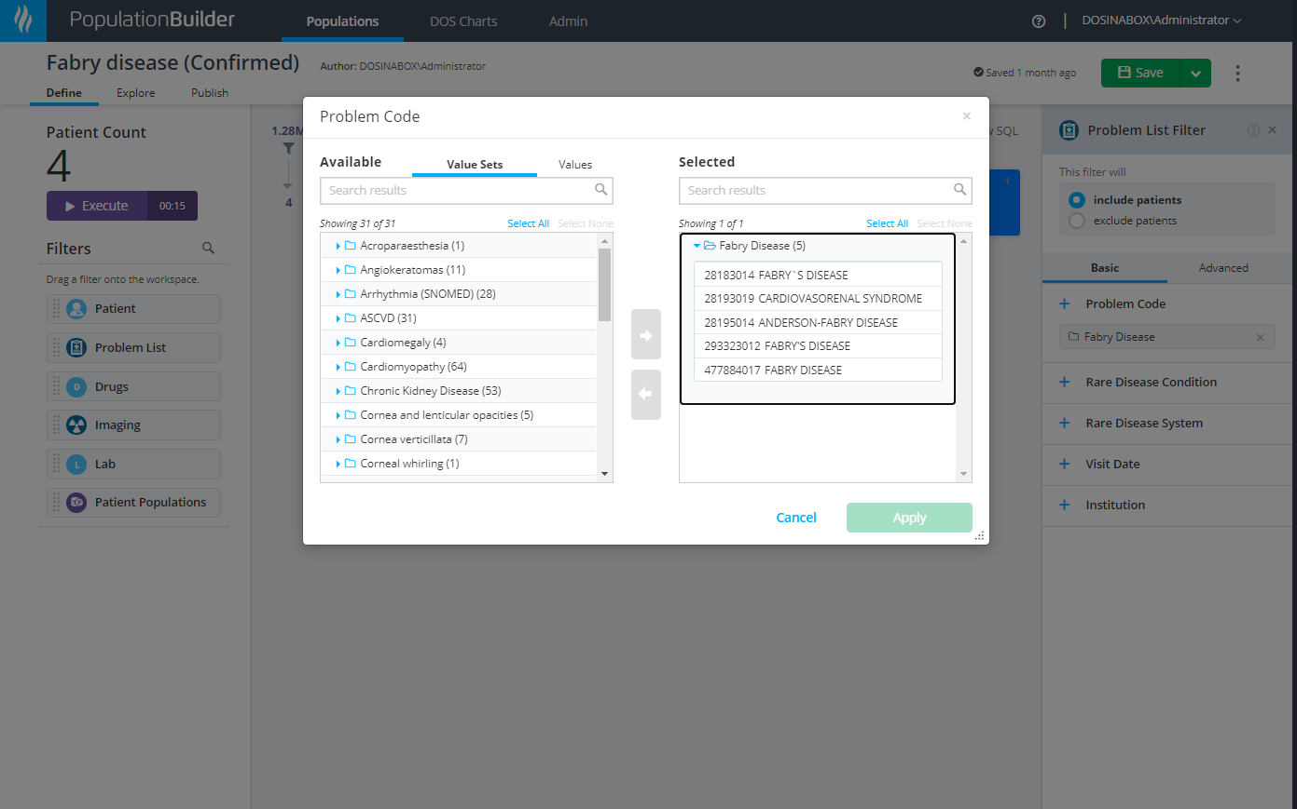

Supplementary Figure 2: Filtering using Health Catalyst’s Population Builder tool allowed filtering of 1.28 million patients using the Fabry disease screening criteria
